Intersections and unions
Students learn about the concepts of set notation, empty sets, intersections, unions and disjoint sets, using Venn diagrams. Students analyse student subject selections to determine which subjects should be run separately and those that could be run simultaneously.

Learning intentions
- To know how to represent sets using Venn diagrams.
- To understand how to interpret intersections, unions and disjoint sets.

Success criteria
- I can construct Venn diagrams.
- I can interpret Venn diagrams and use them to make informed decisions.
- I can use set notation to describe relationships between sets, including the notation for intersections, unions and disjoint sets.
- I can apply my understanding of unions and intersections to solve problems.

Outcomes
A student:
- develops understanding and fluency in mathematics through exploring and connecting mathematical concepts, choosing and applying mathematical techniques to solve problems, and communicating their thinking and reasoning coherently and clearly MAO-WM-01
- solves problems involving probability in a variety of contexts MAV-11-09

Content

Sets and set notation
- Define the empty set as the set with no elements, denoted in set notation as $∅$
- Define the intersection $A∩B$ of sets $A$ and $B$ to be the set of elements that are in $A$ and in $B$
- Define the union $A∪B$ of sets $A$ and $B$ to be the set of elements that are in $A$ or in $B$
- Define sets $A$ and $B$ to be disjoint if $A∩B=∅$, that is, they have no elements in common
- Use Venn diagrams in practical situations to represent and interpret sets that may intersect in various ways within a universal set
- Establish and use the rule $\left|A∪B\right|=\left|A\right|+\left|B\right|-\left|A∩B\right|$

Probability
- Use Venn diagrams to represent the relationship between events within the same sample space, including mutually exclusive events, that is, events that as subsets of the sample space are disjoint
- Establish and use the rules $P\left(\overline{A}\right)=1-P(A)$ and $P\left(A∪B\right)=P\left(A\right)+P\left(B\right)-P(A∩B)$
Mathematics Advanced 11–12 Syllabus © NSW Education Standards Authority (NESA) for and on behalf of the Crown in right of the State of New South Wales, 2024.

Table 1: lesson summary
Section | Summary of activity | Teaching strategies | Teaching points
Activating prior knowledge | Use slides 4–5 of the PowerPoint Intersections and unions to display a question on subsets and Venn diagram definitions to revise previous content knowledge required for this lesson. | Think-Pair-Share | Students should recall set notation and Venn diagrams, so they can apply it to determine intersections and unions.
Connecting learning | Students analyse subject selection data and construct Venn diagrams using Appendix A. | Visibly random groups of 3  Vertical non-permanent surfaces  Gallery walk  Pose-Pause-Pounce-Bounce | This activity allows students to explore where intersections and unions are used in the real-world within their own context.
Releasing responsibility | Use slides 7–11 to display definitions and notations of intersection, unions and disjoint sets and Worked examples.  Establish the rules $\left|A∪B\right|=\left|A\right|+\left|B\right|-\left|A∩B\right|$ and $P\left(A∪B\right)=P\left(A\right)+P\left(B\right)-P\left(A∩B\right)$, by using slides 12–16 to display definitions and Worked examples.  Students complete Appendix B. | Think-Pair-Share  Worked examples (Your turn)  Four quadrant notes | The purpose of this section is for students to connect the new notation and rules with a Venn diagram and relate it to the context of subjects at school.
Independent practice | Using Appendix C and slide 14, students apply their knowledge to determine which faculty in a school has the greatest need for a new teacher. | Visibly random groups of 3  Vertical non-permanent surfaces | The purpose of this problem is for students to solve an unfamiliar problem and communicate their reasoning, by completing and using a triple Venn diagram.

Activity structure
Please use the associated PowerPoint Intersections and unions to display images in this lesson.

Activating prior knowledge
- Use slide 4 of the PowerPoint to display a question for students to complete in a Think-Pair-Share (bit.ly/thinkpairsharestrategy). Solutions are provided on slide 4 of the PowerPoint as an animation.
- Conduct a class discussion for students to share their answers and check for understanding of set concepts. Prompting questions could include:
- Are there some elements that are not included in either set $A$ or set $B$?
- Are there some elements that are in both set $A$ and set $B$?
This activity is designed to make connections to students’ prior learning by:
- Revising the terminology of sets and subsets.
- Reinforcing students’ skills representing sets using the correct notation.
- Initiating conversations for when sets have elements in common.
- To complete the next activity students will need to construct a Venn diagram.
Venn diagrams may have been introduced in the Stage 5 Probability B, Path outcome
MA5-PRO-P-01. However, this could be the first time some students will have seen a Venn diagram. If required, use slide 5 to model a Venn diagram to students for categorising the numbers 110, as factors of 12 and/or 20.

Slide 5 could be used to model the features of a Venn diagram, including:
- A Venn diagram is a graphical representation containing several, typically, overlapping circles.
- Define and explain the section of the overlapping circles and the area outside the circles, using the given example.

Connecting learning
For the first part of this section, students will be engaging with the data provided in Appendix A ‘Subject selection’. Alternatively, you can use real data collected from your own class for a more authentic experience for the students.
- Explain to students that they are going to be assisting with planning the timetable for Year 11 the following year by looking at the current subject selection data.
- Ask students to consider whether they have any classes in common with students in their mathematics class and what factors may have influenced the creation of their timetables. To scaffold the activity, use prompting questions which could include:
- Why might Subject A and Subject B run at separate times?
- Since Student X and Student Y do the same subject, why are they not in the same class?
- Assign students to visibly random groups of 3 (bit.ly/visiblegroups) at vertical non-permanent surfaces (bit.ly/VNPSstrategy).
- Distribute Appendix A to students, which contains a list of 14 students and their 6 subject selections for Year 11.
- Explain to students that the Deputy Principal is deciding how to schedule subjects, determining which subjects should be offered at different times. Their task is to use Venn diagrams, each representing the overlap in student interest between 2 subjects, to recommend 3 pairs of subjects that should be offered at different times and 3 pairs of subjects that could be offered at the same time.
- Students are to do a gallery walk (bit.ly/DLSgallerywalk) of each other’s timetabling suggestions and Venn diagrams for students to provide peer feedback. Ask students to consider if other groups had similar recommendations to their own.
- Conduct a class discussion where students share their suggestions. Check for understanding by using the Pose-Pause-Pounce-Bounce questioning strategy (PDF 557 KB) (bit.ly/posepausepouncebounce) to determine if each group agreed with another’s suggestion. Encourage students to share their reasoning using prompting questions, such as:
- Why did you choose those 2 subjects to be offered at different times?
- Which part of the Venn diagram did you use to make the decision?
During the class discussion, students should be encouraged to refer to different parts of their Venn diagram when giving the reasons for their subject pairings. Students should be able to identify that subjects that had the largest overlap were the subjects that should be offered at different times.

Releasing responsibility
- Use slides 7–9 from the PowerPoint to introduce the terminology and notation for empty set, union, intersection and disjoint. Each slide contains self-explanation prompts. Allow time for students to Think-Pair-Share their answers to these prompts.
- Use slides 10–11 for the Worked examples (Your turn) method (bit.ly/supportingstrategies) to model how to solve problems involving intersections and unions.
- Display slide 12 which shows the rule $\left|A∪B\right|=\left|A\right|+\left|B\right|-\left|A∪B\right|$ and its visual representation in Venn diagrams. Have students, in a Think-Pair-Share, explain why the rule works.
- Select non-volunteer students to explain why the rule works.
Students should be guided to understand that when adding the number of elements in sets A and B, the elements in the intersection ($A∩B$) are counted twice – once in A and once in B – so the intersection must be subtracted to avoid double-counting.
- Ask students in their pairs to consider how this rule may apply when finding the $P(A∪B)$, by considering a rule that contains $P\left(A\right), P\left(B\right)and P(A∩B)$.
- Animate the slide to display the rule $P\left(A∪B\right)=P\left(A\right)+P\left(B\right)-P(A∩B)$ and explain to students that this rule works in a similar way to the previous one.
Students should be guided to understand that when calculating $P(A∪B),$ we are finding the probability that an outcome is in set A, set B, or both. If we simply add $P(A)+P(B)$, the outcomes that belong to both sets ($A∩B$) are counted twice, once in each set. To correct for this, we subtract $P(A∩B)$ to ensure each outcome is only counted once.
- Use slides 13–16 for the Worked examples (Your turn) method to model how to solve problems using the established rules $\left|A∪B\right|=\left|A\right|+\left|B\right|-\left|A∩B\right|$ and $P\left(A∪B\right)=P\left(A\right)+P\left(B\right)-P(A∩B)$.
- Have students create Four quadrant notes (bit.ly/supportingstrategies) using Appendix B ‘Four quadrant notes’.
- Students may benefit from completing practice questions from an existing resource to consolidate their understanding of empty sets, intersections, unions, disjoint sets and using the rules $\left|A∪B\right|=\left|A\right|+\left|B\right|-\left|A∩B\right|$ and $P\left(A∪B\right)=P\left(A\right)+P\left(B\right)-P(A∩B)$.

Independent practice
- Verbally pose the following problem to students.
Venn High School has the opportunity to hire a new teacher. Before advertising the position, they must determine which faculty has the greatest need for a new staff member. The HSIE faculty argues that the teacher should be placed in their department, while the Science faculty disagrees.
- Establish new visibly random groups of 3 on vertical non-permanent surfaces and distribute Appendix C ‘Hiring a new teacher’ to each student.
- Explain to students that they are to complete the Venn diagram on their vertical non-permanent surface using the information provided and determine the most suitable faculty for the new teacher, giving reasons. Appendix C is used to provide independent practice for students.
- Conduct a class discussion for students to share their decisions. Use the Pose-Pause-Pounce-Bounce questioning strategy to check for understanding and to determine if other groups made the same decision. Encourage students to provide reasons and to refer to their Venn diagram.
Sample solutions have been provided for this activity, which contain possible reasons for each faculty.

Assessment and differentiation

Suggested opportunities for differentiation
Activating prior knowledge
- Students may need to be reminded of what a subset is and the correct notation for writing a set.
Connecting learning
- Depending on students’ familiarity with Venn diagrams, they may need explicit instructions to compare some of the popular pairings, such as Biology and Chemistry or Business Studies and Legal Studies.
Releasing responsibility
- If students are struggling to make the connection between the real-world example and the terminology, students could each be given a piece of paper with their subjects on it. The class can then go outside where a Venn diagram with 2 overlapping circles are drawn and students can move into their appropriate place within the Venn diagram.
Independent practice
- Students may require some assistance in understanding the triple Venn diagram contained in Appendix C.
- As this activity has no incorrect answers and is subject to opinion, all students should be able to attempt to make a decision.

Suggested opportunities for assessment
Activating prior knowledge
- A Think-Pair-Share provides students with the opportunity to reflect on their understanding.
- Monitor responses in class discussions to check for student understanding of sets and subsets.
Connecting learning
- When placed in groups of 3, students provide and receive peer feedback on their understanding.
- Students working at vertical non-permanent surfaces means the teacher can assess student progress and provide support where appropriate.
Releasing responsibility
- Student responses to the provided prompts could be collected as a work sample for assessment.
- Monitor student responses in the ‘Your turn’ section to check for understanding.
Independent practice
- Students will demonstrate their Working mathematically skills in discussions and justifications.

Appendix A

Subject selection
- Below are the subject selections for 14 students from Year 11.
Student | Subject 1 | Subject 2 | Subject 3 | Subject 4 | Subject 5 | Subject 6
Ava | English Advanced | Mathematics Standard | Biology | Legal Studies | Ancient History | Hospitality
Ben | English Advanced | Mathematics Standard | Legal Studies | PDHPE | Visual Arts | French
Cal | English EAL/D | Mathematics Advanced | Biology | Chemistry | Business Studies | Legal Studies
Dax | English Standard | Numeracy | Biology | Dance | Drama | Food Technology
Eli | English Advanced | Mathematics Advanced | Ancient History | Modern History | Japanese | Business Studies
Fin | English Standard | Mathematics Advanced | Biology | Chemistry | Business Studies | Legal Studies
Gus | English Standard | Mathematics Standard | Biology | Business Studies | Ancient History | PDHPE
Hao | English Studies | Mathematics Advanced | Chemistry | Physics | Business Studies | Japanese
Ian | English Standard | Numeracy | Biology | Chemistry | Business Studies | Legal Studies
Jai | English Standard | Mathematics Advanced | Chemistry | Physics | Business Studies | Economics
Kau | English Advanced | Mathematics Advanced | Biology | Chemistry | PDHPE | Drama
Liv | English Advanced | Mathematics Standard | Biology | Business Studies | Modern History | Industrial Technology
Mae | English Standard | Mathematics Standard | Chemistry | Business Studies | Legal Studies | Modern History
Nat | English Advanced | Mathematics Advanced | Biology | Chemistry | Business Studies | Legal Studies
- Recommend 3 pairs of subjects that should run simultaneously and 3 pairs of subjects that should be offered at different times. Explain your answer.

Appendix B

Four quadrant notes
Example 1  In a community centre, people attend either yoga $(Y)$ or pilates $(P)$. If 42 people attend yoga, 39 people attend pilates, and 6 people attend both.  Find $\left|Y∪P\right|.$  $$\left|Y∪P\right|=\left|Y\right|+\left|P\right|-\left|Y∩P\right|$$  $$\left|Y∪P\right|=+-$$  $$\left|Y∪P\right|=$$  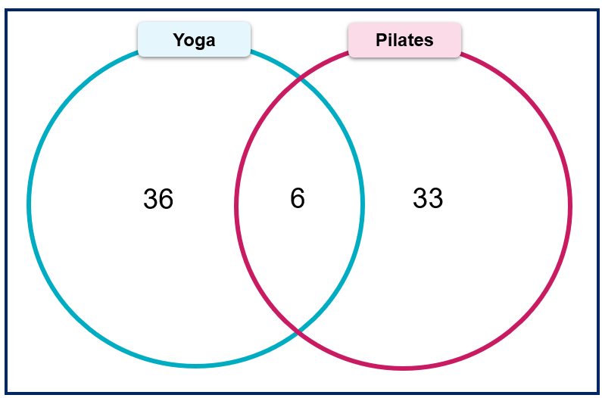 | Example 2  In a group of 60 students:  - 38 play basketball (B)  - 35 play hockey (H)  - 23 play both sports.  What is the probability that a student chosen at random plays basketball or hockey?
Notes to future forgetful selves | Example 3

Appendix C

Hiring a new teacher
Venn High School has the opportunity to hire a new teacher. Before advertising the position, they must determine which faculty has the greatest need for a new staff member. The HSIE faculty argues that the teacher should be placed in their department, while the Science faculty disagrees.
- Each Venn diagram is incomplete. Use the following statements to complete each of the diagrams.
- There are 100 Year 11 students currently enrolled at Venn High School.
- $\left|LS∪E\right|=57$
- $\left|C∩P\right|=9$
Year 11 HSIE | Year 11 Science
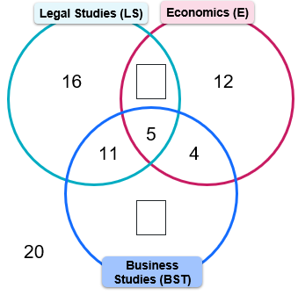 | 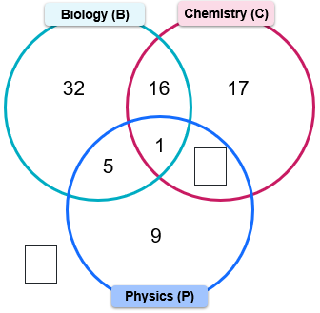
- Each Year 11 class can have a maximum of 24 students.
Use the data of current enrolments in Year 11 HSIE and Science subjects to analyse and identify the most suitable faculty for the new teacher, supporting your argument with reasoning.

Sample solutions

Appendix B – Four quadrant notes
Example 1  In a community centre, people attend either yoga $(Y)$ or pilates $(P)$. If 42 people attend yoga, 39 people attend pilates, and 6 people attend both.  Find $\left|Y∪P\right|.$  $$\left|Y∪P\right|=\left|Y\right|+\left|P\right|-\left|Y∩P\right|$$  $$\left|Y∪P\right|=42+39-6$$  $$\left|Y∪P\right|=75$$  Alternate method:  Number of people who attend only yoga  $$=42-6 \\ =36$$  Number of people who attend only Pilates  $$=39-6 \\ =33$$  $$\left|Y∪P\right|=36+6+33=75$$ | Example 2  In a group of 60 students:  - 38 play basketball (B)  - 35 play hockey (H)  - 23 play both sports.  What is the probability that a student chosen at random plays basketball or hockey?  $$P\left(B∪H\right)=P\left(B\right)+P\left(H\right)-P(B∩H) \\ =\frac{38}{60}+\frac{35}{60}-\frac{23}{60} \\ =\frac{5}{6}$$  Alternate method:  Number of students who play only basketball  $$=38-23 \\ =15$$  Number of students who play only hockey  $$=35-23 \\ =12$$  $$P\left(B∪H\right)=\frac{15+23+12}{60}=\frac{5}{6}$$  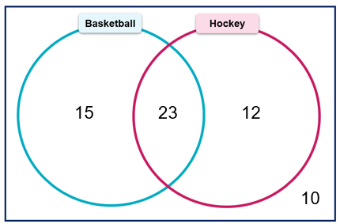

Appendix C – hiring a new teacher

Year 11 HSIE | Year 11 Science
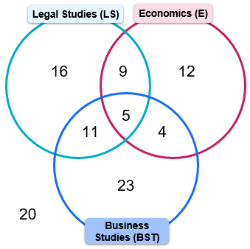 | 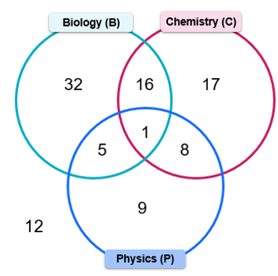
- This question has no correct answers. Possible arguments could include:
Arguments for hiring a HSIE teacher | Arguments for hiring a Science teacher
- HSIE has a higher number of students completing 3 courses, 5 students compared to one in Science.  - HSIE has at least 2 classes running in each of the 3 HSIE subjects displayed, with 2 classes in Legal Studies for the 41 students, 2 classes in Economics for the 30 students and 2 classes in Business studies for the 43 students. Compared to Science that only has one class running in Physics for the 23 students. | - Science has a higher number of students completing at least 2 of their subjects, 30 students compared to 29 in HSIE.  - Science has more students engaging in their subjects, that is, they have a lower number of students that don’t do any Sciences, 15 compared to 20 in HSIE.  - Science has 3 classes in one subject area, Biology for the 54 students, whereas HSIE only has 2 classes for each of their 3 subjects.

References
This resource contains NSW Curriculum and syllabus content. The NSW Curriculum is developed by the NSW Education Standards Authority. This content is prepared by NESA for and on behalf of the Crown in right of the State of New South Wales. The material is protected by Crown copyright.
Please refer to the NESA Copyright Disclaimer for more information https://educationstandards.nsw.edu.au/wps/portal/nesa/mini-footer/copyright.
NESA holds the only official and up-to-date versions of the NSW Curriculum and syllabus documents. Please visit the NSW Education Standards Authority (NESA) website https://educationstandards.nsw.edu.au/ and the NSW Curriculum website https://curriculum.nsw.edu.au/.
Mathematics Advanced 11–12 Syllabus © NSW Education Standards Authority (NESA) for and on behalf of the Crown in right of the State of New South Wales, 2024.

© State of New South Wales (Department of Education), 2025
The copyright material published in this resource is subject to the Copyright Act 1968 (Cth) and is owned by the NSW Department of Education or, where indicated, by a party other than the NSW Department of Education (third-party material).
Copyright material available in this resource and owned by the NSW Department of Education is licensed under a Creative Commons Attribution 4.0 International (CC BY 4.0) license.

This license allows you to share and adapt the material for any purpose, even commercially.
Attribution should be given to © State of New South Wales (Department of Education), 2025.
Material in this resource not available under a Creative Commons license:
- the NSW Department of Education logo, other logos and trademark-protected material
- material owned by a third party that has been reproduced with permission. You will need to obtain permission from the third party to reuse its material.
Links to third-party material and websites
Please note that the provided (reading/viewing material/list/links/texts) are a suggestion only and implies no endorsement, by the New South Wales Department of Education, of any author, publisher, or book title. School principals and teachers are best placed to assess the suitability of resources that would complement the curriculum and reflect the needs and interests of their students.
If you use the links provided in this document to access a third-party's website, you acknowledge that the terms of use, including licence terms set out on the third-party's website apply to the use which may be made of the materials on that third-party website or where permitted by the Copyright Act 1968 (Cth). The department accepts no responsibility for content on third-party websites.

