Identifying the mode and median
In this lesson, students will learn about mode and median by engaging with frequency and cumulative frequency graphs and tables of winners’ ages for tennis and swimming events. Students will identify these measures of central tendency and interpret their significance in relation to peak performance age in sports.

Learning intention
- To understand how to identify and interpret the mode and median from frequency and cumulative frequency graphs and tables.

Success criteria
- I can determine the mode and median of datasets from tables and graphs.
- I can explain what the mode and median indicate in the context of the data.
- I can compare findings from different datasets and hypothesise reasons for observed trends.
- I can use mathematical language to communicate my findings and conclusions effectively.

Outcomes
A student:
- develops understanding and fluency in mathematics through exploring and connecting mathematical concepts, choosing and applying mathematical techniques to solve problems, and communicating their thinking and reasoning coherently and clearly MAO-WM-01
- displays and analyses datasets using summary statistics and graphical representations MAV-11-10

Content

Data
- Graph the frequency, relative frequency, and cumulative frequency histograms and polygons of datasets, using spreadsheets or graphing applications, and identify the mode and median from the graphs and from tables
Mathematics Advanced 11–12 Syllabus © NSW Education Standards Authority (NESA) for and on behalf of the Crown in right of the State of New South Wales, 2024.

Table 1: lesson summary
Section | Summary of activity | Teaching strategies | Teaching points
Activating prior knowledge | Use slide 4 of the PowerPoint or Appendix A to display the 4 datasets for students to discuss ‘Which one doesn’t belong?’ | Which one doesn’t belong?  Visibly random groups  Vertical non-permanent surfaces  Pose-Pause-Pounce-Bounce | Students think critically about and collaboratively explore features of datasets by reviewing prior knowledge of calculating the mode and median.
Connecting learning | Use slide 6 to discuss US Open winners and watch the video ‘Djokovic: 35 is the new 25’ (0:30) (https://bit.ly/Djokovic35new25).  Students use Appendix B to analyse tennis data to reflect critically on the statement and review the definitions of mode and median using slides 7 to 14. | Think-Pair-Share  Self-explanation prompts | Students use data to analyse and evaluate the validity of a statement.
Releasing responsibility | Students synthesise their findings before justifying if ‘35 is the new 25’, using their data analysis. | Think-Pair-Share  Assessing and advancing questions | Students use mode and median to think critically about how age impacts success in sports and the broader implications for athlete training and career longevity.
Independent practice | Students analyse swimming data in Appendix C and compare the data to the earlier tennis data with a focus on peak performance age in different sports. Slides 16 to 17 can be used to display the data. | Think-Pair-Share  Assessing and advancing questions | Students discuss how understanding these statistics can inform sports management, coaching and training strategies.

Activity structure
Please use the associated PowerPoint Identifying the mode and median to display images in this lesson.

Activating prior knowledge
- Use slide 4 of the PowerPoint to show the 4 datasets below. These are also available in Appendix A ‘Which one doesn’t belong?’, to hand out to each group.
- Dataset A: [10, 14, 16, 18, 20, 25, 28, 30, 32, 34]
- Dataset B: [10, 14, 18, 20, 22, 22, 25, 28, 30, 34]
- Dataset C: [8, 14, 18, 18, 22, 22, 25, 28, 30, 38]
- Dataset D: [10, 18, 18, 22, 25, 28, 34]
- Assign students to visibly random groups of 3 (bit.ly/visiblegroups) at vertical non-permanent surfaces (bit.ly/VNPSstrategy) and ask them to consider ‘Which one doesn’t belong?’ (talkingmathwithkids.com/wodb-about/). Prompt students to perform statistical calculations. Observe each group to assess students' understanding as they collaborate.
- Facilitate a class discussion to deepen student thinking and understanding by having groups share and compare their insights using the Pose-Pause-Pounce-Bounce questioning strategy (PDF 557 KB) (bit.ly/posepausepouncebounce).
Possible reasons for each dataset not belonging:
- Dataset A: Only one with a different median (22.5 instead of 22); No mode.
- Dataset B: Only one with a single mode of 22.
- Dataset C: Only one with 2 modes, 18 and 22 (bimodal); Only one with different lowest score, highest score and range.
- Dataset D: Only one with fewer values (7 instead of 10) or an odd number of values; Only one with a single mode of 18.

Connecting learning
- Display slide 6 of the PowerPoint and discuss the content with the class.
- Show students the video ‘Djokovic: 35 is the new 25’ (0:30) (https://bit.ly/Djokovic35new25).
- Ask the class to consider if they agree or disagree with Djokovic’s statement and why. Use the Pose-Pause-Pounce-Bounce questioning strategy to encourage evidence-based reasoning by asking students to suggest what data could be used to determine if the statement is true.
- Tell students that the objective of this lesson is to consider data about tennis winners’ ages to reflect on the statement, ‘35 is the new 25’.
- Using a Think-Pair-Share (bit.ly/thinkpairsharestrategy), guide students to reflect critically on the statement ‘35 is the new 25’ by analysing the combined women’s and men’s US Open data on slide 7. Using evidence from the data to support their conclusions, encourage students to discuss if they still agree or disagree with the statement and why. This data is available as part of Appendix B ‘Tennis tournament data’, which pairs will require later in the lesson.
Students should be familiar with measures of centre and range, as well as frequency as they have displayed and interpreted frequency histograms and polygons in the Stage 4 Data classification and visualisation outcome MA4-DAT-C-01 and described and analysed data using measures of centre and range in the Stage 4 Data analysis outcome MA4-DAT-C-02.
- Revisit prior learning by using slides 8–10 to review and unpack the definitions of mode and median. Use the self-explanation prompts to guide students in articulating their understanding of how to find these measures of centre.
Grouped data is used in the activity below, despite it not being specifically mentioned in the syllabus. It has been included to initiate discussion around how grouped data can be useful in summarising large sets of information.
- In the same pairs, ask students to collaboratively identify the mode and median age for the next 2 sets of frequency data (Wimbledon and French Open) from Appendix B. Encourage student pairs to discuss how this data contributes to their reflection on the statement ‘35 is the new 25’. This data is also available to display on slides 11–12.
- Display slide 13, which shows a cumulative frequency histogram with self-explanation prompts. In a Think-Pair-Share, have students discuss the prompts.
- Model the process of finding the median using a cumulative frequency histogram. Think aloud as you demonstrate, highlighting key steps and decision-making processes.
Students were introduced to cumulative frequency histograms in Lesson 1 – organising datasets of Unit 1 – probability and data.
- In the same pairs, ask students to collaboratively identify the mode and median age for the Australian Open winners, available as part of Appendix B. Encourage student pairs to discuss how this data contributes to their reflection on the statement ‘35 is the new 25’. This data is also available to display on slide 14.
During this activity, you could discuss with students the benefits of using the frequency data for finding the mode and the cumulative frequency data for finding the median.

Releasing responsibility
- Using a Think-Pair-Share, ask students to synthesise all the tennis data analysed to conclude if they agree or disagree with the statement ‘35 is the new 25’. Students should record a written response to the statement, supporting their answer with evidence from the data.
- As pairs share their reasoning with the class, pose assessing and advancing questions (bit.ly/supportingstrategies) to check for understanding and deepen student thinking. Some suggestions are provided in the table below. Encourage students to elaborate on their responses and consider alternative viewpoints.

Table 2: assessing and advancing questions
Assessing questions | Advancing questions
What do the mode and median tell us about the data? | How do the mode and median relate to the concept of peak performance age in tennis?
Which displays were easier to use to find the mode and the median? | What do you think made Djokovic say that ‘35 is the new 25’?
How did you reach your conclusion and why? | How would peak performance age differ in other sports? Consider factors such as physical endurance and experience.
Possible discussion responses:
- The mode indicates the most frequently occurring age among the winners, giving us an idea of the age that most champions are when they win.
- The median provides the middle value of the dataset, helping us understand the central tendency of the ages, which is less affected by extreme values.
- The mode and median ages might reflect the point where experience, physical talent, strategy and mental strength align optimally for many players.
- The mode and median for all the datasets have values between 22 and 26, therefore, mid-twenties is the peak performance age. Djokovic and Gauff are outliers.

Independent practice
- Distribute Appendix C ‘Swimming data’ to pairs of students, which shows the Australian Open Water Swimming Championship winner ages displayed in a frequency table and histogram, and a cumulative frequency table and polygon. This data is also available to display on slides 16–17 of the PowerPoint.
- In a Think-Pair-Share, prompt students to compare the swimming and tennis data. Guide them to discuss what these statistics suggest about peak performance ages in each sport. Encourage students to identify and compare measures of central tendency in each dataset to support their discussions.
- As pairs share their ideas with the class, use assessing and advancing questions to deepen student thinking. Some suggestions are provided in the table below. Model how to ask follow-up questions that challenge students to elaborate on their reasoning or consider different perspectives.
Table 3: assessing and advancing questions
Assessing questions | Advancing questions
What trends do you notice in the age data for swimming versus tennis champions? | Why might peak performance ages differ between tennis and swimming?
How do the mode and median ages differ between tennis and swimming? | How could external factors (for example, training, technology) influence these peak performance ages?
Can you identify any outliers in the data? How might these affect the overall analysis? | What additional data might help you refine your analysis of peak performance ages?
Which displays were easier to use when finding the mode and the median? | How could understanding these trends in peak performance influence training practices in each sport?
Possible discussion responses:
- The mode (21) and median (22) ages of winners in swimming are younger than those in tennis (mid-twenties). This could be due to the physical and mental demands unique to each sport.
- In tennis, players often require years of experience to reach the grand slam level, which may explain the older winning ages. In contrast, swimming might allow for younger athletes to excel due to the nature of the sport.
- We might need to look at injury rates to see if that affects when athletes peak.
- Comparing coaching styles between the 2 sports could provide insight into how they influence the age at which athletes reach peak performance.
- Understanding these ages could help coaches tailor training programs for athletes at different stages. For example, if we know that swimmers peak younger, we might focus on developing skills earlier in their careers.

Assessment and differentiation

Suggested opportunities for differentiation
Activating prior knowledge
- The ‘Which one doesn’t belong?’ activity poses an open question that is accessible to all students as there are many correct responses.
- Mini whiteboards or sticky notes can be used for students to write down their reasoning before sharing.
Connecting learning
- During class discussions, provide varying levels of questions based on student readiness.
- Encourage students who grasp the concepts quickly to explain them to peers who may need additional support. Peer learning reinforces student understanding and builds collaborative skills.
- Students can be extended by being asked to find the mode using a cumulative frequency histogram.
Releasing responsibility
- Students may need scaffolded sentences to help them respond to the statement and provide reasons why they agree or disagree.
Independent practice
- Students might need to be prompted to find the mode and median age for the swimming data to compare to the tennis data.
- Extend students by asking more challenging questions, such as, ‘What are the implications of median and mode age on athlete training strategies in different sports?’ or ‘Has peak performance age in sports changed over decades? Why?’

Suggested opportunities for assessment
Activating prior knowledge
- Observe group discussions to assess reasoning and justification skills by listening for mathematical language and evidence-based reasoning.
Connecting learning
- Circulate and listen to student discussions to check for accuracy, understanding and misconceptions. Encourage students to justify their answers referencing the data.
Releasing responsibility
- During class discussions, gauge depth of understanding by varying the level of questioning.
- Students’ written responses to the statement, which include evidence from the data, can be collected as evidence of learning.
Independent practice
- During class discussions, assess students' ability to draw connections. Encourage students to justify conclusions using data rather than opinion.

Appendix A

Which one doesn’t belong?
Dataset A: [10, 14, 16, 18, 20, 25, 28, 30, 32, 34]
Dataset B: [10, 14, 18, 20, 22, 22, 25, 28, 30, 34]
Dataset C: [8, 14, 18, 18, 22, 22, 25, 28, 30, 38]
Dataset D: [10, 18, 18, 22, 25, 28, 34]

Appendix B

Tennis tournament data

US Open
Table 4: US Open winner ages
Age | Frequency
19 | 2
20 | 0
21 | 5
22 | 5
23 | 4
24 | 9
25 | 12
26 | 9
27 | 8
28 | 3
29 | 2
30 | 1
31 | 6
32 | 0
33 | 1
34 | 0
35 | 0
36 | 2
Figure 1: US Open Winner Ages frequency histogram
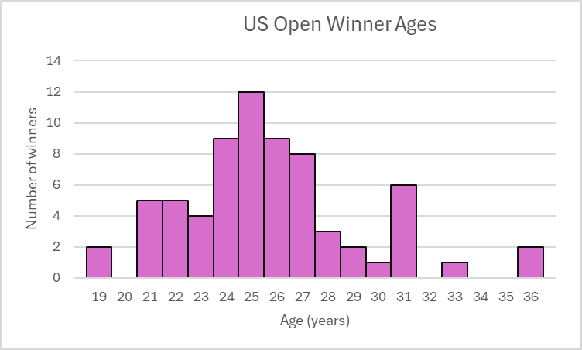

Wimbledon
Table 5: Wimbledon winner ages
Age | Frequency
18 | 1
19 | 1
20 | 2
21 | 2
22 | 10
23 | 7
24 | 8
25 | 5
26 | 5
27 | 5
28 | 5
29 | 3
30 | 3
31 | 3
32 | 2
33 | 1
34 | 1
35 | 1
36 | 1
Figure 2: Wimbledon Winner Ages frequency histogram
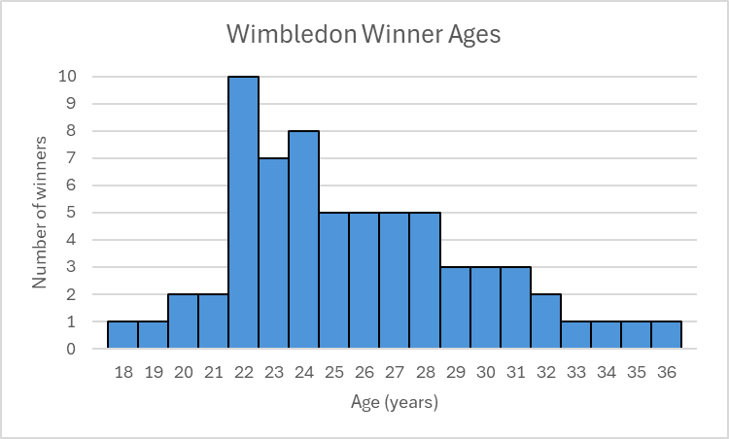

French Open
Table 6: French Open winner ages
Age | Frequency
17–19 | 6
20–22 | 12
23–25 | 20
26–28 | 16
29–31 | 10
32–34 | 5
35–37 | 3
Figure 3: French Open Winner Ages frequency histogram
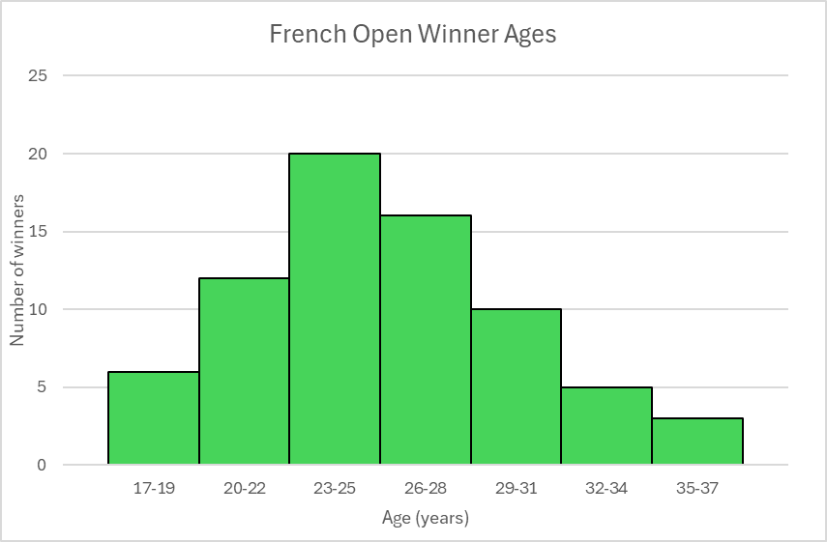

Australian Open
Table 7: Australian Open winner ages
Age | Frequency | Cumulative frequency
18 | 2 | 2
19 | 2 | 4
20 | 1 | 5
21 | 5 | 10
22 | 4 | 14
23 | 5 | 19
24 | 7 | 26
25 | 8 | 34
26 | 3 | 37
27 | 2 | 39
28 | 4 | 43
29 | 5 | 48
30 | 5 | 53
31 | 2 | 55
32 | 1 | 56
33 | 2 | 58
34 | 1 | 59
35 | 1 | 60
36 | 4 | 64
37 | 1 | 65
Figure 4: Australian Open Winner Ages cumulative frequency histogram
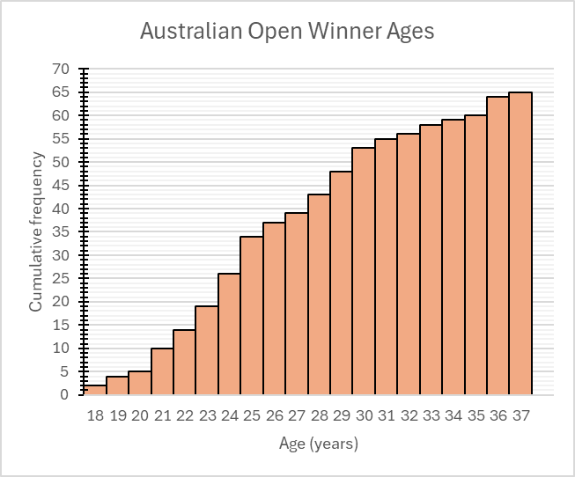

Appendix C

Swimming data

Frequency data
Table 8: Australian Open Water Swimming Championships Winner Ages
Age | Frequency
14 | 1
15 | 0
16 | 0
17 | 1
18 | 1
19 | 2
20 | 3
21 | 5
22 | 4
23 | 2
24 | 4
25 | 2
26 | 1
27 | 2
28 | 1
29 | 1
Figure 5: Australian Open Water Swimming Championships Winner Ages frequency histogram
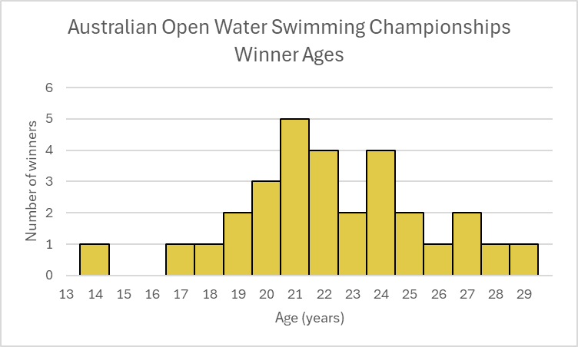

Cumulative frequency data
Table 9: Australian Open Water Swimming Championships cumulative frequency of winner ages
Age | Cumulative frequency
14 | 1
15 | 1
16 | 1
17 | 2
18 | 3
19 | 5
20 | 8
21 | 13
22 | 17
23 | 19
24 | 23
25 | 25
26 | 26
27 | 28
28 | 29
29 | 30

Figure 6: Australian Open Water Swimming Championships Winner Ages cumulative frequency polygon
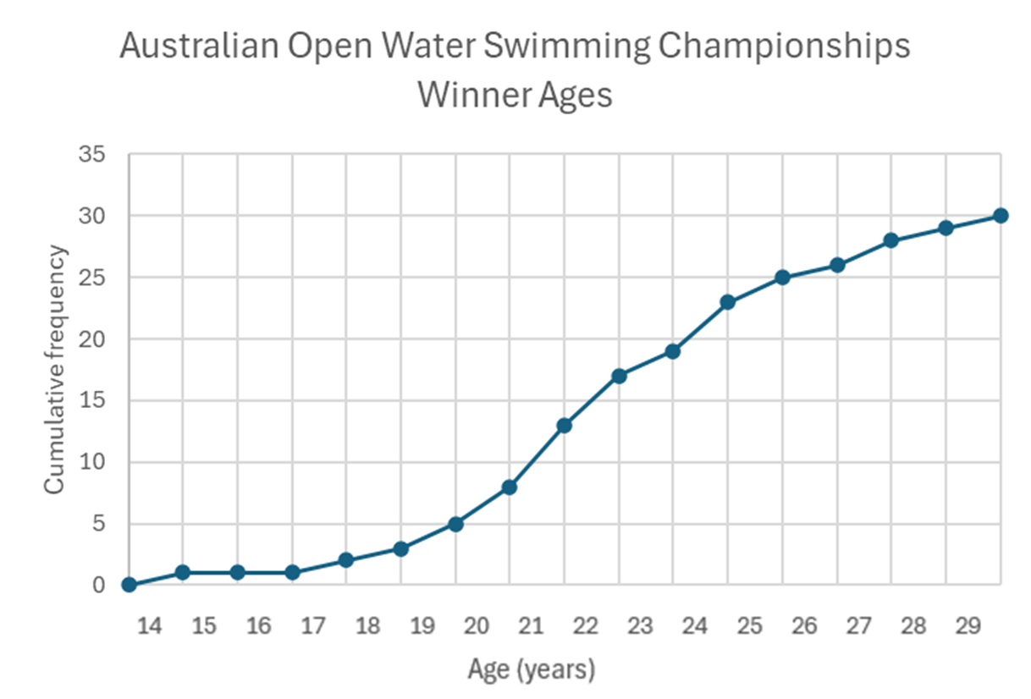

Sample solutions

Appendix A – Which one doesn’t belong?
Possible reasons for each not belonging:
- Dataset A: Only one with a different median (22.5 instead of 22); No mode.
- Dataset B: Only one with a single mode of 22.
- Dataset C: Only one with 2 modes, 18 and 22 (bimodal); Only one with different lowest score, highest score and range.
- Dataset D: Only one with fewer values (7 instead of 10) or an odd number of values; Only one with a single mode of 18.

References
This resource contains NSW Curriculum and syllabus content. The NSW Curriculum is developed by the NSW Education Standards Authority. This content is prepared by NESA for and on behalf of the Crown in right of the State of New South Wales. The material is protected by Crown copyright.
Please refer to the NESA Copyright Disclaimer for more information https://educationstandards.nsw.edu.au/wps/portal/nesa/mini-footer/copyright.
NESA holds the only official and up-to-date versions of the NSW Curriculum and syllabus documents. Please visit the NSW Education Standards Authority (NESA) website https://educationstandards.nsw.edu.au/ and the NSW Curriculum website https://curriculum.nsw.edu.au/.
Mathematics Advanced 11–12 Syllabus © NSW Education Standards Authority (NESA) for and on behalf of the Crown in right of the State of New South Wales, 2024.

© State of New South Wales (Department of Education), 2025
The copyright material published in this resource is subject to the Copyright Act 1968 (Cth) and is owned by the NSW Department of Education or, where indicated, by a party other than the NSW Department of Education (third-party material).
Copyright material available in this resource and owned by the NSW Department of Education is licensed under a Creative Commons Attribution 4.0 International (CC BY 4.0) license.

This license allows you to share and adapt the material for any purpose, even commercially.
Attribution should be given to © State of New South Wales (Department of Education), 2025.
Material in this resource not available under a Creative Commons license:
- the NSW Department of Education logo, other logos and trademark-protected material
- material owned by a third party that has been reproduced with permission. You will need to obtain permission from the third party to reuse its material.
Links to third-party material and websites
Please note that the provided (reading/viewing material/list/links/texts) are a suggestion only and implies no endorsement, by the New South Wales Department of Education, of any author, publisher, or book title. School principals and teachers are best placed to assess the suitability of resources that would complement the curriculum and reflect the needs and interests of their students.
If you use the links provided in this document to access a third-party's website, you acknowledge that the terms of use, including licence terms set out on the third-party's website apply to the use which may be made of the materials on that third-party website or where permitted by the Copyright Act 1968 (Cth). The department accepts no responsibility for content on third-party websites.

