Dilations of trigonometric functions
Students use graphing applications to explore dilations of trigonometric functions. They then apply these principles of transformations to graph transformations of trigonometric functions.
Students will need at least one digital device per pair to interact with Amplify Classroom during this lesson.

Learning intentions
- To be able to apply transformation principles to graph transformed trigonometric functions.
- To be able to develop and use transformed trigonometric models to represent real-world situations.

Success criteria
- I can describe the effect of vertical dilation on amplitude.
- I can describe the effect of horizontal dilation on period.
- I can apply multiple transformations in the correct order to graph a variety of trigonometric functions.
- I can construct a transformed trigonometric function to model a given situation and interpret its meaning in context.

Outcomes
A student:
- develops understanding and fluency in mathematics through exploring and connecting mathematical concepts, choosing and applying mathematical techniques to solve problems, and communicating their thinking and reasoning coherently and clearly MAO-WM-01
- uses algebraic and graphical techniques to analyse trigonometric functions MAV-12-01
- models, analyses and solves practical problems involving functions and their transformations MAV-12-02

Content

Transformations of trigonometric functions
- Use graphing applications to explore reflections, translations and dilations of, and confirm that the principles of transformations hold for, the trigonometric functions $f\left(x\right)=\sin{x}$, $f\left(x\right)=\cos{x}$ and $f(x)=\tan{x}$
- Apply the principles of transformations to graph transformations of the trigonometric functions $f\left(x\right)=\sin{x}$, $f\left(x\right)=\cos{x}$ and $f(x)=\tan{x}$, describe which transformations have been applied to $y=f(x)$ and determine the domain, range, horizontal translation, vertical translation, dilation factor, period and amplitude when applicable

Modelling with functions
- Model and solve problems involving periodic phenomena using transformations of the trigonometric functions $f\left(x\right)=\sin{x}$, $f\left(x\right)=\cos{x}$ or $f(x)=\tan{x}$, without the use of calculus
- Model and solve practical problems involving functions and their transformations, within the scope of the Mathematics Advanced course, using graphical and algebraic techniques
Mathematics Advanced 11–12 Syllabus © NSW Education Standards Authority (NESA) for and on behalf of the Crown in right of the State of New South Wales, 2024.

Table 1: lesson summary
Section | Summary of activity | Teaching strategies | Teaching points
Retrieval practice | Use Appendix A for students to match dilated graphs with their functions and determine the type of dilation and scale factor. | Turn and talk | Reinforce understanding of vertical and horizontal dilations and how scale factors affect graphs. Draw attention to connections between algebraic form and graphical features.
Activating prior knowledge | Use slide 4 of the PowerPoint Dilations of trigonometric functions to present a quadratic modelling scenario and have students solve to meet a given condition. Use slide 5 to compare algebraic and graphical solution methods. | Mini whiteboards  Think-Pair-Share | Emphasise the connection between algebraic and graphical methods, including the trade-off between exact solutions and visual interpretation. Draw attention to how transformations affect the model and its solutions.
Connecting learning | Students use an Amplify Classroom activity (bit.ly/DilateTrig) to explore dilations of trigonometric functions. They then use slides 7–9 to determine the amplitude from equations and connect this to graphical representations, before extending to period and domain. | Think-Pair-Share  Pose-Pause-Pounce-Bounce | Emphasise how dilations affect key features including amplitude, period, domain and range. Draw attention to differences between vertical and horizontal dilations and how they are represented algebraically and graphically. Highlight when transformations affect the domain and when order matters.
Releasing responsibility | Use slide 11 to connect dilations to amplitude and period. Use Appendix B to generalise transformation rules, slides 12–14 to model worked examples, and Appendix C for students to apply transformations. | Worked examples (Your turn)  Visibly random groups of 3  Turn and talk | Emphasise connections between algebraic form and key features (amplitude, period, domain, range). Support students to generalise transformation rules and compare methods for interpreting horizontal dilations.
Independent practice | Use slide 16 to revise the Approaching questions scaffold, then use Appendix D or slide 17 for students to complete an HSC-style question and slide 18 to review solutions and refine responses. | Mini whiteboards  Turn and talk  Pose-Pause-Pounce-Bounce | Emphasise structured problem-solving and connections between algebraic and graphical representations. Support students to verify solutions using key features such as amplitude and period.

Activity structure
Please use the associated PowerPoint Dilations of trigonometric functions to display images in this lesson.

Retrieval practice
- Distribute a copy of Appendix A ‘Card match’ to pairs of students for them to match the dilated graphs with the functions.
Cards are not in order so teachers can give students the appendix to cut out if they wish. The black curve is the dilated graph. The dashed blue curve is original function $f\left(x\right)=x(x+1)(x-1)$.
- Once students have matched each graph with its function, ask students to determine if the graph has undergone a vertical or horizontal dilation or both and determine the dilation factor.
Students learnt about dilation factors in Year 11 – Unit 4 – Lesson 9 – dilations (horizontal and vertical).
- Have students compare their solutions with another pair and discuss if their solutions differ.

Activating prior knowledge
- Display the following scenario to students using slide 4 of the PowerPoint:
The power output of a solar system (in $\text{kW}$) is modelled by
$$P\left(t\right)=-{\left(t-5\right)}^{2}+7$$
where $t$ is the number of hours after $7 \text{am}$.
A household needs at least $5 \text{kW}$ to cover its needs without drawing from the grid.
After an upgrade, the panels generate $\frac{5}{3}$ times as much power as they did before.
For how many hours does the upgraded system generate at least $5 \text{kW}?$
- Distribute mini whiteboards (bit.ly/miniwhiteboards) and provide time for students to solve the problem in pairs.
- Display slide 5 which shows both the algebraic and graphical methods of solving the problem.
- In a Think-Pair-Share (bit.ly/thinkpairsharestrategy), have students compare both methods and discuss some of the advantages of each method.
Students may mention that the algebraic method can provide more exact solutions while the graph is better for showing how many solutions exist.

Connecting learning
- With at least one device per pair, assign the Amplify Classroom activity ‘Dilations of trigonometric functions’ (bit.ly/DilateTrig) for students to complete screens 1–3.
Before completing this activity, you will need to set up an Amplify Classroom (bit.ly/createamplifyclassroom).
Amplify Classroom provides the opportunity for immediate feedback as well as tailored feedback from the teacher as students progress.
In Year 11 – Unit 4 – Lesson 9 – dilations (horizontal and vertical), students learnt that a vertical dilation by a factor of $k$ is produced by replacing $y$ with $\frac{y}{k}$ and a horizontal dilation by a factor of $l$ is produced by replacing $x$ with $\frac{x}{l}$.
- Using slides 7–9, check for student understanding of how to determine the amplitude of a trigonometric function from the equation.
Animations on each slide show the correct answer.
- Extend the pacing of the Amplify Classroom activity to screens 4–8 for students to complete.
- In a Think-Pair-Share, ask students to discuss how they could restrict the domain of the function $y=\tan{ax}$ such that the value of $a$ represents the number of repetitions of the tangent function.
Students may suggest a possible answer as $0≤x≤π$. Other students may suggest that any domain restriction of interval length $π$ would work.
On screen 8, the table will only accept simplified forms for the period. For example, $\frac{2π}{4}$ would not be marked as correct but $\frac{π}{2}$ will be. Ensure students are simplifying before entering into the table.
- Extend the pacing of the Amplify Classroom activity to screens 9–10 for students to determine the period of trigonometric functions.
- Using a Pose-Pause-Pounce-Bounce questioning strategy (PDF 557KB) (bit.ly/posepausepouncebounce) check for student understanding of the effect of dilations on trigonometric functions. Some possible prompts include:
- Does vertically dilating a trigonometric function always change the range?
- When does a horizontal dilation affect the domain?
- How can the period and amplitude be determined from a trigonometric function?
- Extend pacing to screen 11 and provide time for students to determine the values of $k$ and $a$ for each function from the graphs.

Releasing responsibility
- Display slide 11 to show the connection between a vertical dilation and the amplitude, and a horizontal dilation and the period.
- Distribute Appendix B ‘General transformations’ for students to label all the variables with their respective transformation. Students should also annotate the appendix showing how each transformation affects the domain, range, period and amplitude of trigonometric functions.
- Have students compare their labels with another student and add to their annotations as required.
- Use slides 12–13 to model worked examples of graphing trigonometric functions using the Worked example (Your turn) (bit.ly/supportingstrategies) method.
- Display slide 14 which shows a comparative worked example of 2 methods to interpret horizontal transformations. Lead a class discussion around the advantages and drawbacks of each method.
- Distribute Appendix C ‘Variation theory’ (variationtheory.com/introduction) for students to determine the transformation, period, amplitude, domain and range for trigonometric functions as well as sketch the function in their workbooks.
The second page of Appendix C contains 6 blank graphs. Teachers may wish to print 3 copies of this page and give to students to support them in their graphing.

Independent practice
- Use slide 16 to unpack the Approaching questions scaffold for students.
The Approaching questions scaffold offers students a 4-step framework to work through questions. Each step is accompanied by an icon which corresponds to different aspects of the solution process.
- Distribute Appendix D ’HSC-style question’ to students to complete individually. These can also be displayed using slide 17.
- Have students compare their equation and graph with another student to discuss similarities and differences.
- Using the Pose-Pause-Bounce-Pounce questioning strategy, ask students to consider how they could check their equation and graph. Some prompting questions include:
- How are the period and amplitude incorporated into the equation?
- How can knowing the period and amplitude help to confirm that the graph is accurate?
- Display slide 18 which shows the solution.

Assessment and differentiation

Suggested opportunities for differentiation
Retrieval practice
- Support students by setting up a Desmos graph with sliders for the dilations. Students can adjust the sliders to the set function and then match the graph. Have students describe the dilation as this occurs.
Activating prior knowledge
- To support students, scaffold the problem by asking them to write down the new function when the panels generate $\frac{5}{3}$ times more power.
Connecting learning
- Adjust the pacing of the Amplify Classroom activity to better support or extend students as required.
- On screen 11 of the Amplify Classroom, support students by displaying ‘Student View’ on the screen and lead a class discussion around how to determine period and amplitude before having students independently write the function into the activity.
Releasing responsibility
- Support students to annotate Appendix B by having them work on mini whiteboards and share their annotations with another student before completing their own notes.
- For Appendix C, teachers may wish to add more transformation combinations for students to sketch and determine key features.
Independent practice
- Support students by having them work in pairs to share ideas and strategies.
- Extend students by asking them to consider when both graphs are increasing or decreasing.

Suggested opportunities for assessment
Retrieval practice
- Monitor student conversations as they match the cards and compare their solutions with another pair to check for understanding of dilations.
Activating prior knowledge
- Use students’ mini whiteboard answers as a formative assessment tool to provide immediate feedback and adjust instruction accordingly.
Connecting learning
- Monitor responses in class discussions to check for student understanding of how dilation factors affect the period and amplitude as well as domain and range.
Releasing responsibility
- Review Appendix B for understanding of how graph transformations affect trigonometric functions.
- Student responses to the self-explanation prompts during worked examples provide an opportunity to assess student reasoning around how to interpret transformations.
- Monitor student responses in the Your turn section to check for understanding of how to interpret and apply transformations.
- Teachers can facilitate class discussions and observe students’ reasoning and justification as they compare the worked examples, explaining their preferred method and how it supports their understanding of graph transformations.
Independent practice
- Appendix D could be collected as a work sample for assessment.
- Monitor responses during class discussions to check for student understanding of how the period and amplitude are interpreted and applied to a graph.

Appendix A

Card match
Cut out each card and match the graph with the function. The original dashed curve is:
$$f\left(x\right)=x(x+1)(x-1)$$
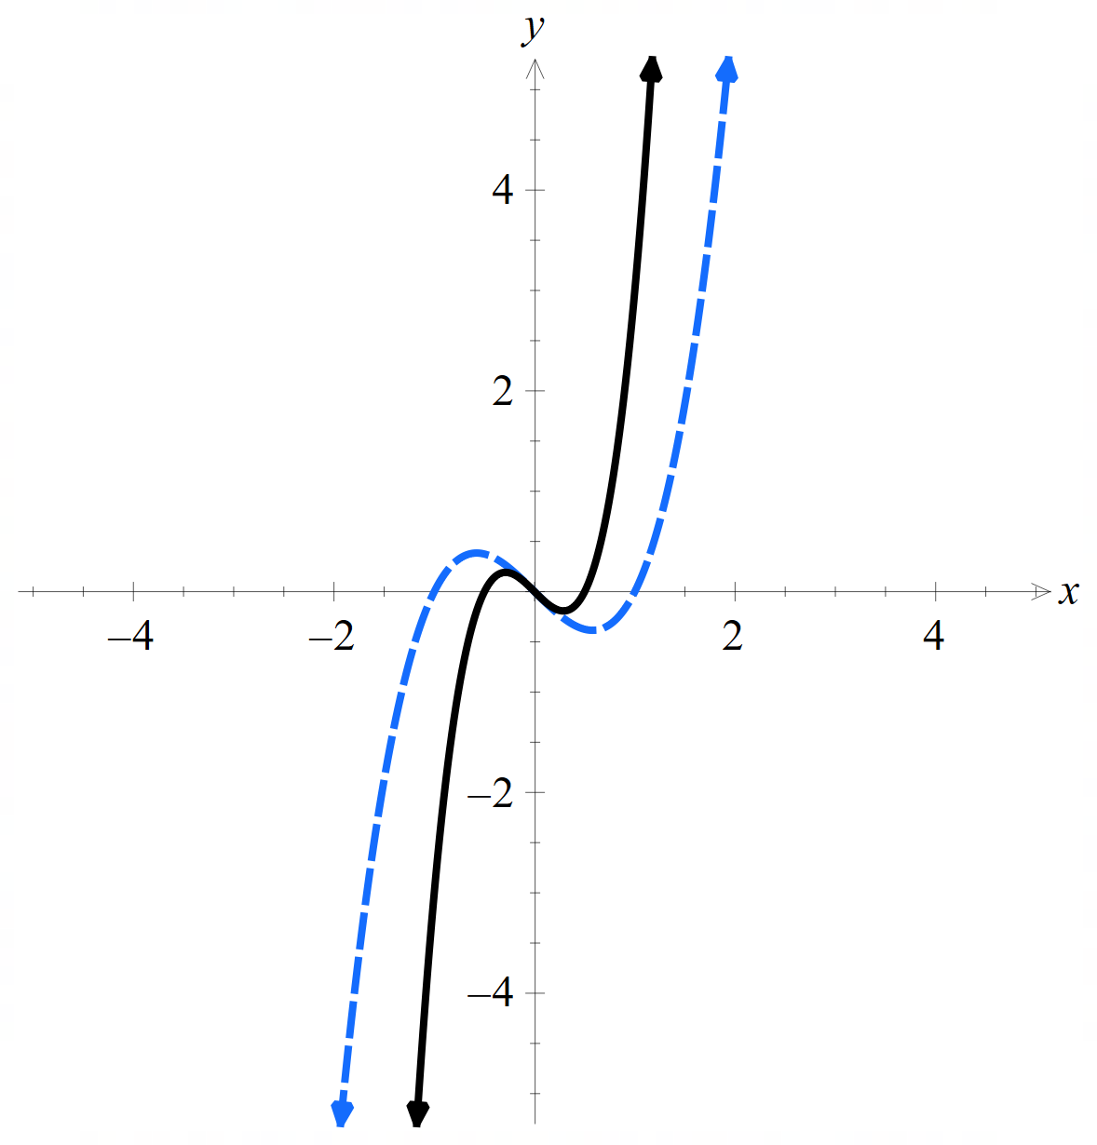 | 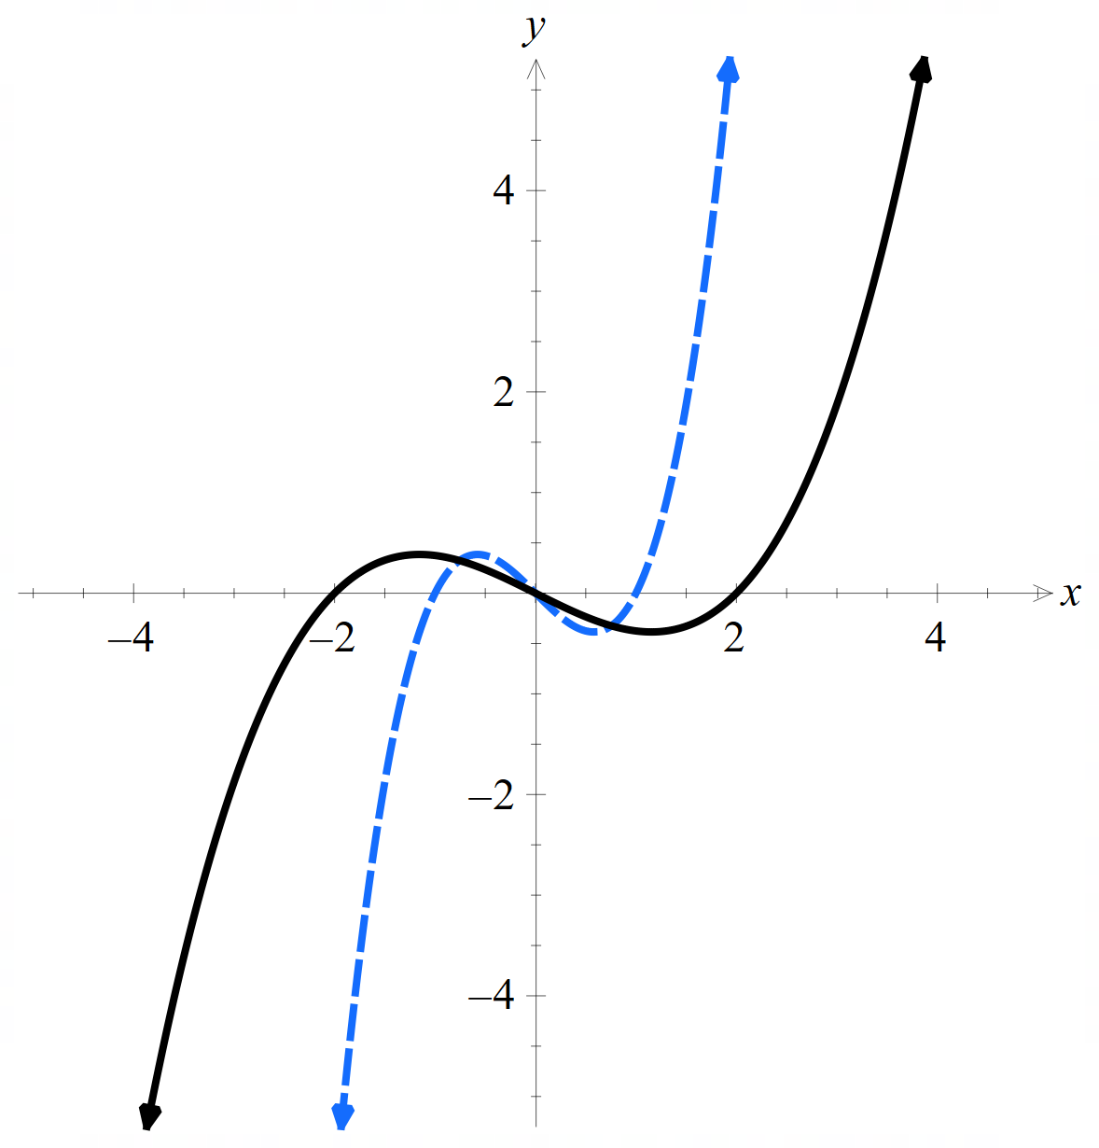 | 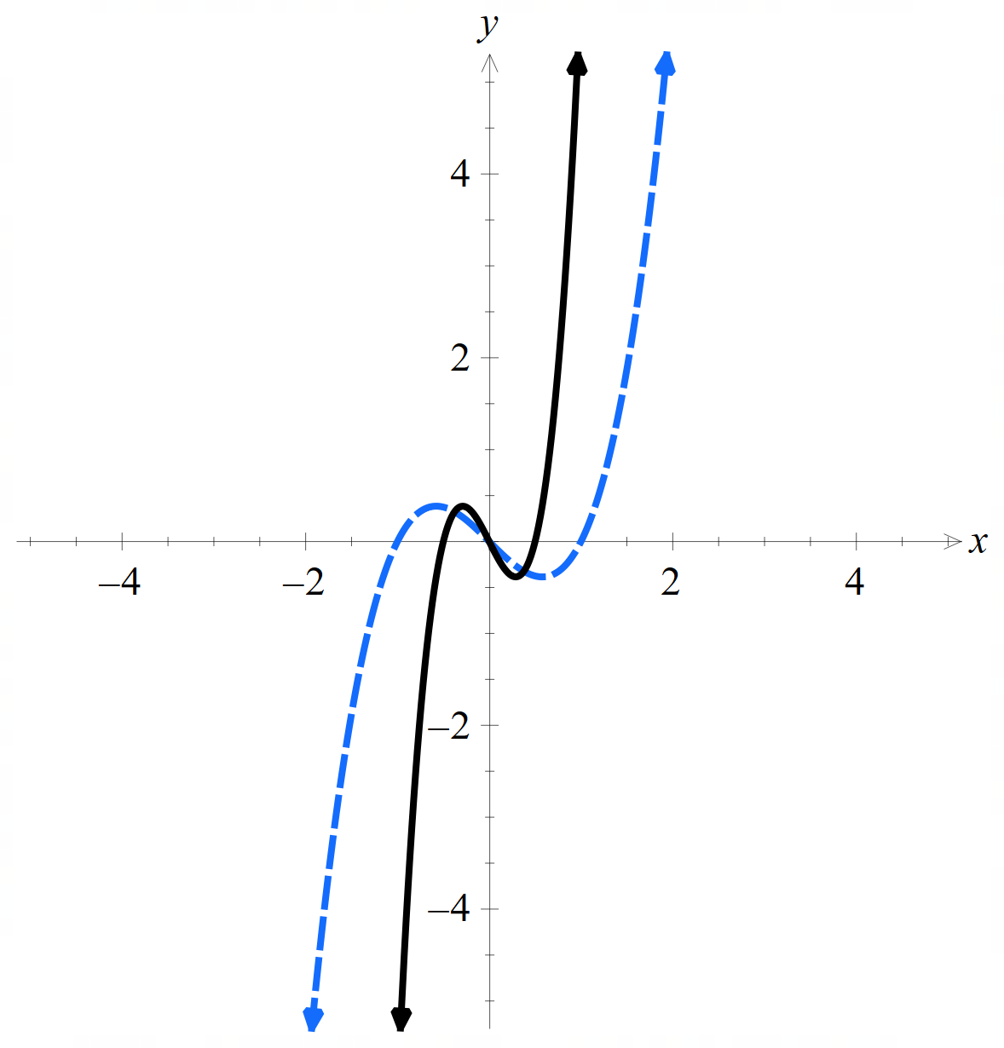
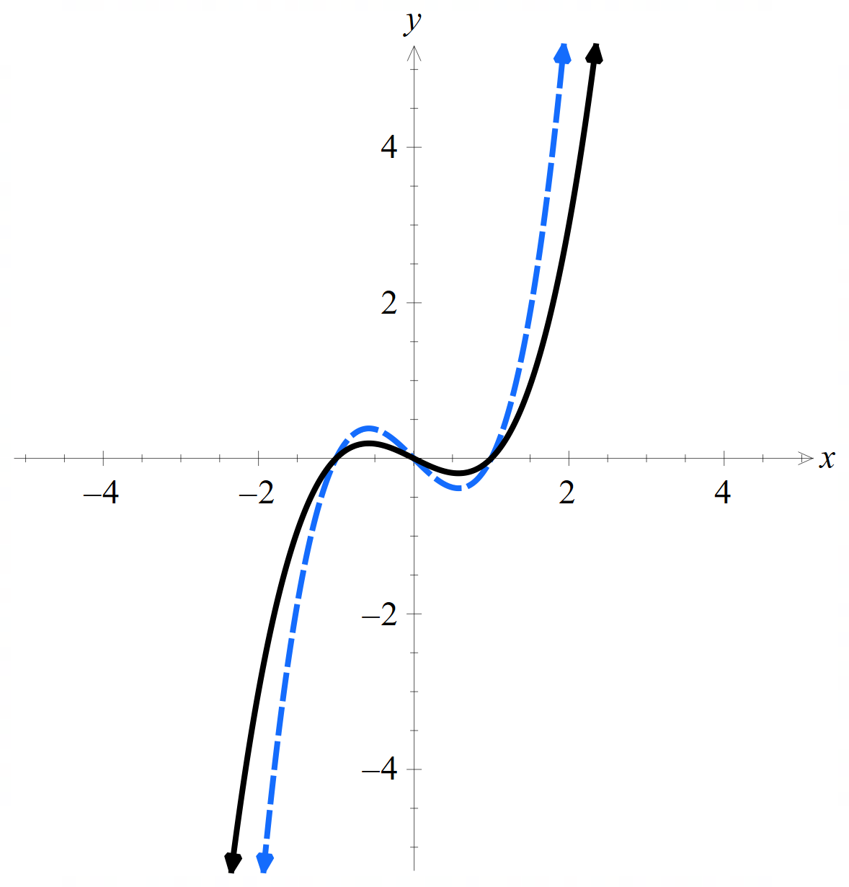 | 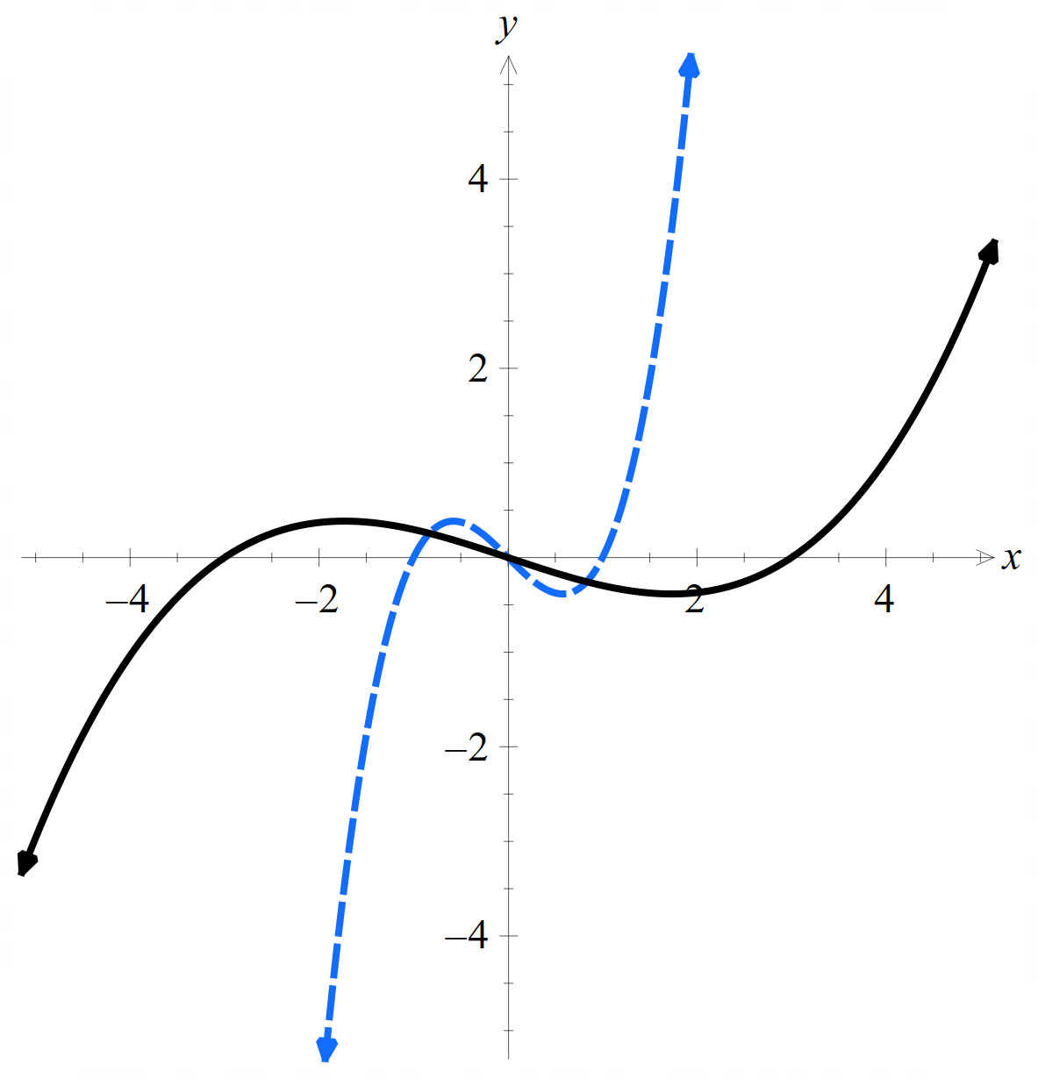 | 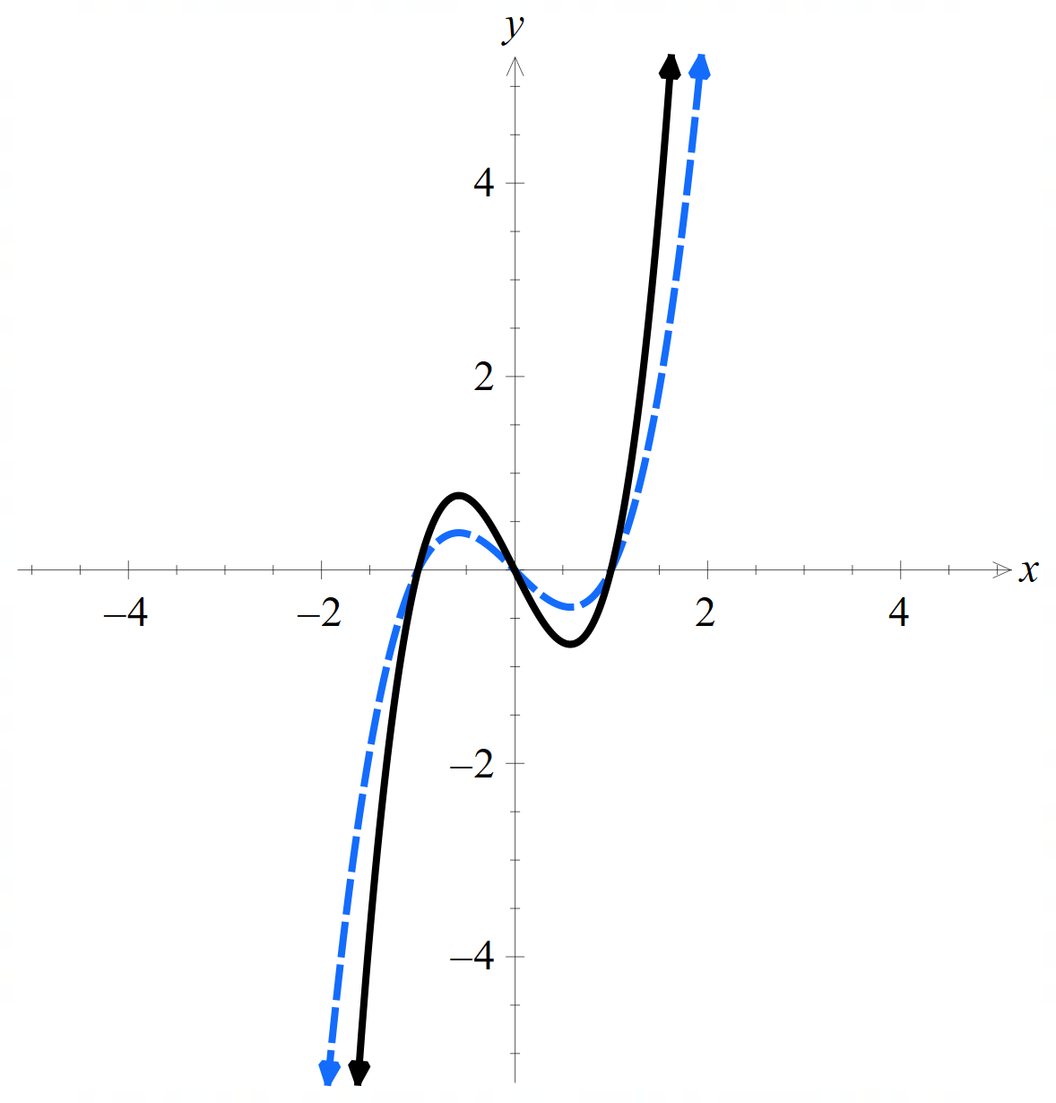
$$f\left(x\right)=\frac{x}{2}(x+1)(x-1)$$ | $$f\left(x\right)=2x\left(x+1\right)\left(x-1\right)$$ | $$f\left(x\right)=2x(2x+1)(2x-1)$$
$$f\left(x\right)=\frac{x}{2}\left(\frac{x}{2}+1\right)\left(\frac{x}{2}-1\right)$$ | $$f\left(x\right)=x\left(2x+1\right)\left(2x-1\right)$$ | $$f\left(x\right)=\frac{x}{3}\left(\frac{x}{3}+1\right)\left(\frac{x}{3}-1\right)$$

Appendix B

General transformations
$$y=kf\left(a\left(x+b\right)\right)+c$$
How does this affect:
 | $$f\left(x\right)=\sin{x}$$ | $$f\left(x\right)=\cos{x}$$ | $$f\left(x\right)=\tan{x}$$
Domain
Range
Period
Amplitude

Appendix C

Variation theory
For each function, describe the transformations and determine the period, amplitude, domain and range, then sketch the new function.
- $y=2\sin\left(2x\right)$
- $y=\sin\left(x-\frac{π}{4}\right)$
- $y=-3\sin{x}$
- $y=\sin{(-x)}$
- $y=-2\sin\left(2x-\frac{π}{2}\right)$
- $y=-\frac{1}{2} \sin\left(2x-\frac{π}{2}\right)+1$

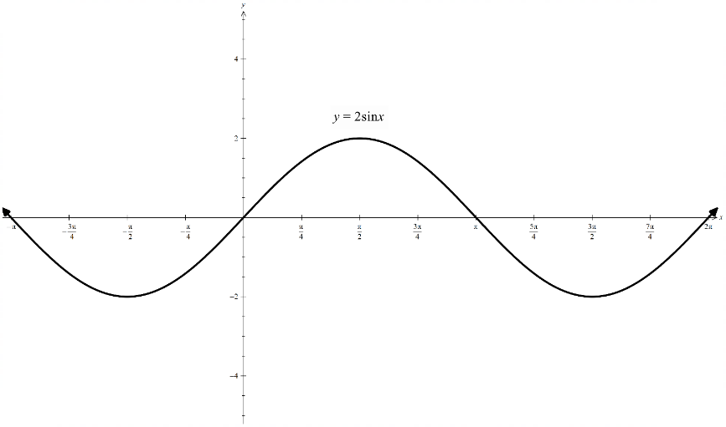
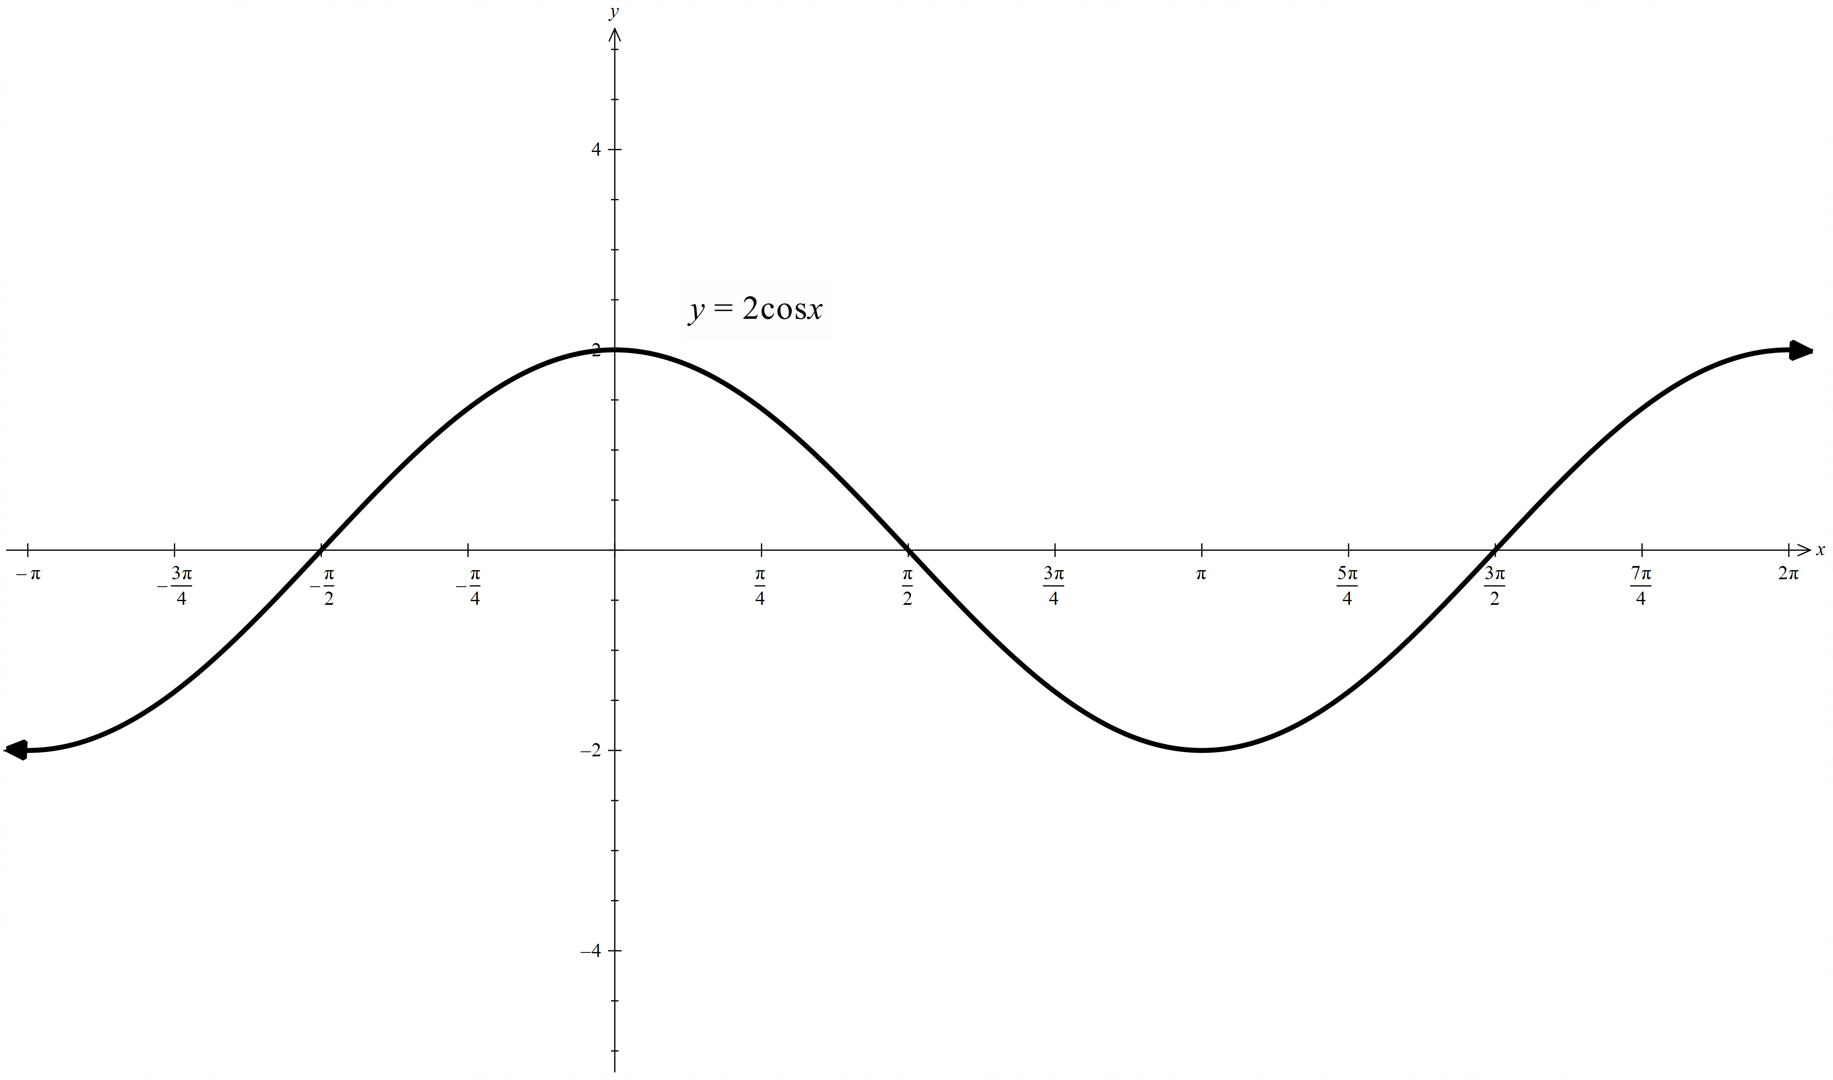
- $y=2\cos\left(2x\right)$
- $y=\cos\left(x-\frac{π}{4}\right)$
- $y=-3\cos{x}$
- $y=\cos{(-x)}$
- $y=-2\cos\left(2x-\frac{π}{2}\right)$
- $y=-\frac{1}{2}\cos\left(2x-\frac{π}{2}\right)-3$

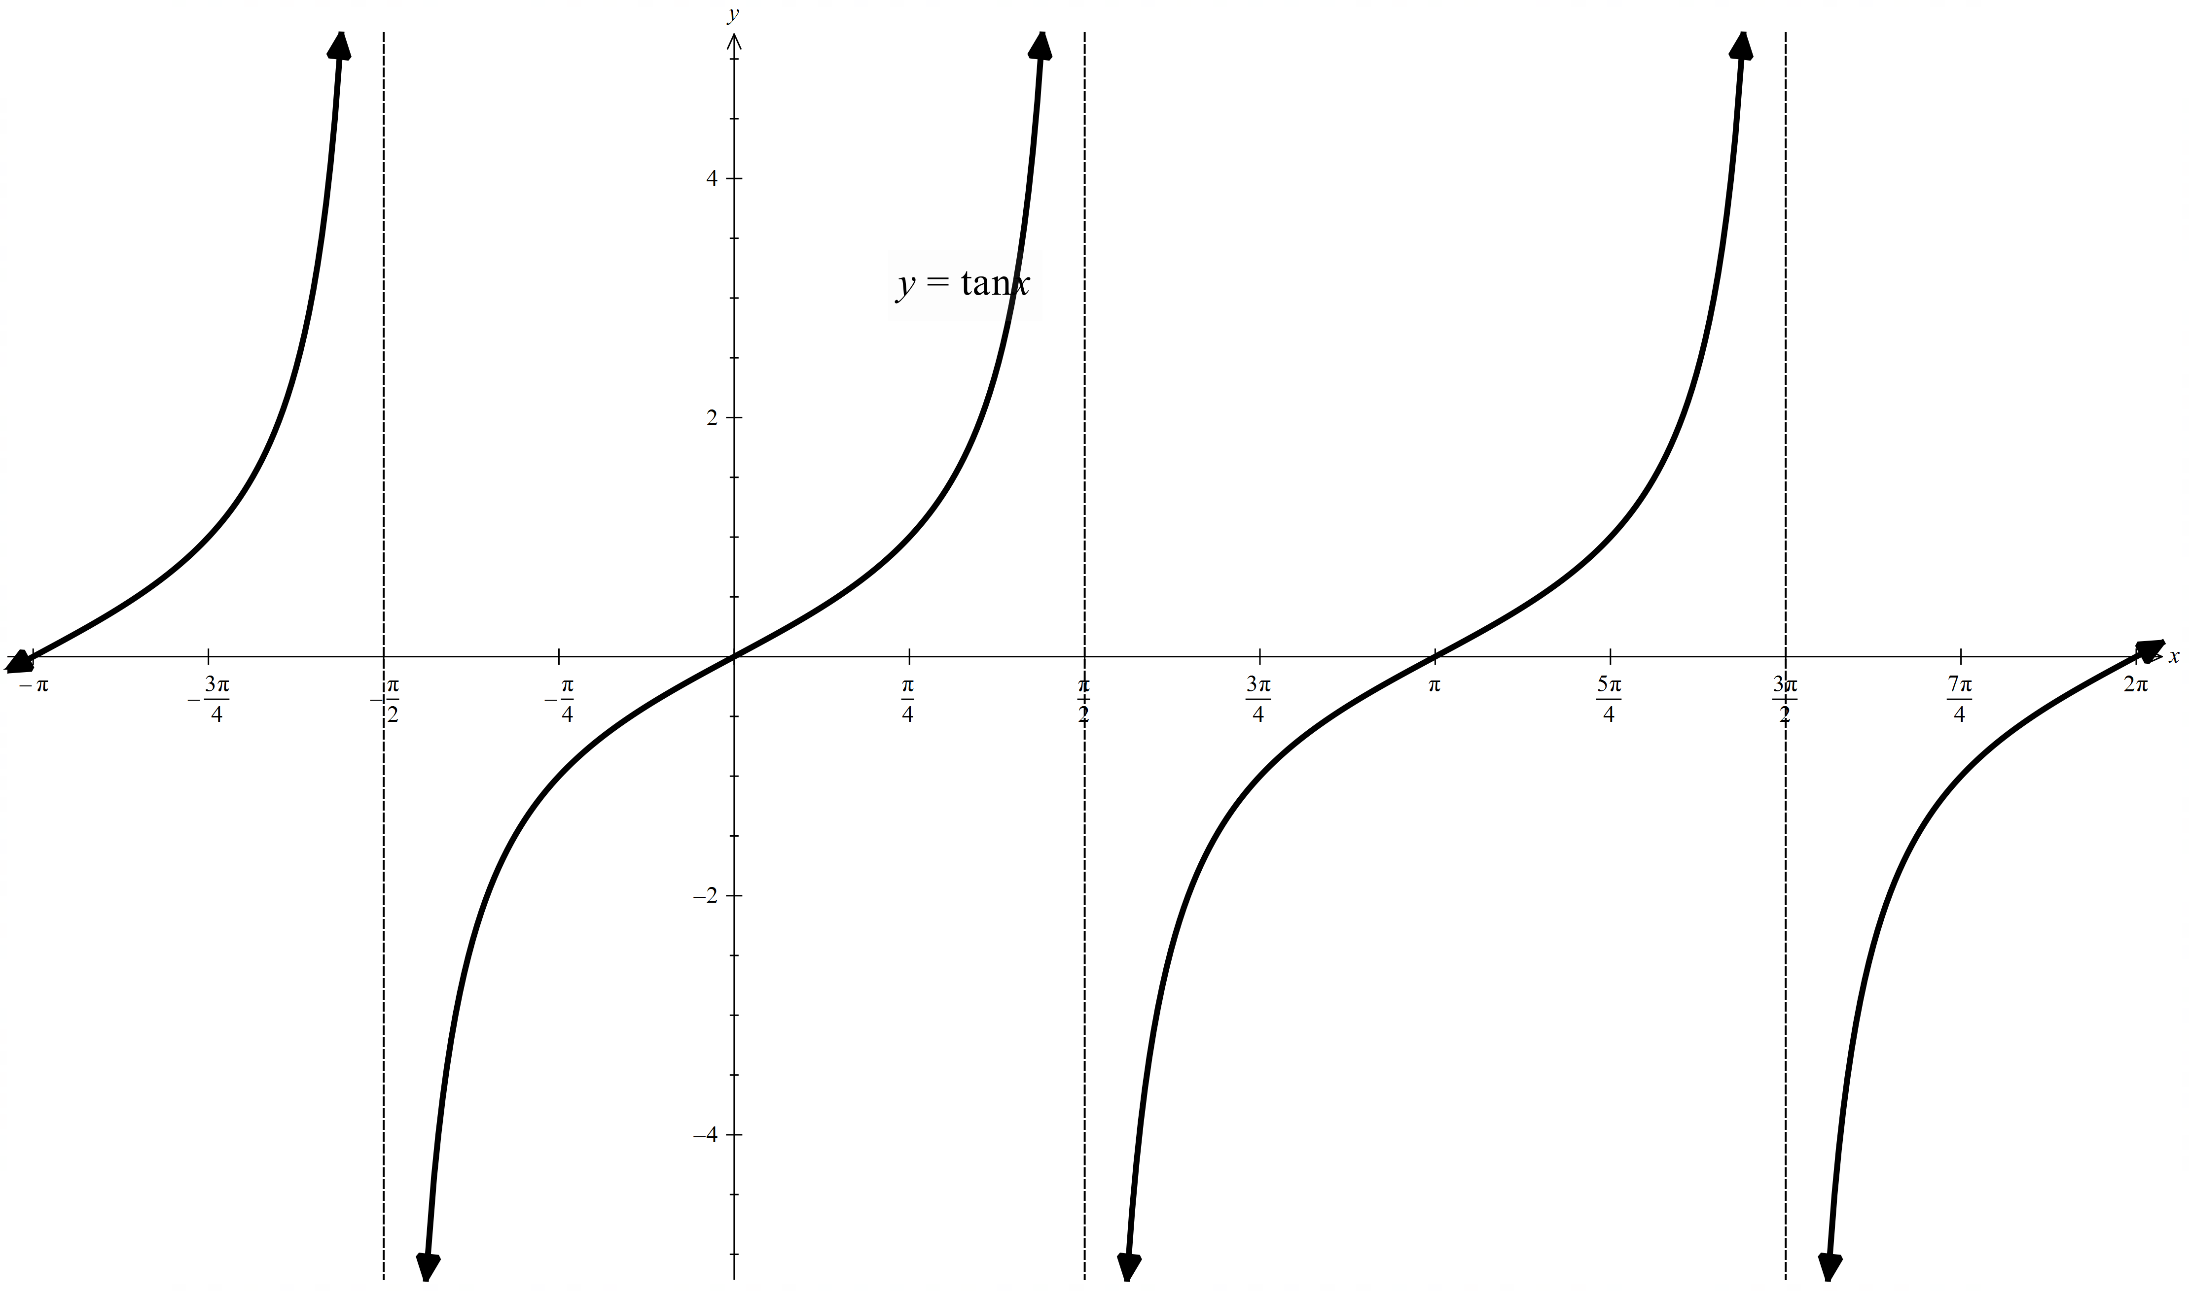
- $y=2\tan{x}$
- $y=\tan{2x}$
- $y=\tan\left(x+\frac{π}{4}\right)$
- $y=-2\tan\left(x+\frac{π}{4}\right)$
- $y=-\frac{1}{2}\tan\left(2x+\frac{π}{2}\right)$
- $y=-\tan\left(2x+\frac{π}{2}\right)-1$

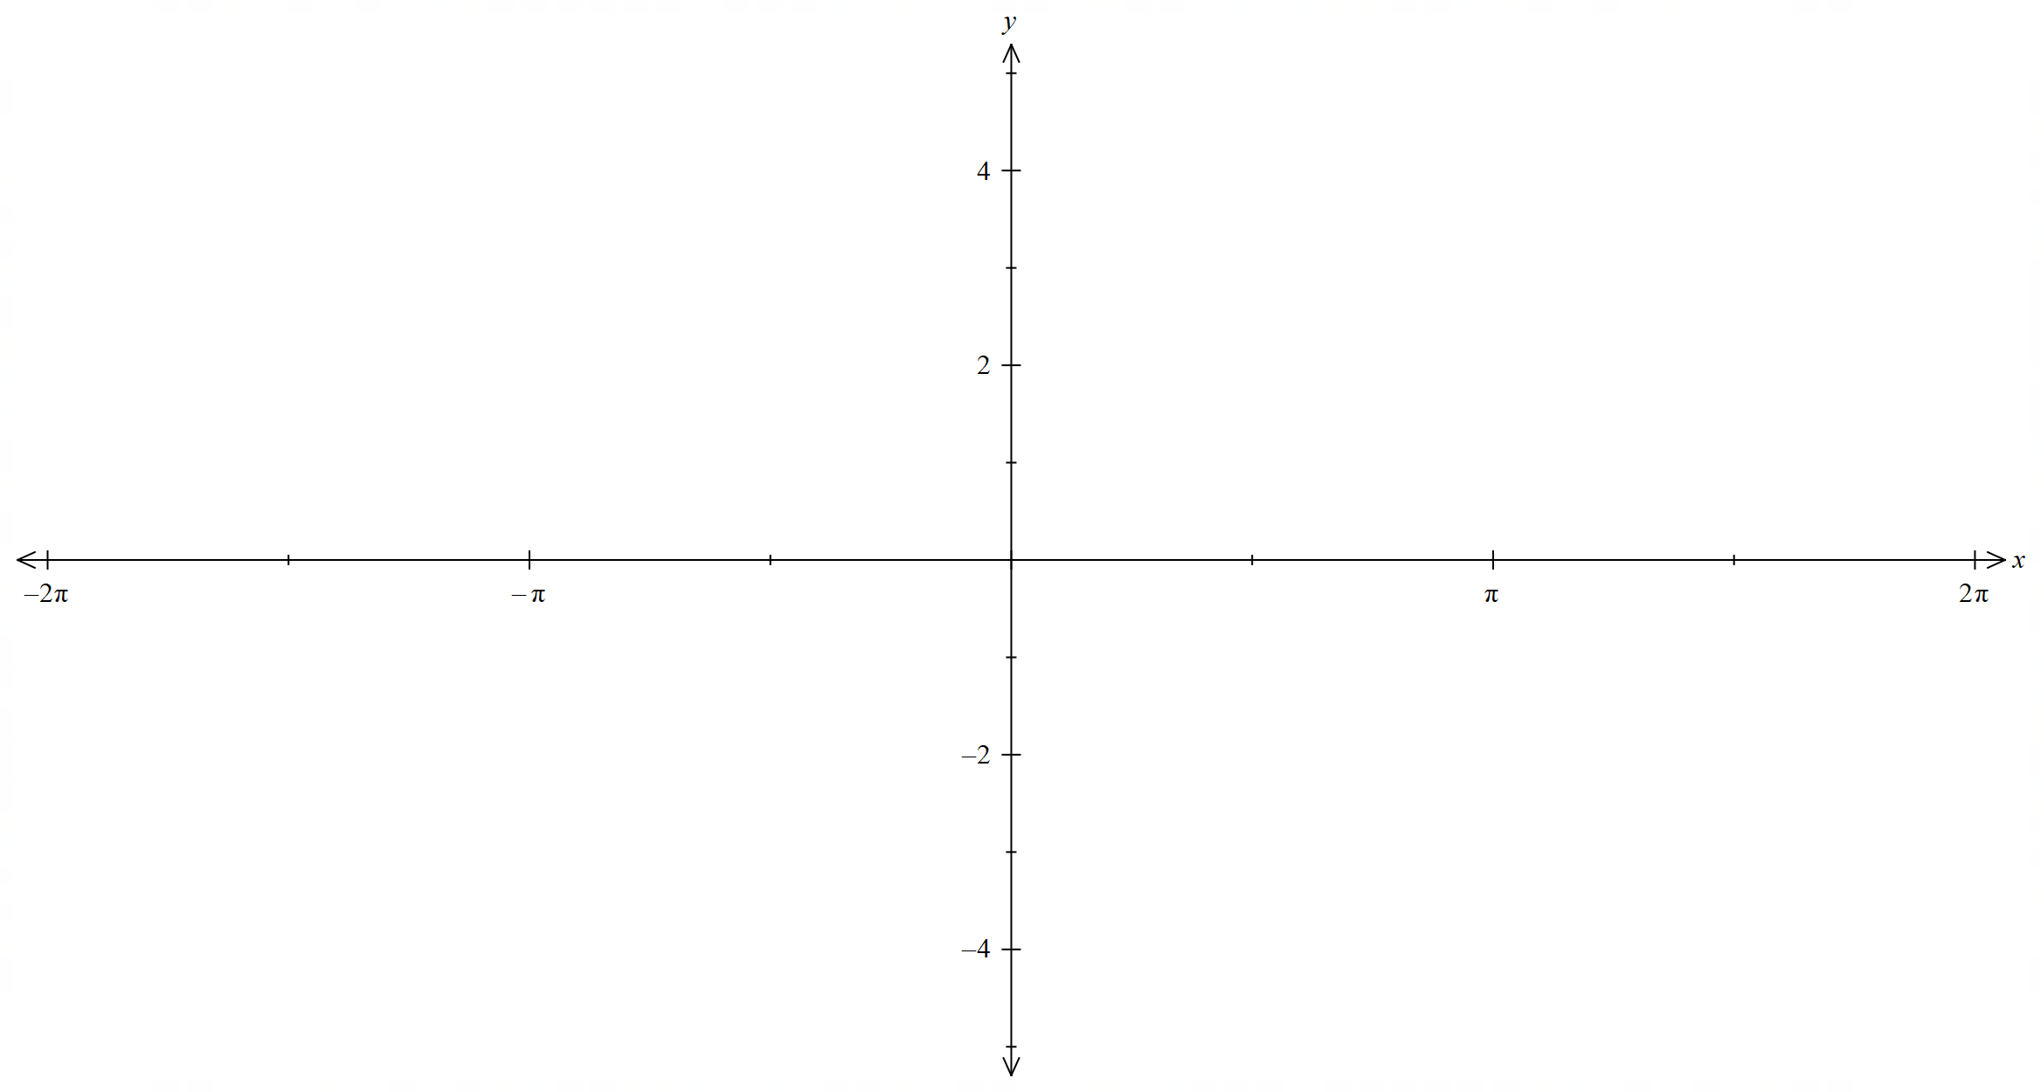

Appendix D

HSC-style question
The height of a wave can be modelled by:
$$h\left(t\right)=k\sin\left(at\right)$$
where $h$ is the height of the water in metres and $t$ is the time in seconds.
Question 1
- Write an equation for the wave $h_{1}\left(t\right)$ with amplitude $1.5 \text{m}$ and a period of $6 \text{s}$.
- The graph of $h_{1}(t)$ from part a. is shown below.
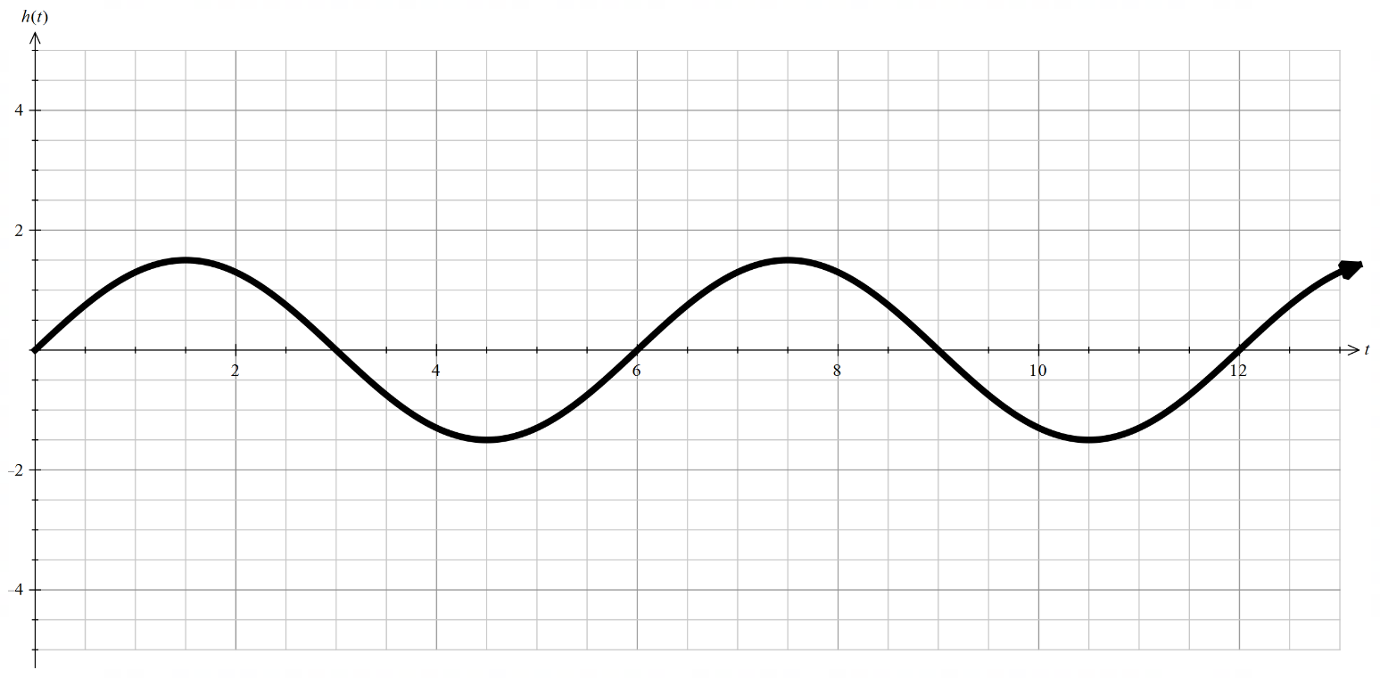
On the same diagram, sketch the graph of $h_{2}\left(t\right)=3\sin\left(\frac{π}{6}t\right)$ for $0≤t≤12$.

Sample solutions

Appendix A – card match
$$f\left(x\right)=x\left(2x+1\right)\left(2x-1\right)$$  Vertical dilation factor: $\frac{1}{2}$  Horizontal dilation factor: $\frac{1}{2}$ | $$f\left(x\right)=\frac{x}{2}\left(\frac{x}{2}+1\right)\left(\frac{x}{2}-1\right)$$  Horizontal dilation factor: $2$ | $$f\left(x\right)=2x(2x+1)(2x-1)$$  Horizontal dilation factor: $\frac{1}{2}$
$$f\left(x\right)=\frac{x}{2}(x+1)(x-1)$$  Vertical dilation factor: $\frac{1}{2}$ | $$f\left(x\right)=\frac{x}{3}\left(\frac{x}{3}+1\right)\left(\frac{x}{3}-1\right)$$  Horizontal dilation factor: $3$ | $$f\left(x\right)=2x\left(x+1\right)\left(x-1\right)$$  Vertical dilation factor: $2$

Appendix C – variation theory

$$y=2\sin{x}$$
 | $$y=2\sin{2x}$$  Transformation:  Horizontal dilation of $\frac{1}{2}$  Period: $π$  Amplitude: $2$  Domain: $\left(-∞,∞\right)$  Range: $\left[-2,2\right]$ | 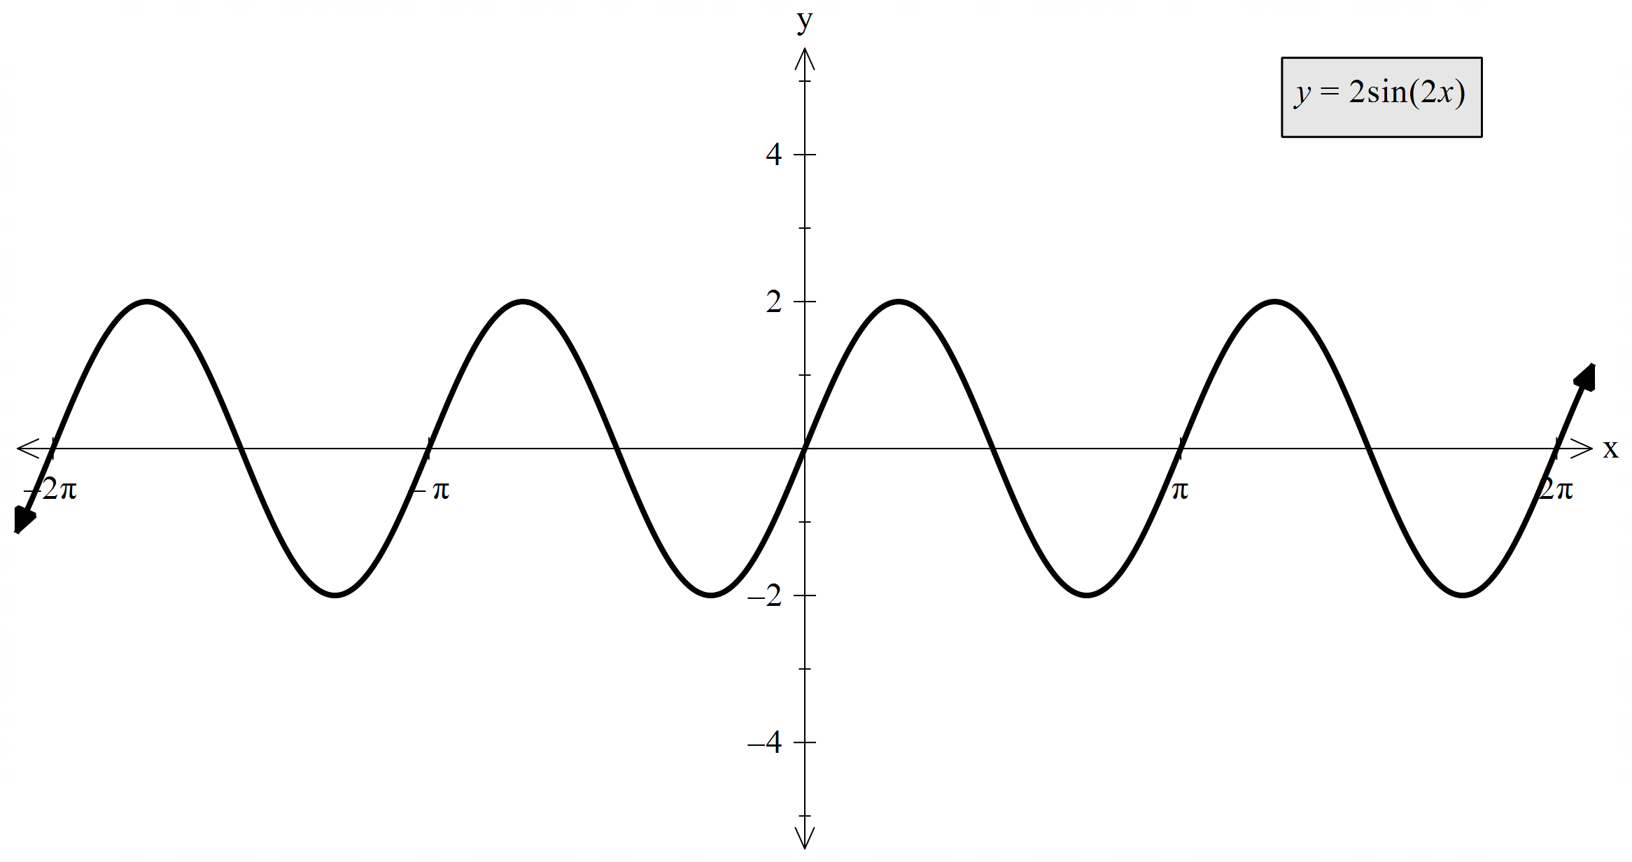
 | $$y=\sin\left(x-\frac{π}{4}\right)$$  Transformation:  Right by $\frac{π}{4}$ units  Vertical dilation of $\frac{1}{2}$  Period: $2π$  Amplitude: $1$  Domain: $\left(-∞,∞\right)$  Range: $\left[-2,2\right]$ | 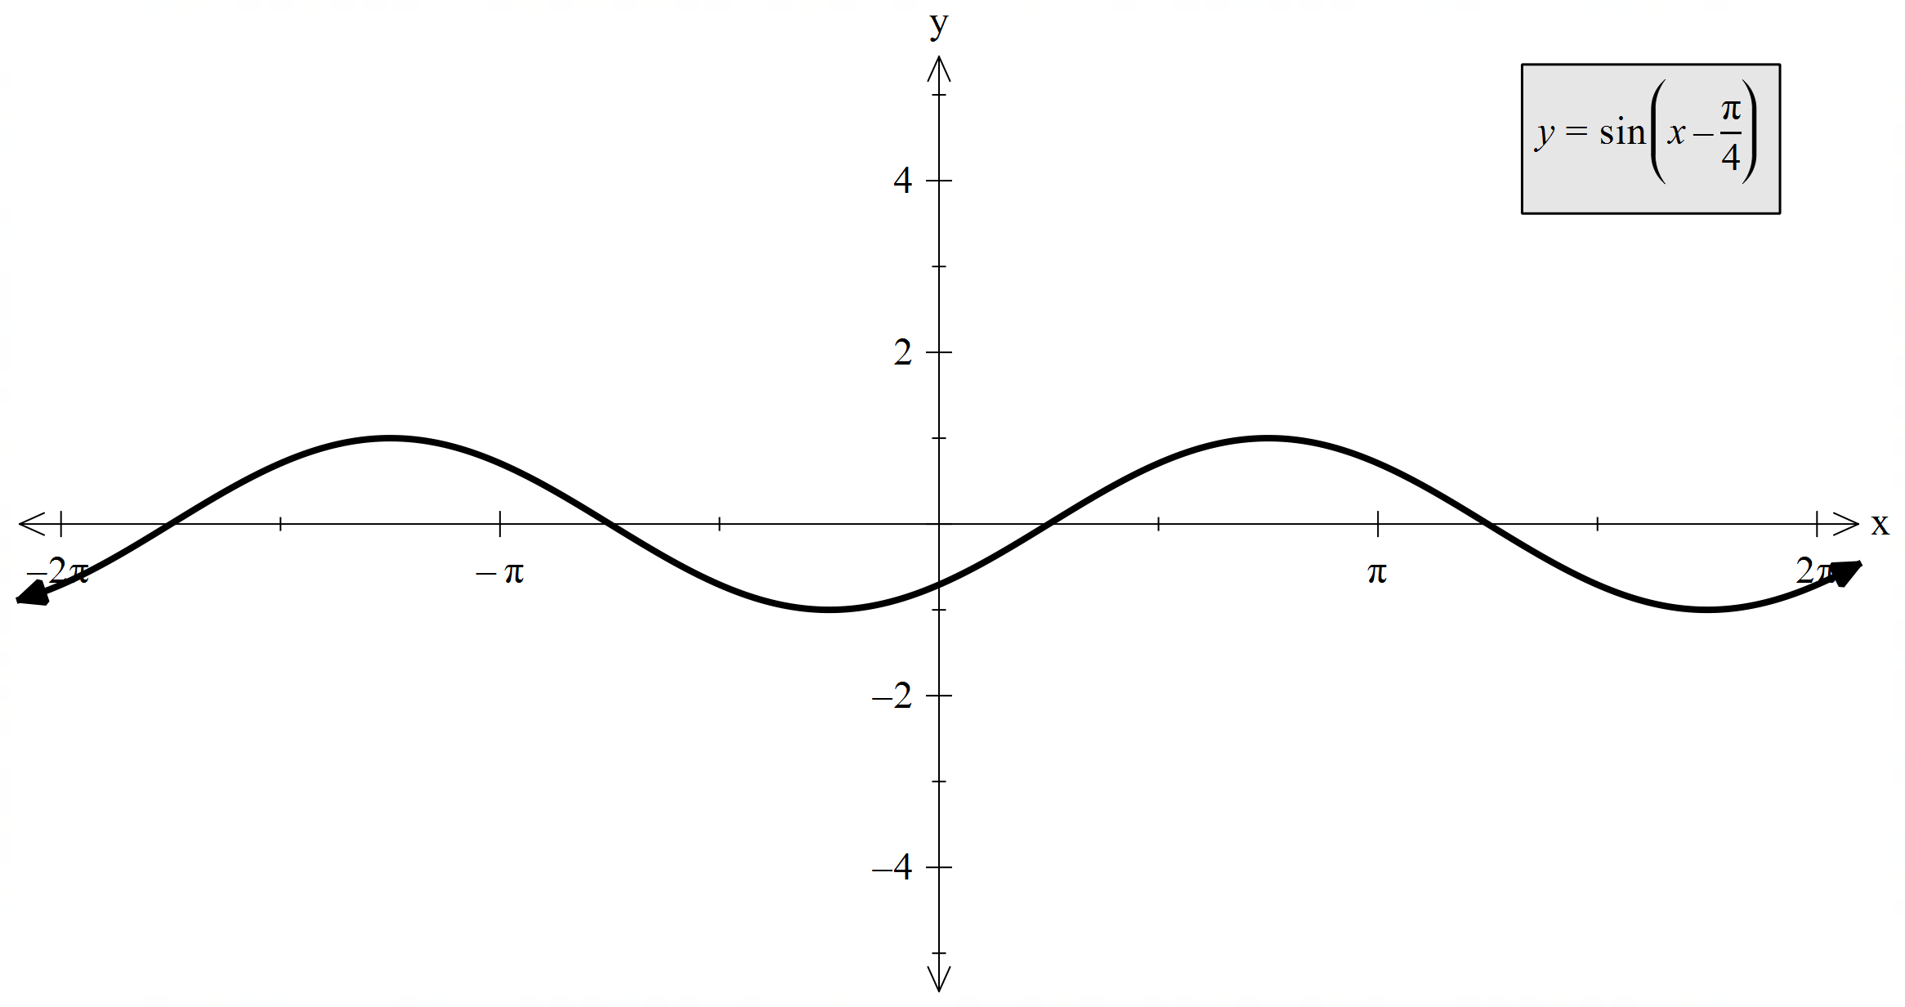
 | $$y=-3\sin{x}$$  Transformation:  Reflection across $x$-axis  Vertical dilation of $\frac{3}{2}$  Period: $2π$  Amplitude: $3$  Domain: $\left(-∞,∞\right)$  Range: $\left[-2,2\right]$ | 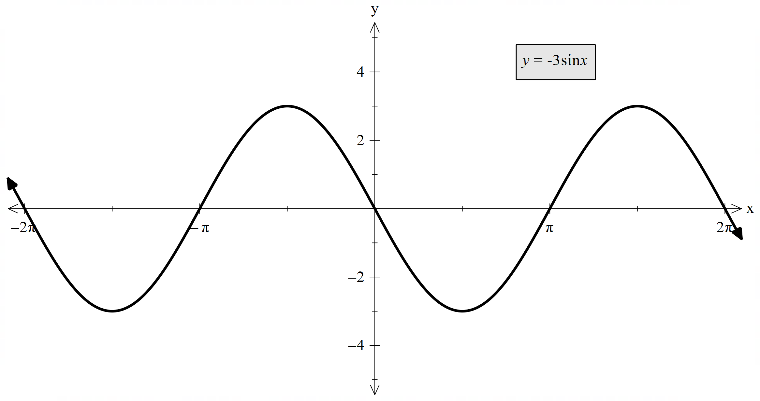
 | $$y=\sin\left(-x\right)$$  Transformation:  Reflection across $y$-axis  Vertical dilation of $\frac{1}{2}$  Period: $2π$  Amplitude: $1$  Domain: $\left(-∞,∞\right)$  Range: $\left[-2,2\right]$ | 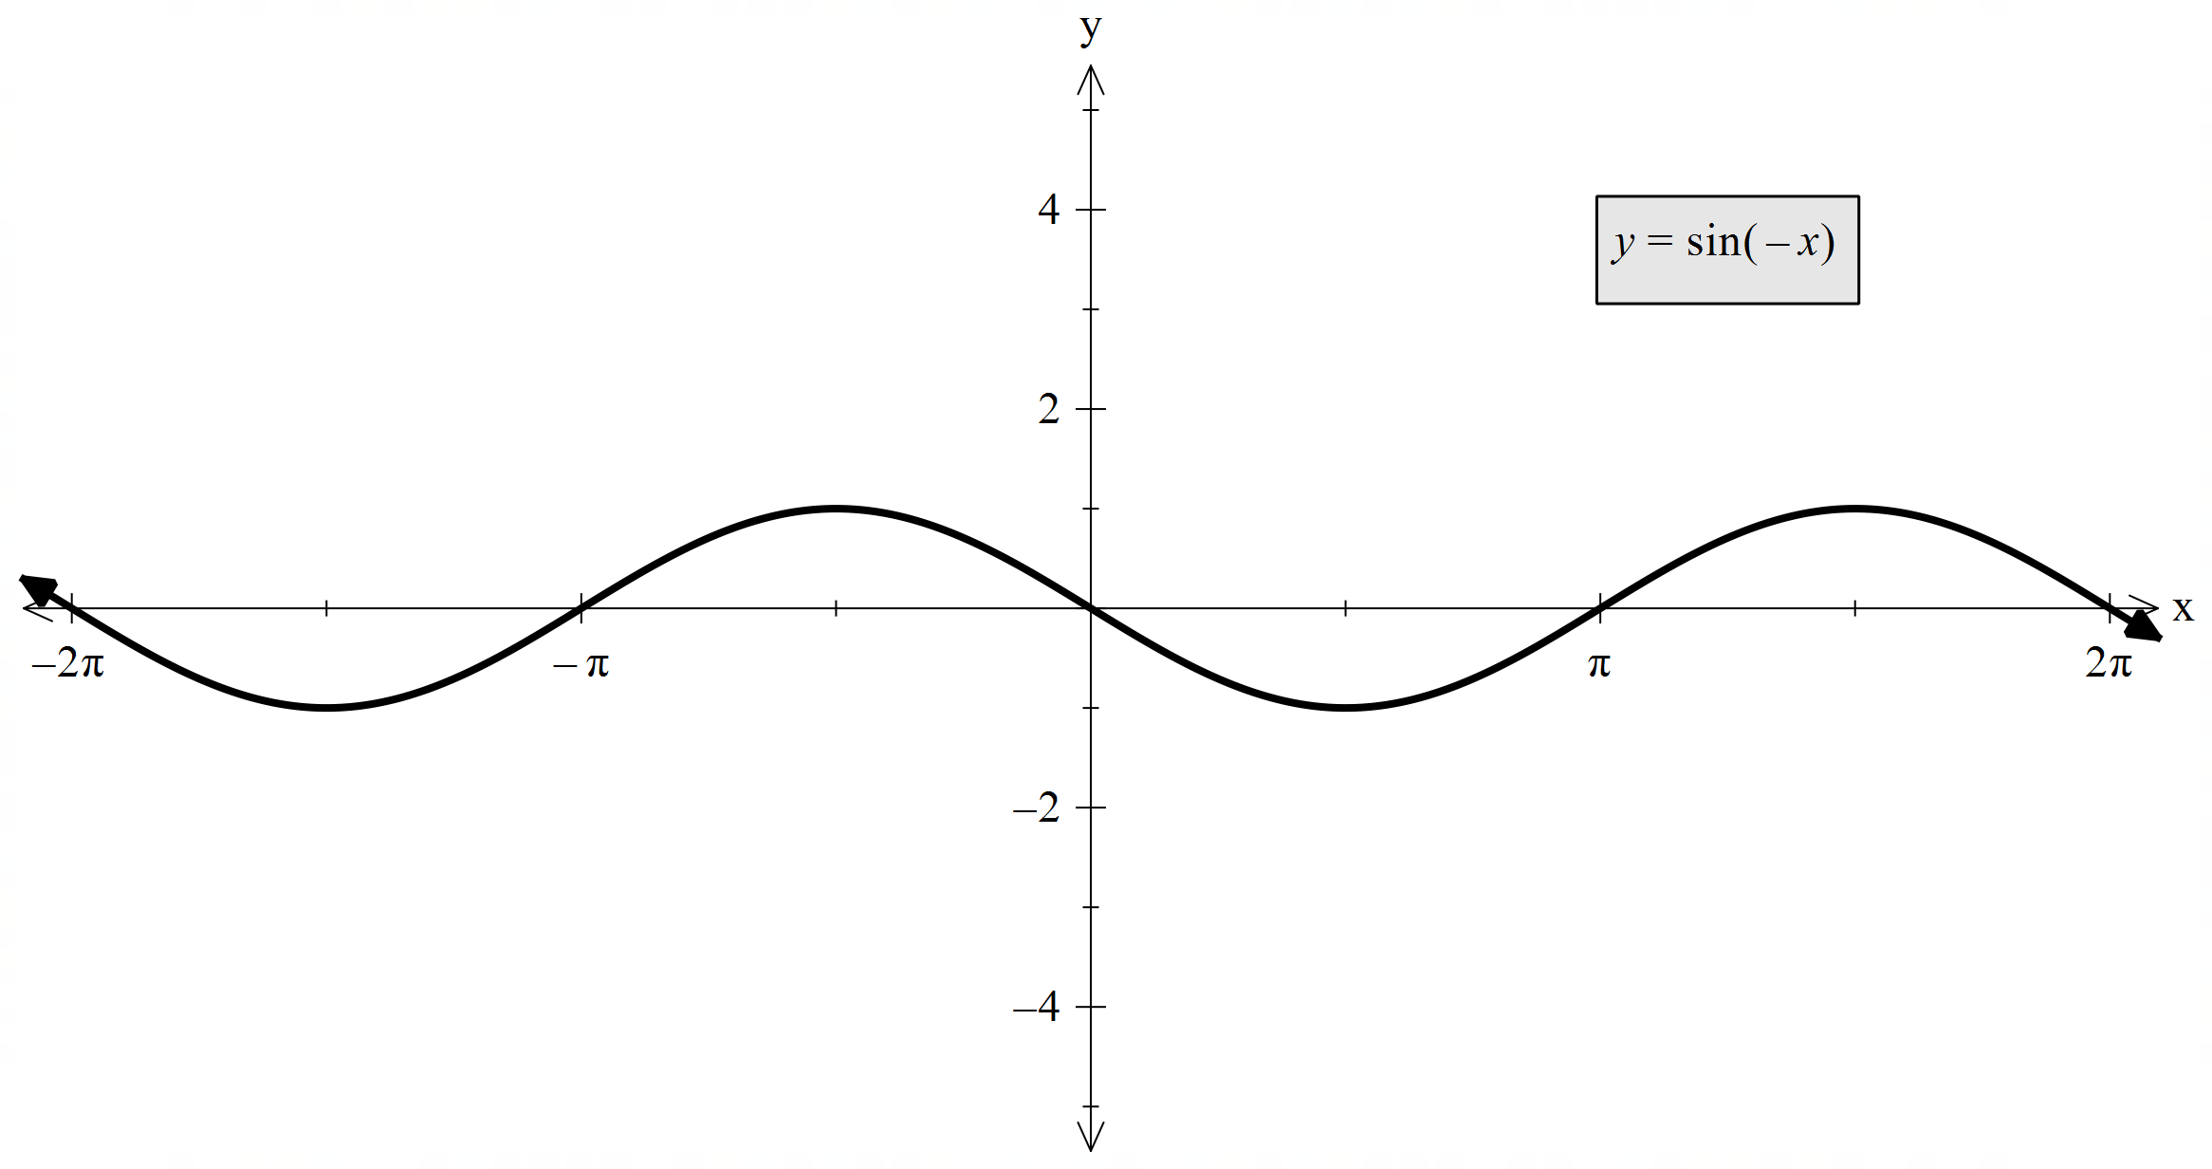
 | $$y=-2\sin\left(2x-\frac{π}{2}\right)$$  Transformation:  Horizontal dilation of $\frac{1}{2}$  Right by $\frac{π}{4}$ units  Reflection across $x$-axis  Period: $2π$  Amplitude: $2$  Domain: $\left(-∞,∞\right)$  Range: $\left[-2,2\right]$ | 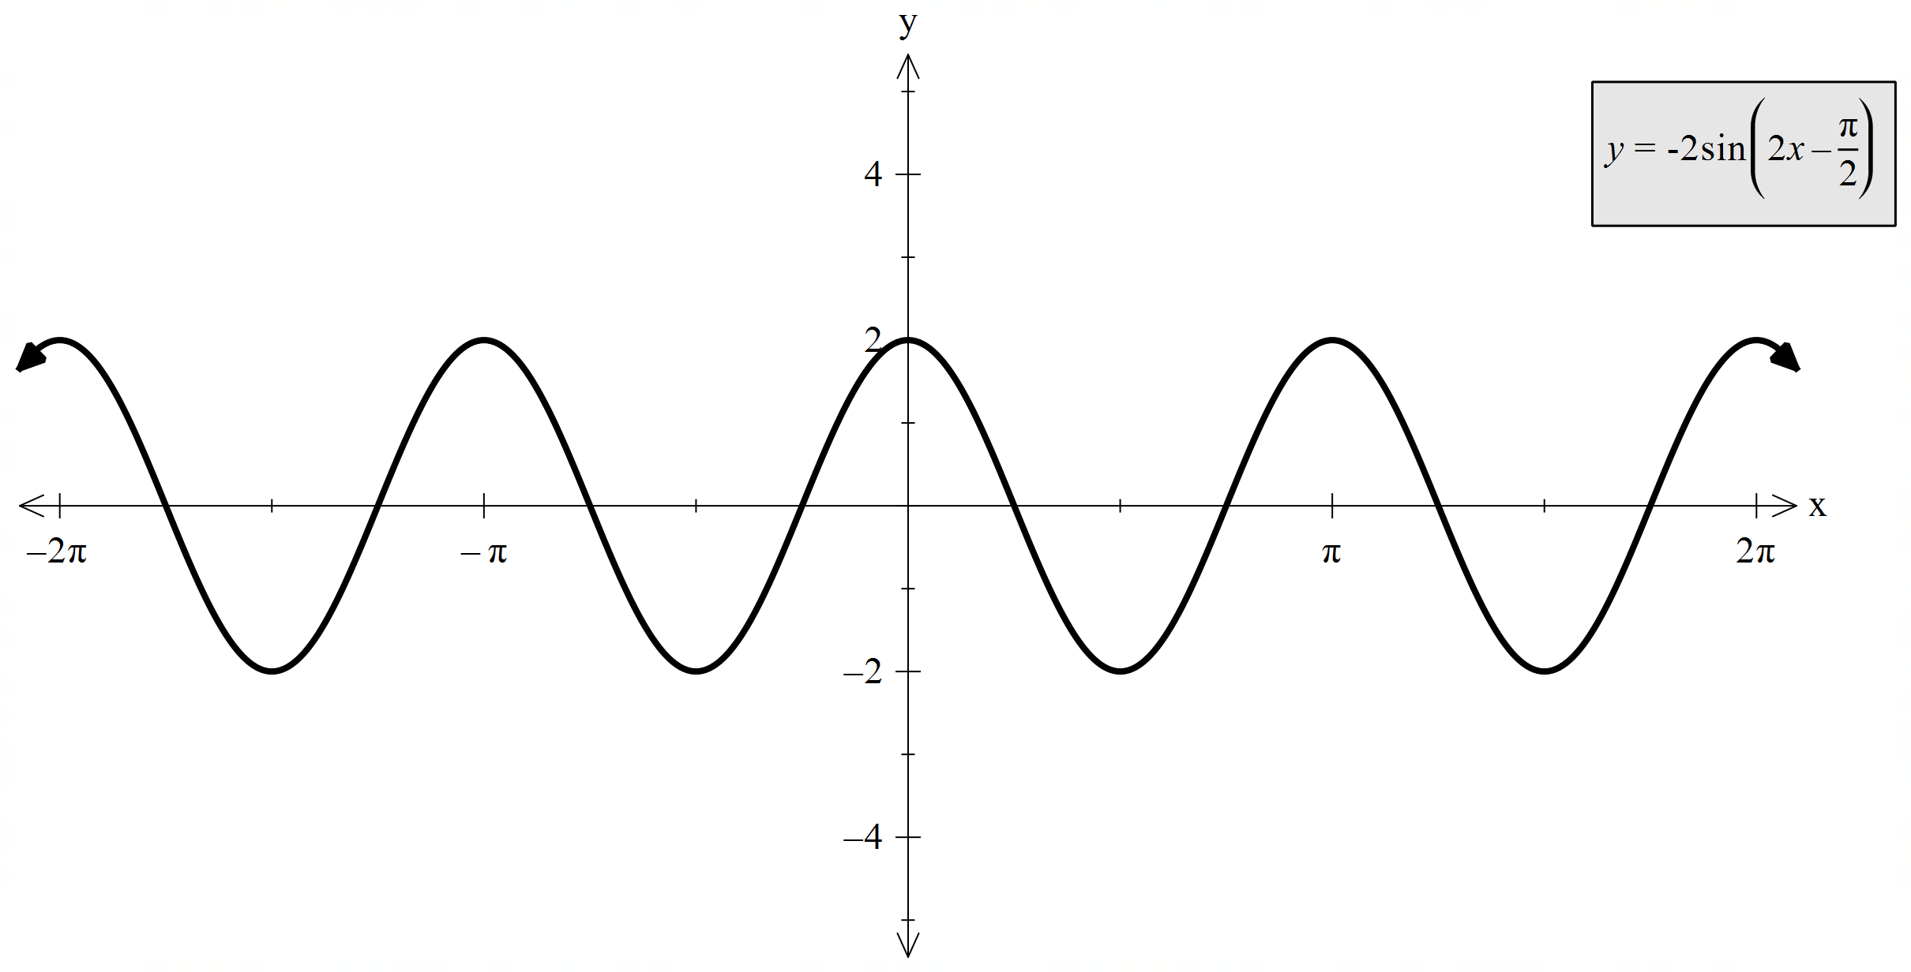
 | $$y=-\frac{1}{2}\sin\left(2x-\frac{π}{2}\right)+1$$  Transformation:  Horizontal dilation by $\frac{1}{2}$  Right by $\frac{π}{4}$ units  Reflection across $x$-axis  Vertical dilation by $\frac{1}{4}$  Up by $1$ unit  Period: $2π$  Amplitude: $\frac{1}{2}$  Domain: $\left(-∞,∞\right)$  Range: $\left[-1,3\right]$ | 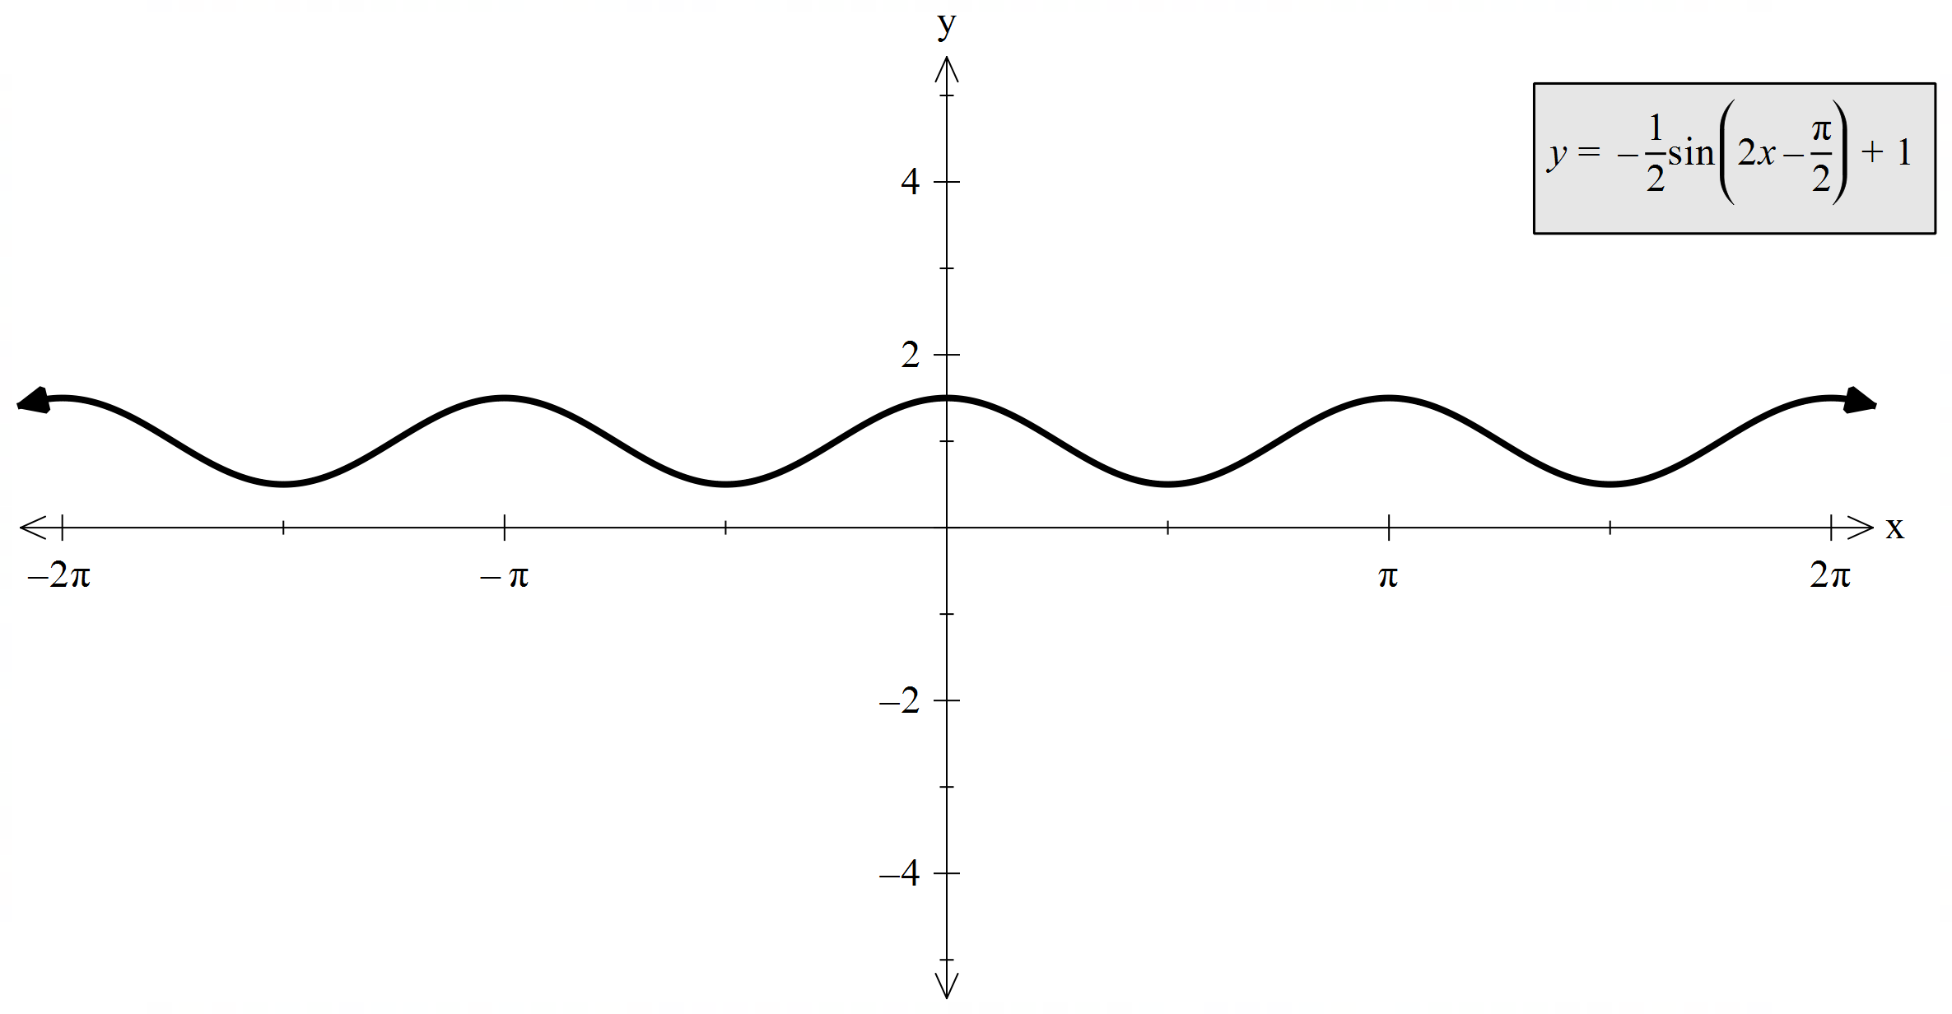

$$y=2\cos{x}$$
 | $$y=2\cos\left(2x\right)$$  Transformation:  Horizontal dilation of $\frac{1}{2}$  Period: $π$  Amplitude: $2$  Domain: $\left(-∞,∞\right)$  Range: $\left[-2,2\right]$ | 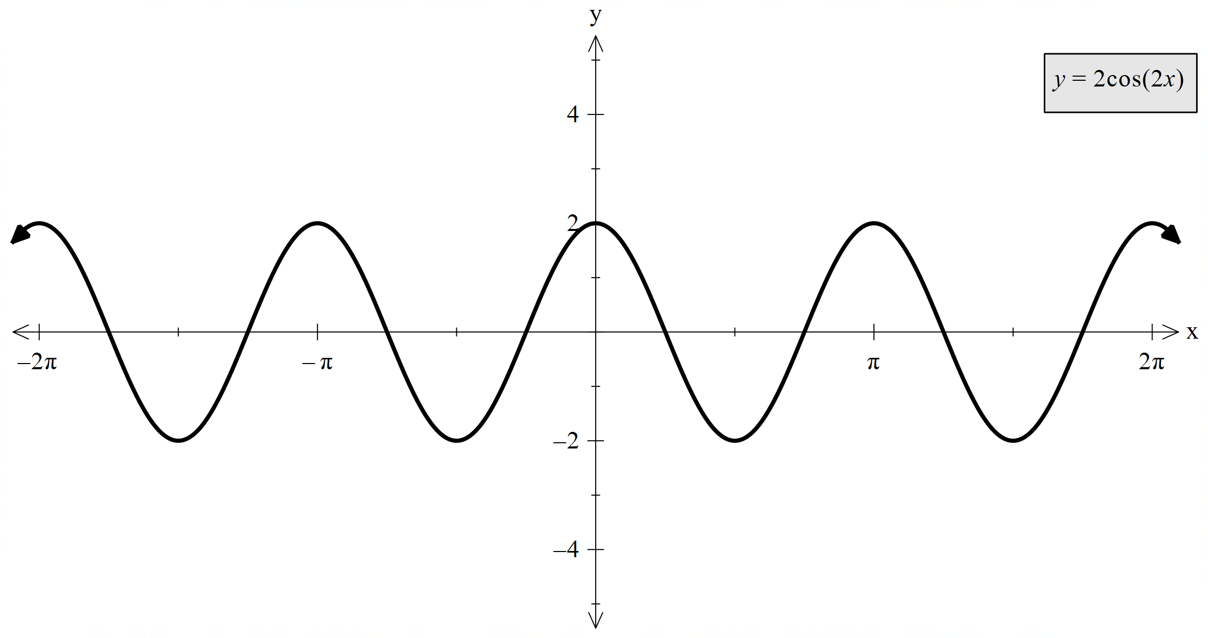
 | $$y=\cos\left(x-\frac{π}{4}\right)$$  Transformation:  Right by $\frac{π}{4}$ units  Vertical dilation by $\frac{1}{2}$  Period: $2π$  Amplitude: $1$  Domain: $\left(-∞,∞\right)$  Range: $\left[-2,2\right]$ | 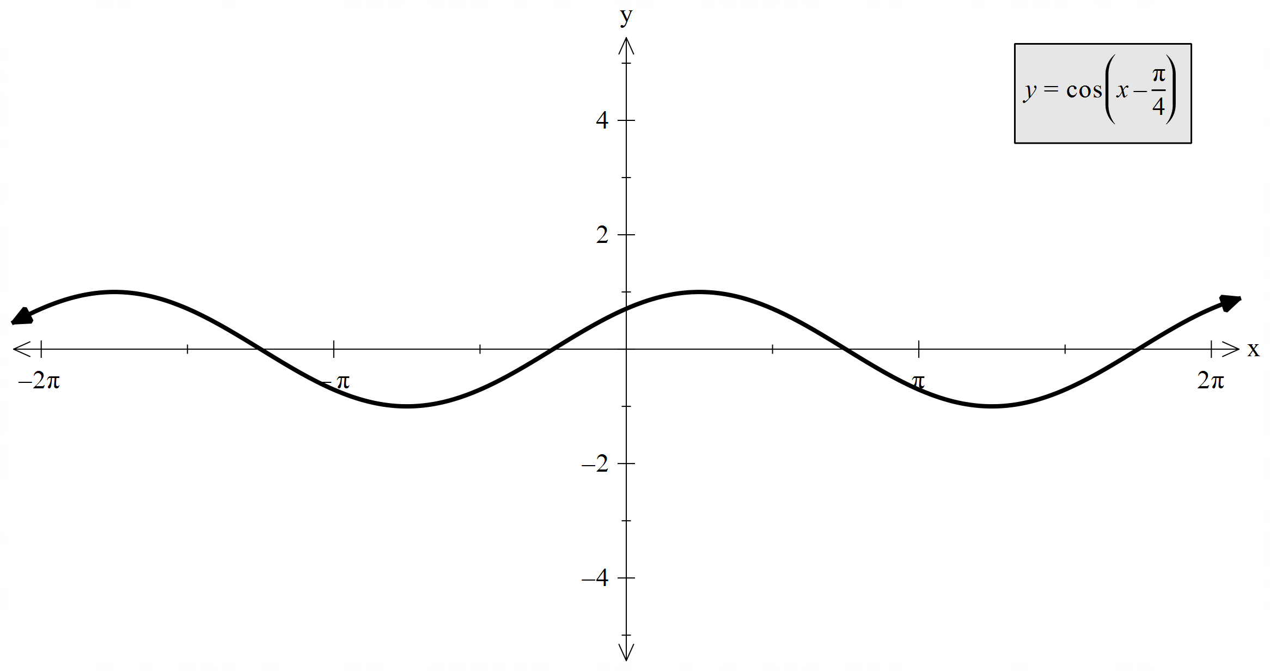
 | $$y=-3\cos{x}$$  Transformation:  Reflection across $x$-axis  Vertical dilation by $\frac{3}{2}$  Period: $2π$  Amplitude: $3$  Domain: $\left(-∞,∞\right)$  Range: $\left[-2,2\right]$ | 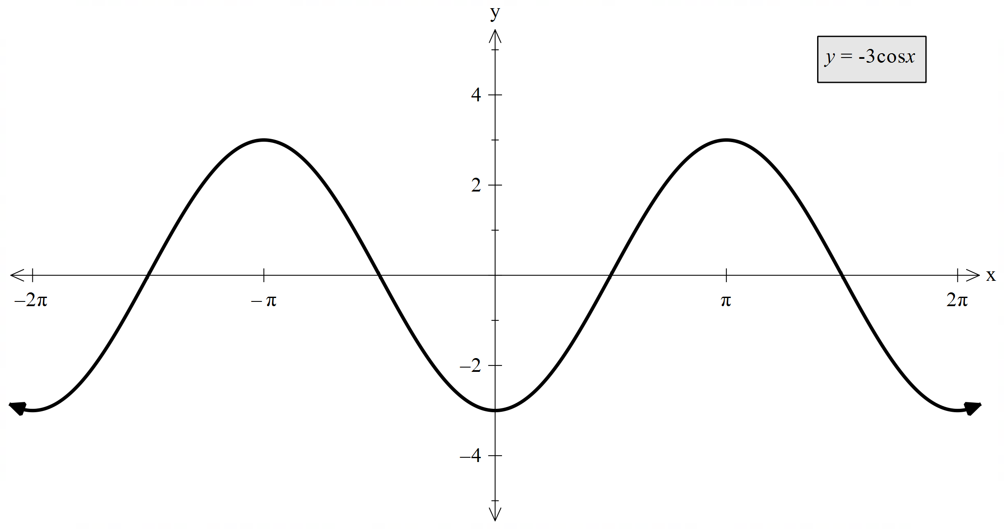
 | $$y=\cos\left(-x\right)$$  Transformation:  Reflection across $y$-axis  Vertical dilation by $\frac{1}{2}$  Period: $2π$  Amplitude: $1$  Domain: $\left(-∞,∞\right)$  Range: $\left[-2,2\right]$ | 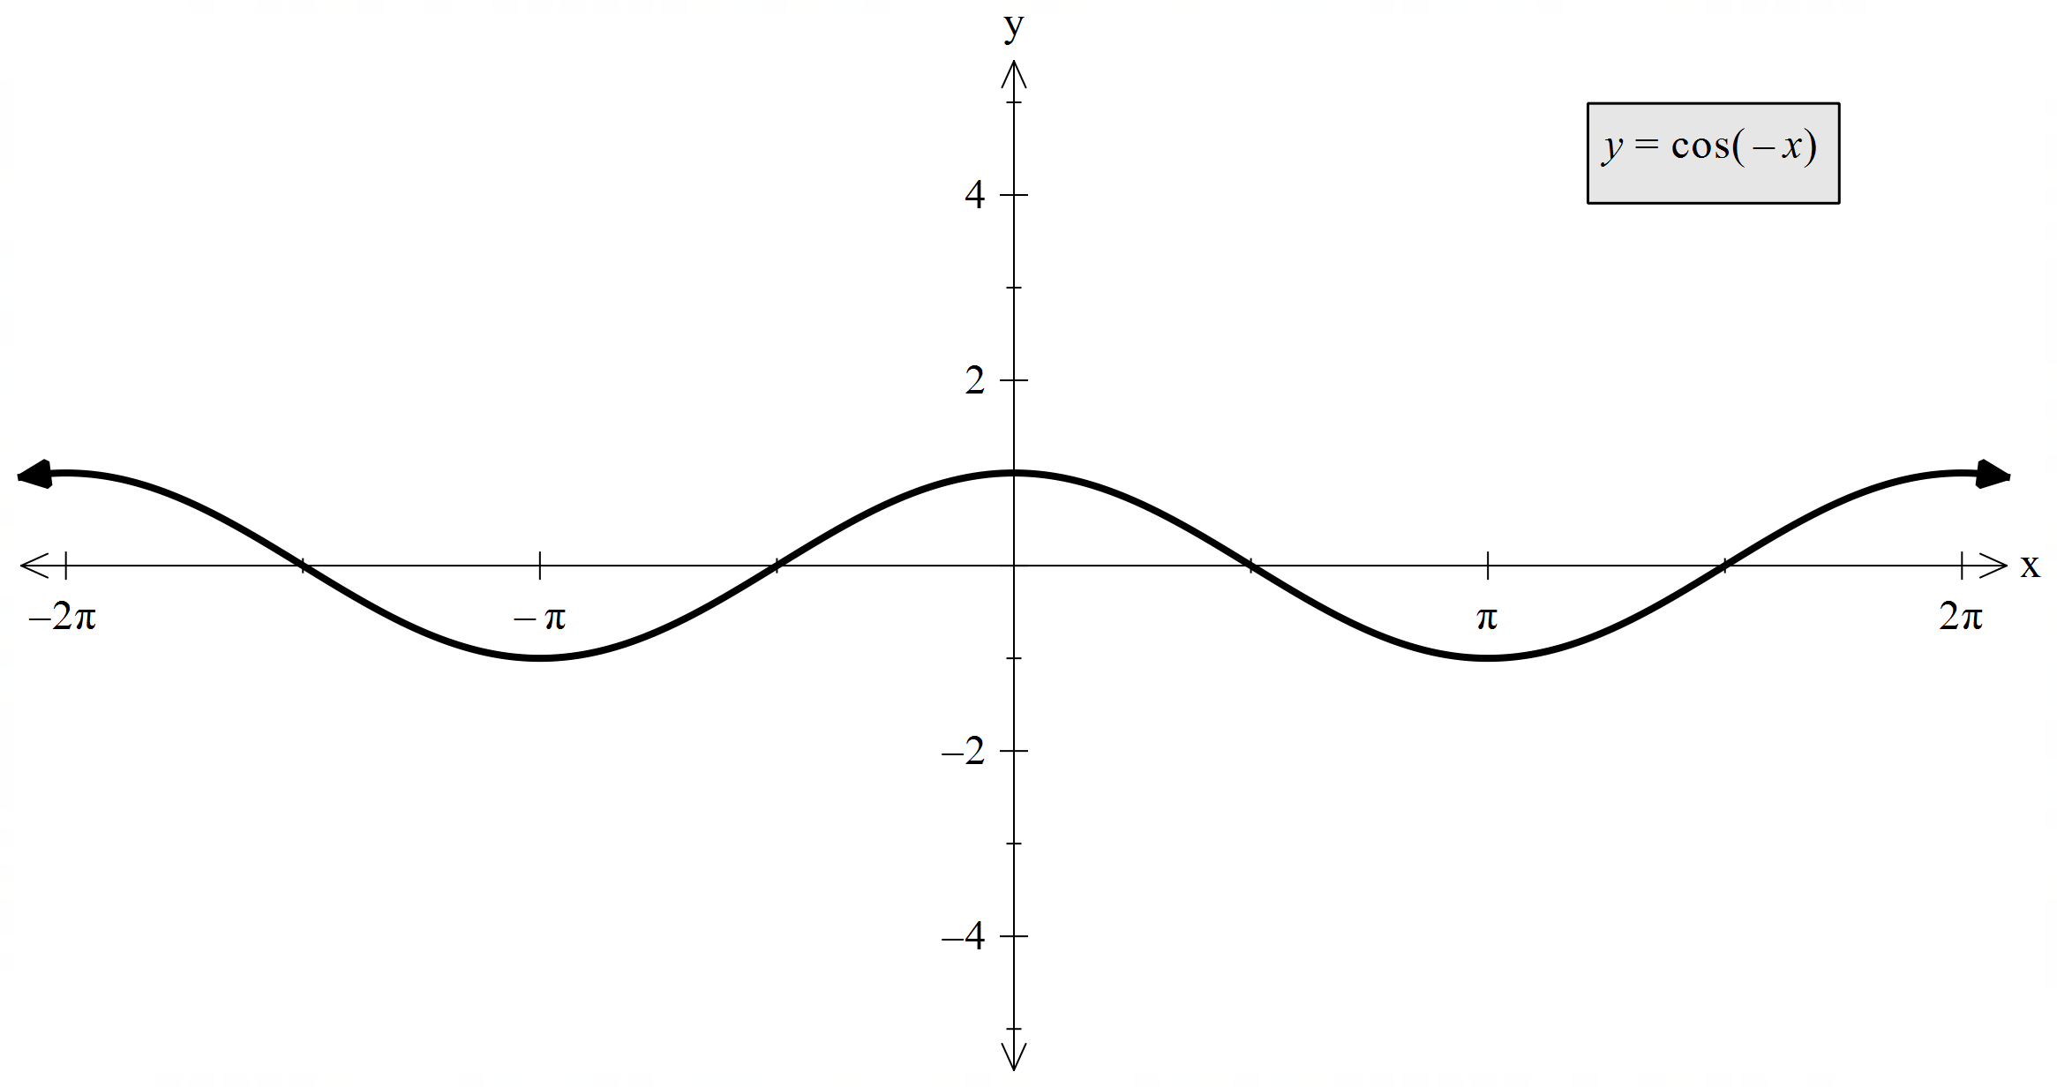
 | $$y=-2\cos\left(2x-\frac{π}{2}\right)$$  Transformation:  Horizontal dilation of $\frac{1}{2}$  Right by $\frac{π}{4}$ units  Reflection across $x$-axis  Period: $2π$  Amplitude: $2$  Domain: $\left(-∞,∞\right)$  Range: $\left[-2,2\right]$ | 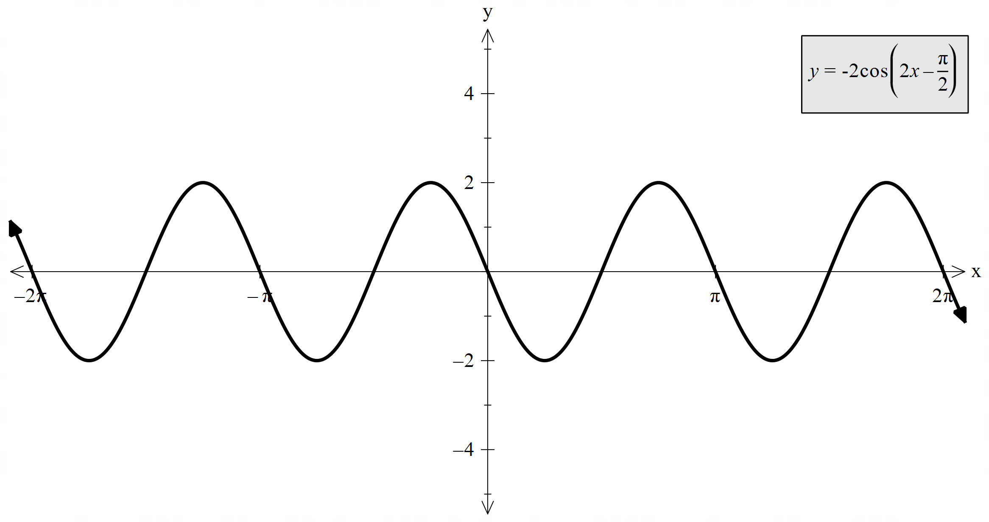
 | $$y=-\frac{1}{2}\sin\left(2x-\frac{π}{2}\right)-3$$  Transformation:  Horizontal dilation by $\frac{1}{2}$  Right by $\frac{π}{4}$ units  Reflection across $x$-axis  Vertical dilation by $\frac{1}{4}$  Down by 3 unit  Period: $2π$  Amplitude: $\frac{1}{2}$  Domain: $\left(-∞,∞\right)$  Range: $\left[-5,-1\right]$ | 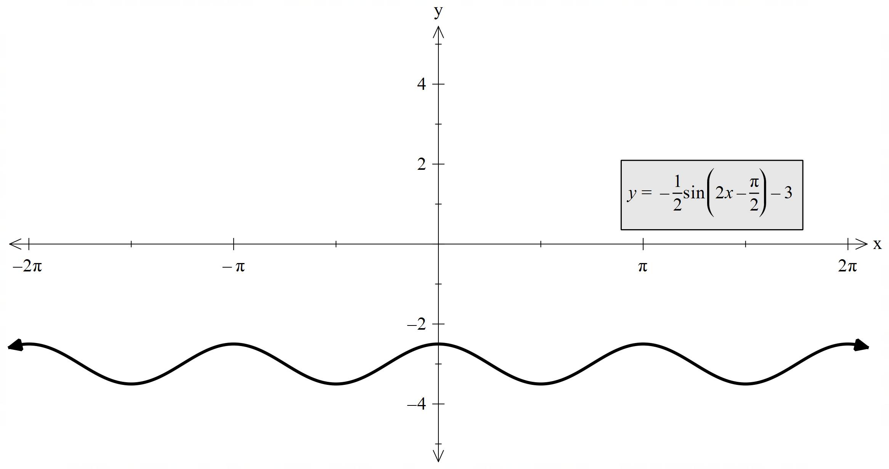

$$y=\tan{x}$$
 | $$y=2\tan{x}$$  Transformation:  Vertical dilation of $2$  Period: $π$  Amplitude: none  Domain: $x≠\frac{π}{2}+kπ, k \text{integer}$  Range: $\left(-∞,∞\right)$ | 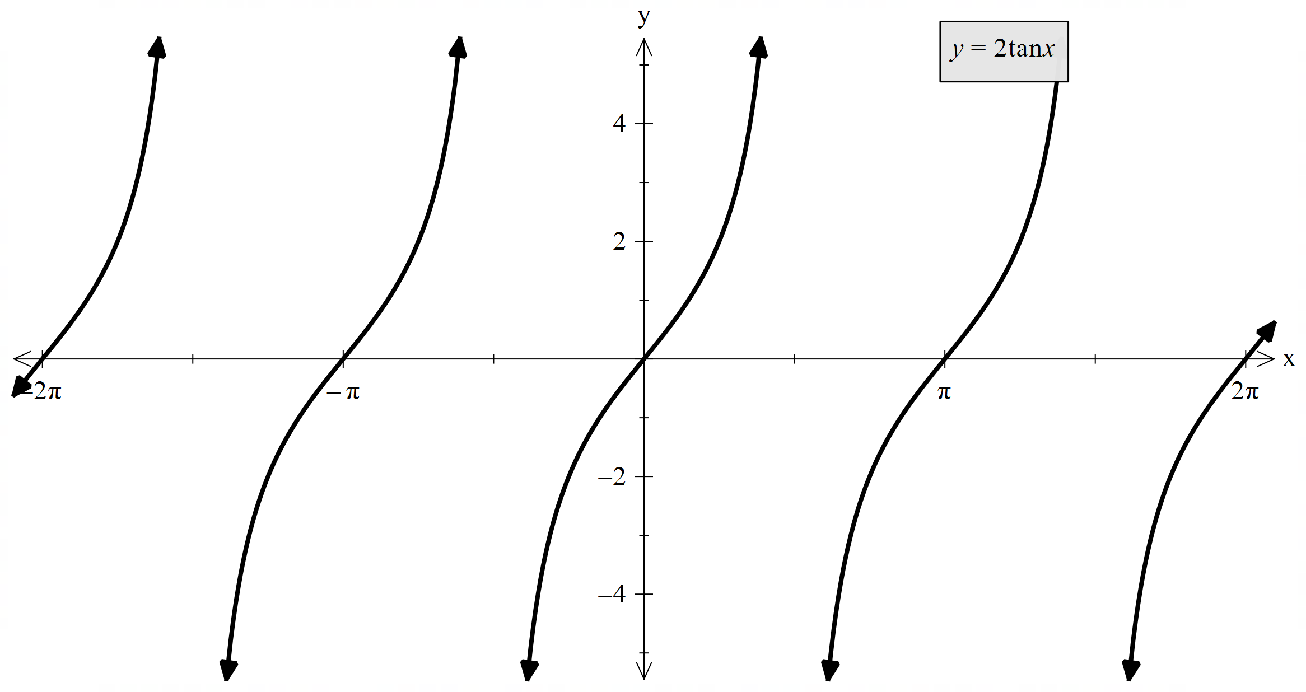
 | $$y=\tan{2x}$$  Transformation:  Horizontal dilation of $\frac{1}{2}$  Period: $\frac{π}{2}$  Amplitude: none  Domain: $x≠\frac{π}{4}+kπ, k \text{integer}$  Range: $\left(-∞,∞\right)$ | 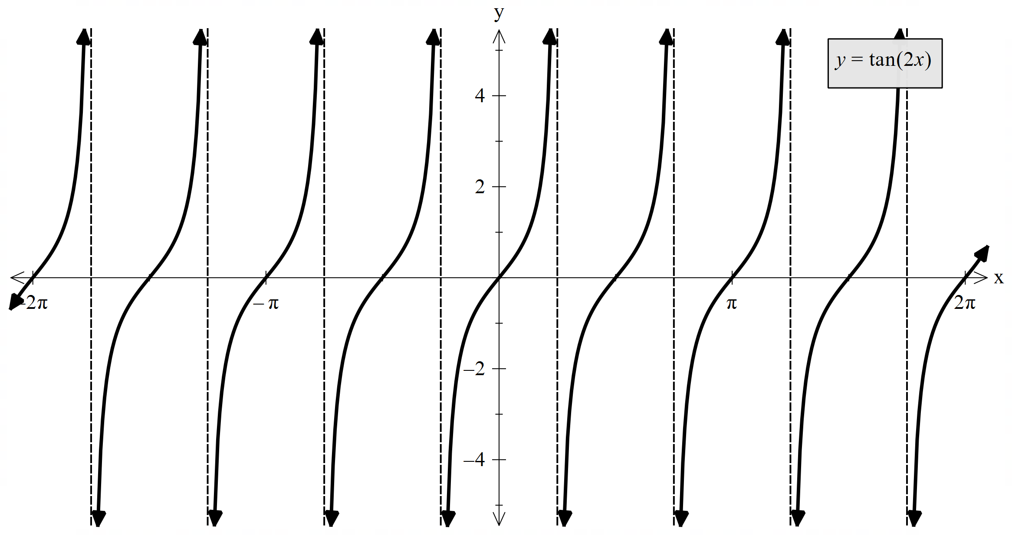
 | $$y=\tan\left(x+\frac{π}{4}\right)$$  Transformation:  Left by $\frac{π}{4}$ units  Period: $π$  Amplitude: none  Domain: $x≠\frac{π}{4}+kπ, k \text{integer}$  Range: $\left(-∞,∞\right)$ | 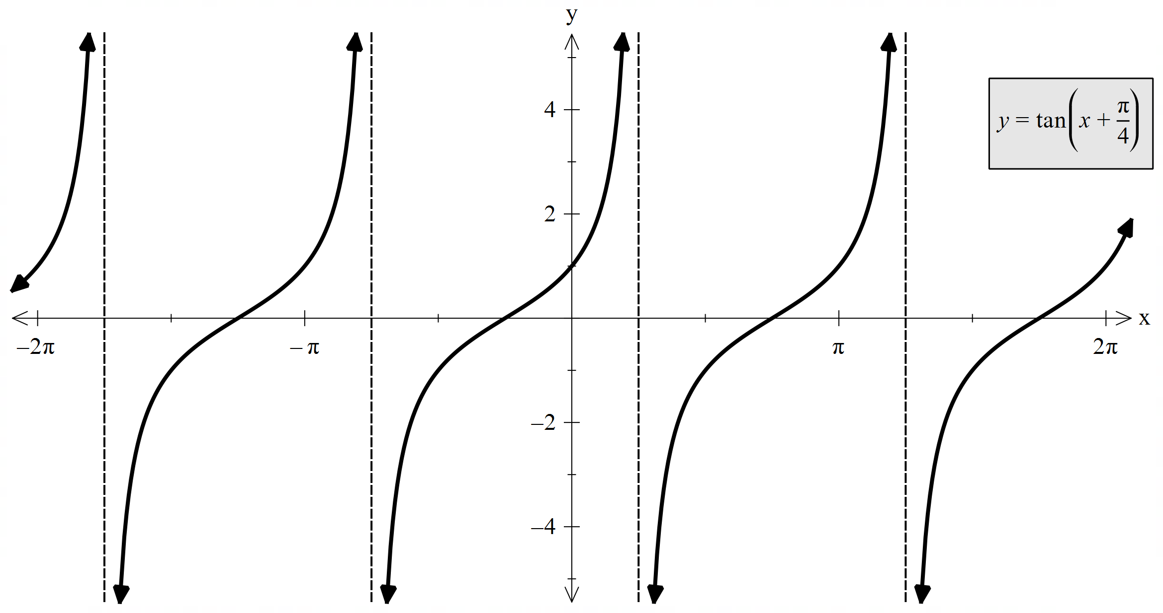
 | $$y=-2\tan\left(x+\frac{π}{4}\right)$$  Transformation:  Vertical dilation of $2$  Reflection across $y$-axis  Left by $\frac{π}{4}$ units  Period: $π$  Amplitude: none  Domain: $x≠\frac{π}{4}+kπ, k \text{integer}$  Range: $\left(-∞,∞\right)$ | 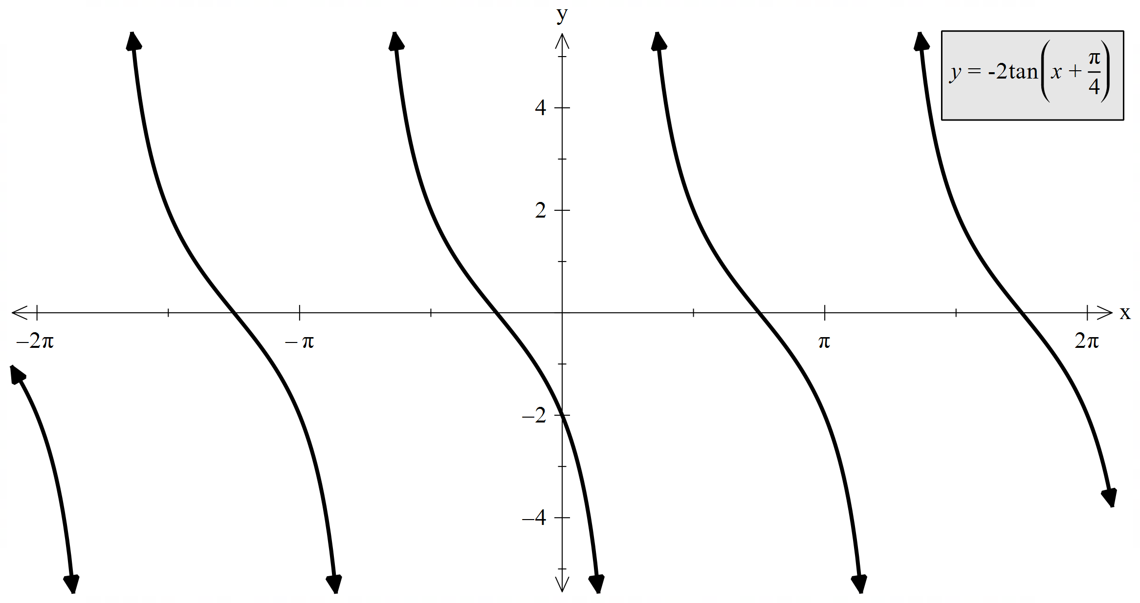
 | $$y=-\frac{1}{2}\tan\left(2x+\frac{π}{2}\right)$$  Transformation:  Vertical dilation of $\frac{1}{2}$  Reflection across $y$-axis  Horizontal dilation of $\frac{1}{2}$  Left by $\frac{π}{4}$ units  Period: $\frac{π}{2}$  Amplitude: none  Domain: $x≠\frac{kπ}{2}, k \text{integer}$  Range: $\left(-∞,∞\right)$ | 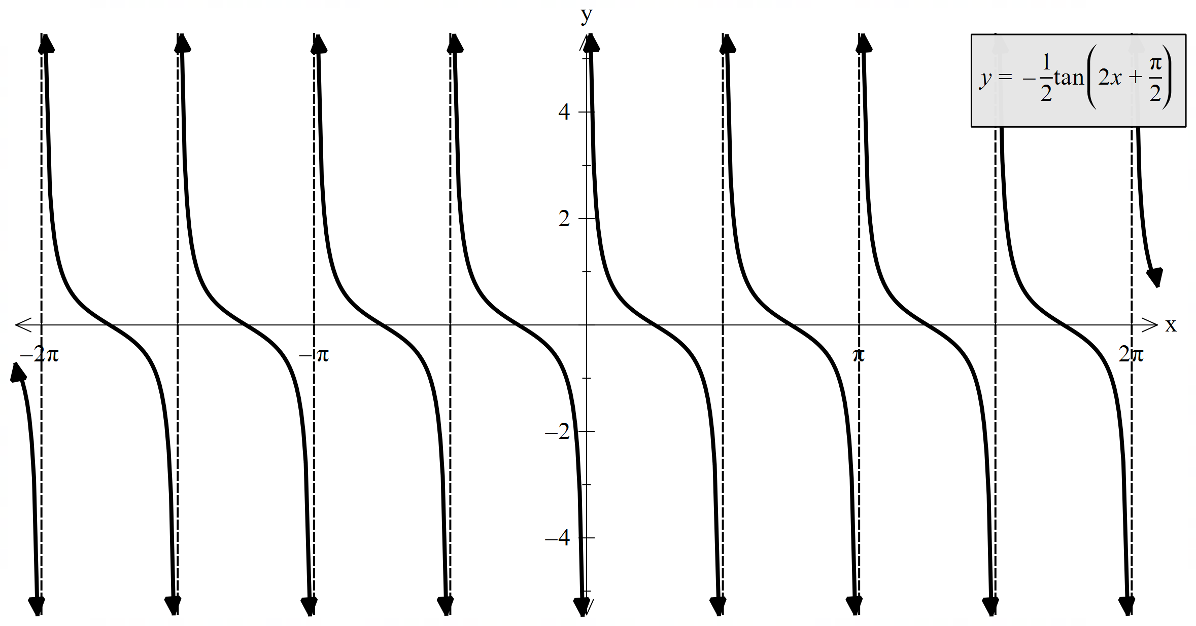

 | $$y=-\tan\left(2x+\frac{π}{2}\right)-1$$  Transformation:  Reflection across $y$-axis  Down by $1$ unit  Horizontal dilation of $\frac{1}{2}$  Left by $\frac{π}{4}$ units  Period: $\frac{π}{2}$  Amplitude: none  Domain: $x≠\frac{kπ}{2}, k \text{integer}$  Range: $\left(-∞,∞\right)$ | 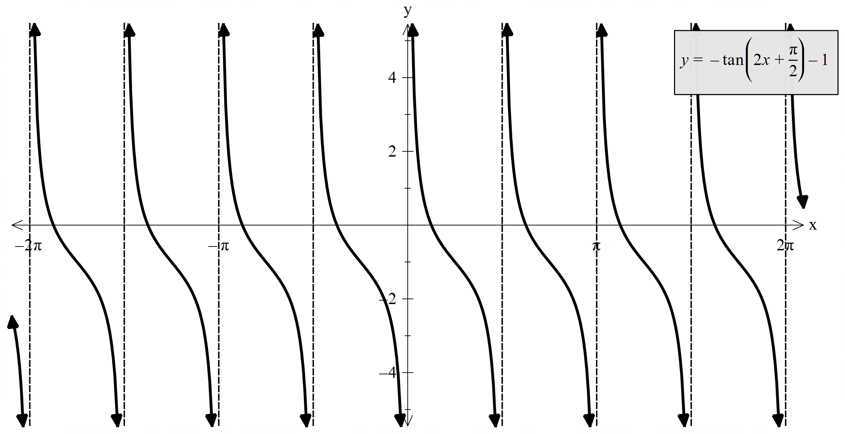

References
This resource contains NSW Curriculum and syllabus content. The NSW Curriculum is developed by the NSW Education Standards Authority (NESA). This content is prepared by NESA for and on behalf of the Crown in right of the State of New South Wales. The material is protected by Crown copyright.
Please refer to the NESA Copyright Disclaimer for more information https://www.nsw.gov.au/education-and-training/nesa/copyright.
NESA holds the only official and up-to-date versions of the NSW Curriculum and syllabus documents. Please visit NESA https://www.nsw.gov.au/education-and-training/nesa/copyright and NSW Curriculum https://curriculum.nsw.edu.au.
Mathematics Advanced 11–12 Syllabus © NSW Education Standards Authority (NESA) for and on behalf of the Crown in right of the State of New South Wales, 2024.

© State of New South Wales (Department of Education), 2026
The copyright material published in this resource is subject to the Copyright Act 1968 (Cth) and is owned by the NSW Department of Education or, where indicated, by a party other than the NSW Department of Education (third-party material).
Copyright material available in this resource and owned by the NSW Department of Education is licensed under a Creative Commons Attribution 4.0 International (CC BY 4.0) license.

This license allows you to share and adapt the material for any purpose, even commercially. Attribution should be given to © State of New South Wales (Department of Education), 2026.
Material in this resource not available under a Creative Commons license:
- the NSW Department of Education logo, other logos and trademark-protected material
- material owned by a third party that has been reproduced with permission. You will need to obtain permission from the third party to reuse its material.
Links to third-party material and websites
Please note that the provided (reading/viewing material/list/links/texts) are a suggestion only and implies no endorsement, by the New South Wales Department of Education, of any author, publisher, or book title. School principals and teachers are best placed to assess the suitability of resources that would complement the curriculum and reflect the needs and interests of their students.
If you use the links provided in this document to access a third-party's website, you acknowledge that the terms of use, including licence terms set out on the third-party's website apply to the use which may be made of the materials on that third-party website or where permitted by the Copyright Act 1968 (Cth). The department accepts no responsibility for content on third-party websites.

