Organising datasets
In this lesson, students build on their understanding of data representations and random variables using real-world airport data. They analyse flight data to explore how it can inform airport decisions and use spreadsheets to create and interpret tables and graphs to support their conclusions.
Students will need at least one digital device per pair to interact with the Organising datasets spreadsheet during this lesson.

Learning intentions
- To understand the difference between discrete and continuous random variables.
- To understand how to organise data using spreadsheets.
- To be able to apply knowledge of relative frequency and use representations to interpret real-world data scenarios.

Success criteria
- I can explain the difference between discrete and continuous random variables using examples.
- I can organise data into a table using a spreadsheet, including frequency, relative frequency, cumulative frequency and relative cumulative frequency columns.
- I can create a graph related to a table using a spreadsheet, including frequency, relative frequency, and cumulative frequency histograms and polygons.
- I can estimate the probability of events using relative frequencies.
- I can use data from tables and graphs to explain and justify my decisions.

Outcomes
A student:
- develops understanding and fluency in mathematics through exploring and connecting mathematical concepts, choosing and applying mathematical techniques to solve problems, and communicating their thinking and reasoning coherently and clearly MAO-WM-01
- solves problems involving probability in a variety of contexts MAV-11-09
- displays and analyses datasets using summary statistics and graphical representations MAV-11-10

Content

Data
- Define a random variable as a variable whose values is the outcome of a random experiment
- Compare discrete random variables with continuous random variables, describe their differences, and give practical examples of each
- Organise finite datasets using a table or a spreadsheet, listing the values, frequency, relative frequency, cumulative frequency, and cumulative relative frequency
- Graph the frequency, relative frequency, and cumulative frequency histograms and polygons of datasets using spreadsheets or graphing applications, and identify the mode and median from graphs, and from tables
- Use the relative frequency to estimate the probability of results in experiments
Mathematics Advanced 11–12 Syllabus © NSW Education Standards Authority (NESA) for and on behalf of the Crown in right of the State of New South Wales, 2024.

Table 1: lesson summary
Section | Summary of activity | Teaching strategies | Teaching points
Activating prior knowledge | Have students complete Appendix A by matching frequency data with probability statements and then discuss their solutions.  Using the Organising datasets spreadsheet, students sort variables into the categories of discrete random variable and continuous random variable. Instructions for sharing the spreadsheet are found in Appendix B. | Visibly random groups of 3  Vertical non-permanent surfaces  Gallery walk  Examples and non-examples  Think-Pair-Share | Appendix A reviews students’ prior knowledge of frequency, frequency histograms and polygons and relative frequency. Students then use airport data to review prior knowledge of discrete and continuous random variables that has previously been explored in Stage 4.
Connecting learning | Use the spreadsheet to model how to organise flight data into a table, using formulas in the spreadsheet. Model how to populate the relative frequency, cumulative frequency and relative cumulative frequency rows from the frequency table using formulas.  Students then observe graphs created from this table and are shown how to adjust these before explaining the similarities and differences between each graph. | Turn and talk  Notice and wonder  Think-Pair-Share | This activity develops students’ ability to organise and analyse real-world data using spreadsheets, applying their understanding of frequency, relative frequency, and cumulative frequency. Students also learn how to use spreadsheet features such as formulas, cell referencing, and graphing tools to interpret data and support practical decision-making, like staffing at Sydney Airport.
Releasing responsibility | Students use the data organised in the spreadsheet to solve a problem analysing the flight data.  Students analyse the tables and graphs they have produced to identify trends in the data to suggest how staffing levels at the airport might be affected. | Pose-Pause-Pounce-Bounce  Notes to their future forgetful selves | This activity helps students interpret and evaluate different graphical representations to make data-informed decisions in a real-world context. They consolidate their understanding of frequency, cumulative frequency, and variable types while developing critical thinking skills.
Independent practice | Students use the data provided in the spreadsheet to evaluate airline reliability, using tables and graphs to justify their conclusions and decisions. Students are to find the probability that the airline will have a ‘good day’ if it means they have 2 or less cancellations, compared to a bad day being 6 or more cancellations. | Turn and talk  Visibly random groups of 3 | This activity supports students in applying cumulative and relative frequency to calculate probabilities and compare real-world outcomes.

Activity structure

Activating prior knowledge
Please refer to the associated spreadsheet Organising datasets throughout this lesson.
- Assign students to visibly random groups of 3 (bit.ly/visiblegroups) at vertical non-permanent surfaces (bit.ly/VNPSstrategy).
- Distribute Appendix A ‘Matching activity’ to each group and have them match the frequency table with the frequency histogram or polygon, the relative frequency table and the probability statement.
Appendix A is designed to make connections to students’ prior learning from Stage 4 and 5. Students are familiar with these representations as they were addressed in the Stage 4 Data classification and visualisation outcome MAT4-DAT-C-01.
- Students are to do a gallery walk (bit.ly/DLSgallerywalk) of each other’s solutions, to provide peer feedback and return to make any final changes to their own work.
- Lead a class discussion where students share their results. Encourage students to explain their reasoning and describe the steps they took, for example, which representations they matched first and why.
- Explain to students that they will be analysing airport data in this lesson. Check for understanding of different data types by using a Think-Pair-Share (bit.ly/thinkpairsharestrategy), for students to brainstorm different types of data that can be collected from an airport.
- Display the ‘Random and non-random variables’ tab of the spreadsheet. Use the examples and non-examples (bit.ly/nonexamplesstrategy) to help scaffold students’ understanding of the concept of a random variable.
- Ask students to consider a definition for a random variable and ask non-volunteer students to provide some suggestions.
Define a random variable as a variable whose possible values are outcomes of a statistical experiment or random phenomenon.
- Provide students with a digital copy of the Organising datasets spreadsheet.
There are instructions in Appendix B ‘Save a local copy of a file’ on how to provide students with access to a spreadsheet file. Displaying the spreadsheet Organising datasets for students to view and follow along is highly recommended.
- In pairs, direct students to the ‘Discrete and continuous’ tab in the spreadsheet and have them classify the random variables as either discrete or continuous by dragging the text boxes into the appropriate section of the spreadsheet.
Students are familiar with the concept of a discrete variable and a continuous variable from the Stage 4 Data classification and visualisation outcome MAT4-DAT-C-01. Students may need to be reminded of the definitions prior to completing this activity:
A discrete random variable is a numerical variable whose values can be listed.
A continuous random variable is a numerical variable that can take any value along a continuum.
- Once student pairs have completed the task, ask them to compare their answers with another pair. Prompt students to discuss any similarities or differences and come to an agreement on the correct response, before you reveal the answers to the whole class.

Connecting learning
- Explain to students that they are going to assist with the rostering of staff at Sydney Airport by looking at flight data, that is, the number of flights in and out of the airport.
- In a Think-Pair-Share, ask students to determine how flight data might help to determine airport staffing needs.
- Explain to students that the tab ‘Sydney flight data’ lists the number of flights that have departed and/or arrived in Sydney Airport each month from 2009 to 2024. Allow students time to look at the data on this tab.
- Ask students what they notice and wonder (bit.ly/noticewonderstrategy) about any trends in the data and how this data may be used to inform airport staffing needs.
Students may notice that in most months, the airport has approximately the same number of flight movements. They may also notice that there was a drop in the number of flights from 2020 to 2022.
Students may wonder why, for most years, there is a decrease in the flight movements in February when compared to January and March.
Students may share that knowing which months have more flights and which have fewer may help to inform them about when extra staff should be rostered. Students may also indicate that the raw data is too overwhelming and needs to be organised prior to being able to use it effectively.
- Conduct a class discussion to check for understanding of how students might organise this data. Students may suggest tables and graphs. Use prompts to determine if students can give specifics of this, linking back to the tables and graphs in the ‘Activating prior knowledge’ section of this lesson.
The following section of the lesson is where the teacher will model to students how to organise the data into a table on the spreadsheet. Provide time after each step for students to complete this in their own copy of the spreadsheet.
- Explain to students that they will now use the tab ‘Sydney flight table and graphs’ to organise the data from the ‘Sydney flight data’ tab, as seen in Figure 1. Display the ‘Sydney flight data’ tab on the screen before displaying the ‘Sydney flight table and graphs’ tab and direct students to have this tab open on their screens.
Figure 1: screenshot of Sydney Flight table and graphs tab
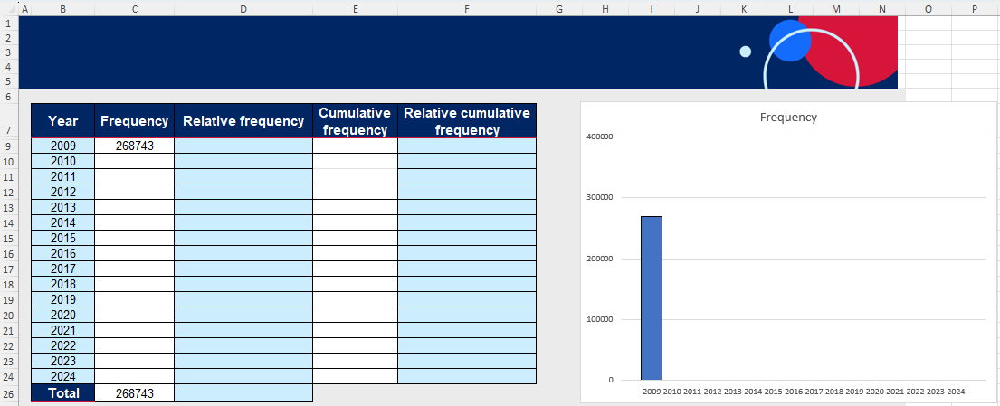
- Ask students to turn and talk (bit.ly/classroomtalkmoves) to discuss:
- What data will go into each of the columns in the table?
- What does the number in cell C9 represent and where did it come from?
Make connections to students' prior knowledge, as they should be familiar with frequency and relative frequency as they have organised data into frequency histograms and polygons in the Stage 4 Data classification and visualisation outcome MA4-DAT-C-01, explored relative frequency in the Stage 4 Probability outcome MA4-PRO-C-01 and analysed histograms in the Stage 5 Probability A Core outcome MA5-DAT-C-01. Cumulative frequency is the only new content that has not been addressed in Stages 4 or 5.
- Have a class discussion to define each of the 4 column headings and model to students how to construct a glossary definition for each of the 4 headings in the spreadsheet using the comment feature.

The following are some examples of possible definitions:
- Frequency: the number of times a particular value or category appears in a dataset.
- Relative frequency: the ratio of the frequency of a particular value to the total number of data points in the dataset.
- Cumulative frequency: the accumulating total of frequencies within an ordered dataset.
- Relative cumulative frequency: the accumulating total of relative frequencies within an ordered dataset.

Frequency
- Model to students by clicking in the cell C9, how to use a formula to retrieve information from the previous tab on how many flights occur in the year. Explain to students that they are going to copy this formula down the column to populate every year. To do this, students will need to drag the formula from C9 to cell C24, by clicking in cell C9, then moving their cursor to the small square at the bottom-right corner of the cell until a small black cross appears. Model to students how to then click and drag down to cell C24.
- Ask students to turn and talk to discuss how they could find the total for the Frequency column in cell C26, using a spreadsheet formula.
Students may suggest individually adding the cells together using a formula similar to =C9+C10+C11+… or they may know the ‘SUM’ function on a spreadsheet.
- Explain to students that the ‘SUM’ function can be used to add cells in a range. Model to students how to use this function by entering =SUM(C9:C24) formula into cell C26 to calculate the total for the Frequency column.

As students complete this column, the respective frequency graph will display on the right-hand side of the spreadsheet, as seen in Figure 2.
Figure 2: screenshot of completed Frequency column showing completed frequency graph
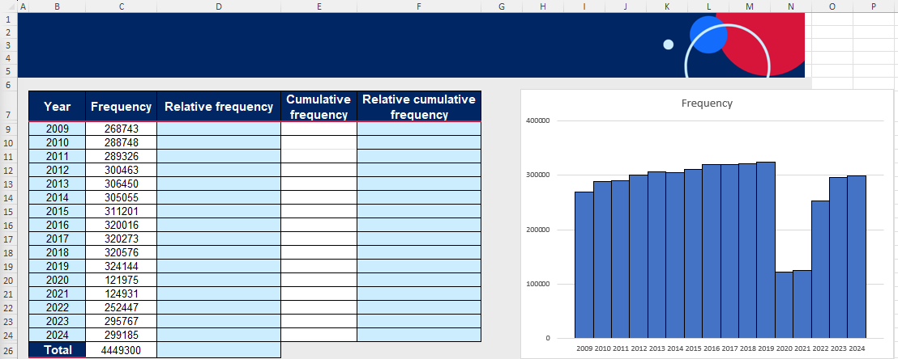
The graph of the relative frequency and the cumulative frequency will also display as data is filled into their respective columns

Relative frequency
- Ask students to turn and talk to discuss how they might calculate relative frequency from the frequency table.
Remind students that they need the frequency of the specific year and the total. Encourage students to use the cell references when determining how to calculate relative frequencies.
- Model to students how to calculate the relative frequency by using the formula =C9/$C$26 in cell D9. Then select and hold the bottom right-hand corner of cell D9 and drag it down to cell D24.
- In a Think-Pair-Share, ask students to consider the formula in each cell of the relative frequency column and what they think the $ sign in the formula may be doing.
The $ sign in the formula locks the formula to a specific cell when it is copied. In this case, having it in the denominator of the formula ensures that the total is always referencing the value in cell C26 and therefore remains the same.
Figure 3: screenshot of completed Frequency and Relative frequency columns and their respective graphs
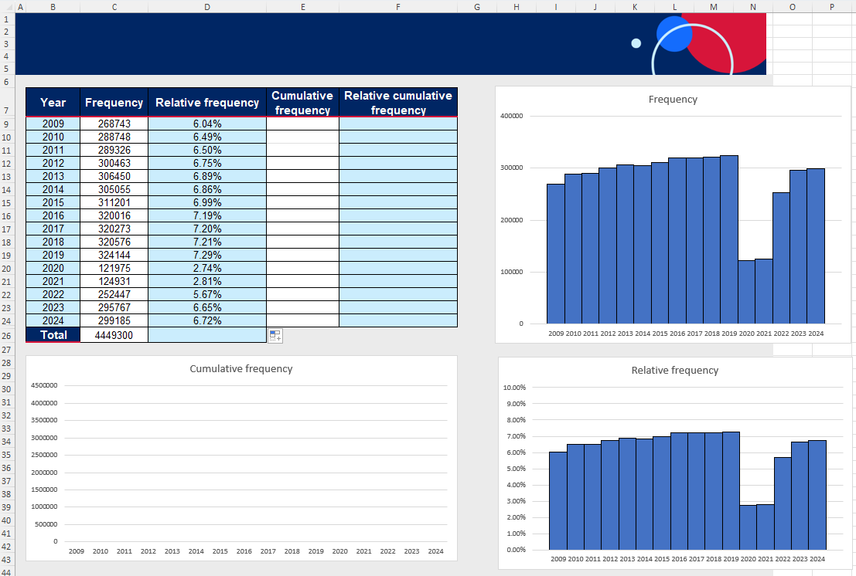
- Allow each pair time to repeat the process from step 11 to find the total for the relative frequency column in cell D26, using a spreadsheet formula, prior to modelling it for students.
Prompt students to recognise that the sum of relative frequency is equal to 100% as it verifies that the total of probabilities of all possible outcomes of an event is 1.
- Ask students what they notice and wonder about the frequency and relative frequency columns of the table and their respective graphs.

Students should notice that the shape of both histograms is identical, however the $y$-axis is different.
Students may wonder what happened in 2020 and 2021 to affect the shape of the graph.

Cumulative frequency
- Model to students how to complete the cumulative frequency column by first copying the value from cell C9 into cell E9 by using the formula =C9 in cell E9.
- Explain to students that we want to add the frequency for 2009 and 2010 together and ask if they can determine a formula that can calculate this. Encourage them to use cell references in their explanation.
- Model for students how to input the formula =E9+C10 into cell E10. Explain to students that for each consecutive cell in the spreadsheet, we want to add the next cell from the frequency column. Ask students if they can recall how this might be done, rather than individually doing a new formula for each cell.
- Model to students how to highlight cell E10 and drag the bottom right-hand corner down to cell E24.
- Ask students what they notice and wonder about the frequency and cumulative frequency columns in the table and their respective graphs.
Figure 4: screenshot showing completed Frequency, Relative frequency and Cumulative frequency with their respective graphs
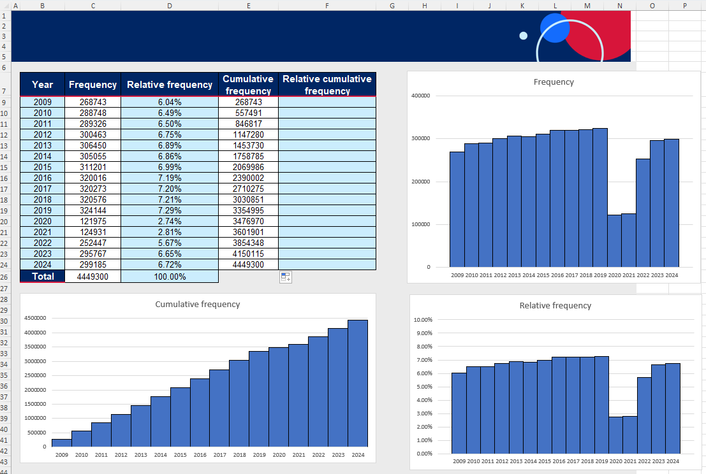
Students should notice that the cumulative frequency table values are always increasing and that the final value in the cumulative frequency column is the same as the total in the frequency column. They may notice that the cumulative frequency graph steps upwards to the total.

Relative cumulative frequency
- In a Think-Pair-Share, have students discuss the relative frequency column. Use prompting questions to check for understanding, which may include:
- How might you calculate the relative cumulative frequency?
- What might be the value in the final cell in the column and why?
- What formula might be used in cell F9 that can be dragged down?
Students have already completed the Relative frequency column and the process to calculate the cumulative relative frequency is similar. Encourage students to use cell references from the cumulative frequency column to describe the formula.
- Model to students how to use the formula =E9/$E$24 in cell F9 and to drag the bottom right-hand corner down to cell F24.
Students are not required to graph the relative cumulative frequency. However, you may want to ask students what they think the shape of this graph would be. You can use the graphs of frequency and relative frequency to prompt students.

Using spreadsheets to graph
Model to students how to change the graphs from histograms to polygons, by following the steps:
- Select the graph.
- Select Chart Design in the ribbon at the top.
- Select Change Chart Type, see Figure 5.
- Choose Line, see Figure 6.

Screenshots to demonstrate how to change the chart type.
Figure 5: screenshot highlighting the Change Chart Type button in Excel
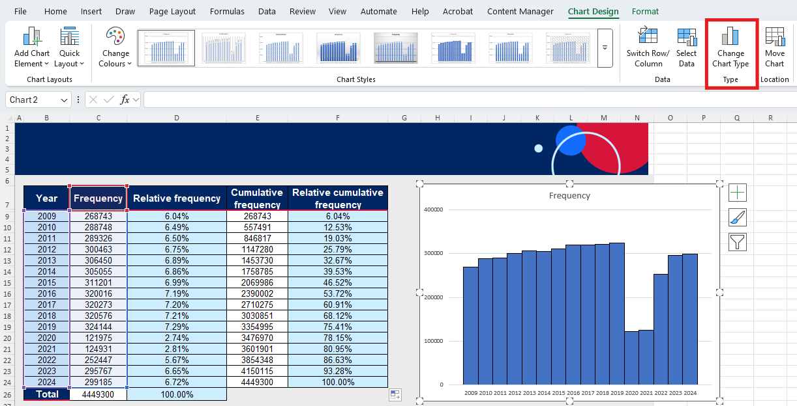
Figure 6: screenshot showing the different chart types, highlighting line
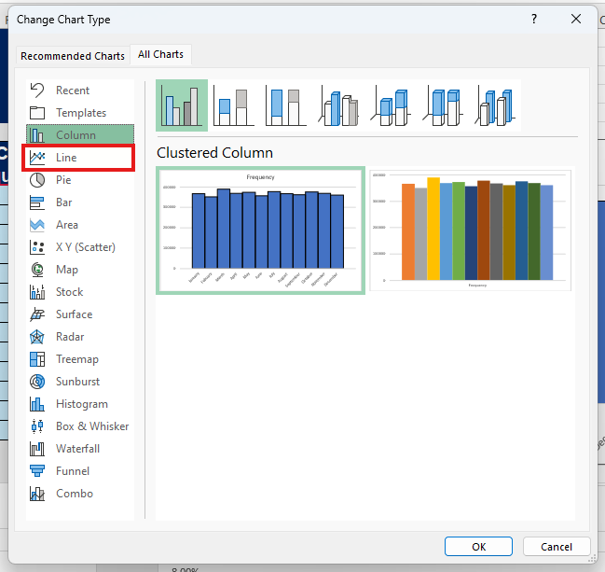
The histogram chart in Excel has not been used in this spreadsheet since it doesn't provide the half column gap at the start as demonstrated in the Stage 4 Data classification and visualisation outcome MA4-DAT-C-01 examples. The charts displayed have been created using the column chart with hidden data in rows 8 and 21.

Releasing responsibility
- Verbally pose the following problem to students:
Flight data helps Sydney Airport management decide how many staff to employ. Examine the data to identify any trends in the number of flights. Based on these trends, suggest how staffing levels at the airport might be affected. Use the graphs in your spreadsheet to support your response.
- In a Think-Pair-Share, ask students to discuss the problem and suggest what management should decide. Encourage students to use evidence from the data to support their conclusions.
- Check for understanding by using the Pose-Pause-Pounce-Bounce questioning strategy (PDF 557 KB) (bit.ly/posepausepouncebounce) to discuss which graphical display helped to solve the problem.
- Conduct a class discussion to deepen student understanding using the prompting questions below to explore each graph, its features, and when it is most useful for interpreting data. Use prompting questions to scaffold the discussion, such as:
- What information can be read off a frequency graph?
- Why might we prefer a cumulative frequency graph?
- An airport maintenance supervisor needs the maintenance team to inspect the runway every 1 million flights. Which graph can easily display this information?
- Students are to create notes to their future forgetful selves (bit.ly/notestofutureself) on the table and each of the graphical representations explored this lesson, identifying their features. Students should also include definitions and examples for discrete and random variables.

Independent practice
- Pose the following problems to students and explain that the frequency column represents the number of cancellations the airline recorded in the previous year.
Airlines are having a ‘good day’ if they have 2 or less cancellations on a given day, while they are having ‘bad day’ if they have 6 or more cancellations on any given day. By considering Aero Australis’ cancellation data, what is the probability that the airline will have a good day? How does the probability of having a ‘good day’ compare to the probability of having a ‘bad day’?
- In pairs have students complete as much of the table as they believe necessary to solve the problems.
The graphs for relative frequency and cumulative frequency will automatically display once data is entered.
Figure 7: screenshot of completed table and their graphs
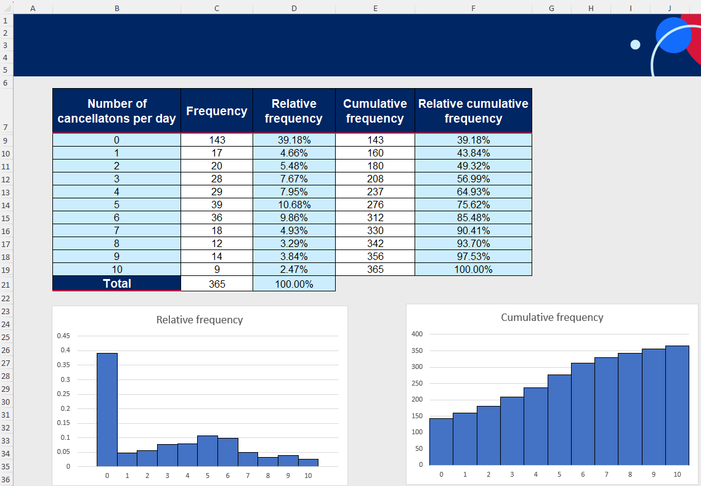
- Students are to discuss in their pairs which of their representations can be used to solve the problem. Students are to construct a response to the problem with reference to the graphical representations.
- Use the Pose-Pause-Pounce-Bounce questioning strategy to discuss what information from either the table or the graph assisted in solving the problems.
Depending on student responses, draw their attention to the following points:
- The relative cumulative frequency row for 2 cancellations is the value of the probability of a ‘good day’.
- If students calculated relative cumulative frequency by adding frequencies and then dividing by the total, highlight that this method gives the same result as using the cumulative frequency and relative cumulative frequency columns.
- Some students may have used the complement to calculate a ‘bad day’, identifying that the complement of 5 cancellations or fewer is the same as 6 or more cancellations.

Assessment and differentiation

Suggested opportunities for differentiation
Activating prior knowledge
- Students may benefit from matching the frequency tables to the frequency histograms and polygons first. Then, match the relative frequency tables with the probability statements. Finally, match the frequency tables with the relative frequency tables.
Connecting learning
- Extend students by having them study the formula in cell C9 and interpret its meaning. Ask students what differences they notice about the formula in cell C9 and cell C10. Ask students to describe what occurred when they dragged cell C9 down to cell C24.
Independent practice
- Provide students with more direction as to how much of the table they need to complete. Some students may only complete the relative frequency column and add the appropriate probabilities.
- Extend students by having them only complete the cumulative frequency and relative cumulative frequency columns to solve the problems.
- Extend students by asking them to consider which airline they would prefer to fly with and why, given the following information:
- The probability of a good day for Aero Australis and Southern Skies is 49.32% and 43.29% respectively.
- The probability of a bad day for Aero Australis and Southern Skies is 24.38% and 17.18% respectively.

Suggested opportunities for assessment
Activating prior knowledge
- When placed in groups of 3, students provide and receive peer feedback on their understanding of frequency and relative frequency tables and graphs.
- Students working on vertical non-permanent surfaces means the teacher can assess student understanding of frequency and relative frequency and provide support where appropriate.
- Teachers could ask students to explain and justify the strategy they used to match the different representations.
Connecting learning
- Monitor student responses during discussions to assess their understanding of the different columns in the table and the features of the graphs.
Releasing responsibility
- Observe students’ reasoning and justification in response to the provided prompting questions.
Independent practice
- Observe students’ reasoning and justification as they discuss the problems in their pairs and with the class.
- Create an exit ticket with 2 or 3 graphs that have no heading and have students determine which graph is the cumulative frequency and which is the frequency and/or relative frequency.

Appendix A

Matching activity
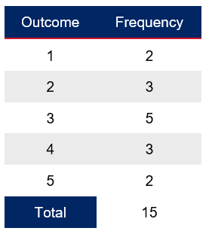 | 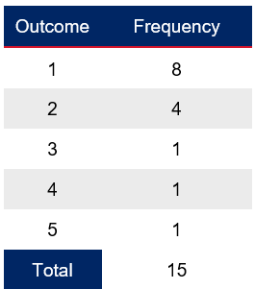 | 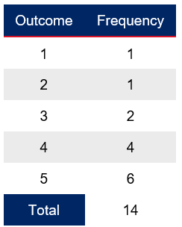
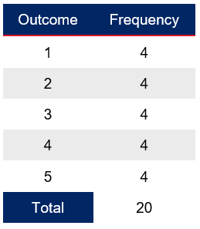 | 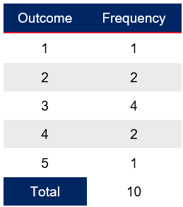 | 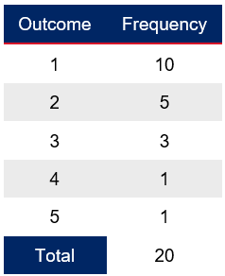
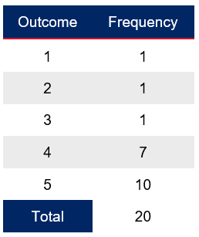 | 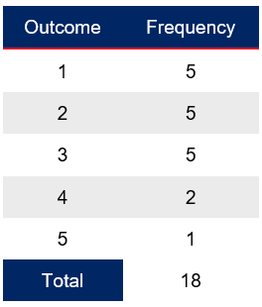 | 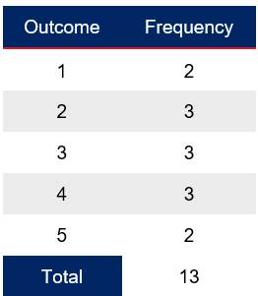

The most common outcome is 3, with outcomes 1 and 5 being equally less likely. | Outcome 1 is highly likely compared to other outcomes, which are much less frequent. | Outcome 5 is the most frequent, while outcomes 1 and 2 are rare.
All outcomes are equally likely. | Outcome 3 is the most frequent, with outcomes 2 and 4 being moderately likely. | Outcome 1 is very common, while outcomes 4 and 5 are rare.
Outcome 5 is highly likely, while outcomes 1, 2, and 3 are much less frequent. | Outcomes 1, 2, and 3 are equally likely, with outcomes 4 and 5 being less common. | Outcomes 2, 3, and 4 are more likely, with outcomes 1 and 5 being less frequent.
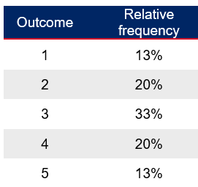 | 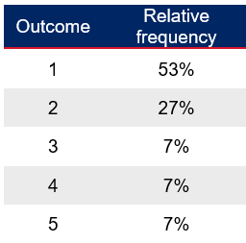 | 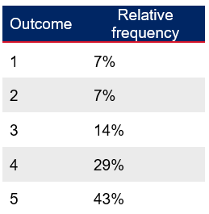
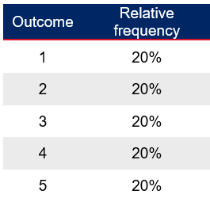 | 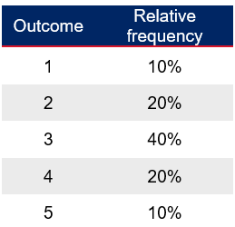 | 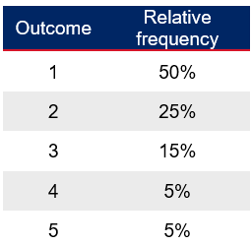
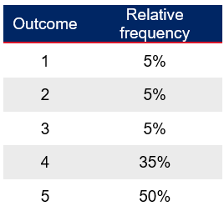 | 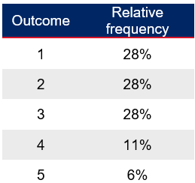 | 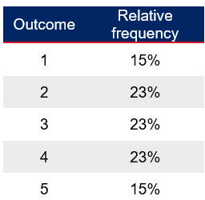

Appendix B

Save a local copy of a file
How to save a local copy of an Excel spreadsheet.

File sharing and saving
- Save the Excel file Organising datasets in a place where students can easily access the file.
This could be done through Google Classroom, by sharing a OneNote link, or by emailing students a copy of the document.
- Have students open the document on their own device.
- Instruct students to select the File tab and then Save a Copy.
Figure 8: Save a copy screenshot

- Students can save the document in their individual OneDrive by selecting the option OneDrive – NSW Department of Education.
Figure 9: save to OneDrive screenshot
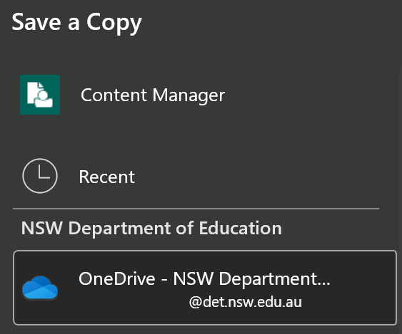
- Best practice would be to keep the file name the same. Students can then select Save and a copy will be stored on their OneDrive.
Figure 10: save with the same file name screenshot
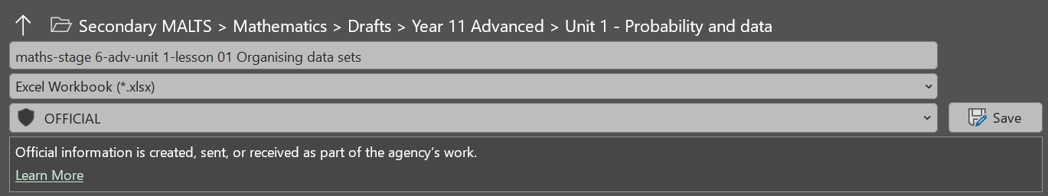

Sample solutions

Appendix A
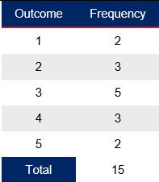 | 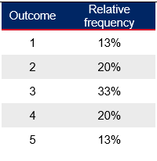 | 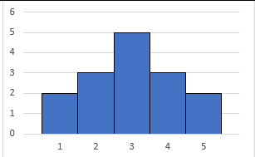  The most common outcome is 3, with outcomes 1 and 5 being equally less likely.
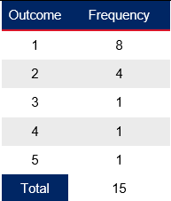 | 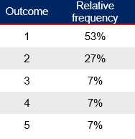 | 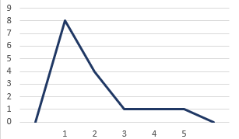  Outcome 1 is highly likely compared to other outcomes, which are much less frequent.
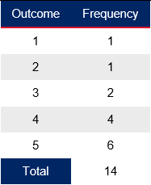 | 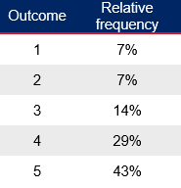 | 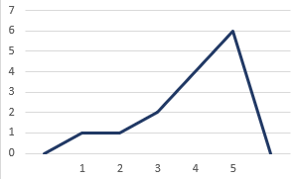  Outcome 5 is the most frequent, while outcomes 1 and 2 are rare.
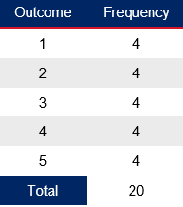 | 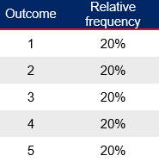 | 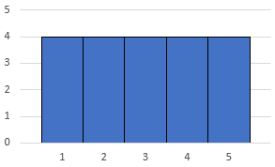  All outcomes are equally likely.
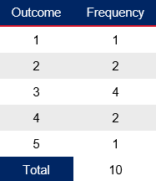 | 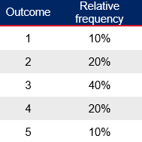 | 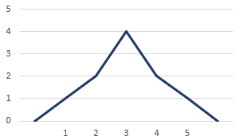  Outcome 3 is the most frequent, with outcomes 2 and 4 being moderately likely.
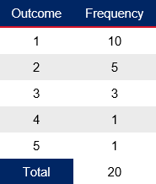 | 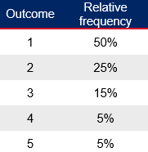 | 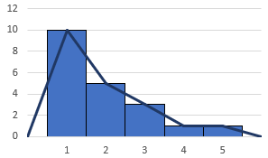  Outcome 1 is very common, while outcomes 4 and 5 are rare.
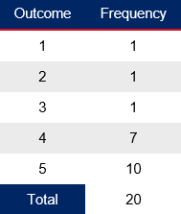 | 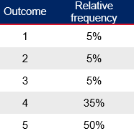 | 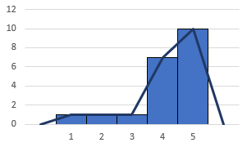  Outcome 5 is highly likely, while outcomes 1, 2, and 3 are much less frequent.
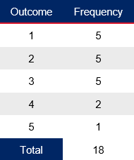 | 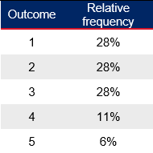 | 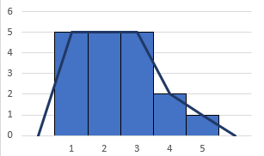  Outcomes 1, 2, and 3 are equally likely, with outcomes 4 and 5 being less common.
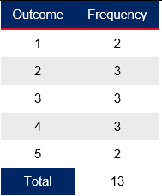 | 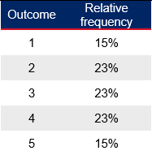 | 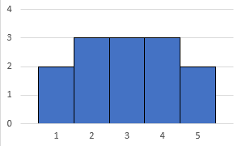  Outcomes 2, 3, and 4 are more likely, with outcomes 1 and 5 being less frequent.

Discrete and continuous
Discrete random variable | Continuous random variable
Number of passengers on a flight | Total baggage weight for a flight
Number of flights arriving late in a day | Flight delay time
Revenue generated from ticket sales on a flight | Amount of fuel used by a plane on a particular flight
Number of emergency landings in a month | Time taken for passengers to board a flight
Number of cancellations in a week
Number of turbulence events on a flight
Total number of meals served on a flight
Number of customer complaints per month

References
This resource contains NSW Curriculum and syllabus content. The NSW Curriculum is developed by the NSW Education Standards Authority. This content is prepared by NESA for and on behalf of the Crown in right of the State of New South Wales. The material is protected by Crown copyright.
Please refer to the NESA Copyright Disclaimer for more information https://educationstandards.nsw.edu.au/wps/portal/nesa/mini-footer/copyright.
NESA holds the only official and up-to-date versions of the NSW Curriculum and syllabus documents. Please visit the NSW Education Standards Authority (NESA) website https://educationstandards.nsw.edu.au/ and the NSW Curriculum website https://curriculum.nsw.edu.au/.
Mathematics Advanced 11–12 Syllabus © NSW Education Standards Authority (NESA) for and on behalf of the Crown in right of the State of New South Wales, 2024.

© State of New South Wales (Department of Education), 2025
The copyright material published in this resource is subject to the Copyright Act 1968 (Cth) and is owned by the NSW Department of Education or, where indicated, by a party other than the NSW Department of Education (third-party material).
Copyright material available in this resource and owned by the NSW Department of Education is licensed under a Creative Commons Attribution 4.0 International (CC BY 4.0) license.

This license allows you to share and adapt the material for any purpose, even commercially.
Attribution should be given to © State of New South Wales (Department of Education), 2025.
Material in this resource not available under a Creative Commons license:
- the NSW Department of Education logo, other logos and trademark-protected material
- material owned by a third party that has been reproduced with permission. You will need to obtain permission from the third party to reuse its material.
Links to third-party material and websites
Please note that the provided (reading/viewing material/list/links/texts) are a suggestion only and implies no endorsement, by the New South Wales Department of Education, of any author, publisher, or book title. School principals and teachers are best placed to assess the suitability of resources that would complement the curriculum and reflect the needs and interests of their students.
If you use the links provided in this document to access a third-party's website, you acknowledge that the terms of use, including licence terms set out on the third-party's website apply to the use which may be made of the materials on that third-party website or where permitted by the Copyright Act 1968 (Cth). The department accepts no responsibility for content on third-party websites.

