Mathematics Advanced Stage 6 (Year 11) – assessment task sample solutions
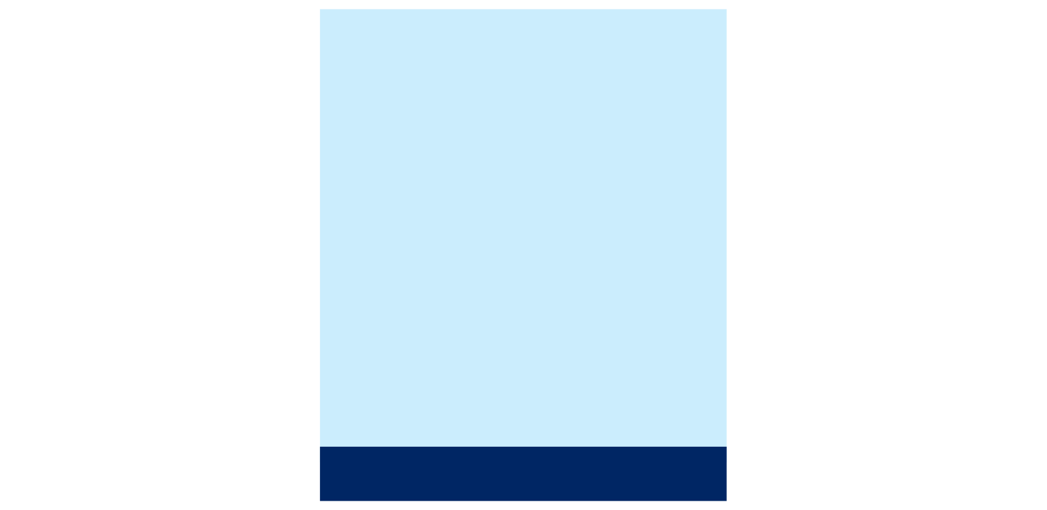
Graph transformations
Contents
About this resource 2
Sample solutions 3
Part A – using mathematics to create shapes 3
Part B – creating a logo 5
Part C – How well can mathematics be used to create art? 9
Marking guidelines 10
References 13

About this resource
This document is Part 3 of an assessment package designed to assess the outcomes from Unit 4 – graphing transformations of the Department of Education’s Stage 6 Year 11 sample scope and sequence.

Sample solutions

Part A – using mathematics to create shapes

Shape | Equation(s) | Justify your equations | Domain restriction | Range restriction
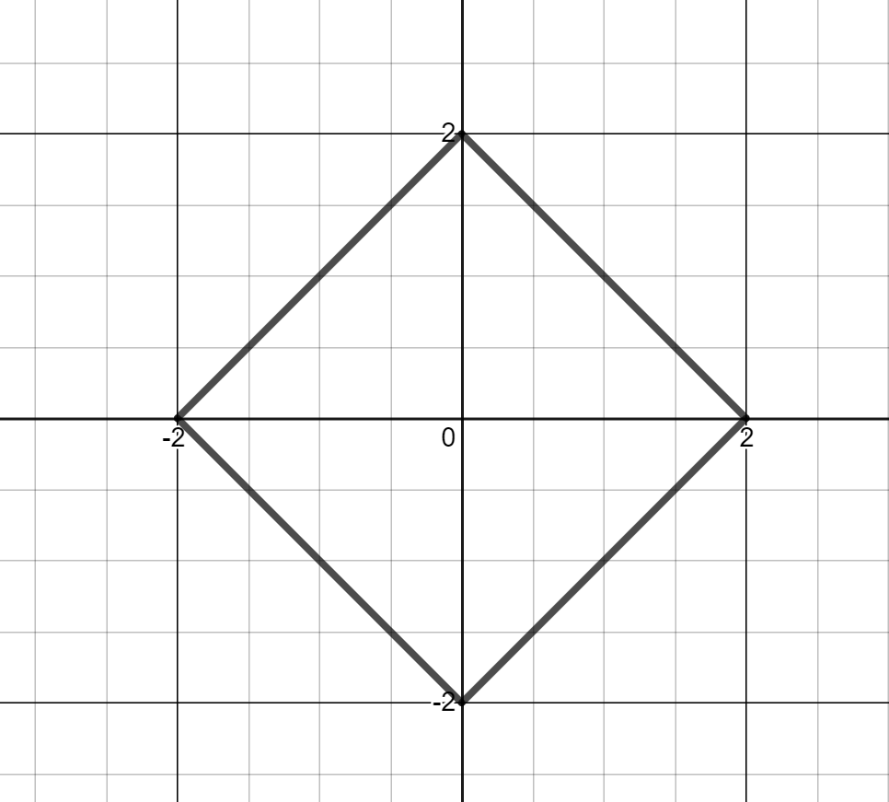 | $$y=-\left|x\right|+2$$  $$y=\left|x\right|-2$$ | The point indicated that I need an absolute value graph so I picked one that was upside down and moved it up. The other graph is the right way up and moved down. I restricted the domain to cut off the graphs outside of −2 and 2. | $$-2≤x≤2$$  $$-2≤x≤2$$ | Nil
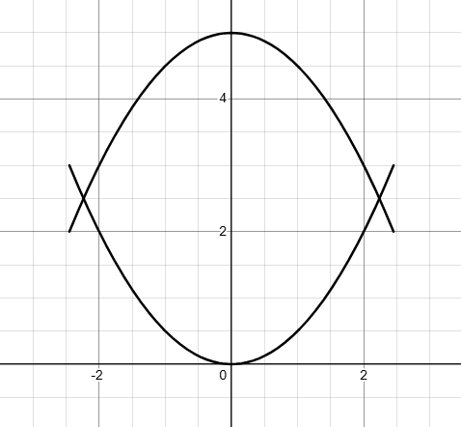 | $$y=-\frac{1}{2}x^{2}+5$$  $$y=\frac{1}{2}x^{2}$$ | I started with an upside down parabola which was up 5 then noticed I need to vertically dilate the parabola so I added ½ to the front and this worked. I checked by substituting in $x=2$ and I got a y value of 3.  The next parabola has the same dilation and no translation, so it was easy. | $$-2.5≤x≤2.5$$  $$-2.5≤x≤2.5$$ | Nil  Nil
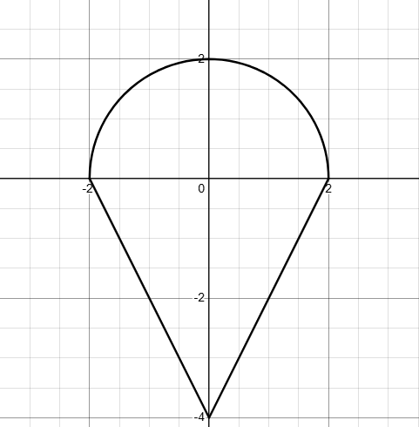 | $$y=\sqrt{4-x^{2}}$$  $$y=\left|2x\right|-4$$ | This shape has a semi-circle and an absolute value function.  I started with $y=\left|x\right|-4$ then realised when I substituted in $x=2$ that it was not 0, so I stretched it vertically by 2 with the equation $y=\left|2x\right|-4$ and it worked. | Nil  $$-2≤x≤2$$ | Nil  Nil
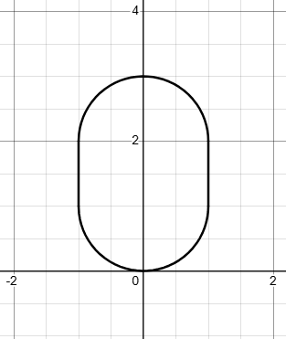 | $$y=\sqrt{1-x^{2}}+2$$  $$y=-\sqrt{1-x^{2}}+1$$  $$x=1$$  $$x=-1$$ | This shape is a capsule. I made it using 2 semi-circles and 2 vertical lines.  One semi-circle had to be reflected, and both had to be vertically translated up.  The vertical lines connecting the semi-circles both needed a restricted range to crop the ends where the intersect with the semi-circles. | Nil  Nil  Nil  Nil | Nil  Nil  $$1≤y≤2$$  $$1≤y≤2$$

Part B – creating a logo
- A copy of my logo.
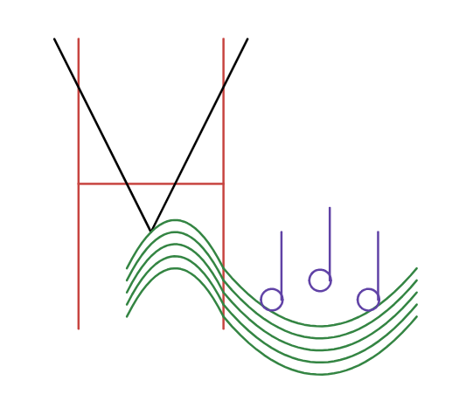

Equation | Justification | Domain restriction | Range restriction
$$y=3$$ | Making a line to create a letter ‘H’ as my business is called ‘Hunter Valley harmonies’. | $$1≤x≤4$$ | Nil
$$x=1$$ | Finishing off the ‘H’. | Nil | $$0≤y≤6$$
$$x=4$$ | Finishing off the ‘H’. | Nil | $$0≤y≤6$$
$$y=2\left|x-2.5\right|+2$$ | Using an absolute value function to create a V. | Nil | $$y<6$$
$$y=-{\left(x-3\right)}^{2}+2.25$$ | Wanted a curved line to create a musical stave. | $$2<x<4$$ | Nil
$$y=-{\left(x-3\right)}^{2}+2$$ | I used the previous parabola so my stave kept the same gradient. I changed the constant term to move each parabola under the one before it. | $$2<x<4$$ | Nil
$$y=-{\left(x-3\right)}^{2}+1.75$$ | As above | $$2<x<4$$ | Nil
$$y=-{\left(x-3\right)}^{2}+1.5$$ | As above | $$2<x<4$$ | Nil
$$y=-{\left(x-3\right)}^{2}+1.25$$ | As above | $$2<x<4$$ | Nil
$$y=0.3{\left(x-6\right)}^{2}+0.05$$ | I wanted the music stave to bend back up to so I started with a concave up parabola, made it wider by dilating it by 0.3, then I moved it until it connected with the top line of the first 5 parabolas. | $$4<x<8$$ | Nil
$$y=0.3{\left(x-6\right)}^{2}+0.05$$ | For this parabola and the next, I just have to lower the constant term by 0.25 so each of the lines of my stave lined up. | $$4<x<8$$ | Nil
$$y=0.3{\left(x-6\right)}^{2}-0.2$$ | As above | $$4<x<8$$ | Nil
$$y=0.3{\left(x-6\right)}^{2}-0.45$$ | As above | $$4<x<8$$ | Nil
$$y=0.3{\left(x-6\right)}^{2}-0.7$$ | As above | $$4<x<8$$ | Nil
$$y=0.3{\left(x-6\right)}^{2}-0.95$$ | As above | $$4<x<8$$ | Nil
$${\left(x-5\right)}^{2}+{\left(y-0.6\right)}^{2}=0.05$$ | Here I wanted to make music notes, so I started with a circle centred at the origin and changed the value of $r^{2}$ until I got the appropriate diameter for the music stave. From there I moved the centre, so the circle (music note) sat perfectly on the top of my stave. | Nil | Nil
$$x=5.2$$ | This straight line was used to draw the ‘stem’ of my note. | Nil | $$0.6<y<2$$
$${\left(x-6\right)}^{2}+{\left(y-1\right)}^{2}=0.05$$ | I took the first circle I created and moved the centre to the right and up to create another music note. | Nil | Nil
$$x=6.2$$ | I made another ‘stem’ for this note (making sure the range restriction was the same so the stem was the same length as the first one). | Nil | $$1<y<2.5$$
$${\left(x-7\right)}^{2}+{\left(y-0.6\right)}^{2}=0.05$$ | Used the same circle equation to create another note and adjusted the centre so it was placed just above the music stave like the first one. | Nil | Nil
$$x=7.2$$ | Repositioned this straight line so it became the ‘stem’ of the note. | Nil | $$0.6<y<2$$

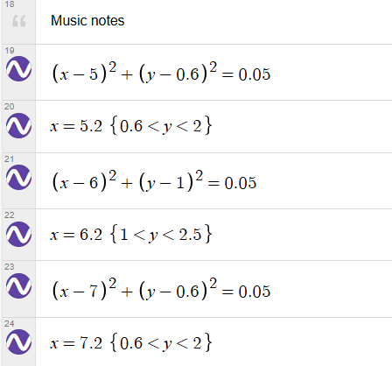
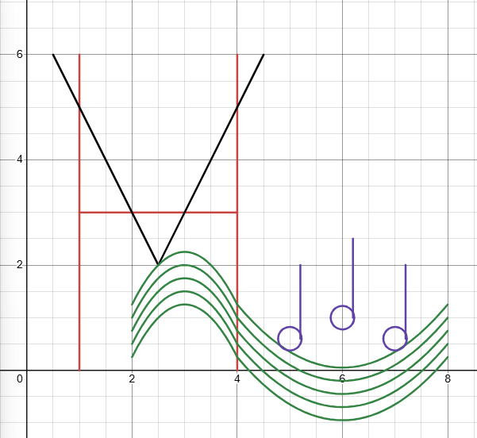
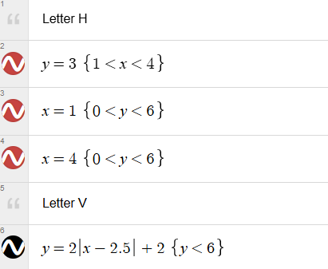

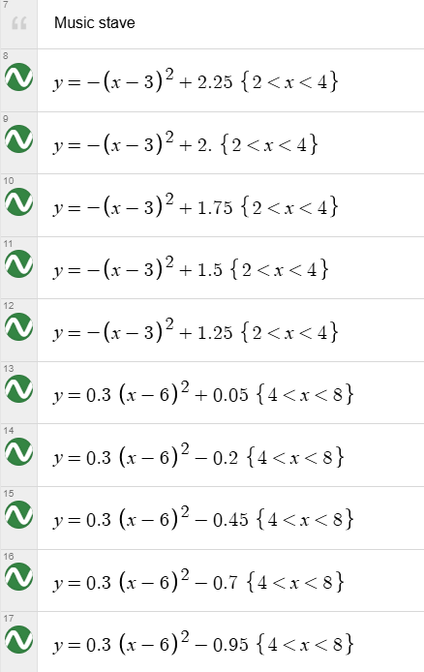

Part C – How well can mathematics be used to create art?
The process of creating my logo showed me that mathematics can be used very effectively to produce detailed and creative artwork, although it also has limitations that required careful adjustment. My design combined straight lines to incorporate a letter H, an absolute value function to incorporate a letter V, parabolas to form a music stave and circles to create notes. The precision of mathematical equations was one of the major strengths of using mathematics to create my logo because once I defined a function, its shape was exact and could be reproduced perfectly.
However, I also discovered certain challenges. Some of the functions were not easy to line up and connect. For instance, when I changed the second set of parabolas to open wider, it became a challenge to get their restricted domains to end and start at the same point. To overcome this, I moved the intersection of the parabolas to be along the line of the letter H to cover any imperfections in the joins.
Another challenge was managing domains and ranges. Although restricting them gave me control over which parts of a graph appeared, it was sometimes difficult to calculate the exact boundaries without creating gaps or overlaps that I didn’t want. Specifically, the ranges of my straight lines which made the ‘stems’ of my notes had to be the right length so the notes didn’t appear to look like a letter ‘d’.
Through experimenting, adjusting and troubleshooting these issues, I gained a deeper understanding of how transforming functions through dilations and translations effects the shape and location of the graph. I enjoyed working with functions to create specific design elements such as symmetry (by adding letters), movement (through the incorporation of parabolas and circles) and balance (I was aiming to keep my logo looking intentional and simple).
Overall, mathematics supported my creative goals effectively by giving me tools to design shapes with structure and precision. While I was limited in the shapes I could produce, these constraints encouraged me to think logically and adapt my ideas, ultimately resulting in a scalable logo that was both artistic and meaningful to my business (Hunter Valley Harmonies).

Marking guidelines
Table 1 – student-facing rubric
Criteria | Working towards developing | Developing | Developed | Well developed | Highly developed
Knowledge of functions and relations, identifying graph types and determining domain and range.  (MAV-11-02) | Demonstrates emerging understanding of functions and relations. Identifies some graphs such as linear or quadratic and attempts to describe domain or range. Uses some functions or relations to represent shapes. | Demonstrates developing understanding of the difference between functions and relations. Identifies several graph types and determines domain and range for some functions and relations when modelling shapes. | Demonstrates sound understanding of functions and relations and identifies a variety of graph types. Determines an appropriate domain and range for most functions and relations used in the design. | Demonstrates strong understanding of functions and relations and accurately classifies a wide variety of graph types. Determines and applies domain and range effectively to construct intended graphical features within the design. | Demonstrates a highly developed understanding of functions and relations, confidently distinguishing between them and accurately identifying a wide variety of graph types. Determines and applies domain and range strategically to model and construct precise graphical features.
Teacher notes: the student has correctly modelled all shapes using appropriate functions and domain and/or range restrictions. Student has incorrectly referred to all graphs as functions, even though they have included circles in their logo design.
Criteria | Working towards developing | Developing | Developed | Well developed | Highly developed
Knowledge transformations, correct terminology, recognising order of transformations and writing transformed equations  (MAV-11-03) | Demonstrates emerging understanding of transformations. Identifies some translations or reflections in graphs and attempts to write equations representing transformed functions or relations. | Describes transformations of functions using some correct terminology such as translations or reflections. Writes equations representing simple transformations. | Applies transformations including translations, reflections and dilations to construct graphs. Writes equations representing transformed functions and relations and recognises how the order of transformations affects the final graph. | Analyses and applies sequences of transformations including reflections, dilations and translations to construct shapes. Writes accurate equations that represent these transformations and explains the effect of transformation order. | Demonstrates a highly developed understanding of transformations by strategically applying sequences of reflections, dilations and translations. Writes precise equations that model these transformations and clearly explains how the order of transformations affects the graphical outcome.
Teacher notes: Justifies function and relation choices. Includes explanation of some transformations applied, relied on trial and error or coincidence. Shows emerging connections between equation and graphical outcome.
Logo demonstrates strategic selection and combination of the required functions and relations to construct a cohesive mathematical design. Accurately applies domain and range restrictions and transformations.
Student does not acknowledge that the order in which the transformations are applied affects the final graph.
Criteria | Working towards developing | Developing | Developed | Well developed | Highly developed
Working mathematically (MAO-WM-01) | Provides a basic reflection with some reference to the mathematical work completed. Identifies some mathematical choices and draws simple conclusions with emerging awareness of their reasonableness or limitations. Uses some mathematical notation, representations and terminology to communicate ideas. | Describes mathematical choices made in constructing shapes and the logo. Identifies at least one strength or limitation of using equations and functions. Draws some logical conclusions and uses generally appropriate mathematical notation and representations to communicate reasoning. | Analyses mathematical decisions made in constructing shapes and the logo, explaining how functions, relations and transformations contributed to the design. Identifies strengths and limitations with reasonable justification. Communicates reasoning clearly using appropriate mathematical notation, terminology and representations. | Provides a clear and well-reasoned evaluation of how mathematical techniques shaped the final artwork. Explains how functions, relations, transformations and restrictions supported the design. Draws logical conclusions about the effectiveness of mathematics for creating art using accurate and purposeful mathematical communication. | Provides a justified and insightful evaluation of how mathematical concepts, techniques and reasoning shaped the final design. Demonstrates strong evidence of exploring and connecting mathematical ideas throughout the task and communicates reasoning coherently and precisely using accurate mathematical notation, terminology and representations.
Teacher notes: Provides clear analysis linking functions, transformations and restrictions to the design with justified strengths and limitations. Student does not always use accurate mathematical terminology, referring to ‘moving up’ rather than translations. To reach ‘Highly developed’, the response would need to evaluate the effectiveness of their choices and suggest mathematically improved alternatives rather than describing adjustments made.

References
This resource contains NSW Curriculum and syllabus content. The NSW Curriculum is developed by the NSW Education Standards Authority (NESA). This content is prepared by NESA for and on behalf of the Crown in right of the State of New South Wales. The material is protected by Crown copyright.
Please refer to the NESA Copyright Disclaimer for more information https://www.nsw.gov.au/education-and-training/nesa/copyright.
NESA holds the only official and up-to-date versions of the NSW Curriculum and syllabus documents. Please visit NESA https://www.nsw.gov.au/education-and-training/nesa and NSW Curriculum https://curriculum.nsw.edu.au.
Mathematics Advanced 11–12 Syllabus © NSW Education Standards Authority (NESA) for and on behalf of the Crown in right of the State of New South Wales, 2024.

© State of New South Wales (Department of Education), 2026
The copyright material published in this resource is subject to the Copyright Act 1968 (Cth) and is owned by the NSW Department of Education or, where indicated, by a party other than the NSW Department of Education (third-party material).
Copyright material available in this resource and owned by the NSW Department of Education is licensed under a Creative Commons Attribution 4.0 International (CC BY 4.0) license.

This license allows you to share and adapt the material for any purpose, even commercially.
Attribution should be given to © State of New South Wales (Department of Education), 2026.
Material in this resource not available under a Creative Commons license:
- the NSW Department of Education logo, other logos and trademark-protected material
- material owned by a third party that has been reproduced with permission. You will need to obtain permission from the third party to reuse its material.
Links to third-party material and websites
Please note that the provided (reading/viewing material/list/links/texts) are a suggestion only and implies no endorsement, by the New South Wales Department of Education, of any author, publisher, or book title. School principals and teachers are best placed to assess the suitability of resources that would complement the curriculum and reflect the needs and interests of their students.
If you use the links provided in this document to access a third-party's website, you acknowledge that the terms of use, including licence terms set out on the third-party's website apply to the use which may be made of the materials on that third-party website or where permitted by the Copyright Act 1968 (Cth). The department accepts no responsibility for content on third-party websites.

