Supporting strategies – worked examples (comparison)
Research shows that annotated examples of high-quality work help clarify success criteria and highlight common misconceptions (AERO 2024). Comparing examples further supports learning by drawing attention to key features that warrant focus, promoting deeper understanding (Gentner 1983). To benefit from these examples, learners must actively explain solution steps to themselves or others.
When comparing examples, the discussion should focus on addressing one of the following key questions:
- Why do the methods work?
- Which method do you prefer and why?
- Which method is incorrect?
When using incorrect examples, the incorrect method should be clearly labelled.
Comparative examples prompt discussion about the effectiveness of different strategies or how multiple representations can be valid and interconnected. The worked examples (comparison) method appears in NSW Department of Education mathematics resources as an explicit teaching approach adapted from the work of Rittle-Johnson et al. (2020), Michael Pershan (2021), Craig Barton (2020) and Hollingsworth and Ybarra (2017).

Process
- Distribute or display 2 or 3 worked solutions for the example problem.
- Prompt students to silently read each of the methods.
- Students independently think through and explain each step of the methods to themselves.
- Once students have completed their thinking and have some level of understanding, they indicate with a thumbs up.
- In pairs, students take turns discussing the following:
- What is happening in each method?
- What are the similarities and differences between the methods?
- Reveal self-explanation prompts for students to discuss in pairs.
Self-explanation prompts should be used to draw attention to the steps that will be referred to during the comparison (see Figure 2).
- Randomly select students to share their responses to the self-explanation prompts.
- The Pose-Pause-Pounce-Bounce questioning strategy (PDF 557KB) (bit.ly/posepausepouncebounce) can be used to elicit and deepen whole-class understanding.
- Ask students to discuss the key comparative question that has been chosen as the focus of the lesson.
The key comparative questions are:
- Why do the methods work?
- Which method do you prefer and why?
- Which method is incorrect?
- Display a ‘Your turn’ question for students to complete individually using one of the correct methods. Then reveal the solution.
Students are only required to complete one method for the solution.
This process may then be repeated, if necessary, for additional worked examples. It could be followed by a note-making strategy to consolidate the learning.

Sample process
Figure 1 – example of slide progression for worked examples (comparison) method – question view
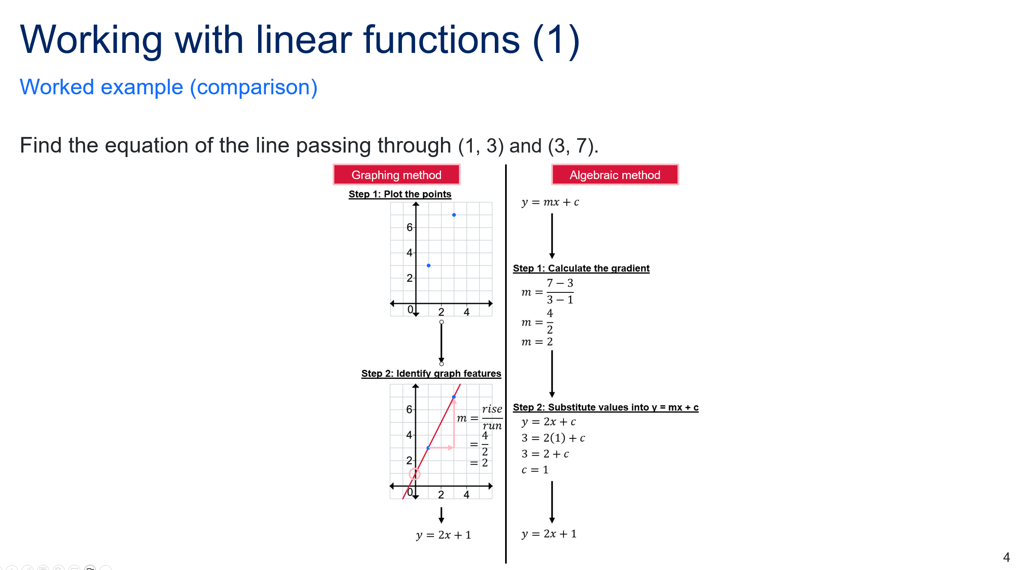
Figure 2 – example of slide progression for worked examples (comparison) method – self-explanation prompts
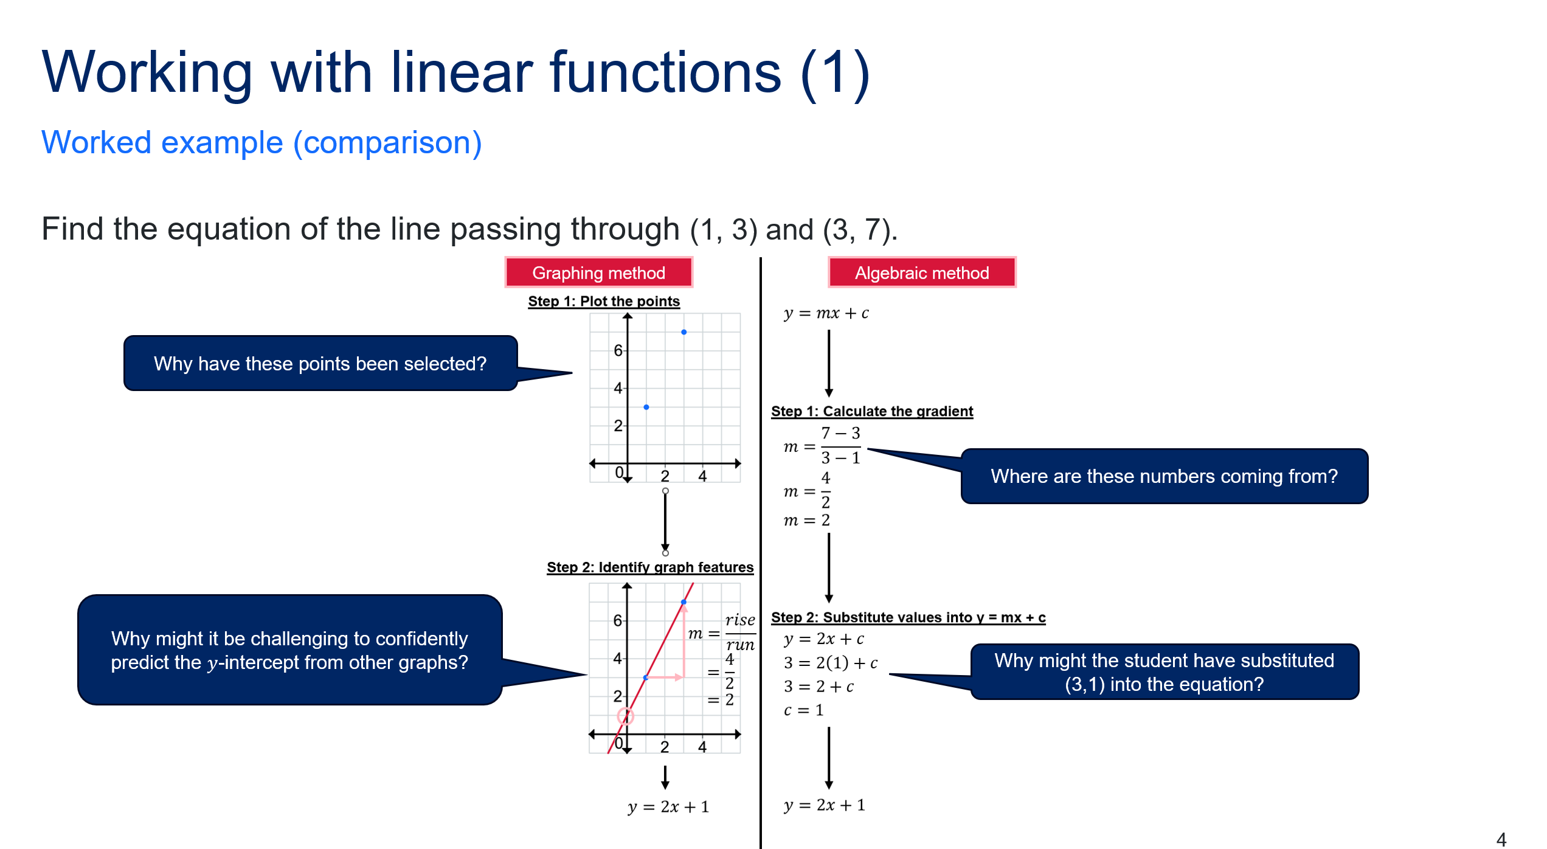

Figure 3 – example of slide progression for worked examples (comparison) method – Your turn
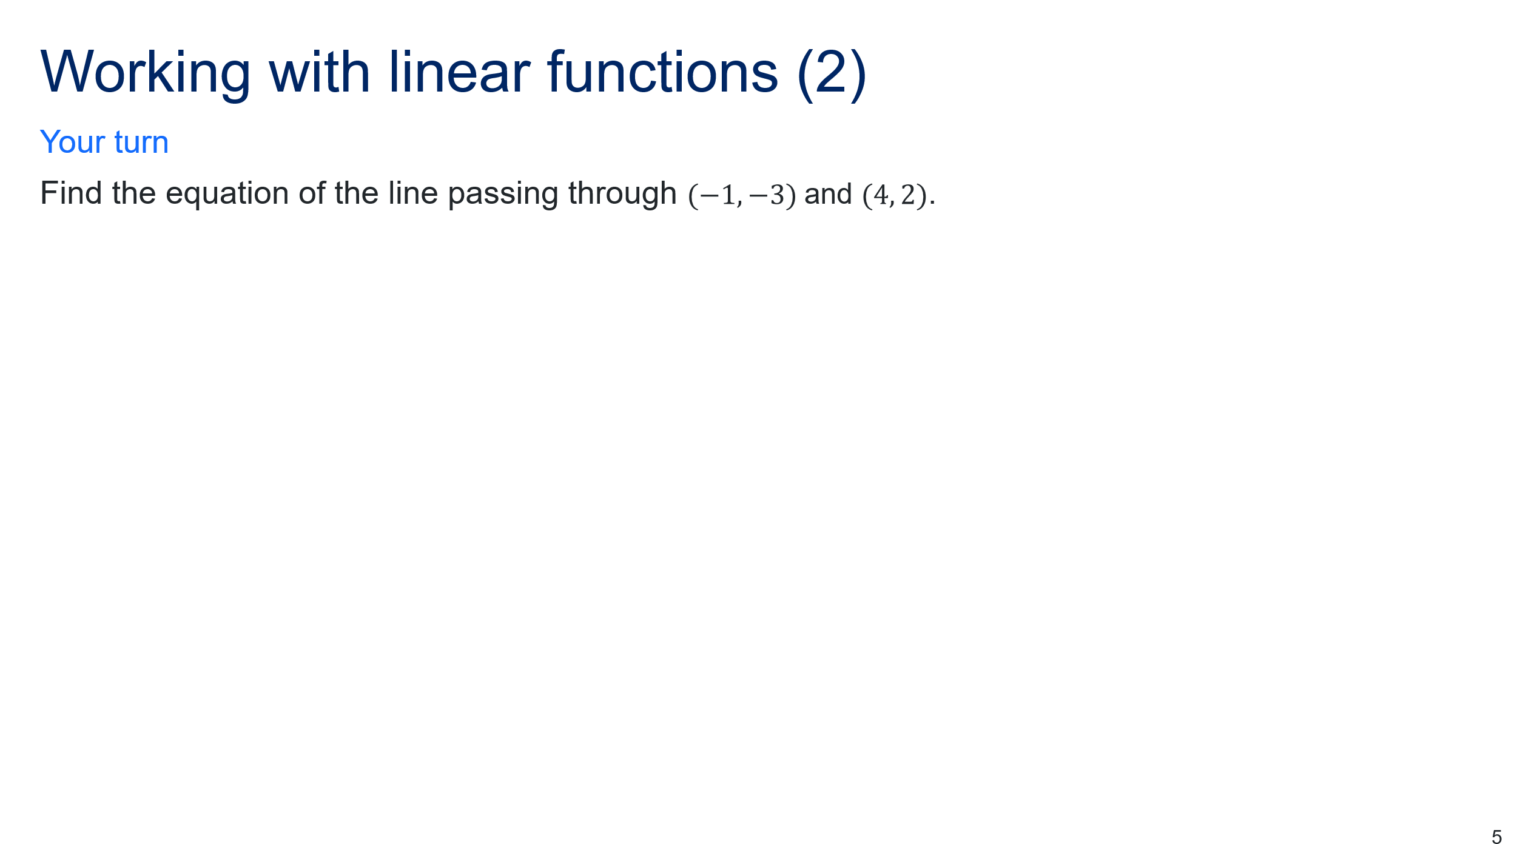
Figure 4 – example of slide progression for worked examples (comparison) method – Your turn (solution)
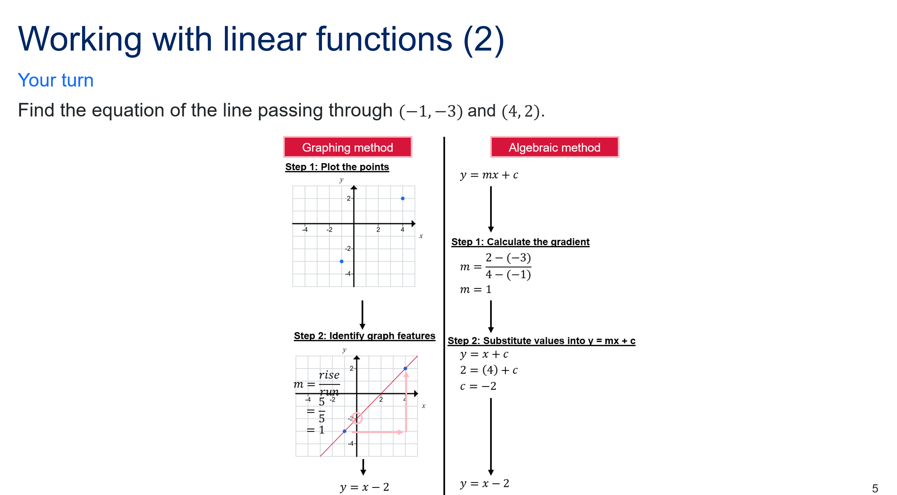

References
AERO (Australian Education Research Organisation) (2024) ‘Scaffold practice’, Practice guide for primary and secondary schools, AERO, accessed 29 January 2026. https://www.edresearch.edu.au/guides-resources/practice-guides/scaffold-practice
Barton C (2020) Reflect, Expect, Check, Explain, John Catt Educational, GB.
Gentner D (1983) ‘Structure-mapping: A theoretical framework for analogy’, Cognitive Science: A Multidisciplinary Journal, 7(2):155–170, doi.org/10.1016/S0364-0213(83)80009-3.
Hollingsworth JR and Ybarra SE (2017) Explicit Direct Instruction (EDI), SAGE Publications Inc, US.
Pershan M (2021) Teaching Math With Examples, John Catt Educational, GB.
Rittle-Johnson B, Star J, Durkin K and Loehr A (2020) ‘Compare and discuss to promote deeper learning’ in Manalo E (ed) Deeper Learning, Communicative Competence, and Critical Thinking: Innovative, Research-Based Strategies for Development in 21st Century Classrooms (pp. 48–64). New York, NY. Routledge.
© State of New South Wales (Department of Education), 2026
The copyright material published in this resource is subject to the Copyright Act 1968 (Cth) and is owned by the NSW Department of Education or, where indicated, by a party other than the NSW Department of Education (third-party material).
Copyright material available in this resource and owned by the NSW Department of Education is licensed under a Creative Commons Attribution 4.0 International (CC BY 4.0) license.

This license allows you to share and adapt the material for any purpose, even commercially.
Attribution should be given to © State of New South Wales (Department of Education), 2026.
Material in this resource not available under a Creative Commons license:
- the NSW Department of Education logo, other logos and trademark-protected material
- material owned by a third party that has been reproduced with permission. You will need to obtain permission from the third party to reuse its material.
Links to third-party material and websites
Please note that the provided (reading/viewing material/list/links/texts) are a suggestion only and implies no endorsement, by the New South Wales Department of Education, of any author, publisher, or book title. School principals and teachers are best placed to assess the suitability of resources that would complement the curriculum and reflect the needs and interests of their students.
If you use the links provided in this document to access a third-party's website, you acknowledge that the terms of use, including licence terms set out on the third-party's website apply to the use which may be made of the materials on that third-party website or where permitted by the Copyright Act 1968 (Cth). The department accepts no responsibility for content on third-party websites.

