Mathematics Stage 5 (Year 9) – sample integrated program of learning
Prisms and cylinders
Contents
Rationale 3
Introduction 4
Integrated teaching and learning programs to meet the needs of diverse learners 4
Life Skills eligibility 5
Assessment of Life Skills outcomes 5
About this resource 6
Purpose of resource 6
Target audience 6
When and how to use 7
Overview 9
Unit outcomes 10
Integrated lesson sequence 11
Lesson 1 – visualising nets 11
Lesson 2 – cube houses 22
Lesson 3 – leftovers challenge 30
Lesson 4 – deep dive 38
Lesson 5 – icing on the cake 50
Differentiation and adjustments 56
Registration and evaluation notes 56
Overall program evaluation prompts 57
Capturing student voice when evaluating a program 57
Support and alignment 59
References 61

Rationale
The NSW Department of Education publishes a range of curriculum support materials, including samples of lesson sequences, scope and sequences, assessment tasks, examinations, student and teacher resource booklets and curriculum planning and curriculum evaluation templates. The samples are not exhaustive and do not represent the only way to complete or engage in each of these processes. Curriculum design and implementation is a dynamic and contextually specific process. While the mandatory components of syllabus implementation must be met by all schools, it is important that the approach taken by teachers is reflective of their needs and faculty or school processes.
The Curriculum planning and programming, assessing and reporting to parents K-12 policy and its associated standards emphasise inclusive programming, ensuring all students have access to educational programs that meet their diverse needs. The NSW Education Standards Authority (NESA) defines programming as ‘the process of selecting and sequencing learning experiences which enable students to engage with syllabus outcomes and develop subject specific skills and knowledge’ (NESA 2022b). A program is developed collaboratively within a faculty. It differs from a unit in important ways. A unit is a contextually-specific plan for the intended teaching and learning for a particular class for a particular period. The organisation of the content in a unit is flexible, and it may vary according to the school, the teacher, the class and the learning space. They should be working documents that reflect the thoughtful planning and reflection that takes place during the teaching and learning cycle. There are mandatory components of programming and unit development, and this template provides one option for the delivery of these requirements. NESA and department guidelines that have influenced this template are elaborated upon at the end of the document.
This resource has been developed to assist teachers in NSW Department of Education schools to create learning that is contextualised to their classroom. It can be used as a basis for the teacher’s own program, assessment or scope and sequence, or be used as an example of how the new curriculum could be implemented. The resource has suggested timeframes that may need to be adjusted by the teacher to meet the needs of their students.

Introduction

Integrated teaching and learning programs to meet the needs of diverse learners
Integrated teaching and learning programs use a multi-tiered approach to support teachers to plan for all students in any class or setting. Integrated programs consider the stage outcomes and Life Skills outcomes to inform teaching and learning to meet the diverse needs of students. By understanding and appreciating learner variability, flexible learning experiences can be planned to provide opportunities for diverse learners in every classroom to engage with curriculum and achieve their full potential, while providing a culturally inclusive space for all.
Universal strategies are quality differentiated teaching practices that are used to optimise learning and engagement for all students. Teachers build on universal strategies and intensify support through targeted differentiation and personalised learning and support to meet identified student needs.
A multi-tiered approach to curriculum planning is a strategic and efficient way for teachers to enhance learning outcomes for every student. It involves increasingly intensified support across 3 tiers.
- Tier 1 – universal – a proactive approach to support inclusive design of the whole learning environment.
- Tier 2 – targeted differentiation – the direct and intentional response of teachers to meet identified needs of individuals or groups of students, in addition to broad universal planning.
- Tier 3 – personalised learning and support – a collaborative process that responds to the individual needs of students with disability in addition to universal planning and targeted differentiation.
This example of an integrated teaching and learning program provides one approach to sequencing and progression of learning based on the pedagogical principles of explicit teaching and inclusive practice. Refer to the Personalised learning and support procedures, Adjustments to teaching and learning and Collaborative curriculum planning process to determine the best model of support for students.

Life Skills eligibility
Life Skills courses are designed for students with intellectual disability or an imputed intellectual disability in Years 7 to 12 who cannot access stage or for whom prior stage outcomes are not appropriate. This is determined through collaborative curriculum planning involving the student, parents or carers, and teachers. They are not suitable for students without intellectual disability or students who could meet outcomes with adjustments.

Assessment of Life Skills outcomes
Students must demonstrate achievement of one or more Life Skills outcomes. Assessments can be flexible through using various written, spoken, visual and assistive technologies, and may be implemented in different learning environments. Formal assessment of Life Skills outcomes is not required.
For further information regarding student eligibility and credentialling requirements, see NESA’s ACE Rule 11.

About this resource
Please note: this learning sequence is a partial example to enable teachers to engage with the multi-tiered planning approach.

Purpose of resource
This sample integrated program of learning supports teachers in NSW Department of Education schools to plan for all students in any class or setting. It supports the diverse learning needs of students in a Mathematics Year 9 class, who are working towards either Stage 5 or Stage 5 Life Skills syllabus outcomes and content.
The template is inclusive of the learning needs of all students. Additional curriculum planning support for Aboriginal and/or Torres Strait Islander students, students learning English as an additional language or dialect (EAL/D), high potential and gifted students and students with disability is available at Curriculum planning K-12 professional learning.

Target audience
This sample is intended to support teachers and curriculum leaders in all settings as they develop contextually appropriate teaching and learning resources for the Mathematics K–10 Syllabus (2022).

When and how to use
Teachers may:
- use this resource as part of a broader curriculum planning and assessment planning process which includes a scope and sequence and assessment plan/schedule
- use the teaching and learning program as a model and make modifications reflective of contextual needs
- examine the program of learning and collaboratively refine them based on faculty or school goals
- examine the materials to collaboratively plan opportunities for team teaching, collaborative resource development, mentoring, lesson observation and the sharing of student samples
- use the programming, assessment practices or syllabus planning detailed in the program as an opportunity to backward map Years 10 to 7.
Incorporating learning activities with a multi-tiered approach
Learning activities: when planning with a multi-tiered approach, consider students’ varied strengths, interests and needs, and use universal strategies to support all learners. Build on this with targeted differentiation, such as scaffolded tasks, flexible groupings or adjusted complexity to support or extend learning. For students with individualised needs, provide personalised adjustments such as tailored instruction, assistive technology or appropriate supports.
The balance between universal, differentiated and personalised approaches may vary depending on the content and skills being taught. Gathering evidence of learning across all tiers supports ongoing reflection on student progress. Keeping a record of planned differentiation and adjustments, including extension strategies, helps maintain a responsive and inclusive classroom environment.
This approach could include starting with universal strategies that all students can engage with, such as clear intentions, visuals and multimodal activities. Learning can then be broken into targeted activities for students learning Life Skills and mainstream content where needed to enable all students to meet the learning intentions. Students may be brought back at the end of the lesson to conclude with another universal strategy. Depending on the content and/or skills, each lesson may require multiple universal and scaffolded sessions. In some instances, a whole lesson may operate on universal strategies. Evidence of learning will need to be integrated into scaffolded activities when separating Life Skills and mainstream syllabus content.
Differentiation/adjustments: document strategies and adjustments required for specific students, this also includes differentiation for extension requirements.

Overview
Description: this integrated program of learning addresses content from the focus areas of Area, Volume, capacity and mass, Addition and subtraction, and Multiplication and division. The lessons and sequences in this program of learning are designed to allow students to make connections across number and measurement and will build on student knowledge and understanding of area to develop and apply formulas for the surface area and volume of prisms.
Duration: this integrated program of learning is designed to be completed over a period of approximately 7 weeks, but can be adapted to suit student needs and school context.

Unit outcomes
Table 1 – Life Skills and mainstream outcomes
Stage 5 Life Skills outcomes | Stage 5 outcomes
A student:  - develops understanding and fluency in mathematics through exploring and connecting mathematical concepts, choosing and applying mathematical techniques to solve problems, and communicating their thinking and reasoning coherently and clearly MAO-WM-01  - measures and uses area in everyday contexts MALS-ARE-01  - measures and uses volume, capacity and mass in everyday contexts MALS-VOL-01  - uses strategies for addition and subtraction MALS-ADS-01  - uses strategies for multiplication and division MALS-MDI-01 | A student:  - develops understanding and fluency in mathematics through exploring and connecting mathematical concepts, choosing and applying mathematical techniques to solve problems, and communicating their thinking and reasoning coherently and clearly MAO-WM-01  - simplifies algebraic fractions with numerical denominators and expands algebraic expressions MA5-ALG-C-01  - solves problems involving the surface area of right prisms and practical problems involving the area of composite shapes and solids MA5-ARE-C-01  - solves problems involving the volume of composite solids consisting of right prisms and cylinders MA5-VOL-C-01
Mathematics K–10 Syllabus © NSW Education Standards Authority (NESA) for and on behalf of the Crown in right of the State of New South Wales, 2022.

Integrated lesson sequence

Lesson 1 – visualising nets
The tables below capture the multi-tiered approach to teaching and learning activities to support students in achieving learning outcomes.
Table 2 – outcomes, learning intentions and success criteria
Life Skills Stage 5 | Stage 5
A student:  - develops understanding and fluency in mathematics through exploring and connecting mathematical concepts, choosing and applying mathematical techniques to solve problems, and communicating their thinking and reasoning coherently and clearly MAO-WM-01  - measures and uses area in everyday contexts MALS-ARE-01  - uses strategies for addition and subtraction MALS-ADS-01  - uses strategies for multiplication and division MALS-MDI-01 | A student:  - develops understanding and fluency in mathematics through exploring and connecting mathematical concepts, choosing and applying mathematical techniques to solve problems, and communicating their thinking and reasoning coherently and clearly MAO-WM-01  - solves problems involving the surface area of right prisms and practical problems involving the area of composite shapes and solids MA5-ARE-C-01
Learning intentions  We are learning to:  - recognise and build shapes with squares  - identify nets that form cubes.  Success criteria  I can:  - fold nets to find open cubes  - describe a pentomino  - create unique shapes joining 5 identical squares, edge to edge  - identify the base and sides of open cubes. | Learning intentions  We are learning to:  - visualise open cubes from nets  - determine if a net represents a given prism.  Success criteria  I can:  - visualise an open cube from its net  - justify whether a diagram represents the net of a prism  - determine which face of an open cube net will become the base  - identify nets that will not form prisms.

Table 3 – universal teaching and learning activities
Universal teaching and learning activities | Evidence of learning
- Display or provide a printed copy of Figure 1 for students and ask whether they think the net will fold to make the pictured cube.  Figure 1 – the net of an open cube  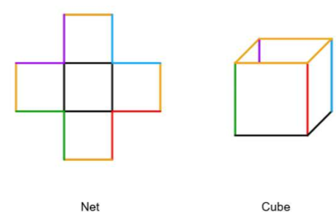  - Using the Pose-Pause-Pounce-Bounce questioning strategy (PDF 557 KB) (bit.ly/posepausepouncebounce) ask students to explain their answer using mathematical reasoning. This allows an opportunity to build on responses by explicitly teaching and revising vocabulary including net, face, edge and vertices.  - Assign students to visibly random groups of 3 (bit.ly/visiblegroups). Students will work through a ‘Which one doesn’t belong?’ (bit.ly/wodbstrategy) activity by analysing each of the 4 nets in Figure 2 to determine which nets will make the given open cube. There is more than one net that doesn’t belong. Advise students that they need to make sure the colour of the edges are in the correct order. Students could also be provided with printed copies of each of the nets to allow them to manipulate it themselves.  Figure 2 – which one doesn't belong activity  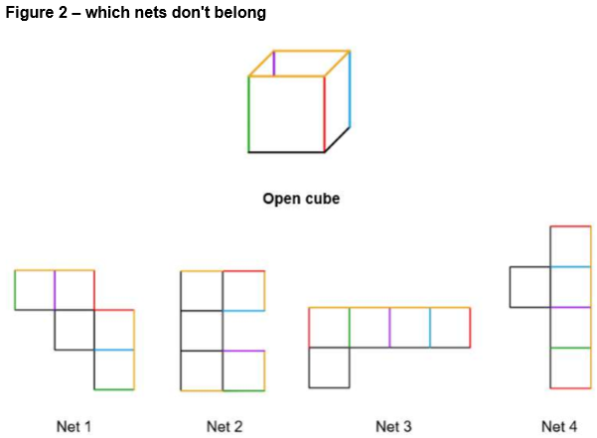  - Once students have had sufficient time to explore the nets, select groups of 3 at random to discuss their strategy in determining which nets make the open cube. Be sure to use and reinforce the correct terminology for face, edge and so on. | Evidence of learning: results could be collected using a Mentimeter or a simple ‘thumbs up’ for yes or ‘thumbs down’ for no.  Students use correct terminology to describe the net and cube and determine which nets will make the given open cube based on this terminology.
Table 4 – targeted teaching and learning activities
Life Skills teaching and learning activities | Mainstream teaching and learning activities
- Clearly define what a pentomino is by stating that it is a shape made by joining 5 equal-sized squares edge to edge. Provide students with an example when defining this.  - In pairs, provide students with individual, cut-out examples and non-examples of pentomino shapes, as in Figure 3. Ask the students to look at these one-by-one and sort them into 2 piles, pentomino shapes and non-pentomino shapes. Some guiding questions could include:  - Does this shape have 5 squares?  - Are the squares joined together?  Figure 3 – examples and a non-example of a pentomino  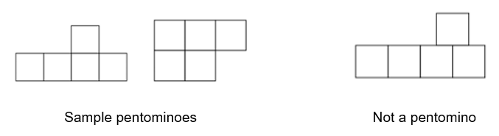  Evidence of learning: students accurately sort shapes into pentomino groups and can explain their reasoning based on the number and arrangement of squares.  - Students are to make 2 or 3 pentominoes following a template or with guided instructions. For example, the guided instructions could be: ‘Make a shape with 5 squares that looks like an “L”. Can you move one square to make a “U” shape?’ Encourage the students to make as many different shapes as possible. Students can explore using any one of the following:  - 5 squares from a tangram set  - 5 flats from a base 10 block set  - 5 plastic squares  - virtual manipulatives such as Amplify Polypad (polypad.amplify.com/p) using the ‘Polygons and Shapes’ function.  Evidence of learning: students successfully create different pentominoes using 5 connected squares, following instructions or templates, and can identify or describe the shapes they construct.  - Provide students with a grid showing the outline (or faint shapes) of the 12 pentominoes arranged to make a rectangle, using Figure 4 as a guide.  Figure 4 – 12 pentominoes arranged to make a rectangle  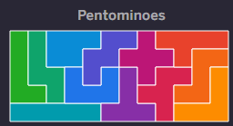  Image created using the free virtual manipulatives at Polypad.org.  - Supply the students with the 12 cut-out pentominoes. Students are to place each pentomino on its matching spot on the grid, fitting the rectangle together. Alternatively, provide students with a blank grid already showing some of the pentomino placements and have the students place the remaining pentominoes onto the grid like a jigsaw puzzle. Some discussion questions could include:  - How many squares does the rectangle have altogether?  - Having another look at the rectangle, how many squares are there in one row? How many rows are there?  - Is there another way we could find out how many squares there are in the rectangle in total without counting every square?  Link this activity to real-life scenarios such as tiling, paving or woodwork panelling.  Evidence of learning: students correctly fit all 12 pentominoes into the grid to form a rectangle and can explain or calculate the total number of squares using rows, columns, or multiplication strategies, connecting their reasoning to real-life situations.  - Provide students with a net of one pentomino that forms an open cube and one that does not. Students attempt to fold the net of both pentominoes so that they make an open cube. For each pentomino tried, have students show their folded attempts. Some guiding questions could include:  - Which pentomino makes a cube with an open top?  - Which part becomes the bottom or the base of the cube?  - What is the difference between the one that worked and the one that didn’t?  Ask the students to colour the base of the net one colour and the sides another colour. Students can repeat with another pair of pentominoes.  Evidence of learning: students accurately identify which pentomino nets can be folded to form an open cube and identify, using colour coding, the base and sides of the cube. | - In pairs, students investigate pentominoes. Clearly define what a pentomino is and provide examples and non-examples to assist with the explanation.  - Students are challenged to discover every possible pentomino arrangement and record their results. Students can explore using any one of the following:  - 5 squares from a tangram set  - 5 flats from a base 10 block set  - 5 plastic squares  - virtual manipulatives such as Amplify Polypad (polypad.amplify.com/p) using the ‘Polygons and Shapes’ function.  Evidence of learning: students create and record all possible unique pentomino arrangements using various manipulatives or digital tools, showing understanding of the criteria for pentomino formation.  - Ask students to reveal how many arrangements they discovered, before revealing that there are 12 pentominoes. Show the students the 12 different arrangements and have them crosscheck with what they discovered.  - Explain to students that the 12 pentominoes can be used to form a rectangle. Students can explore this by cutting out their pentominoes and arranging them on a provided grid.  - Students will explore which pentominoes form nets of an open cube. In pairs they will analyse each of the 12 pentominoes and determine:  - Does this pentomino represent a net of an open cube?  - If yes, which of the faces represents the base face of the cube? Colour the face you think will represent the base.  Students should first visualise folding the net in their minds and then they can check their answers by folding each of their 12 pentominoes to form an open cube.  - Once students have determined which pentominoes represent the net of an open cube, use the pre-made Amplify Polypad page (bit.ly/pentominoactivity) to demonstrate to students which of the 12 pentominoes can be folded to form an open cube. Change the colour of the face that they predict to be the base and test their theory using the fold net function.  Evidence of learning: students accurately identify, create and record all pentominoes, use them to form a rectangle and determine which pentominoes can serve as nets for an open cube by visualising and testing their folding, correctly marking the base.
Table 5 – universal teaching and learning activities
Universal teaching and learning activities | Evidence of learning
- Conduct a class discussion to consider which pentominoes represented open cubes and which face formed the base in each. Students should be encouraged to explain their thinking and how they visualised the open cube. For example:  - Did they visually fold the net in their mind before or after selecting the face that would be the base?  - Were some nets easier to visualise folding into an open cube than others? Why?  Students can show their net, point to the base, or use words, pictures or gestures to explain.  - Students complete the Cube Nets activity (bit.ly/cubenetsnctmactivity) which shows students 24 potential nets of cubes. Students need to determine which ones will make a cube. If needed, the teacher could reduce the number of cubes the students studying Life Skills need to determine will and will not make a cube. | Evidence of learning: students clearly explain and justify which pentominoes form open cubes and which face is the base, describing how they visualised or folded the nets, and use relevant mathematical vocabulary or gestures to communicate their reasoning. Participation and varied explanation methods, such as verbal responses, demonstrations or drawings, further show students understanding of spatial relationships.
Table 6 – lesson closure: universal visualising nets reflection and feedback activity
Universal reflection and feedback activities | Evidence of learning and next steps
- Students complete an exit ticket showcasing an example and non-example of a net of a cube and explain why each represents an example and non-example using appropriate vocabulary. | Evidence of learning: monitor student conversations when discussing techniques and what they are imagining in their minds to check for understanding.  - A strong understanding of the terminology required to communicate what does and does not make a net of a cube will provide a solid foundation for the next lesson where students look at constructing and comparing prisms with differing volumes.

Lesson 2 – cube houses
The tables below capture the multi-tiered approach to teaching and learning activities to support students in achieving learning outcomes.
Table 7 – outcomes, learning intentions and success criteria
Life Skills Stage 5 | Stage 5
A student:  - develops understanding and fluency in mathematics through exploring and connecting mathematical concepts, choosing and applying mathematical techniques to solve problems, and communicating their thinking and reasoning coherently and clearly MAO-WM-01  - measures and uses area in everyday contexts MALS-ARE-01  - uses strategies for addition and subtraction MALS-ADS-01  - uses strategies for multiplication and division MALS-MDI-01 | A student:  - develops understanding and fluency in mathematics through exploring and connecting mathematical concepts, choosing and applying mathematical techniques to solve problems, and communicating their thinking and reasoning coherently and clearly MAO-WM-01  - simplifies algebraic fractions with numerical denominators and expands algebraic expressions MA5-ALG-C-01  - solves problems involving the surface area of right prisms and practical problems involving the area of composite shapes and solids MA5-ARE-C-01
Learning intentions  We are learning to:  - measure and calculate area and cost in practical, everyday ways  - use additive and multiplicative strategies to solve problems.  Success criteria  I can:  - create and explain my cube house design  - calculate the area of individual sides of a cube  - use additive and/or multiplicative strategies to solve problems. | Learning intentions  We are learning to:  - be able to calculate the surface area of prisms.  Success criteria  I can:  - compare the size and shape of 2 prisms  - determine the area of the faces of a prism  - calculate the surface area of a rectangular prism  - calculate the surface area of a triangular prism.
Table 8 – universal teaching and learning activities
Universal teaching and learning activities | Evidence of learning
- Explain to students that in Holland there is a famous architectural structure called ‘The Cube Houses’. The structure is composed of cubes, and the houses are located close to the city centre of Rotterdam.  - Ask students to explain or draw what they imagine the houses might look like (do not show them any pictures at this point).  - Have a few students explain what they are imagining and share some of the students’ drawings.  - Following this, show students images of Rotterdam’s Cube Houses, such as Figure 5, and compare with the images they have drawn.  Figure 5 – the cube houses  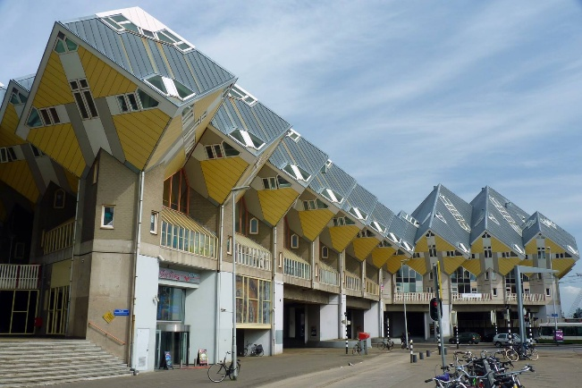  ‘File:Rotterdam Cube House street view’ by Raul Ayres is licensed under CC BY-SA 3.0.  - Pose the following questions to students:  - What if we had a street of houses made from cubes?  - What might this look like?  - Would all the houses look the same?  - What design considerations would we need to consider?  - The students are going to become architects with a challenge to build as many different houses as possible from 4 cubes. The orientation of the house on the ‘block of land’ determines if 2 houses are the same. For example, the 2 houses in Figure 6 are considered different house designs.  Figure 6 – four cube houses  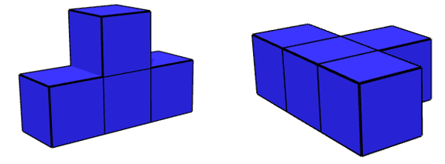  Images created using the free virtual manipulatives at toytheater.com/cube/.  - Assign students to visibly random groups of 3 (bit.ly/visiblegroups). Students will use 4 centicubes to explore the different house designs, recording their designs on isometric paper or using a virtual manipulative.  - Ask each group to share a design until all 15 designs are shared with the class.  - Once students have discovered all possible house designs, ask them to consider:  - What is the same about each of the houses formed?  - What is different about each of the houses formed? |  | Evidence of learning: students create and accurately record all the different possible 4 cube arrangements, demonstrating an understanding of spatial structure and combinations  Students use mathematical language to describe similarities and differences in the cube arrangements, such as position, orientation and shape.  Students explain how orientation affects whether 2 cube arrangements are considered the same or different.  Students demonstrate their understanding that all house designs have the same volume but differ in surface area by identifying, comparing and explaining these properties using appropriate mathematical language.
Table 9 – targeted teaching and learning activities
Life Skills teaching and learning activities | Mainstream teaching and learning activities
- The architects now need to consider the most cost-efficient houses by investigating the cost to build each of the houses. Figure 7 shows a list of the costs to build each section of the house.  Figure 7 – cost per square for each section  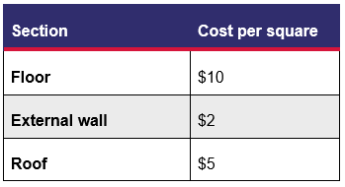  - Provide the students with a template to make their own dice. They will need to create 4 cubes in total. Ask them to select their favourite house design. Then have them recreate it using the dice, connecting them together with adhesive putty.  - Have the students orientate their house on their ‘block of land’ and ask them to identify the floor, external walls and roof of the house. They can then write the cost of each square onto their dice.  - Repeat for their second favourite house design.  - Using a strategy of their choice, have the students determine the cost to build each house. Some questions could include:  - Does each house cost the same to build?  - Has the cost to build changed your mind on which one is your favourite? Why? Why not?  Evidence of learning: students construct different cube house designs, work out how much it costs to build each one and explain which design they like best based on cost and design. | - The architects now need to consider the most cost-efficient houses by investigating the cost to build each of the houses. Figure 8 shows a list of the costs to build each section of the house.  Figure 8 – cost per square for each section  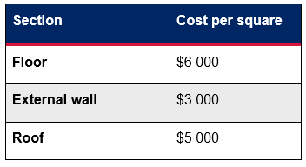  Ask the class to consider and discuss: Will all houses cost the same, since they are all made from 4 cubes?  - Assign students to visibly random groups of 3 (bit.ly/visiblegroups). Students are to select their favourite 3–5 houses and determine the cost to build each of them. They can then select their favourite design by considering the visual design of the house, as well as the cost to build the house.  - Following this, select a few groups to share their findings with the class.  Evidence of learning: students calculate and compare the construction costs of different house designs with the same volume and justify their choice of a preferred design using mathematical reasoning about surface area and cost.
Table 10 – lesson closure: universal cube houses reflection and feedback activity
Universal reflection and feedback activities | Evidence of learning and next steps
- Students choose one house design that they worked on (their own or a shared design). They are to show or describe the house design by drawing it, building it with cubes or describing it in their own words.  - Students are to reflect on this design, answering questions such as:  - What did you notice about its size?  - How did this affect the cost to build?  - What strategy did you use to figure out these things?  - Students then complete an exit ticket answering the following questions:  - What is one thing you learned from this lesson?  - What is something you still want to understand or try next time? | Evidence of learning: students show their understanding by comparing the size and shape of prisms and accurately calculating the surface area of some prisms.  - Next steps include using student reflections to provide targeted feedback and support, addressing common misunderstandings in future lessons, encouraging application of strategies to new problems, and offering extension challenges with more complex shapes.

Lesson 3 – leftovers challenge
The tables below capture the multi-tiered approach to teaching and learning activities to support students in achieving learning outcomes.
Table 11 – outcomes, learning intentions and success criteria
Life Skills Stage 5 | Stage 5
A student:  - develops understanding and fluency in mathematics through exploring and connecting mathematical concepts, choosing and applying mathematical techniques to solve problems, and communicating their thinking and reasoning coherently and clearly MAO-WM-01  - measures and uses area in everyday contexts MALS-ARE-01  - measures and uses volume, capacity and mass in everyday contexts MALS-VOL-01 | A student:  - develops understanding and fluency in mathematics through exploring and connecting mathematical concepts, choosing and applying mathematical techniques to solve problems, and communicating their thinking and reasoning coherently and clearly MAO-WM-01  - solves problems involving the volume of composite solids consisting of right prisms and cylinders MA5-VOL-C-01
Learning intentions  We are learning to:  - construct prisms with differing volumes  - compare prisms with differing volumes.  Success criteria  I can:  - measure the capacity of different containers  - compare which container holds more or less using everyday and mathematical language  - choose suitable containers for everyday items based on their capacity  - explain my reasoning when comparing the size and capacity of containers. | Learning intentions  We are learning to:  - construct prisms with differing volumes  - compare prisms with differing volumes.  Success criteria  I can:  - compare the volume of prisms of similar size  - create a net that makes a rectangular prism  - determine the volume of a rectangular prism  - justify my strategy for determining the maximum volume.
Table 12 – universal teaching and learning activities
Universal teaching and learning activities | Evidence of learning
- Play the ‘Grand Tupperware Challenge (3:10)’ clip (https://bit.ly/hamishandytupperware) for students.  - Have a brief class discussion about what was seen, for example:  - How were points awarded?  - What did Andy do to fit his chocolate cake into the container?  - What do we call the amount of space occupied by a food container? (volume)  - What do we call the amount a container can hold? (capacity)  - Explain to students that they are going to be shown 3–5 food containers that are of similar size. Students will need to order the containers based on which container holds the most.  - Be sure to number each container so answers can be collected from students.  - If food containers cannot be sourced, other suggestions include cereal boxes, shoe boxes and so on.  - To collect results from the students, an online poll system, such as Mentimeter (mentimeter.com), could be used.  - The teacher or students then test the most common ordering. Firstly, fill the suggested smallest container with either water, rice or centicubes and pour that into the suggested next largest container. If it overflows, then the ordering wasn’t correct. Continue this pattern to gain the correct ordering. | Evidence of learning: students demonstrate their understanding of volume and capacity by predicting, ordering and justifying which containers hold the most. They use everyday and mathematical language to describe and compare the size and capacity of containers, explain their reasoning during class discussion, and adjust their predictions based on the results of the practical test.
Table 13 – targeted teaching and learning activities
Life Skills teaching and learning activities | Mainstream teaching and learning activities
- Provide students with 15 cm by 15 cm grids that are pre-marked showing fixed sized squares to cut from each corner, for example, 3 cm squares.  - Students will fold the nets into open containers and explore how much space it holds by filling it with centicubes. Students are to record how many centicubes fit into each of their containers, also recording the container’s base size and height. Some guiding questions could include:  - Which container holds more cubes?  - How do you know?  - Which container is taller?  - What happens if you cut out bigger or smaller corner squares?  - Provide students with 4 different-sized containers. Tell students that they will decide which container would be best suited to each lunch item and why:  - whole salad sandwich  - chopped up carrot sticks  - large portion of leftover fried rice  - 2 boiled eggs.  - Some guiding questions here could include:  - Which container fits this lunch item best? Why?  - Which container is too small or big?  - Students can now complete the mixed lunchbox challenge. They will choose one container and decide which combination of lunch items could fit together in the container. Allow students to ‘make’ each of the items using centicubes to represent each of the lunch options. They can then use these models to estimate which combination of lunch items could fit inside the container. Some prompts to help students show their understanding of which containers work best for different combinations could include:  - My container could fit _____ and _____.  - I learned that _______ containers can hold more.  - Next time I would choose a wider/taller container because ________.  Evidence of learning: students demonstrate their understanding of capacity and measurement by constructing open containers, filling them with centicubes, and recording how many fits in each. They compare and describe containers using everyday and mathematical language such as tall, wide, holds more and fits less, and apply this understanding to select appropriate containers for different lunch items. Through the mixed lunchbox challenge, students show reasoning by estimating, testing and explaining which combinations of items fit best within a given container. | - Show students a 15 cm by 15 cm grid. Explain that they are going to cut out squares from each of the 4 corners and fold up the sides to make a net for a food container with no lid.  - Pose the question to the students: If we want to make a food container that will fit the largest amount of leftovers, what might the net look like and what would the food container’s dimensions be?  - Students will investigate this question in pairs by creating different open prisms.  - Students will create open box nets by cutting out the same-sized square from each of the 4 corners of the grid. They are then to record and/or calculate:  - the number of squares they removed  - the number of squares that remain in their net  - the dimensions of the box they have created  - the volume of the box.  - Students will continue exploring until they believe they have found the box that has the greatest volume.  Evidence of learning: students demonstrate their understanding of volume and surface area by designing, constructing and comparing open prisms created from identical square grids. They use measurement and calculation to determine how changes in dimensions affect capacity, record and interpret results systematically, and justify which net produces the largest volume using mathematical reasoning and appropriate terminology.
Table 14 – lesson closure: universal leftovers challenge reflection and feedback activity
Universal reflection and feedback activities | Evidence of learning and next steps
- Display to students 4 different containers of varying width and heights. Pictures of containers could be used instead. Label each container 1, 2, 3, and 4.  - Ask the students which container they think would hold more water. Ask selected students to explain why they chose their particular container.  - Ask students to use ‘thumbs up’ or ‘thumbs down’ to answer the following true and false questions:  - Does a taller container always hold more?  - Can 2 containers look different but still hold the same amount?  - What if I double the height of a container, will its capacity also double?  - Repeat each of the true and false question and using the Pose-Pause-Pounce-Bounce questioning strategy ask students:  - Can you explain your thinking?  - What measurements or features did you use to make your decision?  - Students complete an exit ticket answering the following questions:  - What did you learn about the relationship between shape and capacity?  - What is one thing you will remember next time you choose a container? | Evidence of learning: students demonstrate their understanding by identifying and comparing how the shape and dimensions of containers affect capacity, using appropriate mathematical terminology.  - Use student responses and reflections to provide targeted feedback addressing misconceptions about the relationship between height, width and volume to reinforce connections between visual estimation, measurement and formula-based reasoning, and encourage the application of strategies to new contexts. Offer extension challenges such as designing a container that holds the most while using the least material.

Lesson 4 – deep dive
The tables below capture the multi-tiered approach to teaching and learning activities to support students in achieving learning outcomes.
Table 15 – outcomes, learning intentions and success criteria
Life Skills Stage 5 | Stage 5
A student:  - develops understanding and fluency in mathematics through exploring and connecting mathematical concepts, choosing and applying mathematical techniques to solve problems, and communicating their thinking and reasoning coherently and clearly MAO-WM-01  - measures and uses area in everyday contexts MALS-ARE-01  - measures and uses volume, capacity and mass in everyday contexts MALS-VOL-01 | A student:  - develops understanding and fluency in mathematics through exploring and connecting mathematical concepts, choosing and applying mathematical techniques to solve problems, and communicating their thinking and reasoning coherently and clearly MAO-WM-01  - solves problems involving the surface area of right prisms and practical problems involving the area of composite shapes and solids MA5-ARE-C-01  - solves problems involving the volume of composite solids consisting of right prisms and cylinders MA5-VOL-C-01
Learning intentions  We are learning to:  - identify solids from a composite solid  - calculate the volume and capacity of a composite solid.  Success criteria  I can:  - identify the solids that make up a composite solid  - calculate the volume of a composite solid. | Learning intentions  We are learning to:  - dissect a composite solid into known solids  - calculate the volume of a composite solid.  Success criteria  I can:  - identify the solids that make up a composite solid  - calculate the volume of a composite solid  - calculate the capacity of a composite solid.
Table 16 – universal teaching and learning activities
Universal teaching and learning activities | Evidence of learning
- Display Figures 9–12 for students to view. Ask students to consider which of the 4 different pools holds the most water and the reasons why.  Figure 9 – resort pool area  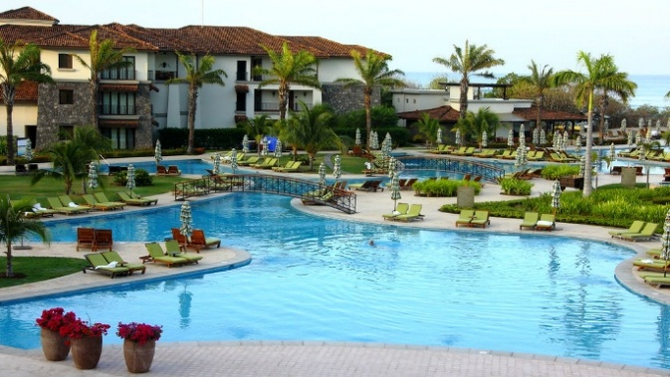  ‘Costa Rica J W Marriott Resort Pool area’ by John Menard is licensed under CC BY-SA 2.0.  Figure 10 – backyard pool before rebuild  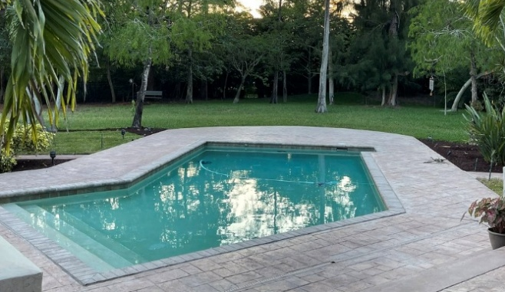  ‘Backyard – pool before rebuild’ by Julie Corsi is licensed under CC BY 2.0.  Figure 11 – pool at Bondi Icebergs  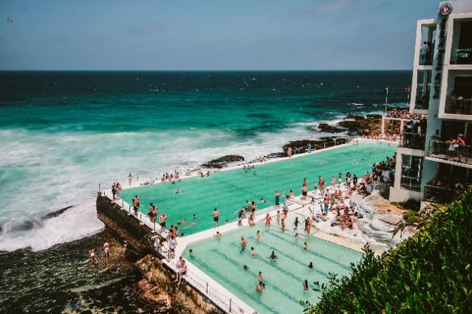  Image by Belle Co is licensed under Pexels License.  Figure 12 – pool at the US Olympic swim team trials  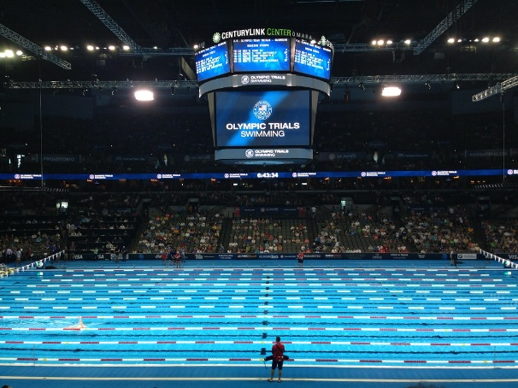  ‘Pool Safely at the U.S. Olympic Swim Team Trials’ by PoolSafely is licensed under CC BY 2.0.  - Students are to Think-Pair-Share (bit.ly/thinkpairsharestrategy) their thoughts on which pool they believe would hold the most water.  - Students’ thoughts should then be shared either through a class discussion or an online poll, such as Mentimeter (mentimeter.com), where reasons should also be shared.  - Ask students to consider their local swimming pool and whether it is the same depth throughout the pool or if it has a shallow end and a deep end. (For the purposes of this activity, the local pool needs to be rectangular and have a shallow end and a deep end. If the school’s local swimming pool is not like this, select another pool for students to consider. Teachers may like to provide an image of their local swimming pool for their students).  - Using mini whiteboards (bit.ly/miniwhiteboards) or otherwise, ask students to individually draw the top view of the local swimming pool. Then ask students to display what they have drawn. This is an opportunity to look for student misconceptions. They should have drawn a rectangle. | Evidence of learning: students compare real world examples to justify which pool would hold the most water, demonstrating understanding of how shape, size and depth influence volume and capacity.
Table 17 – targeted teaching and learning activities
Life Skills teaching and learning activities | Mainstream teaching and learning activities
- Provide students with a side view of the local swimming pool and ask them to identify the deep end and the shallow end.  - Prior to students exploring the local swimming pool, provide students with some rectangular and triangular prisms, ensuring these are numbered to reference. Have students combine the prisms to make a pool shape. They can then describe their design using appropriate mathematical language and identify which end would be the shallow end and which would be the deep end.  - Provide students with the volume and capacity of each of the prisms. Students are to calculate the total volume and capacity of their pool design. A prompting or clarifying question could include: If you swapped the prisms around, would the total volume change?  Evidence of learning: students identify and combine 3D solids to form composite shapes, using given information to calculate, compare and describe total volume and capacity with appropriate mathematical language.  - Students will now explore a resort pool that has a consistent depth, although its top view is made of composite solids. Display Figure 13 for students.  Figure 13 – image of a resort pool  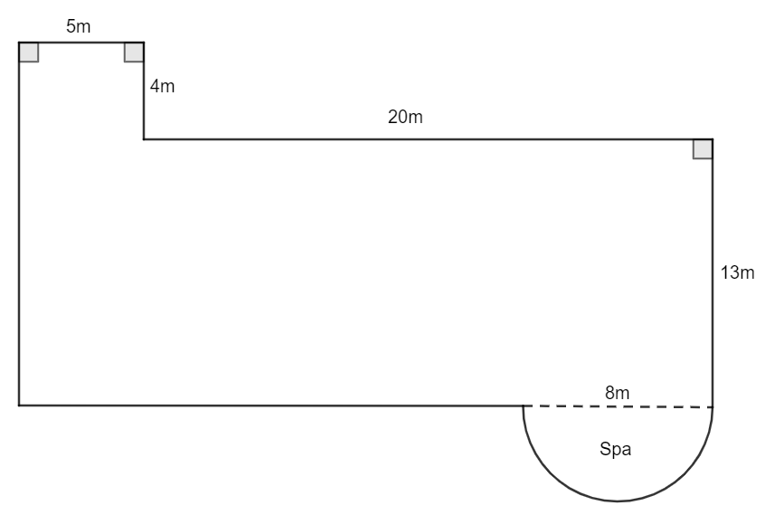  Image created using the free virtual manipulates at geogebra.org.  - Provide students with a word bank of the 2D shapes shown in the resort pool. Students identify and label where each shape appears in the diagram.  - Provide students with a tape measure and have them measure their height. Identify that the depth of the pool is 1.5 m. Have students compare their height against the depth of the pool and ask the students the following questions:  - Is 1.5 m deep or shallow?  - Could you stand up in that depth?  - Approximately where would the water come up to on your body?  - Provide students with the area of each of the 2D shapes. Students are to decide on a suitable strategy and use the depth of the pool to calculate the volume of each of the solids.  - Students are to decide on a suitable strategy to calculate the total volume of the resort pool. Some clarifying questions could include:  - What happens if the pool was deeper?  - What happens if it was shallower?  - Does making it deeper change how much water fits inside?  - Provide students with a copy of Figure 13. A pool cover needs to be purchased to cover the entire pool’s surface including 1 m extra around the perimeter. Students draw an outline around the pool image to represent the extra 1 m space that the cover would need to include. Encourage students to estimate how much larger the cover would be than the pool itself.  Evidence of learning: students identify and label 2D shapes, use given areas and depth to calculate individual and total volumes, interpret the relationship between depth and capacity, and visually represent and estimate area.  - Students are to compare the local pool with the resort pool. Prompting questions could include:  - Which pool holds more water?  - Are they the same depth?  - If you were standing in each pool, which would be easier to stand in?  - Students are to design their own pool to enter a pool design competition. The requirements of the competition state that the pool design:  - have both straight and curved edges around its perimeter  - have a deep end and a shallow end.  - Students are to choose and arrange some 3D solids to form a pool that has a deep end and a shallow end and both straight and curved edges.  - Students are to decide on a depth for the deep end and shallow end and give a reason why they chose each of those depths.  - Provide students with volumes and capacities for each of the solids they have chosen in their design. They are to use these amounts to calculate or describe the total capacity of their pool.  Evidence of learning: students select and combine 3D solids to create a composite design, explain their chosen depths, and use given volumes and capacities to calculate or describe total capacity, demonstrating understanding of how depth and shape affect volume. | - Ask students to draw a side view of the local swimming pool on their mini whiteboards. Allow them time to attempt this without any prompting. After allowing students some time, ask students to consider if they may have forgotten something and eventually remind them that there is a deep end and a shallow end. Ask students to display what they have drawn.  - Prior to students exploring the local swimming pool, as a class discuss how the side view of the swimming pool can be split into rectangular and triangular prisms. Are there multiple ways to do this?  - Arrange students into visibly random groups of 3 (bit.ly/visiblegroups). Students will work in groups with the chosen design of the local swimming pool and its dimensions to perform calculations of the volume and the amount of water it holds.  - Sketch the side view and the 3D solid, including dimensions, which represents the local swimming pool.  - Calculate the volume of the pool.  - A pool cover is to be purchased that needs to cover the entire pool’s surface with 1 m extra around the perimeter. Calculate the dimensions of this cover.  - If the pool is only filled until it is 0.3 m from the surface, calculate the amount of water the pool holds in litres. Remember that $1 cm^{3}=1 mL$ and $1 m^{3}=1000 L$.  - Olympic swimming pools are much deeper than regular pools to decrease the chance of waves forming and increase the swimmers’ performance. In a deeper pool, the splash and turbulence take longer to get down to the bottom of the pool, meaning that it doesn’t ricochet back up into the swimmers. Olympic pools also have a constant depth throughout the entire pool. If the local swimming pool’s depth was to be adjusted to a constant 3 m throughout, by how much would the capacity of the pool change?  Evidence of learning: students represent solids using top and side views, apply formulas to calculate and compare volume and capacity, and demonstrate understanding of how changes in depth affect total volume.  - Students will now explore a resort pool that has a consistent depth, although its top view is made of composite solids. Display Figure 14 for students.  - Ask students to explain how they could break this 2D solid up into known shapes, that is, rectangles and a semicircle.  Figure 14 – image of a resort pool  Image created using the free virtual manipulates at geogebra.org.  - Decide as a class on the depth of each section of the resort pool and have students record this.  - Students will now return to their groups to perform calculations for the resort pool including the volume and the amount of water it holds.  - Split the resort pool into 3 different known shapes and record their dimensions.  - Record the depth of each section of the resort pool.  - Calculate the volume of the pool.  - If the pool is only filled until it is 0.3 m from the surface, calculate the amount of water the pool holds in litres. Remember that $1 cm^{3}=1 mL$ and $1 m^{3}=1000 L$.  - If a pool cover was to be purchased that needed to cover the entire pool’s surface with 1 m extra around the perimeter, calculate the dimensions and area of this cover.  - This pool is the same length as the local swimming pool. Compare the 2 pools, in terms of volume, amount of water they both hold and the size and area of the pool cover.  Evidence of learning: students decompose composite solids into familiar shapes, apply formulas to calculate and compare volumes and capacities, and demonstrate understanding of how shape and depth influence total volume.  - After students have finished their calculations, conduct a class discussion to explore the findings of each pool investigated.  - Students should make notes to their future forgetful selves (bit.ly/notestofutureself) and complete some practice questions.  - Students are to design their own pool to enter a pool design competition. The requirements of the competition state that the pool design must:  - fit within a 6 m by 10 m flat block of land  - have both straight and curved edges around its perimeter  - contain 55 kL to 65 kL.  - Students will need to submit a diagram of the top and side view of the pool as well as supporting calculations.  Evidence of learning: students design and represent a composite solid within given constraints, applying formulas and calculations to determine and communicate total volume and capacity within a specified range.
Table 18 – lesson closure: universal deep dive reflection and feedback activity
Universal reflection and feedback activities | Evidence of learning and next steps
- Students are to display their work around the room and complete a gallery walk (bit.ly/DLSgallerywalk). Some reflection prompts students can complete and submit are:  - What shapes/prisms can you see in this design?  - What do you like about this design?  - Would this pool meet the design rules?  - How does your pool compare to the others in terms of size and capacity?  - Is there a specific design option that allows a pool to hold more water?  - What do you notice about how depth affects capacity? | Evidence of learning: students identify and describe the 3D solids and design features that affect volume and capacity, using everyday and mathematical language to compare and justify their pool designs.  Use student reflections to target misconceptions about the relationship between dimensions, volume and capacity. Reinforce the links between visual estimation, measurement and unit conversion through further practical tasks.

Lesson 5 – icing on the cake
The tables below capture the multi-tiered approach to teaching and learning activities to support students in achieving learning outcomes.
Table 19 – outcomes, learning intentions and success criteria
Life Skills Stage 5 | Stage 5
A student:  - develops understanding and fluency in mathematics through exploring and connecting mathematical concepts, choosing and applying mathematical techniques to solve problems, and communicating their thinking and reasoning coherently and clearly MAO-WM-01  - measures and uses area in everyday contexts MALS-ARE-01  - measures and uses volume, capacity and mass in everyday contexts MALS-VOL-01 | A student:  - develops understanding and fluency in mathematics through exploring and connecting mathematical concepts, choosing and applying mathematical techniques to solve problems, and communicating their thinking and reasoning coherently and clearly MAO-WM-01  - solves problems involving the surface area of right prisms and practical problems involving the area of composite shapes and solids MA5-ARE-C-01  - solves problems involving the volume of composite solids consisting of right prisms and cylinders MA5-VOL-C-01
Learning intention  We are learning to:  - solve practical problems related to the volume and surface areas of composite solids.  Success criteria  I can:  - identify the solids that make up a larger object  - describe which objects hold more or less  - recognise the outside surfaces of an object  - calculate the area of outside surfaces of an object. | Learning intention  We are learning to:  - solve practical problems related to the volume and surface areas of composite solids.  Success criteria  I can:  - name and identify solids that make up a composite solid  - apply my knowledge of volume to solve practical problems  - apply my knowledge of surface area to solve practical problems.

Table 20 – universal teaching and learning activities
Universal teaching and learning activities | Evidence of learning
- Show students Tigga Mac’s cake hack (0:59) video on YouTube (bit.ly/caterpillarcake).  - As students are watching the video, have them write down anything they notice and wonder (bit.ly/noticewonderstrategy).  - Students share their notice and wonder lists with a partner before sharing as a class through a class discussion. Prompts for the class discussion might include:  - What shape/solid was the cake at the start?  - Do you know the name of each shape cut from the original cake? (This is an opportunity for students to explore annuluses.)  - What happened to the icing on the cake? Is there the same amount, more or less than the original cake had?  - Has the volume of the cake changed?  - Explain to students that they will be designing their own birthday cake or a cake for an event of their choosing. For example, a younger child’s birthday, a wedding cake and so on.  - Explain to students that they need to meet the following criteria:  - Their cake must be made from solids that they can name, find the volume of and find the area of each face.  - Students are to draw and label a neat sketch of the dimensions of their cake design. They can do this by any means, including:  - by hand  - using an online applet such as GeoGebra  - using a 3D program such as AutoCAD. | Evidence of learning: students identify and describe the shapes involved in the cake transformation, use observations to compare changes in icing and volume, and communicate their mathematical reasoning through notice and wonder statements and class discussion.  Students create and represent a 3D cake design using identifiable solids, apply volume and surface area calculations, and demonstrate understanding of dimensional constraints through accurate sketches and mathematical reasoning.
Table 21 – targeted teaching and learning activities
Life Skills teaching and learning activities | Mainstream teaching and learning activities
- Students share what they found out about their design with a partner. For example:  - How many and which solids did they combine?  - Do they think their design was stable?  - Did more smaller solids have a greater surface area than fewer larger solids?  Evidence of learning: students use everyday and mathematical language to determine how changes in cake size or layers affect the amount of icing required.  - Pose the following problem for students to explore in pairs:  - 5 friends want to share a cube-shaped chocolate cake with vanilla icing. How can they cut the cake so that everyone receives an equal share of cake?  - To make the problem clearer to students, you could model sharing the cake between:  - 2 friends.  Evidence of learning: students use visual and spatial reasoning to propose and communicate fair ways to divide a 3D object, demonstrating understanding of equal sharing and how cuts relate to equal amounts of cake and icing. | - Once students have considered their design and dimensions, they are to calculate the volume of their cake.  - Students are to then calculate the surface area of their cake that needs to be iced.  Evidence of learning: students use proportional and spatial reasoning to determine how changes in cake size or layers affect the amount of icing required, demonstrating their understanding of the relationship between surface area and practical measurement.  - Pose the following problem for students to explore in visibly random groups of 3 (bit.ly/visiblegroups):  - Jamarra and 5 friends want to share a 30 cm cube-shaped chocolate cake with vanilla icing. How can they cut the cake so that everyone receives an equal share of cake and icing?  - To make the problem clearer to students, you could model sharing the cake between:  - 2 friends  - 3 friends.  Evidence of learning: students demonstrate understanding of fair sharing by proposing and explaining ways to divide a 3D object into equal portions, using spatial reasoning to consider both cake volume and icing distribution.

Differentiation and adjustments
[Record adjustments and differentiation activities for students with identified requirements in the table below. This section is for use in school when making adjustments to support students to achieve in their learning, including extension activities.]
Student | Differentiation and/or adjustments
Student X – outline identified requirements | List of specific differentiation and/or adjustments.

Registration and evaluation notes
[Add registration and evaluation notes for teacher and supervisor sign off in the table below.]
Teacher reflection and evaluation notes on program | Head teacher/supervisor notes and sign off

Overall program evaluation prompts
Collating ongoing evaluations and reflecting on the strengths and areas for development within the program creates opportunities to enhance student outcomes. The following prompts can be used to support your evaluation of the program:
- Did the program assist all students to improve in their learning?
- How could the sequencing of the program be improved?
- What did the student evaluations of the program indicate? How can these be actioned to improve the program?
- The strategies and resources that were most effective for student learning were …
- Teaching strategies and resources that would benefit from review and refinement are …

Capturing student voice when evaluating a program
Student voice is useful in the evaluation process for programs. The statements below could be useful as a starting point when asking students to provide feedback on their learning experiences. These statements are derived from some of the themes from What works best 2020 update (CESE 2020a) and could be useful in teacher reflection on how these themes could be incorporated into a teaching program. The statements could also prompt student reflection on their metacognitive processes while learning. Students’ preferred communication form(s) should be considered when students are providing feedback about their learning.
Please rate how much you agree with these statements:
- My teacher had confidence that I could achieve and improve in my learning. (CESE 2020a Chapter 1: High expectations)
- I had a clear idea of what I was learning and why. (CESE 2020a Chapter 2: Explicit teaching)
- I used the feedback provided to improve my performance. (CESE 2020a Chapter 3: Effective feedback)
- I understood the feedback on the assessment task. (CESE 2020a Chapter 3: Effective feedback)
- I was able to predict the marks I achieved in the assessment tasks. (CESE 2020a Chapter 5: Assessment)
- The activities in the unit prepared me for the assessment task. (CESE 2020a Chapter 5: Assessment)
- I found the activities in the lessons interesting to me. (CESE 2020a Chapter 7: Wellbeing)
- I made valuable contributions to the class during this unit. (CESE 2020a Chapter 7: Wellbeing)
- I ask questions in class when I don’t understand yet. (CESE 2020a Chapter 7: Wellbeing)
Optional open-ended prompts:
- The lessons and/or activities that I most enjoyed were when we … because …
- When the learning was difficult, the strategy I used was …
- If I was giving advice to a student who was starting this unit I would tell them to …
- If I was giving advice to a teacher who was teaching this unit I would tell them to …

Support and alignment
Resource evaluation and support: all curriculum resources are prepared through a rigorous process. Resources are periodically reviewed as part of our ongoing evaluation plan to ensure currency, relevance and effectiveness. For additional support or advice, or to provide feedback, contact the Mathematics 7–12 Curriculum team by emailing mathematics7-12@det.nsw.edu.au.
Differentiation: further advice to support Aboriginal and/or Torres Strait Islander students, students learning English as an additional language or dialect (EAL/D), students with disability and high potential and gifted students can be found on the Planning, programming and assessing 7–12 webpage. This includes the Inclusion and differentiation advice 7–10 webpage.
Assessment: further advice to support formative assessment is available on the Planning, programming and assessing 7–12 webpage. This includes the Classroom assessment advice 7–10. For summative assessment tasks, the Assessment task advice 7–10 webpage is available.
Explicit teaching: further advice to support explicit teaching is available on the Explicit teaching webpage. This includes the CESE Explicit teaching – Driving learning and engagement webpage.
Consulted with: Curriculum, Inclusive Education, Multicultural Education, Aboriginal Outcomes and Partnerships and subject matter experts.
Alignment to system priorities and/or needs: School Excellence Policy, Our Plan for NSW Public Education.
Alignment to the School Excellence Framework: this resource supports the School Excellence Framework elements of curriculum (curriculum provision) and effective classroom practice (lesson planning, explicit teaching).
Alignment to Australian Professional Standards for Teachers: this resource supports teachers to address Proficient Teacher Standard Descriptors 3.2.2, 3.3.2.
Alignment to NSW Education Standards Authority: this resource supports student eligibility and credentialling requirements as referenced by NESA’s ACE Rule 11.
Creation date: November 2025

References
This resource contains NSW and syllabus content. The NSW Curriculum is developed by the NSW Education Standards Authority (NESA). This content is prepared by NESA for and on behalf of the Crown in right of the State of New South Wales. The material is protected by Crown copyright.
Please refer to the NESA Copyright Disclaimer for more information https://www.nsw.gov.au/education-and-training/nesa/copyright.
NESA holds the only official and up-to-date versions of the NSW Curriculum and syllabus documents. Please visit NESA https://www.nsw.gov.au/education-and-training/nesa and NSW Curriculum https://curriculum.nsw.edu.au.
Mathematics K–10 Syllabus © NSW Education Standards Authority (NESA) for and on behalf of the Crown in right of the State of New South Wales, 2022.
AITSL (Australian Institute for Teaching and School Leadership Limited) (n.d.) Learning intentions and success criteria [PDF 251 KB], AITSL website, accessed 18 December 2025.
——(2017) ‘Feedback Factsheet’, AITSL website, accessed 18 December 2025.
Brookhart S (2011) How to Assess Higher-Order Thinking Skills in Your Classroom, Hawker Brownlow Education, Victoria.
CESE (Centre for Education Statistics and Evaluation) (2020a) What works best: 2020 update, NSW Department of Education website, accessed 18 December 2025.
——(2020b) What works best in practice, NSW Department of Education website, accessed 18 December 2025.
NESA (NSW Education Standards Authority) (2022a) ‘Advice on units’, Programming, NESA website, accessed 18 December 2025.
——(2022b) ‘Programming’, Understanding the curriculum, NESA website, accessed 18 December 2025.
——(2024) ‘Proficient Teacher: Standard Descriptors’, Achieve Proficient Teacher Accreditation, NESA website, accessed 18 December 2025.
Rosenshine B (2012) ‘Principles of Instruction: Research-Based Strategies That All Teachers Should Know’, American Educator, 36(1):12–19 accessed 18 December 2025.
Wiliam D (2013) ‘Assessment: The Bridge between Teaching and Learning’, Voices from the Middle, 21(2):15–20, doi:10.58680/vm201324461, accessed 18 December 2025.
——(2017) Embedded Formative Assessment, 2nd edn, Solution Tree Press, Bloomington, IN.
Wisniewski B, Zierer K and Hattie J (2020) ‘The Power of Feedback Revisited: A Meta-Analysis of Educational Feedback Research’, Frontiers In Psychology, 10:3087, doi:10.3389/fpsyg.2019.03087, accessed 18 December 2025.
.
© State of New South Wales (Department of Education), 2026
The copyright material published in this resource is subject to the Copyright Act 1968 (Cth) and is owned by the NSW Department of Education or, where indicated, by a party other than the NSW Department of Education (third-party material).
Copyright material available in this resource and owned by the NSW Department of Education is licensed under a Creative Commons Attribution 4.0 International (CC BY 4.0) license.

This license allows you to share and adapt the material for any purpose, even commercially.
Attribution should be given to © State of New South Wales (Department of Education), 2026.
Material in this resource not available under a Creative Commons license:
- the NSW Department of Education logo, other logos and trademark-protected material
- material owned by a third party that has been reproduced with permission. You will need to obtain permission from the third party to reuse its material.
Links to third-party material and websites
Please note that the provided (reading/viewing material/list/links/texts) are a suggestion only and implies no endorsement, by the New South Wales Department of Education, of any author, publisher, or book title. School principals and teachers are best placed to assess the suitability of resources that would complement the curriculum and reflect the needs and interests of their students.
If you use the links provided in this document to access a third-party's website, you acknowledge that the terms of use, including licence terms set out on the third-party's website apply to the use which may be made of the materials on that third-party website or where permitted by the Copyright Act 1968 (Cth). The department accepts no responsibility for content on third-party websites.

