Preventing and managing malpractice in Stage 6 school-based assessment
Throughout the assessment process, the highest standard of scholarship is required. The honesty of students in completing assessment tasks, exams and tests underpins the integrity of the Higher School Certificate (HSC) (ACE 10.1).

What constitutes malpractice?
Malpractice is any dishonest behaviour and/or attempt to gain an unfair advantage over other students, or knowingly assist other students to engage in malpractice (ACE 10.1). NESA has identified 3 different types of malpractice (ACE 10.1.1):
- misrepresentation
- plagiarism
- collusion
Figure 1 – 3 kinds of malpractice
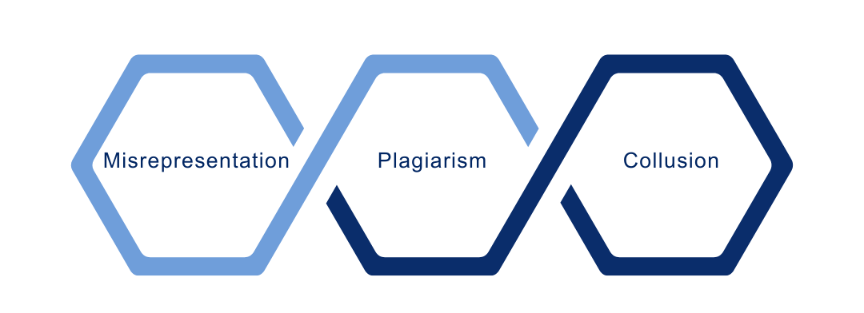

How can schools prevent malpractice in the HSC?
Schools must develop procedures for managing malpractice. These procedures must detail the decision makers and their role in investigating, penalising or considering student appeals concerning suspected malpractice. Decision makers could include the principal, senior executive or a small team delegated by the principal. The process must be communicated via the school-based assessment procedures or through a separate malpractice procedure.
The completion of the All My Own Work program is a requirement of entry into Preliminary and/or HSC courses and must be completed for the award of the HSC (ACE 10.2.1). The course focuses on principles and practices of good scholarship. This includes students understanding, valuing and using ethical practices when locating and using information as part of their HSC studies. Students who have completed the program know about penalties for malpractice and how to avoid malpractice when preparing their work for assessment(s) (NESA n.d.). Students undertaking a full pattern of Life Skills courses do not need to complete All My Own Work.
Schools ensure that students also sign a ‘Confirmation of entry form’ when starting the HSC program. By signing, students declare they are aware of plagiarism and malpractice consequences, including the potential loss of their HSC (Breaking HSC rules).
Schools are also required to certify HSC practical components. HSC students submitting projects, works and performances must sign a student declaration form (Certifying HSC practical component). Students must declare that the work is their own and provide detail where they have received assistance.
It is the student’s responsibility to approach all assessment tasks with honesty.

How can schools manage malpractice?
A school must provide written advice to its students about the requirements for school-based assessments (ACE 2.1 and ACE 10.1) including:
- a definition and description of malpractice in school-based assessment
- details of the school's procedures on malpractice in assessment tasks
- procedures for investigating suspected malpractice, including the decision maker(s) for determining malpractice offences
- a range of possible penalties for malpractice
- details of the procedures for dealing with student appeals arising from assessment tasks, including the decision maker(s) for appeals
- details on the recording of malpractice incidents in HSC school-based assessment in NESA’s Malpractice Register.
Details of the school's procedures on malpractice in assessment tasks must be made clear to students, as students are responsible for understanding and complying with the school malpractice procedures.

What if malpractice is suspected?
Malpractice in any form is unacceptable. NESA treats allegations of malpractice very seriously and detected malpractice may limit a student’s marks and jeopardise their Higher School Certificate (ACE 10.1).
In the case of suspected malpractice, students will be required to provide evidence that all unacknowledged work is entirely their own. Such evidence may include, but is not limited to, the student:
- providing evidence of and explaining the process of their work, which might include diaries, journals or notes, working plans or sketches and progressive drafts to show the development of their ideas
- answering questions regarding the assessment task, examination or submitted work under investigation, to demonstrate their knowledge, understanding and skills (Before you start your HSC).
Schools must follow their own malpractice procedures when managing malpractice. Schools must advise students of the appeals process in line with the school-based assessment procedures. Student appeals concerning malpractice in school-based assessment tasks must be resolved at the school level.
Schools must record malpractice offences in all HSC school-based assessment tasks in NESA’s Malpractice Register in Schools Online. Schools must ensure each malpractice offence is represented uniquely. For each malpractice offence, schools must record the:
- student identifier
- course name
- offence date
- type of assessment task
- type of malpractice offence
- penalty applied.
Details are recorded so that individual students cannot be identified and the aggregated data does not identify individual schools (ACE 10.1.3).

Does the use of generative artificial intelligence (AI) mean malpractice has occurred?
The unapproved use of AI in the completion of assessment tasks is a breach of academic integrity. All work presented in assessment tasks and external examinations (including submitted works and practical examinations) must be a student’s own or must be acknowledged appropriately. The department has developed initial advice on students’ use of generative AI in assessment tasks, which are intended to inform schools in the development of assessment programs and associated policies. The department recommends that school assessment policies explicitly address the use of generative AI in assessment tasks.
Malpractice may occur where generative AI:
- has been used as part of an assessment task when specifically prohibited
- output has not been cited – all work presented in assessment tasks must be a student’s own or must be acknowledged appropriately
- has been used in a way that contradicts the school’s malpractice procedures.
Generative AI tools are a nonrecoverable source which cannot be retrieved or linked and should only be used as instructed. Generative AI plagiarism detection tools are unreliable and are not recommended for use by the department.
Stay up to date with the department’s advice on Artificial intelligence in education. Advice will continue to be updated.
For more information, join the Teaching and Learning 7–12 Microsoft Teams via this form or email secondaryteachingandlearning@det.nsw.edu.au.
For more information about the use of generative AI, email the AI executive leadership group at AI.ELG@det.nsw.edu.au.

References
NESA (NSW Education Standards Authority) (n.d.) All My Own Work, NSW Government website, accessed 16 September 2020.

© State of New South Wales (Department of Education), 2025
The copyright material published in this resource is subject to the Copyright Act 1968 (Cth) and is owned by the NSW Department of Education or, where indicated, by a party other than the NSW Department of Education (third-party material).
Copyright material available in this resource and owned by the NSW Department of Education is licensed under a Creative Commons Attribution 4.0 International (CC BY 4.0) license.

This license allows you to share and adapt the material for any purpose, even commercially.
Attribution should be given to © State of New South Wales (Department of Education), 2025.
Material in this resource not available under a Creative Commons license:
- the NSW Department of Education logo, other logos and trademark-protected material
- material owned by a third party that has been reproduced with permission. You will need to obtain permission from the third party to reuse its material.
Links to third-party material and websites
Please note that the provided (reading/viewing material/list/links/texts) are a suggestion only and implies no endorsement, by the New South Wales Department of Education, of any author, publisher, or book title. School principals and teachers are best placed to assess the suitability of resources that would complement the curriculum and reflect the needs and interests of their students.
If you use the links provided in this document to access a third-party's website, you acknowledge that the terms of use, including licence terms set out on the third-party's website apply to the use which may be made of the materials on that third-party website or where permitted by the Copyright Act 1968 (Cth). The department accepts no responsibility for content on third-party websites.

