How often? – interacting activities

Activity 1 – oral ping-pong
Working in pairs, you each have a different list of sentences. The sentences gradually become longer.
Take turns reading out each sentence to your partner. Your partner must repeat the sentence back to you accurately. Repeat the sentence if your partner makes an error so they can have another attempt.

Activity 2 – gap activity
You and your partner have the names of 12 people in a table. Included next to each name is either an image of an activity they do, or how often (in French) they do an unknown activity.
Work in pairs to find out which activity each person does and how often. The person who has the image of an activity goes first each time. For example:
Student A’s table | Student B’s table
Alice 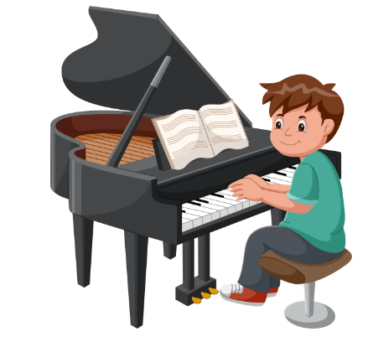  How often? __________ | Alice  Activity? __________  toujours
Using the image above, the interaction would be as follows:
Student A: Alice joue du piano ?
Student B: Oui, Alice joue toujours du piano.
Student A then writes ‘always’ in the space provided in their table. Student B writes ‘plays piano’ in the space provided in their table. Continue until you have the details for all 12 people.

Student A

Activity 1 – oral ping-pong sentences
Je joue au foot.
Je joue au handball le jeudi.
Je joue quelquefois du piano.
Je fais du surf le vendredi après-midi.
Je joue toujours aux jeux vidéo sur la Wii chez moi.
Je vais quelquefois au zoo à Sydney avec des amis.
Je fais souvent les courses en ville avec ma maman.
Je traîne avec des amis à la plage deux fois par semaine.

Activity 2 – gap activity
Alice  How often? __________ | Luca  Activity? __________  le weekend | Nikita 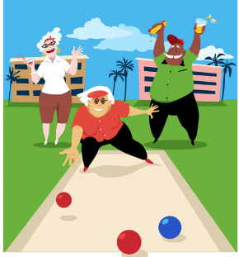  How often? __________
Skye  Activity? __________  souvent | So-Hee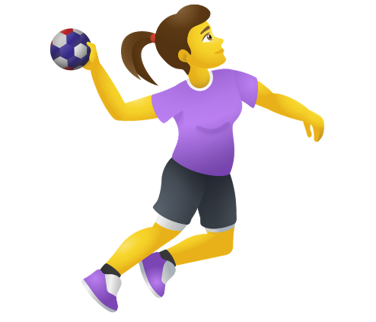  How often? __________ | Ethan  Activity? __________  le jeudi
Amram 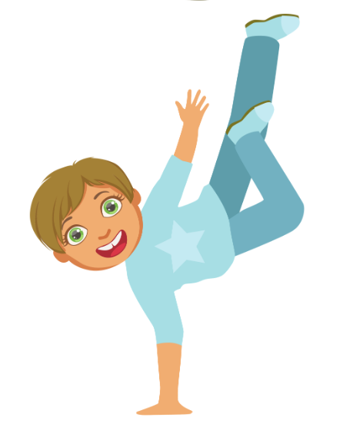  How often? __________ | Ryan  Activity? __________  tous les jours | Linh 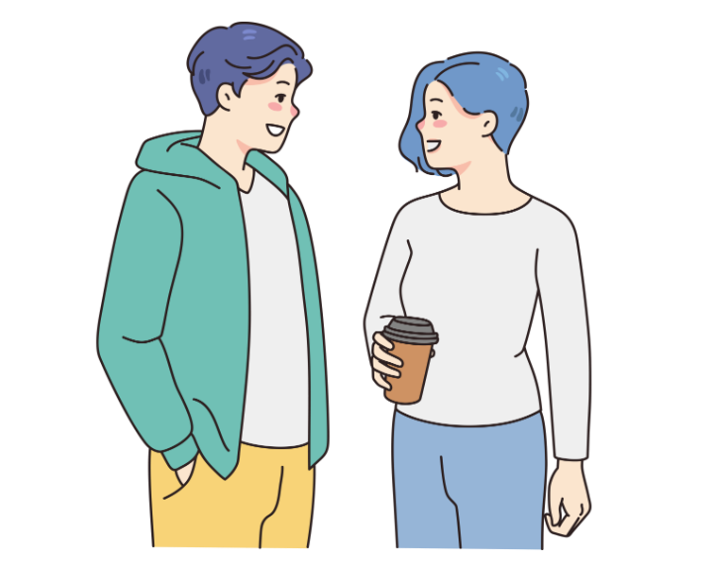  How often? __________
Lily  Activity? __________  le samedi matin | Jasper   How often? __________ | Sienna  Activity? __________  une fois par jour

Student B

Activity 1 – oral ping-pong sentences
Je joue au tennis.
Je joue au basket le weekend.
Je joue souvent de la clarinette.
Je fais du sport le dimanche matin.
J’écoute souvent de la musique avec des amis.
Je fais du shopping à Westfield tous les weekends.
Je joue toujours aux jeux vidéo sur Internet avec mon frère.
Je regarde toujours la télé chez moi avec ma famille le samedi soir.

Activity 2 – gap activity
Alice  Activity? __________  toujours | Luca 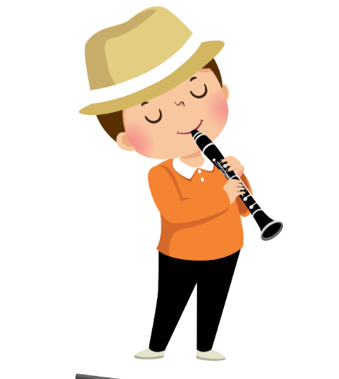  How often? __________ | Nikita  Activity? __________  quelquefois
Skye 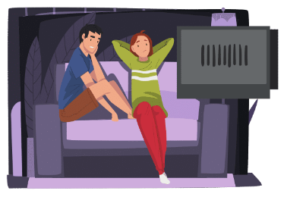  How often? __________ | So-Hee  Activity? __________  tous les jours | Ethan 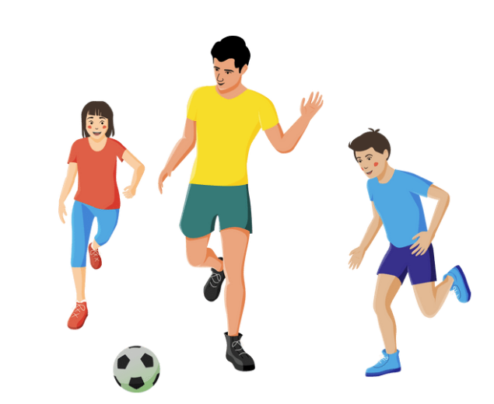  How often? __________
Amram  Activity? __________  deux fois par semaine | Ryan 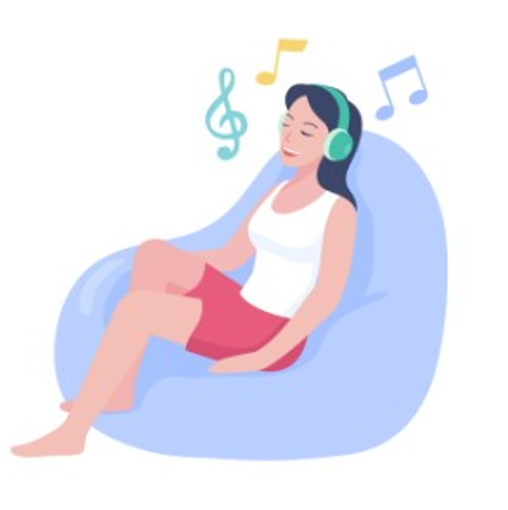  How often? __________ | Linh  Activity? __________  le weekend
Lily 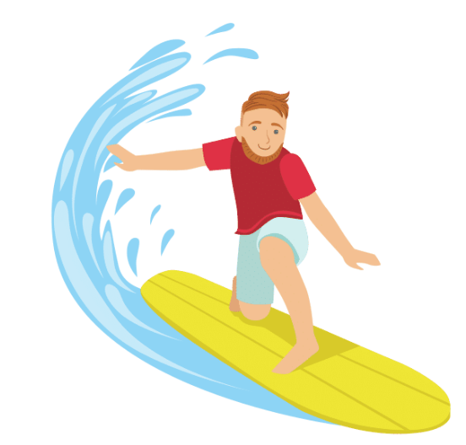  How often? __________ | Jasper  Activity? __________  souvent | Sienna   How often? __________

© State of New South Wales (Department of Education), 2023
The copyright material published in this resource is subject to the Copyright Act 1968 (Cth) and is owned by the NSW Department of Education or, where indicated, by a party other than the NSW Department of Education (third-party material).
Copyright material available in this resource and owned by the NSW Department of Education is licensed under a Creative Commons Attribution 4.0 International (CC BY 4.0) license.

This license allows you to share and adapt the material for any purpose, even commercially.
Attribution should be given to © State of New South Wales (Department of Education), 2023.
Material in this resource not available under a Creative Commons license:
- the NSW Department of Education logo, other logos and trademark-protected material
- material owned by a third party that has been reproduced with permission. You will need to obtain permission from the third party to reuse its material.
Links to third-party material and websites
Please note that the provided (reading/viewing material/list/links/texts) are a suggestion only and implies no endorsement, by the New South Wales Department of Education, of any author, publisher, or book title. School principals and teachers are best placed to assess the suitability of resources that would complement the curriculum and reflect the needs and interests of their students.
If you use the links provided in this document to access a third-party's website, you acknowledge that the terms of use, including licence terms set out on the third-party's website apply to the use which may be made of the materials on that third-party website or where permitted by the Copyright Act 1968 (Cth). The department accepts no responsibility for content on third-party websites.

