Korean Stage 1
누구세요? (Who is it?)
Contents
Unit overview 5
Stage 1 outcomes and content to be addressed 6
Learning map 10
Assessment 13
Assessment opportunities 14
Teaching and learning activities 15
Week 1 – describing others 15
Vocabulary 1 – describing people 16
Activity 1 – learning map 17
Activity 2 – introduce vocabulary 17
Activity 3 – describing people labelling activity 18
Activity 4 – describing others bingo 18
Week 2 – question time 20
Vocabulary 2 – question time 20
Activity 1 – Odd one out! 23
Activity 2 – asking and responding to questions 24
Activity 3 – guess who? 26
Activity 4 – mystery classmate 26
Week 3 – host a game show 28
Vocabulary 3 – host a game show 28
Activity 1 – subject particles game 30
Activity 2 – sentence scaffold 31
Activity 3 – role-play 32
Activity 4 – word relay 33
Week 4 – It’s show time! 34
Activity 1 – listen and draw 34
Activity 2 – partner descriptions 35
Activity 3 – broken telephone 36
Activity 4 – exit ticket 36
Week 5 – assessment criteria and practice task 38
Activity 1 – speed chatting with puppets 38
Activity 2 – assessment task 40
Activity 3 – success criteria 41
Activity 4 – practice task 41
Week 6 – communicative task – Game show – Who is it? 44
Activity 1 – task set-up 45
Activity 2 – communicative task – Guess, who is it? 45
Activity 3 – peer assessment 47
Week 7 – feedback and goal setting 48
Activity 1 – ‘Beat the teacher’ 49
Activity 2 – self-assessment 49
Activity 3 – set learning goals 49
Week 8 – language review 51
Activity 1 – student questions 52
Activity 2 – ‘Snowman’ 52
Activity 3 – draw the character 54
Student resources 55
Resource 1 – describing people flashcards 55
Resource 2 – describing people labelling sheet 57
Resource 3 – bingo card 59
Resource 4 – question cards 60
Resource 5 – subject particles game cards 67
Resource 6 – sentence scaffold 72
Resource 7 – student rubric 74
Resource 8 – peer feedback strategy – Two stars and a wish 75
Support and alignment 76
References 79

Unit overview
Stage: 1
Title: 누구세요? (Who is it?)
Description: In this unit, students use formal and informal language to greet and interview each other in Korean. They use greetings, rehearsed language and formulaic phrases to share information about themselves.
Duration: This lesson sequence is designed to be completed over approximately 8 weeks.
Student proficiency levels: It is assumed that most Stage 1 students have been learning Korean since Kindergarten and their proficiency level will still be Beginner. The assessment tasks in this scope and sequence are aimed at beginner students. Every classroom will be different and teachers will need to adapt to their context. Many classes may include a combination of Beginner, Intermediate and Advanced students with varying skills and abilities within these proficiency levels. Assessment tasks and opportunities in this unit can be differentiated using the ‘Too hard?’ and ‘Too easy?’ suggestions.

Stage 1 outcomes and content to be addressed
The table below outlines the focus area, outcomes and content points for Stage 1 students.
Focus area and outcome | Content points
Interacting  A student:  - exchanges meaning by selecting culturally appropriate modelled language ML1-INT-01 | Exchanging meaning in oral interactions in the target language  - Exchange greetings, farewells and simple information to describe people or objects  - Answer common questions about themselves and their personal world in a guided conversation  - Interact in classroom routines using familiar language  - Interact by selecting modelled language in games or scenarios using imagination  Reproducing oral language to interact in the target language  - Recognise and reproduce modelled sounds, including pronunciation and intonation patterns to interact  - Reproduce familiar vocabulary and short formulaic phrases to interact  Applying knowledge of the target language culture(s) to interact  - Use familiar verbal and nonverbal communication that is appropriate to cultural practices
Understanding texts  A student:  - recognises and responds to information in simple texts to demonstrate understanding  ML1-UND-01 | Understanding and responding to target language texts  - Follow instructions  - Use auditory cues, gestures, visuals and other forms of nonverbal communication to support comprehension  - Associate vocabulary on familiar themes with known actions, people, places, objects and ideas  - Recognise information in simple texts and respond to simple questions in the target language and/or English to show understanding of texts  - Demonstrate understanding when responding to texts using actions, drawing, singing or simple exchanges in the target language and/or English  Applying knowledge of language systems to understand and respond to target language texts  - Recognise and use sounds of modelled vocabulary and phrases to understand and respond to texts  - Recognise sound–symbol correspondences in modelled words and phrases to understand and respond to texts  - Recognise and use knowledge of modelled vocabulary, high-frequency words and formulaic phrases on familiar themes to understand and respond to texts  - Use simple grammar patterns to understand and respond to texts  - Recognise that the target language has features that may be similar to or different from English  - Recognise and reproduce symbols or modelled vocabulary and phrases of the writing system to understand and respond to texts  Developing intercultural understanding through target language texts  - Notice that language is used in ways that reflect cultural practices and reflect on their own language and cultural practices
Creating texts  A student:  - creates simple texts by selecting culturally appropriate modelled language ML1-CRT-01 | Creating spoken, written and multimodal texts in the target language  - Create texts using familiar vocabulary, phrases and visuals to express meaning  - Label or describe objects and images  Applying knowledge of language systems to create texts in the target language  - Use pronunciation patterns to create spoken texts  - Use familiar sound–symbol correspondences to create written texts  - Use familiar vocabulary and formulaic phrases to create texts  - Use simple modelled sentence structures to create texts  - Reproduce modelled features of the target language writing system to create written texts  Reproducing how target language speakers communicate to create texts  - Reproduce language appropriate to cultural practices to create texts
Modern Languages K–10 Syllabus © NSW Education Standards Authority (NESA) for and on behalf of the Crown in right of the State of New South Wales, 2022.

Learning map
The creation of maps for learning is a planning process that incorporates Aboriginal intellectual tradition. Learning maps are a visual pathway of what students will learn.
Share the learning map with your students, briefly explaining the learning that will happen in each lesson. Provide students with a copy of the learning map or display the learning map in the classroom. This learning map can be adapted to Korean by accessing a copy of Learning map –누구세요? (Who is it?) (Stage 1).

Figure 1 – Who is it? learning map
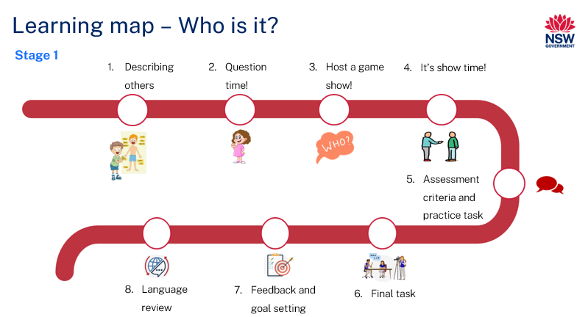

Figure 2 – 누구세요? learning map
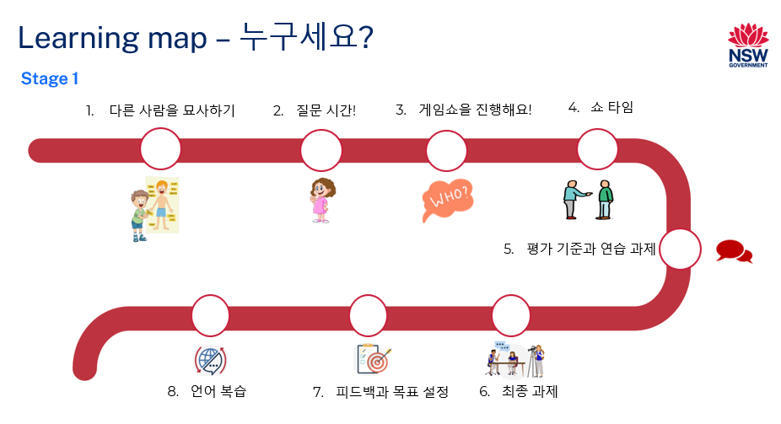

Assessment
Stage 1 communicative task: You are a contestant in a game show ‘Who is it?’ You need to guess the identity of a person based on clues about their appearance, age, gender, hair and eye colour.
Too hard?
You need to guess the identity of a person based on clues about their appearance, age and gender.
Too easy?
You need to guess the identity of a person based on clues about their appearance, age, gender, hair, eye colour and a personality trait.
Context: your school is hosting a game show
Audience: host of the show
Purpose: to guess the name of a person

Assessment opportunities
The table below details assessment opportunities and differentiation ideas.
Assessment opportunities | Too hard? | Too easy?
Week 1 – describing people labelling activity  Students label the corresponding pictures of images with the correct Korean words. | Describing people labelling activity  Provide students with a set of Resource 1 – describing people flashcards to assist them with vocabulary. | Describing people labelling activity  Students draw and label other physical features not included on Resource 2 – describing people labelling activity in Korean.
Week 3 – role-play  Students take turns role-playing as a contestant and a host in the game show ‘Who is it?’ | Role-play  Students ask the host 2 questions using Resource 4 – question cards. | Role-play  Students ask the host additional questions not included on Resource 4 – question cards.
Week 4 – partner descriptions  In pairs, students write descriptions of each other's physical characteristics in Korean. | Partner descriptions  Students refer to Resource 1 – describing people flashcards for vocabulary assistance and grammatical structure. | Partner descriptions  Students read descriptions written by different pairs and make additional guesses about who is being described.

Teaching and learning activities

Week 1 – describing others
The table below outlines the learning intention and success criteria of the lesson, and materials that the teacher and students will need to complete the teaching and learning activities.
Learning intention and success criteria | Materials
Students will identify and say words in Korean that describe eye colour, hair type, gender and height.  Students can:  - say words in Korean to describe people. | - Resource 1 – describing people flashcards  - Resource 2 – describing people labelling sheet (A3 sized copy)  - Resource 3 – bingo card  - Learning map  - Counters  - Writing materials

Vocabulary 1 – describing people
Note: the term for 'hair' in Korean is 머리카락 (meorikarak) but when describing the hair of a person the word can be shortened to 머리 (meori).
The table below outlines the suggested vocabulary used throughout this learning sequence. It includes the Korean words and phrases and their corresponding English translations.
English | Romanised Korean | Korean
long hair | gin-meoli | 긴 머리
short hair | jjal-beun | 짧은 머리
curly hair | gobseul-meoli | 곱슬 머리
straight hair | jigmo-meoli | 직모 머리
black hair | geomjeong-meoli | 검정 머리
brown eyes | gaelsaeg-nun | 갈색눈
green eyes | cholog-nun | 초록눈
blue eyes | palan-nun | 파란눈
tall | kiga keun | 키가 커요
short | kiga jag eun | 키가 작아요

Activity 1 – learning map
Explain and display the Learning map to give students a more detailed breakdown of lessons during the unit. Point out that the learning map is a plan that may need to change.

Activity 2 – introduce vocabulary
- Display the images in Resource 1 – describing people flashcards. Ask students to identify how many words they think they know when answering the following questions by showing a thumbs up at their chests. Ask:
- Do you know all the words for these pictures in Korean?
- Do you know most of them?
- Do you know any of them?
- In pairs, students Think-Pair-Share the words they know. Match the relevant word to each image as students share their understanding.
- Model and drill the correct pronunciation of Resource 1 – describing people flashcards vocabulary with students.

Activity 3 – describing people labelling activity
- Remove Resource 1 – describing people flashcards from display and show the whole class a large, A3-sized version of Resource 2 – describing people labelling sheet. Use this to demonstrate the correct way to label each picture with the appropriate Korean words.
- Point to the images on the labelling activity and ask students to describe the type of hair, eye colour, or height of each person in Korean.
- Distribute a copy of Resource 2 – describing people labelling sheet to each student to complete.
Note: students with Advanced proficiency levels can draw and label additional personal descriptions not included in the activity.

Activity 4 – describing others bingo
- Play a whole-class communicative language learning game, such as bingo, to reinforce vocabulary related to describing people in Korean. Show students Resource 1 – describing people flashcards. Ask them to create a bingo card by drawing 6 images of words from Vocabulary 1 – describing people on Resource 3 – bingo card. Lead a whole-class game by calling out the vocabulary for describing people in Korean, making sure to model the correct pronunciation.
- Provide a handful of counters to each student. Each time an adjective from the flashcards is called out in Korean, a counter must be placed on that word on the student's bingo card. The winner is the first student to get a whole row of counters.
- Students play a few more games in small groups with the bingo caller changing each time.
Note: for students with Advanced proficiency levels, ask them to write the words in Korean instead of drawing the images in the squares.
Evaluation: use Intentional observation checklist for communicative activities to make notes about student understanding of the target language, their pronunciation and use of gesture, facial expression and tone to support communication.

Week 2 – question time
The table below outlines the learning intention and success criteria of the lesson, and materials that the teacher and students will need to complete the teaching and learning activities.
Learning intention and success criteria | Materials
Students will learn to ask and respond to questions in Korean to describe others.  Students can:  - ask and answer questions about someone's physical appearance, including hair type, eye colour, gender and height, in Korean.  - determine whether to use sentence endings 이에요 or 예요 based on the consonant endings of nouns. | - Resource 4 – question cards  - Hand puppets  - Korean exercise books  - Writing materials

Vocabulary 2 – question time
Note: the vocabulary listed in the table below is available in Resource 4 – question cards.
The table below outlines the suggested vocabulary used throughout this learning sequence. It includes the Korean words and phrases and their corresponding English translations.
English | Romanised Korean | Korean
Is it a boy or a girl? | Namja-aieyo?  Yeoja-aieyo? | 남자 아이예요?  여자 아이예요?
Is he tall?  Is she tall? | Geunneun-kiga-keoyo?  Geunyeoneun-kiga-keoyo? | 그는 키가 커요?  그녀는 키가 커요?
Is he short?  Is she short? | Geuneun-kiga-jag-ayo?  Geunyeoneun-kiga-jag-ayo? | 그는 키가 작아요?  그녀는 키가 작아요?
Does he have brown eyes?  Does she have brown eyes? | Geuneun galsaeg nun-ieyo?  Geunyeoneun galsaeg nun-ieyo? | 그는 갈색 눈이에요?  그녀는 갈색 눈이에요?
Does he have green eyes?  Does she have green eyes? | Geuneun cholog nun-ieyo?  Geunyeoneun cholog nun-ieyo? | 그는 초록 눈이에요?  그녀는 초록 눈이에요?
Does he have blue eyes?  Does she have blue eyes? | Geuneun palan nun-ieyo?  Geunyeoneun palan nun-ieyo? | 그는 파란 눈이에요?  그녀는 파란 눈이에요?
Does he have curly hair?  Does she have curly hair? | Geuneun gobseulmeoliyeyo?  Geunyeoneun gobseulmeoliyeyo? | 그는 곱슬머리예요?  그녀는 곱슬머리예요?
Does he have long hair?  Does she have long hair? | Geunyeoneun gin meoliyeyo?  Geuneun gin meoliyeyo? | 그는 긴 머리요?  그녀는 긴 머리예요?
Does he have short hair?  Does she have short hair? | Geunyeoneun jjalb-eun meoliyeyo?  Geuneun jjalb-eun meoliyeyo? | 그녀는 짧은 머리예요?  그는 짧은 머리예요?
Does he have straight hair?  Does she have straight hair? | Geunneun jigmoyeyo?  Geunyeoneun jigmoyeyo? | 그는 직모예요?  그녀는 직모예요?
Is it [Name?] | [Name] ieyo/yeyo? | [이름]이에요/예요?
Yes | Ne | 네
No | Aniyo | 아니요
Note: adapt these questions to suit the composition of your class. You may choose to include questions regarding skin colour and cultural aspects such as religious garments to ensure inclusivity, or to differentiate for students with Advanced proficiency. Appropriate words to describe skin colour in English include black, brown, beige, white and pink. If you choose to include such questions, explain that it is important to normalise the concept that people come in different skin tones, just like we have different hair and eye colours. They may share experiences of family and friends. This promotes positive and open communication to students, enabling them to understand and celebrate diversity. Such discussions would address the PDHPE outcomes: PDH1-1, PDH1-3, PDH 1-10.

Activity 1 – Odd one out!
Call out words from Vocabulary 1 to revise vocabulary taught. Read aloud 3 Korean words, ensuring that 2 words belong to the same category, and one is the odd one out. Students identify and call out the word that does not belong.
- eyes, hair, straight hair – 눈, 머리, 직모
- tall, short, blue –키가 커요, 키가 작아요, 파란색
- brown, green, tall –갈색, 초록색, 키가 커요.
In small groups students take turns saying 3 words and classmates identify the odd one out.

Activity 2 – asking and responding to questions
Note: explain that subject pronouns, such as 그 (he) and 그녀 (she), are optional in Korean, unlike in English. This is because the verb ending indicates the subject. Subject pronouns are often used to provide emphasis. The question cards contain questions that include the gender pronouns 그 (he) and 그녀 (she). However, the formal sentence structure may not be suitable for teaching Beginner students. To simplify, the gender pronouns can be removed. For example, instead of그/그녀는 긴 머리예요? (Does he or she have long hair?) students can use긴 머리예요? (Do you have long hair?) Teachers should explain that gender pronouns such as 그 (he) and 그녀 (she) can be omitted in Korean, unlike English. This is because the subject of a sentence is usually understood from context or the formality level of the conversation.
- Before introducing the question cards to students, it is important to clarify the use of the sentence endings 예요 and 이에요, focusing on the concept of 받침 'batchim' or final consonants in Korean.
- 받침 'Batchim' refers to the consonant at the bottom of a block of Korean text, indicating the final consonant in a syllable. Use 이에요 when the noun at the end of the sentence includes a 받침 batchim (a final consonant).
- For example, if the noun is '학생' (student), which ends with a 받침 batchim ('ㅇ'), the correct ending is 이에요, making it 학생이에요 (It's a student). On the other hand, use 예요 when the noun does not have a 받침 batchim. For example, 사과 (apple) does not end in a consonant, so it would be 사과예요 (It's an apple).
- To pre-assess students’ vocabulary before teaching new words, have students Think-Pair-Share to discuss any Korean words they might use when describing someone's appearance.
- Display Resource 4 – question cards on the board. Read each question aloud in Korean. After reading, ask students to show a thumbs up near their chest if they know the question well, a thumb sideways if they somewhat understand it and a thumbs down if they have never heard the question.
- Read aloud the Korean questions using Resource 4 – question cards and have students repeat each word after you call them out. Model and drill each question card emphasising the phrase 이에요 and 예요.
- Explain to the students that a straightforward response to these questions can be a 네 ne (yes) or 아니요 aniyo (no) answer. Demonstrate how to do this in Korean, encouraging the students to practise these responses with you.
- Have students record the new language into their Korean exercise books.

Activity 3 – guess who?
- Introduce a game called Guess Who? – a communicative language activity designed to reinforce students' ability to practise asking and answering descriptive questions in Korean.
- Ask a student to come to the front and think of a person from the class. Write the person’s name on a piece of paper and keep it a secret.
- Display Resource 4 – question cards on the board. Read the questions aloud and have that student respond. The student who correctly guesses the name of the classmate then comes to the front to take a turn.
- Play several rounds to ensure students have understood the game.
- Students pair up and play the game with each other.
Note: as students practise language in pairs use the Intentional observation checklist for communicative activities to record your observations of students' pronunciation and their use of vocabulary.

Activity 4 – mystery classmate
Note: make multiple copies of Resource 4 – question cards.
- Demonstrate with a volunteer student, by using a hand puppet and Resource 4 – question cards to show students what they will be doing in their groups.
- Divide the class into groups of 5 or 6 students and distribute a hand puppet and a set of Resource 4 – question cards to each group.
- To begin, one student will be the host in each group who chooses another group member as the mystery classmate without revealing their identity to the rest of the group.
- Students take turns using the hand puppet to ask a question from the Resource 4 – question cards directed at the student (host) who chose the mystery classmate. The student who is the host answers each question with only 네 ne (yes) or 아니요 aniyo (no), based on the attributes of the mystery classmate.
- The aim is for the rest of the group to guess the identity of the mystery classmate based on these yes or no answers.
- The first group member to correctly guess the identity of the mystery classmate becomes the new host. They then select a new mystery classmate from among the group members and the game continues.
- Continue the activity, ensuring each student has had a turn to hold the puppet and ask questions, as well as answer questions by being the host.
Note: if you don't have access to hand puppets, you can create them using craft sticks, paper and markers.
Evaluation: use Intentional observation checklist for communicative activities to make notes about student understanding of the target language, their pronunciation and use of gesture, facial expression and tone to support communication.

Week 3 – host a game show
The table below outlines the learning intention and success criteria of the lesson, and materials that the teacher and students will need to complete the teaching and learning activities.
Learning intention and success criteria | Materials
Students will introduce a contestant on the game show in Korean.  Students can:  - apply Korean grammar structures correctly during introductions  - introduce a contestant on the show. | - Resource 4 – question cards  - Resource 5 – subject particles game cards  - Resource 6 – sentence scaffold  - Korean exercise books  - Writing materials

Vocabulary 3 – host a game show
The table below outlines the suggested vocabulary used throughout this learning sequence. It includes the Korean words and phrases and their corresponding English translations.
English | Romanised Korean | Korean
Welcome to ‘Who is it?’ | ‘Wuguseyo?’ e osin geos-eul hwan-yeonghabnida. | 누구세요? 에 오신 것을 환영해요.
[Name] is the contestant today. | [Name] i/ga oneul-ui chamgajayeyo. | [이름]이/가 오늘의 참가자예요.
You have [number] questions to guess who is on this card. | Nuga kadeue issneunji [number] gaeui jilmun-eul hal su iss-eoyo. | 누가 카드에 있는지 [숫자]개의 질문을 할 수 있어요.
Congratulations! You are correct Chulsu | Chughagaeyo! Chulsu, jeongdab-ieyo. | 축하해요! 철수, 정답이에요.
Go! | Sijag! | 시작!
Three | Segae | 세개
Four | Negae | 네개
Five | Daseosgae | 다섯개

Activity 1 – subject particles game
Note: subject particles indicate the role of a word in a sentence. Remind students of the grammar rule for subject particles in Korean. If the subject ends with a consonant, the subject particle becomes 이 (e). The subject particle 가 (ga) is used when the subject ends with a vowel. Explain to students that there are subject particles 이 (e) /가 (ga) used in the Korean language. If the subject (noun) ends with a consonant use 이 (e). If the subject ends with a vowel use 가 (ga).
- In Korean, subject particles are used to indicate the subject of a sentence. The most common subject particles are 이(e) or 가 (ga), which are used to mark the subject of a sentence depending on the final sound of the preceding word.
- Subject particles help clarify the role of the subject in a sentence and are essential for proper grammar in Korean. Resource 5 – subject particles game cards may be used to teach this grammar rule.
- Display Resource 5 – subject particles game cards to help students learn which subject particles to use in sentences.
- During the game, students are instructed to form an ‘o’ shape with their hand if they think the sentence should use the subject particle 이 (e), and a ‘v’ shape if they believe 가 (ga) should be used.
- Show the first statement from the Resource 5 – subject particles game card, 제임스가/이 오늘의 참가자예요. (James is the contestant today), students are reminded that the name 제임스 (James) does not end with a consonant in Korean, so the correct subject particle is 가 (ga).
- The next statement 수잔가/이 오늘의 참가자예요 (Susan is the contestant today). The name 수잔 (Susan) does end with a consonant in Korean so the correct subject particle is ‘이 (e).’
- Divide students into groups of 5 or 6 and provide each group with Resource 5 – subject particles game cards.
- Students take turns picking a card and announcing the noun followed by the correct subject particle.
- Students create their own sentences using each other’s names following the sentence structure of the Resource 5 – subject particles game cards. For example: 에밀리가 오늘의 참가자예요. (Emily is the contestant today.)

Activity 2 – sentence scaffold
- Explain to students that they will use a sentence scaffold to assist them in practising how to introduce contestants on the game show 누구세요? ‘Who is it?’.
- In pairs, students will use Resource 6 – sentence scaffold to create sentences introducing various classmates as contestants.
- Review the sentence structure with the class. The sentence should follow this pattern:
- Welcome to the game show ‘Who is it?’ Chulsu is the contestant today.
- 누구세요? 에 오신 것을 환영해요. 철수가 오늘의 참가자예요.
- You have 5 questions to guess who is on the card.
- 누가 카드에 있는지 5개의 질문을 할 수 있어요.
- Students take turns sharing their sentences with each other introducing a contestant on the show.
- Students write their sentences in their Korean exercise books.

Activity 3 – role-play
Note: Advanced students may ask questions not included on the question cards. Beginner students can ask 2 questions.
- Arrange the classroom to mimic a game show setting. Have a host area and a contestant space. You might use chairs, tables or other classroom resources to create this environment.
- Divide the students into groups of 5 or 6. Provide each group with a set of Resource 4 – question cards and Resource 6 – sentence scaffold.
- In each group, assign one student the role of the game show host.
- Choose another student to be the contestant, with the remaining group members acting as the audience.
- Each student will have a turn as the host and will use the sentence scaffold to introduce a contestant from the group. The host will keep a particular group member in mind. The contestant, using Resource 4 – question cards, is allowed to ask up to 4 questions to guess the identity of the person in the host's mind. Once guessed correctly, the roles swap: the contestant becomes the host, and the host joins the audience.
- Continue this rotation until all students have had the opportunity to experience being a contestant, host, and an audience member.
Note: as students practise language in pairs use the Intentional observation checklist for communicative activities to record your observations of students' pronunciation and their use of vocabulary.

Activity 4 – word relay
- Play a class game of 'Word relay'.
- Students stand in a large, open area, maintaining a short distance from each other.
- Call out words from Resource 1 – describing people flashcards.
- When a student correctly translates the called-out word, they get to move and gently tap another student.
- The tapped student must quickly translate the word just used and a new word or phrase that the teacher calls out.
- If the tapped student successfully translates both, they remain in the game and can tap another student.
- Continue playing until all students in the class have had a turn at tapping and being tapped.
- After playing as a whole class, divide students into smaller groups of 5 or 6 to continue with more rounds, allowing for more individual participation and practise.
Evaluation: use Intentional observation checklist for communicative activities to make notes about student understanding of the target language, their pronunciation and use of gesture, facial expression and tone to support communication.

Week 4 – It’s show time!
The table below outlines the learning intention and success criteria of the lesson, and materials that the teacher and students will need to complete the teaching and learning activities.
Learning intention and success criteria | Materials
Students will describe features of their classmates in Korean.  Students can:  - use adjectives to convey physical characteristics, such as hair type, eye colour, gender and height.  - correctly apply subject particles 이 (e) after consonants and 가 (ga) after vowels in sentences.  - say and write words in the correct order in sentences. | - Resource 1 – describing people flashcards  - Erasers  - Individual whiteboards  - Korean exercise books  - Markers  - Sticky notes  - Writing materials

Activity 1 – listen and draw
- Demonstrate a class game of 'Show and Tell' to review vocabulary taught throughout the unit.
- Display Resource 1 – describing people flashcards along with individual whiteboards, markers, and erasers to each student.
- Display the words from the flashcards one by one, showcasing different physical characteristics. For example, the flashcard might say ‘straight hair’ (그녀는 직모예요).
- Students then use their individual whiteboards to draw the physical trait shown on the flashcard.
- After going through several flashcards as a whole class, have students pair up.
- In pairs, students take turns to select a flashcard from their collection without showing their partner.
- The student then draws the characteristic depicted in the illustration on their individual whiteboard, while their partner attempts to guess the vocabulary word. After the word is correctly guessed, they switch roles.

Activity 2 – partner descriptions
- Review Vocabulary 1 with the class then and have students pair up with a partner. Each pair decides who will write the description first in this activity.
- Each student picks another classmate (not their partner) to describe in their Korean exercise books, focusing on physical characteristics. Without revealing who they chose, students write a description in their Korean exercise books for their partner. Their partner reads and guesses who the mystery classmate is. Encourage them to use vocabulary from Resource 1 – describing people flashcards . For example, they might write, 곱슬 머리 (curly hair).
- Students swap their written descriptions with their partner.
- Each student reads the description received and guesses the identity of the person described.
Note: Advanced students may swap with another pair to read and guess other students’ descriptions. Provide a copy of Resource 1 – describing people flashcards to Beginner students.

Activity 3 – broken telephone
- Play a communicative class game called ‘Broken telephone’ with the class.
- Students sit in a circle.
- Select a student to begin the game. This student will whisper a word or phrase from Vocabulary 1, Vocabulary 2 or Vocabulary 3.
- The message is then passed along quietly around the circle from one student to the next.
- This continues until it reaches the last student, who then announces the word or phrase aloud in Korean.
- The aim is for the final pronunciation to match the original whispered word or phrase. Play several rounds to practise a variety of words or phrases taught so far.

Activity 4 – exit ticket
Note: students may not know how to spell the names of their classmates in Korean. They can write this in English or use Romanised Korean and say it verbally as they leave the class. Unlike English, the Korean language follows the sentence structure of subject–object–verb. Therefore, the sentence “Welcome to ‘Who is it?’ Chulsu is the contestant today” becomes 누구세요? (subject) 에 오신것을 (object/place) 환영해요 (verb). 철수가 (subject) 오늘의 (time) 참가자 (object) 예요 (verb).
To assess students’ understanding of sentence scaffold, divide the board into 4 sections and ask students to write 누구세요? 에오신것을 환영해요. 철수가 오늘의 참가자예요. “Welcome to ‘Who is it?’ [Chulsu] is the contestant today” on 4 different coloured sticky notes (see Figure 3).
As students leave the class, have them stick their notes in the correct order to make a simple sentence on the board. For example, “Welcome to ‘Who is it?’ Chulsu is the contestant today.” (see Figure 3).
Figure 3 – exit ticket example
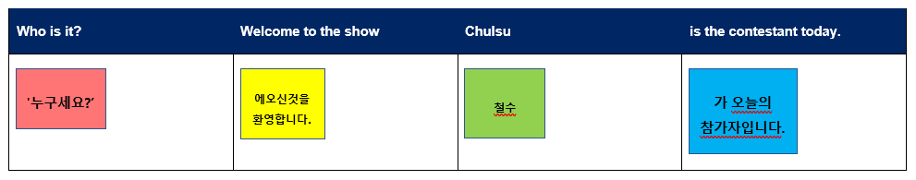

Week 5 – assessment criteria and practice task
The table below outlines the learning intention and success criteria of the lesson, and materials that the teacher and students will need to complete the teaching and learning activities.
Learning intention and success criteria | Materials
Students will develop a clear understanding of the requirements of the assessment task.  Students can:  - suggest appropriate success criteria  - explain what they need to do to be successful in the task. | - Resource 4 – question cards  - Resource 6 – sentence scaffold  - Hand puppets

Activity 1 – speed chatting with puppets
- Divide students into pairs and give each student a hand puppet.
- Explain that they will be role-playing different puppet characters and speed chatting by taking turns asking and answering questions about their puppet's appearance and characteristics.
- Provide each pair with a set of Resource 4 – question cards.
- Model the activity by selecting a student volunteer. Take on a puppet character and have the student do the same. Demonstrate the back-and-forth questioning and answering as puppet characters.
- Instruct student pairs to begin speed chatting as their puppet characters, taking turns asking and answering questions from the cards. Encourage them to be creative with their puppet voices and personalities.
- After a few minutes, have pairs switch puppets with each other and continue the speed chatting with new puppet identities.
- Circulate around the classroom, monitoring the conversation and providing support if needed.
Example interaction:
- Host: 누구세요? 에 오신 것을 환영해요. 철수가 오늘의 참가자예요. 누가 카드에 있는지 5개의 질문을 할 수 있어요. (Welcome to ‘Who is it?’ Chulsu is the contestant today. You have 5 questions to guess who is on this card.)
- Contestant: 남자아이예요? (Is it a boy?)
- Host: 네 (Yes)
- Contestant: 그는 곱슬머리예요? (Does he have curly hair?)
- Host: 아니요 (No)
- Contestant: 그는 키가 작아요? (Is he short?)
- Host: 네 (Yes)
- Contestant: 그는 갈색 눈이에요? (Does he have brown eyes?)
- Host: 네 (Yes)
- Contestant: 정수예요? (Is it Jung su?)
- Host: 네! 축하해요! (Yes! Congratulations!)

Activity 2 – assessment task
Explain the communicative task: You are a contestant in a game show ‘Who is it?’. You need to guess the identity of a person based on clues about their appearance, age, gender, hair and eye colour.
Point out that:
- the context of the task is that your school is hosting a game show
- the audience of the communication will be the host of the show
- the communicative purpose or reason is to guess the name of a person.

Activity 3 – success criteria
After looking at the assessment task, students Think-Pair-Share and suggest appropriate success criteria, for example:
I will be successful if I can:
- use appropriate greetings with the host and audience such as 안녕하세요 (hello).
- ask questions about eye colour, hair, gender, and height, for example 그는 곱슬 머리예요? (does he have curly hair?)
- say words in the right order
- speak loudly and clearly
- use the correct subject particle 이 (e) or 가 (ga) when introducing contestants.
Explain Resource 7 – student rubric and adjust if necessary.

Activity 4 – practice task
- Distribute a copy of Resource 4 – question cards and a copy of Resource 6 – sentence scaffold.
- Divide students into pairs to play a mini game of 누구세요? (‘Who is it?’).
- Each student will have a turn being the contestant and use Resource 4 – question cards to ask the host questions about the mystery classmate, while the host will use Resource 6 – sentence scaffold to introduce the contestant and respond to the questions.
- Once the contestant has guessed correctly, they swap over so that each student will get a chance to act in both roles.
- Below is a sample interaction illustrating the conversation patterns students should follow.
Example interaction:
- Host: ‘누구세요?’에 오신 것을 환영해요. 철수가 오늘의 참가자예요. 누가 카드에 있는지 5개의 질문을 할 수 있어요. (Welcome to ‘Who is it?’ Chulsu is the contestant today. You have 5 questions to guess who is on this card.)
- Contestant: 남자아이예요? (Is it a boy?)
- Host: 네 (Yes)
- Contestant: 그는 곱슬머리예요? (Does he have curly hair?)
- Host: 아니요 (No)
- Contestant: 그는 키가 작아요? (Is he short?)
- Host: 네 (Yes)
- Contestant: 그는 갈색 눈이에요? (Does he have brown eyes?)
- Host: 네 (Yes)
- Contestant: 정수예요? (Is it Jung su?)
- Host: 네! 축하해요! (Yes! Congratulations!)
Note: Advanced students can ask additional questions not on the questions cards.

Week 6 – communicative task – Game show – Who is it?
The table below outlines the learning intention and success criteria of the lesson, and materials that the teacher and students will need to complete the teaching and learning activities.
Learning intention and success criteria | Materials
Students will ask questions about eye colour, type of hair and height.  Students can:  - use appropriate greetings with the host and audience such as 안녕하세요 (hello).  - ask questions about eye colour, hair, gender, and height, for example 그는 곱슬 머리예요? (does he have curly hair?)  - say words in the right order  - speak loudly and clearly  - use the correct subject particle 이 (e) or 가 (ga) when introducing contestants. | - Resource 8 – peer feedback strategy – Two stars and a wish  - Microphone (if possible)  - Recording device

Activity 1 – task set-up
Students get into groups of 3. Groups are given a few minutes to ensure everybody knows the order in which they will perform each role. The contestant is the student who will be completing the assessed communicative task.
Suggested rotations:
- Role-play 1: Student 1 – Host, Student 2 – Contestant, Student 3 – Peer-assessor/Camera operator
- Role-play 2: Student 1 – Peer-assessor/Camera operator, Student 2 – Host, Student 3 – Contestant
- Role-play 3: Student 1 – Contestant, Student 2 – Peer-assessor/Camera operator, Student 3 – Host

Activity 2 – communicative task – Guess, who is it?
Note: make sure to space students apart when filming. Demonstrate how to film using a recording device. Use microphones, if possible, to maximise sound quality. Highlight the importance of holding the recording device still by using a tripod or resting it on a table.
Students get into groups of 3 and complete the task.
Example interaction:
- Host: 누구세요? 에 오신 것을 환영해요. 철수가 오늘의 참가자예요. 누가 카드에 있는지 5개의 질문을 할 수 있어요. (Welcome to ‘Who is it?’ Chulsu is our contestant today. You have 5 questions to guess who is on this card.)
- Contestant: 남자아이예요? (Is it a boy?)
- Host: 네 (Yes)
- Contestant: 그는 곱슬머리예요? (Does he have curly hair?)
- Host: 아니요 (No)
- Contestant: 그는 키가 작아요? (Is he short?)
- Host: 네 (Yes)
- Contestant: 그는 갈색 눈이에요? (Does he have brown eyes?)
- Host: 네 (Yes)
- Contestant: 정수예요? (Is it Jung su?)
- Host: 네! 축하해요. (Yes! Congratulations!)
Note: before recording interactions, check if any students do not have permission to be filmed. Alternatives to video recording include audio recording or the teacher watching the interactions while taking notes and marking the rubric.

Activity 3 – peer assessment
Note: this may be the first time students have engaged in peer assessment. As a result, you may need to provide further explanation on why this is important, and what students should and should not do while giving and receiving peer assessment.
- Students pair up and give each other feedback on the questions they asked using Resource 8 – peer feedback strategy – Two stars and a wish.
- Explain that it is important that students check not only their own work, but also provide feedback to classmates regarding their work. Remind students that they need to be respectful to each other when giving and receiving feedback.
- Co-construct ‘ground rules’ for peer feedback. It may be helpful to provide sentence starters to prompt students. For example, ‘I like the way …’, ‘You did an excellent job of …’, ‘My favourite part was …’, ‘I didn’t understand …’. Emphasise that the peer feedback should be related to the visual rubric provided for this task.
- Each student will provide and receive feedback to the student who was the contestant when they had the role of peer assessor/camera operator. Peer feedback is provided verbally and may be followed up with a completed peer feedback slip.

Week 7 – feedback and goal setting
Note: if there is insufficient time to mark the videos before Week 8, Weeks 7 and 8 can be swapped.
The table below outlines the learning intention and success criteria of the lesson, and materials that the teacher and students will need to complete the teaching and learning activities.
Learning intention and success criteria | Materials
Students will reflect on recordings of themselves completing the task to assess how well they completed the task and to set learning goals.  Students can:  - accurately self-assess their completion of the task  - set appropriate learning goals based on previous learning goals and teacher-, peer- and self-assessment. | - Resource 1 – describing people flashcards  - Korean exercise books
Note: prior to this lesson, view each video and mark each student according to the criteria on the rubric for communicative language tasks.

Activity 1 – ‘Beat the teacher’
- Introduce the activity as a listening game to practise describing people.
- Display one image at a time from Resource 1 – describing people flashcards, making sure they are visible to all students but not to yourself.
- Try to describe the person on the card. If the description matches the image on the card, the class must all repeat it immediately. If this happens, students get a point.
- If your description doesn't match the image, the class remains silent and doesn’t repeat the description.
- If students repeat the wrong description, then you get a point. If all students stay silent, the students get a point.

Activity 2 – self-assessment
Students watch the video of themselves completing the task and mark themselves using the rubric. Students then compare both the teacher completed rubric and the one they completed.

Activity 3 – set learning goals
- Students reflect on the teacher-, peer- and self-evaluation to set learning goals for the next phase of learning. Example learning goals could be: ‘I will not be worried about making a mistake when speaking Korean’. Learning goals are written in their language notebooks.
Note: this may be the first time students will be setting learning goals. Students will choose a suggested learning goal from the list below by raising their hand.
- To foster student ownership of their learning, facilitate a class discussion to help students reflect on their marked rubric, peer- and self-assessment and set their own personalised learning goals for the next phase. Use simplified language to ensure that the students can understand and engage with the discussion effectively.
- Suggest learning goals, such as:
- I will be confident when saying words in Korean.
- I will try to say Korean words in the correct order.
- I will practise saying tricky sounds in Korean, for example, double consonants ㄲ, ㄸ, ㅃ, ㅆ, ㅉ.
- Encourage students to raise their hands when they hear a goal that resonates with them.
- Students record their learning goals.
Evaluation: students set appropriate learning goals based on previous learning goals and/or teacher-, peer and self-assessment.

Week 8 – language review
Note: if there is insufficient time to mark the videos before Week 8, Weeks 7 and 8 can be swapped.
The table below outlines the learning intention and success criteria of the lesson, and materials that the teacher and students will need to complete the teaching and learning activities.
Learning intention and success criteria | Materials
Students will review the language learned during this unit to be able to give class instructions.  Students can:  - ask questions about vocabulary, grammar or pronunciation they have used in this unit  - use the Korean they have learned to communicate with classmates. | - Resource 1 – describing people flashcards  - Coloured pencils  - Erasers  - Individual whiteboards  - Markers  - Paper
Note: over the course of the unit, gaps in student knowledge, misconceptions and misuse of language will have been identified. These observations are addressed using engaging and interactive activities and strategies. The activities below are examples and will need to be supplemented with activities to address your observations.

Activity 1 – student questions
Remind students of the activities and tasks they have completed over the course of the unit. Give students time to Think-Pair-Share any questions they may have about any aspect of the language taught.

Activity 2 – ‘Snowman’
- Display images from Resource 1 – describing people flashcards.
- Set up the board for ‘Snowman’ with gaps marked out for the letters in the words, for example, 곱슬 머리 (curly hair).
- Display the 24 letters of the Korean alphabet.
- Students are invited to guess a letter in the words. When a letter is guessed, it is crossed out from the displayed alphabet.
- If a letter is guessed correctly, it is written in the appropriate gap(s). When letters are incorrectly guessed, parts of a snowman are drawn with each incorrect guess. The class can have a set number of incorrect guesses before the snowman is completed.
- The class can have 7 incorrect guesses which equate to the following:
- one large circle for the base
- a smaller circle for the body
- one small circle for the head
- two guesses for the eyes
- one guess for a carrot nose
- one smile to finish.
- Additional guesses can be allowed by adding arms and hands.
- The class will win if they can fill all the gaps before the body of the snowman is drawn.
- A student is selected to lead the next round.
Figure 4 – example of a snowman


Activity 3 – draw the character
- The teacher describes a student from the class or a famous person in Korean, focusing on physical features like eye colour, hair type, and so on.
- Students draw the person being described with coloured pencils and paper, adding features as the teacher provides more description.
- Students can ask yes or no questions in Korean to get more information about the person in their picture, like 그는 곱슬 머리예요? (Does he have curly hair?)
- The teacher responds only with네 ne (yes) or아니요 aniyo (no) until one student can guess the identity of the person the teacher has in mind based on their picture and the information gathered through questioning.
- In small groups, students take turns describing a person for their classmates to draw and then guess who was being described.

Student resources

Resource 1 – describing people flashcards
 |  |  |  |  |  |  |  | 
긴 머리 |  | 짧은 머리 |  | 곱슬 머리 |  | 직모 머리 |  | 검정 머리
 |  |  |  |  |  |  |  | 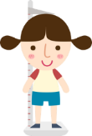
갈색 눈 |  | 초록 눈 |  | 파란 눈 |  | 키가 커요 |  | 키가 작아요

long hair |  | short hair |  | curly hair |  | straight hair |  | black hair
 |  |  |  |  |  |  |  | 
brown eyes |  | green eyes |  | blue eyes |  | tall |  | short
This resource can be adapted by replacing the text to suit your language.

Resource 2 – describing people labelling sheet
Name:_____________________________________________
Label the pictures
Label each picture using the correct Korean word.
 |  | 
 |  | 
 |  | 

long hair | curly hair | short
blue eyes | tall | brown eyes
이름:_____________________________________________
자르고 붙히기 활동
올바른 한국어 단어를 사용하여 각 그림에 라벨을 붙이세요.

긴 머리 | 곱슬 머리 | 키가 작아요
파란 눈 | 키가 커요 | 갈색 눈
This resource can be adapted by replacing the text to suit your language.

Resource 3 – bingo card
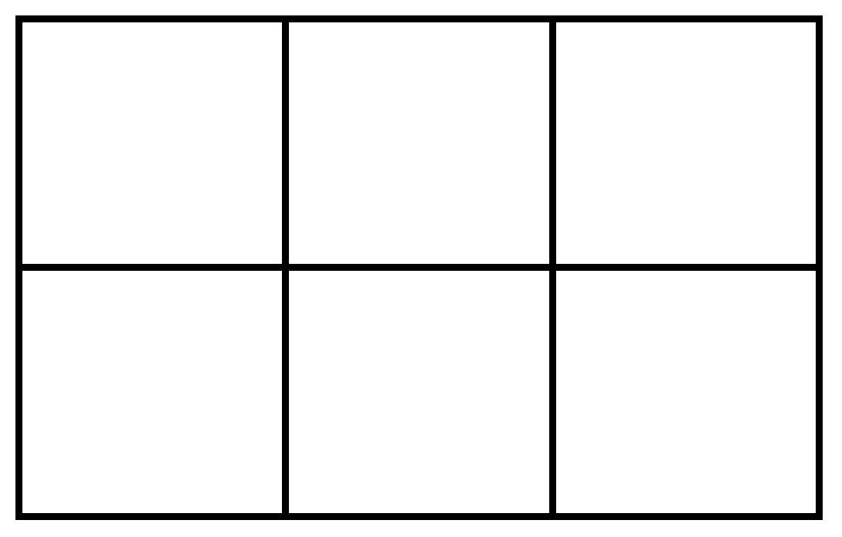

Resource 4 – question cards
Is this a boy or a girl? |  | Is he/she tall?
Is he/she short? |  | Does he/she have brown eyes?
남자아이예요? namja-aieyo?  여자아이예요? yeoja-aieyo? |  | 그는 키가 커요?  geunneun-kiga-keoyo?  그녀는 키가 커요?  geunyeoneun-kiga-keoyo?
그는 키가 작아요?  geuneun-kiga-jag-ayo?  그녀는 키가 작아요?  geunyeoneun-kiga-jag-ayo? |  | 그는 갈색 눈이에요?  geuneun galsaeg nun-ieyo?  그녀는 갈색 눈이에요?  geunyeoneun galsaeg nun-ieyo?
Does he/she have green eyes? |  | Does he/she have blue eyes?
Does he/she have curly hair? |  | Does he/she long hair?
그는 초록 눈이에요?  geuneun cholog nun-ieyo?  그녀는 초록 눈이에요?  geunyeoneun cholog nun-ieyo? |  | 그는 파란 눈이에요?  geuneun palan nun-ieyo?  그녀는 파란 눈이에요?  geunyeoneun palan nun-ieyo?
그는 곱슬머리예요?  geuneun gobseulmeoliyeyo?  그녀는 곱슬머리예요?  geunyeoneun gobseulmeoliyeyo? |  | 그는 긴 머리예요?  geunyeoneun gin meoliyeyo?  그녀는 긴 머리예요?  geuneun gin meolilyeyo?

Does he have short hair?  Does she have short hair? |  | Does he have straight hair?  Does she have straight hair? |  | Is it [name]?

그는 짧은 머리예요?  geunyeoneun jjalb-eun meoliyeyo?  그녀는 짧은 머리예요?  geuneun jjalb-eun meoliyeyo? |  | 그는 직모예요?  geunneun jigmoyeyo?  그녀는 직모예요?  geunyeoneun jigmoyeyo? |  | [이름] 이에요/예요?  [Name] ieyo/yeyo?

Yes |  | No
네  ne |  | 아니요  aniyo

Resource 5 – subject particles game cards
SUBJECT PARTICLES | Is it 이 or 가?
If you think it is 이 make your hand like this. | If you think it is 가 make your hand like this.

James is the contestant today.
제임스가/이 오늘의 참가자예요.

James is the contestant today.
제임스가/이 오늘의 참가자예요.
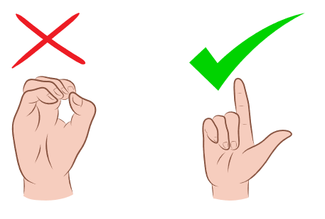
Susan is the contestant today.
수잔가/이 오늘의 참가자예요.
Susan is the contestant today.
수잔가/이 오늘의 참가자예요.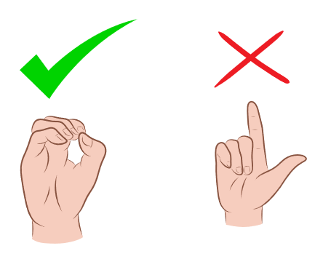

Resource 6 – sentence scaffold
Who is on the card | number | have questions to guess
누가 카드에 있는지  nuga kadeue issneunji | 3 개의  segaeui | 질문을 할 수 있어요.  jilmun-eul hal su issseoyo.
4 개의
negaeui
5 개의
daseosgaeui

You have | [number] questions | to guess who is on the card.
 | 3
 | 4
 | 5

Welcome to the game show | Who is it? | [Name] | is the contestant today.
에 오신 것을 환영해요  e osin geos-eul hwan-yeonghaeyo | 누구세요?  ‘Nuguseyo?’ | 철수  Chulsu | 가 오늘의 참가자예요.  ga oneul-ui chamgajayeyo.

Resource 7 – student rubric
I can greet the host of the show.
I can ask questions about eye colour, hair, gender, and height.
I can speak loudly and clearly.
I can say words in the right order.
I can use the correct subject particle 이 (e) or 가 (ga) when introducing contestants.

Resource 8 – peer feedback strategy – Two stars and a wish
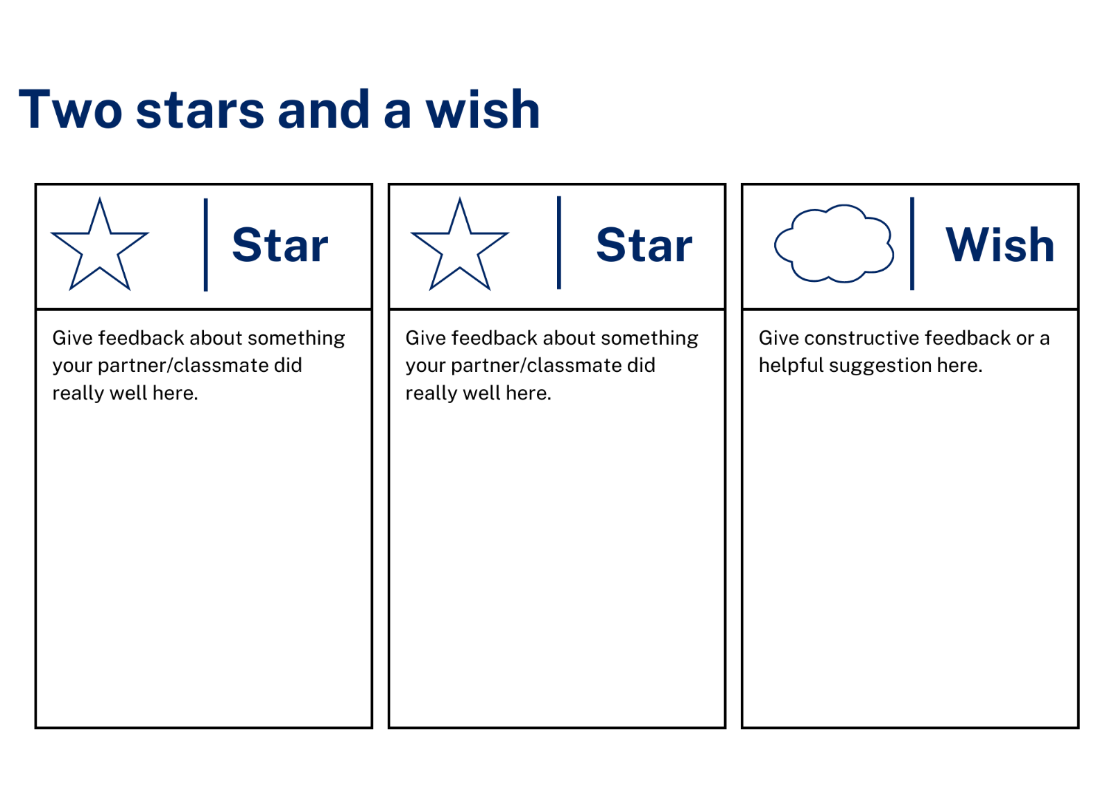

Support and alignment
Resource evaluation and support: all curriculum resources are prepared through a rigorous process. Resources are periodically reviewed as part of our ongoing evaluation plan to ensure currency, relevance, and effectiveness. For additional support or advice, contact the Primary Languages team by emailing primlang@det.nsw.edu.au.
Alignment to system priorities and/or needs: School Excellence Policy
Alignment to the School Excellence Framework: this resource supports the School Excellence Framework elements of curriculum (curriculum provision, teaching and learning programs) and effective classroom practice (lesson planning).
Alignment to Australian Professional Teaching Standards: this resource supports teachers to address Australian Professional Teaching Standards 2.2.2, 3.2.2.
Consulted with: Curriculum, Secondary Learners, school-based staff and NESA subject matter experts. Advice from Aboriginal Outcomes and Partnerships, EAL/D, HPGE and Inclusive Education for Modern Languages Stage 3 Italian Mangiare in Ristorante has been considered in preparing this document.
NSW syllabus: Modern Languages K–10 Syllabus
Syllabus outcomes: ML1-INT-01, ML1-UND-01, ML1-CRT-01
Author: Primary Curriculum
Publisher: State of NSW, Department of Education
Resource: unit
Related resources: further resources to support Stage 1 Modern Languages can be found on the Languages K–6 curriculum page.
Professional learning: relevant professional learning is available through Primary Languages Statewide Staffroom on Teams (staff only).
Universal Design for Learning: support the diverse learning needs of students using inclusive teaching and learning strategies. Some students may require more specific adjustments to allow them to participate on the same basis as their peers. For further advice see Inclusive practice resources for primary school.
Differentiation: when using these resources in the classroom, it is important for teachers to consider the needs of all students in their class, including:
- Aboriginal and Torres Strait Islander students. Targeted strategies can be used to achieve outcomes for Aboriginal students in K-12 and increase knowledge and understanding of Aboriginal histories and cultures. Teachers should use students’ Personalised Learning Pathways to support individual student needs and goals.
- EAL/D learners. EAL/D learners may require scaffolding to support them to gain content knowledge, while providing extra time and assistance to master the English language required to engage with texts or complete classroom tasks. View some samples of differentiating through scaffolding.
- Students with additional learning needs. Learning adjustments enable students with disability and additional learning and support needs to access syllabus outcomes and content on the same basis as their peers. Teachers can use a range of adjustments to ensure a personalised approach to student learning.
- High potential and gifted learners. Assessing and identifying high potential and gifted learners will help teachers decide which students may benefit from extension and additional challenge. In addition, the Differentiation Adjustment Tool can be used to support the specific learning needs of high potential and gifted students.
Creation date: 4 March 2024
Rights: © State of New South Wales, Department of Education

References
This resource contains NSW Curriculum and syllabus content. The NSW Curriculum is developed by the NSW Education Standards Authority. This content is prepared by NESA for and on behalf of the Crown in right of the State of New South Wales. The material is protected by Crown copyright.
Please refer to the NESA Copyright Disclaimer for more information https://educationstandards.nsw.edu.au/wps/portal/nesa/mini-footer/copyright.
NESA holds the only official and up-to-date versions of the NSW Curriculum and syllabus documents. Please visit the NSW Education Standards Authority (NESA) website https://educationstandards.nsw.edu.au/wps/portal/nesa/home and the NSW Curriculum website https://curriculum.nsw.edu.au.
Modern Languages K–10 Syllabus © NSW Education Standards Authority (NESA) for and on behalf of the Crown in right of the State of New South Wales, 2022.
8 Ways (n.d.) 8 Aboriginal Ways of Learning [website], accessed 13 December 2022.
AITSL (Australian Institute for Teaching and School Leadership (2017) ‘Feedback Factsheet’, AITSL, accessed 4 March 2024.
Brookhart SM (2011) How to Assess Higher-Order Thinking Skills in Your Classroom, Hawker Brownlow Education, Victoria.
CESE (Centre for Education Statistics and Evaluation) (2020a) What works best: 2020 update, NSW Department of Education, accessed 4 March 2024.
CESE (Centre for Education Statistics and Evaluation) (2020b) What works best in practice, NSW Department of Education, accessed 4 March 2024.
Conti G (28 September 2015) ‘16 tips for effective grammar teaching in the foreign language classroom’, The Language Gym, accessed 4 March 2024.
Conti G (28 May 2017) ‘From Target Language to Model Language – the mind shift that has transformed my teaching’, The Language Gym, accessed 4 March 2024.
Henshaw FG and Hawkins MD (2022) Common Ground: Second Language Acquisition Theory Goes to the Classroom, Focus, Indianapolis, accessed 4 March 2024.
Jones J and Wiliam D (2014) Modern Foreign Languages Inside the Black Box: Assessment for Learning in the Modern Foreign Languages Classroom (Black P, Harrison C, Marshall B and Wiliam D eds), Learning Sciences International, United States.
NESA (NSW Education Standards Authority) (2020) ‘NSW Curriculum Review – final report’, NESA, accessed 04 March 2024.
Rosenshine B (2012) ‘Principles of Instruction: Research-Based Strategies That All Teachers Should Know’, American Educator, 36(1):12–19, 39, accessed 4 March 2024.
Smith S (2022) Becoming an Outstanding Languages Teacher, 2nd edn, Routledge, United Kingdom.
Wisniewski B, Zierer K and Hattie J (2020) ‘The Power of Feedback Revisited: A Meta-Analysis of Educational Feedback Research’, Frontiers In Psychology, 10(3087), doi:10.3389/fpsyg.2019.03087, accessed 4 March 2024.
Wiliam D (2013) ‘Assessment: The bridge between teaching and learning’, Voices from the Middle, 21(2):15–20, accessed 4 March 2024.
Wiliam D and Leahy S (2015) Embedding Formative Assessment: Practical Techniques for K–12 Classrooms, Learning Sciences International, United States.

© State of New South Wales (Department of Education), 2024
The copyright material published in this resource is subject to the Copyright Act 1968 (Cth) and is owned by the NSW Department of Education or, where indicated, by a party other than the NSW Department of Education (third-party material).
Copyright material available in this resource and owned by the NSW Department of Education is licensed under a Creative Commons Attribution 4.0 International (CC BY 4.0) license.

This license allows you to share and adapt the material for any purpose, even commercially. Attribution should be given to © State of New South Wales (Department of Education), 2024.
Material in this resource not available under a Creative Commons license:
- the NSW Department of Education logo, other logos and trademark-protected material
- material owned by a third party that has been reproduced with permission. You will need to obtain permission from the third party to reuse its material.
Links to third-party material and websites
Please note that the provided (reading/viewing material/list/links/texts) are a suggestion only and implies no endorsement, by the New South Wales Department of Education, of any author, publisher, or book title. School principals and teachers are best placed to assess the suitability of resources that would complement the curriculum and reflect the needs and interests of their students.
If you use the links provided in this document to access a third-party's website, you acknowledge that the terms of use, including licence terms set out on the third-party's website apply to the use which may be made of the materials on that third-party website or where permitted by the Copyright Act 1968 (Cth). The department accepts no responsibility for content on third-party websites.

