Do you like …? – Σου αρέσει/αρέσουν…;

Activity 1
In the ‘L η γνώμη μου’ column of the table below, write your opinion of the school subject indicated. Choose from Μου αρέσει/αρέσουν πολύ (😍), Μου αρέσει/αρέσουν (😊), Μου αρέσει/αρέσουν λίγο (🙂), Δε μου αρέσει/αρέσουν (😑) or Δε μου αρέσει/αρέσουν καθόλου (😖). The first one has been done for you as an example. Take care with ‘Maths’, ‘English’ and ‘Greek’ as the verb changes to αρέσουν.
When you have finished, ask a classmate in Greek whether they like the subjects in the table to see if they agree with you or not. Write their opinions in the ‘Φίλος/Φίλη’ column on the right-hand side. The first one has been done for you as an example. If your classmate agrees with you, remember to say ‘Κι εμένα!’ (‘Me too!’) and if they disagree, say ‘εντάξει’ (‘OK’).
Μάθημα | L η γνώμη μου | Φίλος/Φίλη
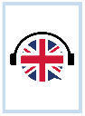 | Μου αρέσουν τα αγγλικά. | δεν του αρέσουν.
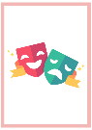
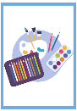

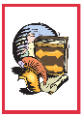
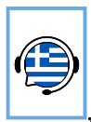
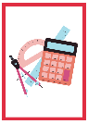
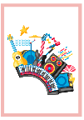
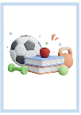



Activity 2
Listen to students talking about school. Complete the table below in English by identifying what the school subject is and how much the student likes or dislikes the subject. The first one has been done for you as an example.
Student | Μάθημα | Γνώμη
1 | History | Doesn’t like it at all
2
3
4
5
6

Activity 3
Choose any 4 subjects and give your own opinion of each of them by writing a full sentence in Greek using the space below.

For the teacher
Remove this section before sharing this resource with students.

Activity 2

Audio file
Activity 2 – do you like (1:01)

Transcript
- Δε μου αρέσει καθόλου η ιστορία.
- Μου αρέσει πολύ η επιστήμη.
- Σου αρέσει η μουσική; Μου αρέσει λίγο.
- Δε μου αρέσουν τα μαθηματικά.
- Μου αρέσουν τα αγγλικά αλλά προτιμώ τα ελληνικά.
- Μου αρέσει λίγο η φυσική αγωγή.
Student | Μάθημα | Γνώμη
1 | History | Doesn’t like it at all
2 | Science | Really likes it
3 | Music | Likes it a bit
4 | Mathematics | Doesn’t like it at all
5 | English or Greek | Likes or prefers it
6 | PDHPE | Likes it a bit

© State of New South Wales (Department of Education), 2025
The copyright material published in this resource is subject to the Copyright Act 1968 (Cth) and is owned by the NSW Department of Education or, where indicated, by a party other than the NSW Department of Education (third-party material).
Copyright material available in this resource and owned by the NSW Department of Education is licensed under a Creative Commons Attribution 4.0 International (CC BY 4.0) license.

This license allows you to share and adapt the material for any purpose, even commercially.
Attribution should be given to © State of New South Wales (Department of Education), 2025.
Material in this resource not available under a Creative Commons license:
- the NSW Department of Education logo, other logos and trademark-protected material
- material owned by a third party that has been reproduced with permission. You will need to obtain permission from the third party to reuse its material.
Links to third-party material and websites
Please note that the provided (reading/viewing material/list/links/texts) are a suggestion only and implies no endorsement, by the New South Wales Department of Education, of any author, publisher, or book title. School principals and teachers are best placed to assess the suitability of resources that would complement the curriculum and reflect the needs and interests of their students.
If you use the links provided in this document to access a third-party's website, you acknowledge that the terms of use, including licence terms set out on the third-party's website apply to the use which may be made of the materials on that third-party website or where permitted by the Copyright Act 1968 (Cth). The department accepts no responsibility for content on third-party websites.

