At what time …? Τι ώρα είναι…; – profile cards

Activity 1
Your teacher will give you a profile card. Imagine you are the person on the card and write your answers to the following questions in Greek:
- Πόσω(ν) χρονών είσαι;
- Πού μένεις;
- Πώς πηγαίνεις στο σχολείο; Με αυτοκίνητο; Με τρένο;
- Τι ώρα πηγαίνεις στο σχολείο;
- Τι ώρα πηγαίνεις σπίτι;
- Τι ώρα τρως στο σχολείο;

Activity 2 – find someone who …
In the ‘My answer’ column, write your answers from Activity 1. Next, interact with other class members using the questions from Activity 1 to find someone who has the same answer as you for each question. Write the name from their profile card in the space provided in the table below. To ask about and say names, remember to use the Πώς σε λένε; Με λένε… structure.
Question | My answer | Matching person’s name
1
2
3
4
5
6

For the teacher
Remove this section before sharing this resource with students.
Print and cut out these cards prior to the activity. Provide each student with a different profile card.
Name: Elias  Age: 15  City: Athens  Arrive: 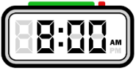  Eat: 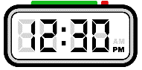  Go home: 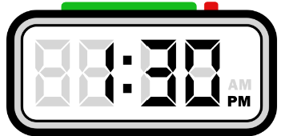  Transport:  | Name: Anastasia  Age: 17  City: Athens  Arrive: 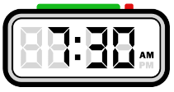  Eat:  Go home: 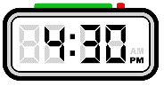  Transport:  | Name: Michalis  Age: 16  City: Athens  Arrive:  Eat: 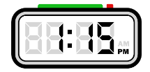  Go home: 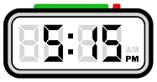  Transport:
Name: Irene  Age: 11  City: Heraklion  Arrive:  Eat: 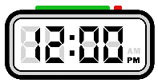  Go home:  Transport: | Name: Angeliki  Age:14  City: Heraklion  Arrive:  Eat:  Go home: 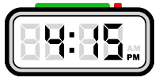  Transport: | Name: Katerina  Age: 16  City: Heraklion  Arrive: 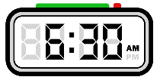  Eat: 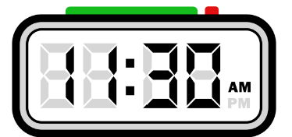  Go home:  Transport:

Name: Mitch  Age: 15  City: Bathurst  Arrive: 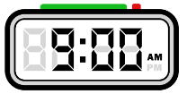  Eat: 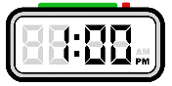  Go home:  Transport: | Name: Karim  Age: 14  City: Bathurst  Arrive: 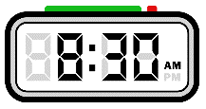  Eat:  Go home: 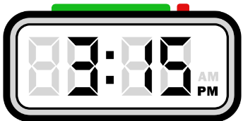  Transport: | Name: Beck  Age:13  City: Bathurst  Arrive:  Eat:  Go home:  Transport: 
Name: Matilda  Age: 12  City: Wollongong  Arrive:  Eat:  Go home: 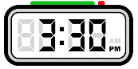  Transport: | Name: Pete  Age: 12  City: Wollongong  Arrive:  Eat:  Go home:  Transport: | Name: Indah  Age: 17  City: Wollongong  Arrive:  Eat:  Go home:  Transport: 

Name: Dimitra  Age: 14  City: Thessaloniki  Arrive:  Eat:  Go home:  Transport: | Name: Sophia  Age: 15  City: Thessaloniki  Arrive:  Eat:  Go home:  Transport: | Name: Christos  Age: 16  City: Thessaloniki  Arrive:  Eat:  Go home:  Transport:
Name: Dimitris  Age: 13  City: Patras  Arrive:  Eat:  Go home:  Transport: | Name: Yiannis  Age: 12  City: Patras  Arrive:  Eat:  Go home:  Transport: | Name: Eleni  Age: 14  City: Patras  Arrive:  Eat:  Go home:  Transport:

Name: Celine  Age: 15  City: Katoomba  Arrive:  Eat:  Go home:  Transport: | Name: Colette  Age: 16  City: Katoomba  Arrive:  Eat:  Go home:  Transport: | Name: Chen  Age: 17  City: Katoomba  Arrive:  Eat:  Go home:  Transport:
Name: Lin  Age: 13  City: Sydney  Arrive:  Eat:  Go home:  Transport: | Name: Ben  Age: 14  City: Sydney  Arrive:  Eat:  Go home:  Transport: | Name: Bai  Age: 15  City: Sydney  Arrive:  Eat:  Go home:  Transport:

Name: Yiorgos  Age: 11  City: Larissa  Arrive:  Eat:  Go home:  Transport: | Name: Diego  Age: 13  City: Larissa  Arrive:  Eat:  Go home:  Transport: | Name: Gianna  Age: 12  City: Larissa  Arrive:  Eat:  Go home:  Transport:
Name: Maria  Age: 14  City: Newcastle  Arrive:  Eat:  Go home:  Transport: | Name: Sofia  Age: 11  City: Newcastle  Arrive:  Eat:  Go home:  Transport: | Name: Lola  Age: 16  City: Newcastle  Arrive:  Eat:  Go home:  Transport:

© State of New South Wales (Department of Education), 2025
The copyright material published in this resource is subject to the Copyright Act 1968 (Cth) and is owned by the NSW Department of Education or, where indicated, by a party other than the NSW Department of Education (third-party material).
Copyright material available in this resource and owned by the NSW Department of Education is licensed under a Creative Commons Attribution 4.0 International (CC BY 4.0) license.

This license allows you to share and adapt the material for any purpose, even commercially.
Attribution should be given to © State of New South Wales (Department of Education), 2025.
Material in this resource not available under a Creative Commons license:
- the NSW Department of Education logo, other logos and trademark-protected material
- material owned by a third party that has been reproduced with permission. You will need to obtain permission from the third party to reuse its material.
Links to third-party material and websites
Please note that the provided (reading/viewing material/list/links/texts) are a suggestion only and implies no endorsement, by the New South Wales Department of Education, of any author, publisher, or book title. School principals and teachers are best placed to assess the suitability of resources that would complement the curriculum and reflect the needs and interests of their students.
If you use the links provided in this document to access a third-party's website, you acknowledge that the terms of use, including licence terms set out on the third-party's website apply to the use which may be made of the materials on that third-party website or where permitted by the Copyright Act 1968 (Cth). The department accepts no responsibility for content on third-party websites.

