Translation cue cards
This resource is for the teacher. It provides the content and instructions you need to share with students.
Students work in pairs or small groups. Use the cue cards provided or use the editable version on Canva to amend the content if required. Print and give each pair or group a copy of the cue cards below. To save time, ask students to cut out their own cue cards.
Students can use their books or mini whiteboards for this activity. Students place the cue cards face down in the middle of the table. Determine who will go first with a round of ‘Rock, paper, scissors’ (πέτρα, ψαλίδι και χαρτί).
To begin the activity, Student A draws a cue card and reads out the short text in English from the card and places the card to the side.
Student B translates the text into Greek on their mini whiteboard or in their book.
Student B then draws a card and reads the text as Student A translates the text into Greek. Student B places the card aside.
Once all cue cards have been used, students collect an answer sheet from the teacher. Students check each other’s translations against the answer sheet. Students receive a point for every text they have translated correctly. The student with the most points wins.
Differentiation examples
High potential and gifted students and students with advanced proficiency – provide more complex sentences on the cue cards; instead of writing down the translation, students can say the translation orally and their partner checks immediately with the answer sheet. If they have made an error, they can try again.
Students requiring additional support – provide students with a list of the translations. Students must select the correct translation which matches the English, rather than write it out independently.

Cue cards
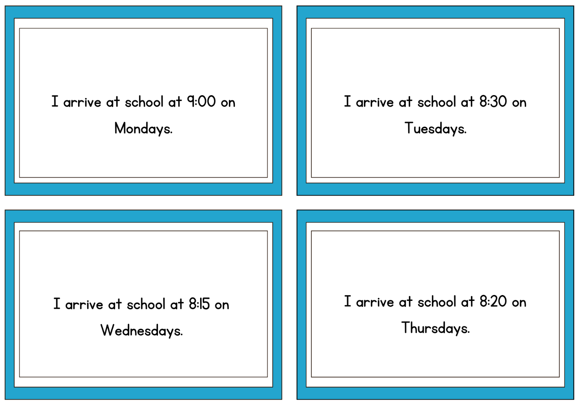
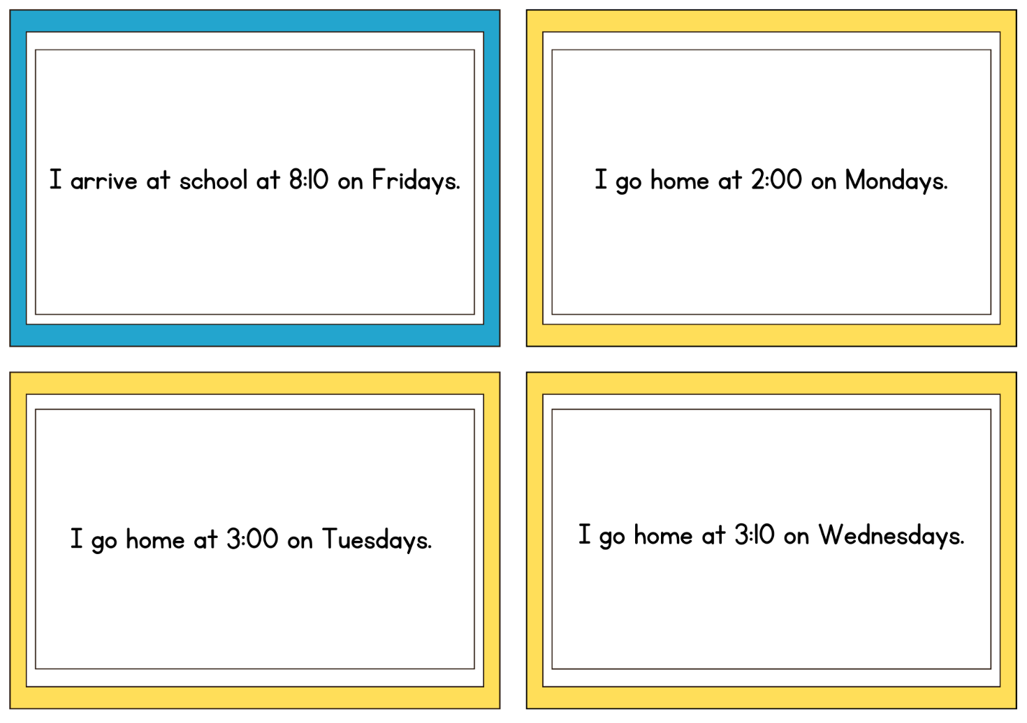
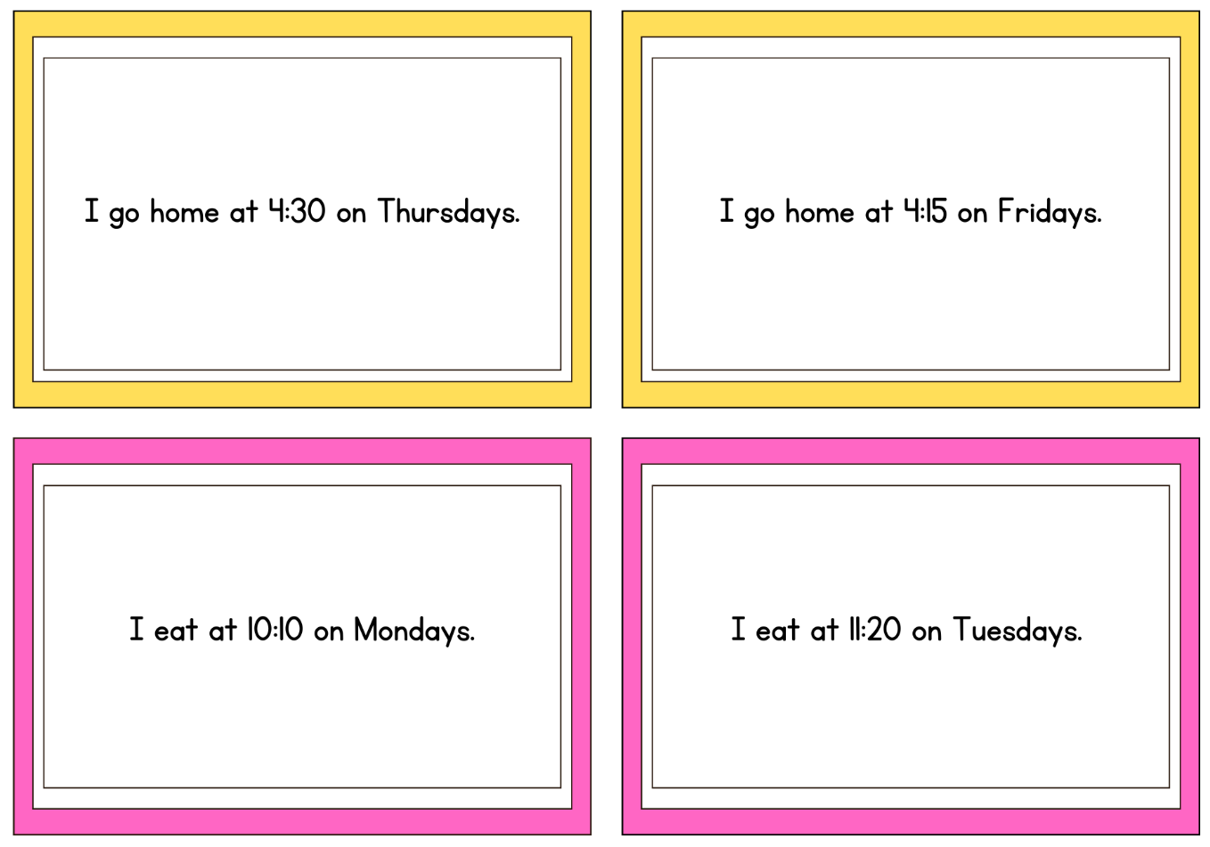
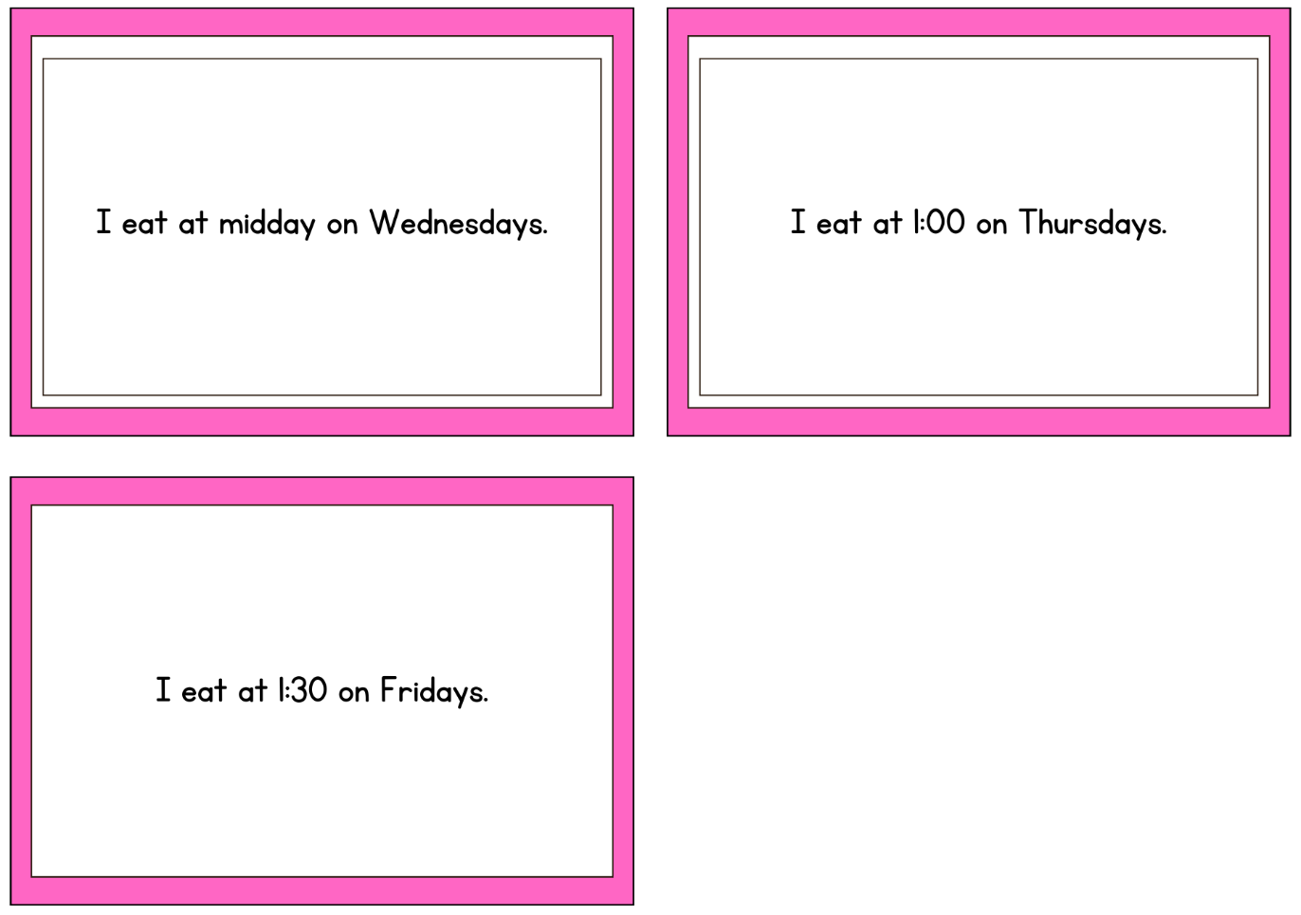

Answer sheet
- Πάω στο σχολείο στις εννέα την Δευτέρα.
- Πάω στο σχολείο στις οκτώ/οχτώ και μισή την Τρίτη.
- Πάω στο σχολείο στις οκτώ/οχτώ και δεκαπέντε/τέταρτο την Τετάρτη.
- Πάω στο σχολείο στις οκτώ/οχτώ και είκοσι την Πέμπτη.
- Πάω στο σχολείο στις οκτώ/οχτώ και δέκα την Παρασκευή.
- Πάω σπίτι στις δύο η ώρα τη Δευτέρα.
- Πάω σπίτι στις τρεις η ώρα την Τρίτη.
- Πάω σπίτι στις τρεις και δέκα την Τετάρτη.
- Πάω σπίτι στις τέσσερις και τριάντα/μισή την Πέμπτες.
- Πάω σπίτι στις τέσσερις και δεκαπέντε/τέταρτο την Παρασκευή.
- Τρώω στη δέκα και δέκα τη Δευτέρα.
- Τρώω στη έντεκα και είκοσι την Τρίτη.
- Τρώω στη μεσημέρι την Τετάρτη.
- Τρώω στη μία την Πέμπτη.
- Τρώω στη μία και τριάντα/μισή την Παρασκευή.

© State of New South Wales (Department of Education), 2025
The copyright material published in this resource is subject to the Copyright Act 1968 (Cth) and is owned by the NSW Department of Education or, where indicated, by a party other than the NSW Department of Education (third-party material).
Copyright material available in this resource and owned by the NSW Department of Education is licensed under a Creative Commons Attribution 4.0 International (CC BY 4.0) license.

This license allows you to share and adapt the material for any purpose, even commercially.
Attribution should be given to © State of New South Wales (Department of Education), 2025.
Material in this resource not available under a Creative Commons license:
- the NSW Department of Education logo, other logos and trademark-protected material
- material owned by a third party that has been reproduced with permission. You will need to obtain permission from the third party to reuse its material.
Links to third-party material and websites
Please note that the provided (reading/viewing material/list/links/texts) are a suggestion only and implies no endorsement, by the New South Wales Department of Education, of any author, publisher, or book title. School principals and teachers are best placed to assess the suitability of resources that would complement the curriculum and reflect the needs and interests of their students.
If you use the links provided in this document to access a third-party's website, you acknowledge that the terms of use, including licence terms set out on the third-party's website apply to the use which may be made of the materials on that third-party website or where permitted by the Copyright Act 1968 (Cth). The department accepts no responsibility for content on third-party websites.

