What time is it? – Τι ώρα είναι;

Activity 1 – break the flow
Listen to your teacher reading the times and identify where the spaces between words should be by drawing a line. The first one has been done as an example.
1. Είναιτρεις.
Είναι | τρεις.
2. Είναιμίακαιδέκα.
3. Είναιεννέακαιτέταρτο.
4. Είναιέντεκα.
5. Είναιοκτώκαιείκοσι.
6. Είναιεπτάκαιπέντε.
7. Είναιδύοκαιείκοσιπέντε.
8. Είναιμίακαιδέκα.
9. Είναιτέσσερις.
10. Είναιέξικαιμισή.

Activity 2 – Τι ώρα είναι;
Complete the clock face with the correct time as indicated. The first one has been done as an example.
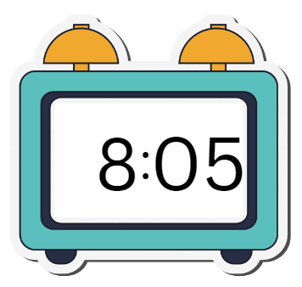 | - Είναι οχτώ/οκτώ και πέντε.
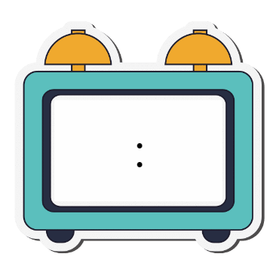 | - Είναι μία και δέκα.
 | - Είναι έντεκα και τέταρτο.
 | - Είναι εφτά και είκοσι.
 | - Είναι εννιά και πέντε.
 | - Είναι δύο και τέταρτο.
 | - Είναι έξι και μισή.
 | - Είναι μεσημέρι.
 | - Είναι δέκα.
 | - Είναι τρεις και μισή.

Activity 3 – write the time
Write the time in Greek according to the cues provided. The first one has been done as an example.
 | 7:00 | Είναι εφτά η ώρα.
 | 7:10
 | 8:05
 | 10:15
 | 11:20
 | 1:30
 | 2:10
 | 4:20
 | 5:25
 | 3:05

For the teacher
Remove this section before sharing this resource with students.

Activity 1 – break the flow

Audio file
Activity 1 – break the flow (1:17)

Answers
- Είναι|τρεις.
- Είναι|μία|και|δέκα.
- Είναι|εννιά|και|τέταρτο.
- Είναι|έντεκα.
- Είναι|οχτώ|και|είκοσι.
- Είναι|επτά|και|πέντε.
- Είναι|δύο|και|είκοσι πέντε.
- Είναι|μία|και|δέκα.
- Είναι|τέσσερις.
- Είναι|έξι|και|μισή.

Activity 2 – Τι ώρα είναι;
- 8:05
- 1:10
- 11:15
- 7:20
- 9:05
- 2:15
- 6:30
- 12:00
- 10:00
- 3:30

Activity 3 – write the time
 | 7:00 | Είναι επτά η ώρα.
 | 7:10 | Είναι επτά και δέκα.
 | 8:05 | Είναι οκτώ και πέντε.
 | 10:15 | Είναι δέκα και τέταρτο.
 | 11:20 | Είναι έντεκα και είκοσι.
 | 1:30 | Είναι μία και μισή.
 | 2:10 | Είναι δύο και δέκα.
 | 4:20 | Είναι τέσσερις και είκοσι.
 | 5:25 | Είναι πέντε και είκοσι πέντε.
 | 3:05 | Είναι τρεις και πέντε.

Activity 4 – Πότε κάνεις…;
This activity is optional and consolidates the vocabulary το πρωί, το απόγευμα, το βράδυ and τη νύχτα, if teaching these expressions to students.
Use this activity if you introduce times of the day with high potential and gifted students. A blank version of the activity can be found on the next page, for sharing with students.
Other responses are possible.
Activity | Time of day
Eat afternoon tea | το απόγευμα
Eat dinner | το βράδυ
Get home from school | το απόγευμα
Watch TV | το απόγευμα or το βράδυ
Eat breakfast | το πρωί
Go to school | το πρωί
Go to bed | τη νύχτα
Do homework | το απόγευμα or το βράδυ

Activity 4 – Πότε κάνεις…; (extension activity)
Write when most people do each activity, using το πρωί, το απόγευμα, το βράδυ or τη νύχτα.
Activity | Time of day
Eat dinner
Get home from school
Watch TV
Eat breakfast
Go to school
Go to bed
Do homework

© State of New South Wales (Department of Education), 2025
The copyright material published in this resource is subject to the Copyright Act 1968 (Cth) and is owned by the NSW Department of Education or, where indicated, by a party other than the NSW Department of Education (third-party material).
Copyright material available in this resource and owned by the NSW Department of Education is licensed under a Creative Commons Attribution 4.0 International (CC BY 4.0) license.

This licence allows you to share and adapt the material for any purpose, even commercially. Attribution should be given to © State of New South Wales (Department of Education), 2025.
Material in this resource not available under a Creative Commons licence:
- the NSW Department of Education logo, other logos and trademark-protected material
- material owned by a third party that has been reproduced with permission. You will need to obtain permission from the third party to reuse its material.
Links to third-party material and websites
Please note that the provided (reading/viewing material/list/links/texts) are a suggestion only and implies no endorsement, by the New South Wales Department of Education, of any author, publisher, or book title. School principals and teachers are best placed to assess the suitability of resources that would complement the curriculum and reflect the needs and interests of their students.
If you use the links provided in this document to access a third-party's website, you acknowledge that the terms of use, including licence terms set out on the third-party's website apply to the use which may be made of the materials on that third-party website or where permitted by the Copyright Act 1968 (Cth). The department accepts no responsibility for content on third-party websites.

