Ages and numbers

Activity 1
Write the Greek word for each number in the first column. In the third column, use this number in a sentence in response to the question Πόσων χρονών είσαι; or Πόσων χρονών είναι; to revise saying people’s ages. Use the prompt in the table: Εγώ (I), αυτός (he), αυτή (she), to formulate the correct response. The first 3 have been done for you as examples.
Remember to drop the final -α and add the -ων to numbers 3 and 4 to express age.
Number | Αριθμός | Πόσων χρονών είσαι; Πόσων χρονών είναι;
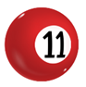 | έντεκα | (Εγώ)  Είμαι έντεκα.
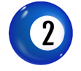 | δύο | (Αυτή)  Είναι δύο.
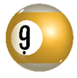 | εννέα | (Αυτός)  Είναι εννέα.
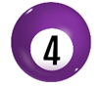 |  | (Εγώ)
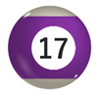 |  | (Αυτός)
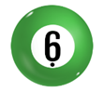 |  | (Αυτή)
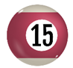 |  | (Εγώ)
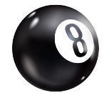 |  | (Αυτός)
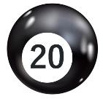 |  | (Εγώ)
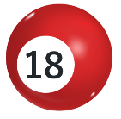 |  | (Αυτός)
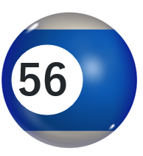 |  | (Εγώ)
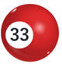 |  | (Αυτός)
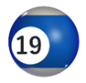 |  | (Αυτή)
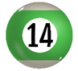 |  | (Εγώ)
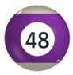 |  | (Αυτός)
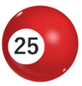 |  | (Εγώ)
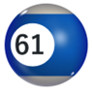 |  | (Αυτή)
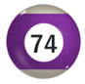 |  | (Εγώ)
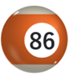 |  | (Αυτός)
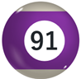 |  | (Αυτή)

Activity 2
Write the next number in each sequence in Greek:
- ένα, δύο, _________________________
- τρία, έξι, _________________________
- δώδεκα, έντεκα, _________________________
- έξι, επτά, _________________________
- δύο, τέσσερα, _________________________
- πέντε, επτά, _________________________
- έντεκα, είκοσι δύο, τριάντα τρία _________________________
- εκατό, ογδόντα πέντε, εβδομήντα, _________________________
- επτά, δεκατέσσερα, _________________________, _________________________, τριάντα πέντε

Activity 3
Solve the following math problems and write the answer in Greek.
- έντεκα + πενήντα = _________________________
- έξι + τριάντα = _________________________
- έντεκα – πέντε = _________________________
- τέσσερα + δεκατέσσερα = _________________________
- πέντε + δώδεκα = _________________________
- τριάντα δύο + σαράντα = _________________________.

For the teacher
Remove this section before sharing this resource with students.

Activity 1
Number | Αριθμός | Πόσων χρονών είσαι; Πόσων χρονών είναι;
 | έντεκα | (Εγώ)  Είμαι έντεκα χρονών.
 | δύο | (Αυτή)  Είναι δύο χρονών.
 | εννέα/εννιά | (Αυτός)  Είναι εννέα/εννιά χρονών.
 | τέσσερα | (Εγώ)  Είμαι τεσσάρων χρονών.
 | δεκαεπτά | (Αυτός)  Αυτός είναι δεκαεπτά χρονών.
 | έξι | (Αυτή)  Αυτή είναι έξι χρονών.
 | δεκαπέντε | (Εγώ)  Εγώ είμαι δεκαπέντε χρονών.
 | οκτώ/οχτώ | (Αυτός)  Αυτός είναι οκτώ/οχτώ χρονών.
 | είκοσι | (Εγώ)  Εγώ είμαι είκοσι χρονών.
 | δεκαοκτώ/δεκαοχτώ | (Αυτός)  Αυτός είναι δεκαοχτώ/δεκαοκτώ χρονών.
 | πενήντα έξι | (Εγώ)  Εγώ είμαι πενήντα έξι χρονών.
 | τριάντα τρία | (Αυτός)  Αυτός είναι τριάντα τριών χρονών.
 | δεκαεννέα/δεκαεννιά | (Αυτή)  Αυτή είναι δεκαεννέα/δεκαεννιά χρονών.
 | δεκατέσσερα | (Εγώ)  Εγώ είμαι δεκατεσσάρων χρονών.
 | σαράντα οχτώ | (Αυτός)  Αυτός είναι σαράντα οχτώ/οκτώ χρονών.
 | είκοσι πέντε | (Εγώ)  Εγώ είμαι είκοσι πέντε χρονών.
 | εξήντα ένα | (Αυτή)  Αυτή είναι εξήντα ένα χρονών.
 | εβδομήντα τέσσερα | (Εγώ)  Εγώ είμαι εβδομήντα τεσσάρων χρονών.
 | ογδόντα έξι | (Αυτός)  Αυτός είναι ογδόντα έξι χρονών.
 | ενενήντα ένα | (Αυτή)  Αυτή είναι ενενήντα ένα χρονών.

Activity 2
- ένα, δύο, τρία
- τρεις, έξι, εννέα/εννιά
- δώδεκα, έντεκα, δέκα
- έξι, επτά, οκτώ/οχτώ
- δύο, τέσσερα, έξι (οκτώ is also acceptable, if students doubled the numbers)
- πέντε, επτά, εννέα/εννιά
- έντεκα, είκοσι δύο, τριάντα τρία, σαράντα τέσσερα
- εκατό, ογδόντα πέντε, εβδομήντα, πενήντα πέντε
- επτά, δεκατέσσερα, είκοσι ένα, είκοσι οκτώ, τριάντα πέντε

Activity 3
1. έντεκα + πενήντα = εξήντα ένα
2. έξι + τριάντα = τριάντα έξι
3. έντεκα – πέντε = έξι
4. τέσσερα + δεκατέσσερα = δεκαοχτώ
5. πέντε + δώδεκα = δεκαεπτά
6. τριάντα δύο + σαράντα = εβδομήντα δύο

© State of New South Wales (Department of Education), 2025
The copyright material published in this resource is subject to the Copyright Act 1968 (Cth) and is owned by the NSW Department of Education or, where indicated, by a party other than the NSW Department of Education (third-party material).
Copyright material available in this resource and owned by the NSW Department of Education is licensed under a Creative Commons Attribution 4.0 International (CC BY 4.0) license.

This license allows you to share and adapt the material for any purpose, even commercially.
Attribution should be given to © State of New South Wales (Department of Education), 2025.
Material in this resource not available under a Creative Commons license:
- the NSW Department of Education logo, other logos and trademark-protected material
- material owned by a third party that has been reproduced with permission. You will need to obtain permission from the third party to reuse its material.
Links to third-party material and websites
Please note that the provided (reading/viewing material/list/links/texts) are a suggestion only and implies no endorsement, by the New South Wales Department of Education, of any author, publisher, or book title. School principals and teachers are best placed to assess the suitability of resources that would complement the curriculum and reflect the needs and interests of their students.
If you use the links provided in this document to access a third-party's website, you acknowledge that the terms of use, including licence terms set out on the third-party's website apply to the use which may be made of the materials on that third-party website or where permitted by the Copyright Act 1968 (Cth). The department accepts no responsibility for content on third-party websites.

