Clūdus

Instructions
Play this game in groups of 3 to 6 (depending on your class size).
For your game, your group will need:
- 9 locations chosen from the 12 locations provided below
- vīlla, vīllae (house, estate)
- silva, silvae (forest)
- taberna, tabernae (shop)
- insula, insulae (island, apartment block)
- rīpa, rīpae (riverbank)
- ōra, ōrae (seashore)
- hortus, hortī (garden)
- ager, agrī (field)
- rīvus, rīvī (stream)
- campus, campī (battlefield)
- mōns, montis (mountain)
- arbor, arboris (tree)
- 6 characters chosen from your textbook, or key historical or mythological figures, for example, Caecilius, Metella, Horatia, Quintus, Marcus, Cornelia, servus, ancilla, Caesar, Cicero, Theseus and Hera
- 6 instruments of murder
- amphora, amphorae (jug)
- flamma, flammae (fire)
- gladius, gladiī (sword)
- hasta, hastae (spear)
- pugiō, pugiōnis (dagger)
- toga, togae (toga)
- a gameboard
- a die
- a ‘Detective notes’ card for each player
- an Arcanum envelope
- playing tokens.

Rules

Set-up
As a group, decide on the characters and locations for your game. Write these names in the nominative and genitive cases on the cards and tokens, and on your own ‘Detective notes’ card.
Sort the characters, locations and weapons cards into 3 separate piles, by type, and shuffle. Without looking, one player takes one card from each pile and slides them into the Arcanum (‘Secret’) envelope and places the envelope on the board on the space marked cistā (trunk).
Shuffle all of the rest of the cards together and deal them clockwise to each player until all cards are dealt. Players may look at their own cards, but they are to be kept confidential by each player.
Place each character token in random locations around the board. The weapons tokens are placed to the side of the board.
Students use their birthdays (youngest to eldest) to determine the order of who gets to select their character.
Once each player has chosen their character token, the game begins with the youngest student going first, proceeding in a clockwise direction around the group. There may be more characters on the board than tokens. Those character tokens remain in place until an accusation is made – they are then moved to the location named in that accusation.

How to play
The aim of the game is to use deduction to work out:
- who committed the crime
- in what location
- with what instrument.
Take it in turns to roll a die and move your character that number of steps (forward or backward, left or right, but not diagonally) to try to land in different locations around the board.
Once you land on a location, you can make a suggestion by stating a murderer, the location you are in and a weapon, using the structure:
[Character in the nominative case] + in [location in the ablative] + [instrument in the ablative] hominem interfēcit. For example, Caecilius in campō hastā hominem interfēcit.
You can only use the location you are in for your suggestion.
When you make a guess, the tokens that you name in your suggestion (character and weapon) are also moved to your location.
If the player to your left has a card that matches one of your guesses, they must show you this card and state the phrase [the character/weapon/location in the accusative case] + habeō’, with the example, Pugiōnem habeō to reveal which card they have. If they have more than one card for a character, location or weapon you have used in your guess, they only need to show you one card of their choosing. If the player to your left is unable to show one of the cards in your suggestion, the next player along to their left checks their cards and shows you only one of the cards in your suggestion, and so on. When a card has been shown, your turn ends and play passes to the next player to the left.
You can only make one guess per turn. If you wish to make another guess from the same location, you must move out of it and re-enter the location by rolling the die.
Players use the ‘Detective notes’ cards to mark off the characters, locations and weapons eliminated from suspicion.
You may make a suggestion for a character, location or weapon whose card you hold in your hand.

Accusing
If you think you have solved the case by eliminating all the false possibilities and have not just had your suggestion disproved when it is your turn, you can make an ‘accusation’. Announce that you are making an accusation, and state your final guess of the murderer, the location and the murder weapon using the structure:
Accūsō [Character in the accusative case] + in [location in the ablative] + [instrument in the ablative]. For example, Accūsō Horātiam in insulā amphorā.
Once this is done, secretly look at the 3 cards in the murder envelope. If you are correct, lay the cards face-up on the table, proving to all players that you have won the game.
If you are wrong, you lose the game! Replace the cards in the Arcanum envelope without revealing them. Your turn is over, and you are now eliminated from the game, but must stay at the table to respond to the accusations of other players.

For the teacher
Remove this section before sharing this resource with students.
Print the gameboard on A3 paper to provide each group with their own board.
Print and cut up the cards and tokens or give them to students to cut out.

Locations – cards
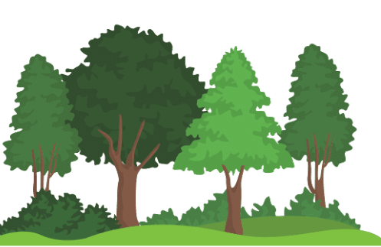  silva, silvae | 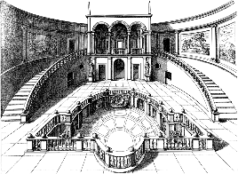  vīlla, vīllae | 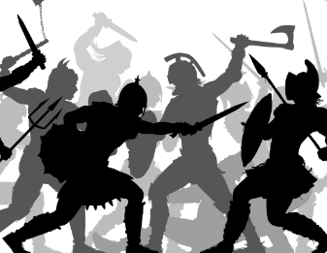 campus, campī |   ōra, ōrae | 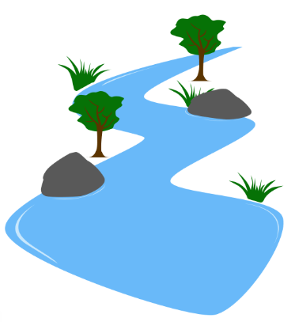  rīvus, rīvī
ager, agrī | mōns, montis | 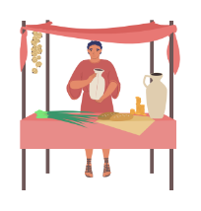taberna, tabernae |   arbor, arboris | 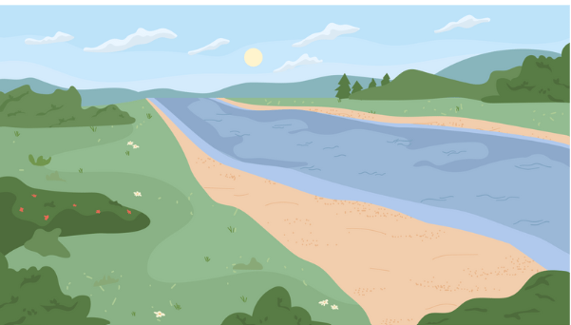  rīpa, rīpae
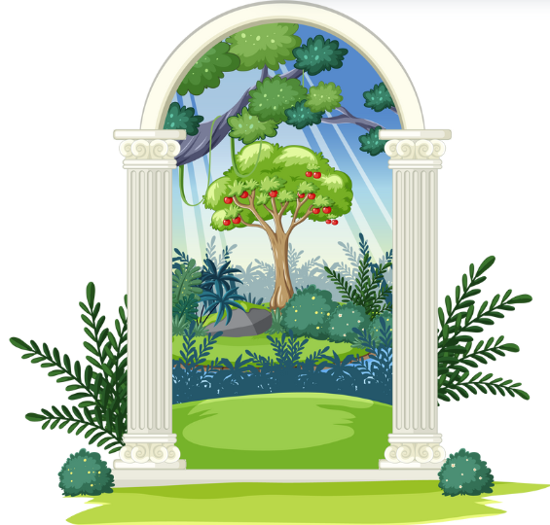hortus, hortī | insula, insulae

Weapons – cards
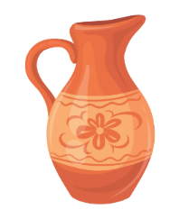  amphora, amphorae | 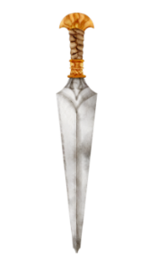  pugiō, pugiōnis |   toga, togae
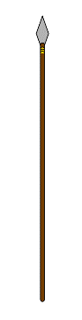  hasta, hastae |   flamma, flammae | 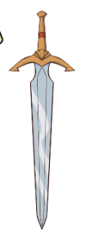  gladius, gladiī

Weapons – tokens
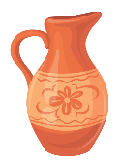 | 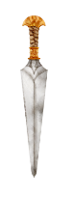 |  | 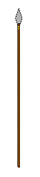 |  | 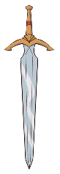

Characters – cards




Characters – tokens
 |  |  |  |  | 
 |  |  |  |  | 

Gameboard
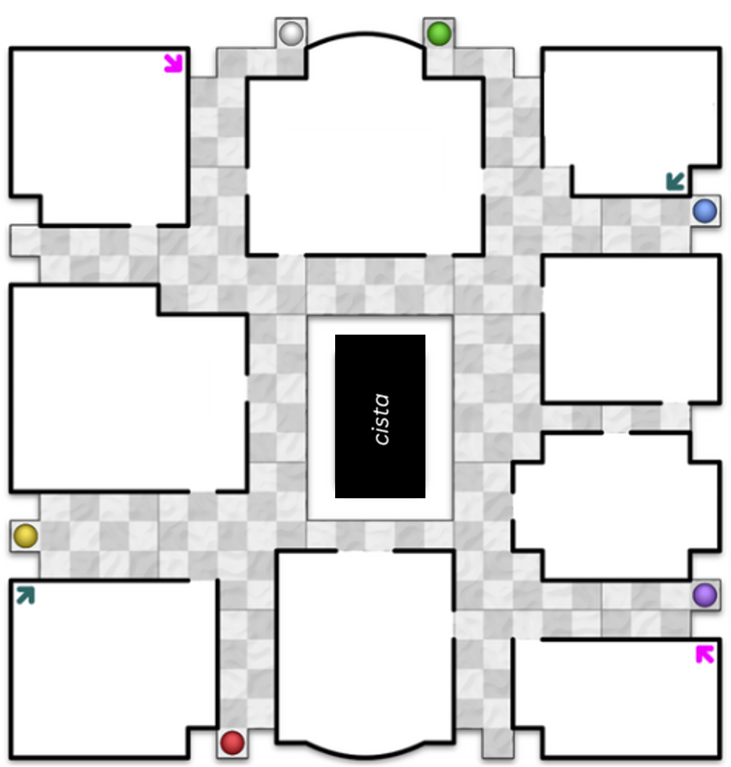

Arcanum envelope
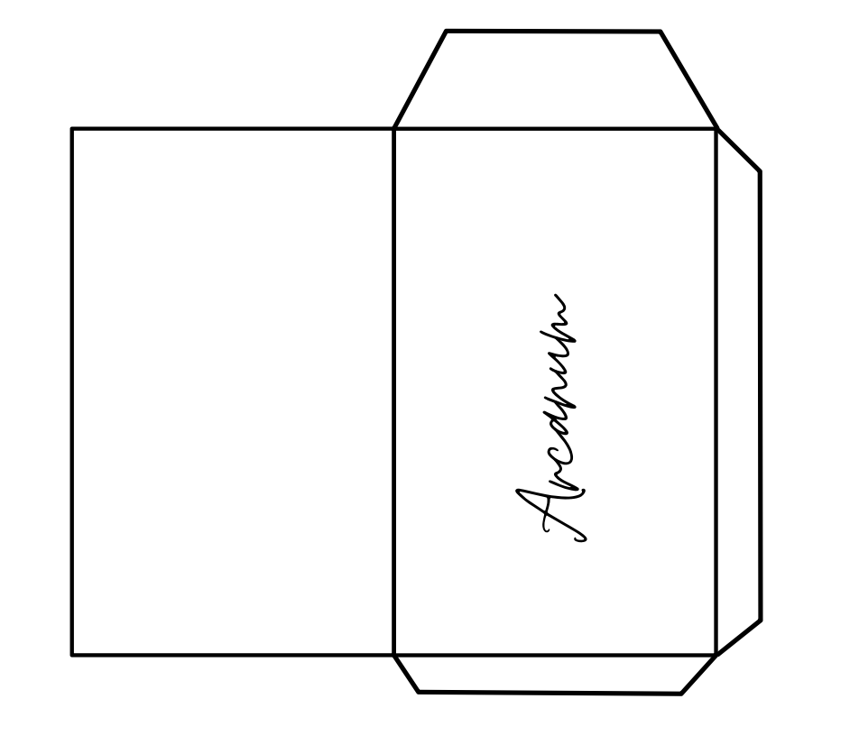

Detective notes – cards
Detective notes – CLŪDUS
Character | Check | Case notes
Weapon
amphora, amphorae (jug)
flamma, flammae (fire)
gladius, gladiī (sword)
hasta, hastae (spear)
pugiō, pugiōnis (dagger)
toga, togae (toga)
Location

© State of New South Wales (Department of Education), 2024
The copyright material published in this resource is subject to the Copyright Act 1968 (Cth) and is owned by the NSW Department of Education or, where indicated, by a party other than the NSW Department of Education (third-party material).
Copyright material available in this resource and owned by the NSW Department of Education is licensed under a Creative Commons Attribution 4.0 International (CC BY 4.0) license.

This license allows you to share and adapt the material for any purpose, even commercially.
Attribution should be given to © State of New South Wales (Department of Education), 2024.
Material in this resource not available under a Creative Commons license:
- the NSW Department of Education logo, other logos and trademark-protected material
- material owned by a third party that has been reproduced with permission. You will need to obtain permission from the third party to reuse its material.
Links to third-party material and websites
Please note that the provided (reading/viewing material/list/links/texts) are a suggestion only and implies no endorsement, by the New South Wales Department of Education, of any author, publisher, or book title. School principals and teachers are best placed to assess the suitability of resources that would complement the curriculum and reflect the needs and interests of their students.
If you use the links provided in this document to access a third-party's website, you acknowledge that the terms of use, including licence terms set out on the third-party's website apply to the use which may be made of the materials on that third-party website or where permitted by the Copyright Act 1968 (Cth). The department accepts no responsibility for content on third-party websites.

