Describing foods and drinks activities

Activity 1 – unjumble
In groups of 2 or 3, unjumble the character cards that your teacher has provided to spell a food or drink in Korean. Create a sentence in Korean by writing the word in the ‘Sentence table’ on the following page, choosing the correct topic particle (는/은) and then adding an appropriate adjective to describe the item. In the fourth column of the sentence table, translate the Korean sentence into English. The first one has been done for you as an example. Choose a word from the ‘Adjective table’ below for the adjective column.

Adjective table
Hangeul | English | Image
맛있어요 | It's delicious. | 
맛없어요 | It's not tasty./It's not good. | 
달아요 | It's sweet. | 
매워요 | It's spicy. | 
뜨거워요 | It's hot. | 
시어요 | It's sour. | 
써요 | It's bitter. | 

Sentence table
음식/음료 | 는/은 | Adjective | English translation
불고기 | 는 | 맛있어요 | Bulgogi is delicious.

Activity 2 – sentence prompts
Use the prompts in the table below to create sentences about foods and drinks in Korean. The first one has been done for you as an example. Don’t forget to include the correct topic particle.
음식/음료 | Adjective | Sentence in Hangeul or Romanised Korean (including 는/은)
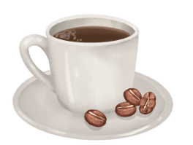 |  | 커피는 써요  Keopineun sseyo.
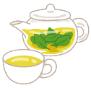
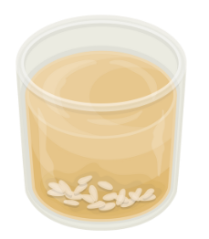

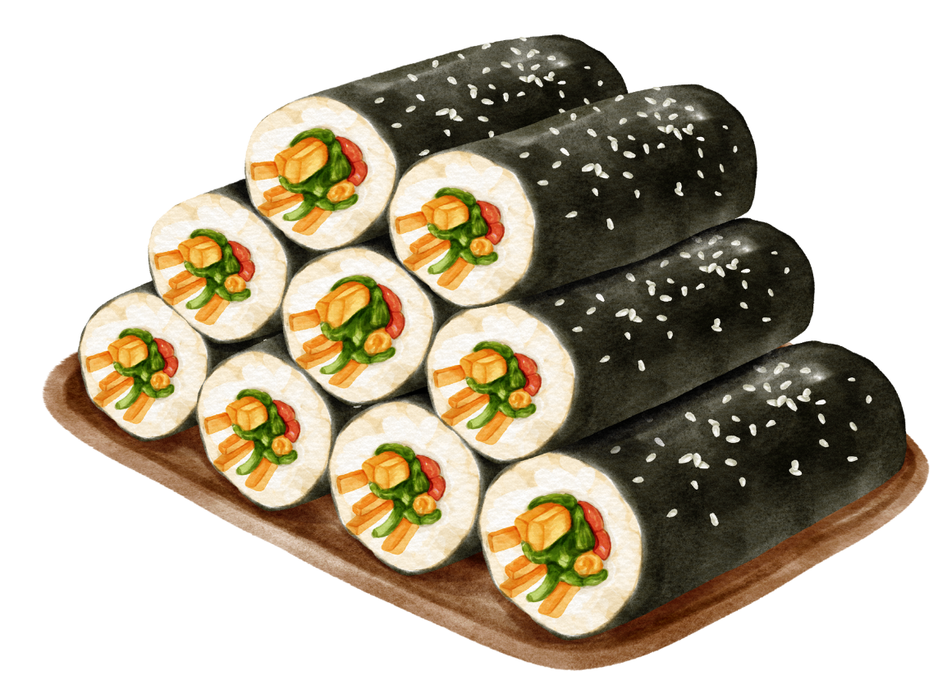
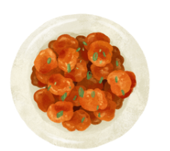
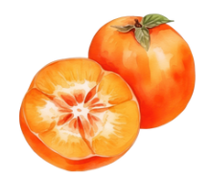

Activity 3 – listening slalom
Listen to your teacher read out the conversations in which people respond to the question 이것은 뭐예요? or 그것은 뭐예요? to identify and describe different foods or drinks in Korean. You must select the word or phrases from each row that you hear, working your way down the grid as the text is read out. You can only use each box once. Then translate the sentence into English. The first sentence has been done for you as an example.
 | A | B | C | D | E | F
1 | 그것 | 이것 | 이것 | 이것 | 그것 | 저것
2 | 은 | 은 | 은 | 은 | 은 | 은
3 | 호떡 | 치킨 | 오렌지 | 딸기 | 피망 | 떡볶이
4 | 예요 | 예요 | 예요 | 이에요 | 이에요 | 이에요
5 | 딸기는 | 피망은 | 치킨은 | 오렌지는 | 호떡은 | 떡볶이는
6 | 맛없어요 | 달아요 | 매워요 | 맛있어요 | 시어요 | 달아요

Sentence 1: 1A/C/D, 2A/B/C/D/E/F, 3C, 4A/B/C, 5D, 6E
이것은 오렌지예요. 오렌지는 시어요. This is an orange. The orange is sour.
Sentence 2:

Sentence 3:

Sentence 4:
Sentence 5:

Sentence 6:

Activity 4 – partial dictation
Listen to your teacher as they read out 4 conversations, asking and answering the question 이것은/그것은/저것은 뭐예요? Complete the responses below with the missing characters.
- 저것은 뭐예요?
__ __은 비빔__이에요. __ __ __은 맛있__ __.
- 저것은 뭐예요?
__ __ __ 라면__ __ __. __ __ __뜨거워요.
- 저것은 뭐예요?
저것은 __ __예요. __ __는 __ __ __. __ __ 맛없어요.
- 저것은 뭐예요?
__ __은 __ __ __ __. __은 __ __ __.

Activity 5 – sentence writing
Write 6 sentences to describe food or drinks in Korean using the structure 이것은/그것은/저것은 [food or drink]예요/이에요. [Food or drink]는/은 [adjective].
An example has been provided for you.
그것은 포도예요. 포도는 달아요. Geugeoseun podoyeyo. Podoneun dalayo.

For the teacher
Remove this section before sharing this resource with students.
 Differentiation examples
Students requiring additional support – provide students with vocabulary lists and/or allow them to complete the activities in romanised Korean. Cards can also be printed in romanised Korean to support students.

Activity 1 – unjumble

Hangeul cards
Print and cut out enough sets of the food and drink vocabulary character cards below to distribute to groups of 2 or 3. When directed, students place all the cards face up on the desk and unjumble them to create food and drink words. They then create a sentence in Korean by writing the word in the sentence table, choosing the correct topic particle (는/은) and adding an appropriate adjective to describe the item. In the final column they translate the Korean sentence into English.
불 | 고 | 기
비 | 빔 | 밥
 | 콜 | 라
떡 | 볶 | 이
 | 식 | 혜
 | 김 | 치
 | 호 | 떡
 | 우 | 유
 | 수 | 박
 | 라 | 면

Romanised Korean cards
bul | go | gi
bi | bim | bap
 | kol | ra
tteok | bokk | i
 | shik | hye
 | kim | chi
 | ho | ddeok
 | u | yu
 | su | bak
 | ra | myeon

Vocabulary with correct topic particles
Adjectives used by students to describe the items will vary.
음식/음료 | 는/은
불고기 | 는
비빔밥 | 은
콜라 | 는
떡볶이 | 는
식혜 | 는
김치 | 는
호떡 | 은
우유 | 는
수박 | 은
라면 | 은

Activity 2 – sentence prompts
음식/음료 | Adjective | Sentence in Hangeul or Romanised Korean
 |  | 커피는 써요.  Keopineun sseyo.
 | 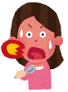 | 차는 뜨거워요.  Chaneun tteugeowoyo.
 |  | 식혜는 달아요.  Shikhyeneun darayo.
 |  | 물은 맛없어요.  Muleun mateopseoyo.
 |  | 김밥은 맛있어요.  Gimbapeun masisseoyo.
 | 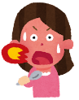 | 치킨은 매워요.  Chikineun maewoyo.
 |  | 감은 시어요.  Gameun sseoyo.

Activity 3 – listening slalom
Read the sentences aloud. Allow time for students to identify the correct characters in each row.
Sentence 1: 1B, 2A/B/C/D/E/F, 3C, 4A/B/C, 5D, 6E
이것은 오렌지예요. 오렌지는 시어요. This is an orange. The orange is sour.
Sentence 2: 1B/C/D, 2A/B/C/D/E/F, 3D, 4A/B/C, 5A, 6F
이것은 딸기예요. 딸기는 달아요. This is a strawberry. The strawberry is delicious.
Sentence 3: 1B/C/D, 2A/B/C/D/E/F, 3E, 4D/E/F, 5B, 6A
이것은 피망이에요. 피망은 맛없어요. This is a capsicum. The capsicum is not delicious.
Sentence 4: 1A/E, 2A/B/C/D/E/F, 3B, 4D/E/F, 5C, 6D
그것은 치킨이에요. 치킨은 맛있어요. That’s chicken. Chicken is delicious.
Sentence 5: 1A/E, 2A/B/C/D/E/F, 3F, 4A/B/C, 5F, 6C
그것은 떡볶이예요. 떡볶이는 매워요. 떡볶이는 맛있어요. That’s tteokbokki. Tteokkbokki is spicy.
Sentence 6: 1F, 2A/B/C/D/E/F, 3A, 4D/E/F, 5E, 6B
저것은 호떡이에요. 호떡은 달아요. That over there is a hoddeok. Hoddeok is sweet.

Activity 4 – partial dictation

Audio file
Activity 4 – partial dictation.mp3 (1:11)

Transcript
- 저것은 뭐예요? What is that over there?
저것은 비빔밥이에요. 비빔밥은 맛있어요. That over there is bibimbap. Bibimbap is delicious.
- 저것은 뭐예요? What is that over there?
저것은 라면이에요. 라면은 뜨거워요. That over there is ramyeon. Ramyeon is hot.
- 저것은 뭐예요? What is that over there?
저것은 양파예요. 양파는 매워요. 양파는 맛없어요. That over there is an onion. The onion is spicy. The onion is not delicious.
- 저것은 뭐예요? What is that over there?
저것은 귤이에요. 귤은 시어요. That over there is a tangerine. The tangerine is sour.

Activity 5 – sentence writing
Student responses will vary.
© State of New South Wales (Department of Education), 2024
The copyright material published in this resource is subject to the Copyright Act 1968 (Cth) and is owned by the NSW Department of Education or, where indicated, by a party other than the NSW Department of Education (third-party material).
Copyright material available in this resource and owned by the NSW Department of Education is licensed under a Creative Commons Attribution 4.0 International (CC BY 4.0) license.

This license allows you to share and adapt the material for any purpose, even commercially.
Attribution should be given to © State of New South Wales (Department of Education), 2024.
Material in this resource not available under a Creative Commons license:
- the NSW Department of Education logo, other logos and trademark-protected material
- material owned by a third party that has been reproduced with permission. You will need to obtain permission from the third party to reuse its material.
Links to third-party material and websites
Please note that the provided (reading/viewing material/list/links/texts) are a suggestion only and implies no endorsement, by the New South Wales Department of Education, of any author, publisher, or book title. School principals and teachers are best placed to assess the suitability of resources that would complement the curriculum and reflect the needs and interests of their students.
If you use the links provided in this document to access a third-party's website, you acknowledge that the terms of use, including licence terms set out on the third-party's website apply to the use which may be made of the materials on that third-party website or where permitted by the Copyright Act 1968 (Cth). The department accepts no responsibility for content on third-party websites.

