At the restaurant

Activity 1 – role-play challenge
Work in pairs or groups of 3 to create the script for a conversation between a customer (or customers) and restaurant employee to order and pay for food and drink.
Use the following resources, provided below, to help you with this challenge:
- the Yummy Food Korea menu
- the shopping phrases table (if required).
In your role-play:
- take turns to greet each other appropriately
- ask the customer what they would like to eat or drink
- make a request for at least 2 foods and one drink
- ask what at least one item on the menu is
- ask the price of the items
- use the conjunction ‘and’
- say ‘thank you’
- say an appropriate farewell.
Your teacher will set a time limit and a word count for the challenge.
When you have finished, swap your role-play with another pair or group, and use the WAGOLL table to provide peer feedback to them.

Yummy Food Korea menu
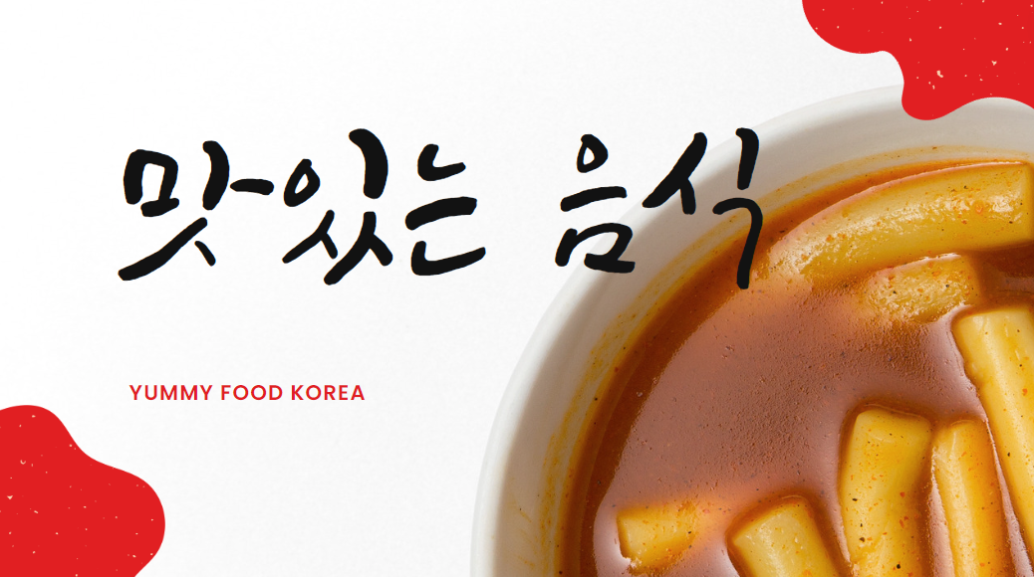
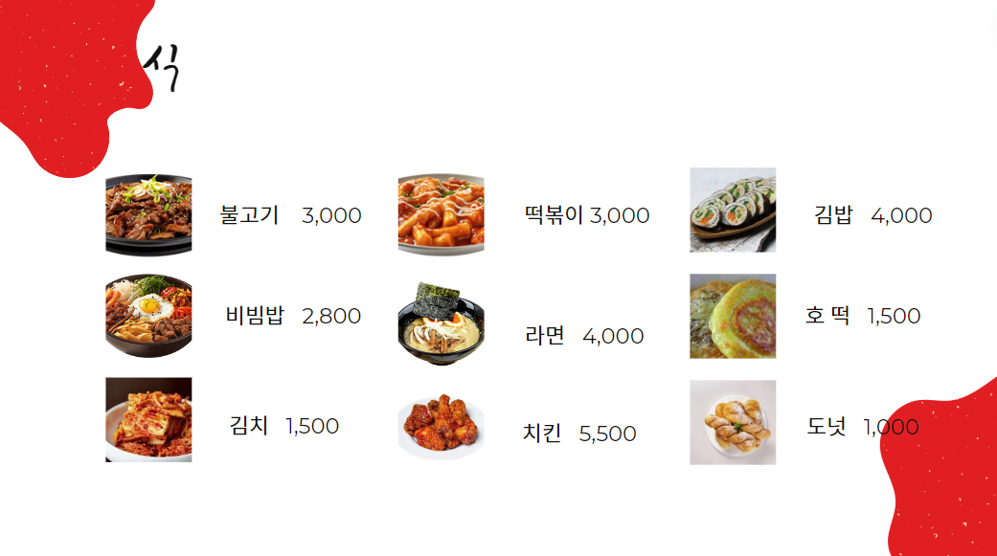
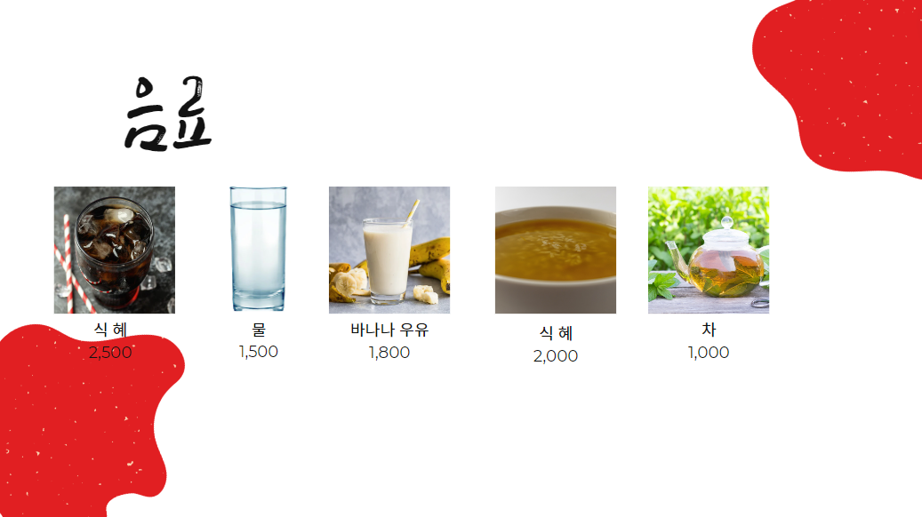

Korean Yummy Food menu – romanised Korean
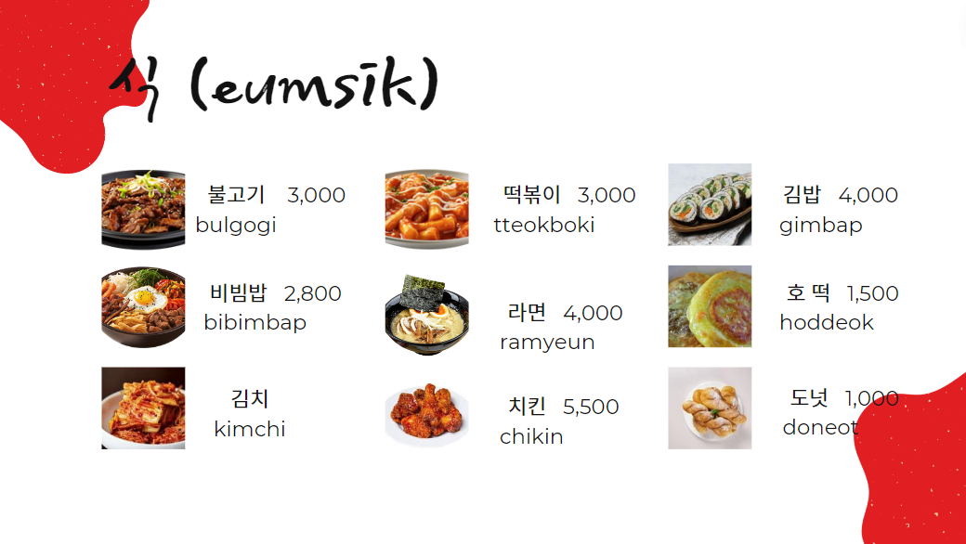
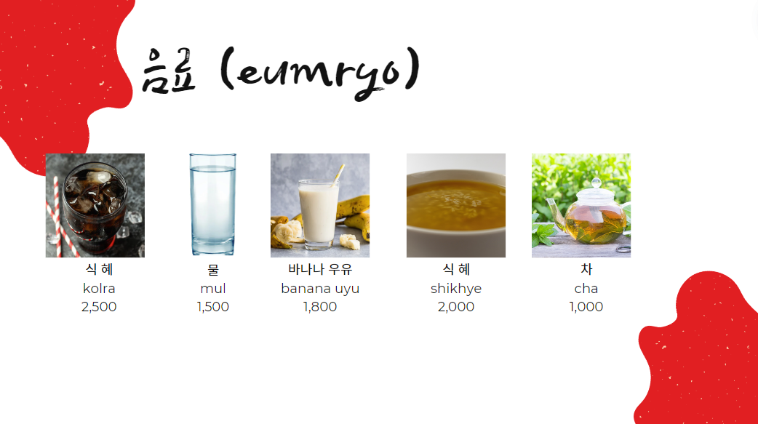

WAGOLL (What a good one looks like)
A good one | A great one
- uses culturally appropriate language to greet and farewell the customer  - makes sense  - follows a logical order  - includes all of the required content  - has well-formed characters that are easy to identify  - includes the linking particle 하고  - includes a thank you  - includes an appropriate farewell. | - includes incidental language like 여기요  - uses different question forms, for example, 무엇을 드릴까요? and ~드릴까요?  - includes additional expressions such as ~가 있어요? 네, 있어요 or 아니요, 없어요  - uses full sentences to respond to questions, for example, 뭐예요? ~예요/~이에요.

Activity 2 – listening task
Listen to the conversations your classmates created for Activity 1. Complete the table below with as many details from their conversations as you can.
Names | Food items | Price

For the teacher
Remove this section before sharing this resource with students.

Role-play challenge
Use the editable link to edit the content of the menu if required. The resource has been provided in Hangeul and romanised Korean for students requiring additional support.

Yummy Food Korea menu – accessible version
Item | Hangeul | Romanised Korean | Price (₩)
marinated beef | 불고기 | bulgogi | 3,000
steamed rice, vegetables and beef dish | 비빔밥 | bibimbap | 2,800
pickled cabbage | 김치 | kimchi | 1,500
spicy rice cakes | 떡볶이 | tteokkbokki | 3,000
instant noodles | 라면 | ramyeun | 4,000
Korean fried chicken | 치킨 | chikin | 5,500
seaweed and rice rolls | 김밥 | gimbap | 4,000
pancake with sweet filling | 호떡 | hoddeok | 1,500
Korean donut | 도넛 | doneot | 1,000
cola | 식혜 | kolra | 2,500
water | 물 | mul | 1,500
banana milk | 바나나 우유 | banana uyu | 1,800
sweet rice drink | 식혜 | shikhye | 2,000
tea | 차 | cha | 1,000

Shopping phrases
For students requiring additional support, provide the table below containing appropriate shopping phrases.
Korean | English
감사합니다. (Gamsahamnida.) | Thank you.
무엇을 드릴까요? (Mu-eoseul deurilkkayo?) | What can I get you?
안녕하세요. (Annyeonghaseyo.) | Hello.
여기요. (Yeogiyo.) | Here, please.
~주세요. ([Food] juseyo.) | [Food], please.
~얼마예요? ([Food] eolmayeyo?) | How much is it?
안녕히 계세요. (Annyeonghi gyeseyo.) | Farewell.
~하고 (hago) | and/also
어서오세요. (Eoseo oseyo.) | Welcome.
안녕히 가세요. (Annyeonghi gaseyo.) | Goodbye

© State of New South Wales (Department of Education), 2024
The copyright material published in this resource is subject to the Copyright Act 1968 (Cth) and is owned by the NSW Department of Education or, where indicated, by a party other than the NSW Department of Education (third-party material).
Copyright material available in this resource and owned by the NSW Department of Education is licensed under a Creative Commons Attribution 4.0 International (CC BY 4.0) license.

This licence allows you to share and adapt the material for any purpose, even commercially. Attribution should be given to © State of New South Wales (Department of Education), 2024.
Material in this resource not available under a Creative Commons licence:
- the NSW Department of Education logo, other logos and trademark-protected material
- material owned by a third party that has been reproduced with permission. You will need to obtain permission from the third party to reuse its material.
Links to third-party material and websites
Please note that the provided (reading/viewing material/list/links/texts) are a suggestion only and implies no endorsement, by the New South Wales Department of Education, of any author, publisher, or book title. School principals and teachers are best placed to assess the suitability of resources that would complement the curriculum and reflect the needs and interests of their students.
If you use the links provided in this document to access a third-party's website, you acknowledge that the terms of use, including licence terms set out on the third-party's website apply to the use which may be made of the materials on that third-party website or where permitted by the Copyright Act 1968 (Cth). The department accepts no responsibility for content on third-party website.

