How much is it?

Activity 1 – calculate costs
Korean won (₩) | Australian dollar ($)
1000 | 1
Using the above exchange rate of Korean won to Australian dollars, calculate how much the items in the table below will cost in Australian dollars (불). Then, write a sentence to state the price in Korean using the structure [item]은/는 [dollar]불 [cents] 센트예요. Don’t forget to choose the correct topic particle for each item (은/는). The first one has been done for you as an example.
Item | ₩ | AUD ($) | [item]은/는 [dollar]불 [cents] 센트예요.
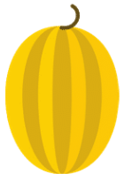 | ₩ 4,800 | $4.80 | 참외는 사불 팔십 센트예요.
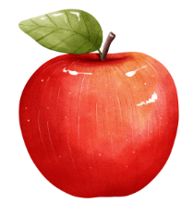 | ₩ 5,500
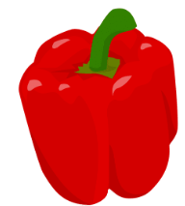 | ₩ 2,000
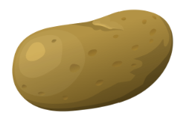 | ₩ 5,000
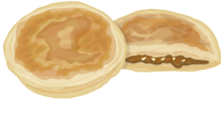 | ₩ 15,000
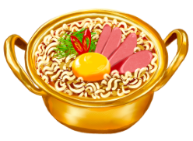 | ₩ 9,000
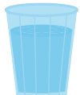 | ₩ 1,100
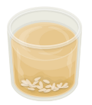 | ₩ 2,300
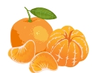 | ₩1,800

Activity 2 – information gap activity

Student A
Using the same exchange rate as Activity 1, convert the missing prices for the first 4 items in the table – banana, watermelon, cola and persimmon. Then, working with a partner, find out the prices of the remaining items in Australian dollars and Korean won using the following structures:
[item]은/는 얼마예요?
[item]은/는 [dollar]불 [cents] 센트예요 and [item]은/는 [price in won] 원이에요.
Item | ₩ | AUD
 | ₩ | $0.20
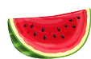 | ₩ 13,000 | $
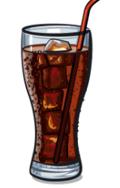 | ₩ | $0.50
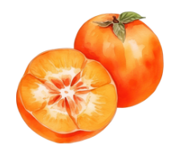 | ₩ | $0.30
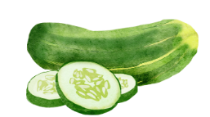 | ₩ | $
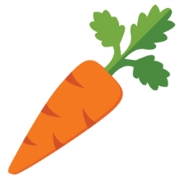 | ₩ | $
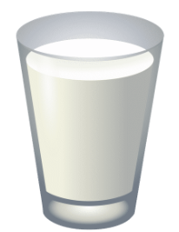 | ₩ | $
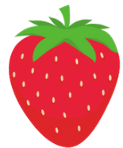 | ₩ | $

Revision activity
Select 3 different items from the table above to write a sentence about how much the item was using Australian currency in Korean.
Now select 3 different items from the above to write a sentence about how much the item is using Korean won, in Korean.

Student B
Using the same exchange rate as Activity 1, convert the missing prices for the last 4 items in the table – cucumber, carrot, milk and strawberries. Then, working with a partner, find out the prices of the remaining items in Australian dollars and Korean won using the following structures:
[item]은/는 얼마예요?
[item]은/는 [dollar]불 [cents] 센트예요 and [item]은/는 [price in won] 원이에요.
Item | ₩ | AUD
 | ₩ | $
 | ₩ | $
 | ₩ | $
 | ₩ | $
 |  | $0.60
 | ₩100
 |  | $2.00
 |  | $0.40

Revision activity
Select 3 different items from the table above to write a sentence about how much the item was using Australian currency in Korean.
Now select 3 different items from the above to write a sentence about how much the item is using Korean won, in Korean.

For the teacher
Remove this section before sharing this resource with students.

Activity 1 – calculate costs
Demonstrate how to convert currency to students using the conversion rate of ₩ 1000 = $1AUD. Provide students who require additional support with a calculator to perform this calculation.
Item | ₩ | AUD ($) | [item]은/는 [dollar]불 [cents] 센트예요
 | ₩ 4,800 | $4.80 | 참외는 사불 팔십 센트예요.
 | ₩ 5,500 | $5.50 | 사과는 오 불 오십 센트예요.
 | ₩ 2,000 | $2.00 | 피망은 이 불이에요.
 | ₩ 5,000 | $5.00 | 감자는 오 불 사십 센트예요.
 | ₩ 15,000 | $15.00 | 호떡은 십오 불이에요.
 | ₩ 9,000 | $9.00 | 라면은 구 불이에요.
 | ₩ 1,100 | $1.10 | 물은 일 불 십 센트예요.
 | ₩ 2,300 | $2.30 | 식혜는 이 불 삼십 센트예요.
 | ₩1,800 | $1.80 | 귤은 일 불 팔십 센트예요.

Activity 2 – information gap activity
Item | ₩ | AUD
 | ₩200 | $0.20
 | ₩ 13,000 | $13
 | ₩500 | $0.50
 | ₩300 | $0.30
 | ₩600 | $0.60
 | ₩100 | $0.10
 | ₩2,000 | $2.00
 | ₩400 | $0.40

Revision activity
Australian currency sample sentences.
- 콜라는 오십 센트예요.
- 바나나는 이십 센트예요.
- 감은 삼십 센트예요.
Korean won sample sentences.
- 수박은 만삼천 원이에요.
- 당근은 백 원이에요.
- 유는 이천 원이에요.

© State of New South Wales (Department of Education), 2024
The copyright material published in this resource is subject to the Copyright Act 1968 (Cth) and is owned by the NSW Department of Education or, where indicated, by a party other than the NSW Department of Education (third-party material).
Copyright material available in this resource and owned by the NSW Department of Education is licensed under a Creative Commons Attribution 4.0 International (CC BY 4.0) license.

This license allows you to share and adapt the material for any purpose, even commercially. Attribution should be given to © State of New South Wales (Department of Education), 2024.
Material in this resource not available under a Creative Commons license:
- the NSW Department of Education logo, other logos and trademark-protected material
- material owned by a third party that has been reproduced with permission. You will need to obtain permission from the third party to reuse its material.
Links to third-party material and websites
Please note that the provided (reading/viewing material/list/links/texts) are a suggestion only and implies no endorsement, by the New South Wales Department of Education, of any author, publisher, or book title. School principals and teachers are best placed to assess the suitability of resources that would complement the curriculum and reflect the needs and interests of their students.
If you use the links provided in this document to access a third-party's website, you acknowledge that the terms of use, including licence terms set out on the third-party's website apply to the use which may be made of the materials on that third-party website or where permitted by the Copyright Act 1968 (Cth). The department accepts no responsibility for content on third-party websites.

