‘This or that’ game cards
This resource is for the teacher. It provides the content and instructions for you to share with students.

Instructions
Cut out enough cards to ensure that each pair or group of 3 students has a set of cards.
Students place the cards face-down on the desk in the following 4 piles:
- arrow cards (to determine proximity to the item)
- food or drink cards (to provide an item to identify)
- question cards (to indicate which question to ask: How much is it? or What is it?)
- price cards (to provide a price).
Students take turns picking up cards to create an interaction, formulating questions based on the cues on the cards. These cards will provide opportunities for 2 different interactions, depending on which question card the students draw. When the cards for each pile run out, direct students to shuffle them and start again from the top of the pile. Card categories can be added or omitted to meet the learning objective of the activity.
Clarify the arrows with students first:
- 이것은 얼마예요?
- 그것은 얼마예요?
- 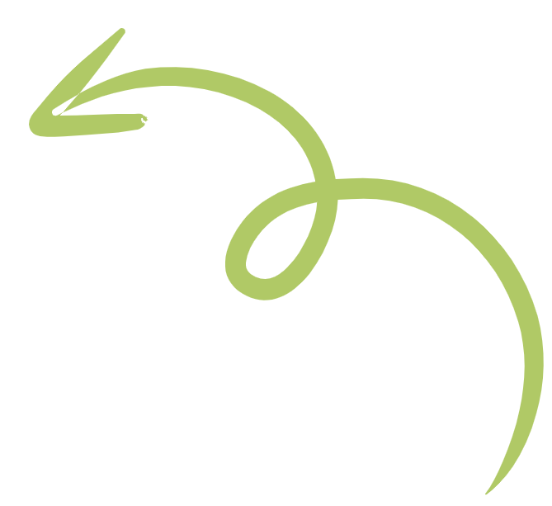저것은 얼마예요?
Example interaction 1:
Student A draws from the arrow cards pile and ₩? from the question cards pile, then formulates the question: 이것은 얼마예요?
Student B draws 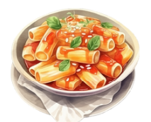 from the food or drink cards pile and says 이것은 떡볶이예요. Student B then draws ₩1,800 from the price cards pile and adds 천팔백 (1800) 원이에요.
Example interaction 2:
Student A draws from the arrow cards and ? from the question cards pile, then formulates the question 그것은 뭐예요?
Student B draws 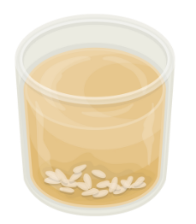 from the food or drink cards pile, then formulates the response 그것은 식혜예요.
Example interaction 3:
Student A draws from the arrow cards pile and ₩? from the question cards pile, then formulates the question저것은 얼마예요?
Student B draws 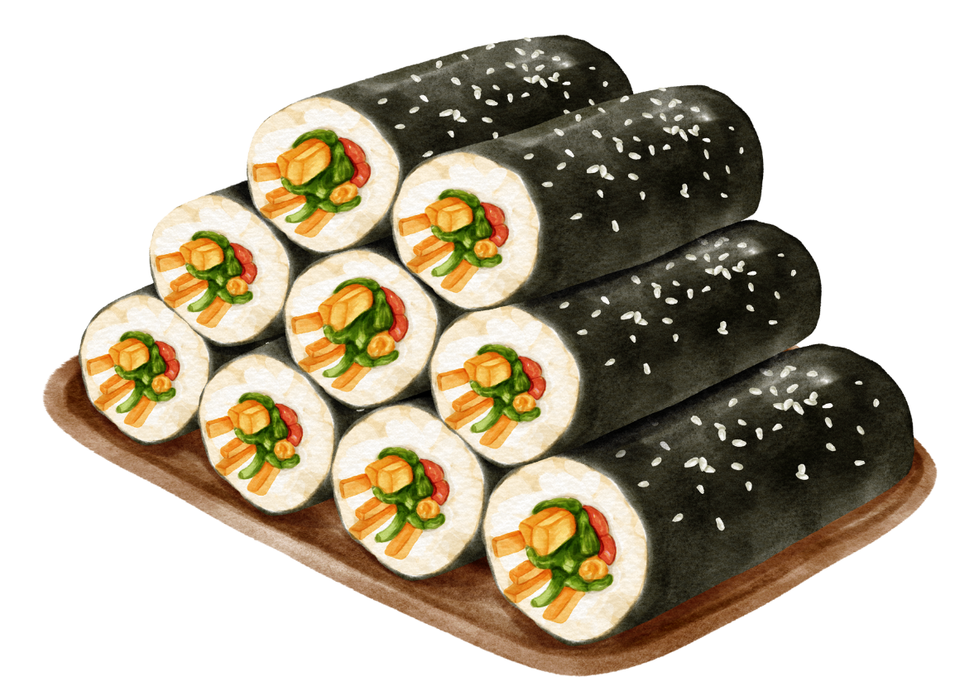 and responds 저것은 김밥이에요. Student B then draws ₩2,200 and says 이천이백 (2200) 원이에요.

Game cards – proximity

Game cards – food or drink
 | 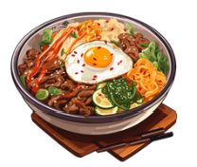 | 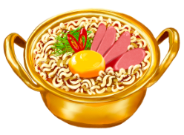
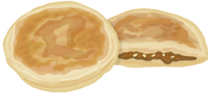 | 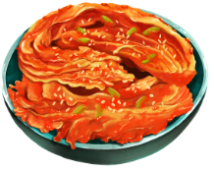 | 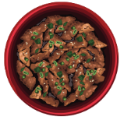
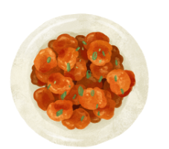

Game cards – questions
₩? | ₩? | ₩?
₩? | ₩? | ₩?
? | ? | ?
? | ? | ?

Game cards – price
₩1,500 | ₩5,600 | ₩2,200
₩3,400 | ₩1,900 | ₩7,100
₩7,700 | ₩4,000 | ₩1,800
 Differentiation examples
High potential and gifted students – students use sentences and include appropriate greetings and a farewell for each interaction. Students draw 2 cards from the arrow pile and 2 cards from the food and drink pile, then use the connecting particle 하고 to ask about both items.
Students with advanced proficiency – students can add more vocabulary to the food and drink items, add more complex prices or interact without the cards as prompts. They can add details about each item, including whether they like it and why, or if they have ever tried it before and where.
Students requiring additional support – provide conversation prompts (see below) to support students in their interaction and/or allow students to write down the interaction, (in Hangeul or Romanised Korean depending on student ability).

Conversation prompts
Card cues | Questions and answers | Translation
+ ? | 이것은 뭐예요? (Igeoseun mwoyeyo?) | What is this?
+ ? | 그것은 뭐예요? (Geugeoseun mwoyeyo?) | What is that?
+ ? | 저것은 뭐예요? (Jeogeoseun mwoyeyo?) | What is that over there?
Answer:  + ? | 이것은 [food or drink] 예요.  (Igeoseun [food or drink] yeyo)  or  이것은 [food or drink] 이에요.  (Igeoseun [food or drink] ieyo) | This is [food or drink that ends in a vowel].  or  This is [food or drink that ends in a consonant].
Answer:  + ? | 그것은 [food or drink] 예요.  (Geugeoseun [food or drink] yeyo)  or  그것은 [food or drink] 이에요.  (Geugeoseun [food or drink] ieyo) | That is [food or drink that ends in a vowel].  or  That is [food or drink that ends in a consonant].
Answer:  + ? | 저것은 [food or drink] 예요.  (Jeogeoseun [food or drink] yeyo)  or  저것은[food or drink] 이에요.  (Jeogeoseun [food or drink] ieyo) | That (over there) is [food or drink that ends in a vowel].  or  That (over there) is [food or drink that ends in a consonant].
+ ₩? | 이것은 얼마예요? (Igeoseun eolmayeyo?) | How much does this cost?
+ ₩? | 그것은 얼마예요? (Geugeoseun eolmayeyo?) | How much does that cost?
+ ₩? | 저건은 얼마예요? (Jeogeoseun eolmayeyo?) | How much does that over there cost?
Answer | [thousands] 천 [hundreds] 백 원 이에요.  ([thousands] cheon [hundreds] baek won ieyo.) | It costs [number] thousand [number] hundred won.

© State of New South Wales (Department of Education), 2024
The copyright material published in this resource is subject to the Copyright Act 1968 (Cth) and is owned by the NSW Department of Education or, where indicated, by a party other than the NSW Department of Education (third-party material).
Copyright material available in this resource and owned by the NSW Department of Education is licensed under a Creative Commons Attribution 4.0 International (CC BY 4.0) license.

This license allows you to share and adapt the material for any purpose, even commercially. Attribution should be given to © State of New South Wales (Department of Education), 2024.
Material in this resource not available under a Creative Commons license:
- the NSW Department of Education logo, other logos and trademark-protected material
- material owned by a third party that has been reproduced with permission. You will need to obtain permission from the third party to reuse its material.
Links to third-party material and websites
Please note that the provided (reading/viewing material/list/links/texts) are a suggestion only and implies no endorsement, by the New South Wales Department of Education, of any author, publisher, or book title. School principals and teachers are best placed to assess the suitability of resources that would complement the curriculum and reflect the needs and interests of their students.
If you use the links provided in this document to access a third-party's website, you acknowledge that the terms of use, including licence terms set out on the third-party's website apply to the use which may be made of the materials on that third-party website or where permitted by the Copyright Act 1968 (Cth). The department accepts no responsibility for content on third-party websites.

