Information gap – How much?

Activity
Work with your partner to complete the menu with the correct price for each item. Use the question [item]는/은 얼마예요? to ask for the price of items that are missing on your menu. Your partner will respond using the structure [item]는/은 [price] 원이에요. Fill in the gaps in your menu according to the responses you hear.
When formulating questions and responses, remember to choose the topic particle carefully: use 는 (neun) if the preceding word ends in a vowel, or use 은 (eun) if the preceding word ends in a consonant.
An example of an interaction has been provided for you:
Student A: 라면은 얼마예요? (Ramyeoneun eolmaeyo?)
Student B: 라면은 삼천오백 원이에요. (Ramyeoneun samcheonohbaek won ieyo.)

Student A
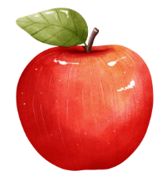  ₩ 680 | 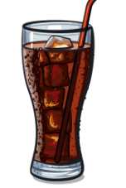 |   ₩ 1,100 | 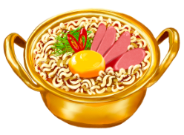
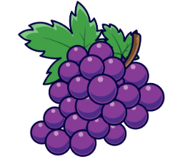 |   ₩ 990 |  | 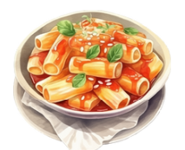  ₩ 3,000
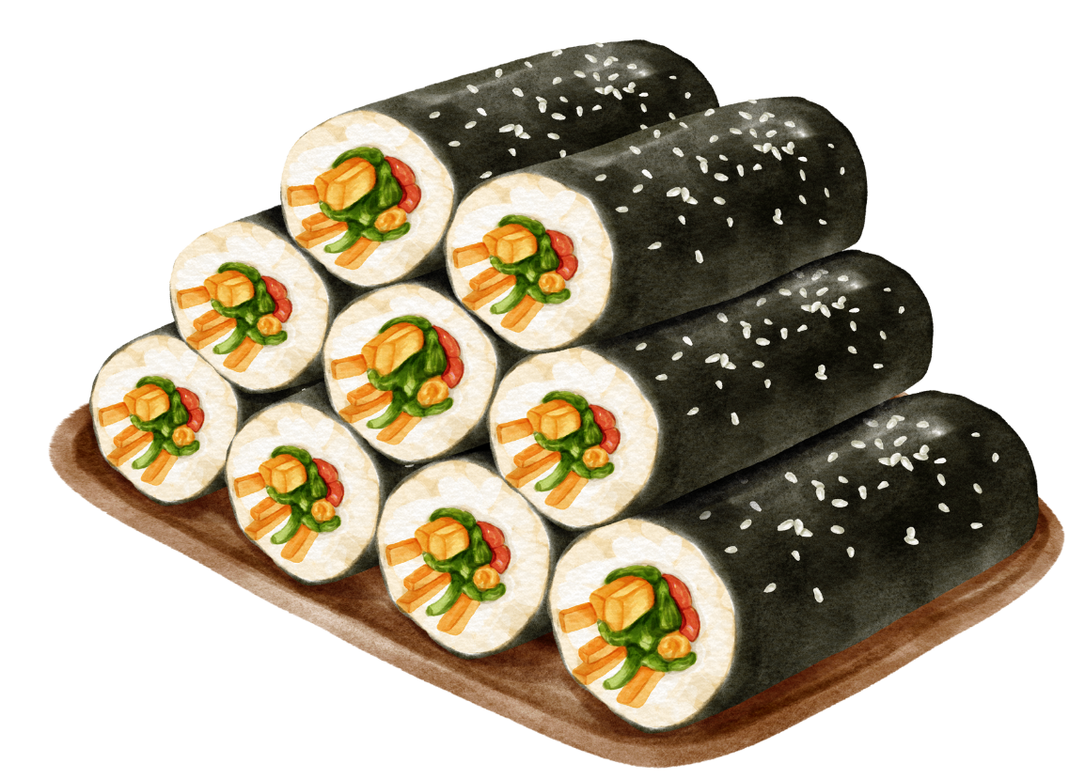 | 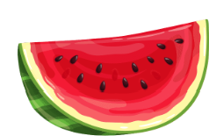  ₩ 29,000 | 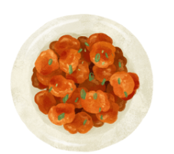  ₩ 17,500 | 
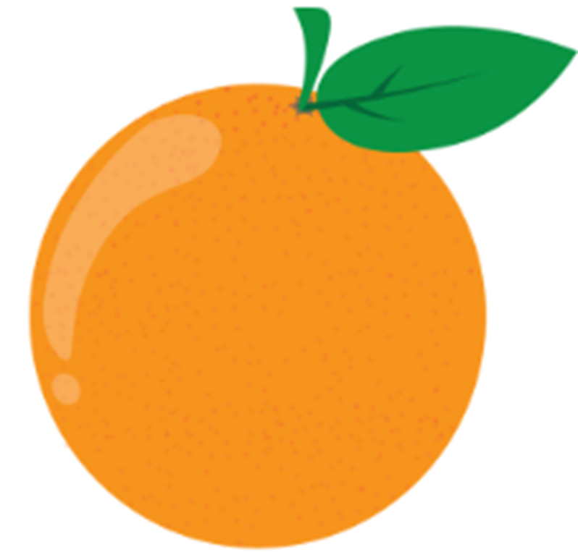 | 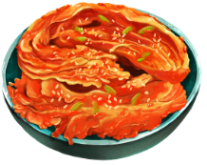  ₩ 14,850 | 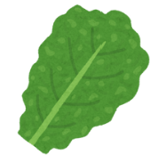  ₩ 1,200 | 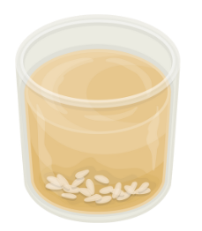

Student B
 | ₩ 2,000 |  | ₩ 3,500
₩ 11,900 |  | ₩ 6,300
₩ 4,200 |  |  | ₩ 1,100
₩ 780 |  |  | ₩ 1,500

For the teacher
Remove this section before sharing this resource with students.
 Differentiation examples
High potential and gifted students – students can add complexity to their interaction by including appropriate greetings and farewells for each interaction, adding more details such as whether they like the item or not, and using conversation fillers where appropriate.
Students with advanced proficiency – students can add more details about each item, including whether they like it and why, or if they have ever tried it before and where.
Students requiring additional support – provide a list of numbers (example below) to help students compose complex numbers. Allow students to use a computer to type or use voice-to-text software, where required. Reduce the number of items required. Allow students to work in small groups rather than in pairs. Provide students with the ‘Alternative activity to accompany Student A price list’ provided in this resource. Provide the sheet with Hangeul or romanised Korean numbers if required.

Numbers
Number | Korean
1 | 일 (il)
2 | 이 (i)
3 | 삼 (sam)
4 | 사 (sa)
5 | 오 (o)
6 | 육 (yuk)
7 | 칠 (chil)
8 | 팔 (pal)
9 | 구 (gu)
10 | 십 (sip)
100 | 백 (baek)
1,000 | 천 (cheon)
10,000 | 만 (man)

Alternative activity to accompany Student A price list
Provide the name of the item in English or Korean that corresponds to the price listed in the Student A price list. This table can be edited to suit the needs and level of your students.
Price | Item
육백팔십 (yuk baek pal sip)
만칠천오백 (man chil cheon o baek)
만사천팔백오십 (man sa cheon pal baek o sip)
삼천 (sam cheon)
이만구천 (i man gu cheon)
천이백 (cheon i baek)
구백구십 (gu baek gu sip)
천백 (cheon baek)

© State of New South Wales (Department of Education), 2024
The copyright material published in this resource is subject to the Copyright Act 1968 (Cth) and is owned by the NSW Department of Education or, where indicated, by a party other than the NSW Department of Education (third-party material).
Copyright material available in this resource and owned by the NSW Department of Education is licensed under a Creative Commons Attribution 4.0 International (CC BY 4.0) license.

This license allows you to share and adapt the material for any purpose, even commercially. Attribution should be given to © State of New South Wales (Department of Education), 2024.
Material in this resource not available under a Creative Commons license:
- the NSW Department of Education logo, other logos and trademark-protected material
- material owned by a third party that has been reproduced with permission. You will need to obtain permission from the third party to reuse its material.
Links to third-party material and websites
Please note that the provided (reading/viewing material/list/links/texts) are a suggestion only and implies no endorsement, by the New South Wales Department of Education, of any author, publisher, or book title. School principals and teachers are best placed to assess the suitability of resources that would complement the curriculum and reflect the needs and interests of their students.
If you use the links provided in this document to access a third-party's website, you acknowledge that the terms of use, including licence terms set out on the third-party's website apply to the use which may be made of the materials on that third-party website or where permitted by the Copyright Act 1968 (Cth). The department accepts no responsibility for content on third-party websites.

