Counting in Korean

Activity 1
Answer the question about how many items there are in Korean in the table below using the structure [item] [number] 개 있어요. Don’t forget to use the appropriate subject particle (가 or 이) after the item in your sentence. The first one has been done for you as an example.
과일/야채 | 몇?
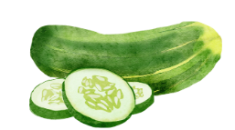 | 오이가 여섯 개 있어요.
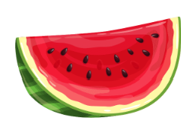
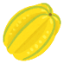
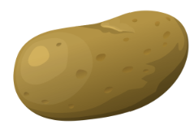
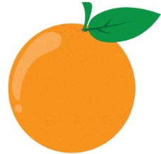
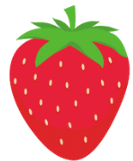
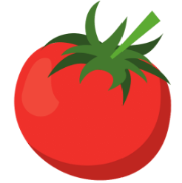

Activity 2
Answer the questions in Korean based on the picture of Soo Jin’s shopping basket below. The first one has been done for you as an example.
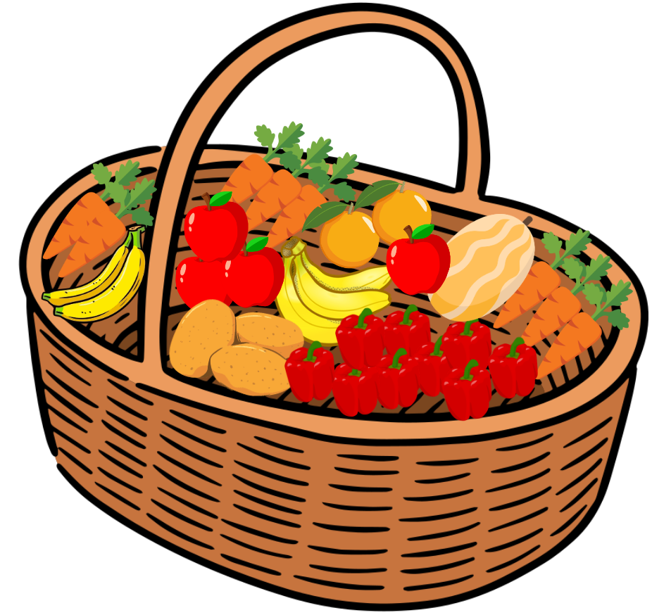
- 사과가 몇 개 있어요?
사과가 네 개 있어요.
- 감자가 몇 개 있어요?
- 참외가 몇 개 있어요?
- 바나나가 몇 개 있어요?
- 오렌지가 몇 개 있어요?
- 피망이 몇 개 있어요?
- 당근이 몇 개 있어요?

For the teacher
Remove this section before sharing this resource with students.

Activity 1
과일/야채 | 몇?
 | 오이가 여섯 개 있어요.
 | 수박이 세 개 있어요.
 | 참외가 한 개 있어요.
 | 감자가 네 개 있어요.
 | 오렌지가 네 개 있어요.
 | 딸기가 일곱 개 있어요.
 | 토마토가 일곱 개 있어요.

Activity 2
- 사과가 몇 개 있어요?
사과가 네 개 있어요.
- 감자가 몇 개 있어요?
감자가 세 개 있어요.
- 참외가 몇 개 있어요?
참외가 한 개 있어요.
- 바나나가 몇 개 있어요?
바나나가 다섯 개 있어요.
- 오렌지가 몇 개 있어요?
오렌지가 개 있어요.
- 피망이 몇 개 있어요?
피망이 아홉 개 있어요.
- 당근이 몇 개 있어요?
당근이 여덟 개 있어요.

© State of New South Wales (Department of Education), 2024
The copyright material published in this resource is subject to the Copyright Act 1968 (Cth) and is owned by the NSW Department of Education or, where indicated, by a party other than the NSW Department of Education (third-party material).
Copyright material available in this resource and owned by the NSW Department of Education is licensed under a Creative Commons Attribution 4.0 International (CC BY 4.0) license.

This license allows you to share and adapt the material for any purpose, even commercially. Attribution should be given to © State of New South Wales (Department of Education), 2024.
Material in this resource not available under a Creative Commons license:
- the NSW Department of Education logo, other logos and trademark-protected material
- material owned by a third party that has been reproduced with permission. You will need to obtain permission from the third party to reuse its material.
Links to third-party material and websites
Please note that the provided (reading/viewing material/list/links/texts) are a suggestion only and implies no endorsement, by the New South Wales Department of Education, of any author, publisher, or book title. School principals and teachers are best placed to assess the suitability of resources that would complement the curriculum and reflect the needs and interests of their students.
If you use the links provided in this document to access a third-party's website, you acknowledge that the terms of use, including licence terms set out on the third-party's website apply to the use which may be made of the materials on that third-party website or where permitted by the Copyright Act 1968 (Cth). The department accepts no responsibility for content on third-party websites.

