At the markets

Activity 1
Using the vocabulary you have learnt so far, write the names of the foods or drinks in Korean under the appropriate heading to demonstrate whether they can be purchased at markets in Australia or in Korea. If they can be purchased in both, write the word in the middle.

Activity 2
Using the pictures of food in the table below as a prompt, complete the sentences in Korean to describe what food can be found at 광장시장 (Gwangjang Market) and at 패디스 마켓 (Paddy’s Market or similar in Australia) using the structure [place] 에는 [food] 이/가 있어요. Be careful with your choice of subject particle (이 or 가). Also write the English translation of each sentence. The first 2 have been done for you as examples.
장소 (place) | 음식 (food) | [place]에는 [food]이/가 있어요.
 | 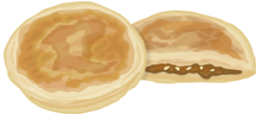 | 광장시장에는 호떡이 있어요.  (At Gwangjang Market there is hoddeok.)
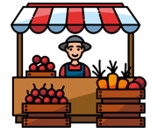 |  | 패디스 마켓에는 당근이 있어요.  (At Paddy’s Market there are carrots.)
 | 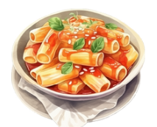 | 광장시장에는
 | 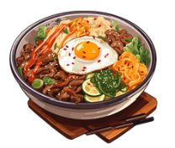 | 광장시장에는
 | 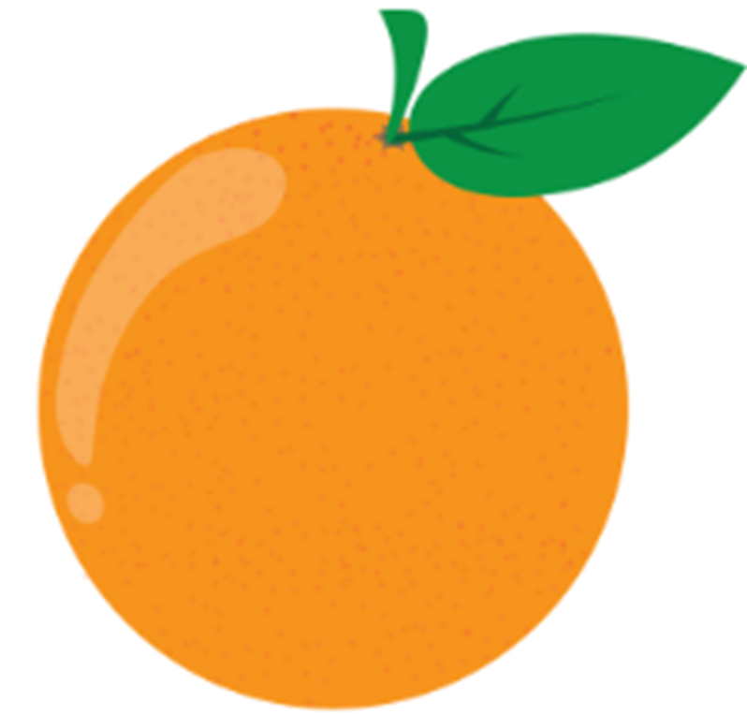 | 패디스 마켓에는
 | 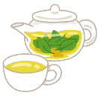 | 광장시장에는
 |  | 패디스 마켓에는

Activity 3
Use the images in the table below as prompts to construct a sentence in Korean with 2 items you can purchase at each market, using the structure ~하고. Also write the English translation of each sentence. The first one has been done for you as an example. Be careful with your choice of subject particle.
장소 (place) | 음식 (food) | [place]에는 [food]하고 [food]이/가 있어요.
 | 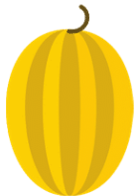 | 광장시장에는 떡볶이하고 참외가 있어요.  (At Gwangjang Market there is tteokbokki and melon.)
 | 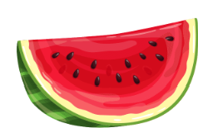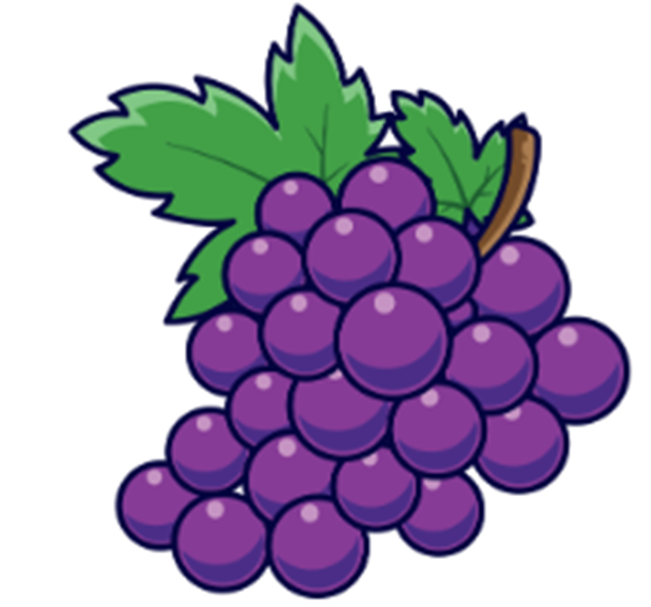
 | 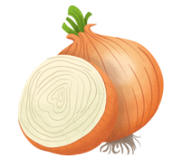
 | 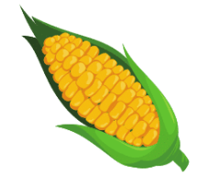

Activity 4
Practise asking whether the shopkeeper at the market has the items you require. Use the images in the table below as prompts to write the question ~이/가 있어요? and an appropriate response. The first 2 have been done for you as examples.
음식/음료 | ~이/가 있어요? | 네, ~이/가 있어요 or 아니요, ~이/가 없어요
✔️ | 우유가 있어요? | 네, 우유가 있어요.
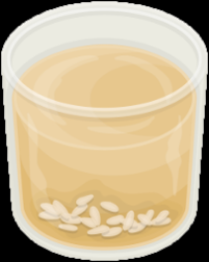❌ | 식혜가 있어요? | 아니요, 식혜가 없어요.
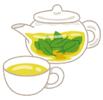❌
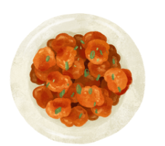✔️
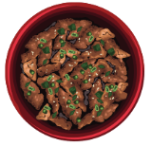✔️
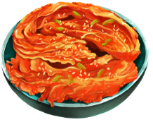❌
✔️
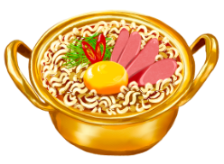❌
❌
✔️
✔️
❌
✔️

Activity 5
Using the information in the table in Activity 4, construct one positive and one negative sentence in the space below. Begin your sentence with 광장시장에는 and include multiple items using the particle 하고. Examples have been provided for you.
Example 1: 광장시장에는 호떡하고 비빔밥이 있어요. (At Gwangjang Market there is hoddeok and bibimbap.)
Example 2: 광장시장에는 라면하고 콜라가 없어요. (At Gwangjang Market there is not ramyeon and there is not cola.)

For the teacher
Remove this section before sharing this resource with students.
These activities are designed to suit a range of abilities and contexts. Adjust the level of difficulty of the activities to suit your student cohort.

Activity 1
Use this table for students who are unable to access the Venn diagram.
In Australia | In both countries | In Korea

Activity 2
장소 (place) | 음식 (food) | [place]에는 [food]이/가 있어요.
광장시장에는 호떡이 있어요.
(At Gwangjang Market there is hoddeok.)
패디스 마켓에는 당근이 있어요.
(At Paddy’s Market there are carrots.)
광장시장에는 김치가 있어요.
(At Gwangjang Market there is kimchi.)
광장시장에는 비빔밥이 있어요.
(At Gwanjang Market there is bibimbap.)
패디스마켓에는 오렌지가 있어요.
(At Paddy’s Market there are oranges.)
광장시장에는 차가 있어요.
(At Gwanjang Market there is tea.)
패디스마켓에는 커피가 있어요.
(At Paddy’s Market there is coffee.)

Activity 3
장소 (place) | 음식 (food) | [place]에는 [food]하고 [food]이/가 있어요.
광장시장에는 떡볶이하고 참외가 있어요.
(At Gwangjang Market there are tteokbokki and melon.)
광장시장에는 수박하고 포도가 있어요.
(At Paddy’s Market there are watermelon and grapes.)
광장시장에는 피망하고 양파가 있어요.
(At Paddy’s Market there are capsicums and onions.)
광장시장에는 콜라하고 옥수수가 있어요.
(At Gwangjang Market there is cola and corn.)

Activity 4
음식/음료 | ~이/가 있어요? | 네, ~이/가 있어요 or 아니요, ~이/가 없어요
✔️ | 우유가 있어요? | 네, 우유가 있어요.
❌ | 식혜가 있어요? | 아니요, 식혜가 없어요.
❌ | 차가 있어요? | 아니요, 차가 없어요.
✔️ | 치킨이 있어요? | 네, 치킨이 있어요.
✔️ | 불고기가 있어요? | 네, 불고기가 있어요.
❌ | 김치가 있어요? | 아니요, 김치가 없어요.
✔️ | 호떡이 있어요? | 네, 호떡이 있어요.
❌ | 라면이 있어요? | 아니요, 라면이 없어요.
❌ | 떡볶이가 있어요? | 아니요, 떡볶이가 없어요.
✔️ | 비빔밥이 있어요? | 네, 비빔밥이 있어요.
✔️ | 커피가 있어요? | 네, 커피가 있어요.
❌ | 콜라가 있어요? | 아니요, 콜라가 없어요.
✔️ | 물이 있어요? | 네, 물이 있어요.

Activity 5
Student responses may vary.

© State of New South Wales (Department of Education), 2024
The copyright material published in this resource is subject to the Copyright Act 1968 (Cth) and is owned by the NSW Department of Education or, where indicated, by a party other than the NSW Department of Education (third-party material).
Copyright material available in this resource and owned by the NSW Department of Education is licensed under a Creative Commons Attribution 4.0 International (CC BY 4.0) license.

This license allows you to share and adapt the material for any purpose, even commercially. Attribution should be given to © State of New South Wales (Department of Education), 2024.
Material in this resource not available under a Creative Commons license:
- the NSW Department of Education logo, other logos and trademark-protected material
- material owned by a third party that has been reproduced with permission. You will need to obtain permission from the third party to reuse its material.
Links to third-party material and websites
Please note that the provided (reading/viewing material/list/links/texts) are a suggestion only and implies no endorsement, by the New South Wales Department of Education, of any author, publisher, or book title. School principals and teachers are best placed to assess the suitability of resources that would complement the curriculum and reflect the needs and interests of their students.
If you use the links provided in this document to access a third-party's website, you acknowledge that the terms of use, including licence terms set out on the third-party's website apply to the use which may be made of the materials on that third-party website or where permitted by the Copyright Act 1968 (Cth). The department accepts no responsibility for content on third-party websites.

