Fruit and vegetables

Activity 1 – fill in the blanks
Complete the table with the missing information. The first row has been done for you as an example. When completing the Hangeul column, choose from the options in the box below:
감, 딸기, 포도, 참외
Food item | Korean (Hangeul) | Romanised Korean
 | 토마토 | tomato
 | 바나나
 | 사과 | sagwa
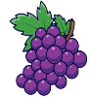 |  | podo
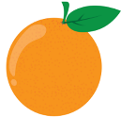 | 오렌지
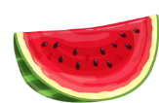 | 수박
 |  | ddalgi
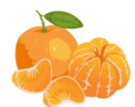 | 귤
 |  | chamoe
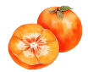 |  | gam

Activity 2 – 뭐예요? (What is it?)
Complete the table by:
- identifying the vegetable written in romanised Korean or Hangeul and writing it in English in the first column
- responding to the question 뭐예요? in the last column. Choose from ~예요 and ~이에요.
The first 2 rows have been completed as examples.
Food | Romanised Korean | Hangeul | 뭐예요?  ~예요 /~이에요.
potato | gamja | 감자 | 감자예요.
carrot | danggeun | 당근 | 당근이예요.
 |  | 양파
 | sangchu
 |  | 옥수수
 | pimang
 |  | 오이
 | maneul

Activity 3 – listening activity
Listen to the fruit and vegetable vocabulary as it is read aloud and number the images in the order you hear them. Then, write the word in Hangeul. The first one has been done for you as an example.
Fruit or vegetable | Number | Hangeul
 | 1 | 참외

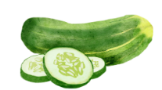
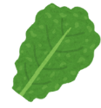

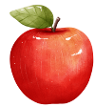
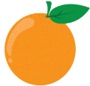


For the teacher
Remove this section before sharing this resource with students.
These activities are designed to suit a range of abilities and contexts. Adjust the level of difficulty of the activities to suit your students.

Activity 1 – fill in the blanks
Food item | Korean (Hangeul) | Romanised Korean
 | 토마토 | tomato
 | 바나나 | banana
Apple | 사과 | sagwa
 | 포도 | podo
 | 오렌지 | orenji
 | 수박 | subak
 | 딸기 | ddalgi
 | 귤 | gyul
 | 참외 | chamoe
 | 감 | gam

Activity 2 – 뭐예요? (What is it?)
Food | Romanised Korean | Hangeul | 뭐예요?  ~예요/~이에요.
potato | gam-ja | 감자 | 감자예요.
carrot | dang-geun | 당근 | 당근이에요.
onion | yang-pa | 양파 | 양파예요.
lettuce | sang-chu | 상추 | 상추예요.
corn | ok-su-su | 옥수수 | 옥수수예요.
capsicum | pi-mang | 피망 | 피망이에요.
cucumber | o-i | 오이 | 오이예요.
garlic | ma-neul | 마늘 | 마늘이에요.

Activity 3 – listening activity

Audio file
Fruits and vegetables – activity 3.mp3 (0:35)
Fruit or vegetable | Number | Hangeul or Romanised Korean
 | 1 | 참 외  chamoe
 | 5 | 피망  pimang
 | 4 | 오이  (oi)
 | 8 | 바나나  banana
 | 9 | 포도  podo
 | 3 | 상추  sangchu
 | 10 | 당근  danggeun
 | 6 | 사과  sagwa
 | 7 | 오렌지  orenji
 | 2 | 딸기  ddalgi

© State of New South Wales (Department of Education), 2024
The copyright material published in this resource is subject to the Copyright Act 1968 (Cth) and is owned by the NSW Department of Education or, where indicated, by a party other than the NSW Department of Education (third-party material).
Copyright material available in this resource and owned by the NSW Department of Education is licensed under a Creative Commons Attribution 4.0 International (CC BY 4.0) license.

This license allows you to share and adapt the material for any purpose, even commercially. Attribution should be given to © State of New South Wales (Department of Education), 2024.
Material in this resource not available under a Creative Commons license:
- the NSW Department of Education logo, other logos and trademark-protected material
- material owned by a third party that has been reproduced with permission. You will need to obtain permission from the third party to reuse its material.
Links to third-party material and websites
Please note that the provided (reading/viewing material/list/links/texts) are a suggestion only and implies no endorsement, by the New South Wales Department of Education, of any author, publisher, or book title. School principals and teachers are best placed to assess the suitability of resources that would complement the curriculum and reflect the needs and interests of their students.
If you use the links provided in this document to access a third-party's website, you acknowledge that the terms of use, including licence terms set out on the third-party's website apply to the use which may be made of the materials on that third-party website or where permitted by the Copyright Act 1968 (Cth). The department accepts no responsibility for content on third-party websites.

