Food and drink cards
This resource is for the teacher. It provides the content and instructions you need to share with students.

Activities
Print as many sets of cards as required for the activities to allow for each pair to have a set. The cards can be printed double-sided with the vocabulary on the back, or single-sided depending on the activity and the level of student support required.

Pair activity
This activity can be played with one set or a combination of the 4 sets of vocabulary cards, depending on how long you would like the students to play.
Students place the pile of cards face-down on the desk. One student picks up the card and shows it to their partner and asks 뭐예요? Their partner must identify the item in Korean using the phrase ~예요 or ~이에요. If they identify the item correctly, they take the card and place it in front of them. If they are unable to identify the item, their partner takes a turn. If the partner is able to identify it correctly, they take the card. If neither student is able to identify the card, it is placed at the bottom of the pile. Students repeat the process until all the cards are gone. The winner is the student with the most correctly-identified cards in their pile.

Memory-style activity
Print the picture and word flashcards at the end of this resource and direct students to place the cards face-down on the desk. Students take turns to turn the cards face-up and try to remember their location to match a picture with the word in Hangeul and/or romanised Korean, depending on student ability, to make pairs. The student with the most pairs of cards wins the game.

무슨 음식에요? – What food is it?
Provide each student with a card with a fruit or vegetable on it. This card may be printed with the romanised Korean and Hangeul on the back if required for additional support. Introduce the phrase 슨음 음식이에요? Practise the phrase as a class and then select individual students to respond to the question with the name of the item on their card. Direct students to switch their cards with another student. Direct students to walk around the room until you tell them to stop and find a partner. Indicate which student in the pair will ask the question (for example, the student closest to the front or window, or the student whose name is first alphabetically). They ask their classmate 무슨 음식이에요? The student being asked the question must identify the food they have on their card in Korean, without showing their partner. If they agree that they have the same item on their card, they confirm this by showing each other the image on their cards, and then sit down. If their cards don’t match they continue until all students have found their match.
 Differentiation examples
The following strategies provide a starting point for how you can differentiate this activity for a range of learners. Adapt or design alternatives, to meet the needs of students in your class.
High potential and gifted students – students ask each other for more detailed information using prior learning, for example, if they like the food, how often they eat the food, or when they last ate the food.
Advanced proficiency – students provide a detailed description of the food or drink, including the ingredients, if they have ever tried them, how they taste, and if they like them.
Students requiring additional support – provide students with the vocabulary lists below or provide the flashcards with the words in Hangeul and romanised Korean on the reverse side to facilitate interactions.

Vocabulary lists

Fruits 과일
English | Korean (Hangeul) | Romanised Korean
tomato | 토마토 | tomato
banana | 바나나 | banana
apple | 사과 | sagwa
grapes | 포도 | podo
orange | 오렌지 | orenji
watermelon | 수박 | subak
strawberry | 딸기 | ddalgi
tangerine | 귤 | gyul
melon | 참외 | chamoe
persimmon | 감 | gam

Vegetables 야채
English | Korean (Hangeul) | Romanised Korean
corn | 옥수수 | oksusu
lettuce | 상추 | sangchu
capsicum | 피망 | pimang
garlic | 마늘 | maneul
cucumber | 오이 | oi
onion | 양파 | yangpa
potato | 감자 | gamja
carrot | 당근 | danggeun

Korean food 한국 음식
English | Korean (Hangeul) | Romanised Korean
spicy rice cake | 떡볶이 | tteokbokki
bibimbap | 비빔밥 | bibimbap
ramyeon | 라면 | ramyeon
Korean sweet pancake | 호떡 | hoddeok
kimchi | 김치 | kimchi
bulgogi | 불고기 | bulgogi
chicken | 치킨 | chikin

Drinks 음료
English | Korean (Hangeul) | Romanised Korean
coffee | 커피 | keo / pi
tea | 차 | cha
coke | 콜라 | kol / ra
Korean sweet rice drink | 식혜 | shik / hye
milk | 우유 | u / yu
water | 물 | mul

Flashcards
Print the flashcards back-to-back or one-sided. The cards can be modified to include or remove the Hangeul or romanised Korean as required.
corn  옥수수 (oksusu) | lettuce  상추 (sangchu)
capsicum  피망 (pimang) | garlic  마늘 (maneul)

 | 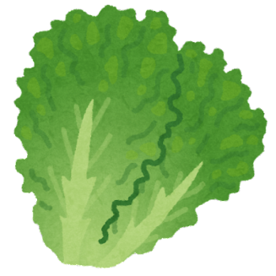
 | 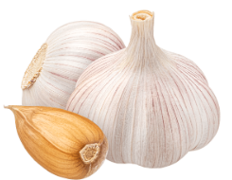

cucumber  오이 (oi) | onion  양파 (yangpa)
potato  감자 (gamja) | carrot  당근 (danggeun)

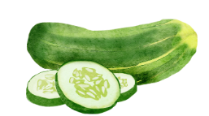 | 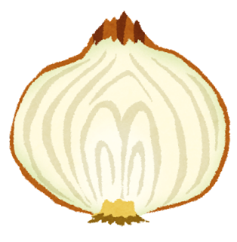
 | 

tomato  토마토 (tomato) | banana  바나나 (banana)
apple  사과 (sagwa) | grapes  포도 (podo)

 | 
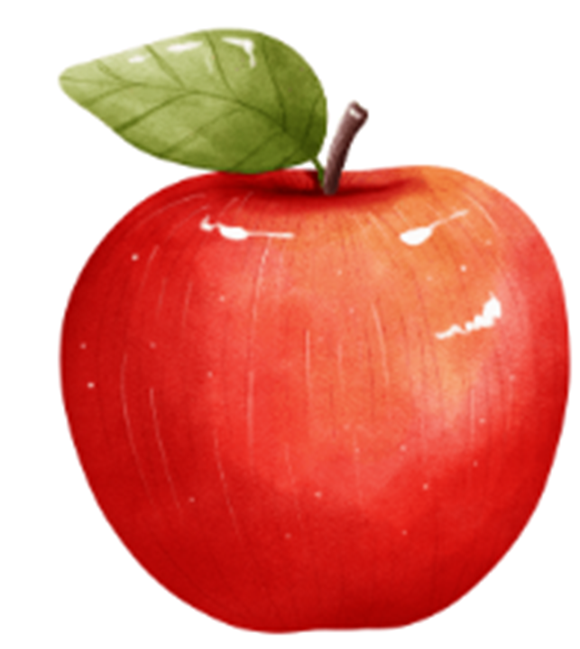 | 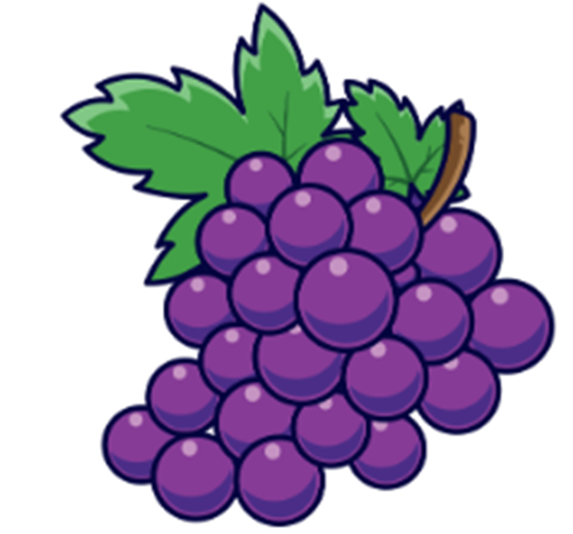

orange  오렌지 (orenji) | watermelon  수박 (subak)
strawberry  딸기 (ddalgi) | tangerine  귤 (gyul)

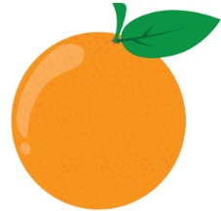 | 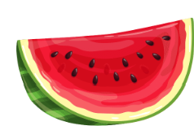
 | 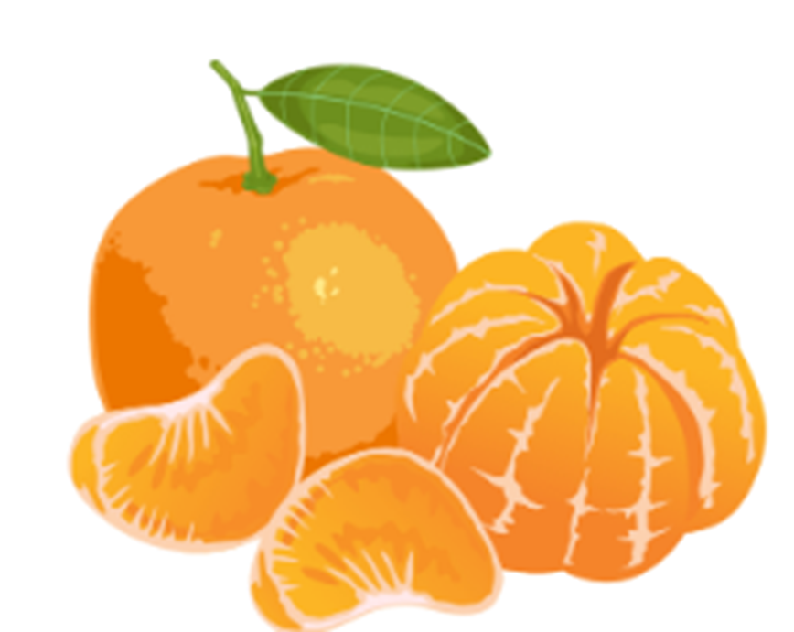

melon  참외 (chamoe) | persimmon  감 (gam)
 | 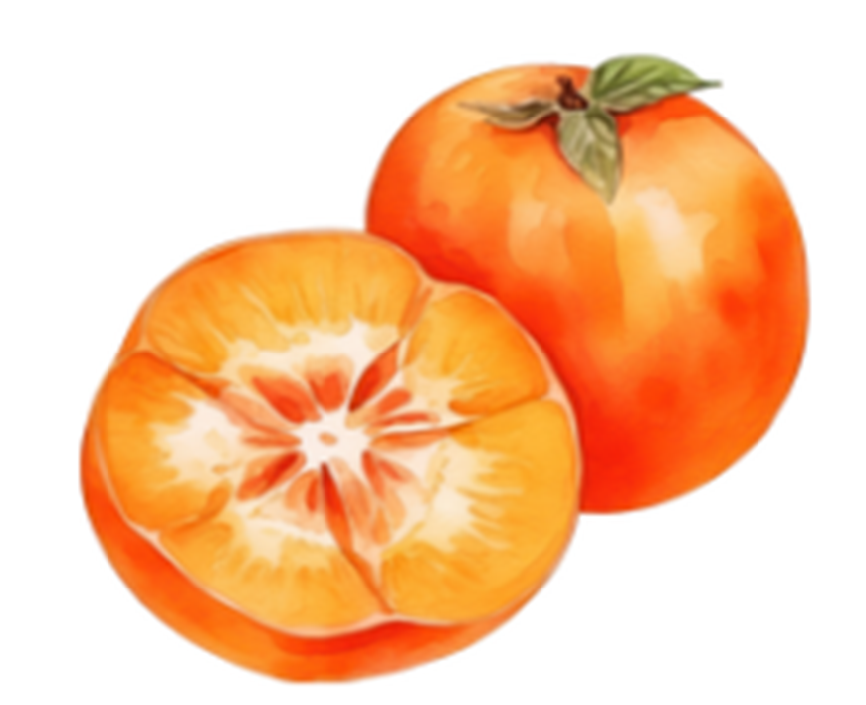

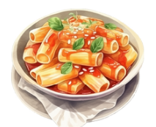 | 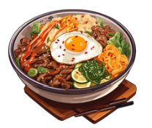
spicy rice cake  떡볶이 (tteokbokki) | bibimbap  비빔밥 (bibimbap)

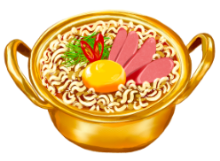 | 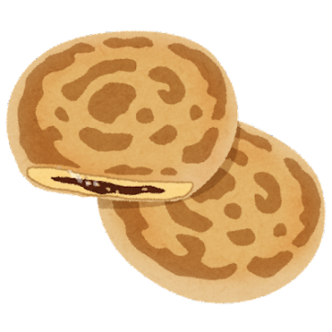
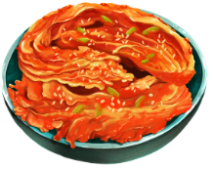 | 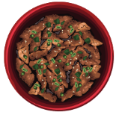

ramyeon  라면 (ramyeon) | Korean sweet pancake  호떡 (hoddeok)
kimchi  김치 (kimchi) | bulgogi  불고기 (bulgogi)

Korean fried chicken  치킨 (chikin) | coffee  커피 (keopi)
tea  차 (cha) | cola  콜 라 (kolra)

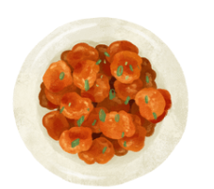 | 
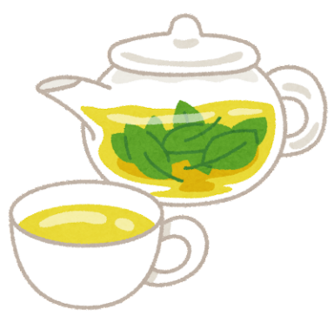 | 

Korean sweet rice drink  식혜 (shikhye) | milk  우유 (uyu)
water
물 (mul)

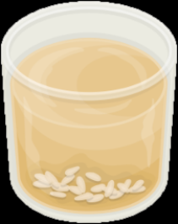 | 


© State of New South Wales (Department of Education), 2024
The copyright material published in this resource is subject to the Copyright Act 1968 (Cth) and is owned by the NSW Department of Education or, where indicated, by a party other than the NSW Department of Education (third-party material).
Copyright material available in this resource and owned by the NSW Department of Education is licensed under a Creative Commons Attribution 4.0 International (CC BY 4.0) license.

This license allows you to share and adapt the material for any purpose, even commercially. Attribution should be given to © State of New South Wales (Department of Education), 2024.
Material in this resource not available under a Creative Commons license:
- the NSW Department of Education logo, other logos and trademark-protected material
- material owned by a third party that has been reproduced with permission. You will need to obtain permission from the third party to reuse its material.
Links to third-party material and websites
Please note that the provided (reading/viewing material/list/links/texts) are a suggestion only and implies no endorsement, by the New South Wales Department of Education, of any author, publisher, or book title. School principals and teachers are best placed to assess the suitability of resources that would complement the curriculum and reflect the needs and interests of their students.
If you use the links provided in this document to access a third-party's website, you acknowledge that the terms of use, including licence terms set out on the third-party's website apply to the use which may be made of the materials on that third-party website or where permitted by the Copyright Act 1968 (Cth). The department accepts no responsibility for content on third-party websites.

