Yōkai booklet – みんなのようかい

ようかいはなんですか
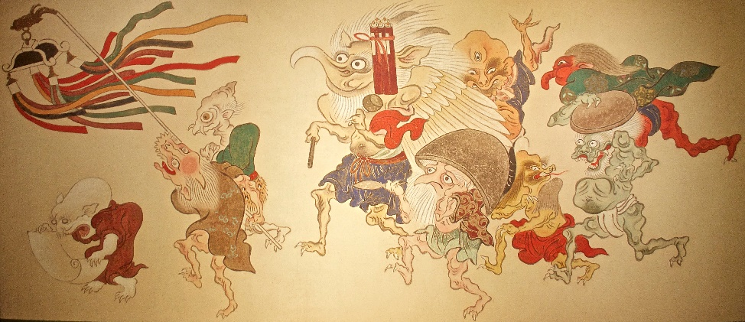
‘Yōkai: Ghosts & Demons Of Japan’ by pecooper98362 is licensed under CC BY-NC-SA 2.0.
Yōkai is a term from Japanese folklore that refers to supernatural or paranormal entities, often translated as ‘ghosts’, ‘monsters’ or ‘spirits’. Yōkai can take on a wide range of forms, from shape-shifting animals and mythical creatures to ghosts and supernatural beings with unique abilities or characteristics. Sometimes yōkai are also known as obake or bakemono.
Yōkai have played an important role in Japanese culture and have been depicted in various art forms, such as woodblock prints, paintings and literature. They are often seen as mischievous or malevolent creatures, but some yōkai are considered benevolent or even protective.
Yōkai continue to have a significant influence on modern Japanese culture. Yōkai have become a popular subject in Japanese pop culture, appearing in manga, anime, video games and movies. Pikachu from Pokemon, which has become a global icon, is based on a yōkai. Other anime that include yōkai themes include Demon Slayer, One Piece, Yu-yu Hakusho, Inuyashiya and Studio Ghibli anime such as Spirited Away and Princess Mononoke.
Many Japanese festivals celebrate yōkai, such as the Obon festival in August, which honors the spirits of ancestors and features dancing performed in yōkai costumes. Yōkai have had a significant role in traditional Japanese culture and continue to do so in modern Japan.

Activity 1 – parts of the body
Let’s learn to name parts of the body for people and creatures. In pairs, take turns to read the body parts, then the parts of the face. からだ means body and かお means face.
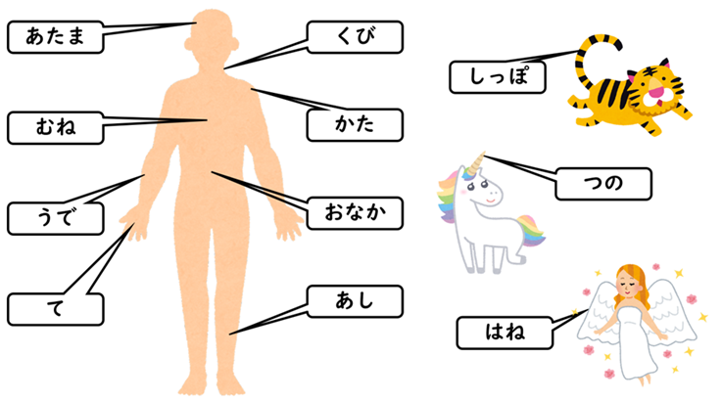
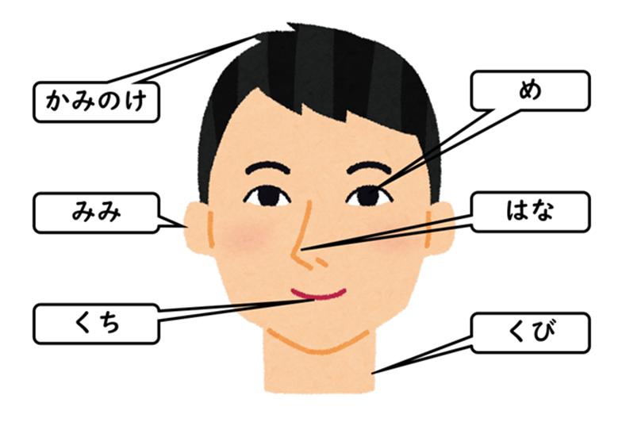

Activity 2 – memory challenge
Listen to your teacher or a partner read the words and see if you can label the parts of the body and face correctly.
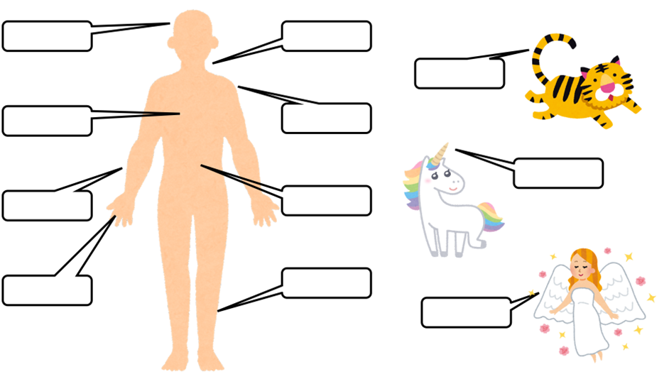
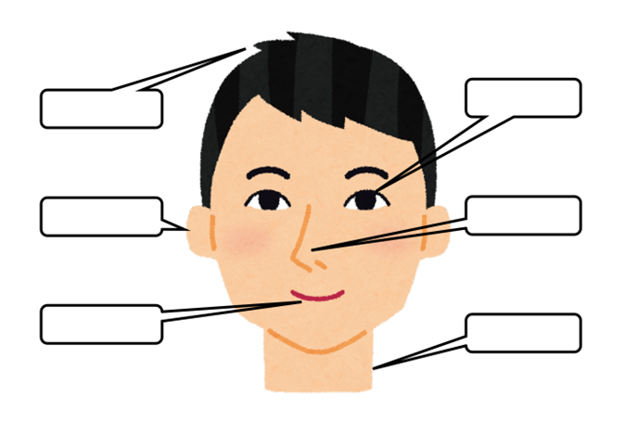

Activity 3 – adjectives
In pairs or as a class, create a bilingual adjective list that you could use to describe yōkai using your own knowledge and/or print or online dictionaries.
English | Japanese

Activity 4 – making descriptive sentences
How can you describe yōkai? The first sentence has been done for you. Look at the word order then try describing the hair, face and nose.
おにはつのがきいろいです。
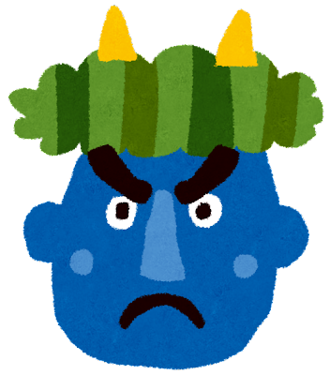
Have a look at this chōchin-obake and see if you can write 3 sentences to describe it in Japanese.
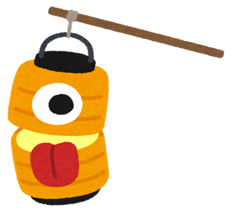

Activity 5 – using あります and ありません
Hang on! What if the creature has no nose? You can use あります and ありません to say that something exists or doesn’t exist. Look at the 2 examples in the table below.
English | Japanese
He has a nose. | はながあります。
He doesn’t have a nose. | はながありません。
If a creature has no ears, what would you say?

If a creature has a tail, what would you say?

Activity 6 – listening activity
- Listen to the audio Activity 6 – listening activity – sample 1.mp3 (0:21) describing a creature and draw what you hear in the box.

- Listen to Activity 6 – listening activity – sample 2.mp3 (0:27) describing a creature and draw what you hear in the box.

Activity 7 – learning about famous yōkai
Read the descriptions of the yōkai in the table below and answer the questions that follow. The vocabulary column has been added to help you.
Name and picture | Description | Vocabulary
かっぱ  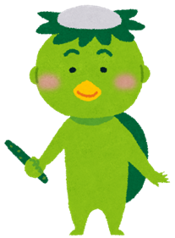 | ぼくはかっぱです。  かわにすんでいます。  からだはみどりです。  きゅうりがすきです。  かっぱはおもしろいです。 | かわ river  みどり green  きゅうり cucumber  おもしろい funny
ろくろっくび  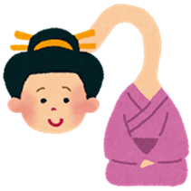 | わたしはろくろっくびです。  まちにすんでいます。  おんなです。  くびがながいです。 | まち town  おんな female  くび neck  ながい long
ぬえ  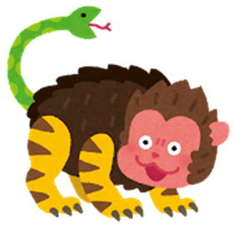 | ぼくはぬえです。  やまにすんでいます。  しっぽがへびです。  かおがさるです。 | やま mountain  へび snake  かお face  さる monkey
ぬらりひょん  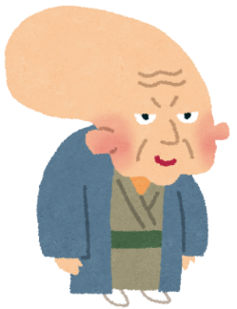 | ぼくはぬらりひょんです。  ようかいのリーダーです。  おじいさんです。  あたまがいいです。 | ーー leader  おじいさん old man  あたまがいい clever
のっぺらぼう  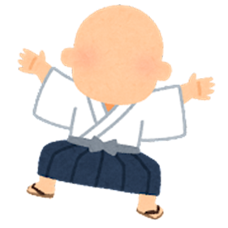 | ぼくはのっぺらぼうです。  おとこです。  まちにすんでいます。  かおがありません。  ふくがしろいです。 | おとこ male  ありません don’t have  ふく clothes  しろい white
ざしきわらし  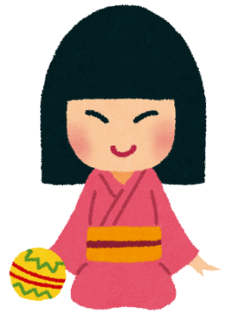 | わたしはざしきわらしです。  ふるいいえにすんでいます。  いえをまもります。  こどもです。 | ふるい old  いえ house  まもります protect  こども child
てんぐ  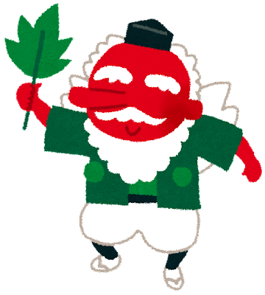 | わたしはてんぐです。  やまにすんでいます。  はながたかいです。（はながながいです。）  からだがあかいです。  しろいはねがあります。 | やま mountain  はね feather
うみぼうず   | ぼくはうみぼうずです。  うみにすんでいます。  からだがくろいです。  とてもおおきいです。 | おおきい big  くろい black
ゆきおんな  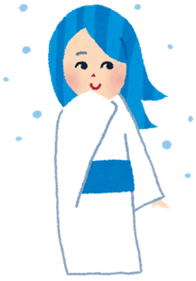 | わたしはゆきおんなです。  やまにすんでいます。  とてもきれいです。  ふゆがすきです。 | きれい beautiful  ふゆ winter  すき like  おんな female  ゆき snow
からかさ  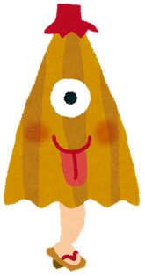 | ぼくはからかさです。  おはかにすんでいます。  あめがすきです。 | おはか cemetery  あめ rain  かさ umbrella

Using the information in the table, answer the following questions.
- Which yōkai has a green body?
- Where does tengu live?
- Which yōkai is clever?
- Which yōkai has the monkey face?
- Which yōkai likes winter?
- What do you learn about umibōzu?
- Which yōkai protects the house?
- List 3 yōkai that live in the mountains.
- Which yōkai has a long neck?
- What does karakasa like?
Using the information in the table, write a suitable word in the blank space to form a correct sentence.
- おには＿＿＿＿＿＿＿＿＿です。
- のっぺらぼうは＿＿＿＿＿＿＿＿＿＿です。
- ざしきわらしは＿＿＿＿＿＿＿＿＿＿です。
- かっぱはきゅうりが＿＿＿＿＿＿＿＿＿＿＿です。
- ろくろっくびは＿＿＿＿＿＿＿＿＿＿にすんでいます。
- ぬえは＿＿＿＿＿＿＿＿＿＿がへびです。
- からかさはおはかに＿＿＿＿＿＿＿＿＿＿＿＿＿＿＿＿。
- うみぼうずはとても＿＿＿＿＿＿＿＿＿＿＿です。
- ゆきおんなは＿＿＿＿＿＿＿＿＿＿＿＿がすきです。
- てんぐははねが＿＿＿＿＿＿＿＿＿＿＿＿です。

Activity 8 – yōkai design
Now it’s your turn to be creative and design a yōkai. Use the descriptions in Activity 7 to help you with describing your yōkai. Write 4 sentences about your yōkai. Be creative and don’t forget to give it a name and include any additional vocabulary you use in the last column.
Name and picture | Description | Vocabulary

Activity 9 – yōkai research
Choose any one of the yōkai below to research, and complete 5 facts about them in English or Japanese using full sentences.
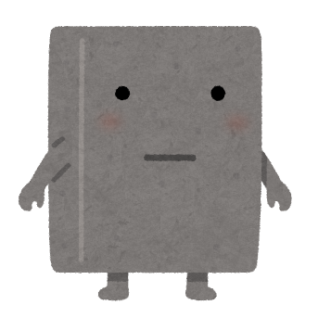  ぬりかべ | 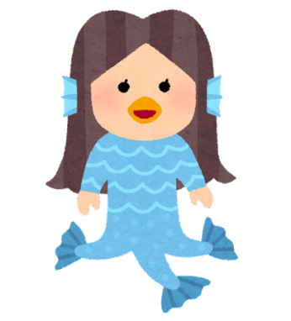アマビエ | 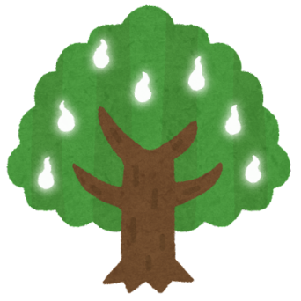  こだま

Name of yōkai | Facts

Activity 10 – reading about yōkai
Read more details about some of the yōkai found in Japanese folklore and answer the questions that follow.
Rokurokubi are typically depicted as humans who can stretch or detach their heads from their bodies and are sometimes referred to as a ‘long necked yōkai’. They are said to have long necks that can grow to incredible lengths and stretch their necks to spy on humans or to attack them.
Nue is typically described as a composite of various animals, including a monkey, a raccoon dog, a snake and a tiger. The nue is often portrayed as a malicious, shape-shifting monster that can cause diseases, including the plague, and can even disrupt the weather and bring about natural disasters. Despite its ominous reputation, the nue is also sometimes depicted as a comical figure and is sometimes said to bring good luck to those who can capture it.
Oni is a type of demon or ogre that is often depicted as having horns, sharp claws and a fearsome appearance. Oni are often portrayed as evil and malevolent beings who torment and harm humans, but there are also tales that show them as more complex characters who can be both cruel and kind, good and bad. They are a common subject in Japanese art, literature and popular culture, and they have become an integral part of the country’s cultural heritage.
The noppera-bō, or faceless ghost, is a Japanese yōkai that looks like a human but has no face. Noppera-bō is known primarily for frightening humans but is usually otherwise harmless. It appears at first as an ordinary human being, sometimes impersonating someone familiar to the victim, before their features disappear, leaving a blank, smooth sheet of skin where its face should be.
Tengu is a type of supernatural creature. It is typically depicted as having both human and bird-like characteristics, often with a long nose and wings. It is considered to be a powerful and mischievous being and is sometimes associated with martial arts and the protection of the mountains.
Yukionna is a mythical creature, often depicted as a beautiful and mysterious woman with long black hair, pale skin and the ability to control snow and ice. She is often associated with winter and is said to lure travellers into the mountains, where she can freeze them to death.
Kappa is a mythical creature, often depicted as a water spirit or demon that dwells in rivers, lakes and other bodies of water. It is typically depicted as having the body of a tortoise and the head of a monkey, with scaly skin and webbed hands and feet. Kappa is often portrayed as mischievous or malevolent, but also as having a mischievous or playful side, and is sometimes said to be able to grant wishes or perform other helpful acts. In Japanese folklore, it is said that one should bow to a kappa to show respect, as they are said to be polite creatures that will return the gesture and may then spare a person from harm. Learn more about the kappa by watching Ancient Aliens: The Legendary Japanese Kappa (2:30).
Umibōzu is a mythical sea monster, often depicted as a giant, ghostly figure with a bald head and a large body that resembles that of a Buddhist priest. It is said to dwell in the ocean and is associated with storms and rough seas. In some legends, umibōzu is said to be a spirit of the sea that demands a toll from sailors for safe passage, while in others it is depicted as a malevolent monster that capsizes ships and drags sailors down to their deaths.
Zashikiwarashi is a supernatural spirit or monster in Japanese folklore. It is typically depicted as a small child with wild, unkempt hair, who lives in old, traditional houses and brings good fortune to the household.
Nurarihyon is a type of supernatural creature. It is often depicted as an old man with a large forehead and an elongated, wrinkled face, who is the leader of a group of yōkai. In some stories, nurarihyon is depicted as a cunning and deceitful figure who uses his wit and powers to manipulate humans and other yōkai to his advantage. In other stories he is portrayed as a benevolent figure who brings good luck and prosperity to households.
Karakasa is a type of supernatural creature. It is typically depicted as a ghostly figure with a large, umbrella-like head that is said to haunt graveyards, abandoned temples and other lonely places. In some legends, it is said to appear on rainy nights and to try to scare or attack people who cross its path. Despite its frightening appearance, the karakasa is also sometimes depicted as a comical figure and is sometimes even said to bring good luck to those who are able to outwit it.
- Which is your favourite yōkai and why? Please answer in English, giving details.
- Complete the table below by filling in the meanings of the English words from the passage. You may use a print or online dictionary to assist you.
Word | Meaning (in English)
composite
malicious
plague
ominious
malevolent
literature
impersonate
mischievous
lure
unkempt
wit
elongated
deceitful
manipulate
outwit

Activity 11 – kanji activity
Complete the table below following these steps:
- Read the word in hiragana and write its meaning in English in the first column.
- The third column displays the stroke number for the kanji as well as a link to see the stroke order. View the stroke order carefully. Use the practice spaces to copy the kanji, using the correct stroke order.
English | Hiragana | Strokes | Kanji | Practice spaces
 | まち | 7 | 町
 | やま | 3 | 山
 | かわ | 3 | 川
 | うみ | 9 | 海
 | おんな | 3 | 女
 | おとこ | 7 | 男
 | あめ | 8 | 雨
 | あかい | 7 | 赤い
 | しろい | 5 | 白い
 | おおきい | 3 | 大きい

Activity 12 – song ゲゲゲのきたろう
Watch the video ゲゲゲのきたろう(1:14) and answer the following questions.
- What do you think ゲゲゲ means?
- Can you name any of the characters in the video?
- How does this song make you feel?

Activity 13 – singalong
Listen to the videoゲゲゲのきたろう(1:14) again and sing along or follow the words.
ゲッゲッ ゲゲゲのゲー
あさはねどこで グーグーグー
たのしいな たのしいな
おばけにゃがっこうも
しけんもなんにもない
ゲッゲッ ゲゲゲのゲー
みんなでうたおう ゲゲゲのゲ
ゲッゲッ ゲゲゲのゲー
よるははかばで うんどうかい
たのしいな たのしいな
おばけはしなない
びょうきもなんにもない
ゲッゲッ ゲゲゲのゲー
みんなでうたおう ゲゲゲのゲ
みんなでうたおう ゲゲゲのゲ
みんなでうたおう ゲゲゲのゲ

Activity 14 – yōkai inTōkyō
Look at the pictures taken in Tokyo. Which yōkai is pictured?
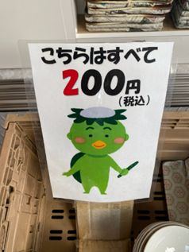 | 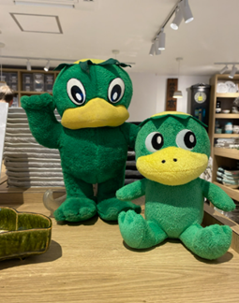 | 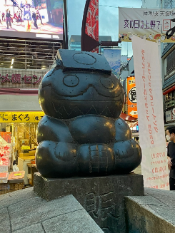 | 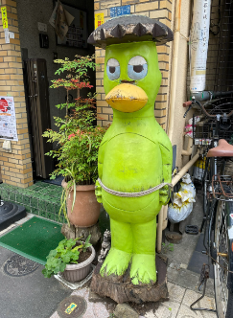
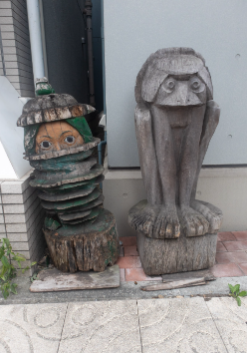 | 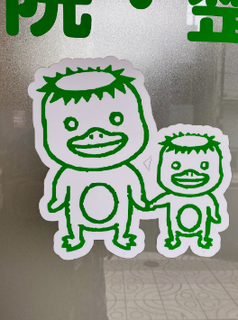 | 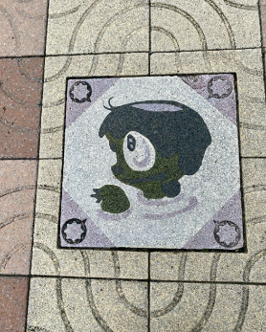 | 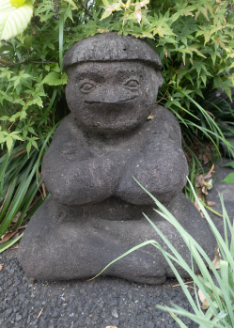

References
HISTORY (8 September 2015) ‘Ancient Aliens: The Legendary Japanese Kappa (S8, E7)’, HISTORY, YouTube, accessed 13 June 2024.
Toho Animation Koshiki (1 April 2018) ‘オープニング主題歌「ゲゲゲの鬼太郎」(歌:氷川きよし)’, YouTube, accessed 13 June 2024.

© State of New South Wales (Department of Education), 2024
The copyright material published in this resource is subject to the Copyright Act 1968 (Cth) and is owned by the NSW Department of Education or, where indicated, by a party other than the NSW Department of Education (third-party material).
Copyright material available in this resource and owned by the NSW Department of Education is licensed under a Creative Commons Attribution 4.0 International (CC BY 4.0) license.

This license allows you to share and adapt the material for any purpose, even commercially.
Attribution should be given to © State of New South Wales (Department of Education), 2024.
Material in this resource not available under a Creative Commons license:
- the NSW Department of Education logo, other logos and trademark-protected material
- material owned by a third party that has been reproduced with permission. You will need to obtain permission from the third party to reuse its material.
Links to third-party material and websites
Please note that the provided (reading/viewing material/list/links/texts) are a suggestion only and implies no endorsement, by the New South Wales Department of Education, of any author, publisher, or book title. School principals and teachers are best placed to assess the suitability of resources that would complement the curriculum and reflect the needs and interests of their students.
If you use the links provided in this document to access a third-party's website, you acknowledge that the terms of use, including licence terms set out on the third-party's website apply to the use which may be made of the materials on that third-party website or where permitted by the Copyright Act 1968 (Cth). The department accepts no responsibility for content on third-party websites.

