Shopping places flashcards
This resource is for the teacher. It provides the content and instructions you need to share with students.
Use the ‘Shopping places flashcards’ at the end of this resource, or use the editable version on Canva.
Print the ‘Shopping places flashcards’ to show students, in conjunction with the ‘Sentence scaffold’ resource (PPTX 892 KB).
Hold up one of the flashcards to the class as a prompt. In pairs, students take turns asking each other a question based on the place. For example, Mau ke pasar? Their partner responds, using the sentence scaffold to assist them in justifying their response. For example, Ya, saya mau ke pasar karena ada banyak pilihan.

Shopping places flashcards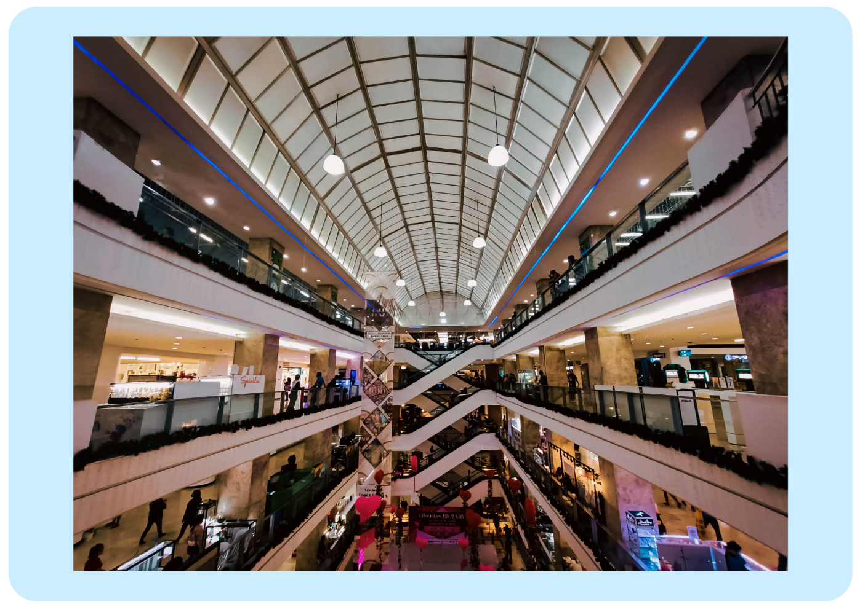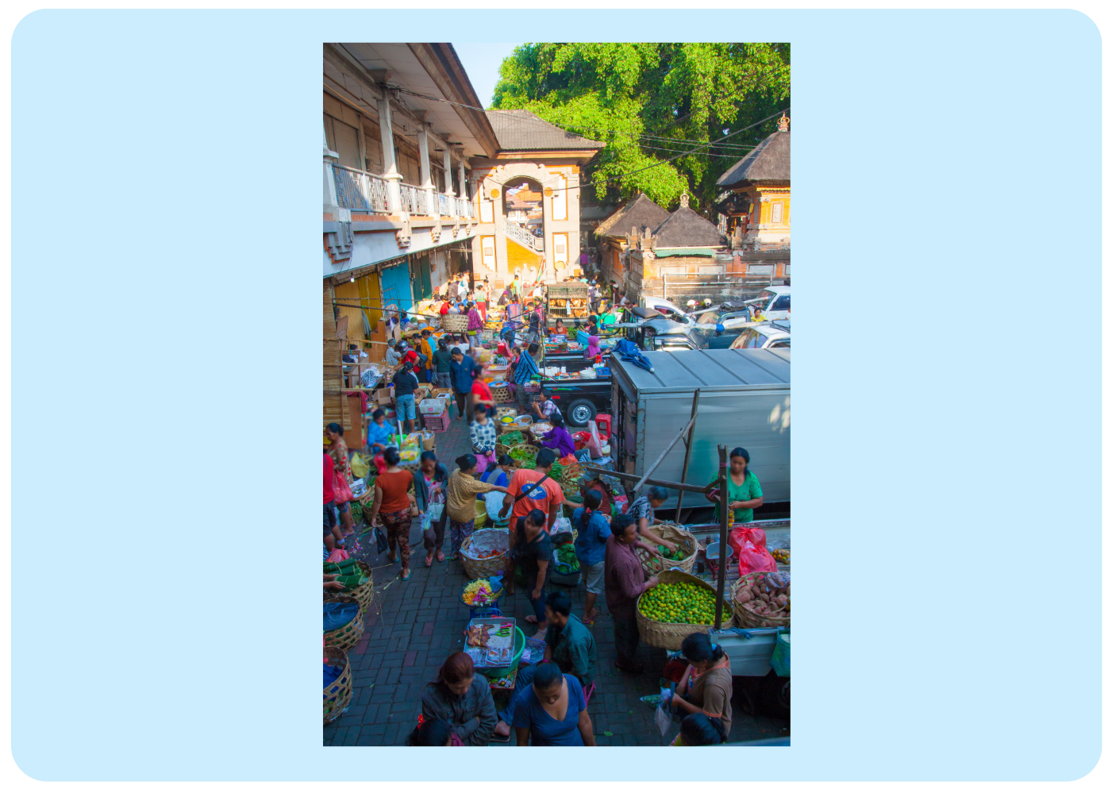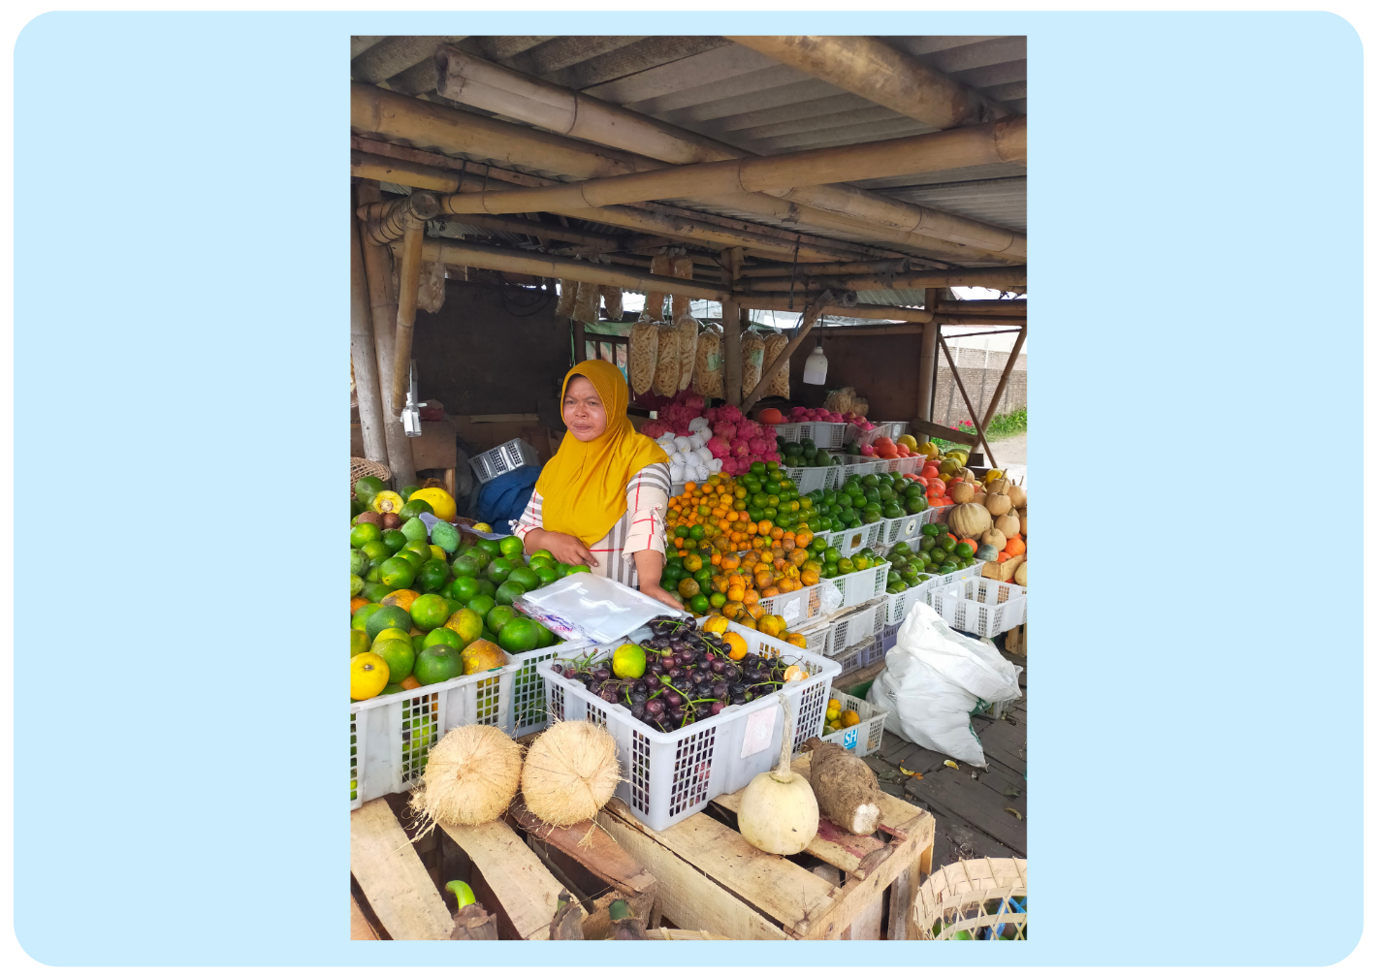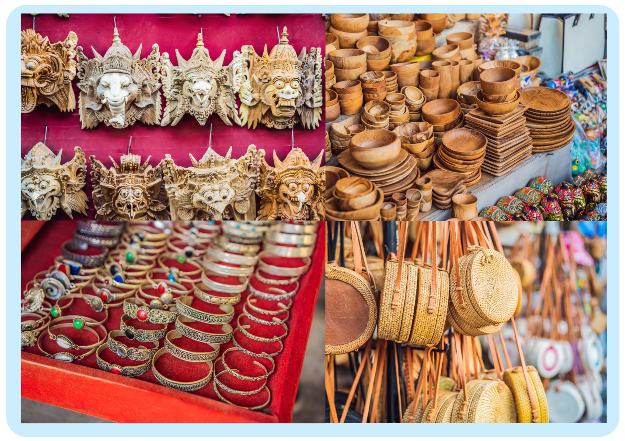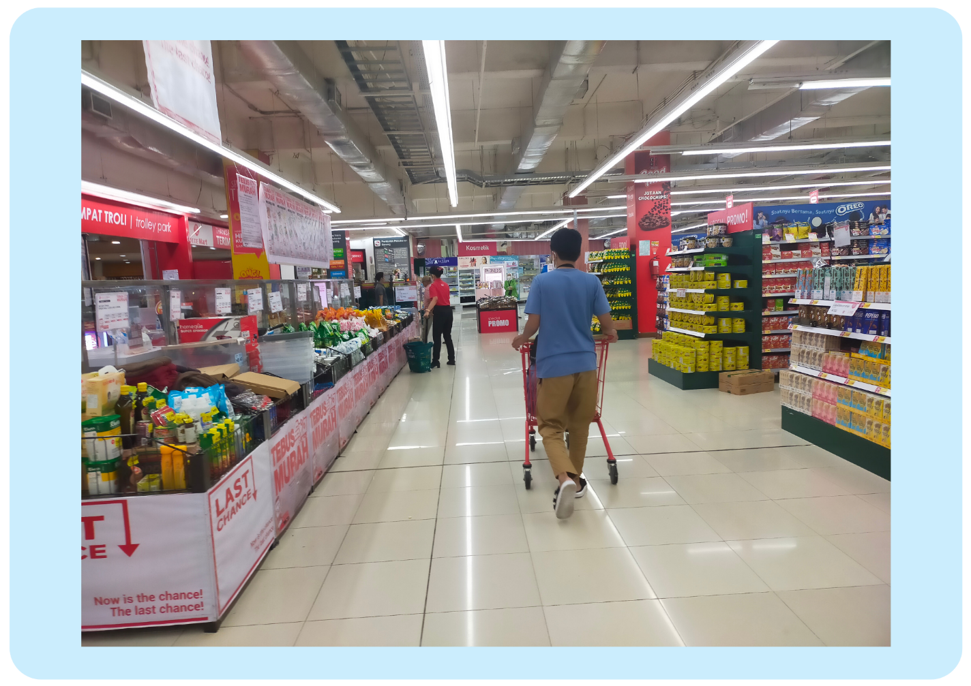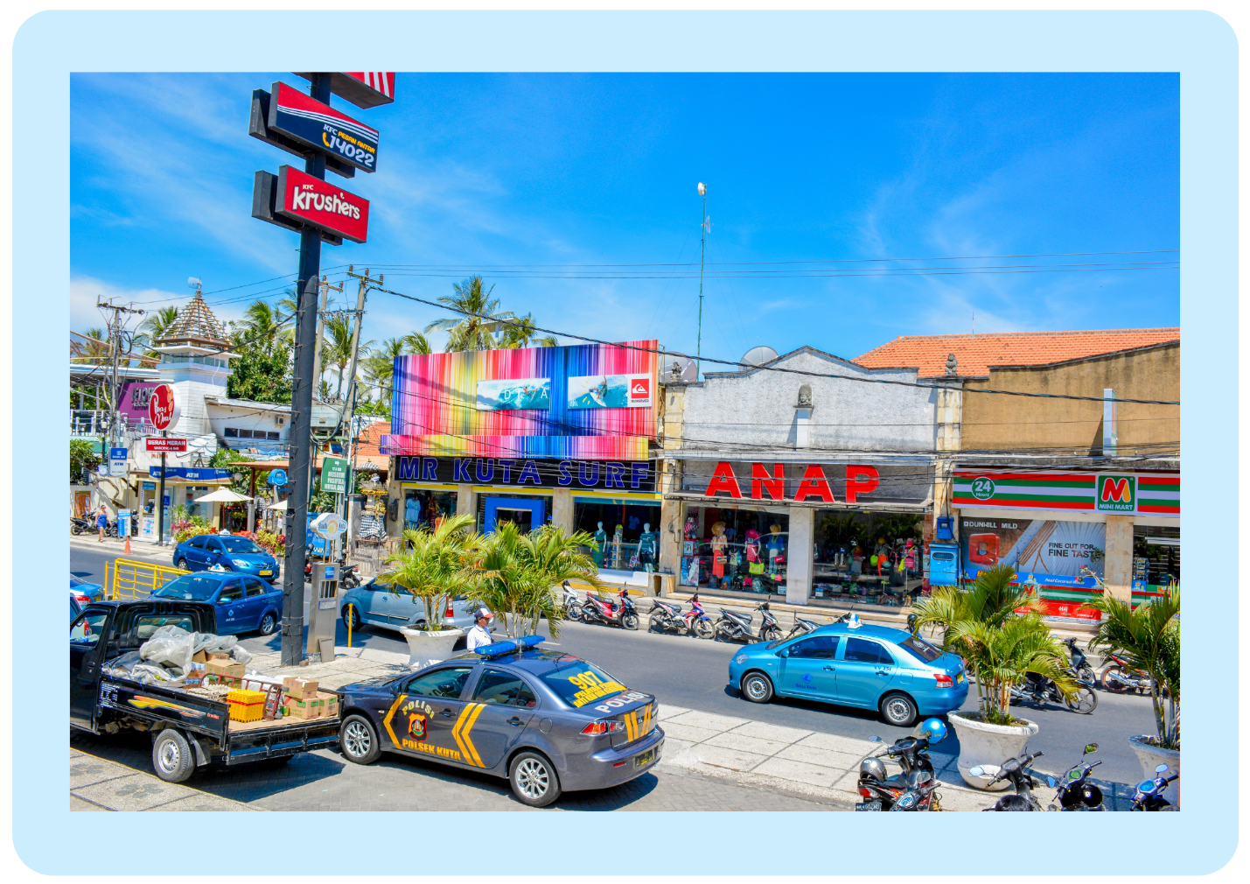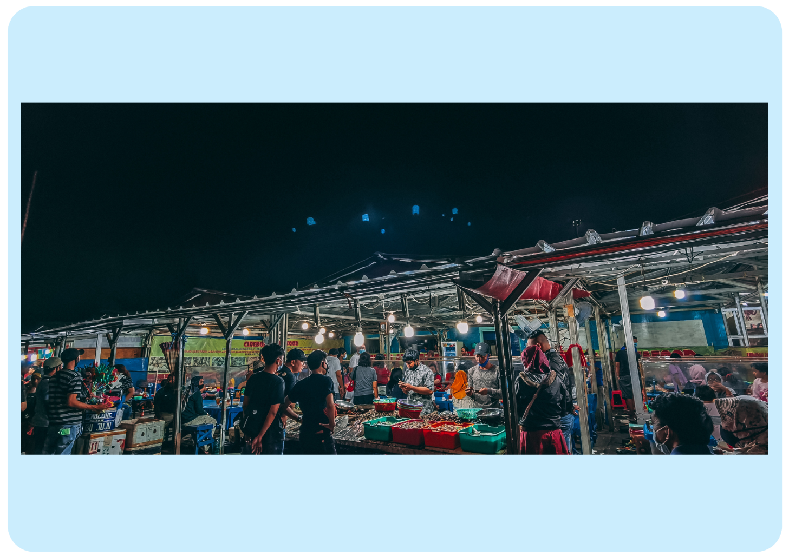

© State of New South Wales (Department of Education), 2024
The copyright material published in this resource is subject to the Copyright Act 1968 (Cth) and is owned by the NSW Department of Education or, where indicated, by a party other than the NSW Department of Education (third-party material).
Copyright material available in this resource and owned by the NSW Department of Education is licensed under a Creative Commons Attribution 4.0 International (CC BY 4.0) license.

This licence allows you to share and adapt the material for any purpose, even commercially. Attribution should be given to © State of New South Wales (Department of Education), 2024.
Material in this resource not available under a Creative Commons licence:
- the NSW Department of Education logo, other logos and trademark-protected material
- material owned by a third party that has been reproduced with permission. You will need to obtain permission from the third party to reuse its material.
Links to third-party material and websites
Please note that the provided (reading/viewing material/list/links/texts) are a suggestion only and implies no endorsement, by the New South Wales Department of Education, of any author, publisher, or book title. School principals and teachers are best placed to assess the suitability of resources that would complement the curriculum and reflect the needs and interests of their students.
If you use the links provided in this document to access a third-party's website, you acknowledge that the terms of use, including licence terms set out on the third-party's website apply to the use which may be made of the materials on that third-party website or where permitted by the Copyright Act 1968 (Cth). The department accepts no responsibility for content on third-party websites.

