Find someone who …
Your teacher will give each student a different identity card. By signing questions to other students, complete the table below with the names of students who match the criteria.
First, practise these questions in Auslan with a partner:
- What is your name?
- How old are you?
- What do you like?
- What don’t you like?
- Are you Deaf/a CODA/hard of hearing/hearing?
- Where do you live?
- What pets do you have?
When you are ready, walk around the room to find out who fits the criteria in the table below, and write their name in the ‘Name’ column. You might find more than one person meets each criteria.
Criteria | Name
Is 13 years old
Is 15 years old
Is 12 years old
Is 14 years old
Is a CODA
Is hearing
Is Deaf
Is hard of hearing
Has a cat
Has a dog
Has a rabbit
Has a horse
Has a bird
Lives in Newcastle
Lives in Taree
Lives in Sydney
Lives in Wollongong
Lives in Armidale
Lives in Bathurst
Likes basketball
Likes swimming
Likes sport
Likes pizza
Likes watching movies
Likes chocolate
Doesn’t like coffee
Doesn’t like dancing
Doesn’t like soccer
Doesn’t like drawing
Doesn’t like sport

For the teacher
Remove this section before sharing this resource with students.
Check students can sign the correct questions before commencing the activity.
- What is your name?
- How old are you?
- What do you like?
- What don’t you like?
- Are you Deaf/a CODA/hard of hearing/hearing?
- Where do you live?
- What pets do you have?
Provide each student with an identity card. There are 15 cards, so some students will have the same card, but this does not affect the activity. This is an editable Canva link if you want to edit the content.

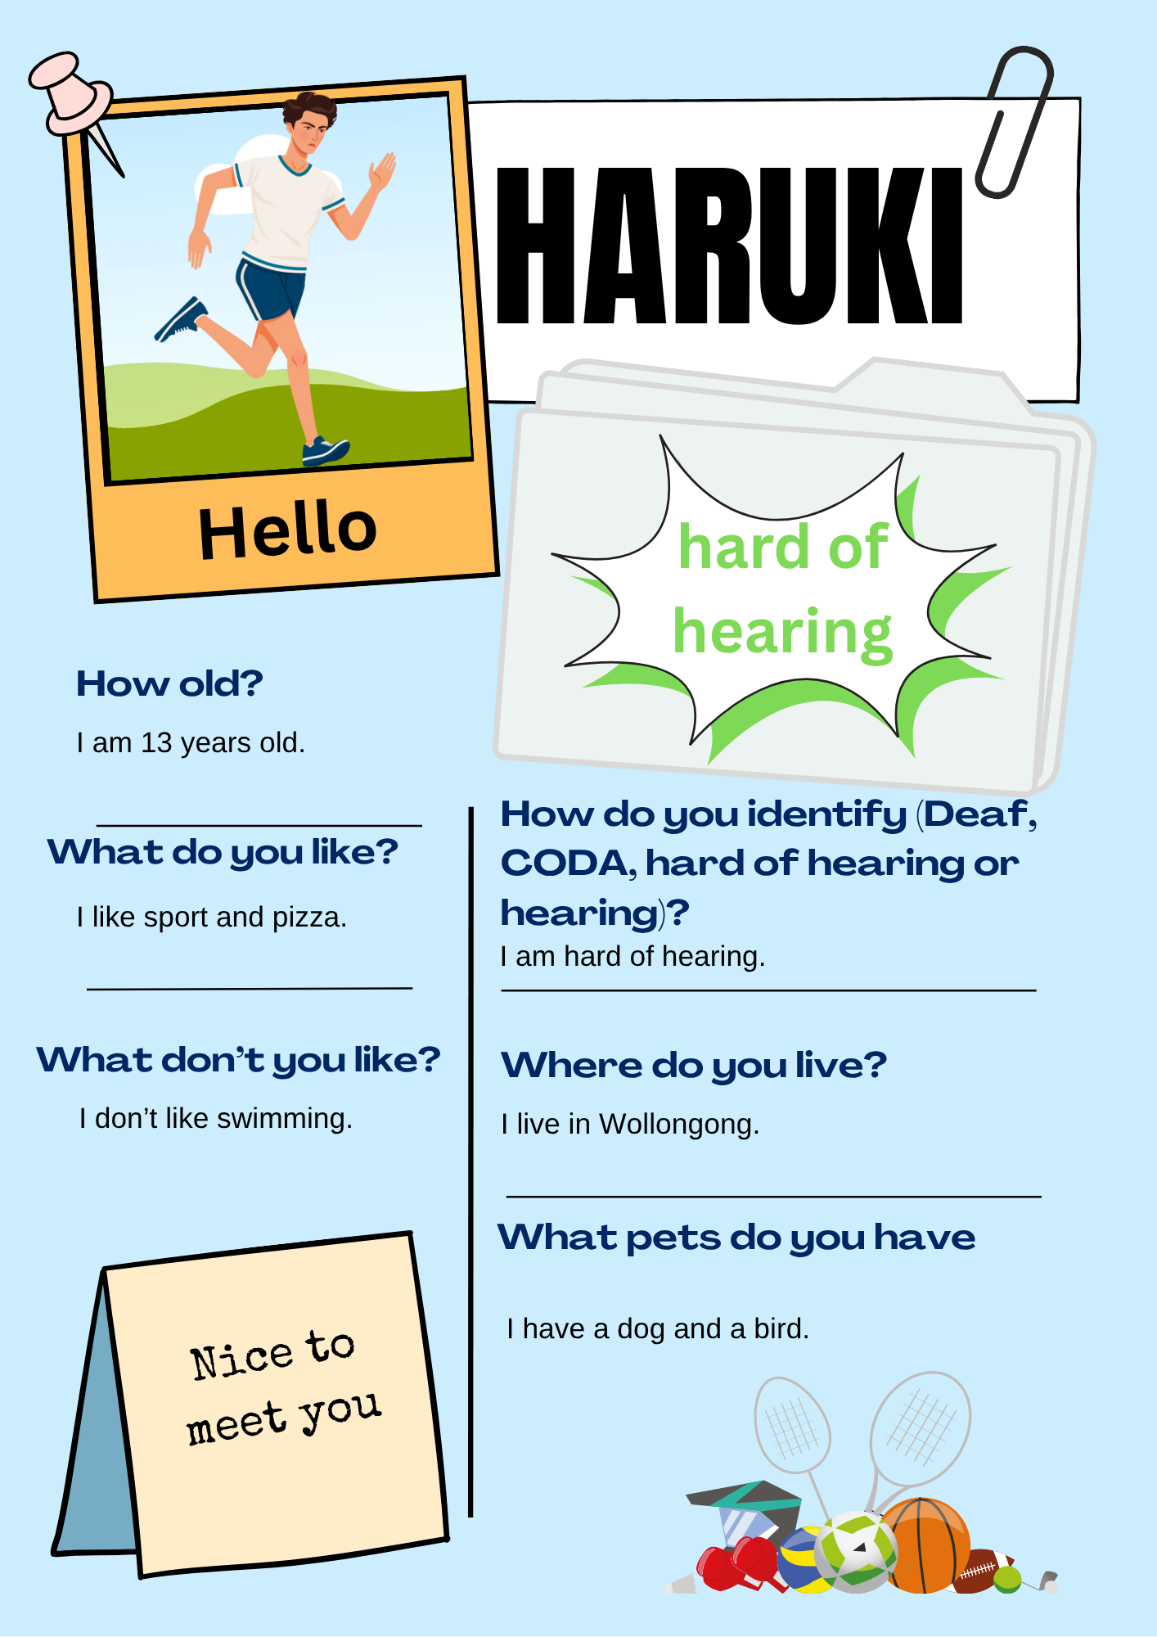 | 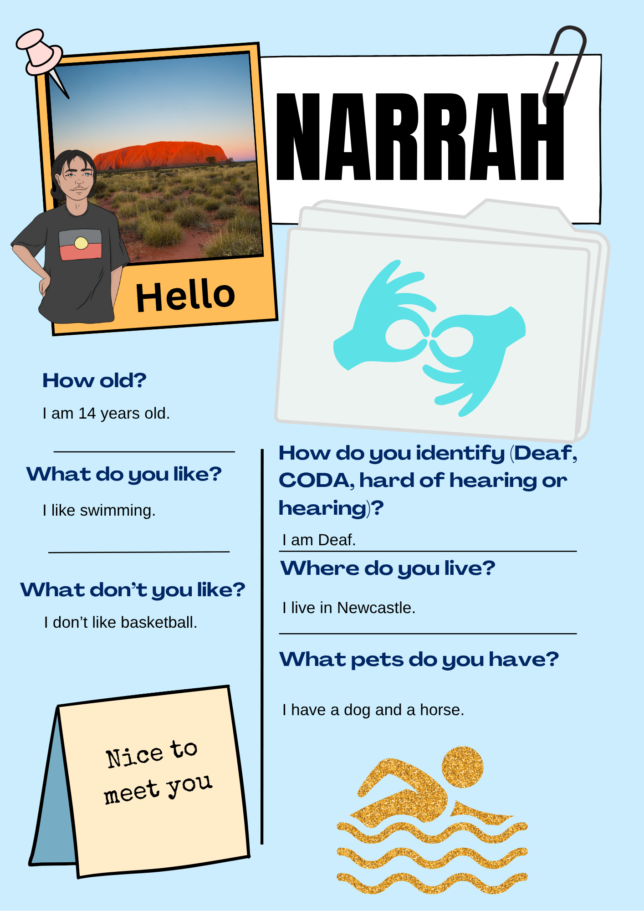
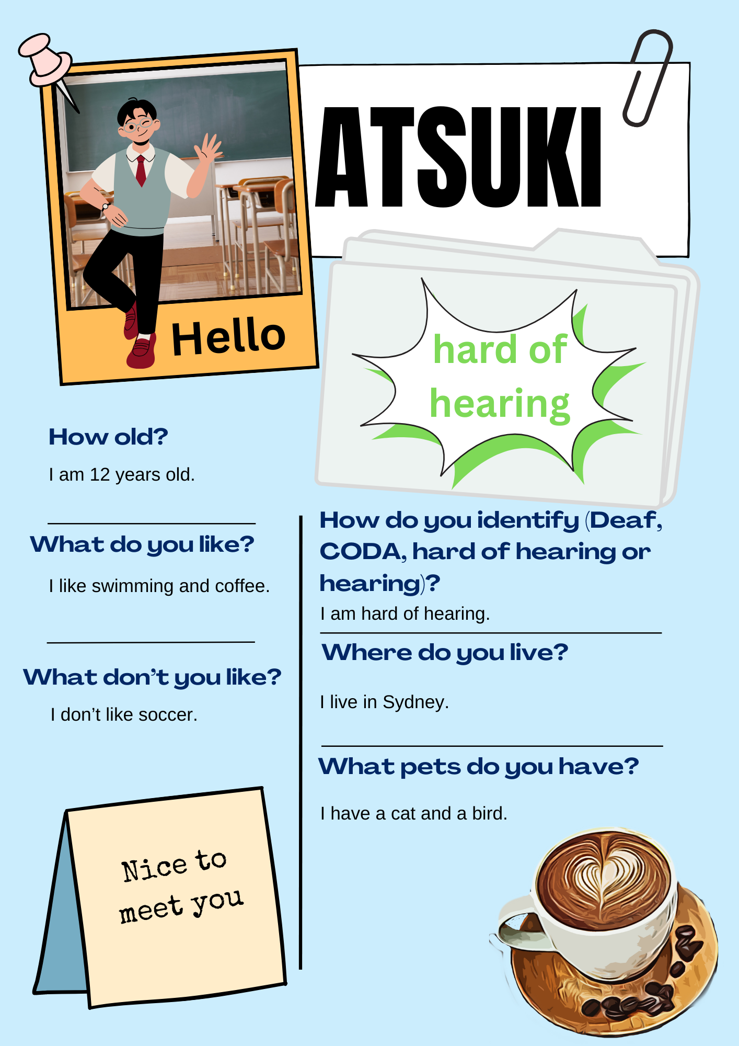 | 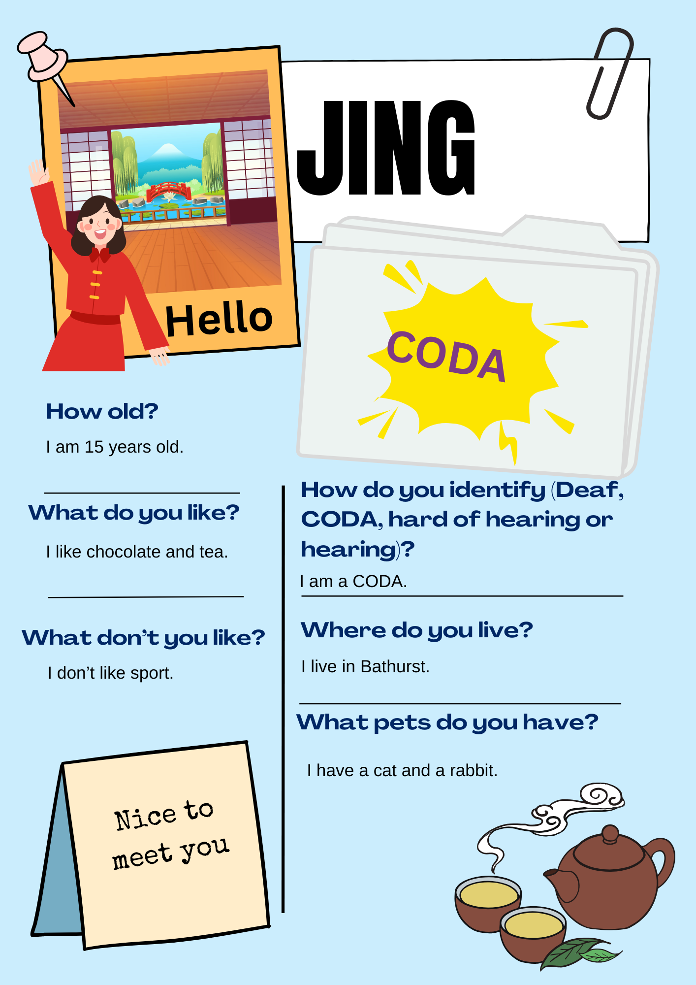
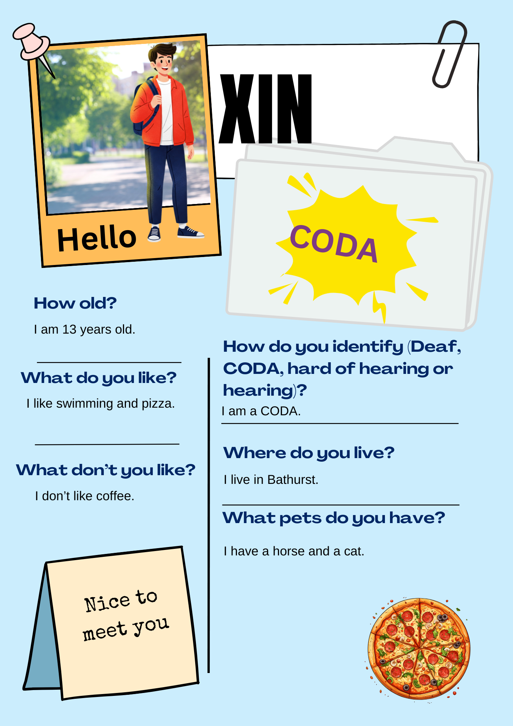 | 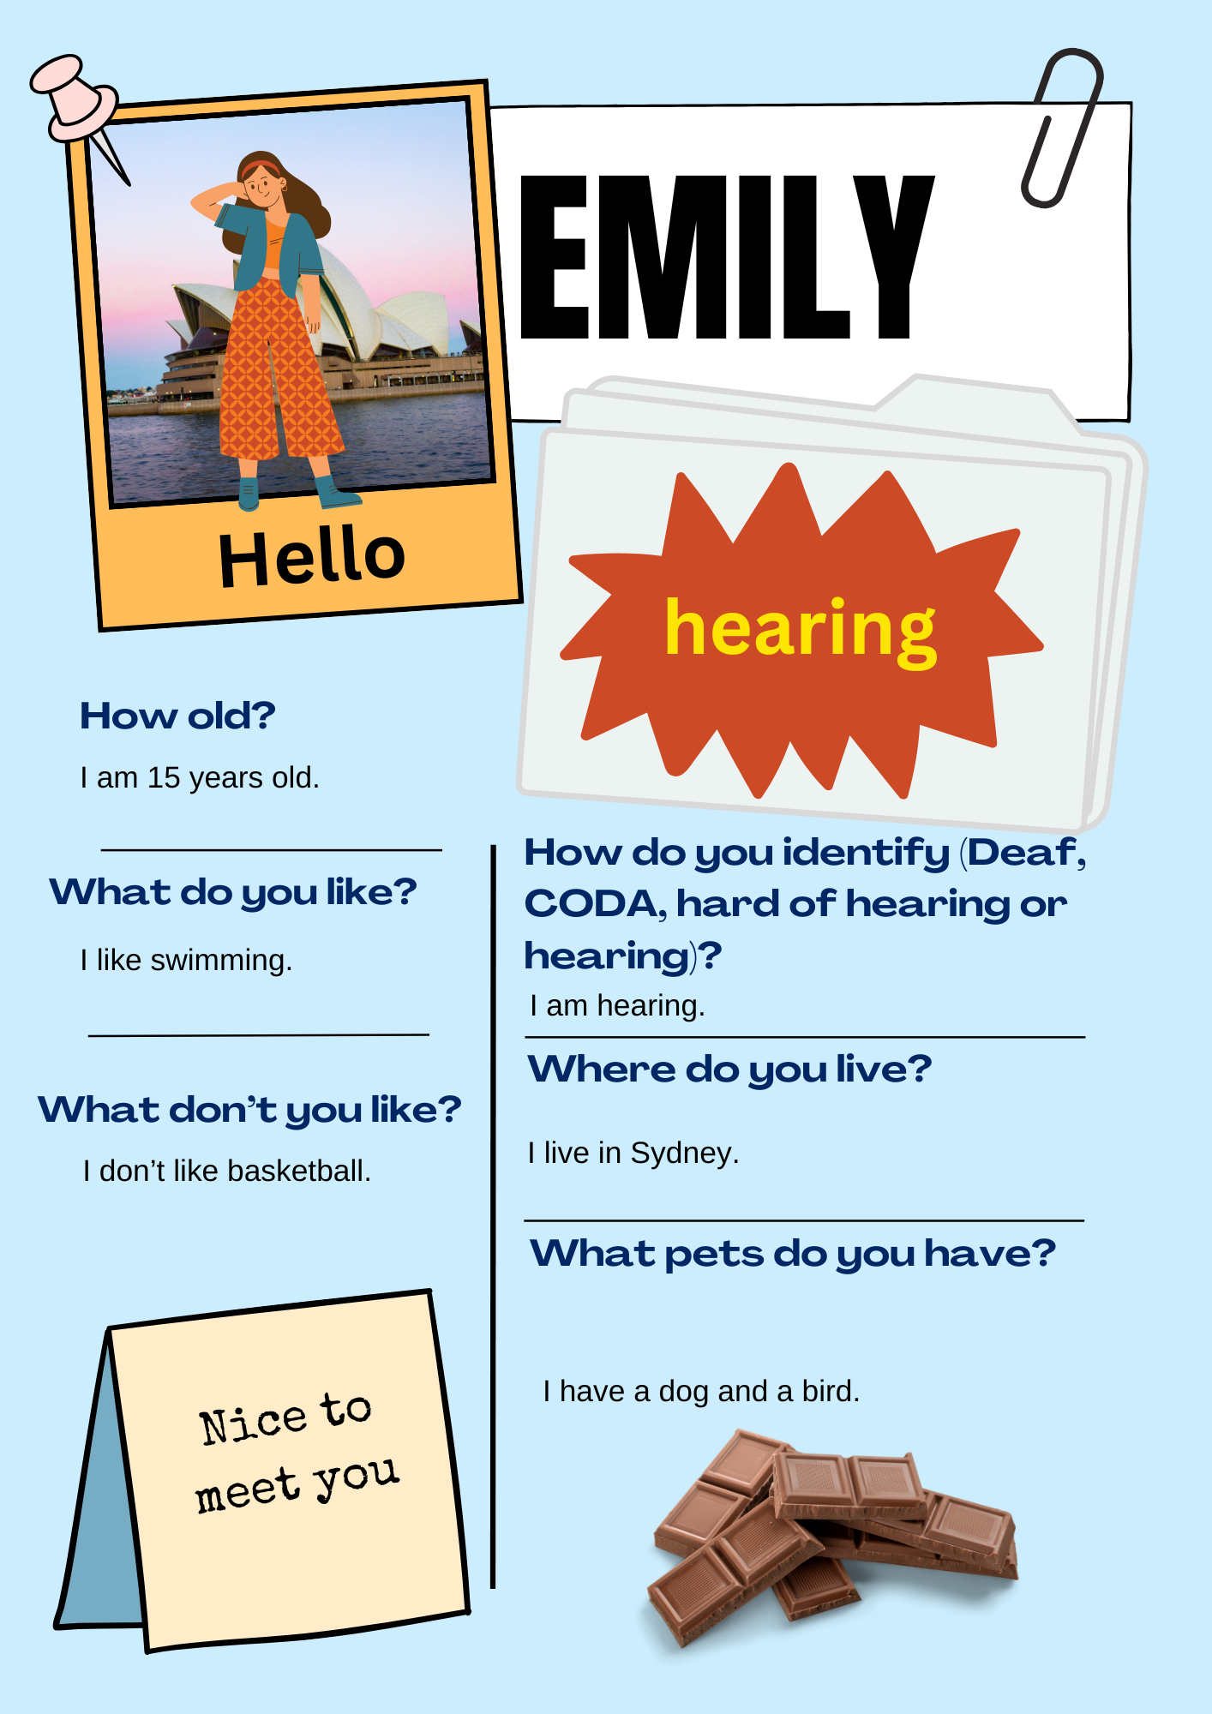
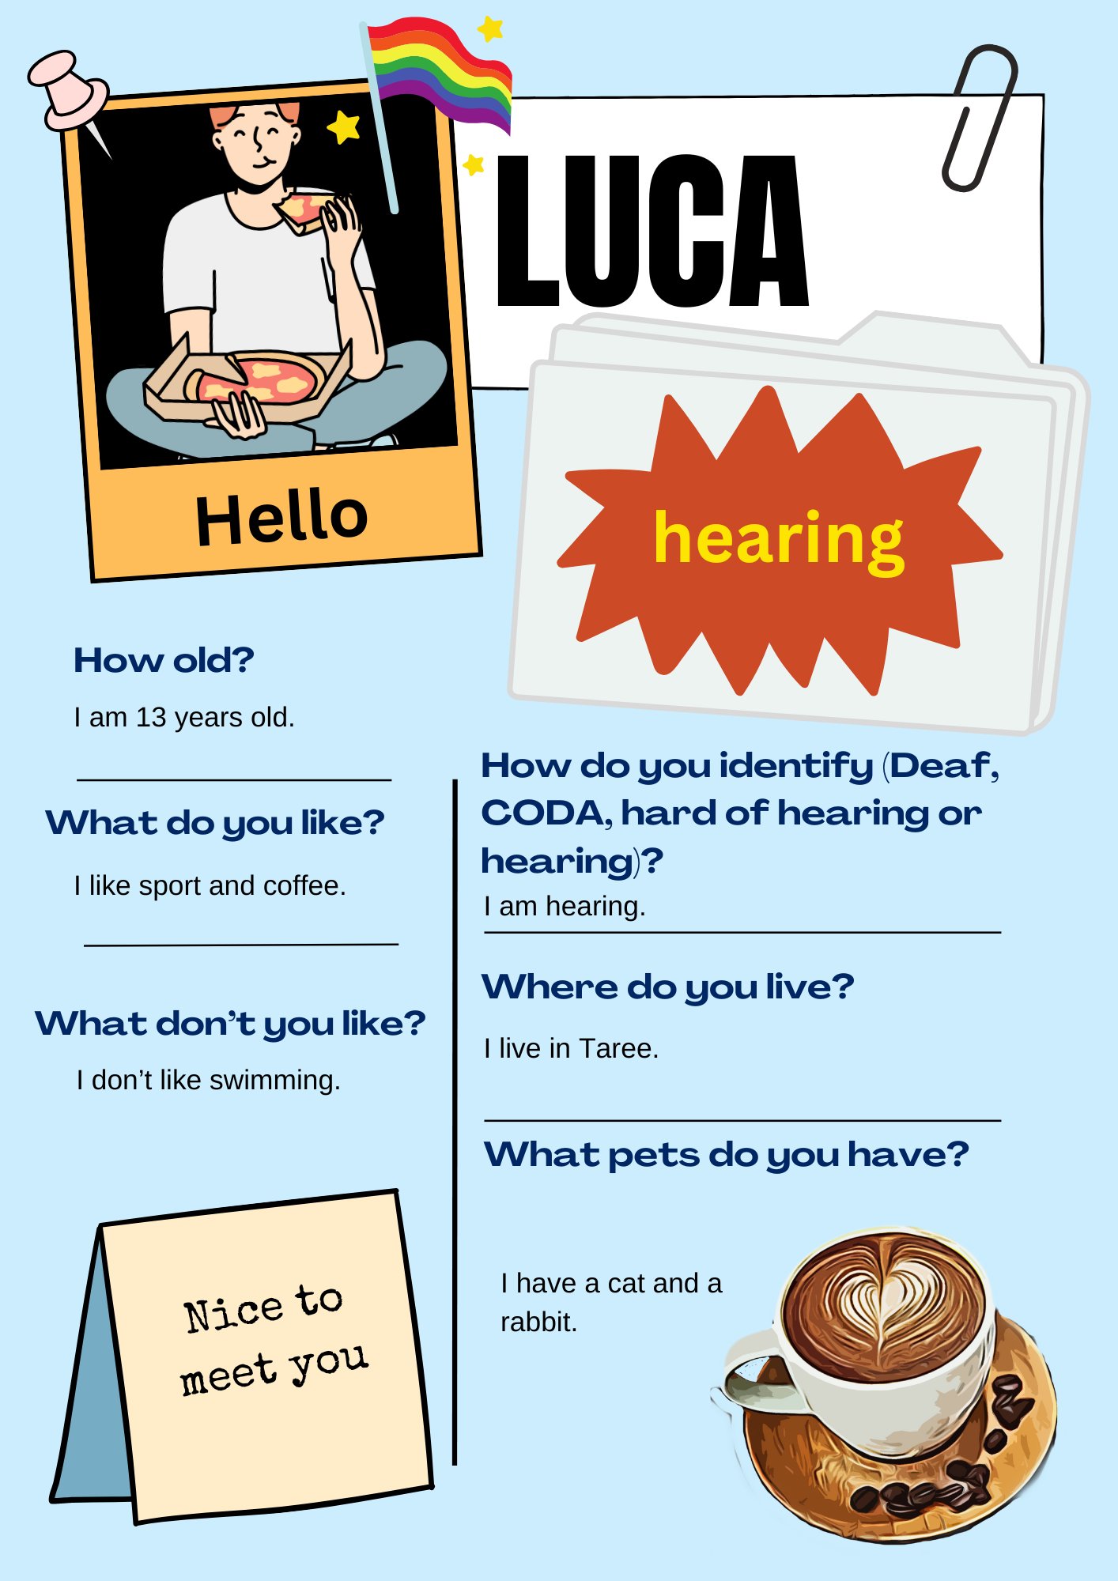 | 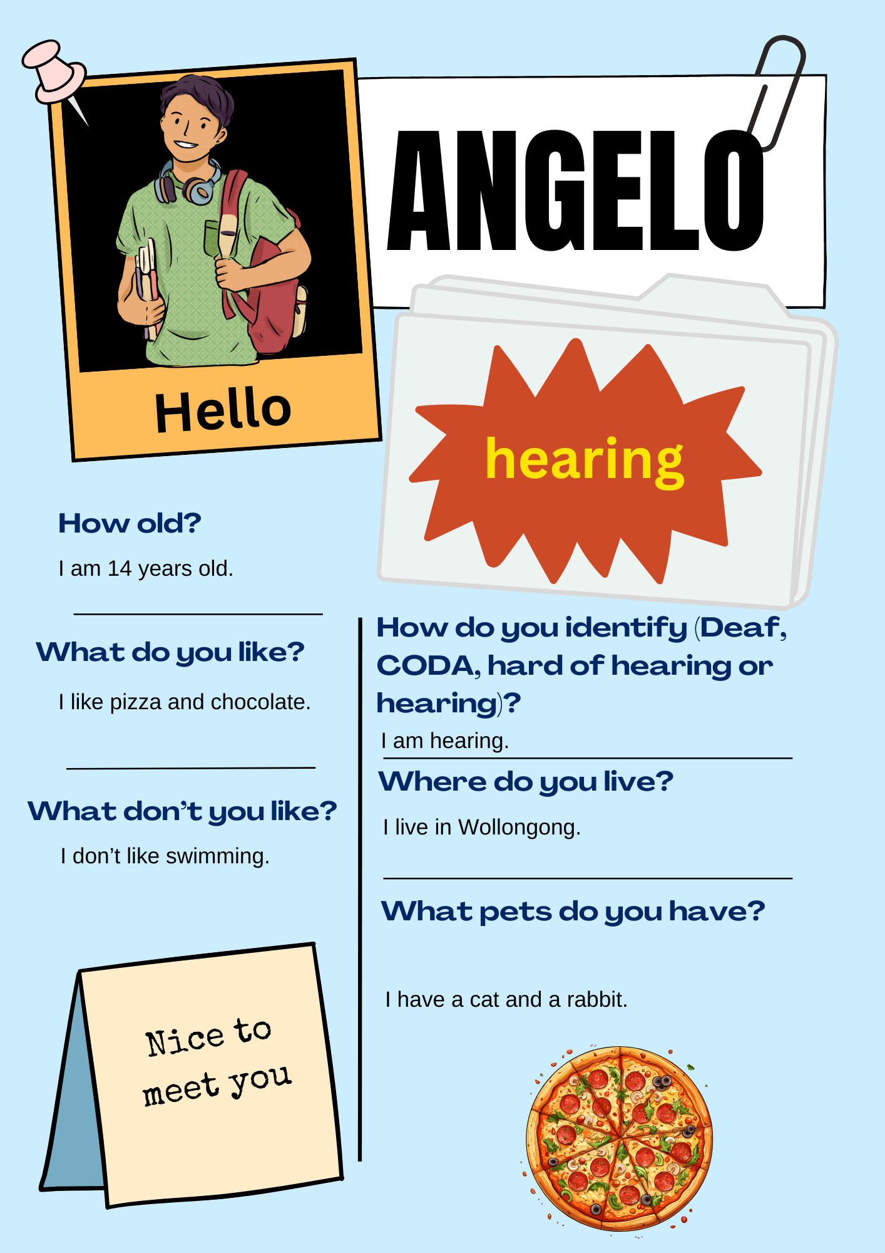
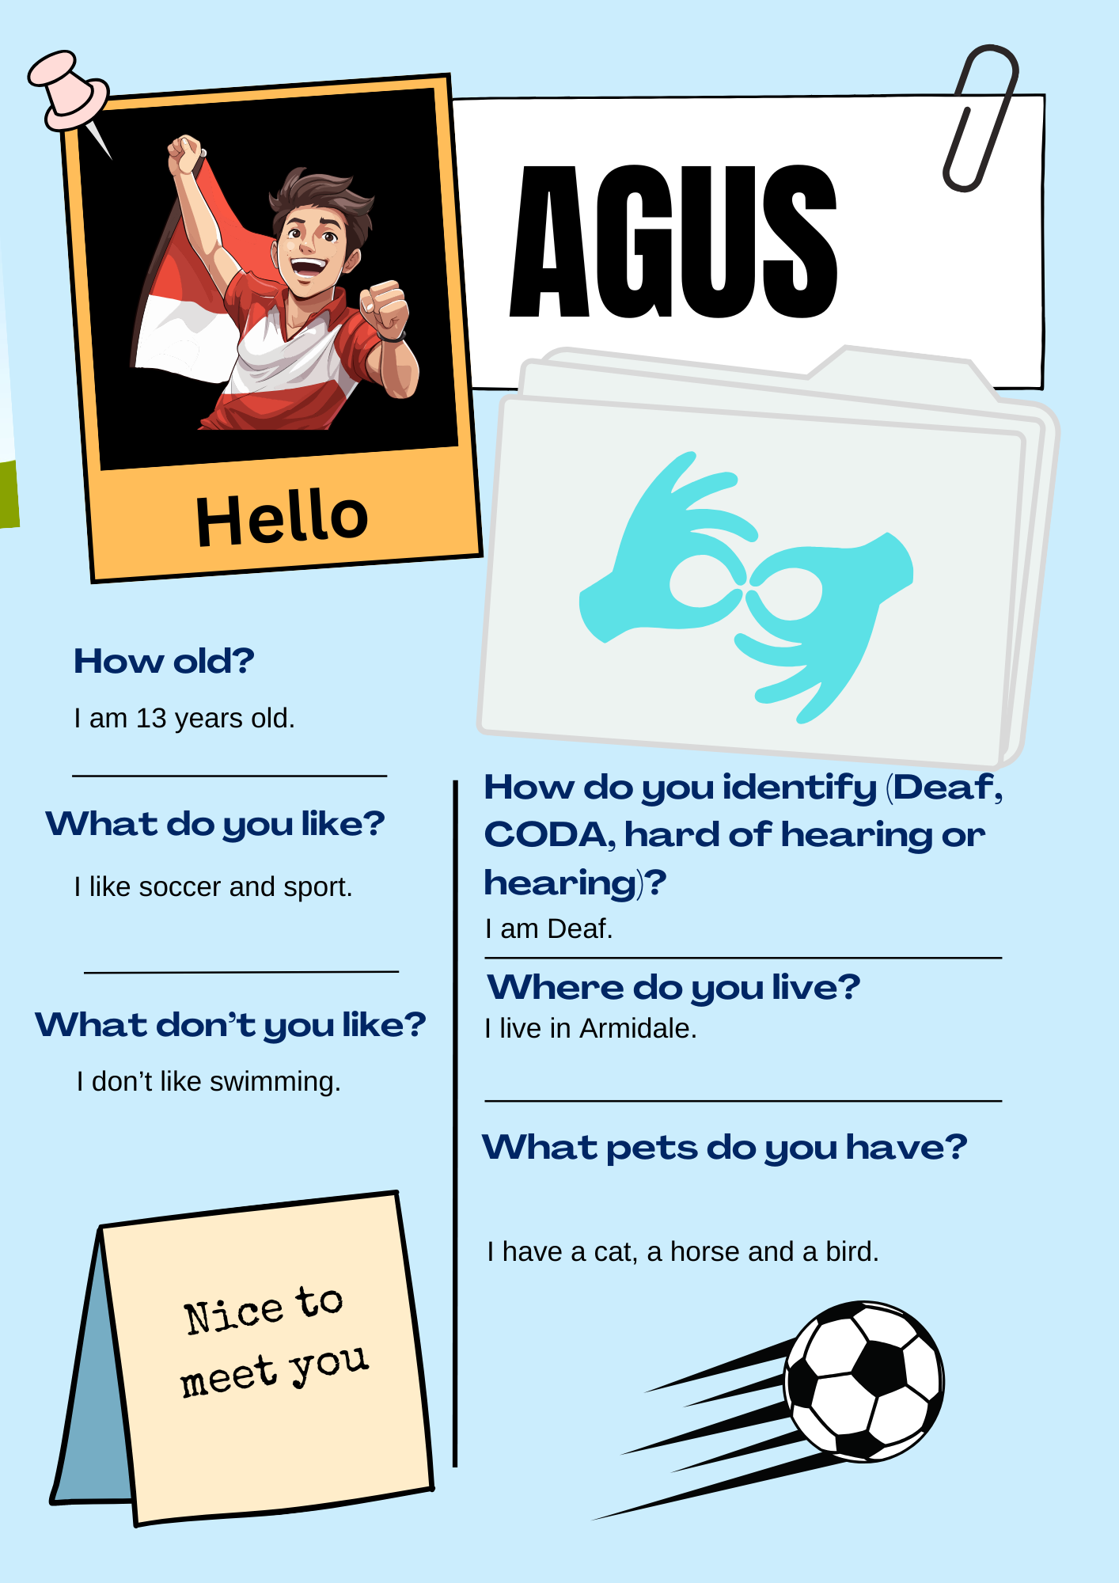 | 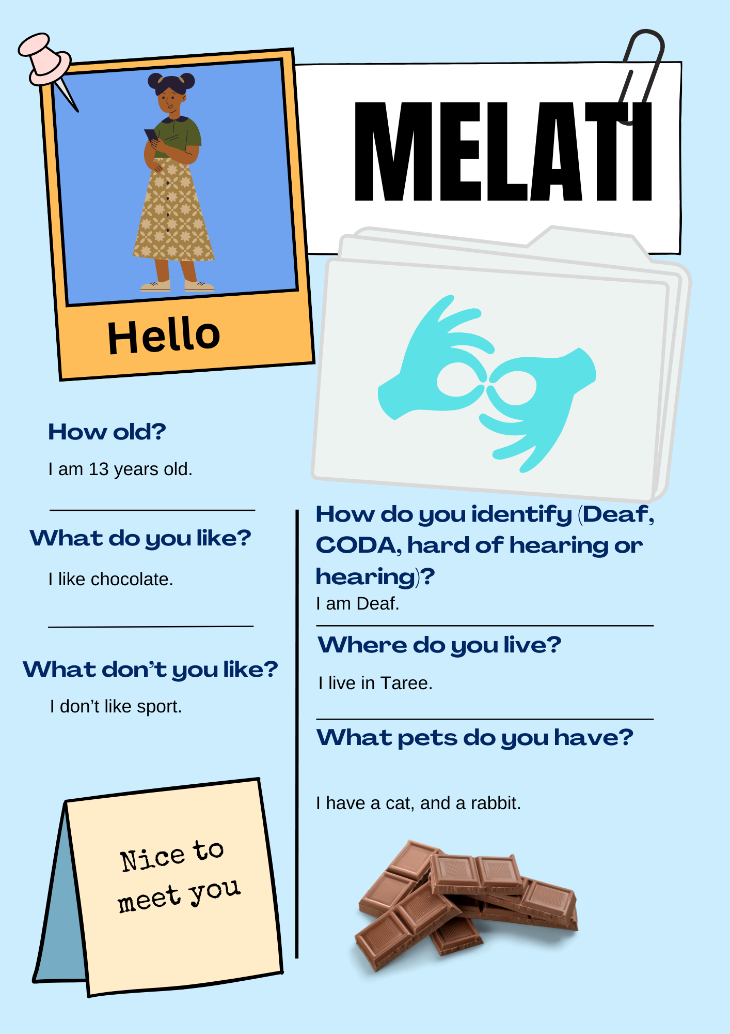
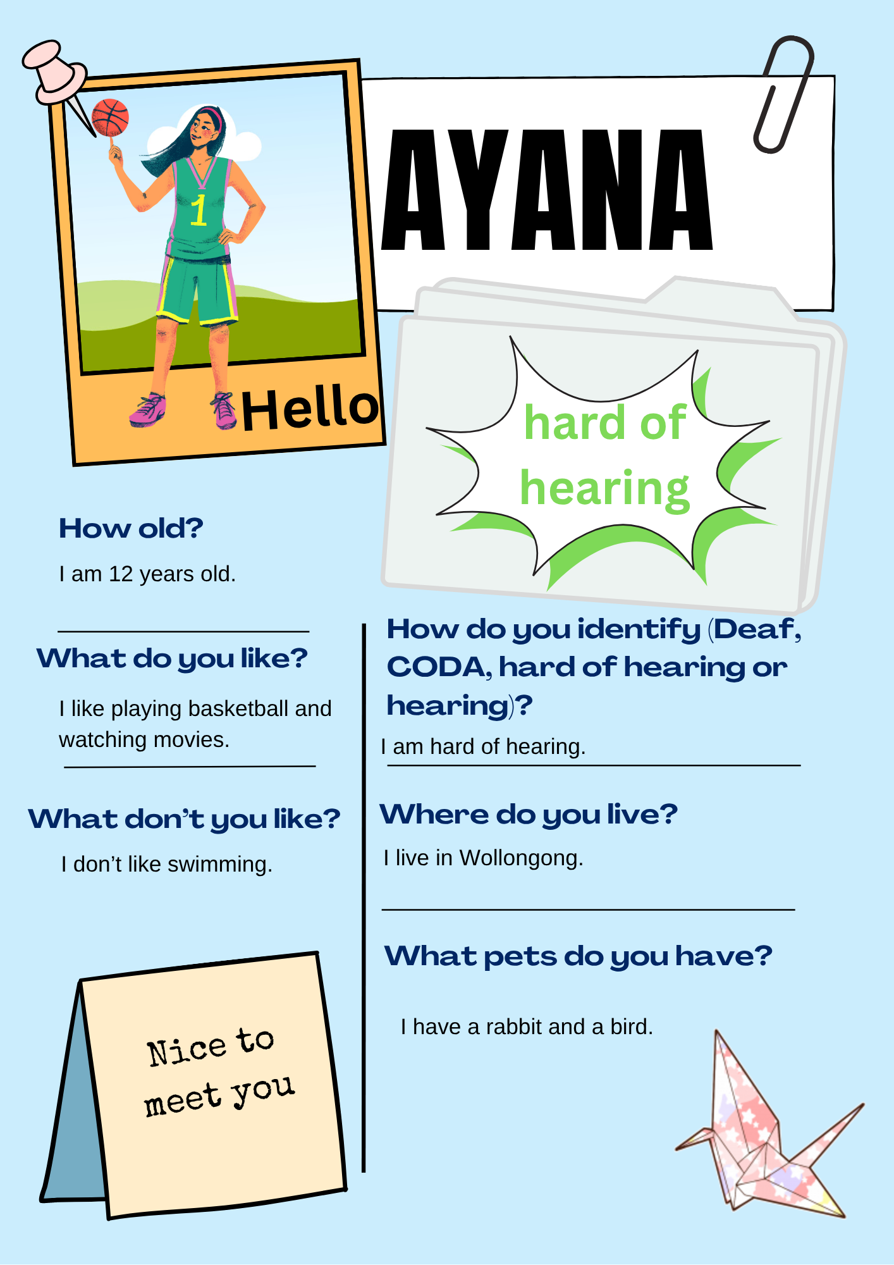 | 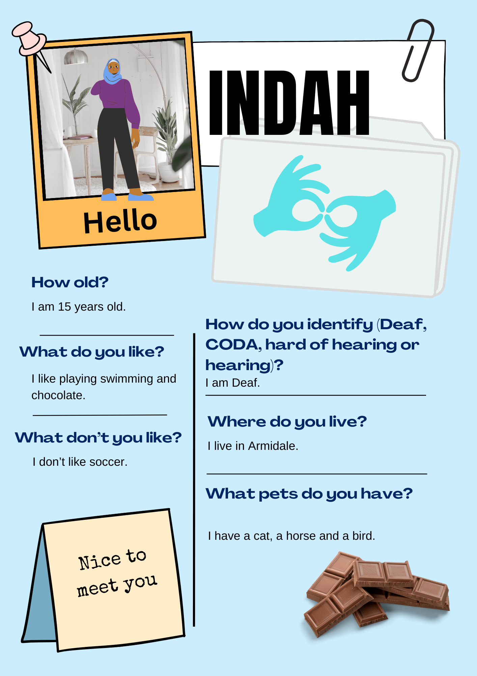
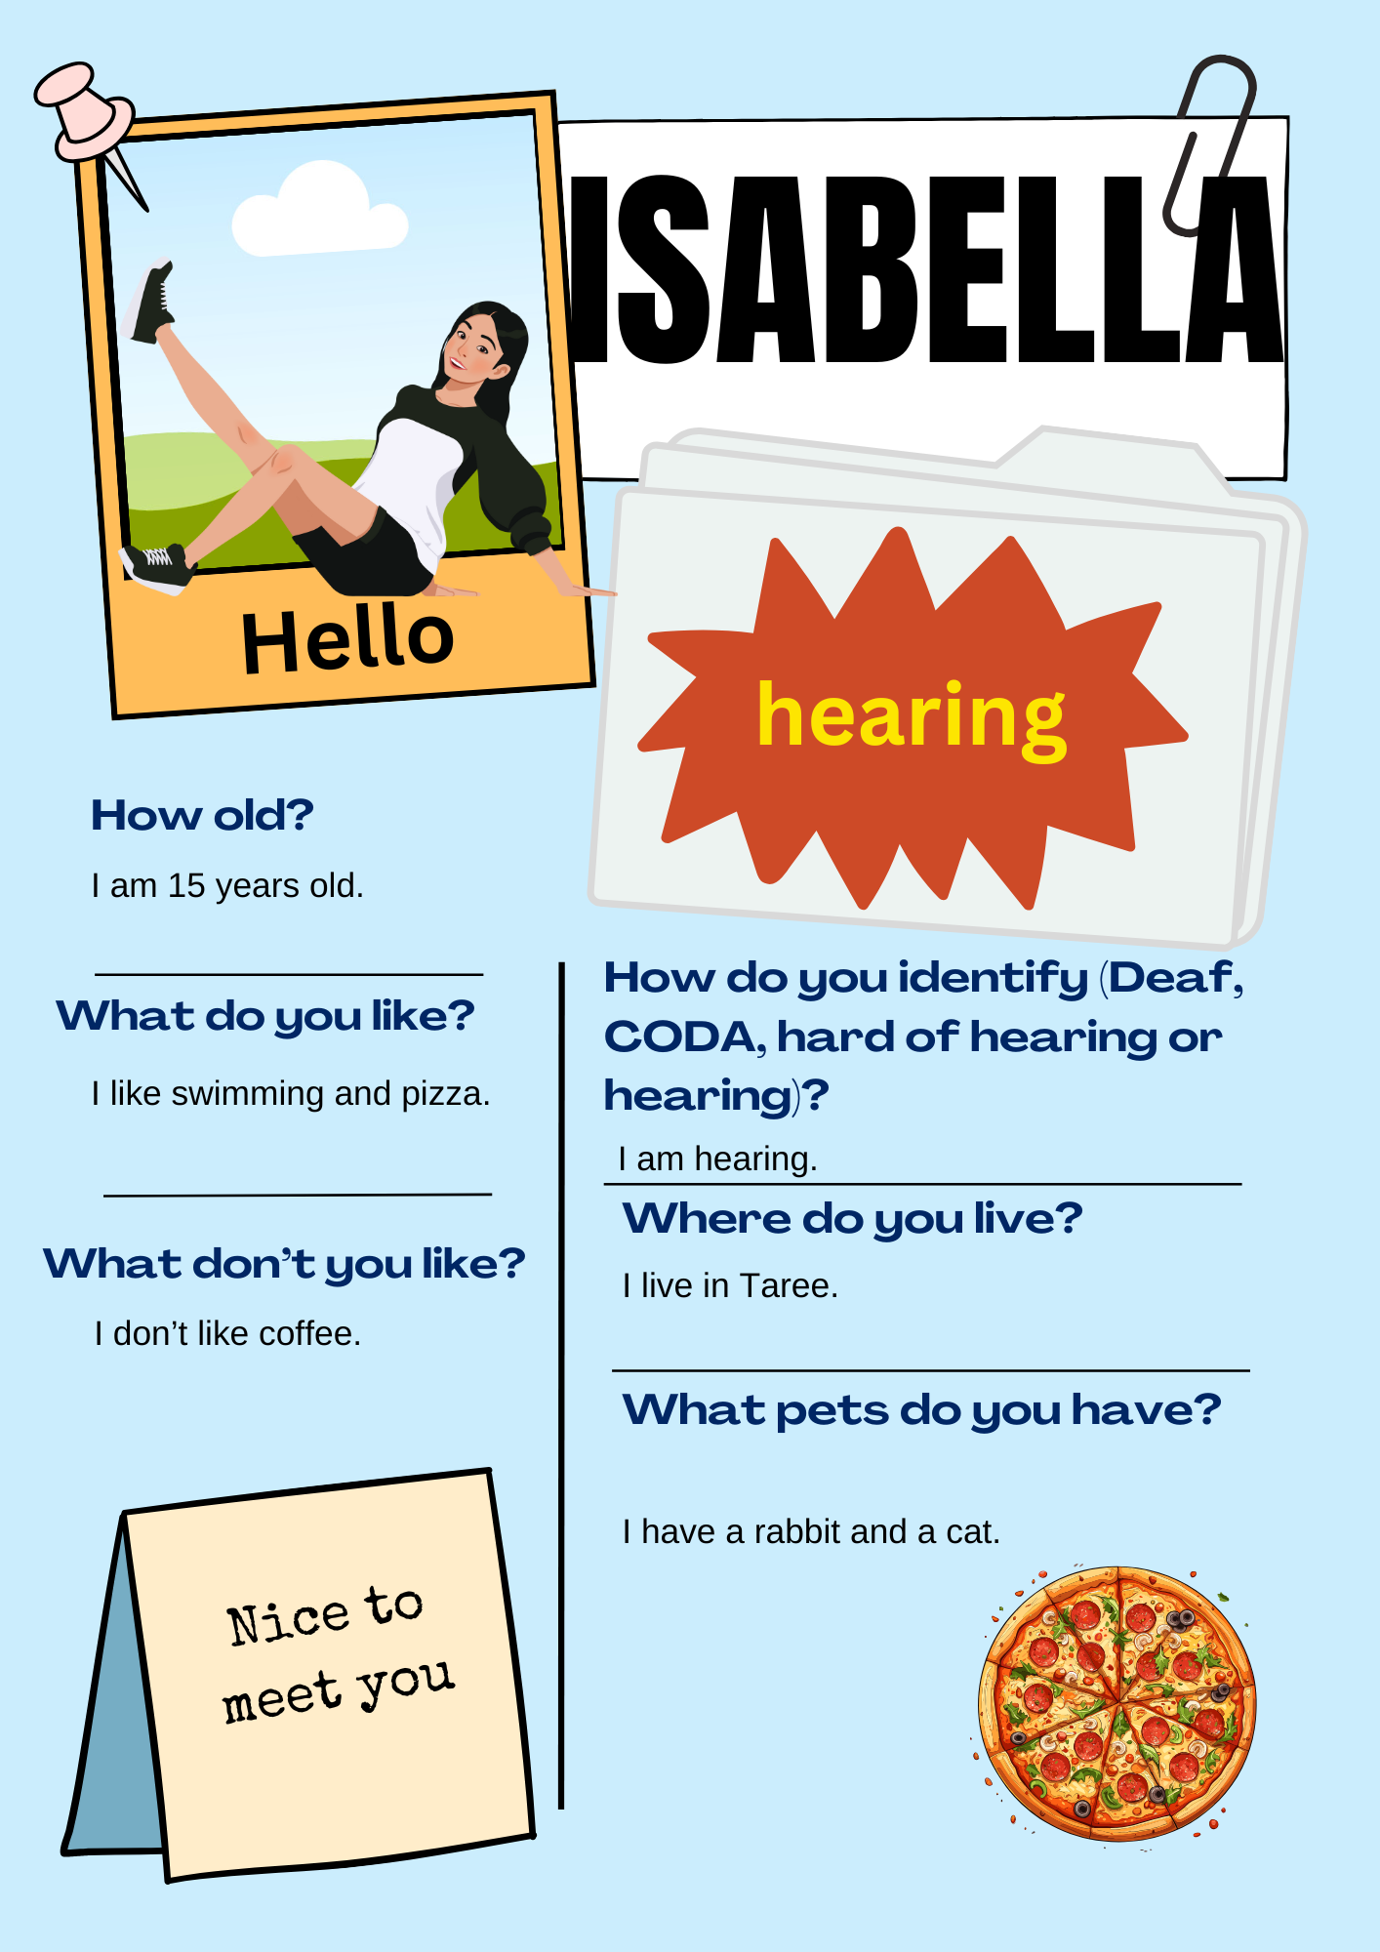 | 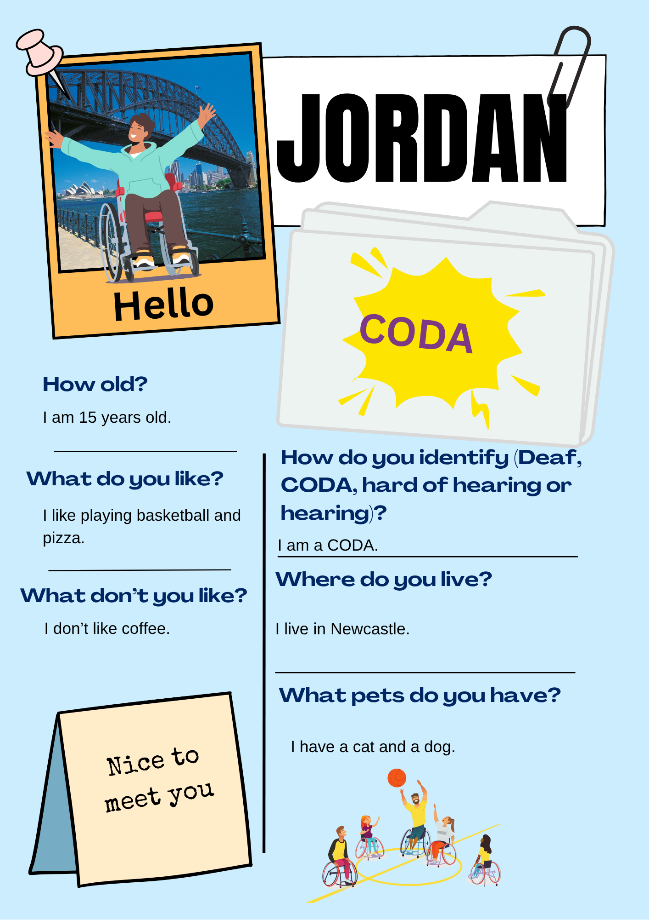
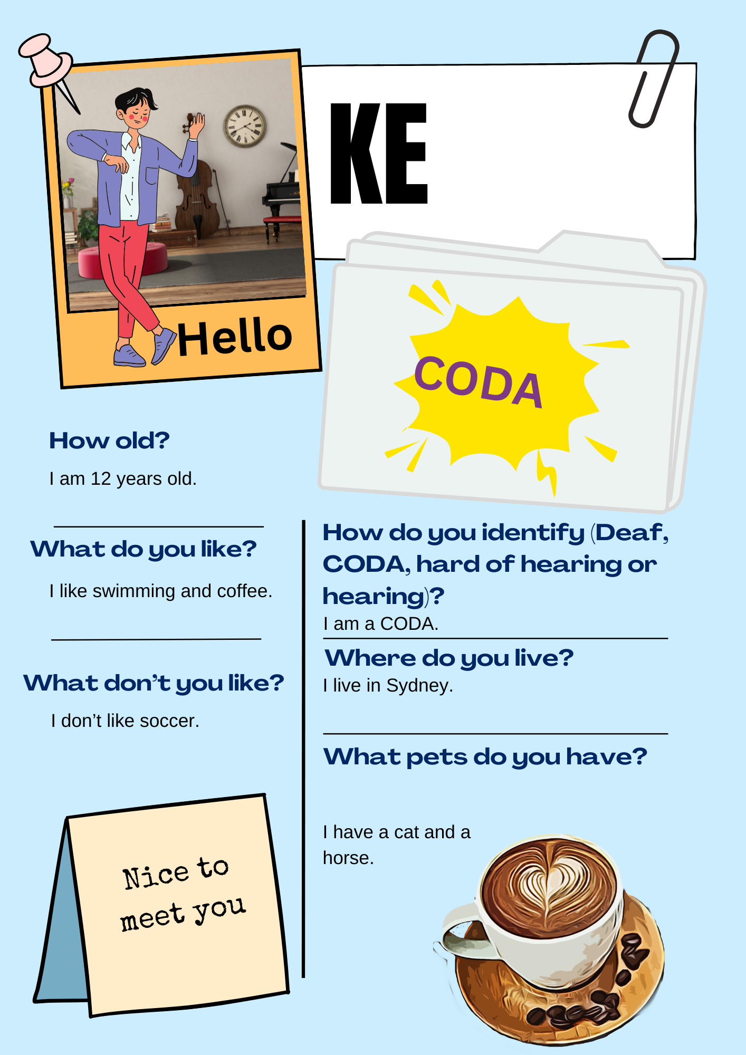

Possible solutions
These are the possible matches students might find.
Criteria | Identity
Is 13 years old | Haruki, Xin, Luca, Agus, Melati
Is 15 years old | Jordan, Emily, Isabella, Indah
Is 12 years old | Ayana, Atsuki, Ke
Is 14 years old | Narrah, Jing, Angelo
Is a CODA | Ke, Jing, Xin, Jordan
Is hearing | Isabella, Luca, Angelo, Emily
Is Deaf | Indah, Agus, Melati, Narrah
Is hard of hearing | Haruki, Atsuki, Ayana
Has a cat | Melati, Jordan, Angelo, Indah, Atsuki, Isabella, Agus, Luca, Ke, Jing, Xin
Has a dog | Jordan, Emily, Narrah, Haruki
Has a rabbit | Ayana, Jing, Isabella, Melati, Angelo, Luca
Has a horse | Melati, Indah, Agus, Xin, Ke, Narrah
Has a bird | Emily, Haruki, Atsuki, Ayana, Indah, Agus
Lives in Newcastle | Jordan, Narrah
Lives in Taree | Isabella, Luca, Melati
Lives in Sydney | Emily, Atsuki, Ke
Lives in Wollongong | Haruki, Ayana, Angelo
Lives in Armidale | Indah, Agus
Lives in Bathurst | Jing, Xin
Likes basketball | Jordan, Ayana
Likes swimming | Emily, Narrah, Indah, Isabella, Atsuki, Xin
Likes sport | Haruki, Ke, Luca, Agus
Likes pizza | Jordan, Haruki, Angelo, Xin, Isabella
Likes watching movies | Ayana,
Likes chocolate | Emily, Jing, Angelo, Melati, Indah
Doesn’t like coffee | Jordan, Xin, Isabella
Doesn’t like dancing | Emily, Narrah
Doesn’t like soccer | Atsuki, Ke, Indah
Doesn’t like drawing | Haruki, Ayana, Luca, Agus, Angelo
Doesn’t like sport | Jing, Melati

© State of New South Wales (Department of Education), 2025
The copyright material published in this resource is subject to the Copyright Act 1968 (Cth) and is owned by the NSW Department of Education or, where indicated, by a party other than the NSW Department of Education (third-party material).
Copyright material available in this resource and owned by the NSW Department of Education is licensed under a Creative Commons Attribution 4.0 International (CC BY 4.0) license.

This license allows you to share and adapt the material for any purpose, even commercially.
Attribution should be given to © State of New South Wales (Department of Education), 2023.
Material in this resource not available under a Creative Commons license:
- the NSW Department of Education logo, other logos and trademark-protected material
- material owned by a third party that has been reproduced with permission. You will need to obtain permission from the third party to reuse its material.
Links to third-party material and websites
Please note that the provided (reading/viewing material/list/links/texts) are a suggestion only and implies no endorsement, by the New South Wales Department of Education, of any author, publisher, or book title. School principals and teachers are best placed to assess the suitability of resources that would complement the curriculum and reflect the needs and interests of their students.
If you use the links provided in this document to access a third-party's website, you acknowledge that the terms of use, including licence terms set out on the third-party's website apply to the use which may be made of the materials on that third-party website or where permitted by the Copyright Act 1968 (Cth). The department accepts no responsibility for content on third-party websites.

