Family and pets card game
This resource is for the teacher. It provides the content and instructions you need to share with students.

Game summary
The object of the game is to collect family member cards to make complete family set of cards.
Each family set has 6 family member cards. All family members are listed on each family member card so that players know who they need to collect to complete the family set. For example, to complete the Clancy family set, players need to collect great grandma, bird, uncle, aunt, male cousin and parents. To complete the Cho family, players need to collect dad, younger sister, mum, older brother, grandma and older sister.
There are 7 family sets in the card deck.
An editable version of the game is available in Canva, where you can change the images and vocabulary to suit your context.

How to play
Students play in groups of 4 or 5.
To play:
- Distribute 6 cards to each player. Place the remaining cards face down in the middle of the table.
- The player to the left of the dealer goes first. They ask any other player, signing in Auslan, if they have a specific card, for example ‘Do you have the mum of the Rossi family?’.
- If the player being asked has the card, they sign ‘Yes, I have’ and give it to the player who asked. If not, they sign ‘No, I don’t have’ and the player who asked draws a card from the centre deck. Play continues in a clockwise direction.
- When a player collects a complete family, they lay their set on the table as part of their turn.
- Players add to the cards in their hand throughout the game (by adding a correct match from another player, or by adding a card from the centre deck) – cards are only discarded by a student when giving them to another player, or laying down a full family set on the table.
- Play continues until there are no remaining cards in the centre stack. At this point, the winner is the player who has collected the most points, using the point system outlined later in this document.

Vocabulary and structures
During play, students can use vocabulary and strictures relating to family, combined with language relevant to game play.
Examples include:
- Do you have the [family member] of the [name] family? YOU HAVE _______ BELONG _____ FAMILY?
- Yes, I have the [family member] of the [name] family? YES, ME HAVE ____ BELONG ____ FAMILY.
- No, I don’t have the [family member] of the [name] family? Sorry. NO/NOTHING ________ BELONG _____ FAMILY.
- Here you are. HAVE <POINT/OFFER>, <RAISE EYEBROWS>
- This is the [family name] family. THIS <POINT> _______ FAMILY.

Differentiation strategies in the game play
Differentiation can be achieved by adding in cards to create spontaneity and opportunities for students to use additional language skills. These cards could be:
- a question card – students have the opportunity to play this card at any time during the game to ask another student a question, demonstrating further questioning skills. For example, ‘What is the dad like?’, ‘What is the sister’s name?’, ‘Is the cousin cranky?’ (DAD GOOD <RAISE EYEBROWS>, SISTER NAME WHAT <RAISE EYEBROWS>, COUSIN ANGRY <RAISE EYEBROWS>)
- a response card – students have the opportunity to play this card to respond to a question asked by another student or the teacher. This promotes spontaneous interaction and the use of a broad range of grammatical structures and vocabulary, including prior learning. For example, ‘The cousin is happy but sick.’ (COUSIN HAPPY BUT <POINT> SICK).
- a comment card – students have the opportunity to play this card at any time during the game to sign an additional comment, demonstrating manipulation and extension of grammatical structures to use a broad range of structures and vocabulary, including prior learning. For example, ‘The grandmother lives in Sydney and is Deaf.’ (GRANDMOTHER LIVE WHERE SYDNEY GRANDMOTHER <POINT> DEAF).
These cards should sit as 3 separate decks to the main play deck – a question card deck, a response card deck and a comment card deck, so they are optional for students to use at any time during the game. Once a student accurately completes the task on the card, such as ask a question, respond to a question or make an additional comment, the card is placed in front of the student. The points on each card can then be added to a final score at the end of play.
Points may be awarded as follows:
Sample cards | Sample points
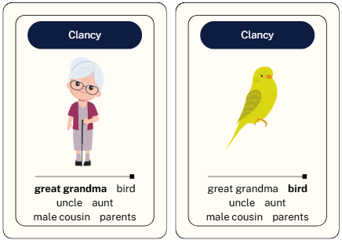 | One point for each family member of an incomplete family set. For example, 2 family member cards indicate 2 points.
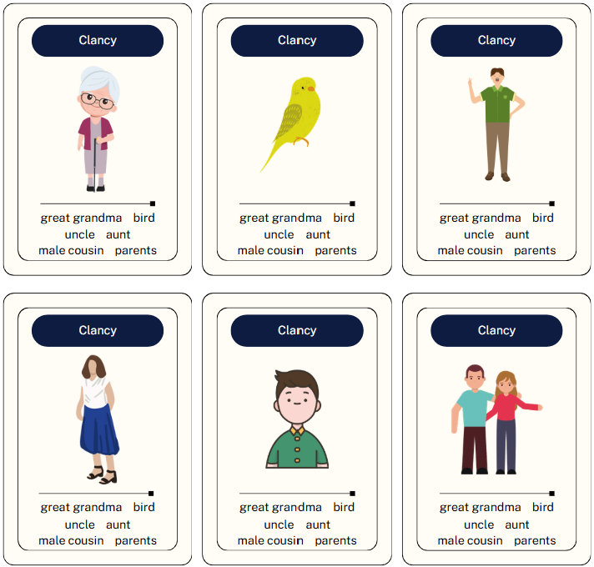 | 10 points for each complete family set collected.
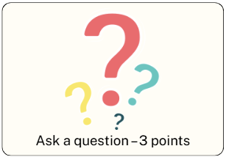 | 3 points for a completing a question card accurately.
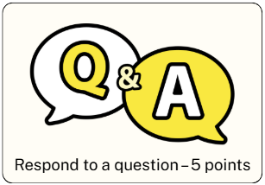 | 5 points for responding accurately to a question.
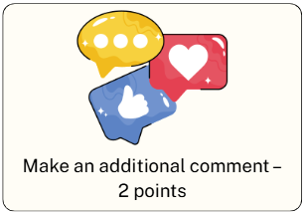 | 2 points for making an additional comment accurately.
An example of scoring 30 points by the end of the game is shown below, including the cards:
- 10 points (family set)
- 6 points for answering 2 questions accurately
- 2 points for 2 family members from an incomplete family set
- 2 points for making an additional comment accurately
- 10 points for responding to 2 questions accurately to a question.
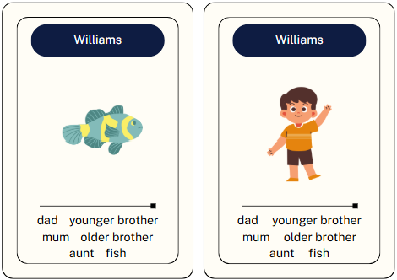
© State of New South Wales (Department of Education), 2025
The copyright material published in this resource is subject to the Copyright Act 1968 (Cth) and is owned by the NSW Department of Education or, where indicated, by a party other than the NSW Department of Education (third-party material).
Copyright material available in this resource and owned by the NSW Department of Education is licensed under a Creative Commons Attribution 4.0 International (CC BY 4.0) license.

This license allows you to share and adapt the material for any purpose, even commercially.
Attribution should be given to © State of New South Wales (Department of Education), 2025.
Material in this resource not available under a Creative Commons license:
- the NSW Department of Education logo, other logos and trademark-protected material
- material owned by a third party that has been reproduced with permission. You will need to obtain permission from the third party to reuse its material.
Links to third-party material and websites
Please note that the provided (reading/viewing material/list/links/texts) are a suggestion only and implies no endorsement, by the New South Wales Department of Education, of any author, publisher, or book title. School principals and teachers are best placed to assess the suitability of resources that would complement the curriculum and reflect the needs and interests of their students.
If you use the links provided in this document to access a third-party's website, you acknowledge that the terms of use, including licence terms set out on the third-party's website apply to the use which may be made of the materials on that third-party website or where permitted by the Copyright Act 1968 (Cth). The department accepts no responsibility for content on third-party websites.

