Animal cards
This resource is for the teacher. It provides the content and instructions you need to share with students.
Print and cut up the flashcards below. These images can be edited for your context using the editable link.

Activity 1
Show students the images below and demonstrate the sign for each one for them to copy.

Activity 2
Print 3 sets of animal cards for each group to play the ‘Animal card game’ in groups of 3 to 4 students. Give each group a deck of animal cards. Students place the deck face down between them and take turns to draw a card from the pile without showing it to anyone else. The student looks at the card and signs the animal in Auslan to the group. The first student to correctly guess the animal on the card wins the card and keeps it. Students take turns around the circle until all cards are used. The player with the most cards at the end wins. Alternatively, students could play to win points for each correct guess and the first player to score 3 points wins.

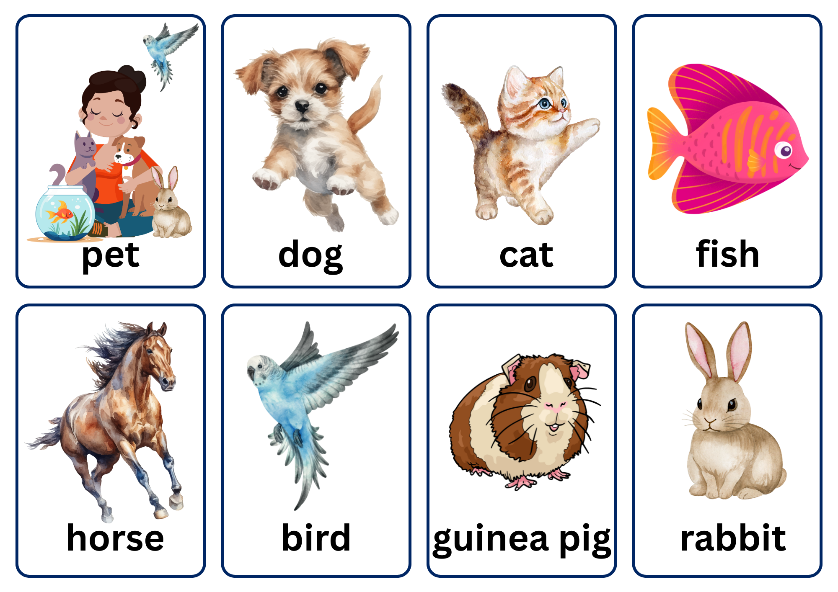
© State of New South Wales (Department of Education), 2025
The copyright material published in this resource is subject to the Copyright Act 1968 (Cth) and is owned by the NSW Department of Education or, where indicated, by a party other than the NSW Department of Education (third-party material).
Copyright material available in this resource and owned by the NSW Department of Education is licensed under a Creative Commons Attribution 4.0 International (CC BY 4.0) license.

This license allows you to share and adapt the material for any purpose, even commercially.
Attribution should be given to © State of New South Wales (Department of Education), 2025.
Material in this resource not available under a Creative Commons license:
- the NSW Department of Education logo, other logos and trademark-protected material
- material owned by a third party that has been reproduced with permission. You will need to obtain permission from the third party to reuse its material.
Links to third-party material and websites
Please note that the provided (reading/viewing material/list/links/texts) are a suggestion only and implies no endorsement, by the New South Wales Department of Education, of any author, publisher, or book title. School principals and teachers are best placed to assess the suitability of resources that would complement the curriculum and reflect the needs and interests of their students.
If you use the links provided in this document to access a third-party's website, you acknowledge that the terms of use, including licence terms set out on the third-party's website apply to the use which may be made of the materials on that third-party website or where permitted by the Copyright Act 1968 (Cth). The department accepts no responsibility for content on third-party websites.

