Flashcards of feelings
This resource is for the teacher. It provides the content and instructions you need to share with students. Print and cut up the flashcards below. These images can be edited (or more feelings added) using the editable link.

Activity 1
Use the images as flashcards. Show students the images of feelings at random and ask them to make the corresponding sign.

Activity 2
Print enough sets of the flashcards for students to work in pairs or small groups. Students place the cards face down in a pile between them. One student picks a card, keeping it hidden from the other group members, and silently signs the feeling on the card including relevant non-manual features. Their pair, or group, try to guess the feeling aloud. Repeat until each student has had 5 turns. If students run out of cards, direct them to shuffle the cards and begin again.

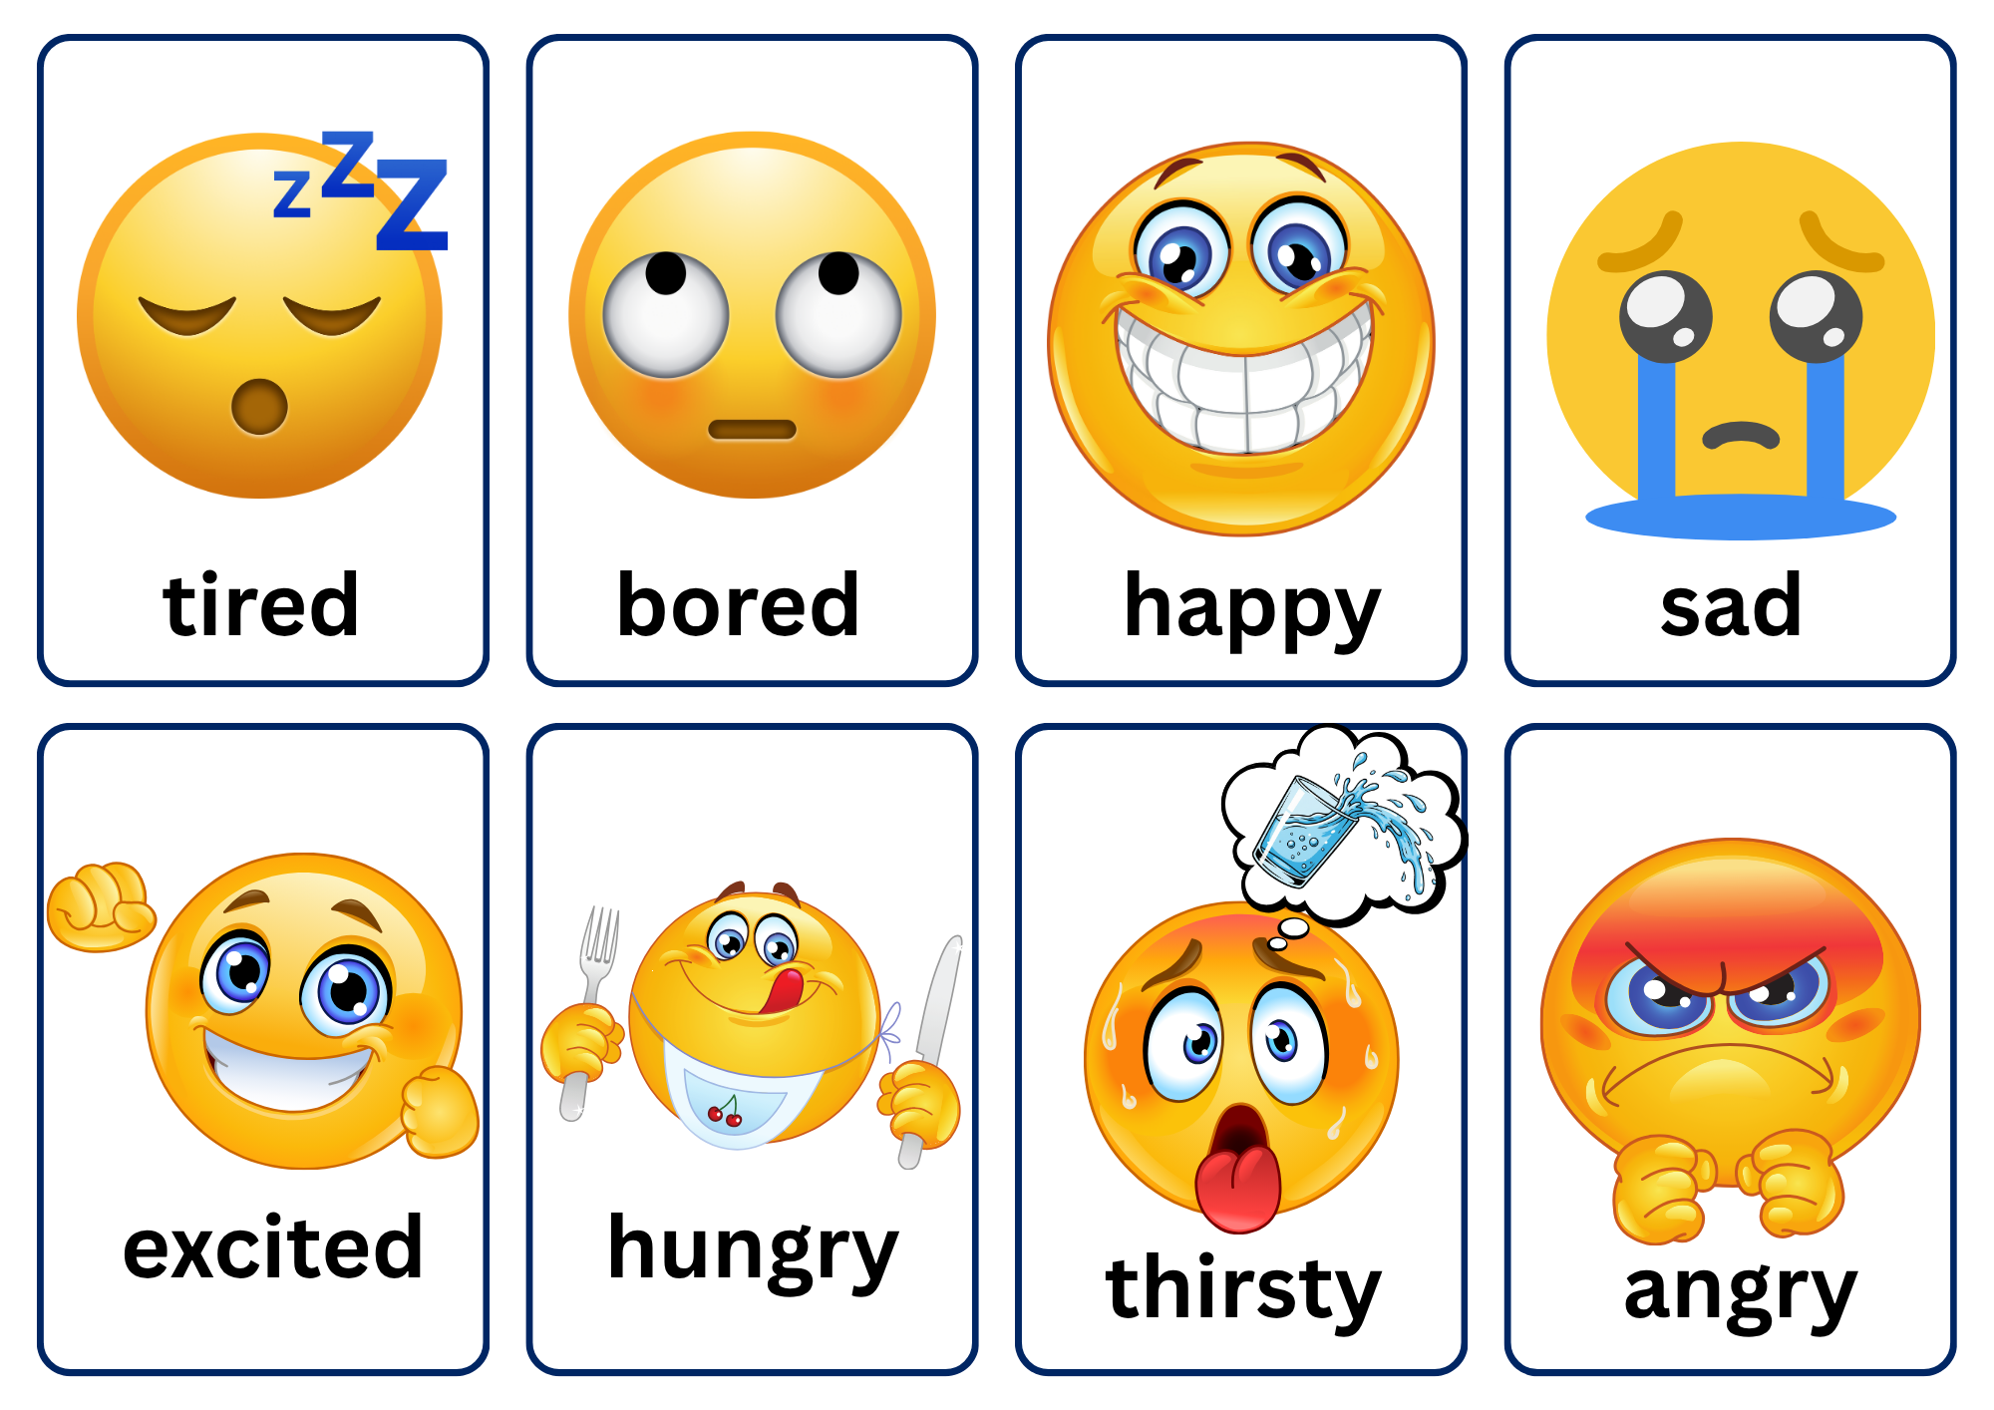
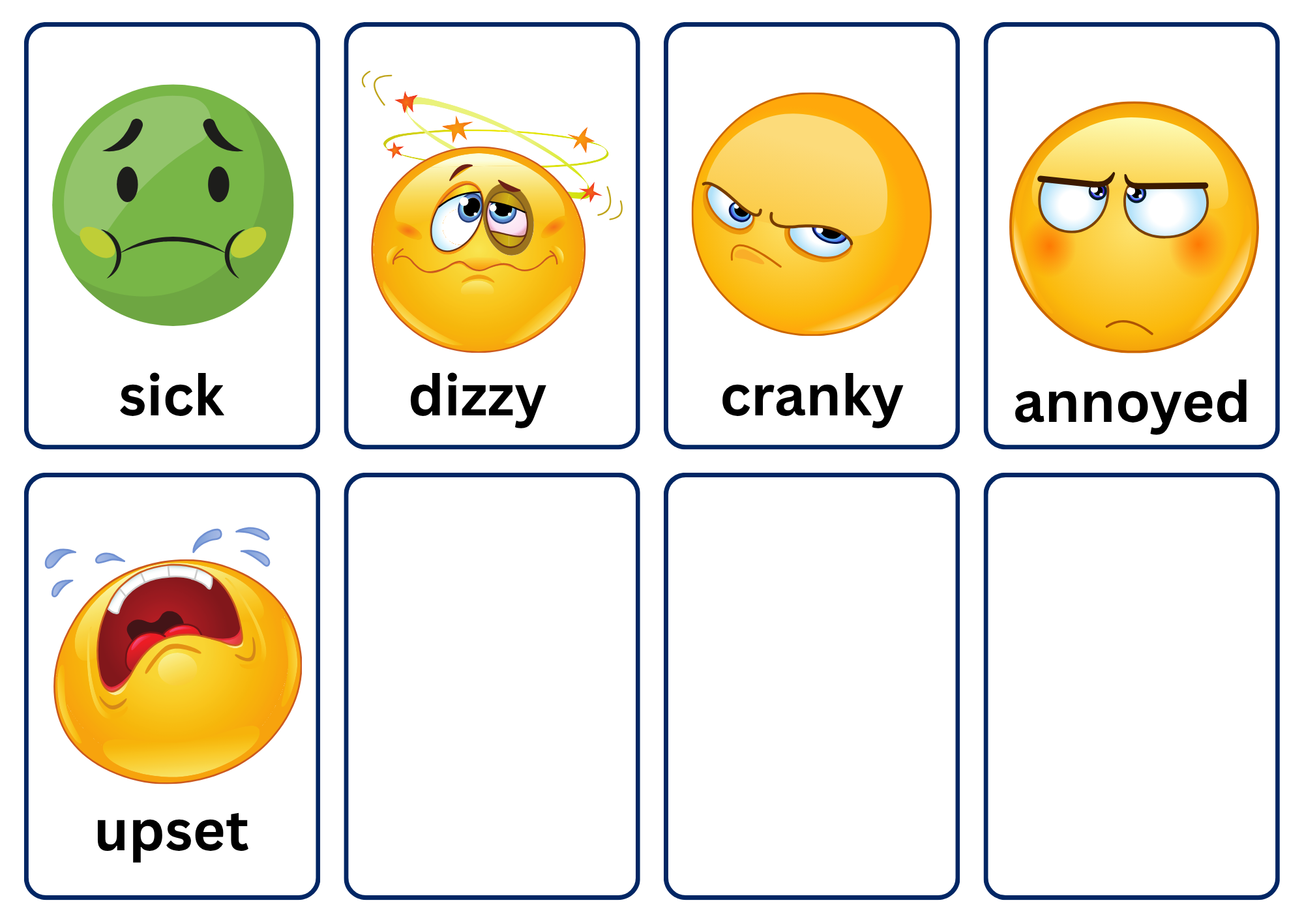

© State of New South Wales (Department of Education), 2025
The copyright material published in this resource is subject to the Copyright Act 1968 (Cth) and is owned by the NSW Department of Education or, where indicated, by a party other than the NSW Department of Education (third-party material).
Copyright material available in this resource and owned by the NSW Department of Education is licensed under a Creative Commons Attribution 4.0 International (CC BY 4.0) license.

This license allows you to share and adapt the material for any purpose, even commercially.
Attribution should be given to © State of New South Wales (Department of Education), 2025.
Material in this resource not available under a Creative Commons license:
- the NSW Department of Education logo, other logos and trademark-protected material
- material owned by a third party that has been reproduced with permission. You will need to obtain permission from the third party to reuse its material.
Links to third-party material and websites
Please note that the provided (reading/viewing material/list/links/texts) are a suggestion only and implies no endorsement, by the New South Wales Department of Education, of any author, publisher, or book title. School principals and teachers are best placed to assess the suitability of resources that would complement the curriculum and reflect the needs and interests of their students.
If you use the links provided in this document to access a third-party's website, you acknowledge that the terms of use, including licence terms set out on the third-party's website apply to the use which may be made of the materials on that third-party website or where permitted by the Copyright Act 1968 (Cth). The department accepts no responsibility for content on third-party websites.

