Modern Languages K–10 Syllabus (2022) – guidelines for assessing ‘Interacting’ in Stage 4

Contents
Sample activities 3
Feedback 9
Differentiating summative assessment 10
Sample summative tasks 11
Foods and drinks – preferences 11
Foods and drinks – opinions 12
Foods and drinks – shopping for items 13
Going to a festival 15
Bargaining at the market 16
Planning an outing 18

Introduction
In the Modern Languages K–10 Syllabus (2022), the ‘Interacting’ focus area and its related Stage 4 and Stage 5 outcomes require students to exchange and negotiate meaning to interact in the target language. ‘Negotiating meaning’ relates to the strategies we use to keep communication flowing, such as pausing to think, seeking clarification, rephrasing and even making mistakes and correcting ourselves. In our first language(s), we usually do this subconsciously. However, when we learn to speak an additional language, we often have to explicitly learn these strategies. It is the same for students in our language classes.
To support students to learn to negotiate meaning, we need to embed an element of ‘the unknown’ into interactions, to encourage a degree of spontaneity. How can we do this with students who are often beginners in the language, and when we have large Stage 4 classes? How do we then assess this?

Formative assessment
Assessing interacting through formative assessment opportunities is the best place to start. While students are engaged in alternative learning activities, either in groups or individually, you can move around the room and gather student achievement data and offer effective feedback.

Sample activities
Here are some formative assessment opportunities to consider.
- Individual question and answer-type tasks. Prepare students with a range of questions they may be asked – these can be co-created with the class. When they have had time to consider and/or prepare, walk around the room and ask students to choose 2 to 3 prompt cards from the pile you have prepared, for example ‘say your name’, ‘ask about someone’s favourite subject’ or ‘say who’s in your family’. Using the prompt, engage in a short interaction with the student. Once students are more confident, after viewing the modelled interactions between you and various students, they can each have their own pile of cards, walking around and practising with classmates while you are assessing students individually or in small groups. You could also have students asking the questions, depending on your context.
- Story cubes are another option, in place of cards. You can play as a class, with large dice, or students can play in pairs or small groups, with their own dice. For example:
- To practise school subjects as a class, you have 2 dice – one with faces indicating degrees of liking something (‘I love’, ‘I like’, ‘I don’t like’, ‘I really don’t like’) and one with different school subjects. Students take turns rolling the dice and you then ask a question, based on the images they have rolled. For example, you ask ‘Do you like maths?’ and the student replies with ‘I really like maths’. Students can play in pairs or small groups with their own dice, when ready, taking turns to ask questions and respond. You can add in further dice, such as adjectives, adding a question such as ‘Why do you like maths?’ and conjunctions to broaden responses. The sample dice below are adapted from our Stage 4 Italian and Stage 4 Modern Greek units.
Figure 1 – sample story cubes
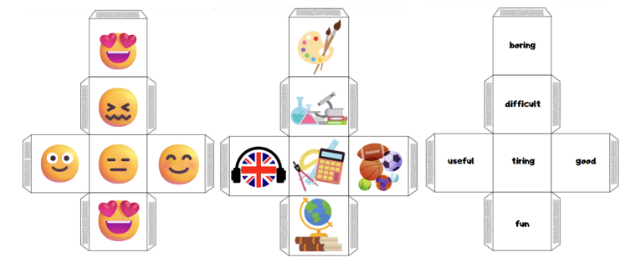
- To practise when you do free-time activities, you have 2 dice – one with days of the week and one with a range of hobbies. Students roll the dice and interact based on the images they have rolled. For example, the first student asks ‘What do you do on Tuesday?’ and the second student replies ‘On Tuesday I watch Netflix.’
You can also find story cubes in Stage 4 Indonesian (bargaining at the market), Stage 4 Korean (buying food at the market) and Stage 4 Spanish (foods and drinks). You can easily differentiate story cubes, based on your context. For example, including vocabulary in the target language on the faces of the cubes and providing students with scaffolds for sentences and questions or vocabulary lists.
- Board games are another way to embed prompts into interactions. Students can also count as they move spaces, and use language associated with turn-taking and game play. Move around the room and listen for pronunciation and spontaneous interactions and/or negotiations. Sit with each group as they play, asking questions based on the spaces students land on. You may also give students feedback on their responses in this informal, friendly space. The board game below is aligned with our generic Stage 4 scope and sequence and can be found in our Resources channel in the statewide staffroom – it can be used with any language. If you’re not yet a member of the statewide staffroom, you can join via our short entry survey (staff only). Search for the Stage 4 generic scope and sequence and related actives in the Resources channel, by your language.
Figure 2 – sample board game
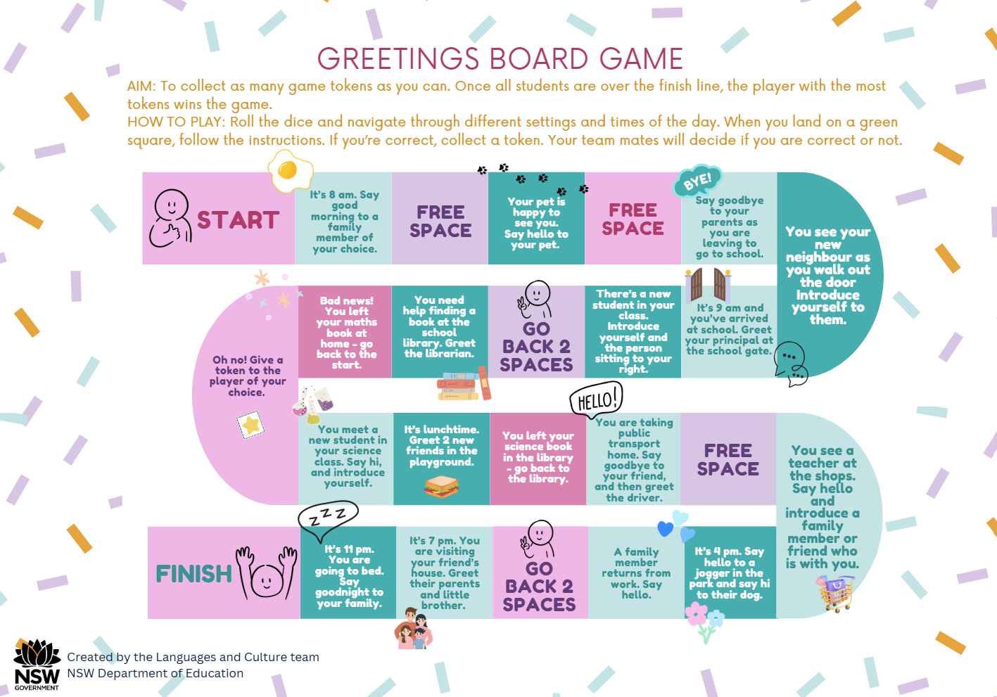
- Card games are another engaging way to encourage students to interact, from something as simple as memory-style games, through to more complex card gathering style games such as ‘Go Fish’.
You can find sample card games in Stage 4 Chinese (a range of flashcard-based games, including greetings, saying how you feel, numbers, simple likes/dislikes and personality), Stage 4 French (describing homes), Stage 4 German (identifying foods) and Stage 4 Spanish (2 games – food and drinks; food preferences). You can explore a more detailed example related to family, adaptable for all languages, in the ‘Assessing ‘Interacting’ through card play – sample’ document. This document includes the game, game play, marking guidelines and a student achievement record template.
- Information gap activities. For example, in this activity from our Stage 4 French unit, Student A’s sheet identifies where some people live in France or Australia (for example, in the north-east) and Student B’s sheet identifies where other people live. Students interact to find out where every person lives.
Figure 3 – sample information gap activity
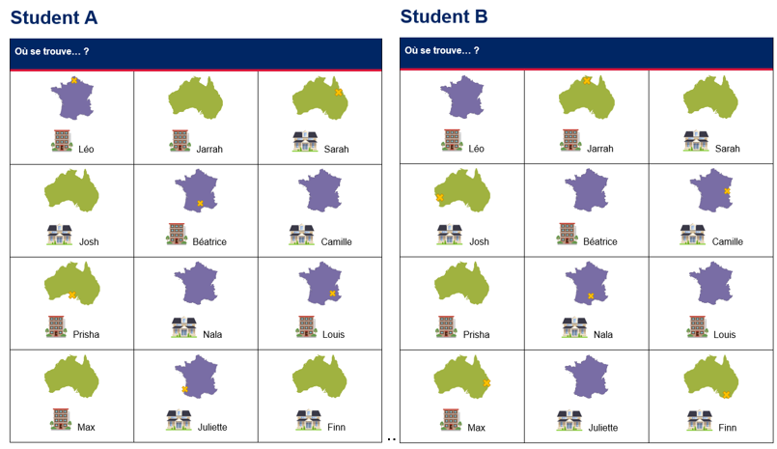
You can also find information gap activities in Stage 4 Arabic (Where do you live?), Stage 4 German (foods and drinks), Stage 4 Korean (prices) and Stage 4 Modern Greek (school timetables).
- Similarly, ‘Battleship’-style games focus on finding out information only the other person has. In this example, students circle dates on a calendar, then interact with each other to find out their partner’s dates. This example is from Stage 4 Chinese.
Figure 4 – sample ‘Battleship’-style activity
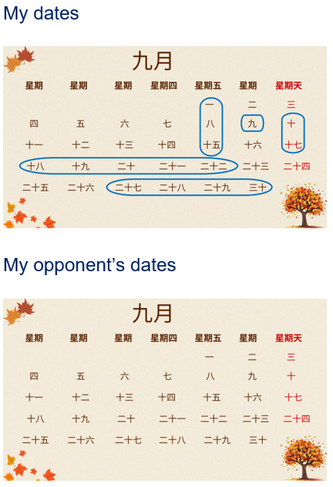
You can also find ‘Battleship’-style activities in Stage 4 German (describing foods and drinks) and Stage 4 Spanish (frequency and mealtimes).
- ‘Find someone who …?’ activities get students moving around the room and interacting.
- Style 1 – each student is given a profile card (prepared by you, or from one of our sample units). A different profile card for each student is ideal or, if you are short on time, the activity would still work of there are 10 different profile cards in a class of 30. Each profile card includes key information from the current unit. Students then move around the room and interact with their peers to ‘find someone who …’ (for example, lives in Berlin; has 4 siblings; finds soccer boring; loves eating fruit). If you join the activity as an extra ‘student’, you can efficiently gather data and offer feedback. This example is from our Stage 4 French unit. You can find other examples of profile cards in Stage 4 Arabic (homes and hobbies), Stage 4 Chinese (introductions), Stage 4 Japanese (activities at a festival) and Stage 4 Modern Greek (getting to and from school – times and transport).
Figure 5 – sample ‘Find someone who …? Activity (style 1)
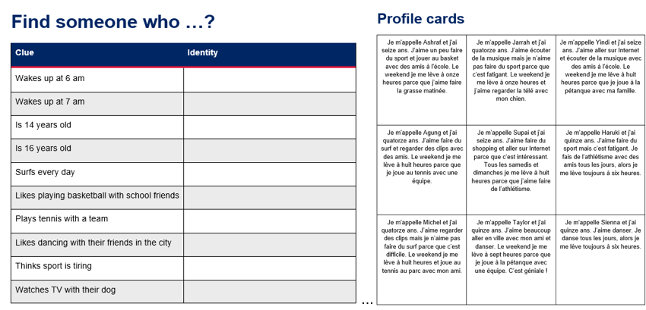
- Style 2 – students identify their own information about a topic, for example which foods they like. You can find examples of this style in Stage 4 Korean (customers and stallholders at the market), Stage 4 Modern Greek (school subjects) and Stage 4 Spanish (foods and drinks).

Feedback
Gathering data and providing feedback during formative assessment opportunities can be as easy as using simple rubrics like the ones below.
Figure 6 – sample rubric 1
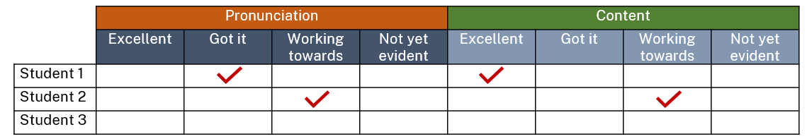
Figure 7 – sample rubric 2
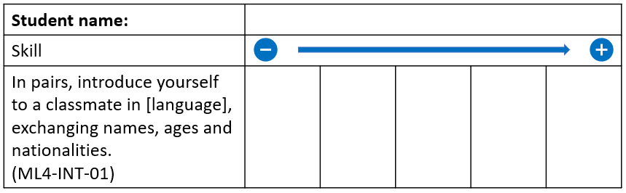
Next time you do a similar activity you can look for a different skill to isolate and assess. This type of rubric could also be used for students to give peer feedback.
Keeping track of student achievement with large numbers of students when you may only see them a couple of times a week does take planning. By formatively assessing these skills throughout a unit of work, and keeping a record, you are still assessing students against the syllabus content dot points which build towards the ‘Interacting’ outcomes. This way you also have evidence of their progress if they are absent for the summative task, or if reports are due before you have completed the summative assessment. This evidence can be helpful especially if your school requires an indicator of progress against all 3 outcomes for every report period.

Summative assessment
Summative assessment tasks can be similar to those used to formatively assess students, however the delivery method may have to be different to ensure the task is fair for all students. For example, students need to be given equitable amounts of time to practise.
Students could film or record their interaction during the first or last 15 minutes of the lesson, all at the same time, to be viewed and marked later by the teacher. You could take students to the library or playground, to reduce background noise. Alternatively, you can move around the room, listening to each pair or small group, and mark them on the spot.

Differentiating summative assessment
When assessing students in groups or pairs, sometimes a student can be hindered or prevented from demonstrating or achieving their best due to the skills of the student they are interacting with. By completing formative assessment tasks at regular intervals throughout the unit of work, and by assessing a variety of content dot points, you will identify those students who still require extra support. When completing the summative task, particularly an ‘Interacting’ task, knowing who requires differentiated support for is vital. In this instance, you could consider the following:
- join the conversation and ask some questions or offer some answers, or subtly prompt the student who is struggling
- provide a scaffold to students who need one, for example a sentence builder or a vocabulary list. Avoid providing whole sentences as this will result in students reading aloud, rather than interacting. Provide enough support for the interaction to occur, even if students may need to make more effort to negotiate meaning
- allow students to refer to anchor charts around the room, or in their books, for vocabulary prompting
- challenge high achieving students not to refer to prompts and to add extra comments or relevant sentences wherever possible.
This also highlights the importance of listening to students interact on more than one occasion or with more than one other student.

Sample summative tasks
In our support, we have included a range of summative tasks which assess ‘Interacting’. These can be adapted for a range of languages, topics and contexts.

Foods and drinks – preferences
This student-facing task is from our German Stage 4 unit. You can find the marking guidelines in the unit.
You are on a school trip in Germany and are meeting your host family for the first time. Your host sibling wants to learn a bit more about your food and drink preferences. Greet your host sibling, and then discuss:
- what you usually eat for breakfast, lunch or dinner (depending on what your host sibling asks you)
- something you like to eat or drink, with a reason (adjective[s] to describe the food or drink)
- if you like a certain food or drink
- your favourite food or drink.
During the interaction, include 2 questions for your host sibling to answer, relating to food and/or drink.

Foods and drinks – opinions
This student-facing task is from Term 2 of the French Stage 4 scope and sequence (refer to the ‘Summative assessment task – Stage 4, Term 2’ document). You can find the related marking guidelines in the task.
In celebration of Bastille Day, your class would like to hold a small party. To help decide what to eat, you will share your opinions about possible food and drink choices for the party.
You will each be given a ‘placemat’ with common French foods and drinks to choose from.
In groups of 2 to 3, take turns to ask each other about the food and drink options. When answering, include your opinion of the food or drink, and the reason. Include conjunctions, for example et (and), mais (but) and parce que (because).
For example:
- Tu aimes le jus ? Oui, j’aime le jus, mais c’est mauvais pour la santé. (Do you like juice? Yes, I like juice but it’s unhealthy.)
- Tu aimes le café ? Non, je déteste le café parce que c’est dégoûtant. (Do you like coffee? No, I hate coffee because it’s disgusting.)
- Tu aimes le chocolat chaud ? Oui, j’aime beaucoup le chocolat chaud et c’est délicieux. (Do you like hot chocolate? Yes, I really like hot chocolate and it’s delicious.)
Once you have each identified a range of likes and/or dislikes, with reasons, call your teacher over and interact in front of them. Each of you will ask and answer 3 questions, showcasing your knowledge of French foods, drinks, opinions, preferences and reasons.
When you have finished, your teacher will ask you what you would like to eat and drink at the party. Each of you chooses one food and one drink, and ‘orders’ it from your teacher, for example:
Pour la fête je voudrais [name of food] et [name of drink], s’il vous plaît. (For the party, I would like [name of food] and [name of drink], please.)
Figure 8 – sample placemat
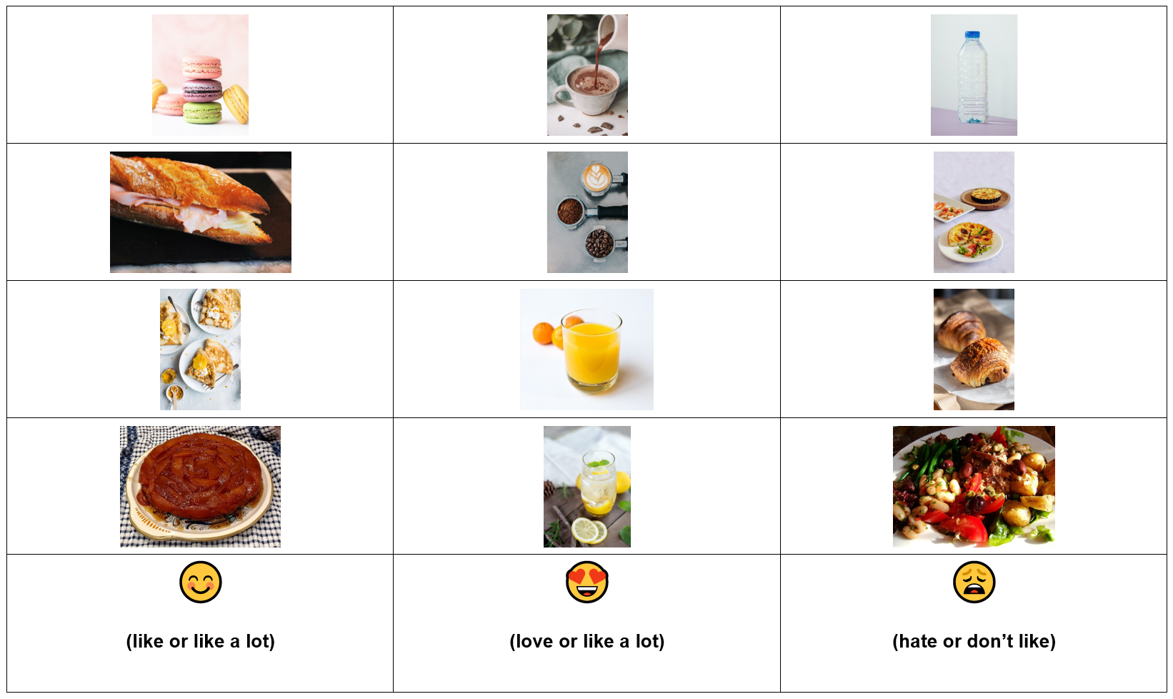

Foods and drinks – shopping for items
This student-facing task is from our Korean Stage 4 unit. You can find the marking guidelines in the unit.
While on exchange in Korea your host mother has given you a shopping list with a variety of items to purchase at the market. She has also told you to purchase something of your own choosing.
With one student as the customer and the other as the shopkeeper, using culturally-appropriate language, have a conversation to make the purchases.
In the conversation include:
- appropriate greetings
- identification of items using demonstrative pronouns, for example, ‘this’, ‘that’, ‘that over there’
- an exchange of information about different items, for example, price or adjectives to describe them
- a negotiation of prices
- the correct language and number system associated with Korean currency, including 원
- asking for specific quantities of items
- establishing that one item is unavailable
- finalising the purchase, expressing thanks and saying goodbye.

Going to a festival
In this example from our Stage 4 Japanese unit, students use a flyer for a stimulus in an interaction. Providing stimulus texts is a great way to support the shift from scaffolded to spontaneous interactions, while encouraging authentic communication. You can find the marking guidelines in the unit.
Firstly, students are assessed on their ability to understand the flyer, including choosing 2 activities to do at the festival and giving a reason why they have chosen each one. Then, students work in pairs to have a conversation about the event. One student takes the role of an Australian exchange student and one takes the role of a Japanese friend. In their conversation, each students presents their 2 choices, including why they are of interest. Students then discuss the options and decide on one activity to attend together and when to go, including:
- each person’s 2 activity choices and why they are preferred and the reasons for your preferences
- a negotiation to identify one activity to attend, with reason(s)
- a plan to go to the event including location and day
- aizuchi (Japanese interjections) to keep the conversation flowing.
Here is a sample of the stimulus flyer.

Figure 9 – image of festival flyer
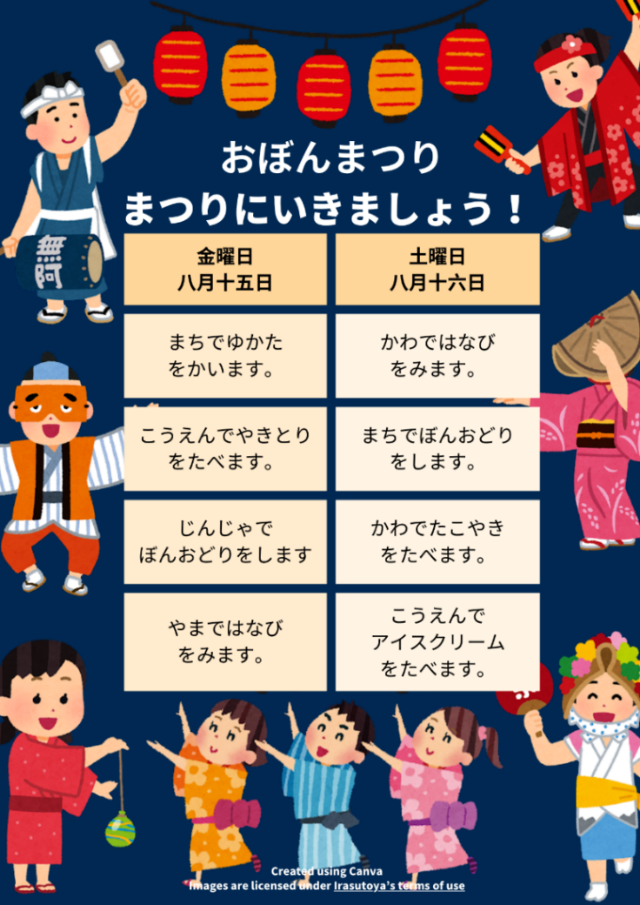

Bargaining at the market
This student-facing task is from our Stage 4 Indonesian unit. You can find the marking guidelines in the unit.
You are shopping in a market in Indonesia and want to buy a souvenir to take back to your friend in Australia. Have a conversation in Indonesian with the seller, outlining the specific item you wish to buy and bargaining to make the purchase.,
During your conversation as the buyer:
- refer to the poster, representing the shop front and decide on an item to buy
- appropriately greet and thank the seller
- identify and describe the item to the seller
- use culturally-appropriate bargaining strategies to make the purchase.
During your conversation as the seller:
- identify the item the buyer wishes to purchase
- appropriately greet and thank the buyer
- use culturally-appropriate bargaining strategies to sell the item.
You and your partner will take turns in both roles of buyer and seller. After the first interaction, you will switch roles so that each person has a turn playing each role.

Planning an outing
This task has been developed from Term 4 of the French Stage 4 scope and sequence.
While your friend from France is visiting you, your family is planning a trip during the school holidays. In pairs, with one of you playing the role of the French friend, discuss:
- where you are going
- what you plan to do, including reasons for the activities
- things that you will need, including clothing
- how you will get there.

Next steps
Conduct an audit of your current ‘Interacting’ assessment tasks and consider:
- Are they assessing ‘Interacting’ (with a degree of unknown/spontaneity) or would they be better suited to assess ‘Creating texts’ in a speaking context? A reminder that scripted and rehearsed role plays assess ‘Creating texts’, as there is no spontaneity of degree of unknown.
- How could you adjust your existing tasks to embed a stronger focus on negotiating meaning?

Support and alignment
Resource evaluation and support: All curriculum resources are prepared through a rigorous process. Resources are periodically reviewed as part of our ongoing evaluation plan to ensure currency, relevance and effectiveness. For additional support or advice, contact the Languages and Culture team by emailing languagesnsw@det.nsw.edu.au.
Explicit teaching: Further advice to support explicit teaching is available on the Explicit teaching webpage. This includes the CESE Explicit teaching – Driving learning and engagement webpage.
Differentiation: Further advice to support Aboriginal and Torres Strait Islander students, EALD students, students with a disability and/or additional needs and High Potential and gifted students can be found on the Planning programming and assessing 7-12 webpage. This includes the Inclusion and differentiation 7–10 advice webpage.
Assessment: Further advice to support formative assessment is available on the Planning, programming and assessing 7–12 webpage. This includes the Classroom assessment advice 7–10. For summative assessment tasks, the Assessment task advice 7–10 webpage is available.
Alignment to system priorities and/or needs: School Excellence Policy, Our Plan for NSW Public Education
Alignment to the School Excellence Framework: This resource supports the School Excellence Framework elements of curriculum (curriculum provision), assessment and effective classroom practice (lesson planning, explicit teaching).
Alignment to Australian Professional Standards for Teachers: This resource supports teachers to address Proficient Teacher Standard Descriptors [3.3.2, 5.1.2].
Consulted with: Curriculum and Reform and subject matter experts
NSW syllabus: Modern Languages K–10 Syllabus
Author: Languages and Culture
Publisher: State of NSW, Department of Education
Resource: Unit of work guidelines and template
Related resources: Further resources to support Modern Languages can be found on the Languages curriculum page.
Professional learning: Relevant professional learning is available through the Languages statewide staffroom (staff only).
Creation date: August 2025
Rights: © State of New South Wales, Department of Education

Evidence base
This resource contains NSW Curriculum and syllabus content. The NSW Curriculum is developed by the NSW Education Standards Authority. This content is prepared by NESA for and on behalf of the Crown in right of the State of New South Wales. The material is protected by Crown copyright.
Please refer to the NESA Copyright Disclaimer for more information https://educationstandards.nsw.edu.au/wps/portal/nesa/mini-footer/copyright.
NESA holds the only official and up-to-date versions of the NSW Curriculum and syllabus documents. Please visit the NSW Education Standards Authority (NESA) website https://educationstandards.nsw.edu.au/ and the NSW Curriculum website https://curriculum.nsw.edu.au/home.
Modern Languages K–10 Syllabus © NSW Education Standards Authority (NESA) for and on behalf of the Crown in right of the State of New South Wales, 2022.

© State of New South Wales (Department of Education), 2025
The copyright material published in this resource is subject to the Copyright Act 1968 (Cth) and is owned by the NSW Department of Education or, where indicated, by a party other than the NSW Department of Education (third-party material).
Copyright material available in this resource and owned by the NSW Department of Education is licensed under a Creative Commons Attribution 4.0 International (CC BY 4.0) license.

This license allows you to share and adapt the material for any purpose, even commercially.
Attribution should be given to © State of New South Wales (Department of Education), 2025.
Material in this resource not available under a Creative Commons license:
- the NSW Department of Education logo, other logos and trademark-protected material
- material owned by a third party that has been reproduced with permission. You will need to obtain permission from the third party to reuse its material.
Links to third-party material and websites
Please note that the provided (reading/viewing material/list/links/texts) are a suggestion only and implies no endorsement, by the New South Wales Department of Education, of any author, publisher, or book title. School principals and teachers are best placed to assess the suitability of resources that would complement the curriculum and reflect the needs and interests of their students.
If you use the links provided in this document to access a third-party's website, you acknowledge that the terms of use, including licence terms set out on the third-party's website apply to the use which may be made of the materials on that third-party website or where permitted by the Copyright Act 1968 (Cth). The department accepts no responsibility for content on third-party websites.

The teacher plays the role of the host sibling. Teacher to provide activities for students to work on quietly, while they interact with each student.
As the teacher, you are adding the element of ‘unknown’, as students do not know which meal they will be asked about.
The teacher provides the list.
As this task assesses interaction, students are encouraged to work in pairs for the conversation. Some students may prefer to work individually and/or use assistive technology to provide oral responses.
Students may do this as a live interaction for the teacher to observe, or record using a voice or video recording application. This could also be adapted to a ‘Creating texts’ task where students create a role play of a bargaining scenario in Indonesia.
Students take turns in each role. After the first interaction, students switch roles so that each student has a turn as buyer and seller. Alternatively, the teacher could play the role of the seller.
The role of the seller may be taken by the teacher if they wish to manage the parameters of the language used, adjusting to the context of their student needs.

