Assessing ‘Interacting’ through card play – sample

Contents
Benefits of assessing through card play 3
Family card game 4
Context 4
Game summary 4
How to play 5
Using the game as an assessment task 6
Vocabulary and structures 6
Differentiation strategies in the game play that allow for discrimination of A to E grades 7
Syllabus outcomes and content dot points 12
Exchanging and negotiating meaning to interact in the target language 13
Applying knowledge of language systems to interact in the target language 13
Applying knowledge of the target language culture(s) to interact 13
Assessing the relevant and assessable content dot points 14
Determining criteria for marking guidelines and linking to syllabus outcome dot points 14
Designing marking guidelines 17
Scaffolding to support all students 22
Implementing the assessment task and marking 22
Sample recording template 24
Sample responses 27
Interrelated task idea 28
Other topics for card game play 28
Evidence base 29

Benefits of assessing through card play
The benefits of card game play as a means to assess ‘Interacting’ outcomes include:
- students can play the game during the unit, for practice and engagement
- the whole class can be assessed during one lesson – students who are not being assessed can remain engaged in the lesson by continuing game play
- enabling a more relaxed environment for students to interact
- supporting a range of learners through game variations.
This document provides one example of a card game, based on family. This could be adapted for different topics and language levels. You can find suggested adaptations across different topics at Other topics for card game play, towards the end of this document.
For more information on assessing ‘Interacting’, please refer to the ‘Modern Languages K–10 Syllabus (2022) – guidelines for assessing ‘Interacting’ in Stage 4’ document on the Planning, programming and assessing languages 7–10 webpage.

Family card game

Context
This game could be used for assessing a unit on family. For the purpose of this document, students have learned:
- family vocabulary (such as ‘brother’, ‘grandma’)
- simple descriptions (such as ‘he is tall’, ‘she is funny’)
- simple likes and dislikes (‘she likes music’).
The game can still be played even if students have learned less language – just make any adaptations, based on your context.
An editable version of the game is available in Canva, where you can change the images, vocabulary and degree of scaffolding.

Game summary
The object of the game is to collect family member cards to make a complete family set of cards.
Each family set has 6 family member cards. All family members are listed on each family member card so that players know who they need to collect to complete the family set.
For example, to complete the Clancy family set, players need to collect great grandma, bird, uncle, aunt, male cousin and parents. To complete the Cho family, players need to collect dad, younger sister, mum, older brother, grandma and older sister.
There are 7 family sets in the card deck.

How to play
Students play in groups of 4 or 5.
To play:
- Distribute 6 cards to each player. Place the remaining cards face down in the middle of the table.
- The player to the left of the dealer goes first. They ask any other player if they have a specific card, for example ‘Do you have the mum of the Rossi family?’.
- If the player being asked has the card, they say ‘Yes, I do’ and give it to the player who asked. If not, they say ‘No, I don’t’ and the player who asked draws a card from the centre deck. Play continues in a clockwise direction.
- When a player collects a complete family, they lay their set on the table as part of their turn.
- Players add to the cards in their hand throughout the game (by adding a correct match from another player, or by adding a card from the centre deck) – cards are only discarded by a student when giving them to another player, or laying down a full family set on the table.
- Play continues until there are no remaining cards in the centre stack. At this point, the winner is the player who has collected the most points, using the point system outlined later in this document.

Using the game as an assessment task
Considerations for using the game as an assessment task include:
- vocabulary and structures that will be assessed
- differentiation strategies in the game play that allow for discrimination of grades across the A to E range
- syllabus outcomes and content dot points that will be assessed
- marking guidelines that clearly outline the criteria for assessment
- designing a process for marking
- scaffolding to support all students to participate
- implementing the assessment
- creating an interrelated task, aligned to 2 syllabus outcomes.

Vocabulary and structures
Vocabulary and structures that can be used in the target language include vocabulary from the topic, family and for game play when socialising with peers.
Examples include:
- Do you have the _____ of the _____ family?
- Yes, I have the _____ of the _____ family.
- No, I don’t have the _____ of the _____ family. Sorry.
- Here you are.
- This is the _____ family.

Differentiation strategies in the game play that allow for discrimination of A to E grades
Quality assessment allows for discrimination of grades across the A to E range – How can this happen with a card game?
By adding in cards that create spontaneity and opportunities for students to use additional language skills, an A to E achievement range can be created. These cards could be:
- a question card – students have the opportunity to play this card at any time during the game to ask another student a question, demonstrating further questioning skills. For example, ‘What is the dad like?’, ‘What does your sister like?’, ‘Is the cousin kind?’
- a response card – students have the opportunity to play this card to respond to a question asked by another student or the teacher. This promotes spontaneous interaction and the use of a broad range of grammatical structures and vocabulary, including prior learning. For example, ‘The cousin is kind, but shy. My sister likes swimming, she is very sporty’
- a comment card – students have the opportunity to play this card at any time during the game to add an additional comment, demonstrating manipulation and extension of grammatical structures to use a broad range of structures and vocabulary, including prior learning. For example, ‘In fact, the dad likes sandwiches and cola. The grandmother lives in Sydney but is Chinese’.
These cards should sit as 3 separate decks to the main play deck – a question card deck, a response card deck and a comment card deck, so they are optional for students to use at any time during the game. When using the game as an assessment task, students should be encouraged to use these additional cards to demonstrate their ability to use relevant and familiar vocabulary, ask and respond to questions and use structures and features of the grammatical system to interact, while you are observing the group. Once a student accurately completes the task on the card, such as asking a question, responding to a question or making an additional comment, the card is placed in front of the student. The points on each card can then be added to a final score at the end of play. While the points on the cards do not relate to the assessment mark, the cards themselves enable students to demonstrate achievement at higher grades. The cards also support game play and provide a purpose for continuing to play the game outside of the assessment task.
Points may be awarded as follows:
Sample cards | Sample points
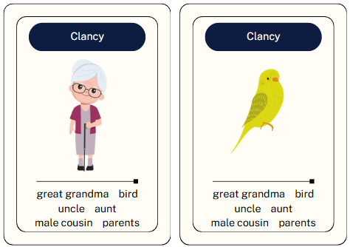 | 1 point for each family member of a family set – sample cards indicate 2 points.
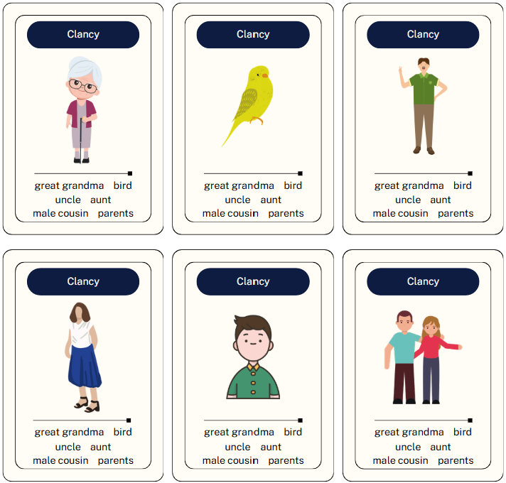 | 10 points for each complete family set collected.
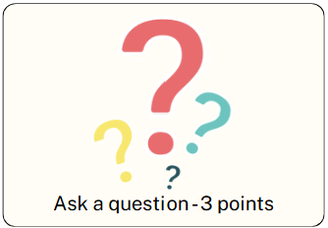 | 3 points for a completing a question card accurately.
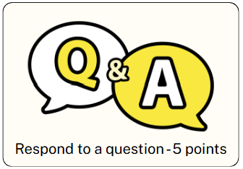 | 5 points for responding accurately to a question.
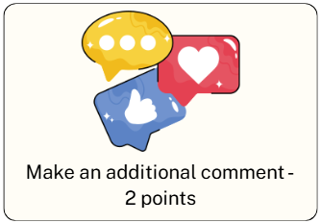 | 2 points for a making an additional comment accurately.
Example of scoring 30 points by the end of the game is shown below, including the cards:
- 10 points (family set)
- 6 points for answering 2 questions accurately
- 2 points for 2 family members from an incomplete family set
- 2 points for making an additional comment accurately
- 10 points for responding to 2 questions accurately to a question.’
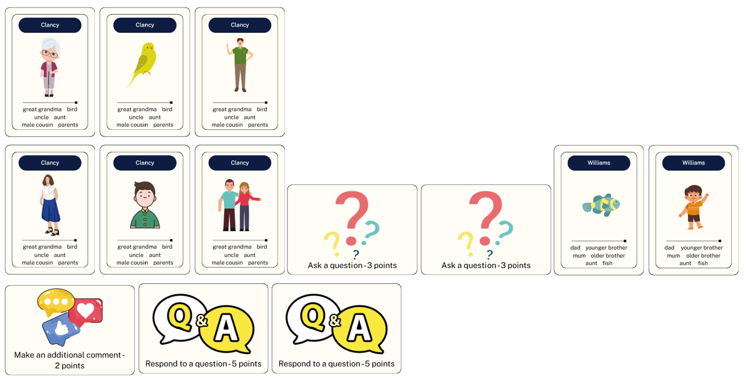

Syllabus outcomes and content dot points
Let’s look at the Stage 4 ‘Interacting’ outcome and related content dot points and determine which ones are relevant to playing the game, as well as which ones are assessable.

Exchanging and negotiating meaning to interact in the target language
- Socialise with peers – relevant, but not assessable
- Understand and reciprocate information about their own and others’ personal worlds – not relevant to this game
- Express and explain emotions, opinions and personal preferences – relevant and assessable
- Ask questions and describe actions – relevant and assessable
- Use a range of communication strategies to facilitate interactions in familiar contexts – relevant and assessable

Applying knowledge of language systems to interact in the target language
- Use features of the sound system in spoken interactions – relevant and assessable
- Use relevant and familiar vocabulary from a range of themes to interact – relevant and assessable
- Use structures and features of the grammatical system to interact – relevant and assessable

Applying knowledge of the target language culture(s) to interact
- Use language that is appropriate to cultural practices and values to interact – relevant and assessable

Assessing the relevant and assessable content dot points
For the purpose of this document, the following outcome content points have been identified. Please amend these, according to your context, if required.
- Ask questions and describe actions
- Use a range of communication strategies to facilitate interactions in familiar contexts
- Use features of the sound system in spoken interactions
- Use relevant and familiar vocabulary from a range of themes to interact
- Use structures and features of the grammatical system to interact

Determining criteria for marking guidelines and linking to syllabus outcome dot points
In an ‘Interacting’ task, the following aspects may be relevant (the suggestions in brackets will guide the inclusions):
- content (What information do you want the students to include?)
- range of vocabulary and grammatical structures (What vocabulary and grammatical structures have been covered during the unit, that you expect to see?)
- spoken communication skills (What oral communication skills do you expect to see, such as pronunciation, fluency, active listening through questioning?)
These 3 aspects have been unpacked in the table below, aligned to the relevant content dot point(s).
Aspect of assessment | Expectations | Content dot point(s) which align with aspect – from the syllabus
Content  What information do you want the students to include? | - Family members and pets  - Descriptions – personality and/or appearance  - Basic likes and dislikes  - Modelled responses in game play:  - indicating whether or not they have a card – ‘Yes, I do’ or ‘No, I don’t’  - turn-taking – ‘It’s your turn’  - polite terms – ‘sorry’, ‘please’, ‘thank you’ | - Use relevant and familiar vocabulary from a range of themes to interact
Range of vocabulary and grammatical structures  What vocabulary and grammatical structures have been covered during the unit, that you expect to see? | - Expressing ownership, for example ‘the mum of the Clancy family’  - Using conjunctions – ‘and’, ‘but’  - Using adjectives  - Expressing likes and dislikes in the third person  - Using a range of sentence starters | - Ask questions and describe actions  - Use structures and features of the grammatical system to interact
Spoken communication skills  What oral communication skills do you expect to see, such as pronunciation, fluency, active listening through questioning? | - Correct pronunciation  - Fluency and timely responses  - Active listening – agreement comments, clarifying questions  - Conversation fillers when thinking | - Use a range of communication strategies to facilitate interactions in familiar contexts  - Use features of the sound system in spoken interactions

Designing marking guidelines
Syllabus outcomes and content dot points | A | B | C | D | E
ML4-INT-01  - Use relevant and familiar vocabulary from a range of themes to interact | Interacts during game play, using a variety of vocabulary with a high level of accuracy, and includes:  - family members and pets  - game play turns  - yes and no for cards they have  - polite terms – ‘sorry’, ‘please’, ‘thank you’  - descriptions of personality and/or appearance of family members  - basic likes and dislikes of family members. | Interacts during game play, using a variety of vocabulary with minor errors, and includes:  - family members and pets  - game play turns  - yes and no for cards they have  - polite terms – ‘sorry’, ‘please’, ‘thank you’  - descriptions of personality and/or appearance of family members  - basic likes and dislikes of family members. | Interacts during game play, using a relevant vocabulary with some errors, and includes most of the following:  - family members and pets  - game play turns  - yes and no for cards they have  - polite terms – ‘sorry’, ‘please’, ‘thank you’  - descriptions of personality and/or appearance of family members  - basic likes and dislikes of family members. | Interacts during game play, with limited vocabulary with errors that impact comprehension and/or meaning, and includes some of the following:  - family members and pets  - game play turns  - yes and no for cards they have  - polite terms – ‘sorry’, ‘please’, ‘thank you’  - descriptions of personality and/or appearance of family members  - basic likes and dislikes of family members.  May rely on scaffolds to interact. | Interacts using single words and/or simple phrases relevant to the topic.  Relies heavily on scaffolds to interact.
ML4-INT-01  - Ask questions and describe actions  - Use structures and features of the grammatical system to interact | Uses a variety of structures, with a high level of accuracy, including:  - asking and responding to questions about what card others have or don’t have  - offering and receiving cards, using polite terms  - using conjunctions to join ideas and sentences – ‘and’, ‘but’  - asking and responding to questions about descriptions  - asking and responding to questions about likes and dislikes. | Uses a variety of structures, with minor errors, including:  - asking and responding to questions about what card others have or don’t have  - offering and receiving cards, using polite terms  - using conjunctions to join ideas and sentences – ‘and’, ‘but’  - asking and responding to questions about descriptions  - asking and responding to questions about likes and dislikes. | Uses a variety of structures, with some errors, including:  - asking and responding to questions about what card others have or don’t have  - offering and receiving cards, using polite terms  - using conjunctions to join ideas and sentences – ‘and’, ‘but’  - asking and responding to questions about descriptions  - asking and responding to questions about likes and dislikes. | Uses some structures, with errors that may hinder comprehension, including some of the following:  - asking and responding to questions about what card others have or don’t have  - offering and receiving cards, using polite terms  - using conjunctions to join ideas and sentences – ‘and’, ‘but’  - asking and responding to questions about descriptions  - asking and responding to questions about likes and dislikes.  May rely on scaffolds to interact. | Use single words and/or phrases, with errors that hinder comprehension.  Relies heavily on scaffolds to interact.
ML4-INT-01  - Use a range of communication strategies to facilitate interactions in familiar contexts  - Use features of the sound system in spoken interactions | Interacts with a high level of accuracy, including:  - correct pronunciation  - fluency and timely responses  - active listening – agreement comments, clarifying questions  - conversation fillers. | Interacts with minor errors, including:  - correct pronunciation  - fluency and timely responses  - active listening – agreement comments, clarifying questions  - conversation fillers. | Interacts with some errors, including:  - correct pronunciation  - fluency and timely responses  - active listening – agreement comments, clarifying questions  - conversation fillers. | Interacts with errors that may hinder communication, including some of the following:  - correct pronunciation  - fluency and timely responses  - active listening – agreement comments, clarifying questions  - conversation fillers. | Attempts to interact, with errors and pace that hinder the flow of communication.

Scaffolding to support all students
To support all students to participate during game play and assessment you may like to consider scaffolds such as:
- vocabulary lists
- sentence builders
- prompt cards
- cloze sentences.
These can be included in the marking guidelines to reflect the grade given based upon the reliance of scaffolds. You can also vary degree of scaffolding on the cards themselves.

Implementing the assessment task and marking
Give the students the task notification with the task description at the start of the unit, so that they know the language and communication skills they will develop during the unit and can connect learning to the assessment task.
The task description could look like this:
In groups of 4 or 5, you will participate in a card game, socialising with your classmates in [Language]. During the game, you will interact with your classmates to exchange information on:
  - family members and pets
  - game play turns
  - positive and negative responses
  - polite terms – ‘sorry’, ‘please’, ‘thank you’
  - descriptions of personality and appearance
  - basic likes and dislikes.
Your teacher will observe your game during play. You will have the opportunity to showcase your skills at higher levels of achievement through bonus cards that give you the opportunity to ask and respond to questions and make additional comments with accurate pronunciation and fluency.
During the unit, prior to the assessment task, play a basic version of the game to familiarise students with the game play, instructions and scoring. By gradually including the bonus cards as the unit progresses, students are supported to develop confidence in the types of responses they can give and becoming spontaneous in asking and responding to questions.
On the day of the assessment, students play in groups of 4 or 5, with the teacher moving around the room to watch the groups and take note of how each student is interacting. These notes can be recorded on a simple template which can include the outcome’s content points and grades A to E. The teacher can have one recording sheet per group and write comments on it with student names and brief observations, such as ‘responded with conjunctions, asked 2 questions, used 3 different adjectives, relied on sentence builder scaffold.’

Sample recording template
Use this template as a sample approach to gathering evidence and providing feedback. You can design your own approach. Other examples of gathering evidence and providing feedback during assessment opportunities can be found in the ‘Modern Languages K–10 Syllabus (2022) – guidelines for assessing ‘Interacting’ in Stage 4’ document on the Planning, programming and assessing languages 7–10 webpage.
- ✅✅✅ = evidence of a broad range
- ✅✅ = evidence of some range
- ✅ = present in student’s interaction
Syllabus outcomes and content dot points | A | B | C | D | E
ML4-INT-01  - Use relevant and familiar vocabulary from a range of themes to interact | [Insert student names and brief comments here.  For example:  Jonah  - family/pets vocab ✅✅✅  - variety of descriptions✅✅✅  - variety of likes/dislikes✅✅✅  - variety of questions and responses✅✅✅  - target language use during play ✅✅✅  - range of sentence starters✅✅✅] | [Insert student names and brief comments here.  For example:  Kirra  - family/pets vocab ✅✅✅  - variety of descriptions✅✅  - variety of likes/dislikes✅✅  - variety of questions and responses✅  - target language use during play ✅✅  - range of sentence starters✅] | [Insert student names and brief comments here.] | [Insert student names and brief comments here.  For example:  Min  Relied on scaffold throughout play  - family/pets vocab ✅  - variety of descriptions  - variety of likes/dislikes✅  - variety of questions and responses  - target language use during play ✅  - range of sentence starters] | [Insert student names and brief comments here.]
ML4-INT-01  - Ask questions and describe actions  - Use structures and features of the grammatical system to interact | [Insert student names and brief comments here.] | [Insert student names and brief comments here.] | [Insert student names and brief comments here.] | [Insert student names and brief comments here.] | [Insert student names and brief comments here.]
ML4-INT-01  - Use a range of communication strategies to facilitate interactions in familiar contexts  - Use features of the sound system in spoken interactions | [Insert student names and brief comments here.] | [Insert student names and brief comments here.] | [Insert student names and brief comments here.] | [Insert student names and brief comments here.] | [Insert student names and brief comments here.]

Sample responses
Sample responses may be given to the students when handing out the assessment notification at the beginning of the unit. This could be in the form of a sample conversation script of a whole interaction. You may also consider sample conversation scripts for parts of the interaction such as likes and dislikes, family members, game play throughout the unit.
When playing the game during the unit, be sure to take the opportunity to create teachable moments by moving around the room and giving students feedback on what they are including that makes their interactions engaging, meaningful and accurate, as well as feedback on what they could include to build their interacting skills such as vocabulary and structures and practising with a partner for fluency.
Game play throughout the unit also offers students opportunity to reflect on the final task marking guidelines to see how they are progressing and set their own learning goals. It is also an opportunity for peer feedback, using tools such as 2 stars and a wish where students identify in each other what structures and vocabulary are being used accurately and with a wide variety and suggestions of what their peers could include to develop their interacting skills further. This also allows for deeper understanding for all students.

Interrelated task idea
This interrelated task could be used as an interrelated task with the Stage 4 ‘Creating texts’ outcome. Examples of a Part B ‘Creating texts’ task may be:
- Using the cards collected during the game, imagine these are your host family during homestay you are on overseas. Write to your [Language] classmates about your new host family. Include how many people are in the family, a description of them, their likes and dislikes, their nationality and where they live.

Other topics for card game play
Other topics that this style of game could be used for are:
- sightseeing – gathering sets of places you can visit and activities you can do when sightseeing in different cities. Questions students could ask include: Have you been there? What did you like there? What did you do there? What is your opinion? Why? Who did you go with? What season did you go? Where is it located?
- school life – gathering sets of subjects on a particular school day. a school day. Questions students could ask include: Do you have maths on Tuesday? Do you like maths? Who is your favourite teacher?
- foods and drinks – gathering sets of meals for different times of day or dishes from places. Questions students could ask include: What do you eat for breakfast? Do you like [drink]? How often to you eat [food]? What does [food] taste like? How often to you drink [drink]?
- places around town – gathering sets of facilities around town. Questions students could ask include: What do you do there? How do you go there? Who do you go with? When do you go there? Where is it located? Do you recommend it? Why?

© State of New South Wales (Department of Education), 2025
The copyright material published in this resource is subject to the Copyright Act 1968 (Cth) and is owned by the NSW Department of Education or, where indicated, by a party other than the NSW Department of Education (third-party material).
Copyright material available in this resource and owned by the NSW Department of Education is licensed under a Creative Commons Attribution 4.0 International (CC BY 4.0) license.

This license allows you to share and adapt the material for any purpose, even commercially.
Attribution should be given to © State of New South Wales (Department of Education), 2025.
Material in this resource not available under a Creative Commons license:
- the NSW Department of Education logo, other logos and trademark-protected material
- material owned by a third party that has been reproduced with permission. You will need to obtain permission from the third party to reuse its material.
Links to third-party material and websites
Please note that the provided (reading/viewing material/list/links/texts) are a suggestion only and implies no endorsement, by the New South Wales Department of Education, of any author, publisher, or book title. School principals and teachers are best placed to assess the suitability of resources that would complement the curriculum and reflect the needs and interests of their students.
If you use the links provided in this document to access a third-party's website, you acknowledge that the terms of use, including licence terms set out on the third-party's website apply to the use which may be made of the materials on that third-party website or where permitted by the Copyright Act 1968 (Cth). The department accepts no responsibility for content on third-party websites.

