What do you do in your neighbourhood?

Activity 1
Identify each activity in Arabic in the space provided in the table below. The first one has been done for you as an example.
Number | Activity | Arabic
 | 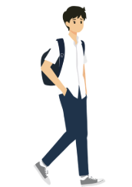 | أذهب
 | 
 | 
 | 
 | 
 | 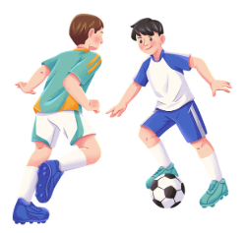

Activity 2
Use the prompts in the table below to write a complete sentence in Arabic. Remember to choose the correct preposition when constructing your sentence: في (in or at) and إلى (to). The first one has been done for you as an example.
Number | Activity | Location | Arabic sentence
 |  | 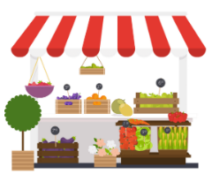 | .أشتري الطعام في السوق
 |  | 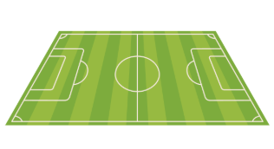
 |  | 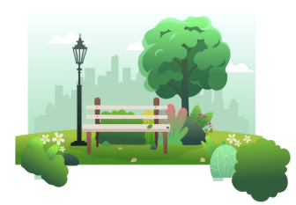
 |  | 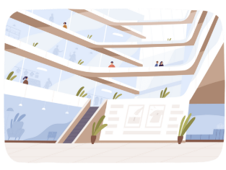
 |  | 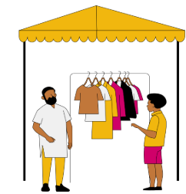

Activity 3
Write the activities and locations you hear in English in the spaces provided in the table below.
Number | Activity | Location

Activity 4
Complete the sentences below with an appropriate activity for each location. There may be more than one answer.
- في المركز التجاري
- في الملعب
- في السوق
- في متجر الحلويات
- في محل الجِزارة

Activity 5
Write 5 sentences to describe the activities you do, the locations you do them and a description of the location in the spaces provided. Follow the example below as a guide.
أشتري الملابس في المركز التجاري. إنه مزدحم

Activity 6
Ask 5 classmates about their activities, where they do them and how they describe the location. Write their answers in English in the table provided below.
Student name | Activity | Location

For the teacher
Remove this section before sharing this resource with students.

Activity 1
Number | Activity | Arabic
 |  | أذهب
 |  | أشتري
 |  | أقضي الوقت
 |  | أشتري الطعام
 |  | أشتري الملابس
 |  | ألعب الرياضة

Activity 2
Number | Activity | Location | Arabic sentence
 |  | 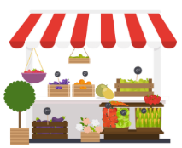 | .أشتري الطعام في السوق
 |  |  | .ألعب الرياضة في الملعب
 |  |  | .أذهب إلى الحديقة
 |  |  | .أشتري الملابس في المركز التجاري
 |  |  | .أقضي الوقت في الملعب
 |  |  | .أذهب إلى المركز التجاري
 |  |  | .أشتري الملابس في السوق
 |  |  | .أقضي الوقت في الحديقة

Activity 3

Audio file
Activity 3 audio (3:01)
Number | Activity | Location | Transcript
 | I shop for food | at the bakery. | .أشتري الطعام في الفرن
 | I shop for clothes | at the market. | .أشتري الملابس في السوق
 | I go | to the park. | .أذهب إلى الحديقة
 | I hang out | at the shopping mall. | .أقضي الوقت في المركز التجاري
 | I play sport | at the sporting field. | .ألعب الرياضة في الملعب
 | I shop | at the shopping mall. | .أشتري في المركز التجاري
 | I hang out | at the park. | .أقضي الوقت في الحديقة
 | I shop | at the perfume shop. | .أشتري في متجر العطور
 | I go | to the bakery. | .أذهب إلى الفرن
 | I go | to the market. | .أذهب إلى السوق

Activity 4
Sample responses may include:
.أذهب إلى المركز التجاري
.ألعب الرياضة في الملعب
.أشتري الملابس في السوق
.أشتري الطعام في متجر الحلويات
.أشتري الطعام في محل الجزارة

Activity 5
Student responses will vary.

Activity 6
Student responses will vary.

© State of New South Wales (Department of Education), 2025
The copyright material published in this resource is subject to the Copyright Act 1968 (Cth) and is owned by the NSW Department of Education or, where indicated, by a party other than the NSW Department of Education (third-party material).
Copyright material available in this resource and owned by the NSW Department of Education is licensed under a Creative Commons Attribution 4.0 International (CC BY 4.0) license.

This license allows you to share and adapt the material for any purpose, even commercially.
Attribution should be given to © State of New South Wales (Department of Education), 2025.
Material in this resource not available under a Creative Commons license:
- the NSW Department of Education logo, other logos and trademark-protected material
- material owned by a third party that has been reproduced with permission. You will need to obtain permission from the third party to reuse its material.
Links to third-party material and websites
Please note that the provided (reading/viewing material/list/links/texts) are a suggestion only and implies no endorsement, by the New South Wales Department of Education, of any author, publisher, or book title. School principals and teachers are best placed to assess the suitability of resources that would complement the curriculum and reflect the needs and interests of their students.
If you use the links provided in this document to access a third-party's website, you acknowledge that the terms of use, including licence terms set out on the third-party's website apply to the use which may be made of the materials on that third-party website or where permitted by the Copyright Act 1968 (Cth). The department accepts no responsibility for content on third-party websites.

