Find someone who …?
Your teacher will give each student a different profile card. Walk around the room asking questions to find someone who fits the criteria in the table below. If you find someone who does, write their profile name in the ‘Profile name’ column. You might find more than one person who meets each criteria. It is also possible that you may not find someone for every criteria.
Here is a list of questions for you to ask your classmates for this activity. Remember to select the appropriate version of the question for the person you are interacting with:
ما نوع المسكن الذي تعيشين فيه؟ (f) / ما نوع المسكن الذي تعيش فيه؟ (m)
أين تعيشين؟ (f) / أين تعيش؟ (m)
كيف هو منزلكِ؟ (f) / كيف هو منزلك؟ (m)
ماذا تفعلين في المنزل؟ (f) / ماذا تفعل في المنزل؟ (m)
(f) ماذا لا تحبين أن تفعلي؟ / (m) ماذا لا تحب أن تفعل؟
Criteria | Profile name
Lives in an apartment
Lives in a 2-storey house
Lives in a house
Lives in a villa
Lives on the coast
Lives in the suburbs
Lives on a farm
Lives in the city
Lives in a town
Lives in the mountains
Lives in a big home
Lives in a small home
Lives in a beautiful home
Lives in a clean home
Lives in a spacious home
Lives in a comfortable home
Lives in a modern home
Reads at home
Relaxes at home
Cooks at home
Listens to music at home
Does their homework at home
Spends time with family/friends at home

Watches TV at home
Plays video games at home
Doesn’t like to cook
Doesn’t like to do homework
Doesn’t like watching TV
Doesn’t like playing video games
Doesn’t like to read

For the teacher
Remove this section before sharing this resource with students.
Provide each student with a profile card in either English or Arabic. There are 14 cards, so some students will have the same card, but this does not affect the activity. You can access an editable version of the profiles to amend for your own context.

Answers
Criteria | Profile name
Lives in an apartment | Lamees, Mona, Hala
Lives in a 2-storey house | Ramzy, Salim, Wissam, Souad
Lives in a house | Walid, Khalil, Jamila, Faris
Lives in a villa | Laila, Ziad, Jad
Lives on the coast | Walid, Khalil, Hala, Jad
Lives on a farm | Wissam, Souad, Faris
Lives in the city | Ziad, Jamila
Lives in a town | Ramzy, Laila
Lives in the mountains | Salim, Lamees, Mona
Lives in a big home | Walid, Ramzy, Salim, Mona, Faris, Jad
Lives in a small home | Lamees, Khalil, Jamila, Hala
Lives in a beautiful home | Laila, Wissam, Jamila, Jad
Lives in a clean home | Lamees, Khalil, Faris
Lives in a spacious home | Ziad, Souad
Lives in a comfortable home | Ramzy, Salim, Mona, Wissam, Souad
Lives in a modern home | Walid, Laila, Hala
Reads at home | Walid
Relaxes at home | Lamees, Wissam, Souad
Cooks at home | Laila
Listens to music at home | Salim, Jad
Does their homework at home | Khalil
Spends time with family/friends at home | Ramzy, Jamila, Hala
Watches TV at home | Mona
Plays video games at home | Ziad, Faris
Doesn’t like to cook | Walid, Khalil, Jad, Souad
Doesn’t like to do homework | Lamees, Salim
Doesn’t like watching TV | Ramzy, Hala
Doesn’t like playing video games | Laila, Mona
Doesn’t like to read | Ziad, Jamila

Profile cards in English
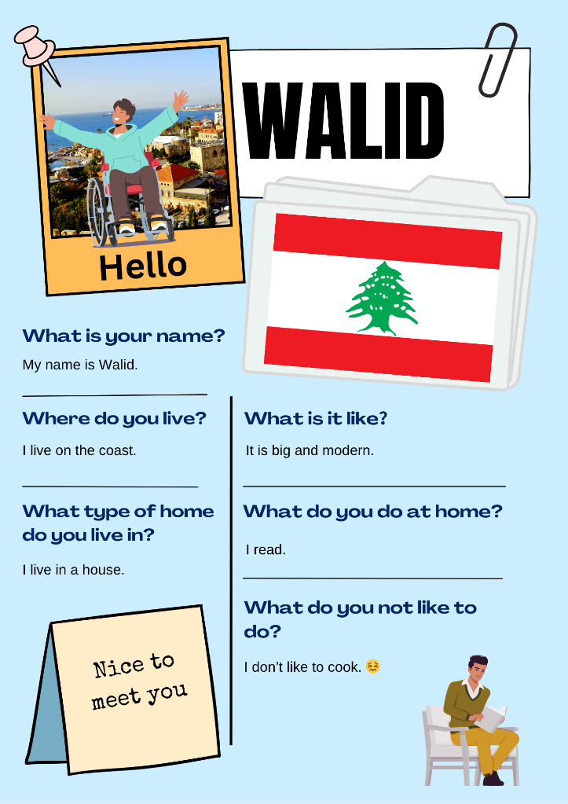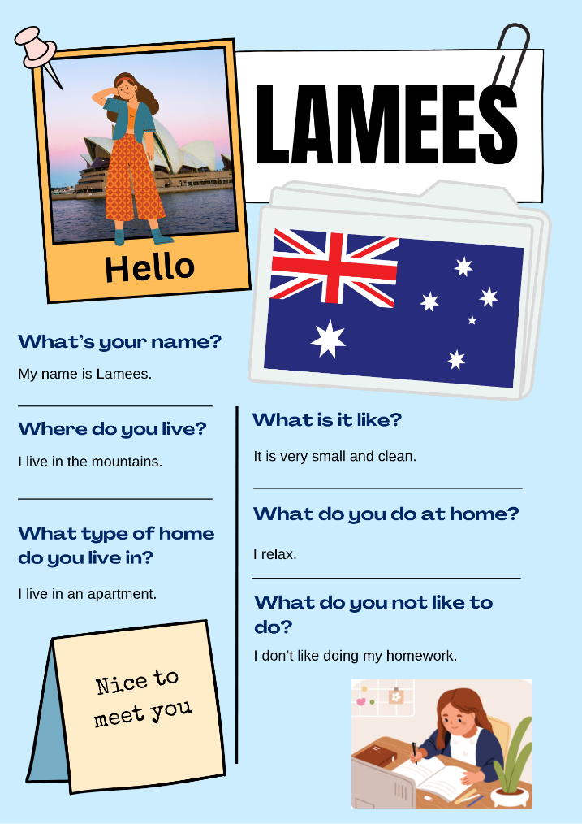
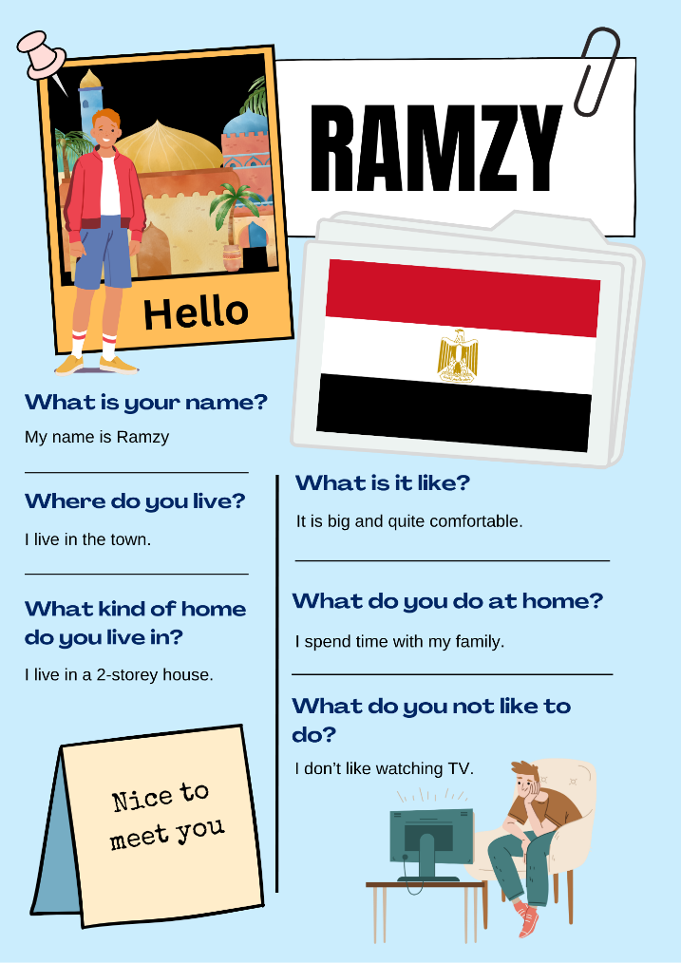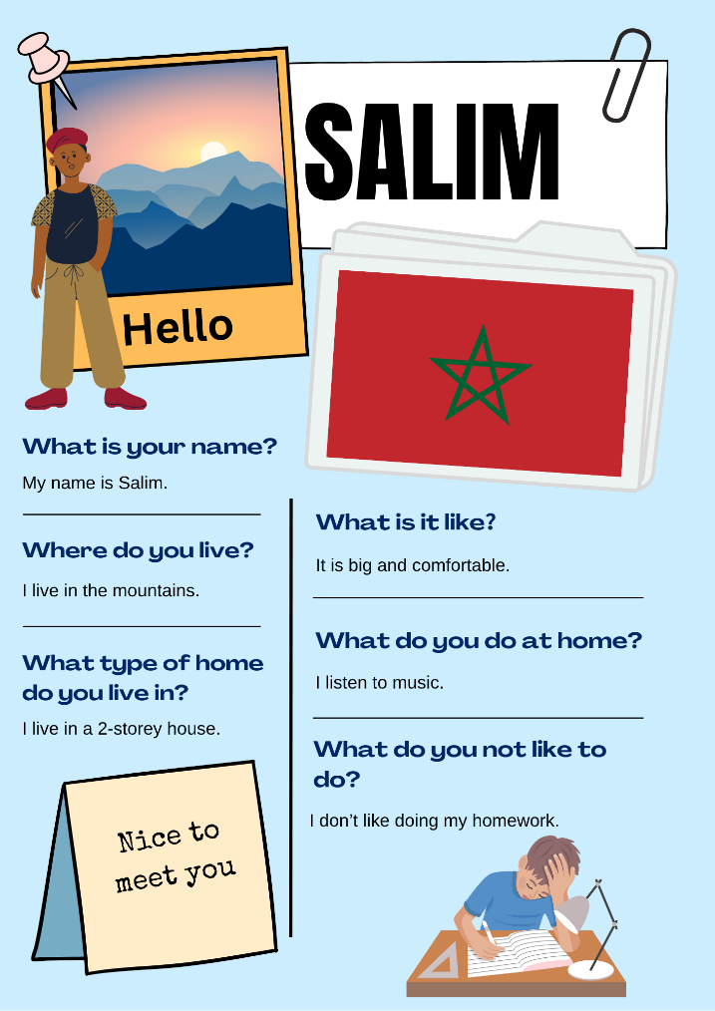
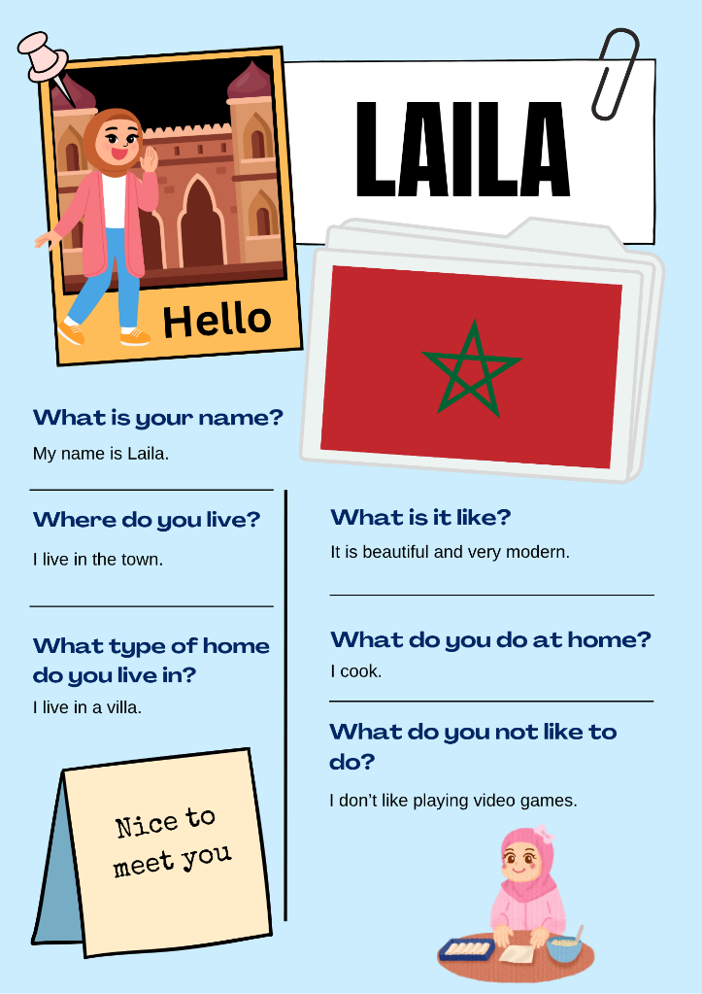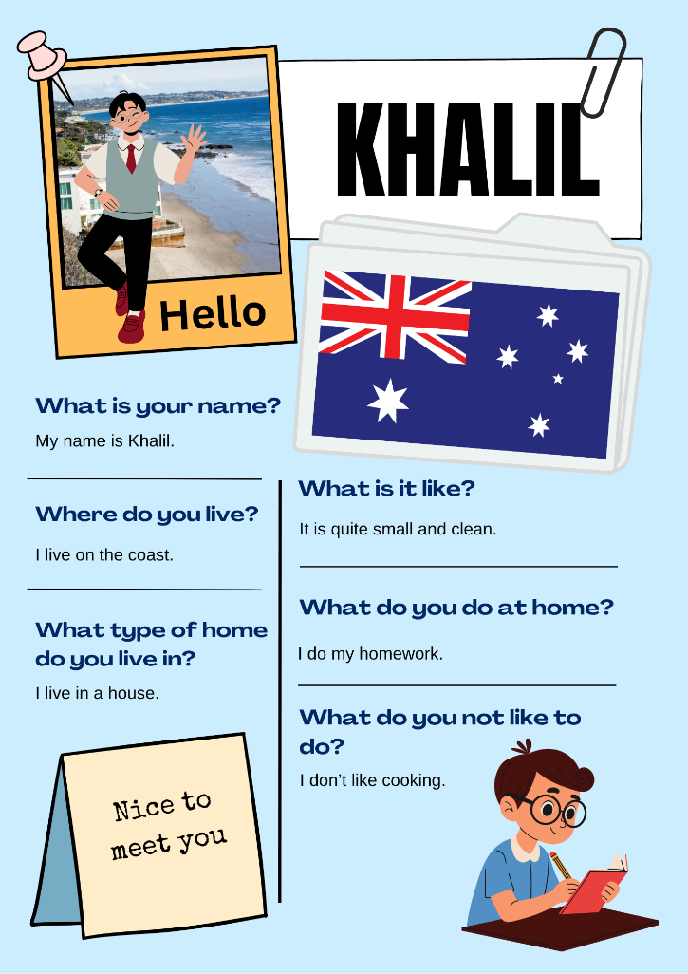
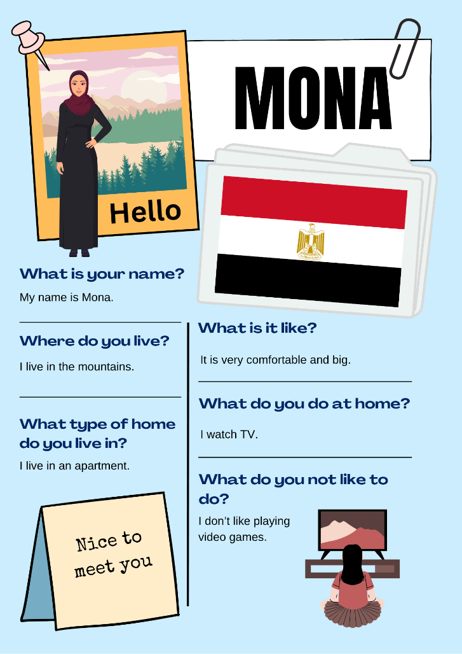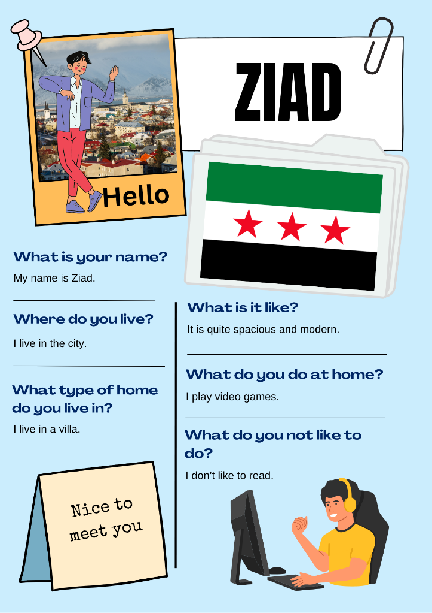
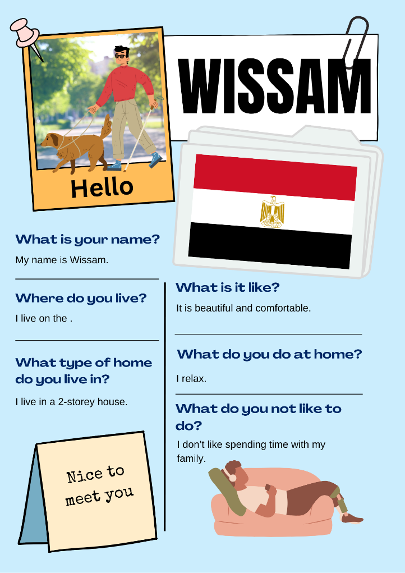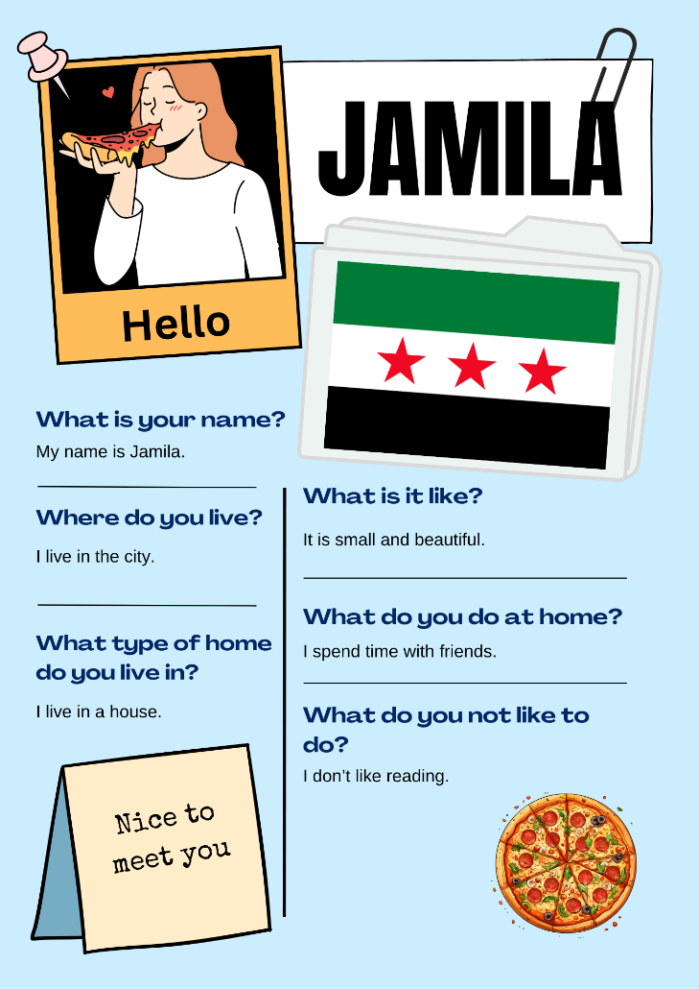
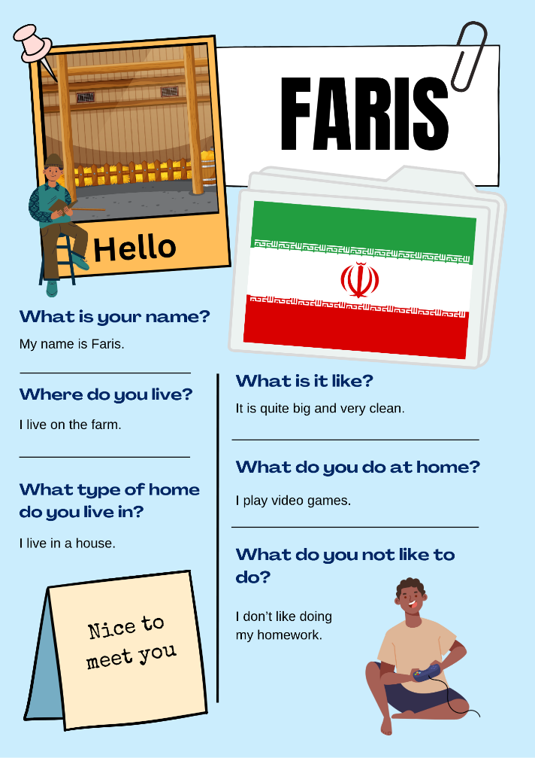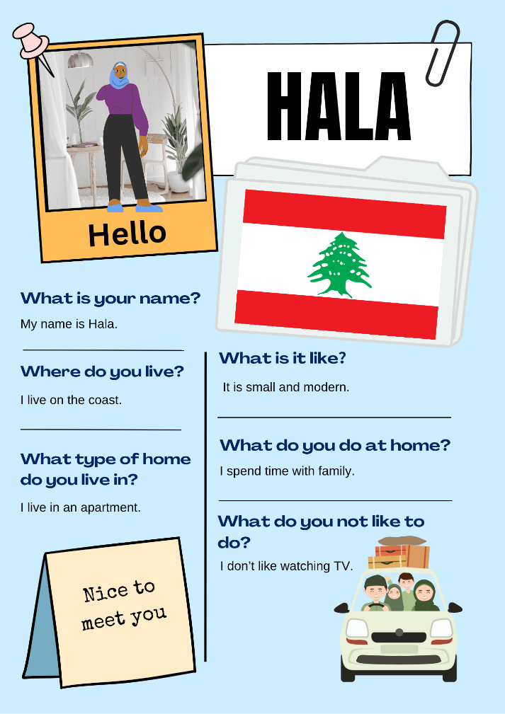
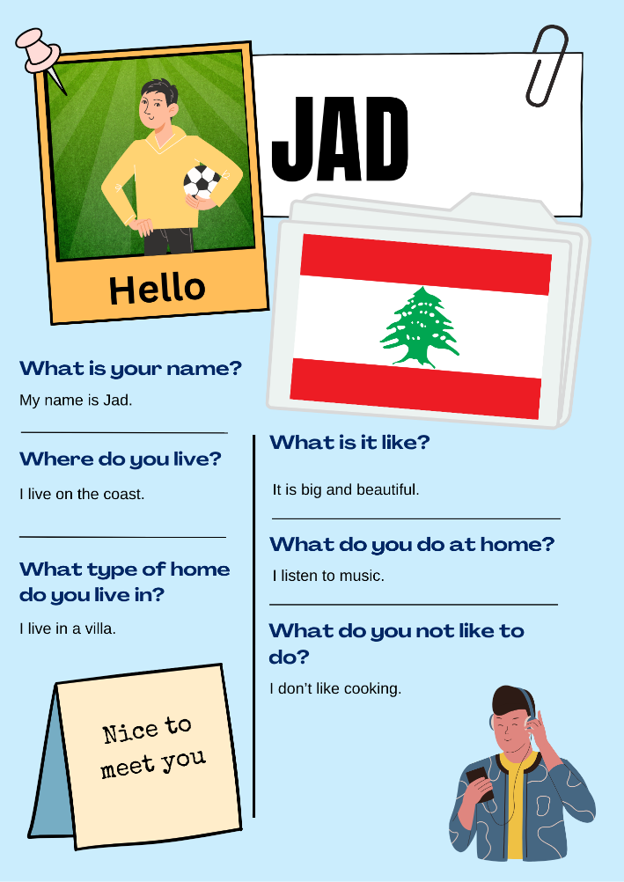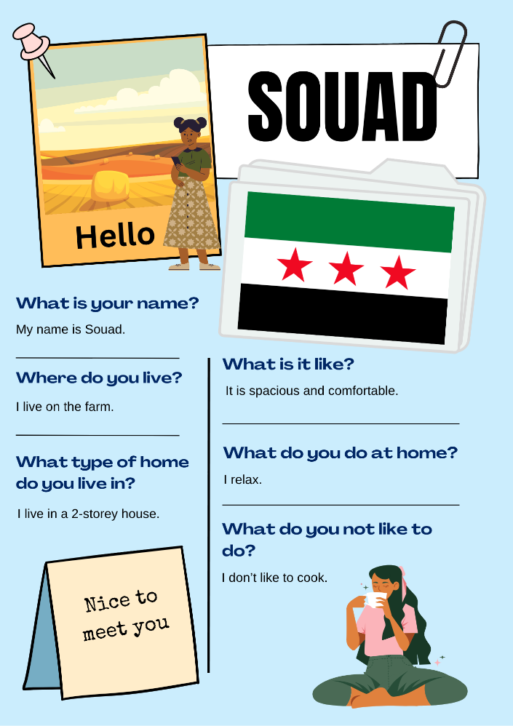

Profile cards in Arabic
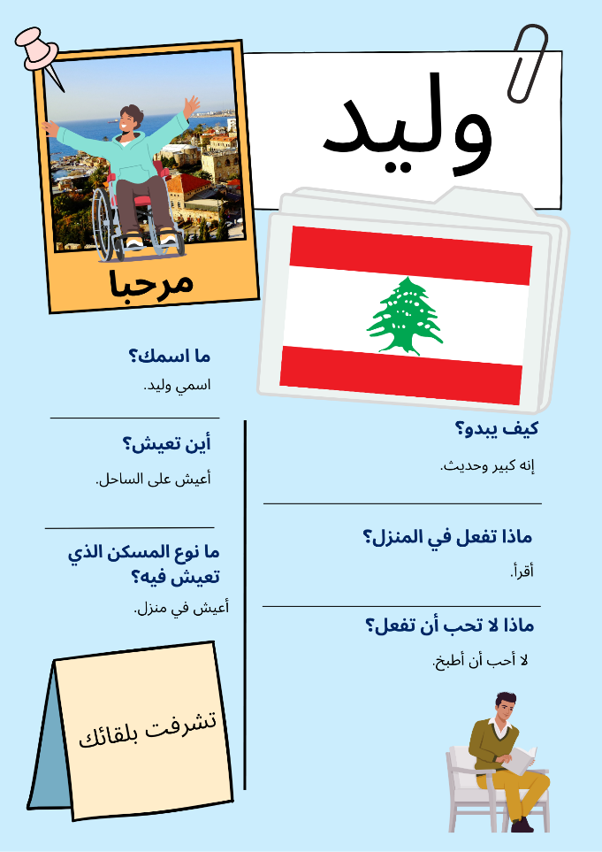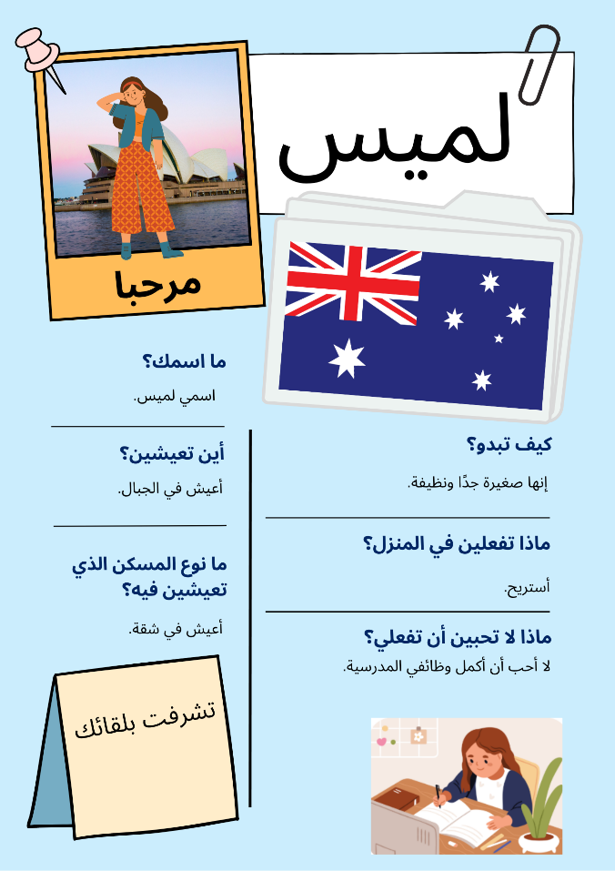
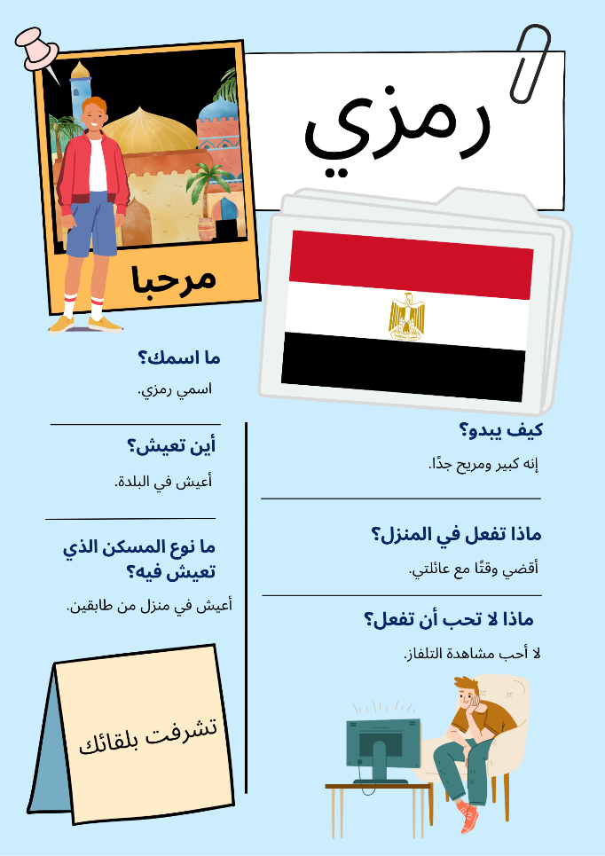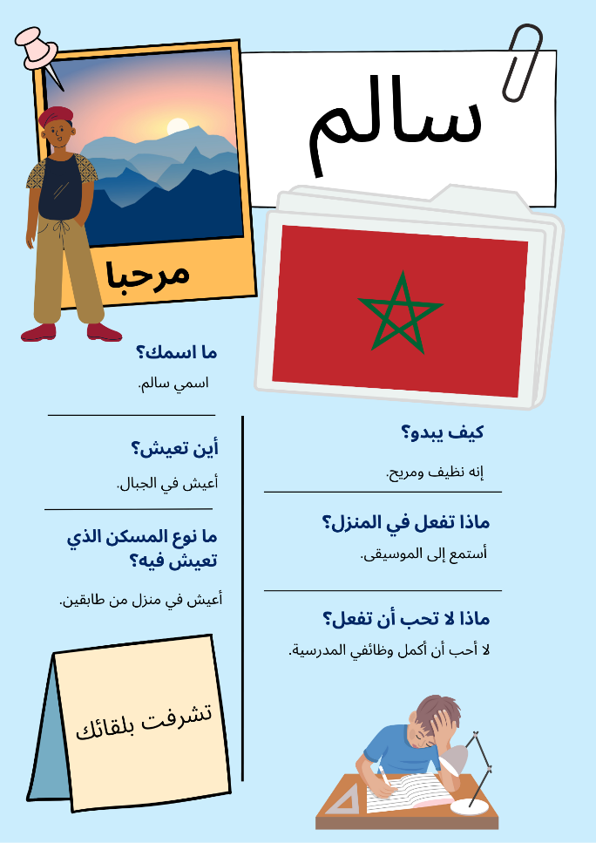
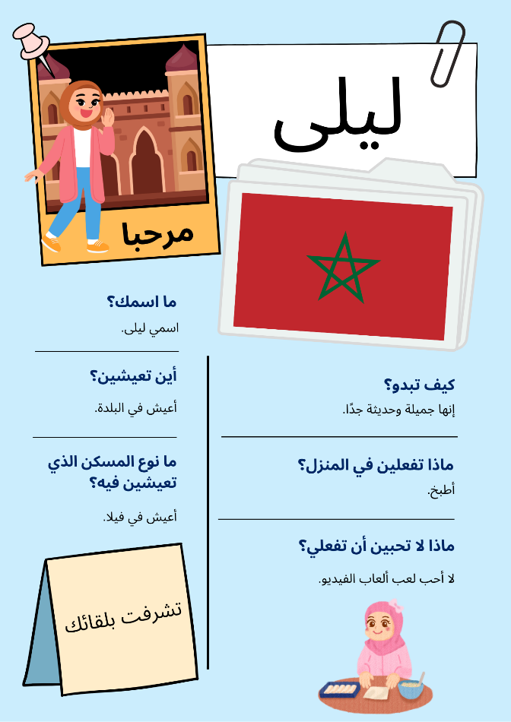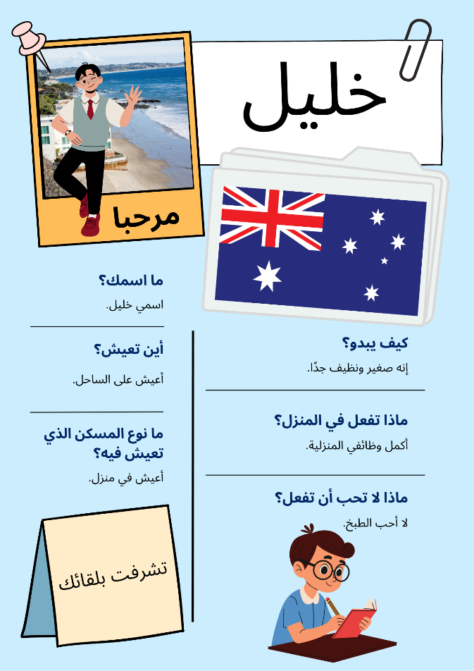
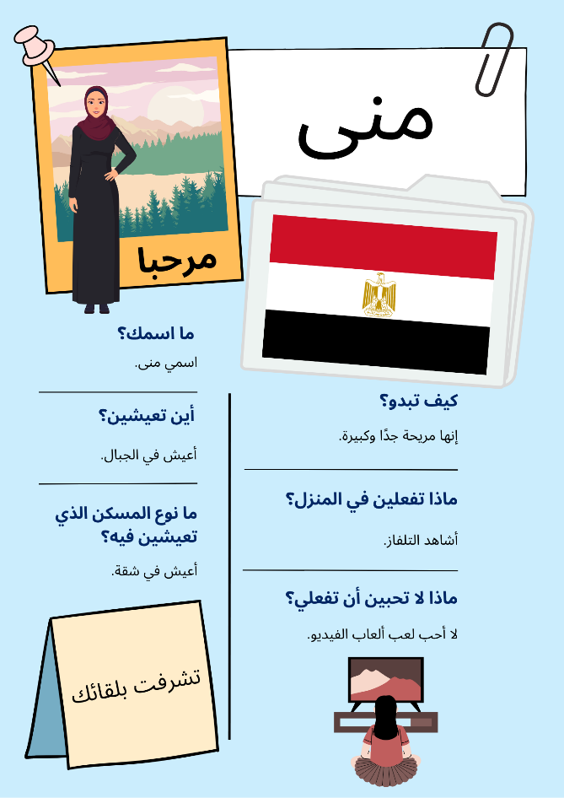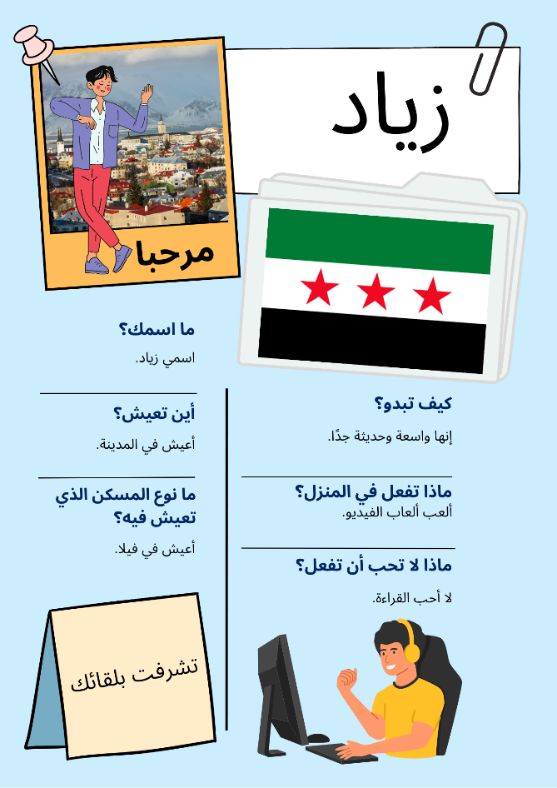
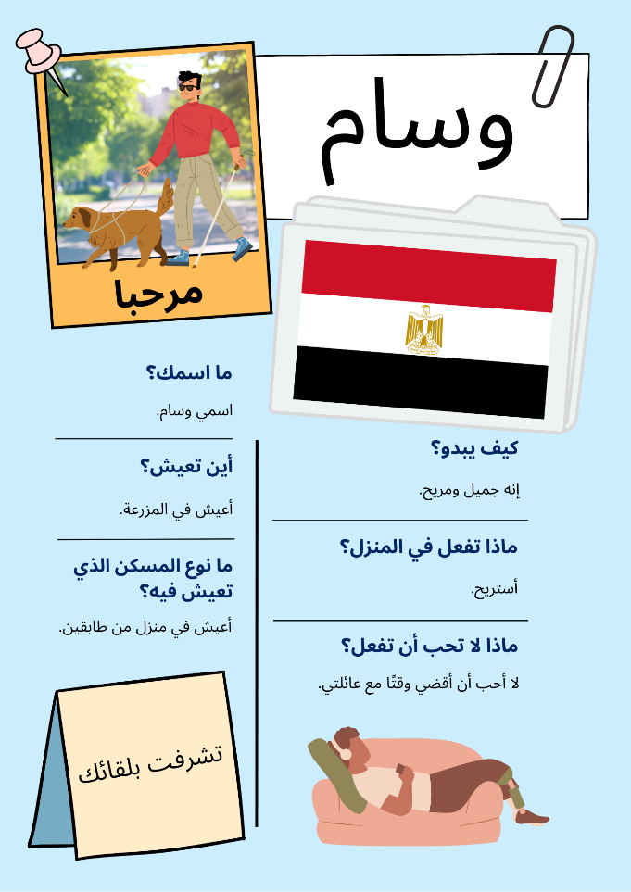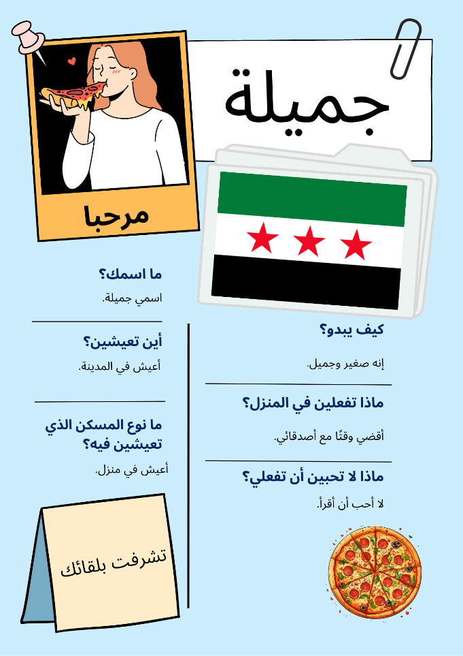
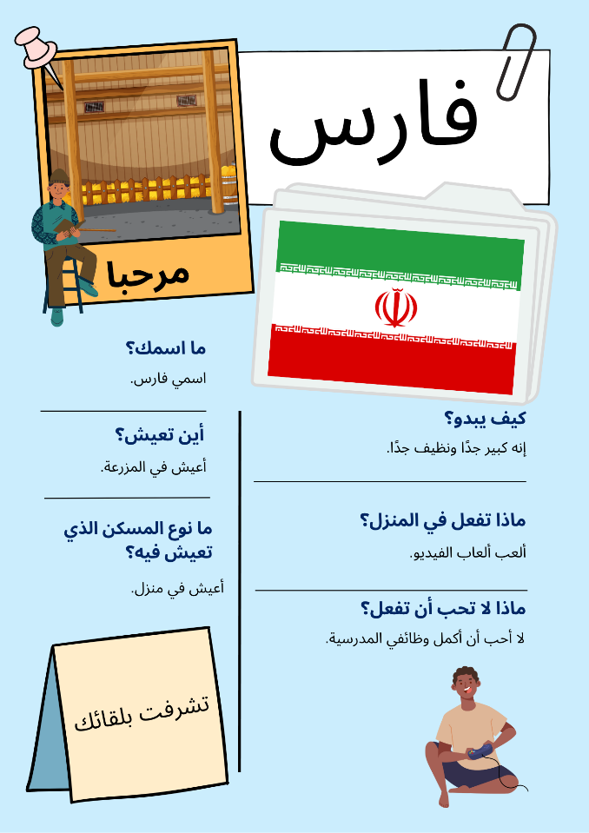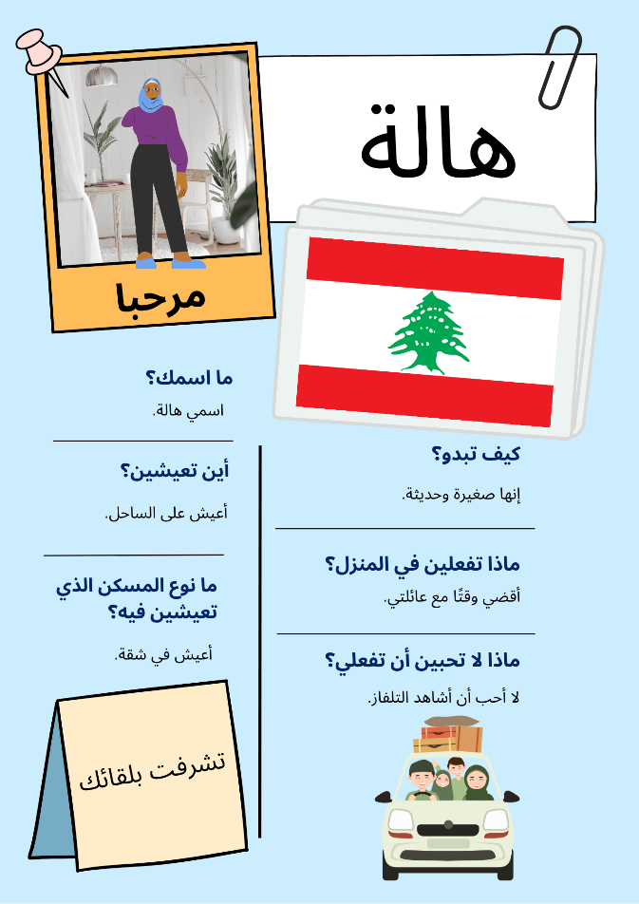
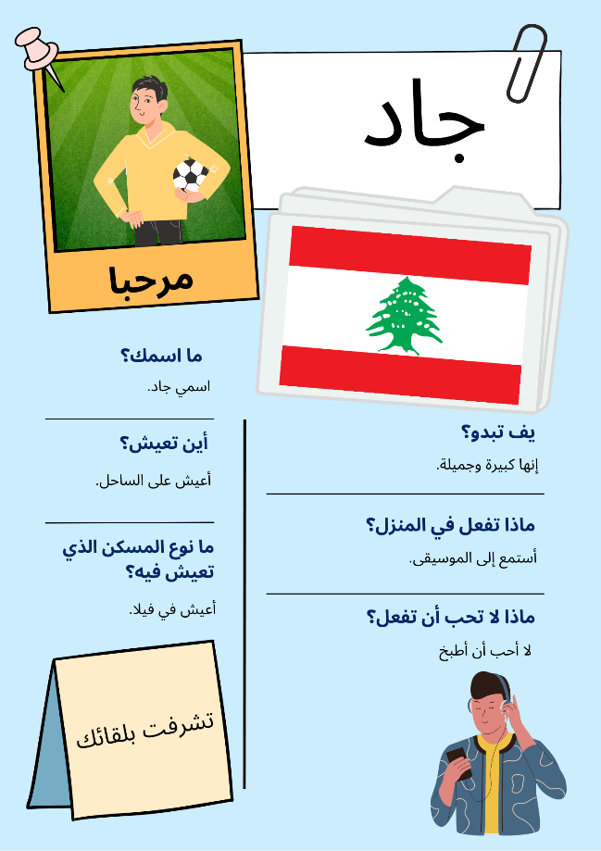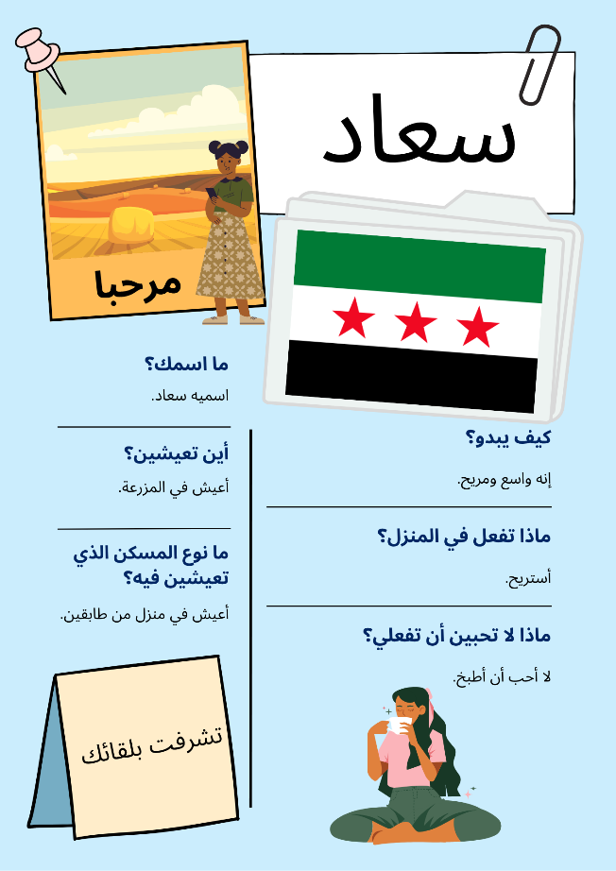

© State of New South Wales (Department of Education), 2025
The copyright material published in this resource is subject to the Copyright Act 1968 (Cth) and is owned by the NSW Department of Education or, where indicated, by a party other than the NSW Department of Education (third-party material).
Copyright material available in this resource and owned by the NSW Department of Education is licensed under a Creative Commons Attribution 4.0 International (CC BY 4.0) license.

This license allows you to share and adapt the material for any purpose, even commercially.
Attribution should be given to © State of New South Wales (Department of Education), 2025.
Material in this resource not available under a Creative Commons license:
- the NSW Department of Education logo, other logos and trademark-protected material
- material owned by a third party that has been reproduced with permission. You will need to obtain permission from the third party to reuse its material.
Links to third-party material and websites
Please note that the provided (reading/viewing material/list/links/texts) are a suggestion only and implies no endorsement, by the New South Wales Department of Education, of any author, publisher, or book title. School principals and teachers are best placed to assess the suitability of resources that would complement the curriculum and reflect the needs and interests of their students.
If you use the links provided in this document to access a third-party's website, you acknowledge that the terms of use, including licence terms set out on the third-party's website apply to the use which may be made of the materials on that third-party website or where permitted by the Copyright Act 1968 (Cth). The department accepts no responsibility for content on third-party websites.

