What do you do at home?

Activity 1
Listen to the rooms or features of the house. Write each one in Arabic and then write the English translation in the table below. The first one has been done for you as an example.
Number | Room or feature in Arabic | English translation
 | الفناء | the courtyard

Activity 2
For each question, select the activity and the room or feature of the house you hear. Next, write the complete sentence in Arabic in the space provided in the table below. The first one has been done for you as an example.
Number | Activity | Room | Arabic sentence
 | ☒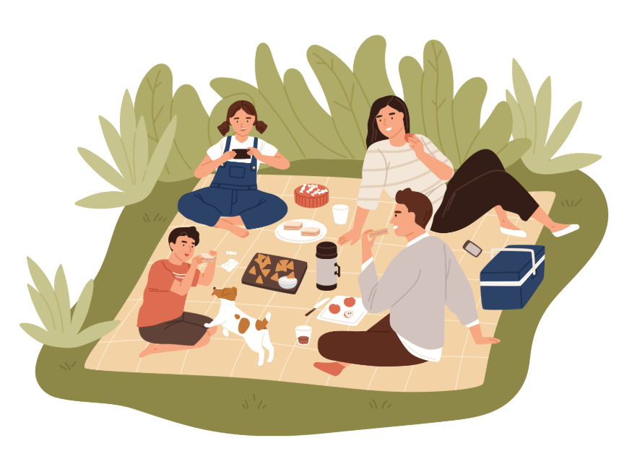  ☐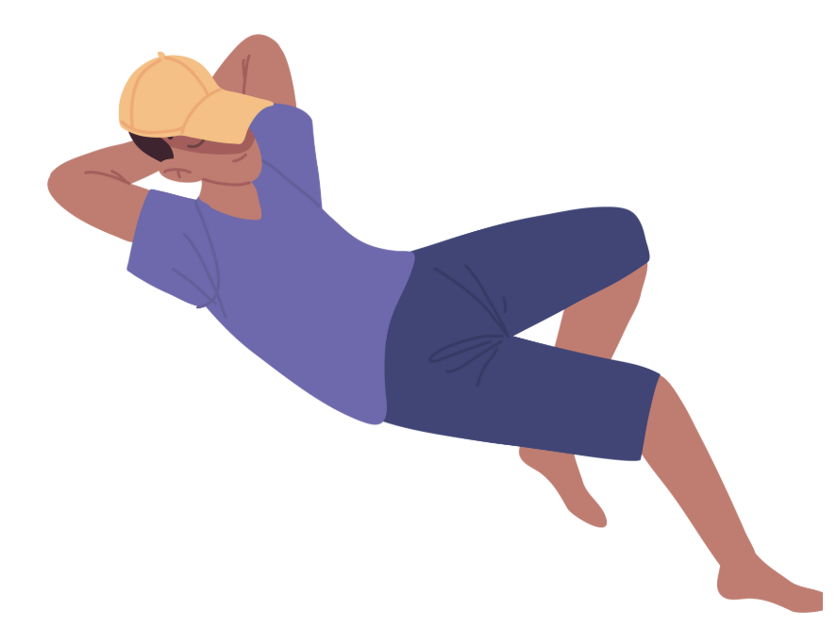 | ☐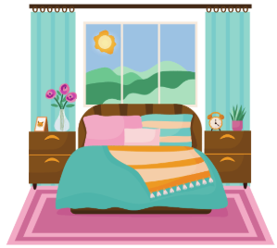  ☒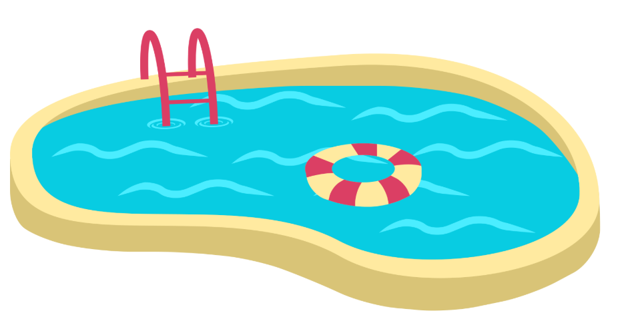 | .أقضي وقتًا مع عائلتي في بركة السباحة
 | ☐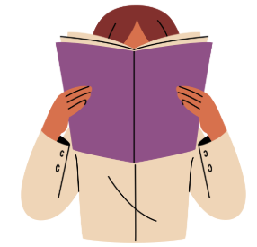  ☐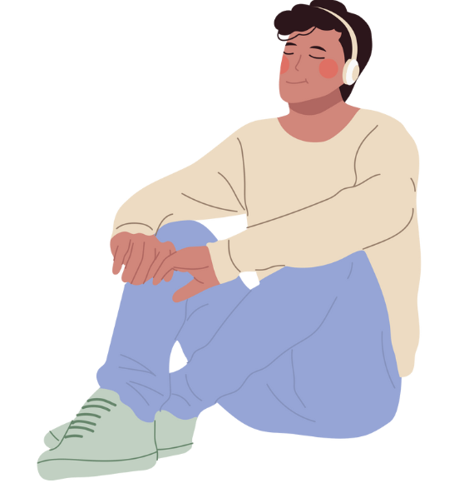 | ☐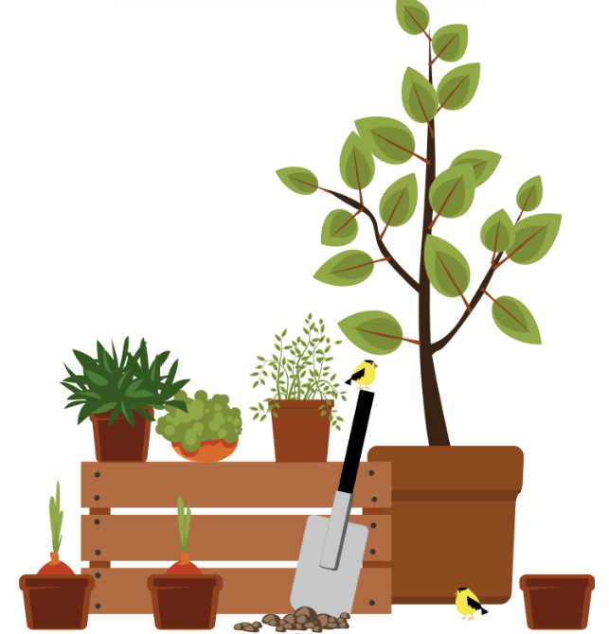  ☐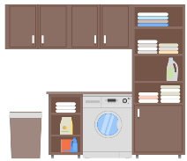
 | ☐  ☐ | ☐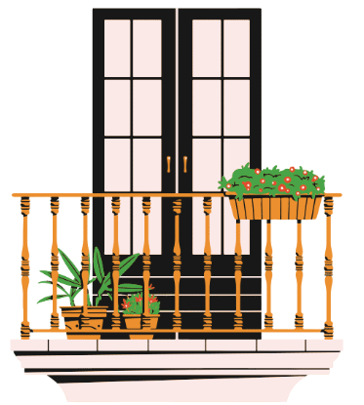  ☐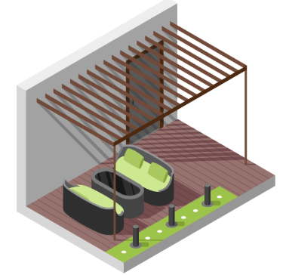
 | ☐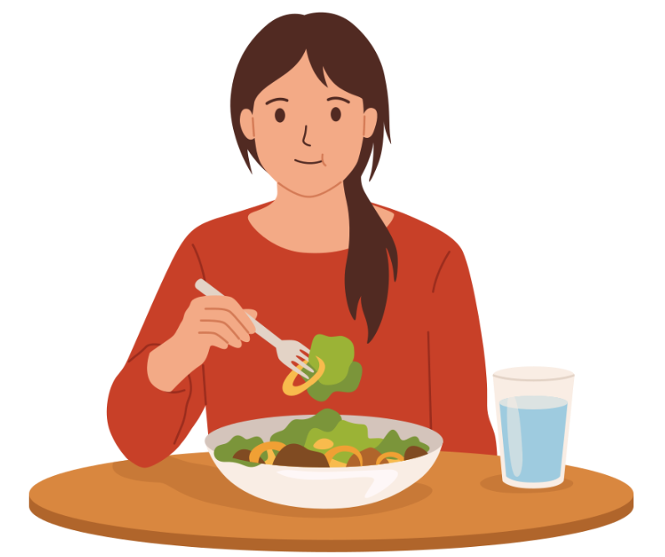  ☐ | ☐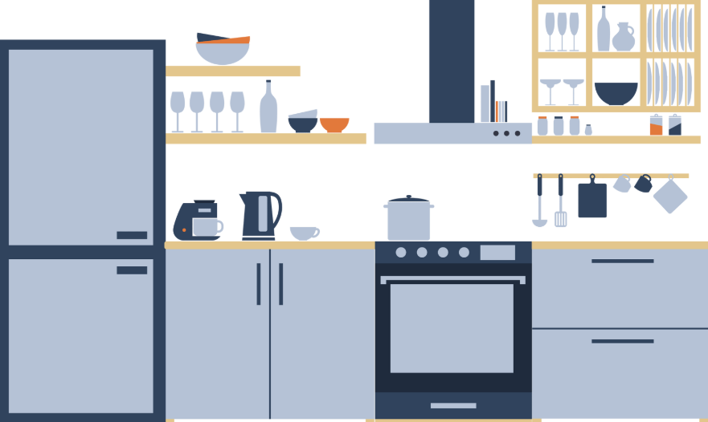  ☐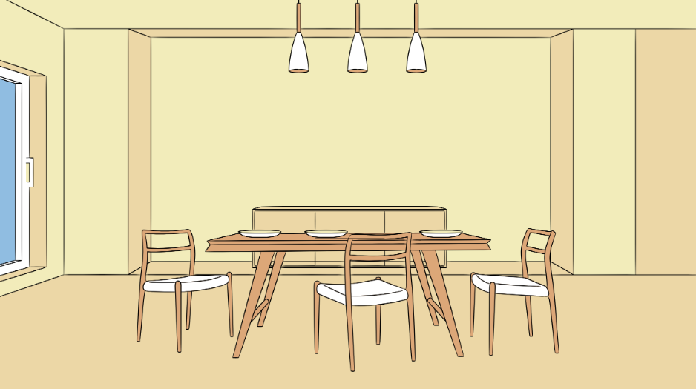
 | ☐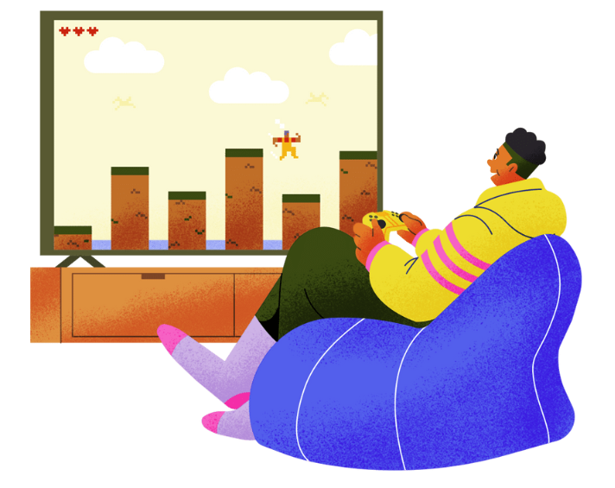  ☐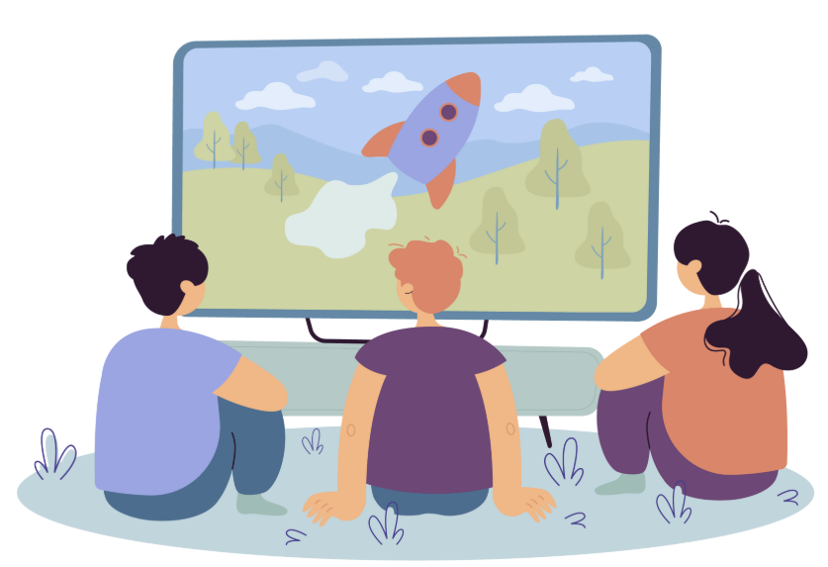 | ☐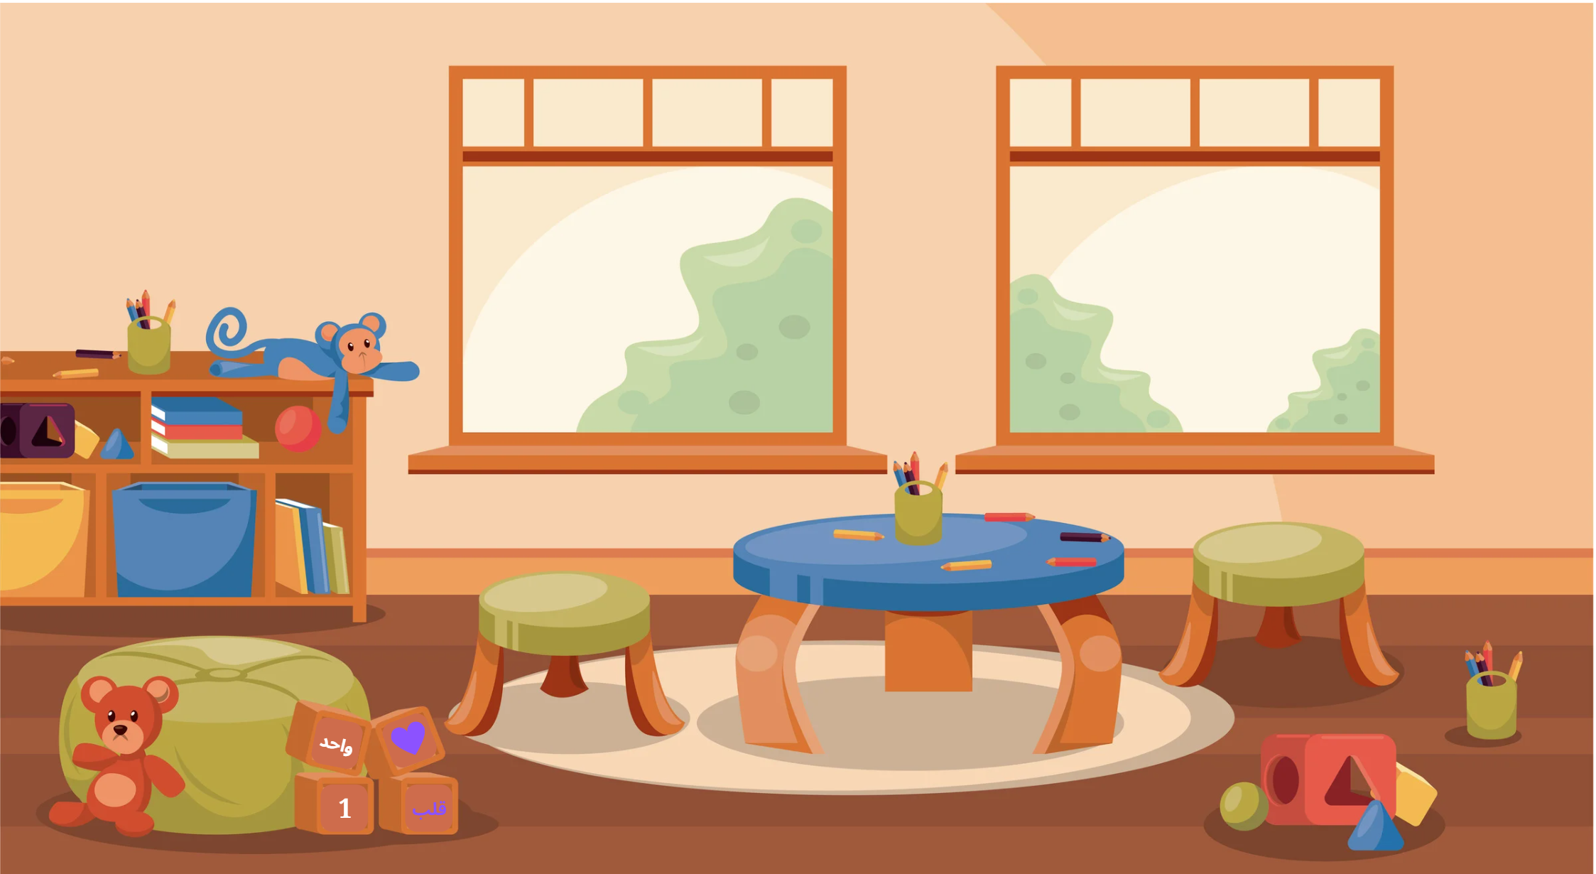  ☐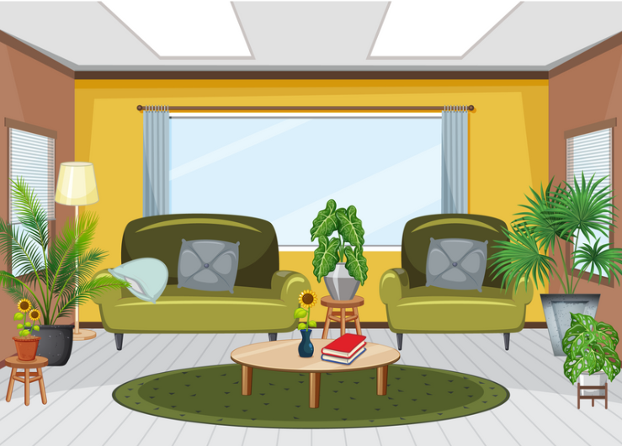
 | ☐  ☐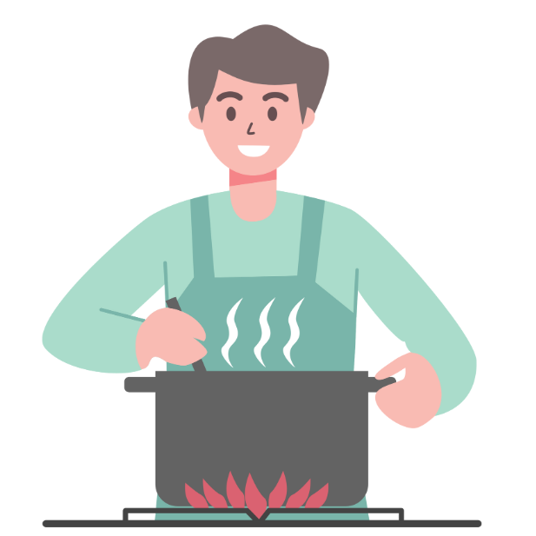 | ☐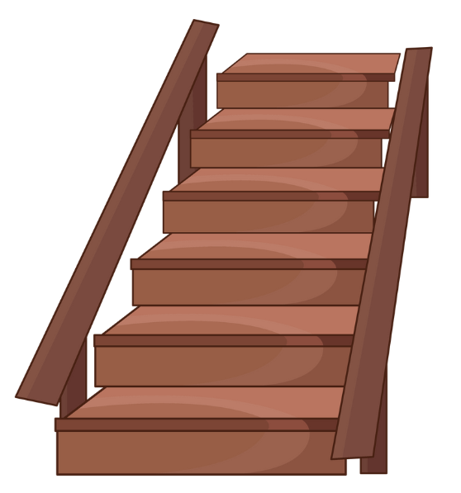  ☐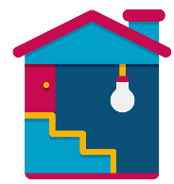

Activity 3
Listen to each statement. If the statement you hear matches the text, tick صحيح (‘true’). If not, tick خطأ (‘false’) and write the correct statement in Arabic in the space provided in the table below. The first one has been done for you as an example.
Number | Statement | صحيح | خطأ | Corrected sentence (if required)
 | .ألعب ألعاب الفيديو في المطبخ |  | ✔️ | .أطبخ في المطبخ
 | .أقرأ في الصالون
 | .أستمع إلى الموسيقى في الحديقة
 | .أقوم بعملي المنزلي في غرفة الغسيل
 | .أقرأ في القبو

Activity 4
Use the prompts provided to create sentences about activities you do in different rooms of the house. Write your sentences in the table below. The first one has been done for you as an example.
 | Prompts | Sentence in Arabic
 | 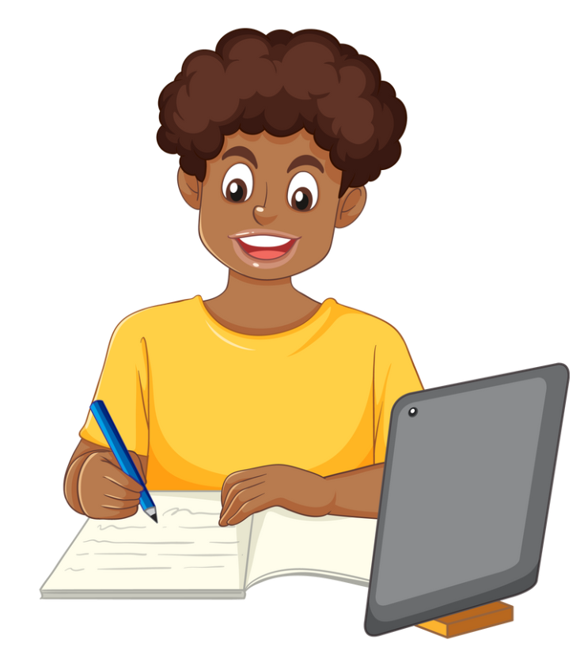 | .أقوم بعملي المنزلي في غرفة اللعب
 | 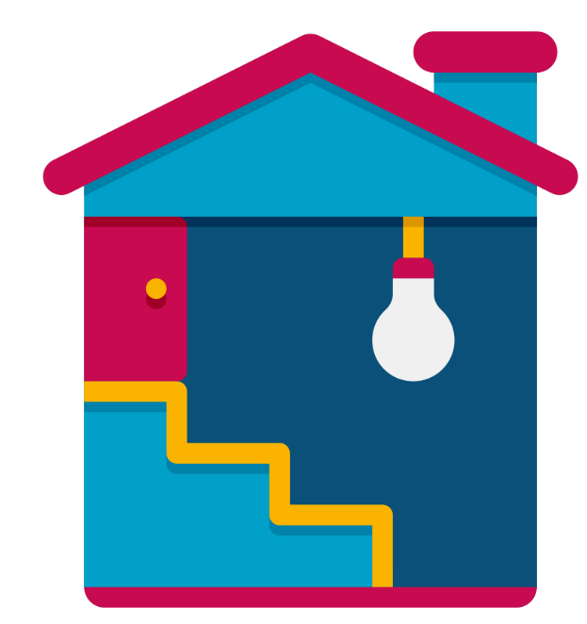

Activity 5
Write 5 sentences describing what activities you do and in which room of the house.

Activity 6
Ask 5 people about what activities they do using the correct form of the question ماذا تفعلين في المنزل؟ (f) or ماذا تفعل في المنزل؟ (m) and complete the table below. For each response include the student’s name, the room and the activity.
Number | Name | Activity | Room

For the teacher
Remove this section before sharing this resource with students.

Activity 1

Audio file
Activity 1 audio (2:33)

Answers
Number | Room or feature in Arabic | English translation
 | الفناء | The courtyard
 | المشربية | The lattice window
 | غرفة النوم | The bedroom
 | المطبخ | The kitchen
 | غرفة الألعاب | The playroom
 | المكتب | The office
 | الحديقة | The garden
 | السلّم | The stairs
 | الحمّام | The bathroom
 | الكراج | The garage

Activity 2

Audio file
Activity 2 audio (1:59)
Number | Activity | Room | Arabic
 | ☒  ☐ | ☐  ☒ | .أقضي وقتًا مع عائلتي في بركة السباحة
 | ☐  ☒ | ☒  ☐ | .أستمع إلى الموسيقى في الحديقة
 | ☐  ☒ | ☐  ☒ | .أقضي وقتًا مع عائلتي في الفناء
 | ☒  ☐ | ☐  ☒ | .أتناول العشاء في غرفة الطعام
 | ☒  ☐ | ☒  ☐ | .ألعب ألعاب الفيديو في غرفة الألعاب
 | ☒  ☐ | ☐  ☒ | .أشاهد التلفاز في القبو

Activity 3

Audio file
Activity 3 audio (1:24)
Number | Statement | صحيح | خطأ | Transcript
 | ألعب ألعاب الفيديو في المطبخ |  | ✔️ | .أطبخ في المطبخ
 | .أقرأ في الصالون | ✔️ |  | .أقرأ في الصالون
 | .أستمع إلى الموسيقى في الحديقة | ✔️ |  | .أستمع إلى الموسيقى في الحديقة
 | .أقوم بعملي المنزلي في غرفة الغسيل |  | ✔️ | .أقوم بعملي المنزلي في المطبخ
 | .أقرأ في القبو |  | ✔️ | .أسترخي في القبو

Activity 4
 Differentiation example
Students requiring additional support – provide students with the Arabic sentences and remove the prompting images from the table. Ask students to translate the sentences into English.
Number | Prompts | Sentence in Arabic
 |  | .أقوم بعملي المنزلي في غرفة اللعب
 |  | .أقضي وقتًا مع عائلتي في الحديقة
 |  | .أشاهد التلفاز في الصالون
 |  | .أستمع إلى الموسيقى في القبو
 |  | .أسترخي في الفناء
 |  | .أطبخ في المطبخ

Activity 5 and Activity 6
Student responses will vary.
Differentiation example
Students with advanced proficiency – students can formulate sentences using the third person structures to ‘report back’ on the information they have gathered.

© State of New South Wales (Department of Education), 2025
The copyright material published in this resource is subject to the Copyright Act 1968 (Cth) and is owned by the NSW Department of Education or, where indicated, by a party other than the NSW Department of Education (third-party material).
Copyright material available in this resource and owned by the NSW Department of Education is licensed under a Creative Commons Attribution 4.0 International (CC BY 4.0) license.

This license allows you to share and adapt the material for any purpose, even commercially.
Attribution should be given to © State of New South Wales (Department of Education), 2025.
Material in this resource not available under a Creative Commons license:
- the NSW Department of Education logo, other logos and trademark-protected material
- material owned by a third party that has been reproduced with permission. You will need to obtain permission from the third party to reuse its material.
Links to third-party material and websites
Please note that the provided (reading/viewing material/list/links/texts) are a suggestion only and implies no endorsement, by the New South Wales Department of Education, of any author, publisher, or book title. School principals and teachers are best placed to assess the suitability of resources that would complement the curriculum and reflect the needs and interests of their students.
If you use the links provided in this document to access a third-party's website, you acknowledge that the terms of use, including licence terms set out on the third-party's website apply to the use which may be made of the materials on that third-party website or where permitted by the Copyright Act 1968 (Cth). The department accepts no responsibility for content on third-party websites.

