Interacting cards – rooms of the house
This resource is for the teacher. It provides the content and instructions you need to share with students.

Instructions

Activity 1
Print the cards on 2 different paper colours so students can distinguish the masculine and feminine vocabulary without seeing the image.
Students work in pairs or groups of 3 for this activity. Students place the pile of cards face down on the desk.
Determine who will go first with a game of مقص، ورقة، حجر (‘Scissors, paper, rock’)
Student A draws a card from the pile and looks at the image without showing their partner.
Student B asks the question ما هو؟ or ما هي؟ depending on the colour of the card.
Student A responds by identifying the room on the card, for example, إنه المطبخ or إنها الحديقة.
If the response is correct, Student A keeps the card. If they are not able to describe the room or their answer is incorrect, the card goes to the bottom of the pile.
After a pre-determined time has passed, using the Rocket Countdown Timer online tool, Student A counts how many cards they have accumulated.
Repeat the activity with the roles reversed.

Activity 2
Introduce students to the question كيف يبدو؟ (masculine) and كيف تبدو؟ (feminine) (‘What is it like?’)
Practise correct pronunciation of the questions until students are confident to use them independently.
Add the adjective cards from resource 9. Adjective cards to create a second pile of cards.
Model the additional steps of the interaction to students.
Once the card has been correctly identified by Student A, Student B asks the correct form of the question كيف يبدو؟ and كيف تبدو؟. Student A draws a card from the adjectives pile and responds using the prompt on the card, for example, إنها جميلة or إنه صغير.

Activity 3 – writing practice
As an additional activity, students must write 5 sentences each to describe the cards they have drawn and write them in the table provided. Print the table on page 8, and provide to students, when ready.

Room cards (masculine)
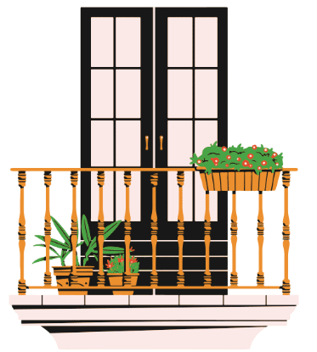 | 
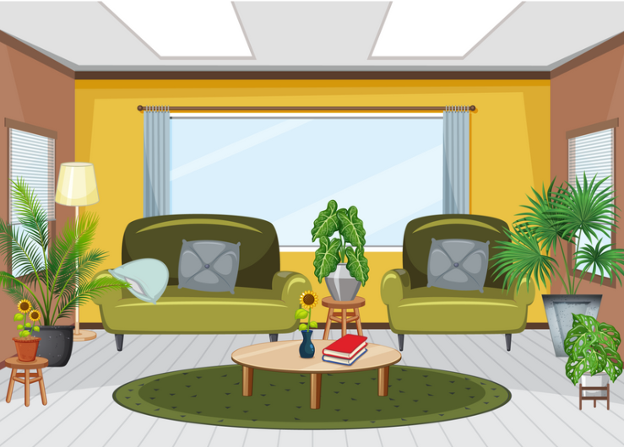 | 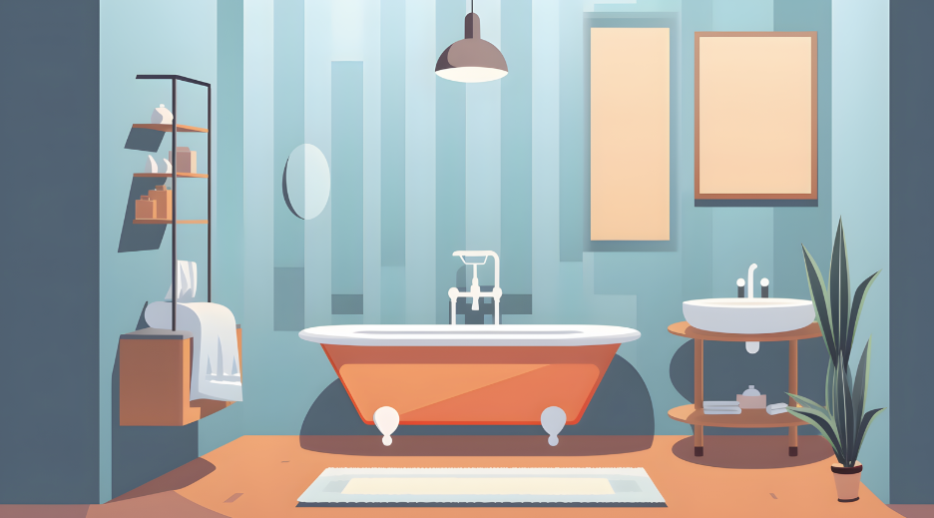
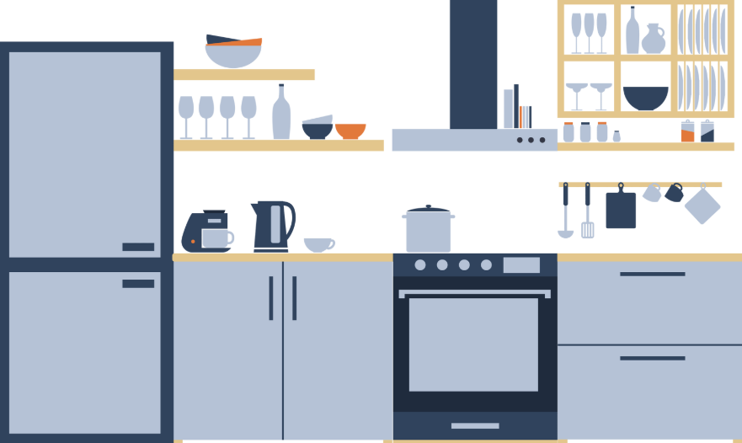 | 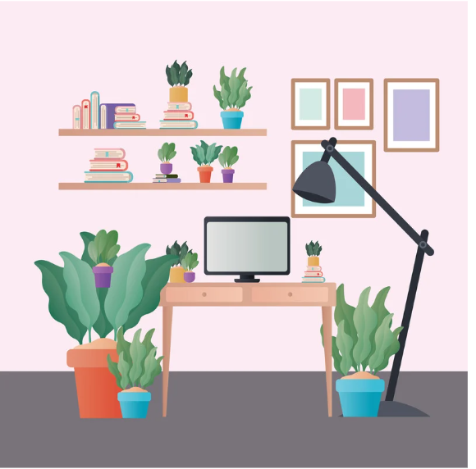
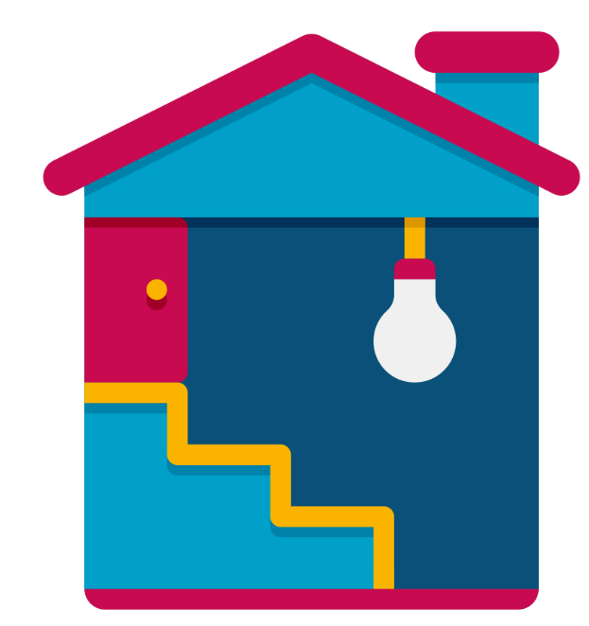 | 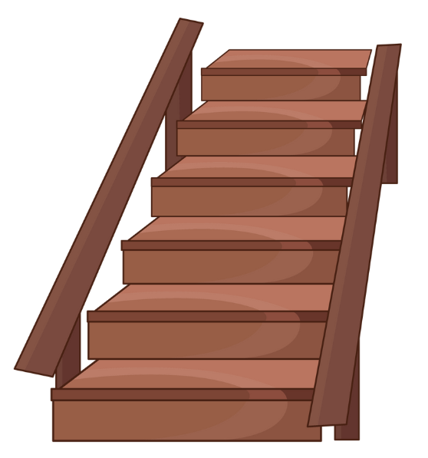

Room cards (masculine) – with Arabic
الشرفة | الكراج
الصالون | الحمام
المطبخ | المكتب
القبو | السلّم

Room cards (feminine)
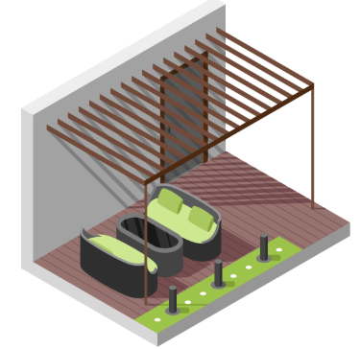 | 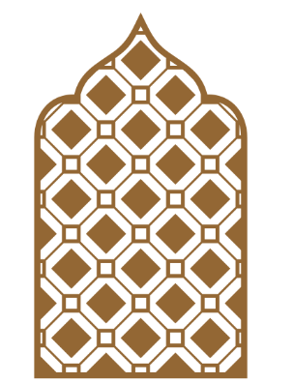
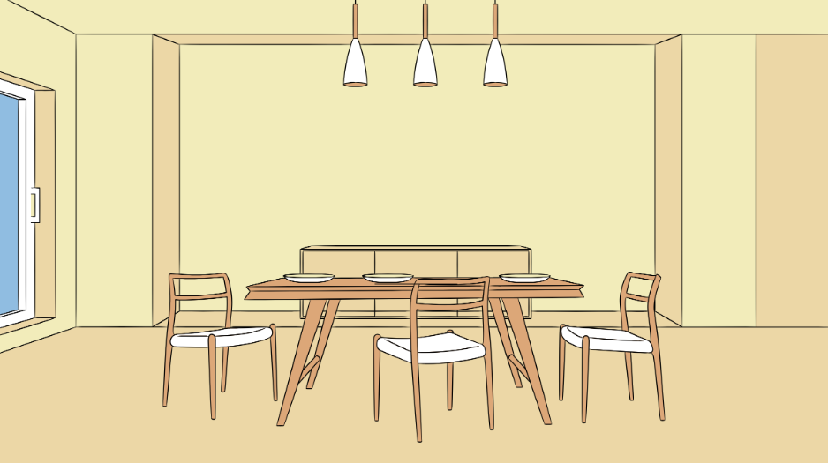 | 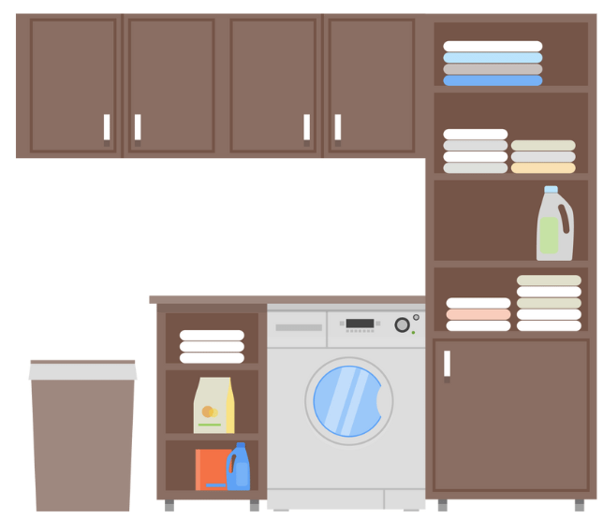
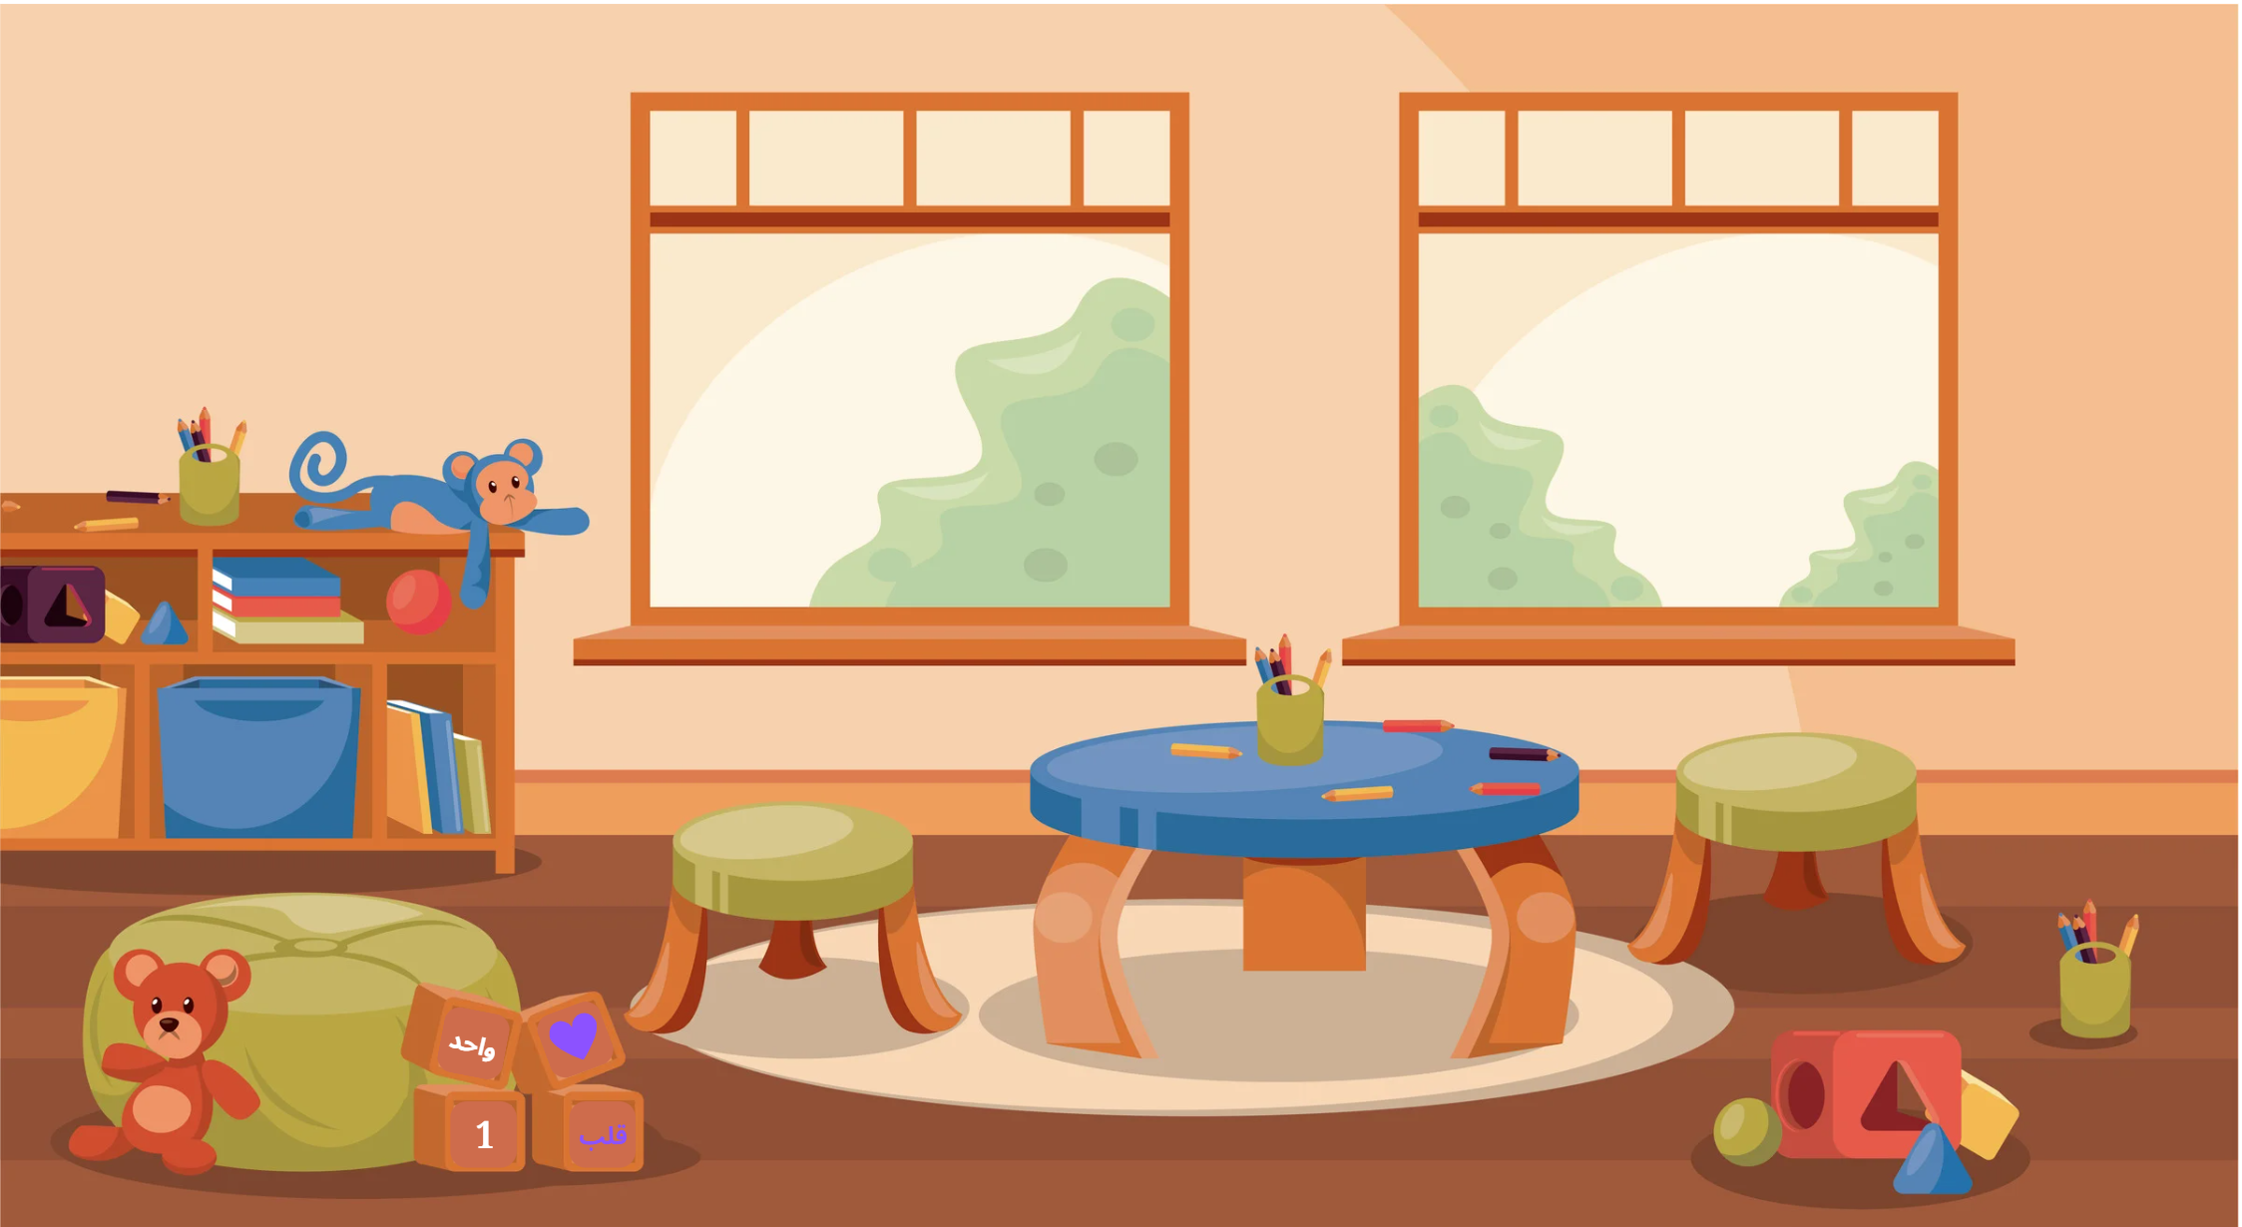 | 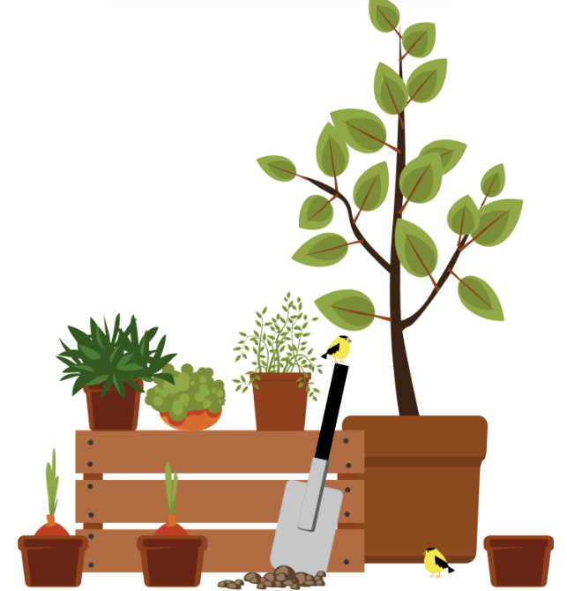
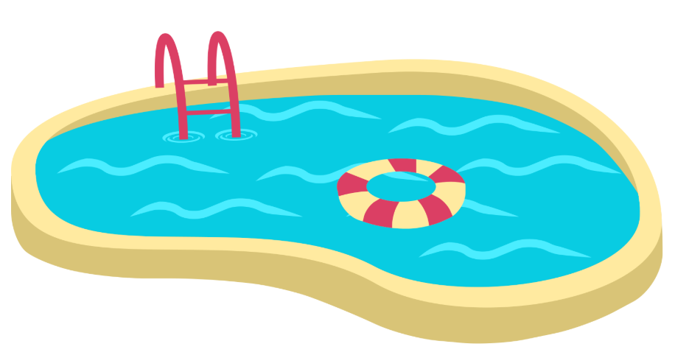 | 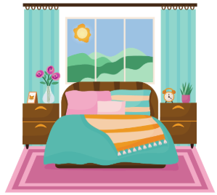

Room cards (feminine) – with Arabic
الفناء | المشربية
غرفة الطعام | غرفة الغسيل
غرفة الألعاب | الحديقة
المسبح | غرفة النوم

 Differentiation examples
The following strategies provide a starting point for how you can differentiate this activity for a range of learners. Adapt or design alternatives, to meet the needs of students in your class.
Students with advanced proficiency – students can formulate a complete sentence from the adjectives and adverbs given to describe each room, including the appropriate form of ‘it is’.
High potential and gifted students – partner students with similar ability. Provide the pair with the resource without colour coded paper. Student B must guess by gender of their partner’s word and use the appropriate question form. If they are wrong, Student A keeps the card and chooses another one. If Student B uses the correct question form for the image on the card, Student A must respond to the question using the correct form of ‘it is’ in their answer. They show the card to Student B to confirm that their answer is correct. If so, they keep the card. If not, Student B keeps the card. Students tally their results and repeat the activity with the roles reversed.
Students requiring additional support – provide students with the Arabic included on the prompt cards and write the questions in their masculine and feminine forms, colour-coded, on a mini whiteboard prior to the activity.

Activity 3 – writing practice
Provide students with the table on the following page to record their responses.

Writing practice (student copy)
Complete the table below using the cards you have drawn. The first one has been provided as an example.
Number | ما هي؟ (f) or ما هو؟ (m) | كيف تبدو؟ (f) or كيف يبدو؟ (m) | Description
 |  | 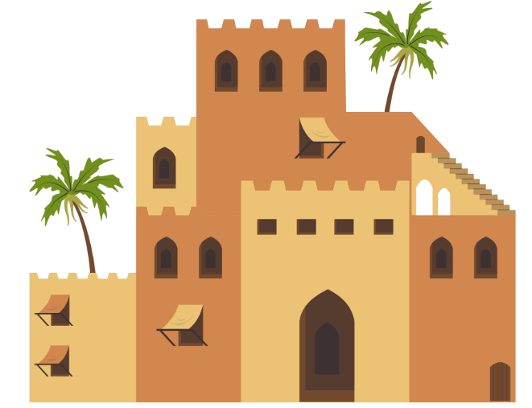 | إنها الحديقة.  إنها كبيرة
.

© State of New South Wales (Department of Education), 2025
The copyright material published in this resource is subject to the Copyright Act 1968 (Cth) and is owned by the NSW Department of Education or, where indicated, by a party other than the NSW Department of Education (third-party material).
Copyright material available in this resource and owned by the NSW Department of Education is licensed under a Creative Commons Attribution 4.0 International (CC BY 4.0) license.

This license allows you to share and adapt the material for any purpose, even commercially.
Attribution should be given to © State of New South Wales (Department of Education), 2025.
Material in this resource not available under a Creative Commons license:
- the NSW Department of Education logo, other logos and trademark-protected material
- material owned by a third party that has been reproduced with permission. You will need to obtain permission from the third party to reuse its material.
Links to third-party material and websites
Please note that the provided (reading/viewing material/list/links/texts) are a suggestion only and implies no endorsement, by the New South Wales Department of Education, of any author, publisher, or book title. School principals and teachers are best placed to assess the suitability of resources that would complement the curriculum and reflect the needs and interests of their students.
If you use the links provided in this document to access a third-party's website, you acknowledge that the terms of use, including licence terms set out on the third-party's website apply to the use which may be made of the materials on that third-party website or where permitted by the Copyright Act 1968 (Cth). The department accepts no responsibility for content on third-party websites.

