Adjective and adverb activities

Activity 1 – listen and write
You will hear 10 questions in Arabic.
For each question, write the adjective and adverb you hear in the second column of the table below. Don’t forget to include ة if the adjective used is its feminine form. In the third column, indicate whether the adjective you heard is masculine or feminine by ticking the box. Then write the translation of the phrase in the last column.
Each question will be read twice. The first one has been done for you as an example.
Number | Adverb and adjective in Arabic | Masculine or feminine | Translation
 | صغير إلى حد ما | ☒ Masculine  ☐ Feminine | quite small
☐ Masculine
☐ Feminine
☐ Masculine
☐ Feminine
☐ Masculine
☐ Feminine
☐ Masculine
☐ Feminine
☐ Masculine
☐ Feminine
☐ Masculine
☐ Feminine
☐ Masculine
☐ Feminine
☐ Masculine
☐ Feminine
☐ Masculine
☐ Feminine

Activity 2 – writing practice
Write sentences using the prompts provided in the table below. The first one has been done for you as an example.
Home | Location | Description | Arabic
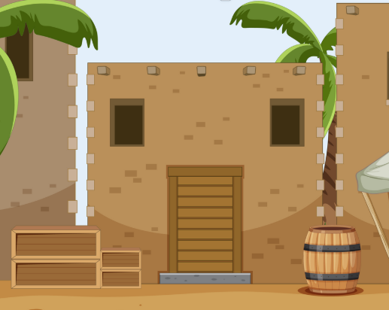 | 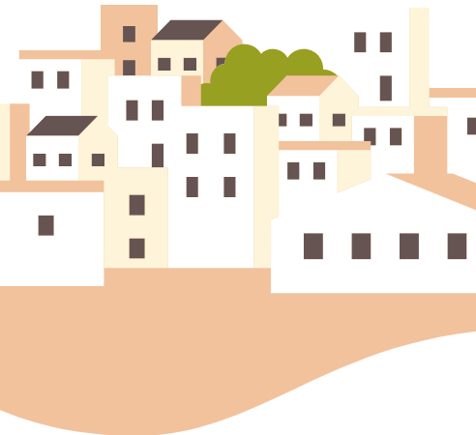 | quite small and very clean | أعيش في بيت في البلدة.  إنه صغير إلى حد ما ونظيف جداً
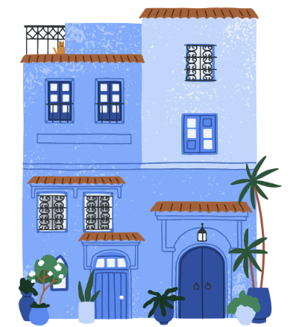 |  | too modern but very beautiful
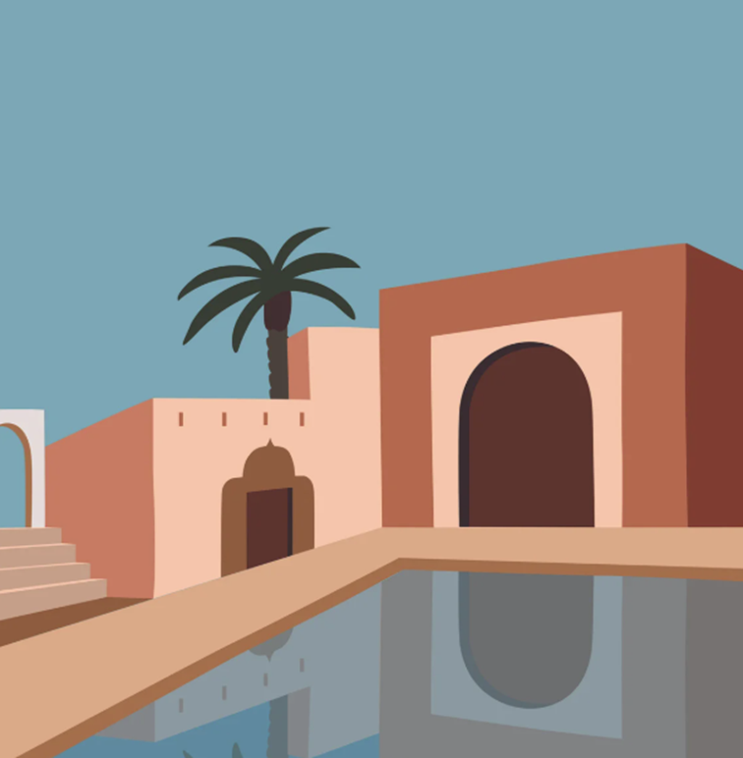 | 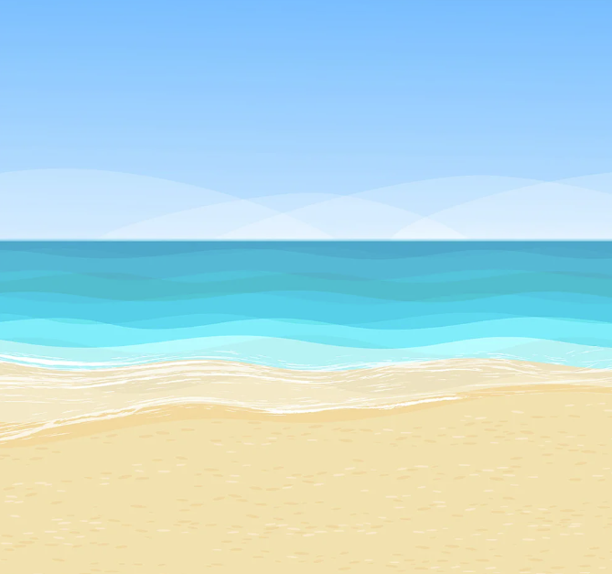 | very spacious and clean
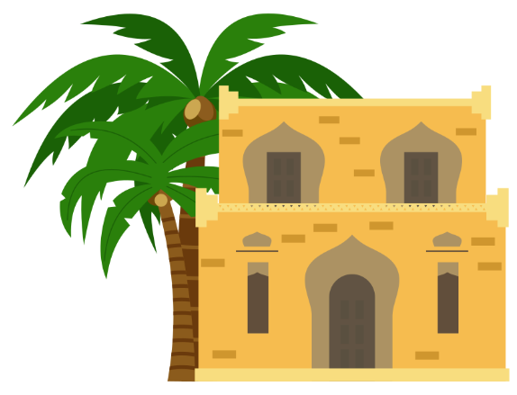 | 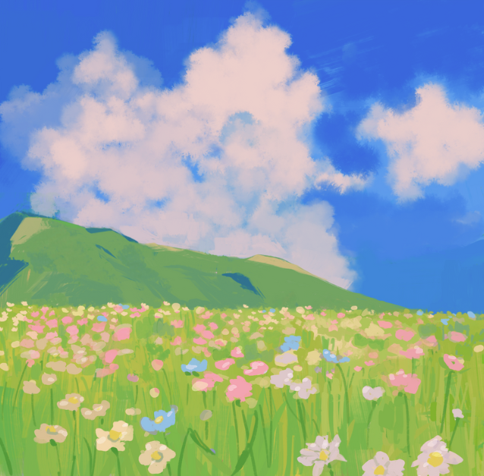 | quite comfortable and very big
 |  | too small but very comfortable

Activity 3 – Where do you live?
Write a sentence to describe where you live. Follow the structure from the previous activity to help you if required. Begin with هذا هو المكان الذي أعيش فيه

Activity 4 – information gap student A
Work with a partner to complete the missing information in the table below. If the question number has an ‘A’ next to it, you need to ask your partner a question to find the missing information for that row in your table. Use the questions provided at the top of each column as prompts. Remember to use the appropriate masculine or feminine form for each question depending on who you are working with.
Number | أين تعيشين؟ (f)  أين تعيش؟ (m) | ما نوع المسكن الذي تعيشين فيه؟ (f)  ما نوع المسكن الذي تعيش فيه؟ (m) | كيف هو منزلكِ؟ (f)  كيف هو منزلك؟ (m)
- A | 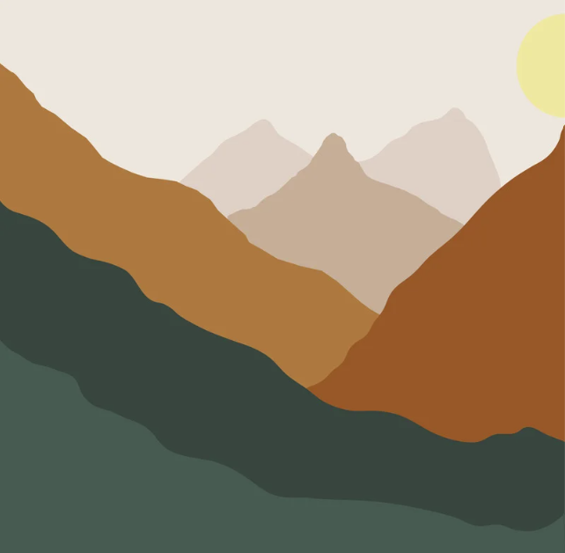 |  | quite small, clean
- B | 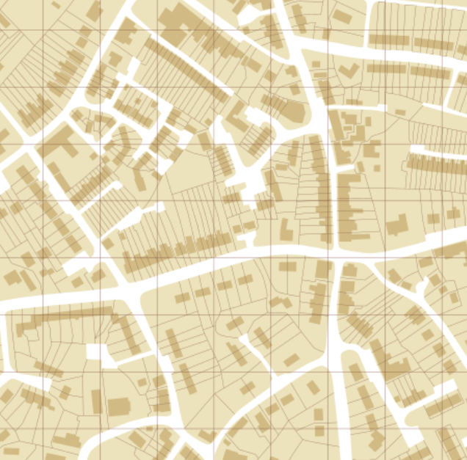 |  | very big, comfortable
- A |  |  | too modern, big
- B |  |  | quite beautiful, comfortable
- A
- B |  |  | too small, modern
- A
- B | 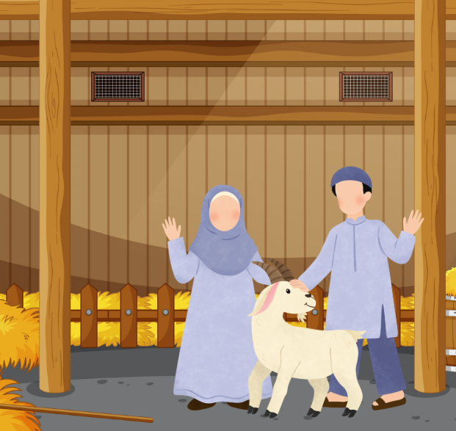 |  | too big, beautiful
- A
- B |  |  | quite comfortable

Activity 4 – information gap student B
Work with a partner to take turns to complete the missing information in the table below. If the question number has an ‘A’ next to it, you need to ask your partner a question to find the missing information for that row in your table. Use the questions provided at the top of each column as prompts. Remember to use the appropriate masculine or feminine form for each question depending on who you are working with.
Number | أين تعيشين؟ (f)  أين تعيش؟ (m) | ما نوع المسكن الذي تعيشين فيه؟ (f)  ما نوع المسكن الذي تعيش فيه؟ (m) | كيف هو منزلكِ؟ (f)  كيف هو منزلك؟ (m)
- A |  |  | quite small, clean
- B |  |  | very big, comfortable
- A |  |  | too modern, big
- B |  |  | quite beautiful, comfortable
- A |  |  | very small, clean
- B
- A |  |  | quite modern, spacious
- B
- A |  |  | very beautiful, clean
- B

For the teacher
Remove this section before sharing this resource with students.

Activity 1

Audio file
Activity 1 audio (2:57)

Answers
Number | Adverb and adjective in Arabic | Masculine or feminine | Translation
 | صغير إلى حد ما | ☒Masculine  ☐Feminine | quite small
 | واسع جدًا | ☒Masculine  ☐Feminine | very spacious
 | نظيفة إلى حد ما | ☐Masculine  ☒Feminine | quite clean
 | حديثة أكثر من اللازم | ☐Masculine  ☒Feminine | too modern
 | صغير جدًا | ☒Masculine  ☐Feminine | very small
 | كبيرة أكثر من اللازم | ☐Masculine  ☒Feminine | too big
 | جميلة جدًا | ☐Masculine  ☒Feminine | very beautiful
 | نظيف جدًا | ☒Masculine  ☐Feminine | very clean
 | واسعة جدًا | ☐Masculine  ☒Feminine | very spacious
 | مريح إلى حد ما | ☒Masculine  ☐Feminine | quite comfortable
 Differentiation examples
The following strategies provide a starting point for how you can differentiate this activity for a range of learners. Adapt or design alternatives, to meet the needs of students in your class.
Students with advanced proficiency – provide students with the resource prior to playing the audio file so that they have to write the phrase in Arabic independently. They can use the audio to confirm their responses.
High potential and gifted students – students can formulate a complete sentence from the adjectives and adverbs given to describe a house, an apartment or a villa using correct sentence structure, including the correct form of ‘it is’.
Students requiring additional support – provide students with the Arabic and English translations of each phrase. Students match the translations and then determine whether the phrase is masculine or feminine.

Activity 2

Answers
Home | Location | Description | Arabic
 |  | quite small and very clean | أعيش في بيت في بلدة.  إنه صغير إلى حد ما ونظيف جداً
 |  | too modern but very beautiful | أعيش في شقة في المدينة  إنها حديثة أكثر من اللازملكنها جميلة جداً
 |  | very spacious and clean | أعيش في فيلا على الساحل  إنها واسعة جداً ونظيفة جداً
 |  | quite comfortable and very big | أعيش في بيت مكون من طابقين في الريف  إنه مريح إلى حد ما وكبير جداً
 |  | too small but very comfortable | أعيش في بيت في الريف  إنه صغير أكثر من اللازم لكنه مريح جداً

Activity 3
Student responses will vary.

Activity 4
For this activity, students work in pairs, with Student A and Student B. Make sure you only give Student A a copy of the Student A activity, and Student B a copy of the Student B activity.
Before beginning the activity, indicate to students whether they should add the answers from their partner to the table in English or Arabic.

© State of New South Wales (Department of Education), 2025
The copyright material published in this resource is subject to the Copyright Act 1968 (Cth) and is owned by the NSW Department of Education or, where indicated, by a party other than the NSW Department of Education (third-party material).
Copyright material available in this resource and owned by the NSW Department of Education is licensed under a Creative Commons Attribution 4.0 International (CC BY 4.0) license.

This license allows you to share and adapt the material for any purpose, even commercially.
Attribution should be given to © State of New South Wales (Department of Education), 2025.
Material in this resource not available under a Creative Commons license:
- the NSW Department of Education logo, other logos and trademark-protected material
- material owned by a third party that has been reproduced with permission. You will need to obtain permission from the third party to reuse its material.
Links to third-party material and websites
Please note that the provided (reading/viewing material/list/links/texts) are a suggestion only and implies no endorsement, by the New South Wales Department of Education, of any author, publisher, or book title. School principals and teachers are best placed to assess the suitability of resources that would complement the curriculum and reflect the needs and interests of their students.
If you use the links provided in this document to access a third-party's website, you acknowledge that the terms of use, including licence terms set out on the third-party's website apply to the use which may be made of the materials on that third-party website or where permitted by the Copyright Act 1968 (Cth). The department accepts no responsibility for content on third-party websites.

