Mini task – progress checkpoint 1
Your school is preparing to welcome a study group from Lebanon. The students have provided your school with brief profiles about themselves. Families at your school have completed similar profiles in English. You have been given the task of matching the visitors with the appropriate ‘buddy’ family. Read the visitors’ profiles and match them with the most appropriate ‘buddy’ family from the English-language profiles. For each match you must provide 2 reasons, in English, to justify your choice.

Visiting student profiles
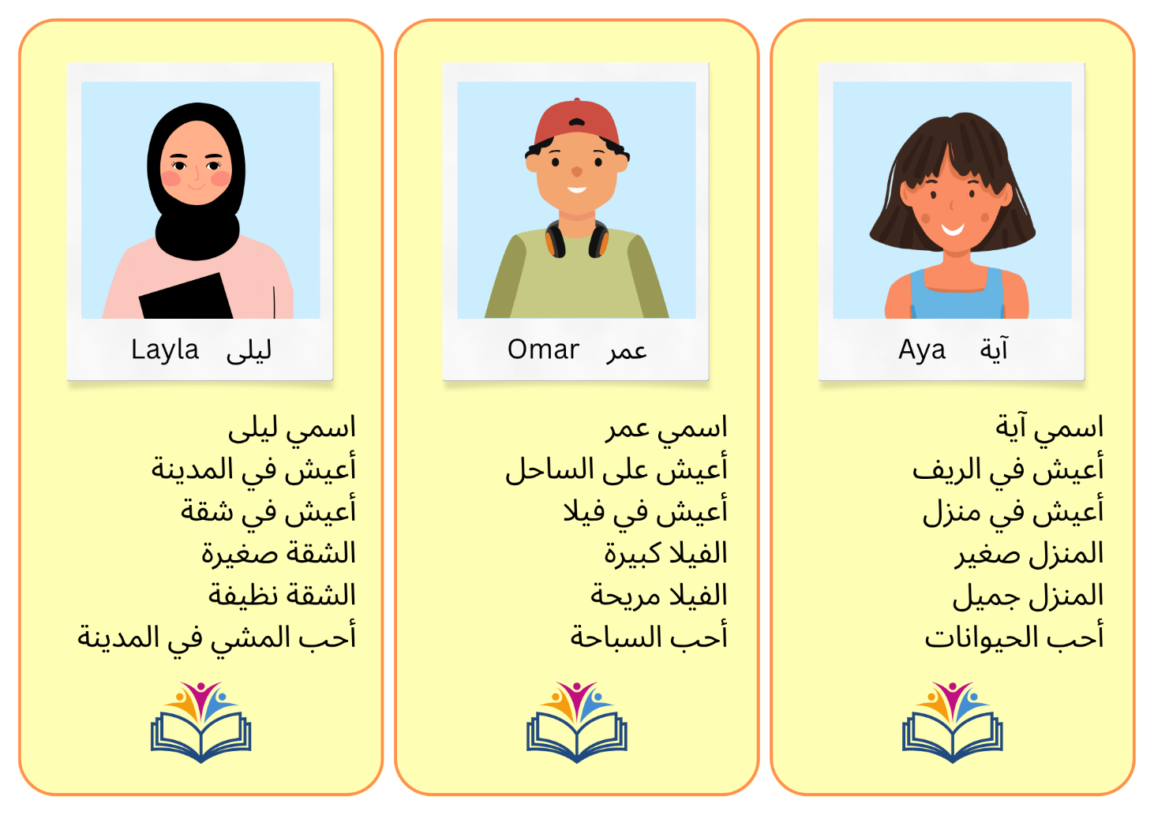

Buddy family profiles
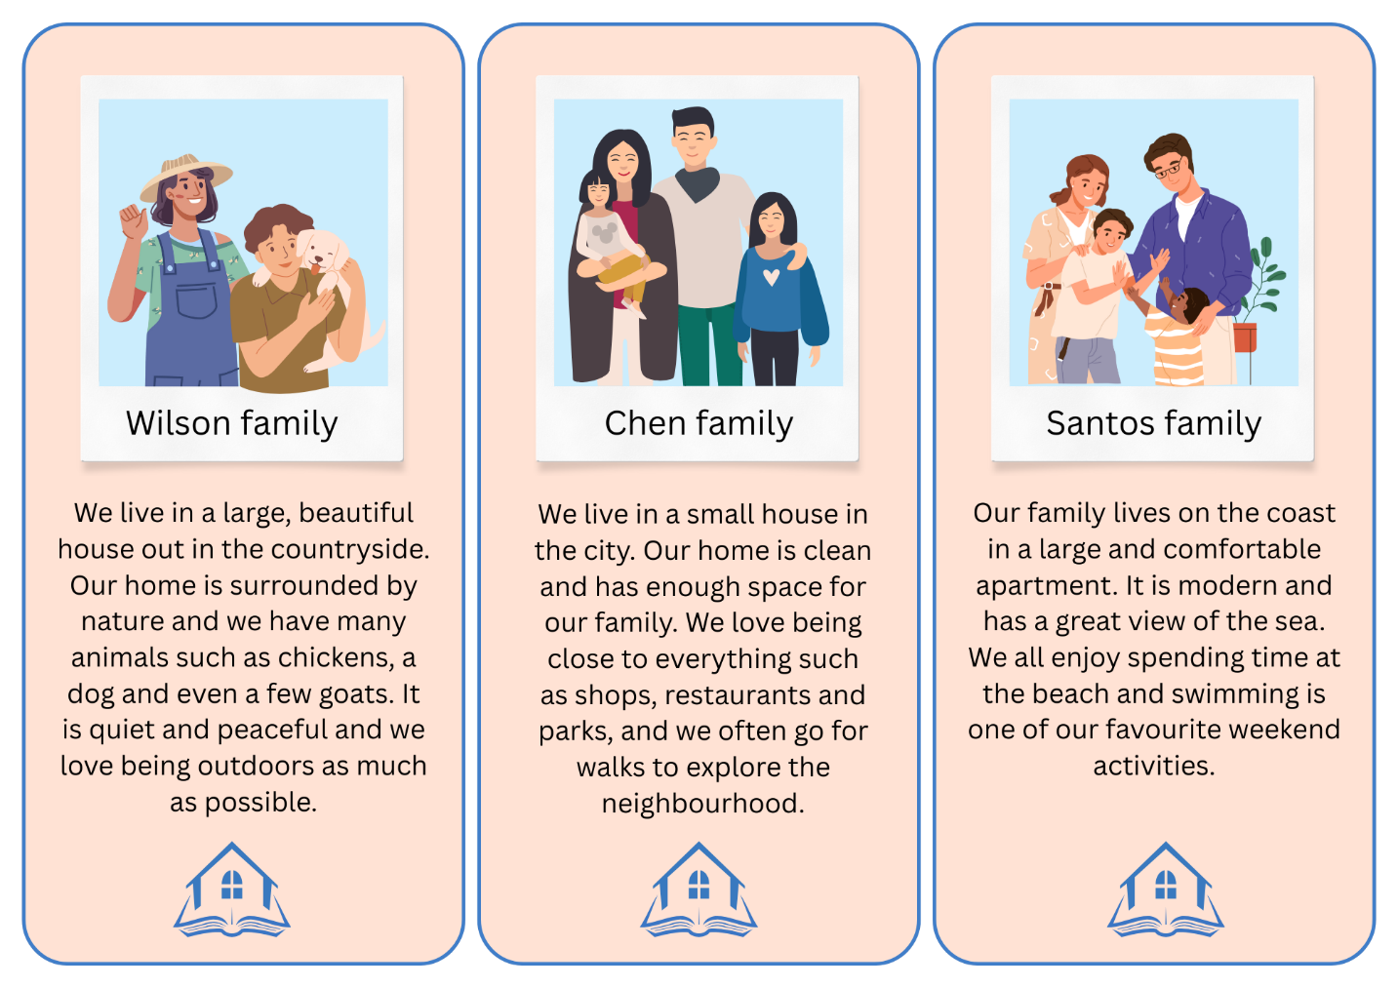
Complete the table below with the buddy family you think best matches each visiting student. In the last column, provide 2 reasons (in English) to justify your choice.
Student name | Buddy family | Reasons
Layla
Omar
Aya

For the teacher
Remove this section before sharing this resource with students.
You can access an editable version of the profiles, to amend for your own context.

Sample answers
Student name | Buddy family | Reasons
Layla | Chen family | - Layla lives in the city, and the Chen family also lives in the city, so they will understand and enjoy the same environment.  - Layla’s home is small and clean, just like the Chen family’s house, so she will feel comfortable with them.
Omar | Santos family | - Omar lives on the coast, and the Santos family lives on the coast too, which means he will be used to that lifestyle and scenery.  - Omar likes swimming, and the Santos family enjoys going to the beach and swimming on the weekends, so they share a common interest.
Aya | Wilson family | - Aya lives in the countryside, and the Wilson family lives in the countryside too, so she will enjoy the same quiet, natural surroundings.  - Aya likes animals, and the Wilson family has many animals at home, so she will enjoy spending time there.

© State of New South Wales (Department of Education), 2025
The copyright material published in this resource is subject to the Copyright Act 1968 (Cth) and is owned by the NSW Department of Education or, where indicated, by a party other than the NSW Department of Education (third-party material).
Copyright material available in this resource and owned by the NSW Department of Education is licensed under a Creative Commons Attribution 4.0 International (CC BY 4.0) license.

This license allows you to share and adapt the material for any purpose, even commercially.
Attribution should be given to © State of New South Wales (Department of Education), 2025.
Material in this resource not available under a Creative Commons license:
- the NSW Department of Education logo, other logos and trademark-protected material
- material owned by a third party that has been reproduced with permission. You will need to obtain permission from the third party to reuse its material.
Links to third-party material and websites
Please note that the provided (reading/viewing material/list/links/texts) are a suggestion only and implies no endorsement, by the New South Wales Department of Education, of any author, publisher, or book title. School principals and teachers are best placed to assess the suitability of resources that would complement the curriculum and reflect the needs and interests of their students.
If you use the links provided in this document to access a third-party's website, you acknowledge that the terms of use, including licence terms set out on the third-party's website apply to the use which may be made of the materials on that third-party website or where permitted by the Copyright Act 1968 (Cth). The department accepts no responsibility for content on third-party websites.

