Masculine and feminine adjectives

Activity 1
Listen to the description and determine whether the adjective you hear is in its masculine or feminine form. Tick the appropriate box. The first one has been done as an example. Each question will be read twice.
Number | Masculine or feminine
 | ☒ masculine or ☐ feminine
 | ☐ masculine or ☐ feminine
 | ☐ masculine or ☐ feminine
 | ☐ masculine or ☐ feminine
 | ☐ masculine or ☐ feminine
 | ☐ masculine or ☐ feminine
 | ☐ masculine or ☐ feminine
 | ☐ masculine or ☐ feminine
 | ☐ masculine or ☐ feminine
 | ☐ masculine or ☐ feminine
 | ☐ masculine or ☐ feminine

Activity 2
For each question choose the sentence in the table which accurately describes each home. Pay close attention to the gender of the adjective and the phrase ‘It is’ (إنه /إنها). For each question, give reasons for your choice. The first one has been done for you as an example.
Number | Home | Description | Reason
 | 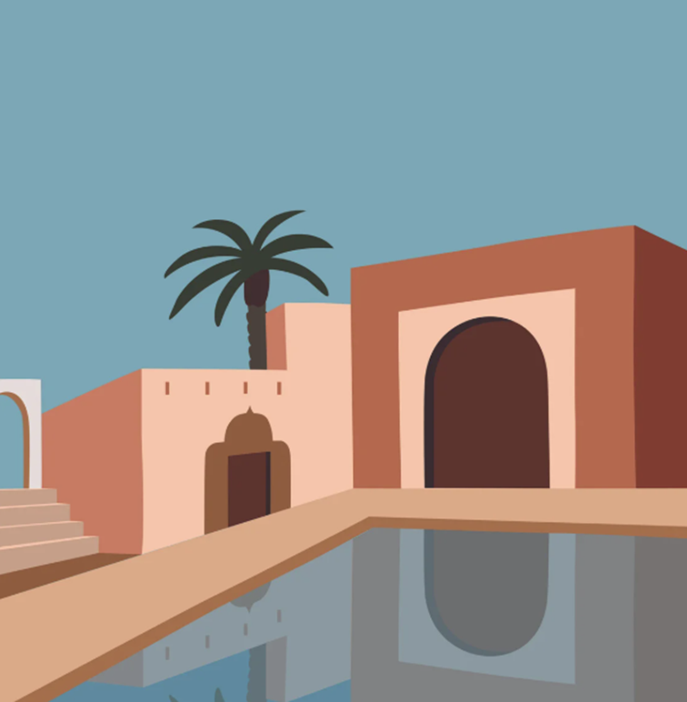 | إنها كبيرة ☒  إنها كبير ☐ | Villa is feminine. كبير is the masculine form of the adjective.
 | 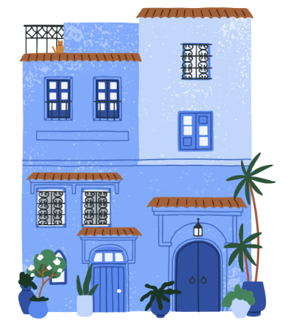 | إنها واسعة ☐  إنه واسعة ☐
 | 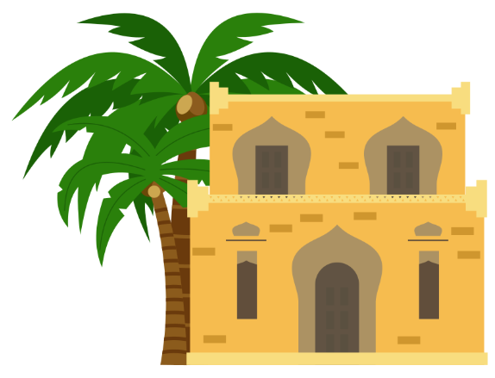 | إنها نظيف ☐  إنه نظيف ☐
 | 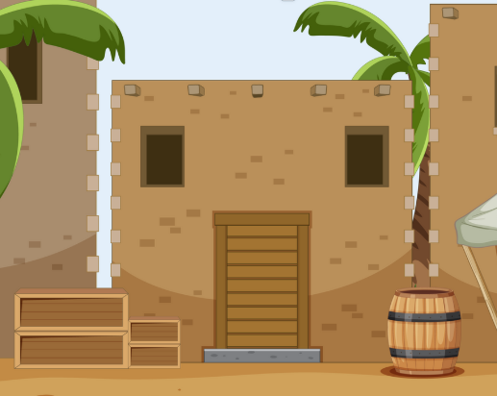 | إنه واسع ☐  إنه واسعة ☐
إنها حديثة ☐
إنها حديث ☐
إنه مريح ☐
إنها مريح ☐
إنه جميل ☐
إنه جميلة ☐
إنها صغير ☐
إنه صغير ☐
إنها نظيفة ☐
إنه نظيف ☐
إنها مريحة ☐
إنها مريح ☐

Activity 3
Write a sentence to describe the home using the prompts given. Choose from إنه and إنها to begin each sentence and include the correct form of each adjective. The first one has done for you as an example.
Number | Home | Adjective | Description
 |  | Clean and spacious | .إنها نظيفة وواسعة
 |  | Small and comfortable
 |  | Clean and beautiful
 |  | Big and spacious
 |  | Comfortable and beautiful

For the teacher
Remove this section before sharing this resource with students.

Activity 1

Audio file
Activity 1 audio (2:04)

Answers
Number | Masculine or feminine | Transcript
 | ☐ masculine or ☒ feminine | صغيرة (‘small’)
 | ☒ masculine or ☐ feminine | كبير (‘big’)
 | ☐ masculine or ☒ feminine | جميلة (‘beautiful’)
 | ☐ masculine or ☒ feminine | نظيفة (‘clean’)
 | ☐ masculine or ☒ feminine | واسعة (‘spacious’)
 | ☒ masculine or ☐ feminine | واسع (‘spacious’)
 | ☐ masculine or ☒ feminine | مريحة (‘comfortable’)
 | ☒ masculine or ☐ feminine | حديث (‘modern’)
 | ☐ masculine or ☒ feminine | كبيرة (‘big’)
 | ☒ masculine or ☐ feminine | صغير (‘small’)
 | ☒ masculine or ☐ feminine | نظيف (‘clean’)

Activity 2

Answers
Number. | Home | Description | Reason
 |  | إنها كبيرة ☒  إنها كبير ☐ | Villa is feminine. كبير is the incorrect form of the adjective.
 |  | إنها واسعة ☒  إنه واسعة ☐ | Apartment is feminine. إنه is the masculine form.
 |  | إنها نظيف ☐  إنه نظيف ☒ | House is masculine. إنها is for feminine nouns.
 |  | إنه واسع ☒  إنه واسعة ☐ | House is masculine. واسعة is the feminine form of the adjective.
 |  | إنها حديثة ☒  إنها حديث ☐ | Villa is feminine. حديث is the masculine form of the adjective.
 |  | إنه مريح ☐  إنها مريحة ☒ | Apartment is feminine. إنها is for feminine nouns. مريحة is the feminine form of the adjective.
 |  | إنه جميل ☒  إنه جميلة ☐ | جميلة is the feminine form of the adjective. House is masculine.
 |  | إنها صغير ☐  إنه صغير ☒ | إنها is the feminine form. House is masculine.
 |  | إنها نظيفة ☒  إنه نظيف ☐ | Apartment is feminine. نظيف is the masculine form of the adjective. إنه is the masculine form.
 |  | إنها مريحة ☒  إنها مريح ☐ | مريح is the masculine form of the adjective. Villa is feminine.

Activity 3

Answers
Number | Home | Adjectives | Description
 |  | Clean and spacious | .إنها نظيفة وواسعة
 |  | Small and comfortable | .إنها صغيرة ومريحة
 |  | Clean and beautiful | .إنه نظيف وجميل
 |  | Big and spacious | .إنه كبير وواسع
 |  | Comfortable and beautiful | .إنها مريحة وجميلة

© State of New South Wales (Department of Education), 2025
The copyright material published in this resource is subject to the Copyright Act 1968 (Cth) and is owned by the NSW Department of Education or, where indicated, by a party other than the NSW Department of Education (third-party material).
Copyright material available in this resource and owned by the NSW Department of Education is licensed under a Creative Commons Attribution 4.0 International (CC BY 4.0) license.

This license allows you to share and adapt the material for any purpose, even commercially.
Attribution should be given to © State of New South Wales (Department of Education), 2025.
Material in this resource not available under a Creative Commons license:
- the NSW Department of Education logo, other logos and trademark-protected material
- material owned by a third party that has been reproduced with permission. You will need to obtain permission from the third party to reuse its material.
Links to third-party material and websites
Please note that the provided (reading/viewing material/list/links/texts) are a suggestion only and implies no endorsement, by the New South Wales Department of Education, of any author, publisher, or book title. School principals and teachers are best placed to assess the suitability of resources that would complement the curriculum and reflect the needs and interests of their students.
If you use the links provided in this document to access a third-party's website, you acknowledge that the terms of use, including licence terms set out on the third-party's website apply to the use which may be made of the materials on that third-party website or where permitted by the Copyright Act 1968 (Cth). The department accepts no responsibility for content on third-party websites.

