Adjective cards
This resource is for the teacher. It provides the content and instructions you need to share with students.

Instructions
Print enough sets of cards so that each group of 3 to 4 students has a set each.
Students form groups of 3 to 4. Provide each group with a set of ‘Home cards’ from resource
5. Home and location cards (Word) and a set of the ‘Adjective image cards’ contained in this resource. Students place the cards in 2 different piles, one for each category (‘home’ and ‘adjectives’), face down on the table. Nominate the student whose birthday is coming next to go first in each group.
When directed, students take turns drawing a card from the ‘home’ pile and a card from the ‘adjective’ pile. The other students ask the appropriate form of the question أين تعيشين؟ (f) / أين تعيش؟ (m). The student holding the cards creates a response in Arabic based on the prompts on the cards. For example, if the student draws the ‘villa’ card and the ‘modern’ card they will construct the sentence أعيش في فيلا. إنها حديثة. (‘I live in a villa, it is modern’), ensuring that the correct form of the adjective is used.
The other students give feedback on the accuracy of the student’s response, calling on the teacher, if required. If the student correctly describes both of the cards, they place the cards in front of them. If the student gives an incorrect phrase for either of the cards, that card is placed at the bottom of the pile. Moving in a clockwise direction, the next student in the group now has a turn. Continue until all the cards have been used.
To make the game more competitive, consider awarding points to the student who accumulates the most cards in each group.
For students requiring additional support, print the cards with the Arabic or English versions on the back, using the ‘Adjectives – words in Arabic’ or ‘Adjectives – words in English’ cards, as appropriate.

Adjective image cards
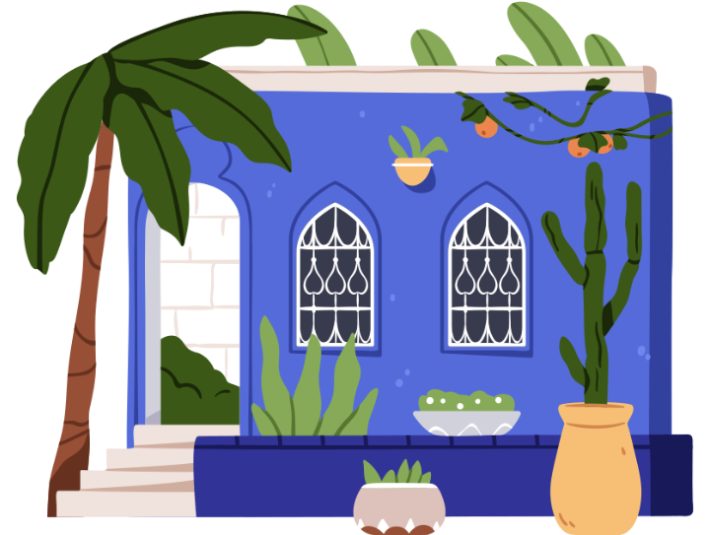 | 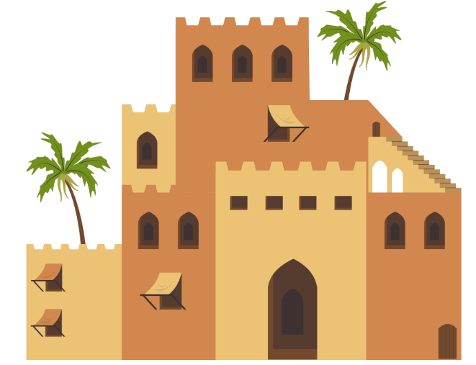
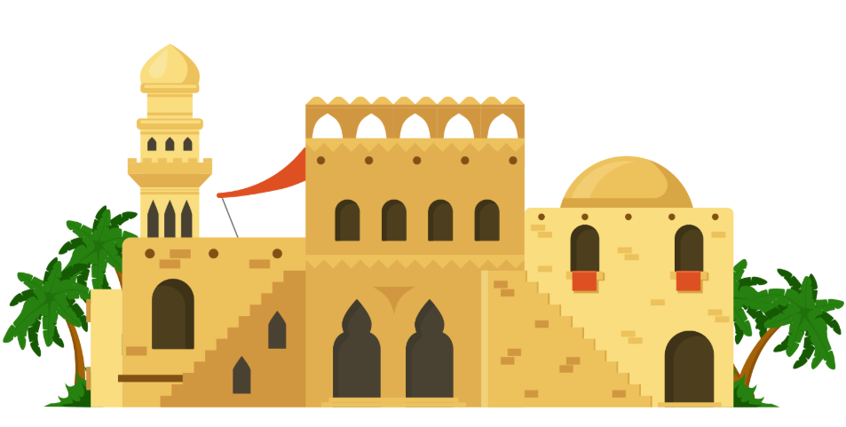 | 
 | 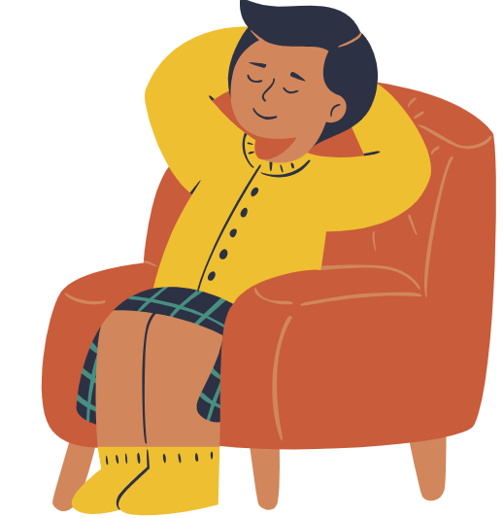

Adjectives – words in Arabic
صغير | كبير
جميل | نظيفة
واسع | مريح
صغيرة | كبيرة
جميلة | نظيفة
واسعة | مريحة

Adjectives – words in English
small (m) | big (m)
beautiful (m) | clean (m)
spacious (m) | comfortable (m)
small (f) | big (f)
beautiful (f) | clean (f)
spacious (f) | comfortable (f)

© State of New South Wales (Department of Education), 2025
The copyright material published in this resource is subject to the Copyright Act 1968 (Cth) and is owned by the NSW Department of Education or, where indicated, by a party other than the NSW Department of Education (third-party material).
Copyright material available in this resource and owned by the NSW Department of Education is licensed under a Creative Commons Attribution 4.0 International (CC BY 4.0) license.

This license allows you to share and adapt the material for any purpose, even commercially.
Attribution should be given to © State of New South Wales (Department of Education), 2025.
Material in this resource not available under a Creative Commons license:
- the NSW Department of Education logo, other logos and trademark-protected material
- material owned by a third party that has been reproduced with permission. You will need to obtain permission from the third party to reuse its material.
Links to third-party material and websites
Please note that the provided (reading/viewing material/list/links/texts) are a suggestion only and implies no endorsement, by the New South Wales Department of Education, of any author, publisher, or book title. School principals and teachers are best placed to assess the suitability of resources that would complement the curriculum and reflect the needs and interests of their students.
If you use the links provided in this document to access a third-party's website, you acknowledge that the terms of use, including licence terms set out on the third-party's website apply to the use which may be made of the materials on that third-party website or where permitted by the Copyright Act 1968 (Cth). The department accepts no responsibility for content on third-party websites.

