Card scramble
This resource is for the teacher. It provides the content and instructions you need to share with students.

Instructions
Print enough sets of cards so that each group of 3 to 4 students has a set each. Cards can be printed individually or back-to-back for students requiring additional support.
Students form groups of 3 to 4.

Activity 1 – ‘vocab grab’
Play a ‘vocab grab’ game in groups. Students place all cards face-up on the desk.
Call out prompts. Students then race each other to grab the matching card.
This activity can also be played with the cards in English and the prompts in Arabic.

Activity 2 – memory
Play a memory-style game, matching the images of adjectives with the word in Arabic.

Activity 3 – sentence formation
Students place all cards face-up on the desk.

Variation 1
Students scramble to form as many grammatically correct sentences as possible in the allocated time.

Variation 2
Provide students with a series of sentences on the board. Students scramble to form as many of the sentences as possible in the allocated time. The sentences can be written in English or in Arabic, depending on the student’s ability.

Variation 3
Call out sentences in Arabic. Students then race to be the first group to form the completed sentence accurately. Alternatively, call out sentences in English for students to find the matching cards in Arabic to form the sentence.

Adjectives – images
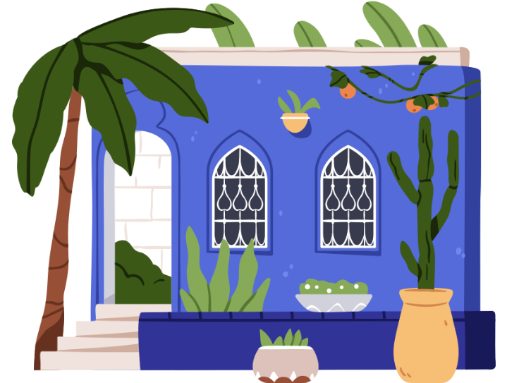 | 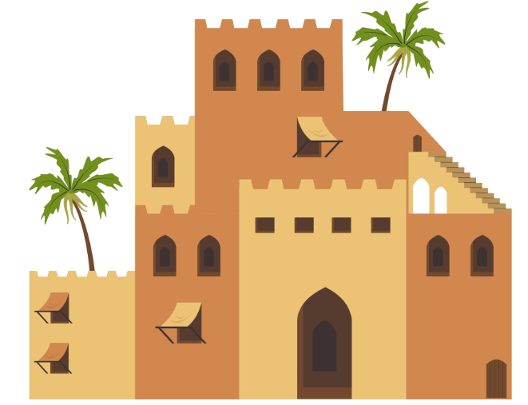
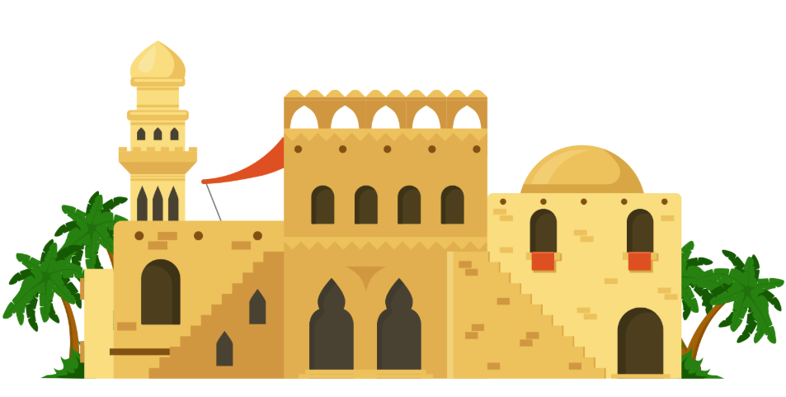 | 
 | 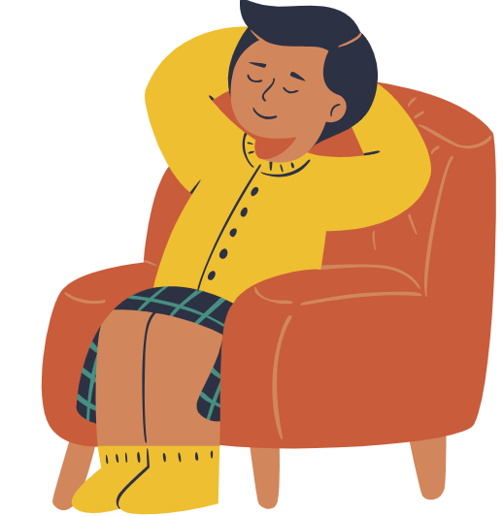

Adjectives – masculine and feminine
صغير | كبير
جميل | نظيفة
واسع | مريح
صغيرة | كبيرة
جميلة | نظيفة
واسعة | مريحة

Adjectives – English
small (m) | big (m)
beautiful (m) | clean (m)
spacious (m) | comfortable (m)
small (f) | big (f)
beautiful (f) | clean (f)
spacious (f) | comfortable (f)

It is
إنه | إنه
إنه | إنه
إنه | إنه
إنها | إنها
إنها | إنها
إنها | إنها

© State of New South Wales (Department of Education), 2025
The copyright material published in this resource is subject to the Copyright Act 1968 (Cth) and is owned by the NSW Department of Education or, where indicated, by a party other than the NSW Department of Education (third-party material).
Copyright material available in this resource and owned by the NSW Department of Education is licensed under a Creative Commons Attribution 4.0 International (CC BY 4.0) license.

This license allows you to share and adapt the material for any purpose, even commercially.
Attribution should be given to © State of New South Wales (Department of Education), 2025.
Material in this resource not available under a Creative Commons license:
- the NSW Department of Education logo, other logos and trademark-protected material
- material owned by a third party that has been reproduced with permission. You will need to obtain permission from the third party to reuse its material.
Links to third-party material and websites
Please note that the provided (reading/viewing material/list/links/texts) are a suggestion only and implies no endorsement, by the New South Wales Department of Education, of any author, publisher, or book title. School principals and teachers are best placed to assess the suitability of resources that would complement the curriculum and reflect the needs and interests of their students.
If you use the links provided in this document to access a third-party's website, you acknowledge that the terms of use, including licence terms set out on the third-party's website apply to the use which may be made of the materials on that third-party website or where permitted by the Copyright Act 1968 (Cth). The department accepts no responsibility for content on third-party websites.

