Describing where I live

Activity 1 – locations
Listen to each statement. If it matches the image, tick true, if it does not, tick false. Each phrase will be read twice. The first one has been done for you as an example.
Number | Location | True or false
1. | 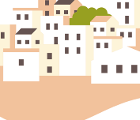 | ☐ true  ☒ false
2. | 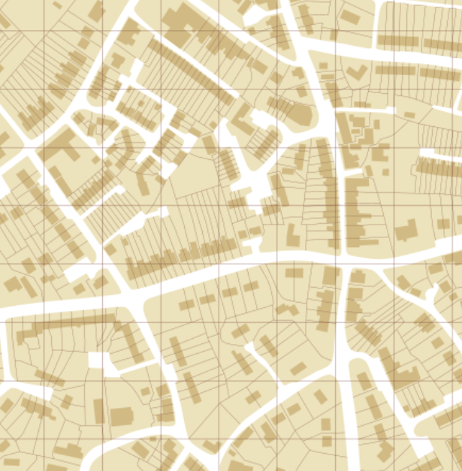 | ☐ true  ☐ false
3. | 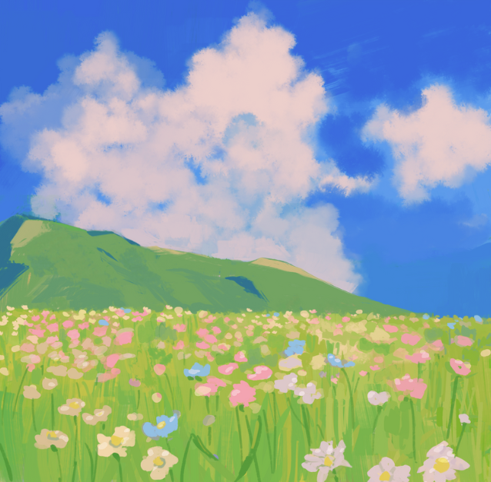 | ☐ true  ☐ false
4. |  | ☐ true  ☐ false
5. | 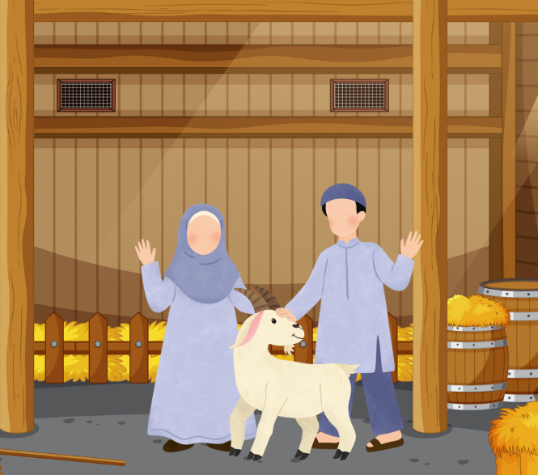 | ☐ true  ☐ false
6. | 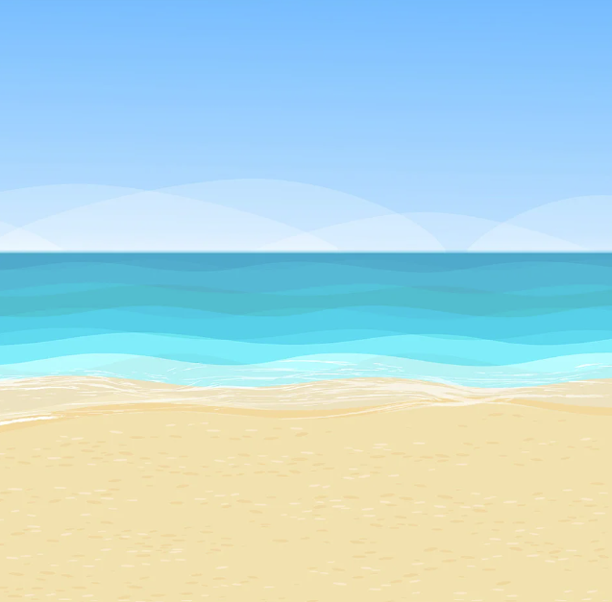 | ☐ true  ☐ false
7. | 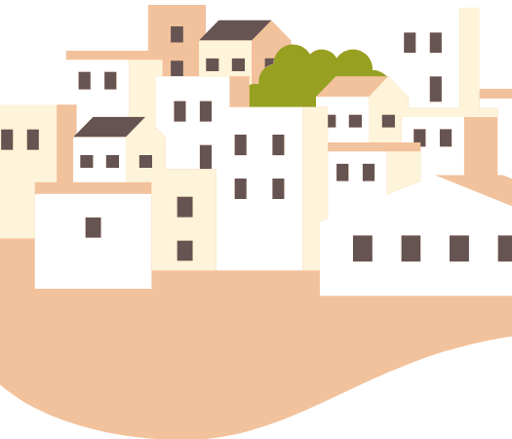 | ☐ true  ☐ false
8. |  | ☐ true  ☐ false
9. | 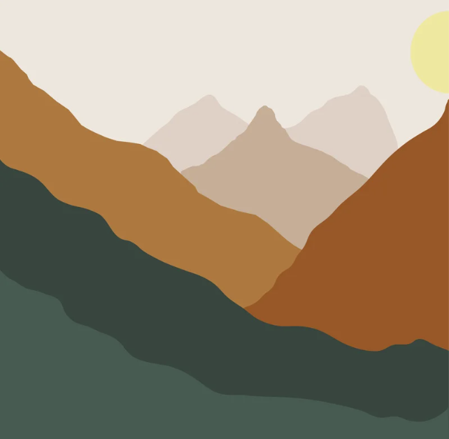 | ☐ true  ☐ false
10. |  | ☐ true  ☐ false

Activity 2
Listen to the statement and select the location being described by ticking the box The first one has been done for you as an example.
Number | Locations
1. | ☒ or ☐
2. | ☐ or ☐
3. | ☐ or ☐
4. | ☐ or ☐
5. | ☐ or ☐

Activity 3
Listen to the description and write the location you hear in English.
Number | Location
1.
2.
3.
4.
5.

Activity 4
Translate the responses from Activity 3 into Arabic. Begin each sentence with أعيش (‘I live’).

Activity 5
Write the English translation of each type of home in the table below.
Number | English translation | Home
1. |  | في منزل من طابقين
2. |  | في منزل
3. |  | في شقة
4. |  | في فيلا

Activity 6
Using the images as prompts, write a sentence in Arabic to describe where you live. Begin each response with هذا هو المكان الذي أعيش فيه (‘This is where I live’). The first one has been done for you as an example.
Number | Prompts | Response
1. | 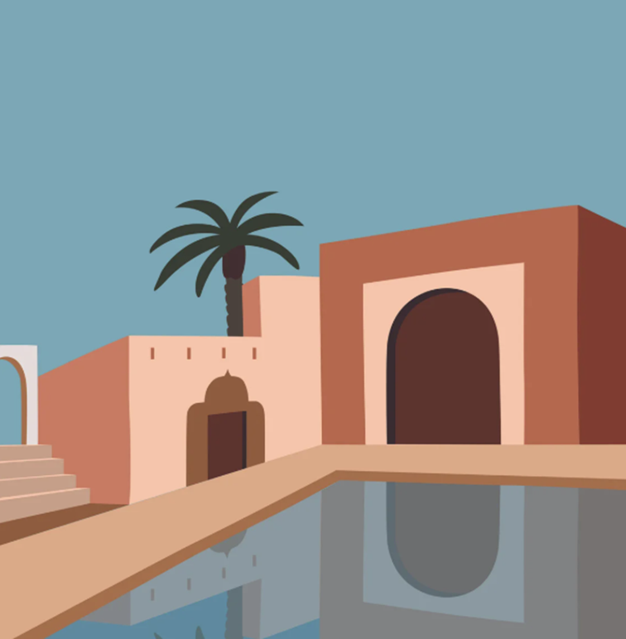 | .هذا هو المكان الذي أعيش فيه  .أعيش في فيلا على الساحل
2. | 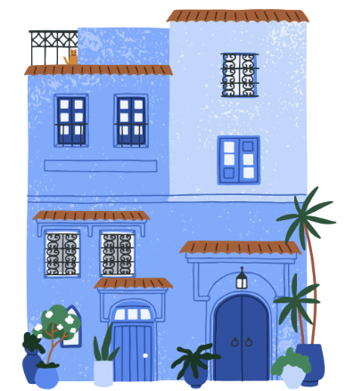
3. | 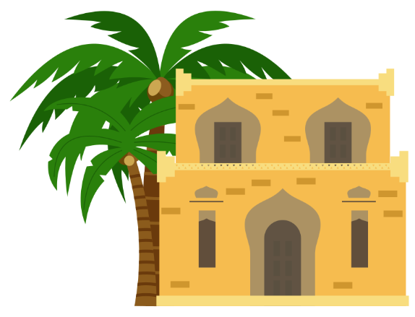
4. | 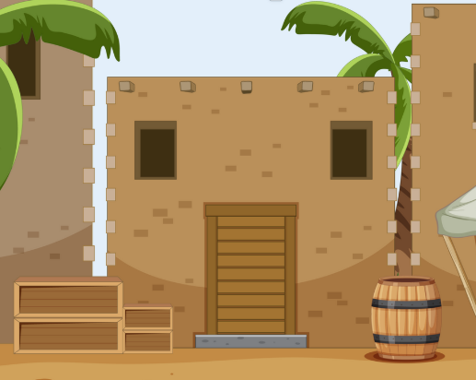
5.

For the teacher
Remove this section before sharing this resource with students.

Activity 1

Audio file
Activity 1 audio (2:12)

Answers
Number | Location | True or false | Transcript
1. |  | ☐ true  ☒ false | (I live in the city)  أعيش في المدينة
2. |  | ☐ true  ☒ false | (I live in the mountains)  أعيش في الجبال
3. |  | ☒ true  ☐ false | (I live in the country)  أعيش في الريف
4. |  | ☒ true  ☐ false | (I live in the city)  أعيش في المدينة
5. |  | ☒ true  ☐ false | (I live on the farm)  أعيش في المزرعة
6. |  | ☐ true  ☒ false | (I live in the suburbs)  أعيش في الضواحي
7. |  | ☐ true  ☒ false | (I live on the farm)  أعيش في المزرعة
8. |  | ☐ true  ☒ false | (I live in the country)  أعيش في الريف
9. |  | ☒ true  ☐ false | (I live in the mountains)  أعيش في الجبال
10. |  | ☐ true  ☒ false | (I live in the town)  أعيش في البلدة

Activity 2

Audio file
Activity 2 audio (0:59)

Answers
Number | Locations | Transcript
1. | ☒ or ☐ | الجبال في
2. | ☒ or ☐ | في الضواحي
3. | ☐ or ☒ | في المدينة
4. | ☒ or ☐ | في المزرعة
5. | ☒ or ☐ | على الساحل

Activity 3

Audio file
Activity 3 audio (1:07)

Transcript
Number | Location | Transcript
1. | City | أعيش في المدينة
2. | Farm | أعيش في المزرعة
3. | Coast | أعيش على الساحل
4. | Suburbs | أعيش في الضواحي
5. | Mountains | أعيش في الجبال

Activity 4

Answers
أعيش في المدينة
أعيش في المزرعة
أعيش على الساحل
أعيش في الضواحي
أعيش في الجبال

Activity 5

Answers
Number | English translation | Home
1. | in a 2-storey house | في منزل من طابقين
2. | in a house | في منزل
3. | in an apartment | في شقة
4. | in a villa | في فيلا

Activity 6

Answers
Number | Prompts | Response
1. |  | .هذا هو المكان الذي أعيش فيه  .أعيش في فيلا على الساحل
2. |  | .هذا هو المكان الذي أعيش فيه  .أعيش في شقة في البلدة
3. |  | .هذا هو المكان الذي أعيش فيه  .أعيش في منزل من طابقين في الجبال
4. |  | .هذا هو المكان الذي أعيش فيه  .أعيش في منزل في الريف
5. |  | .هذا هو المكان الذي أعيش فيه  .أعيش في شقة في المدينة

© State of New South Wales (Department of Education), 2025
The copyright material published in this resource is subject to the Copyright Act 1968 (Cth) and is owned by the NSW Department of Education or, where indicated, by a party other than the NSW Department of Education (third-party material).
Copyright material available in this resource and owned by the NSW Department of Education is licensed under a Creative Commons Attribution 4.0 International (CC BY 4.0) license.

This license allows you to share and adapt the material for any purpose, even commercially.
Attribution should be given to © State of New South Wales (Department of Education), 2025.
Material in this resource not available under a Creative Commons license:
- the NSW Department of Education logo, other logos and trademark-protected material
- material owned by a third party that has been reproduced with permission. You will need to obtain permission from the third party to reuse its material.
Links to third-party material and websites
Please note that the provided (reading/viewing material/list/links/texts) are a suggestion only and implies no endorsement, by the New South Wales Department of Education, of any author, publisher, or book title. School principals and teachers are best placed to assess the suitability of resources that would complement the curriculum and reflect the needs and interests of their students.
If you use the links provided in this document to access a third-party's website, you acknowledge that the terms of use, including licence terms set out on the third-party's website apply to the use which may be made of the materials on that third-party website or where permitted by the Copyright Act 1968 (Cth). The department accepts no responsibility for content on third-party websites.

