Home and location cards
This resource is for the teacher. It provides the content and instructions you need to share with students.

Instructions
Distribute cards so that each student has a location card and a home card.
Students use the prompts on the cards to write a sentence describing where they live in their books, or in the space provided on the sheet.
The sentence must include هذا هو المكان الذي أعيش فيه (‘This is where I live’), the type of home and the location of their home. For example, هذا هو المكان الذي أعيش فيه. أعيش في شقة في المدينة (‘This is where I live. I live in an apartment in the city’).
To begin the activity, students move around the room. When directed to stop, students play a round of مقص، ورقة، حجر (‘Scissors, paper, rock’) with the nearest person to determine who will ask the appropriate form of the question أين تعيشين؟/(f) أين تعيش؟ (m) (‘Where do you live?’) first.
Their partner must respond using the sentence they have constructed. The student who has asked the question must note down (in English or in Arabic) the person’s name and their response, including the type of home and the location in the table provided. Repeat the process until students have all asked at least 5 different people. Encourage students to greet and thank the person in Arabic for an authentic interaction.

Student responses

My response
In the space provided below, write your response according to the prompts on the cards you have been given. The sentence must include هذا هو المكان الذي أعيش فيه (‘This is where I live’), the type of home and the location of your home. For example, هذا هو المكان الذي أعيش فيه. أعيش في شقة في المدينة. (‘This is where I live. I live in an apartment in the city’).

My peers’ responses
When the activity starts, move around the room. When directed to stop, play a round of مقص، ورقة، حجر (‘Scissors, paper, rock’) with the nearest person to determine who will ask the question أين تعيشين؟/(f) أين تعيش؟ (m) (‘Where do you live?’) first.
If you ask the question, note down (in English or in Arabic) the person’s name and their response, including the type of home and the location in the table below. Repeat the process until all students have asked at least 5 different people.
Student name | Home | Location

Location cards
 | 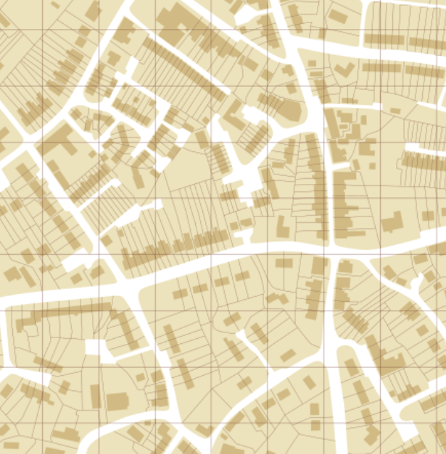
 | 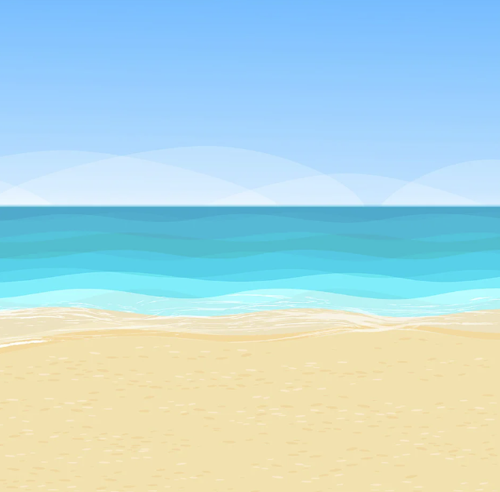
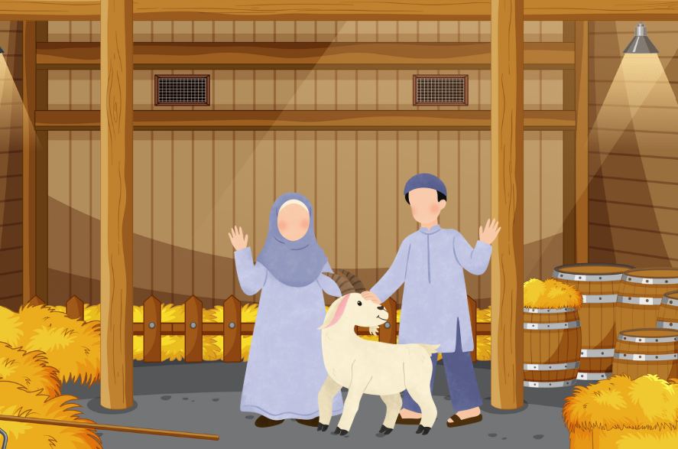 | 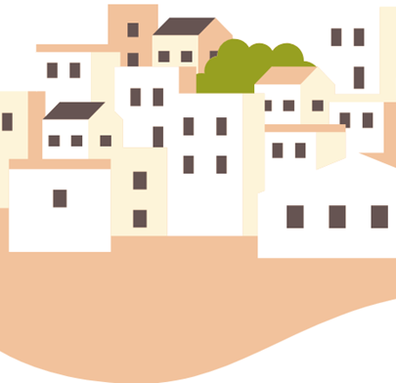
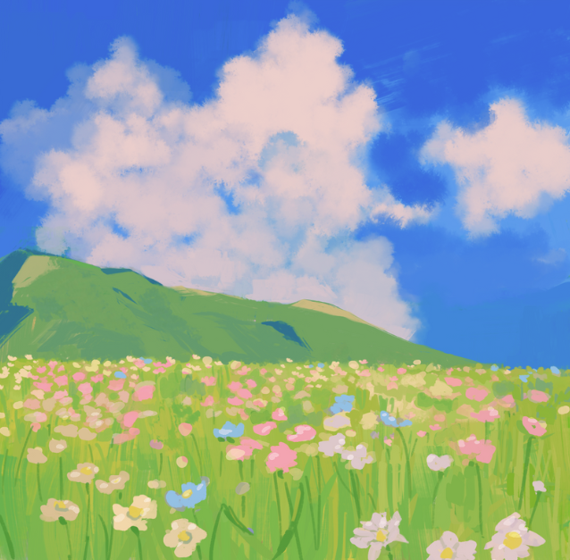

Home cards
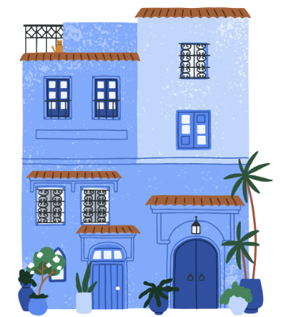 | 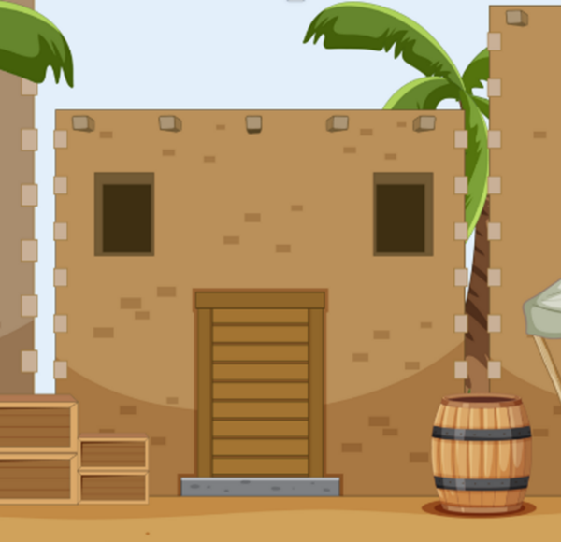
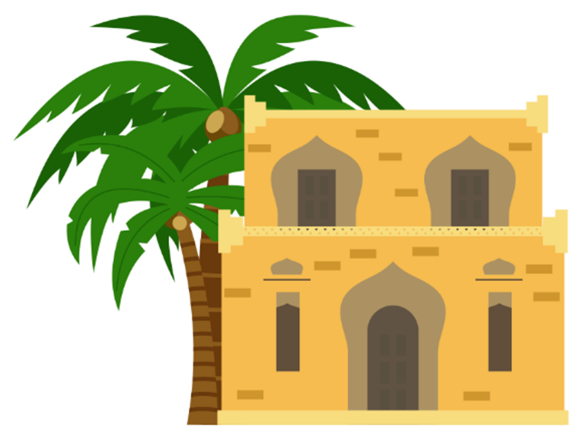 | 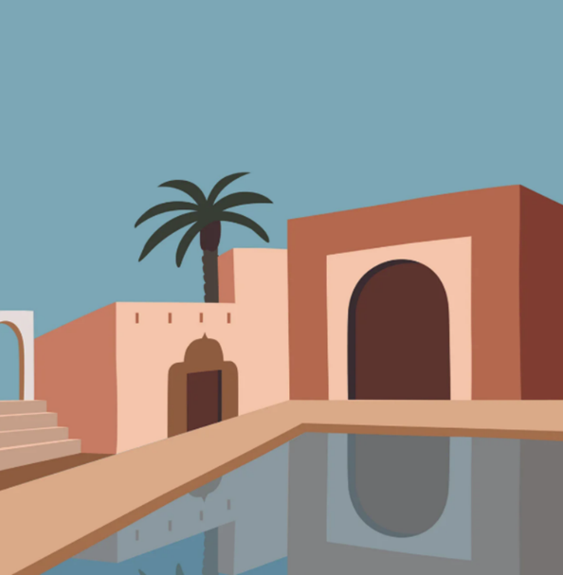

© State of New South Wales (Department of Education), 2025
The copyright material published in this resource is subject to the Copyright Act 1968 (Cth) and is owned by the NSW Department of Education or, where indicated, by a party other than the NSW Department of Education (third-party material).
Copyright material available in this resource and owned by the NSW Department of Education is licensed under a Creative Commons Attribution 4.0 International (CC BY 4.0) license.

This license allows you to share and adapt the material for any purpose, even commercially.
Attribution should be given to © State of New South Wales (Department of Education), 2025.
Material in this resource not available under a Creative Commons license:
- the NSW Department of Education logo, other logos and trademark-protected material
- material owned by a third party that has been reproduced with permission. You will need to obtain permission from the third party to reuse its material.
Links to third-party material and websites
Please note that the provided (reading/viewing material/list/links/texts) are a suggestion only and implies no endorsement, by the New South Wales Department of Education, of any author, publisher, or book title. School principals and teachers are best placed to assess the suitability of resources that would complement the curriculum and reflect the needs and interests of their students.
If you use the links provided in this document to access a third-party's website, you acknowledge that the terms of use, including licence terms set out on the third-party's website apply to the use which may be made of the materials on that third-party website or where permitted by the Copyright Act 1968 (Cth). The department accepts no responsibility for content on third-party websites.

