Place cards
This resource is for the teacher. It provides the content and instructions you need to share with students.

Instructions
Print and cut out enough sets of cards to provide one set per group of 3 to 4 students.
Direct students to form groups of 3 to 4.
Provide each group with a set of cards.
Students place the cards face down on the desk between them.
Indicate which student in the group will go first, for example, closest to the front or back door of the classroom.
When it is time to begin, the designated student will pick up a card from the pile and show the group without looking at the image themselves. They try to guess what the image is on the card by making a statement in Arabic, using the structure [place] أعيش. If the image matches the sentence, the group says نعم (‘yes’), and the student keeps the card. If their guess is incorrect, the group says لا (‘no’) and the student must place the card at the bottom of the pile.
Students progress around the group, taking turns to guess the image on the card.
As students practise saying the phrases, move around the room to monitor and correct pronunciation as required.
The winner is the student who has accumulated the most cards when the time has elapsed, or the student who is the first to reach a predetermined number of cards.
 | 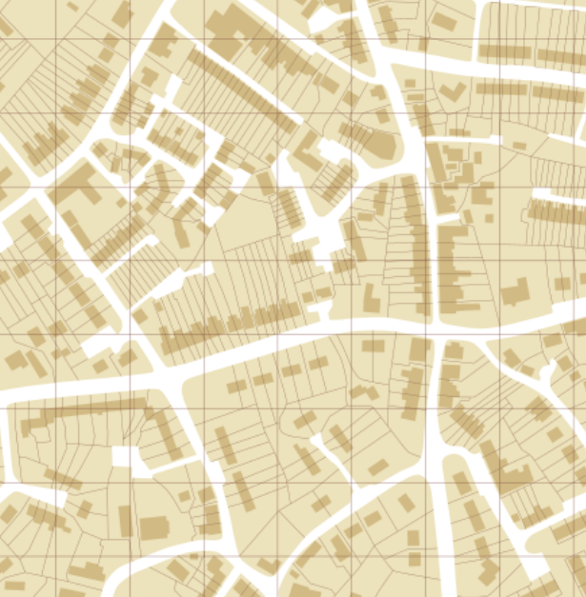
 | 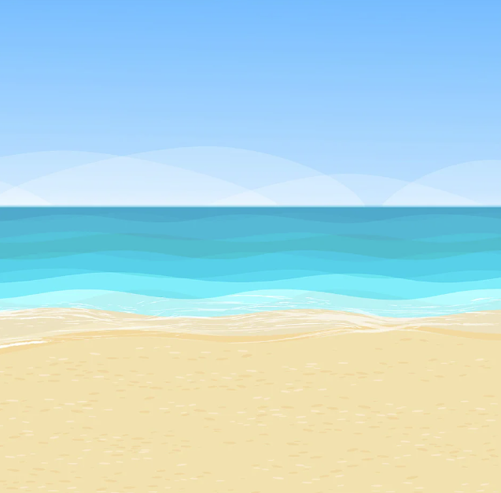
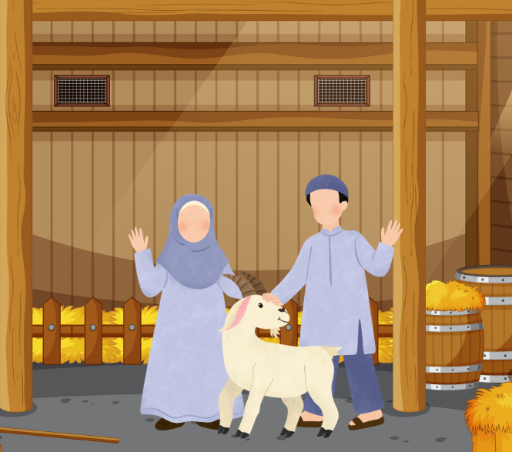 | 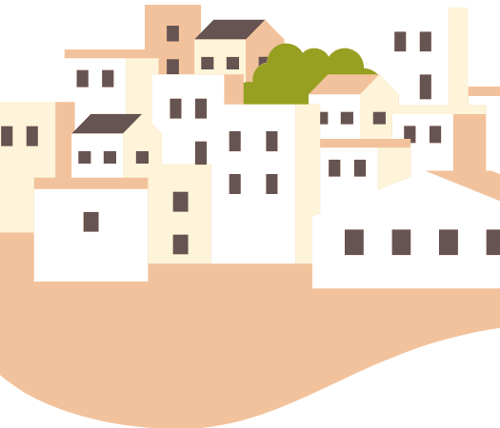
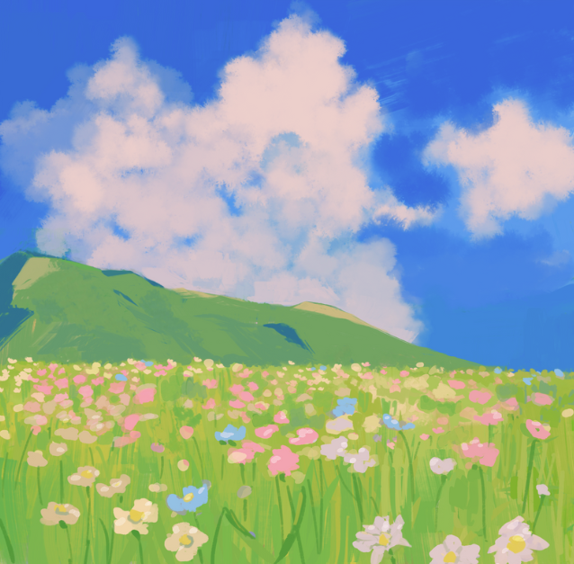
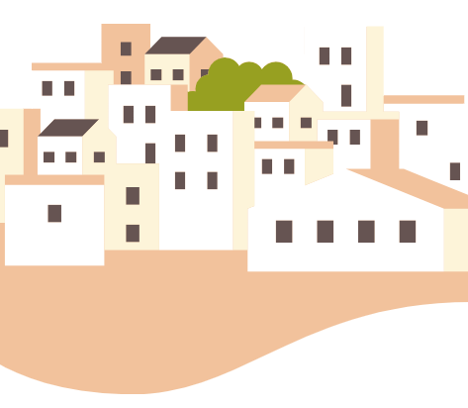

© State of New South Wales (Department of Education), 2025
The copyright material published in this resource is subject to the Copyright Act 1968 (Cth) and is owned by the NSW Department of Education or, where indicated, by a party other than the NSW Department of Education (third-party material).
Copyright material available in this resource and owned by the NSW Department of Education is licensed under a Creative Commons Attribution 4.0 International (CC BY 4.0) license.

This license allows you to share and adapt the material for any purpose, even commercially.
Attribution should be given to © State of New South Wales (Department of Education), 2025.
Material in this resource not available under a Creative Commons license:
- the NSW Department of Education logo, other logos and trademark-protected material
- material owned by a third party that has been reproduced with permission. You will need to obtain permission from the third party to reuse its material.
Links to third-party material and websites
Please note that the provided (reading/viewing material/list/links/texts) are a suggestion only and implies no endorsement, by the New South Wales Department of Education, of any author, publisher, or book title. School principals and teachers are best placed to assess the suitability of resources that would complement the curriculum and reflect the needs and interests of their students.
If you use the links provided in this document to access a third-party's website, you acknowledge that the terms of use, including licence terms set out on the third-party's website apply to the use which may be made of the materials on that third-party website or where permitted by the Copyright Act 1968 (Cth). The department accepts no responsibility for content on third-party websites.

