Vietnamese Stage 3
Lưu Bút của chúng ta (Our yearbook)
Contents
Unit overview 5
Stage 3 outcomes and content to be addressed 6
Learning map 10
Assessment 13
Assessment opportunities 14
Teaching and learning activities 16
Week 1 – school subjects 16
Vocabulary 1 – school subjects 17
Activity 1 – learning map 18
Activity 2 – school subjects 18
Activity 3 – subject bingo 19
Activity 4 – class survey 20
Activity 5 – find someone who? 23
Week 2 – the best thing 24
Vocabulary 2 – nouns 24
Vocabulary 3 – verbs 25
Activity 1 – friendship circle 26
Activity 2 – friends 27
Activity 3 – the best thing 27
Activity 4 – interview questions 29
Week 3 – superlatives 32
Vocabulary 4 – superlatives 32
Activity 1 – introducing superlatives … 33
Activity 2 – snakes and ladders 34
Activity 3 – interview role play 35
Activity 4 – vocabulary hot seat 37
Week 4 – memorable moments 39
Vocabulary 5 – memorable moments 40
Activity 1 – pre-assessment of vocabulary 41
Activity 2 – matching it 42
Activity 3 – most to least 42
Activity 4 – sentence builder 43
Activity 5 – role play 44
Week 5 – assessment criteria and practice task 46
Activity 1 – odd one out! 46
Activity 2 – introduce the assessment task 47
Activity 3 – success criteria 47
Activity 4 – discuss the rubric 48
Activity 5 – practice task 48
Week 6 – communicative task – Our yearbook 51
Activity 1 – warm up activity – bingo 52
Activity 2 – task set-up 52
Activity 2 – communicative task – Our yearbook 53
Activity 3 – peer-assessment 55
Week 7 – feedback and goal setting 57
Activity 1 – warm up activity – hot seat 58
Activity 2 – self-assessment 58
Activity 3 – set learning goals 58
Week 8 – language review 60
Activity 1 – student questions 61
Activity 2 – vocabulary work 61
Activity 3 – pick the errors 61
Activity 4 – delayed dictation 63
Student resources 64
Resource 1 – school subject flashcards 64
Resource 2 – find someone who 66
Resource 3 – ‘the best thing’ sentence builder 68
Resource 4 – snakes and ladders 70
Resource 5 – memories flashcards 72
Resource 6 – matching words 74
Resource 7 – sentence builder 76
Resource 8 – role-play scaffold cards 78
Resource 9 – assessment task – Our yearbook 79
Resource 10 – rubric – Our yearbook 82
Resource 11 – peer feedback strategy – TAG feedback slip 85
Resource 12 – learning goal form 86
Support and alignment 87
References 90

Unit overview
Stage: 3
Title: Lưu Bút của chúng ta (Our yearbook)
Description: In this unit, students create a video yearbook in Vietnamese about their time at primary school.
Duration: This lesson sequence is designed to be completed over approximately 8 weeks.
Student proficiency levels: It is assumed that most Stage 3 students have been learning Vietnamese since Kindergarten and their proficiency level will be Intermediate. This unit is aimed at Intermediate students. Every classroom will be different, and teachers will need to adapt to their context. Many classes may include a combination of Beginner, Intermediate and Advanced students. Assessment tasks and opportunities in this unit can be differentiated using the ‘Too hard?’ and ‘Too easy?’ suggestions.

Stage 3 outcomes and content to be addressed
The table below outlines the focus area, outcomes and content points for Stage 3 students.
Focus area and outcome | Content points
Interacting  A student:  - exchanges information and opinions in familiar contexts by using culturally appropriate rehearsed language ML3-INT-01 | Exchanging meaning in oral interactions in the target language  - Understand and share information about themselves and their personal world  - Ask and answer questions with familiar structures  - Express and describe emotions and personal preferences  - Address a new acquaintance and introduce themselves  - Ask for clarification or repeat information to facilitate understanding in familiar interactions  Applying knowledge of language systems to interact in the target language  - Use key features of the sound system including pronunciation, intonation patterns, stress and/or rhythms to interact  - Use familiar vocabulary to interact  - Use modelled grammatical structures to interact  Applying knowledge of the target language culture(s) to interact  - Use language and nonverbal communication that are appropriate to cultural practices
Understanding texts  A student:  - identifies and responds to information and opinions in texts to demonstrate understanding ML3-UND-01 | Understanding and responding to target language texts  - Listen to, read and view information and opinions in a range of texts on familiar themes  - Use comprehension strategies to process information and opinions in texts  - Respond in the target language and/or English to main points and specific information in familiar texts to explain understanding and express opinions  Applying knowledge of language systems to understand and respond to target language texts  - Identify and use the sounds of the target language to understand and respond to texts  - Identify and use sound–symbol correspondences to understand and respond to texts  - Use knowledge of vocabulary and phrases from familiar themes to understand and respond to texts  - Use modelled sentence structures and grammar patterns to understand and respond to texts  - Use familiar metalanguage to compare some target language structures and features with English  - Recognise and use familiar structures and features of the target language writing system to understand and respond to texts  Developing intercultural understanding through target language texts  - Respond to texts and consider how language is connected with cultural practices and compare how this is evident in their own language(s), culture(s) and identity
Creating texts  A student:  - creates a range of texts for familiar communicative purposes by using culturally appropriate rehearsed language ML3-CRT-01 | Creating spoken, written and multimodal texts in the target language  - Create imaginative texts appropriate to context, purpose and audience using a series of sequenced sentences and visuals to express ideas on familiar themes  Applying knowledge of language systems to create texts in the target language  - Use pronunciation, intonation patterns, stress and/or rhythms to create spoken texts  - Use sound–symbol correspondences to create written texts  - Use relevant vocabulary, formulaic expressions or modelled phrases from familiar themes to create texts  - Use a range of modelled sentence and grammatical structures to create texts  - Select structures and features of the target language writing system to create written texts  Applying knowledge of the target language culture(s) to create texts  - Use language appropriate to cultural practices to create texts
Modern Languages K–10 Syllabus © NSW Education Standards Authority (NESA) for and on behalf of the Crown in right of the State of New South Wales, 2022.

Learning map
The creation of maps for learning is a planning process that incorporates Aboriginal intellectual tradition. Learning maps are a visual pathway of what students will learn.
Share the learning map with your students, briefly explaining the learning that will happen in each lesson. Provide students with a copy of the learning map or display the learning map in the classroom. This learning map can be adapted to Vietnamese by accessing a copy of Learning map – Lưu Bút của chúng ta (Our yearbook) (Stage 3).
Figure 1 – Our yearbook learning map
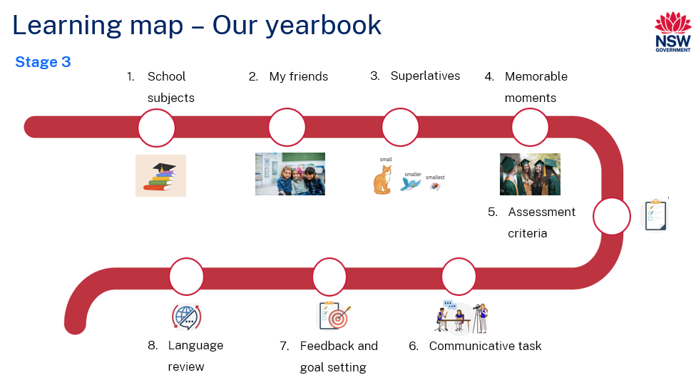
Figure 2 – Lưu Bút của chúng ta learning map
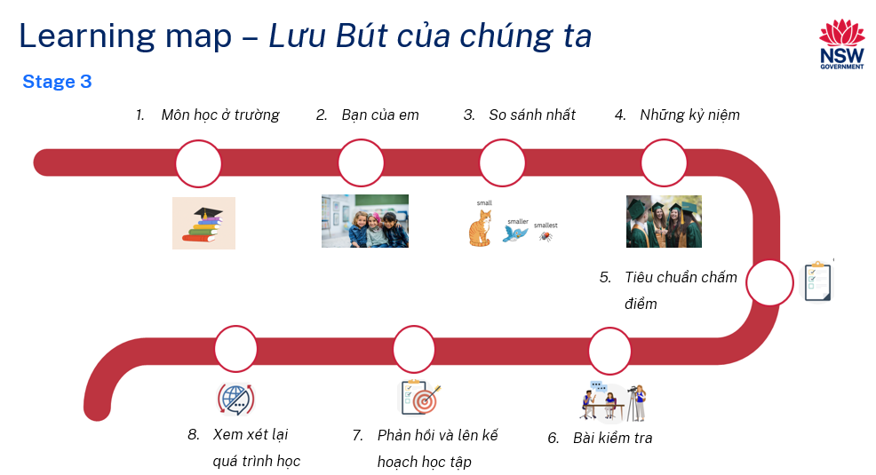

Assessment
Stage 3 communicative task: Your class has been asked to create a video yearbook in Vietnamese to celebrate your time in primary school. Provide information to a student journalist on your favourite subjects, friends, and memories.
Too hard?
Provide a scaffold template for students with visuals and some phrases.
Too easy?
Students provide detailed information about their friendship and/or explanations for their favourite subjects and memories.
Context: creating an end-of-school video yearbook
Audience: student journalist
Purpose: to talk about your memories

Assessment opportunities
The table below details assessment opportunities and differentiation ideas.
Assessment opportunities | Too hard? | Too easy?
Week 1 – subject bingo  Students make bingo cards with 9 boxes. In each box they place the name of a subject in Vietnamese. The first student with all 9 of their subjects called out wins. | Subject bingo  Students are allowed to add the names of their subjects in English as well as Vietnamese. | Subject bingo  Students make their own cards with only the pictures and no words so when a subject is called out they cannot read it on their card.
Week 3 – vocabulary hot seat  Students from each team will take turns giving clues in English to their teammate in the hot seat, without using the Vietnamese or English word written on the board. | Vocabulary hot seat  Students can use Vocabulary 2 and Vocabulary 3 tables to refer to. | Vocabulary hot seat  Students can give clues in Vietnamese or students can be given clues in Vietnamese.
Week 4 – matching it  Students are given a list of memorable moments in Vietnamese which they must cut out and match with their Vietnamese counterpart. | Matching it  Students are given an already matching list that they can use to match the jumbled version. | Matching it  Students are only given the Vietnamese list and must write the English translation for each word.

Teaching and learning activities

Week 1 – school subjects
The table below outlines the learning intentions and success criteria of the lesson, and materials that the teacher and students will need to complete the teaching and learning activities.
Learning intentions and success criteria | Materials
Students will:  - learn how to say and identify school subjects in Vietnamese.  - ask questions to find out basic information about another person.  Students can:  - say and write the names of school subjects  - ask other students questions about their favourite school subjects. | - Resource 1 – school subject flashcards  - Resource 2 – find someone who (one per student)  - A3 white paper  - A4 white paper  - Class timetable  - Counters  - Vietnamese workbooks

Vocabulary 1 – school subjects
The table below outlines the suggested vocabulary used throughout this learning sequence. It includes the Vietnamese words and phrases and their corresponding English translations.
English | Vietnamese
Maths | Toán
English | Anh Văn
Science | Khoa Học
Creative arts | Mỹ Thuật
History | Lịch Sử
Geography | Địa Lý
Sports | Thể Thao
Vietnamese | Tiếng Việt
subject | môn học
favourite | yêu thích
at school | ở trường

Activity 1 – learning map
Explain and display the Learning map to give students a more detailed breakdown of lessons during the unit. Point out that the Learning map is a plan that may need to change.

Activity 2 – school subjects
- Have students Think-Pair-Share any names they know in Vietnamese for school subjects. Students share this knowledge with the class.
- Display Resource 1 – school subject flashcards on the board. Call out each word on the flashcard in English and ask students to tell their partners the words they know by saying them in Vietnamese. Model and drill the correct pronunciation by reading from Resource 1 – school subject flashcards aloud, and have students repeat each word after you. Ensure correct pronunciation of the names of subjects in Vietnamese.
- Have students copy the new vocabulary and glue Resource 1 into their workbooks. Create a word wall and add the new vocabulary to it.
- Introduce the sentence ‘Môn học em thích là ...’ (My favourite subject is ...). Say it aloud and have students repeat.
- Give students time to discuss with a partner in English which subject is their favourite and why. Once they have decided, they practise saying it to their partner. Examples include:
Table 1 – favourite subjects
Toán – Maths | Môn học em thích là Toán. (My favourite subject is Maths.)
Anh Văn – English | Môn học em thích là Anh Văn. (My favourite subject is English.)
Mỹ Thuật – Creative Arts | Môn học em thích là Mỹ Thuật. (My favourite subject is Creative arts.)
Thể Thao – Sport | Môn học em thích là Thể Thao. (My favourite subject is Sport.)
- Ask students to write a sentence about their favourite subject in their workbooks.

Activity 3 – subject bingo
- Play a whole-class communicative language learning game, such as bingo, to review Vocabulary 1 words.
- Show students the word wall and ask them to make a bingo card by dividing a blank piece of paper into 6 squares and then writing 6 Vietnamese words for subjects from the word wall in each square.
- Lead a whole-class game by calling out words from the word wall, ensuring to model the correct pronunciation.
- Provide a handful of counters to each student. Each time a word is called out in Vietnamese, a counter must be placed on that word called on the bingo card. The winner is the first student to get a whole row of counters.

Activity 4 – class survey
- Introduce the question ‘Bạn thích môn học gì ở trường?’ (What is your favourite subject at school?). Ask individual students in Vietnamese, positively acknowledging appropriate English or Vietnamese responses. Ask the class what the question means in English, then say it aloud and have students repeat several times until the pronunciation is correct. Students practise saying this to a partner.
- Tell students that you want to find out what the most popular subject in this class is.
- Once they have mastered the question ‘Bạn thích môn học gì ở trường?’ (What is your favourite subject at school?), students can add the response ‘Môn học mình thích là …’ (My favourite subject is …).
- Students practise this with a partner until they are familiar and fluent with the phrase.
- In their workbooks ask students to write down the names of school subjects in Vietnamese.
- Model the question and answer again, then instruct students to go around the classroom, asking their classmates the same question and tally mark all the answers.
- Demonstrate an example of a tally chart (see Table 2). Explain to students that this is just a made-up example and that they will be collecting their own data to produce their own tally graph.

Table 2 – student sample of tally marks
Subject | Tally
Toán (Maths) | ||||
Anh Văn (English)
Thể Thao (Sports) | ||
Lịch Sử (History)
Mỹ Thuật (Arts) | |||| ||
Khoa Học (Science)
Tiếng Việt (Vietnamese) | ||||
- Using the data from Table 2, demonstrate how create a bar graph (see Figure 3).
- To create their own tally graphs, students set about writing up all the subject names just like in Table 2. Students then walk around the class and ask up to 10 students what their favourite subjects are.
Figure 3 – bar graph data on subjects
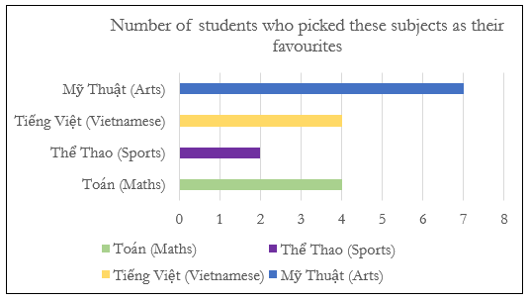
- Once they have collected this information they can create their own bar graph in their workbooks like Figure 3.
- When students are finished creating their own bar graphs, they can go on a gallery walk to discuss their findings.
Note: a gallery walk activity gets students engaged in their learning by moving around the classroom and exploring a range of documents, images, or student work displayed around the classroom to share their feedback.

Activity 5 – find someone who?
- Revise the following question and answer in Vietnamese about school subjects:
- Bạn thích môn gì ở trường? (What is your favourite subject at school?)
- Môn học mình thích là … (My favourite subject is …).
- Students write the question and the answer in their workbooks in both English and Vietnamese.
- In pairs, ask students to take turns asking and answering questions about the subjects they like.
- Hand out Resource 2 – find someone who to students (one per student).
- Ask students to walk around the classroom and ask modelled questions to complete it. The same name cannot be used twice. The first student to fill in their Resource 2 – find someone who worksheet is the winner.

Week 2 – the best thing
The table below outlines the learning intention and success criteria of the lesson, and materials that the teacher and students will need to complete the teaching and learning activities.
Learning intention and success criteria | Materials
Students will learn how to talk and write about their best friends.  Students can:  - ask questions about their friends  - use simple sentences to talk about their friends  - ask their friend what the best thing about school is  - respond about what the best thing about school is. | - Resource 1 – subject flashcards  - Resource 3 – ‘the best thing’ sentence builder  - A soft ball  - Mini whiteboards  - Vietnamese workbooks

Vocabulary 2 – nouns
The table below outlines the suggested vocabulary used throughout this learning sequence. It includes the Vietnamese words and phrases and their corresponding English translations.
English | Vietnamese
the best thing | điều tốt nhất
teacher | thầy giáo (male), cô giáo (female)
lunchtime | giờ ăn trưa
friends | các bạn
free time | giờ chơi
school holidays | kỳ nghỉ hè
the canteen | căn-tin

Vocabulary 3 – verbs
The table below outlines the suggested vocabulary used throughout this learning sequence. It includes the Vietnamese words and phrases and their corresponding English translations.
English | Vietnamese
playing | chơi
learning | học hỏi
going to | đi

Activity 1 – friendship circle
- As a warm-up, have students sit in a big circle on the floor. Explain that they will take turns asking and answering the same questions. Start with introducing and asking names.
- Remind students of the question ‘Bạn tên gì?’ (What's your name?). Say it aloud and have students repeat several times until the pronunciation is correct. Students practise saying this to a partner, adding the response ‘Tên tôi là …’ (My name is …). Say the response aloud to remind students of the correct form. Have students repeat several times until the pronunciation is correct. Students write the question and the answer in their workbooks in both English and Vietnamese.
- One student will hold a soft ball (the talking piece) and say ‘Tên tôi là …’ (My name is …). They then pass it to a student sitting next to them (clockwise), at the same time asking the student, ‘Bạn tên gì?’ (What’s your name?).
- The student receiving the ball will start by saying their name and then pass it to the person sitting next to them while asking them their name. The students keep passing the ball until everyone has had a turn at asking and answering the question.

Activity 2 – friends
- Explain to students that when creating a yearbook for school, a big part will feature the friends that you made and being able to communicate who they are.
- Introduce and model the question ‘Bạn của bạn là ai?’ (Who is your friend?). Say it aloud and have students repeat several times until the pronunciation is correct. Students practise saying this to a partner.
- Once they have mastered the question ‘Bạn của bạn là ai?’ (Who is your friend?) students can add the response ‘Bạn mình là’ (My friend is …). Say it aloud and have students repeat several times until the pronunciation is correct. Students practise saying this to a partner.
- Explain that students are going to play the friendship game again. This time however, instead of asking ‘Bạn tên gì?’ (What's your name?), and students responding with ‘Tên tôi là’ (My name is …), students will ask ‘Bạn của bạn là ai?’ (Who is your friend?) and respond with ‘Bạn mình là’ (My friend is …).
- Repeat the activity to practise the new sentence structures.
- As a class, discuss any new vocabulary and add this to the word wall. Students then write the above sentences in their workbooks.

Activity 3 – the best thing
- Ask students: What are some of the best things about school?
- Provide examples using familiar contexts, such as:
- The best thing about school is playing with friends
- Điều tuyệt vời nhất ở trường là được chơi với các bạn
- The best thing about school is recess
- Điều tuyệt vời nhất ở trường là giờ ra chơi
- The best thing about school is playing sport
- Điều tuyệt vời nhất ở trường là được chơi thể thao.
- Have students Think-Pair-Share their own examples to share with the class.
- Students share their findings with the class while suggestions are written on the board.
- Suggestions for the best things about school may include: recess, lunch, learning, friends, excursions, the canteen, teachers, sport, school holidays, free time and playing with my friends.
- Ask students if they know any of these words in Vietnamese. Have students Think-Pair-Share with a partner. Students say them out aloud and they are written on the board. Include any words not mentioned from the vocabulary list to the board. Similarly add any words suggested by students on the board to the vocabulary list.
- Say each of the words on ‘the best’ list by saying ‘The best thing about school is …’ (Điều tuyệt vời nhất ở trường) in front of each one aloud in English and Vietnamese and have students repeat.
- Display Resource 3 – ‘the best thing’ sentence builder. Students are to choose 5 of the best things about school and write them in sentences using the sentence builder.
- Once they have written 5 sentences in their workbooks, they read them to a peer and have a discussion as to why they chose these things to be in their top 5.
- As a class, discuss the new vocabulary and add it to the word wall.

Activity 4 – interview questions
- Explain to students that they will combine everything that they have learned so far and interview each other.
- Explain that in an interview it is important to start and end in a certain way. In the interview there is one person who is asking the questions, and the other person is answering them.
- Write the following introductory question and answer on the board in Vietnamese and read it out loud:
- Hello, could you tell me about your time in Primary school?
- Xin chào, bạn có thể nói về thời gian mình học ở tiểu học không?
- Sure, I would love to.
- Tất nhiên rồi, mình cũng rất muốn kể cho bạn.
- Ask students if they understand:
- Both the question and answer?
- Only the question?
- Only the answer?
- Students respond by showing a thumbs up once to express which question applies to them.
- Say the opening question and answer aloud and have students repeat. Do this several times until all students in the class are pronouncing them correctly.
- Have students write these down in their books and practise saying with a peer.
- Once they have practised with a partner, they can repeat the process with the following question and answer examples:
- Example question 1: What is your favourite subject?
- Môn học ưa thích của bạn là gì?
- Example answer 1: My favourite subject is …
- Môn học thích nhất của mình là …
- Example question 2: Who is/are your friend(s)?
- Bạn của bạn là ai?
- Example answer 2: My friend(s) is/are …
- Bạn của mình là …
- Example question 3: What is the best thing about school?
- Điều gì tuyệt vời nhất ở trường?
- Example answer 3: The best thing about school is …
- Điều tuyệt vời nhất ở trường là …
- Have students practise asking and answering the example and introductory questions with a partner. Explain that as well as this being a speaking exercise, it is also a listening exercise. Both students have a turn at being the interviewer and the person being interviewed.
- When all students have had a turn at both roles, the class gathers and students share the information they found out about their partners. They must do this in Vietnamese. For example, ‘Môn học thích nhất của Cooper là Toán, bạn của bạn ấy là Matthew và Jack, và điều tuyệt vời nhất ở trường là giờ chơi.’ (Cooper’s favourite subject is maths, his friends are Matthew and Jack, and the best thing about school is free time).

Week 3 – superlatives
The table below outlines the learning intention and success criteria of the lesson, and materials that the teacher and students will need to complete the teaching and learning activities.
Learning intention and success criteria | Materials
Students will learn how to use superlative words and phrases such as ‘the best’, and ‘the most’ in Vietnamese.  Students can:  - say and write ‘the best’ and ‘the most’ in Vietnamese sentences  - use superlatives such as ‘funniest’, ‘happiest’, ‘most interesting’ and ‘most exciting’ in sentences. | - Resource 4 – snakes and ladders  - Intentional observation checklist for communicative activities  - Counters and dice  - Whiteboards and markers

Vocabulary 4 – superlatives
The table below outlines the suggested vocabulary used throughout this learning sequence. It includes the Vietnamese words and phrases and their corresponding English translations.
English | Vietnamese
funniest | vui nhất
most interesting | hay nhất
happiest | hạnh phúc nhất
most exciting | thú vị nhất

Activity 1 – introducing superlatives …
- Explain to students that they will be learning about superlatives. Tell students that superlatives are terms used to describe the highest or lowest degree of a quality among 2 or more items or people.
- Write ‘hay nhất’, ‘thú vị nhất’, ‘vui nhất’ and ‘hạnh phúc nhất’ (the most interesting, the most exciting, the funniest and the happiest) on the board.
- Explain as an example that you can be ‘vui’ (happy) when you are learning at school, however you are ‘vui nhất’ (happiest) when you are playing with your friends.
- Write the following superlative phrases on the board in Vietnamese and read them out loud:
- The most interesting (Điều hay nhất)
- The most exciting (Điều thú vị nhất)
- The funniest (Điều vui nhất)
- The happiest (Điều hạnh phúc nhất)
- Ask students: Do you know:
- all of these phrases?
- some of these phrases?
- any of these phrases?
- Students respond by showing a thumbs up once to express what they already know.
- Say the superlative phrases aloud and have students repeat. Do this several times until all students in the class are pronouncing them accurately.
- Have students write these in their workbooks in both English and Vietnamese. Next to each phrase students write what they find ‘the most interesting’, ‘the most exciting’, ‘the funniest’ and ‘the happiest’ memories from their primary school years so far. Explain that they will be using these in a later lesson.

Activity 2 – snakes and ladders
- Tell students that they will play snakes and ladders to reinforce the new vocabulary.
- Display the Resource 4 – snakes and ladders board and go through the vocabulary again. Model how to say each word aloud and have students repeat each word before playing the game.
- In small groups, students play the snakes and ladders game.
- Each group gets a counter for each player, one die and Resource 4 – snakes and ladders board.
- Place counters on the board in the ‘Start’ location. Players take turns rolling the die. The student with the largest number starts the game.
- As each student rolls their die they must say the number aloud in Vietnamese and move along the number of spaces indicated. At each space students read the word that they land on in Vietnamese
- If students land on a ladder space and can correctly say the word, they move up the ladder. If they don’t say the word correctly they stay where they are until their next turn. When they land on the snake space they must move down the snake unless they can say the word correctly and give the English word as well. If they are correct, they stay where they are. If they are incorrect, they must move down the snake.
- The next student will then roll the die and have their turn. The game continues with everyone taking their turns. The game ends when the first student reaches ‘Finish’.

Activity 3 – interview role play
- Review the following phrases with the class by saying them and displaying them on the board.
- Introductory question: Hello, could you tell me about your time in Primary school?
- Introductory answer: Sure. I would love to.
- Chắc chắn rồi! Mình sẽ kể cho bạn nghe
- Example question 1: What is your favourite subject?
- Môn học ưa thích của bạn là gì?
- Example answer 1: My favourite subject is …
- Môn học thích nhất của mình là…
- Example question 2: Who is/are your friend(s)?
- Bạn của bạn là ai?
- Example answer 2: My friend(s) is/are …
- Bạn của mình là…
- Example question 3: What is the best thing about school?
- Điều gì tuyệt vời nhất ở trường?
- Example answer 3: The best thing about school is…
- Điều tuyệt vời nhất ở trường là …
- Remind students that in an interview it is important to start and end in a certain way. Explain that we are going to add the following closing phrases to the end of the interview:
- Thank you for talking to me today.
- Cám ơn bạn đã chia sẻ.
- You’re welcome.
- Không có chi.
- Say the phrases out aloud and have students repeat. Continue saying aloud and having the students repeat until the phrases have been mastered. Students write these in their workbooks to the bottom of the script they used in Week 2, Activity 4 – interview questions.I
- Students add the new vocabulary to the beginning and the end of their script.
- Closing sentence 1: Thank you for talking to me today.
- Cám ơn bạn đã chia sẻ.
- Closing sentence 2: You’re welcome.
- Không có chi
- With their script, students get into pairs and take turns at being the interviewer and person being interviewed.

Activity 4 – vocabulary hot seat
- Play a communicative language learning game, ‘hot seat’, with the whole class to practise the words from Vocabulary tables 2 and 3.
- Divide the class into 2 teams. Select one player from each team to sit with their back to the board.
- Write the word for the best thing about school from Vocabulary 2 – nouns or Vocabulary 3 – verbs on the board.
- Students from each team will take turns giving clues in English to their teammate in the hot seat, without using the Vietnamese or English word written on the board; for example, ‘This is the first break we have in day’. The first student in the hot seat to correctly say the word for ‘recess’ in Vietnamese earns a point for their team.
Evaluation: use the Intentional observation checklist for communicative activities to make notes about student understanding of the vocabulary. Advanced students can give clues in Vietnamese.

Week 4 – memorable moments
The table below outlines the learning intention and success criteria of the lesson, and materials that the teacher and students will need to complete the teaching and learning activities.
Learning intention and success criteria | Materials
Students will learn how to talk and write about memorable moments at school.  Students can:  - talk about memorable events and activities at school  - write simple sentences about events and activities at school. | - Resource 1 – school subject flashcards  - Resource 5 – memories flashcards  - Resource 6 – matching words  - Resource 7 – sentence builder  - Resource 8 – role-play scaffold cards  - Intentional observation checklist for communicative activities  - Glue  - Scissors  - Whiteboards and markers  - Vietnamese exercise books

Vocabulary 5 – memorable moments
The table below outlines the suggested vocabulary used throughout this learning sequence. It includes the Vietnamese words and phrases and their corresponding English translations.
English | Vietnamese
excursions | Đi du ngoạn
camp | đi cắm trại
Easter hat parade | cuộc diễu hành mũ Phục Sinh
swimming carnival | hạnh phúc nhất
athletics carnival | lễ hội thể thao
concert | buổi hòa nhạc
multicultural day | lễ hội văn hóa
mufti day | ngày mặc quần áo thường
Book Week | Tuần Lễ Sách

Activity 1 – pre-assessment of vocabulary
- Have students Think-Pair-Share their:
- most interesting memory of school
- funniest memory of school
- happiest memory of school.
- Students share their findings with the class while suggestions are written on the board in English. Suggestions may include excursions, concerts, Easter hat parade, camp, swimming or athletics carnival or multicultural day.
- Display Resource 5 – memories flashcards and hand out whiteboards and markers to each student. Read through each phrase in Vocabulary 5 – memorable moments.
- As you read through the list in English, ask students if they know any of these words in Vietnamese. If they do know the word, they say it to a partner first, and then write the word on their whiteboard and hold it up in front of them. If they think know the word, encourage students to write their best attempt. Note any misconceptions and address these misconceptions in Weeks 7 or 8.
- Write down all the corresponding Vietnamese words for the list and read each one aloud. Students repeat each word.
- Students record the new vocabulary in their Vietnamese exercise books.

Activity 2 – matching it
- Hand out Resource 6 – matching words to each student. Explain that the Vietnamese words and phrases on the right-hand side do not correspond with the English words and phrases on the left and tell the students it is their job to match them all up correctly.
- Students cut up all the words and find the matching pairs of English and Vietnamese words.
- Once the words have been matched, students have a peer check their work and fix any errors they identify. The matching words are then glued into their workbooks.
- Students read out their list of words in Vietnamese to a partner.

Activity 3 – most to least
- Hand out a copy of Resource 1 – school subject flashcards and Resource 6 – matching words for each student to cut up and place in front of them. Explain that you would like them to take each school subject flashcard and place them in a row in order from most interesting to least interesting subjects. Students then Think-Pair-Share with a partner why they have chosen to put the subjects in this order.
- Explain that on one end of the row is their most interesting subject and on the other end of the row is their least interesting subject. And even though other subjects can be fun, some are more fun than others and this is why we use the word ‘most’ in front of it.
- Once students have put these subjects in order they match them with the cut-up Vietnamese words from Activity 2 and stick these into their workbooks.
- Students write a sentence about their most interesting subject, using the phrase ‘Điều hay nhất’.

Activity 4 – sentence builder
- Introduce the following question and answer to the class by saying them aloud and displaying them on the board.
- What is your most interesting memory of school?
- Kỷ niệm nào đáng nhớ nhất ở trường?
- My most interesting memory is …
- Kỷ niệm đáng nhớ nhất của mình là ...
- Ask students to Think-Pair-Share what these phrases mean in Vietnamese and share this with the class. Say the phrases aloud and have students repeat them.
- Model the sentence using a superlative from Vocabulary 4 – superlatives. For example, ‘My happiest memory of school is camp’.
- Students self-assess their understanding of each phrase by raising their thumb up to their chest if they are familiar with the meaning of each phrase.
- Explain that this phrase is used to share their best memories of school. Highlight the role of superlatives in describing their memories.
- Display Resource 7 – sentence builder. Model each phrase, and have students repeat after you, first as a class. Then, ask them to turn to a partner and repeat the phrase. Ensure students practise using different superlatives and memories.
- Students walk around the room sharing memories of school with approximately 5 other students.
- Students then record their sentences in their exercise books.
Evaluation: use the Intentional observation checklist for communicative activities to make notes about student understanding of the target language, their pronunciation and use of gesture, facial expression and tone to support communication.

Activity 5 – role play
- Divide students into pairs and provide each pair with a set of Resource 8 – role-play scaffold cards. Each pair will alternate roles between 'interviewer' and 'interviewee.'
- Demonstrate the role-play, showing students how to use greetings and the role-play scaffold cards.
- Suggested interaction:
- Student A: Hello, could you tell me about your time in Primary school?
- Xin chào! Bạn có thể nói về kỷ niệm của mình ở trường tiểu học không?
- Student B: Sure, I would love to.
- Chắc chắn rồi! Mình sẽ kể cho bạn nghe.
- Student A: What is the best thing about school?
- Điều tuyệt vời nhất ở trường là gì?
- Student B: The best thing about school is my teacher.
- Điều tuyệt vời nhất ở trường là cô giáo của mình.
- Student A: What is your happiest memory of school?
- Kỷ niệm nào ở trường là vui nhất?
- Student B: My happiest memory of school is going to school camp.
- Kỷ niệm vui nhất ở trường là khi mình đi cắm trại.
- Student A: Thank you for talking to me today.
- Cám ơn bạn đã chia sẻ.
- Student B: You’re welcome.
- Không có chi.
- Divide students into pairs and have them perform the role-play, using the suggested interaction as a guide.
- Students have a turn at both asking the questions and answering the questions. Explain to students that ‘most interesting’ can be replaced with ‘funniest’ or ‘happiest.’
Note: students that are not confident or fluent can use their sentence builders for this role play.

Week 5 – assessment criteria and practice task
The table below outlines the learning intention and success criteria of the lesson, and materials that the teacher and students will need to complete the teaching and learning activities.
Learning intention and success criteria | Materials
Students will develop a clear understanding of the requirements of the assessment task.  Students can:  - suggest appropriate success criteria.  - explain what they need to do to be successful in the task. | - Resource 9 – assessment task – Our yearbook  - Resource 10 – rubric – Our yearbook  - Intentional observation checklist for communicative activities

Activity 1 – odd one out!
Use the word wall to play a class game for 2 or 3 rounds. Read aloud 3 Vietnamese words to the students, ensuring that 2 words belong to the same category and one is the odd one out. Students identify and call out the word that does not belong. Then, in groups of 5 or 6, have the students play several rounds of this game. See below suggested examples:
- maths, geography, swimming carnival (toán, địa lý, lễ hội bơi lội)
- favourite, canteen, recess (nhất, căn-tin, giờ ra chơi)
- learning, teacher, playing (học, giáo viên, chơi)

Activity 2 – introduce the assessment task
- Hand out Resource 9 – assessment task – Our yearbook.
- Explain the communicative task: Your class has been asked to create a video yearbook in Vietnamese to celebrate your time in primary school and you must provide information on your favourite subjects, friends, and memories.
- Students will be interviewed by a student journalist who will ask questions about their favourite things about school and students must answer.
- Point out that:
- the context of the task is that your school is creating an end of school video yearbook
- the audience of the communication will be a student journalist
- the communicative purpose or reason is to talk about your memories.

Activity 3 – success criteria
After looking at the assessment task, students Think-Pair-Share and suggest appropriate success criteria, such as:
I will be successful if I can:
- speak in Vietnamese using modelled sentences
- speak in a well-paced manner
- include personal information such as my favourite subject, best friend, and memories
- correctly use grammar and pronounce learned vocabulary
- use superlatives to describe my memories.

Activity 4 – discuss the rubric
- Show students an unmarked copy of Resource 10 – rubric – Our yearbook. This may need to be adapted if the class has decided on different success criteria.
- Explain metalanguage such as fluency, accuracy, pronunciation and vocabulary.
- Students read and then discuss the ‘excellent’ column of the rubric in pairs. They then share their understanding of what is needed to be successful.
- Point out and provide examples of what ‘excellent’ and ‘sound’ samples of task completion, fluency, accuracy, pronunciation and vocabulary look and sound like.

Activity 5 – practice task
- Explain to students that you are being interviewed by the principal of your local high school who wants to know more information about you. They are especially interested in your primary school experience and are going to ask you to talk about all the things you enjoyed.
- Divide students into pairs and explain that they will each have a turn at being the ‘Student’ and the ‘School principal’.
- Below is a sample interaction illustrating the conversation pattern students should follow:
- School principal: Hello, could you tell me about your time in primary school?
- Xin chào, bạn có thể kể về kỷ niệm của mình ở trường tiểu học không?
- Student: Sure, I would love to.
- Chắc chắn rồi, mình sẽ kể cho bạn nghe.
- School principal: Wonderful. What is your favourite subject?
- Tuyệt vời, môn học yêu thích của bạn là gì?
- Student: My favourite subject is maths.
- Môn học yêu thích của mình là Toán.
- School principal: What is the best thing about school?
- Điều tuyệt vời nhất ở trường là gì?
- Student: The best thing about school is lunchtime.
- Điều tuyệt vời nhất ở trường là giờ ăn trưa
- School principal: And finally, what is your funniest memory of school?
- Câu hỏi cuối cùng, kỷ niệm vui nhất của bạn là gì?
- Student: My funniest memory is at camp.
- Kỷ niệm vui nhất của mình là khi đi cắm trại.
- School principal: Thank you for talking to me today.
- Cám ơn bạn đã chia sẻ.
- Student: You’re welcome.
- Không có chi.
- Ensure that all students have had a turn at being both characters and that they replace the blanks in the sample interaction with their own choices.
Evaluation: use the Intentional observation checklist for communicative activities to make notes about student understanding of the target language, their pronunciation and use of gesture, facial expression and tone to support communication.

Week 6 – communicative task – Our yearbook
The table below outlines the learning intention and success criteria of the lesson, and materials that the teacher and students will need to complete the teaching and learning activities.
Learning intention and success criteria | Materials
Students will create a video yearbook in Vietnamese to celebrate their time in primary school. They need to include information on subjects, friends, and memories.  Students can:  - speak in Vietnamese using modelled sentences  - speak in a well-paced manner  - include personal information such as their favourite subject, best friend, and memories  - correctly use grammar and pronounce learned vocabulary  - use superlatives to describe their memories. | - Resource 11 – peer feedback strategy – TAG feedback slip  - Tablets or other recording devices for each group  - Tripod and/or microphone (if possible)

Activity 1 – warm up activity – bingo
In groups of 4 or 5, students create their own bingo cards featuring various words and phrases that have been taught throughout the unit.
On the cards, students write down 6 of these words or phrases. One student calls the words or phrases out one at a time from the word wall. The student who has all their words or phrases called out first wins the game. Play this till every student has a chance at calling out the phrases.

Activity 2 – task set-up
Tell students they will use the language they have learned in this unit in an interview with a student journalist. Everyone will have a turn of playing the role of journalist. Students get into groups of 4. Groups are given a few minutes to ensure everybody knows the order in which they will perform each role. The student being interviewed will be completing the assessed communicative task.
Suggested rotations:
Role-play 1: Student 1 – Student, Student 2 – Journalist, Student 3 – Peer-assessor, Student 4 – Camera operator
Role-play 2: Student 1 – Peer-assessor, Student 2 – Camera operator, Student 3 – Student, Student 4 – Journalist
Role-play 3: Student 1 – Journalist, Student 2 – Peer-assessor Student 3 – Camera operator, Student 4 – Student
Role-play 4: Student 1 – Camera operator, Student 2 – Student, Student 3 – Journalist, Student 4 – Peer-assessor.

Activity 2 – communicative task – Our yearbook
Note: make sure to space students apart when filming. Demonstrate how to film using a recording device. Use microphones, if possible, to maximise sound quality. Highlight the importance of holding the recording device still by using a tripod or resting it on a table.
- Students get into groups of 4 and complete the task.
- Example interaction:
- Student: Sure, I would love to.
- Chắc chắn rồi, mình sẽ kể cho bạn nghe.
- Student journalist: Wonderful. What is your favourite subject?
- Tuyệt vời, môn học yêu thích của bạn là gì?
- Student: My favourite subject is Vietnamese.
- Môn học yêu thích của mình là Tiếng Việt.
- Student journalist: Who is your friend?
- Bạn của bạn là ai?
- Student: My friend is Kim.
- Bạn của mình là Kim.
- Student journalist: What is the best thing about school?
- Điều tuyệt vời nhất ở trường là gì?
- Student: The best thing about school is playing with my friends.
- Điều tuyệt vời nhất ở trường là được vui chơi cùng các bạn.
- Student journalist: What is your happiest memory of school?
- Kỷ niệm vui nhất ở trường là gì?
- Student: My happiest memory is camp.
- Kỷ niệm vui nhất ở trường là khi đi cắm trại.
- Student journalist: Thank you.
- Cám ơn bạn.
- Student: You’re welcome.
- Không có chi.
- Make sure there is space for students to perform their task. If possible, provide microphones to maximise sound quality. Highlight the importance of holding the device still, using a tripod or resting it on a table. Demonstrate how to film using the selected device.
- Students get into groups of 4
- One student records the interaction between the interviewed student and the student journalist. Another student will provide peer-assessment to the interviewed student after the interaction using the Tell, Ask, Give strategy.
- Students provide peer feedback verbally and follow up by completing the peer feedback slip.
Note: before recording interactions, check if any students do not have permission to be filmed. Alternatives to video recording include audio recording or watching students’ interactions while taking notes and marking against the rubric.

Activity 3 – peer-assessment
Note: this may be the first-time students have engaged in peer-assessment. As a result, you may need to provide further explanation on why this is important and what students should and should not do while giving and receiving peer-assessment.
- Students pair up and give each other feedback on their introduction of one or more family members using Resource 11 – peer feedback strategy – TAG feedback slip.
- Explain that it is important that students check not only their own work, but also provide feedback to classmates regarding their work. Remind students that they need to be respectful to each other when giving and receiving feedback.
- Co-construct ‘ground rules’ for peer feedback. It may be helpful to provide sentence starters to prompt students. For example, ‘I like the way …’, ‘You did an excellent job of …’, ‘My favourite part was …’, ‘I didn’t understand …’. Emphasise that the peer feedback should be related to the visual rubric provided for this task.
- Each student will provide and receive feedback to the student who was ‘you’ when they had the role of peer-assessor/camera operator. Peer feedback is provided verbally and may be followed up with a completed peer feedback slip.

Week 7 – feedback and goal setting
Note: if there is insufficient time to mark the videos before Week 8, Weeks 7 and 8 can be swapped.
The table below outlines the learning intention and success criteria of the lesson, and materials that the teacher and students will need to complete the teaching and learning activities.
Learning intention and success criteria | Materials
Students will reflect on recordings of themselves to assess how well they completed the task and to set learning goals.  Students can:  - accurately self-assess how they completed the task  - set appropriate learning goals based on previous learning goals as well as teacher, peer- and self-assessment. | - Blank Resource 10 – rubric – Our yearbook for self-assessment (one per student)  - Teacher completed copy of Resource 10 – rubric – Our yearbook  - Resource 12 – learning goal form  - Tablets or other recording devices  - Vietnamese exercise books
Note: prior to this lesson, view each video and mark each student according to the criteria on Resource 10 – rubric – Our yearbook.

Activity 1 – warm up activity – hot seat
- Play a communicative language learning game, such as ‘hot seat,’ with the whole class to practise the vocabulary of school subjects in Vietnamese.
- Divide the class into 2 teams. Select one player from each team to sit with their back to the board.
- Write the name of a school subject in Vietnamese on the board. Examples include maths, English, geography, sports, history and science.
- Students from each team will take turns giving clues in English to their teammate in the hot seat, without using the Vietnamese word written on the board; for example, ‘for this subject you can use a calculator.’ The first student in the hot seat to correctly say the word for ‘maths’ in Vietnamese earns a point for their team.

Activity 2 – self-assessment
Students watch the video of themselves completing the task and mark themselves using the rubric. Students then compare both the teacher completed rubric and the one they completed.

Activity 3 – set learning goals
Note: Learning goals should be SMART: Specific, Measurable, Achievable, Realistic, Timely.
Students reflect on the teacher, peer- and self-evaluation to set goals for the next phase of learning. Example learning goals include:
- I will use the correct sentence structure by putting question words like ‘how’, ‘who’, ‘what’, ‘when’, ‘where’, and ‘why’ at the end of the question
- I will not worry about making small mistakes when having a conversation in Vietnamese
- I will use words like, và (and), nhưng (but), and vì (because), to link ideas.
Students record their learning goals using a copy of Resource 12 – learning goal form.

Week 8 – language review
Note: if there is insufficient time to mark the videos before Week 8, Weeks 7 and 8 can be swapped.
The table below outlines the learning intention and success criteria of the lesson, and materials that the teacher and students will need to complete the teaching and learning activities.
Learning intention and success criteria | Materials
Students will reflect on and ask questions about the language taught in this unit.  Students can:  - ask questions about vocabulary, grammar or pronunciation they have used in this unit  - use Vietnamese vocabulary and sentence structures they have learned to communicate with classmates. | - Resource 5 – memories flashcards  - Resource 7 – sentence builder  - Mini whiteboards  - Swatters  - Whiteboard markers  - Vietnamese exercise books
Note: over the course of the unit, gaps in student knowledge, misconceptions and misuse of language will have been identified. These observations are addressed using engaging and interactive activities and strategies. The activities below are examples and will need to be supplemented with activities to address your observations.

Activity 1 – student questions
Remind students of the activities and tasks they have completed over the course of the unit. Give students time to Think-Pair-Share any questions they may have about any aspect of the language taught.

Activity 2 – vocabulary work
Suggested activities:
- Word bingo: students write 10 words from the vocabulary taught throughout the unit. A nominated student out the words from the list. The first student to tick off all words is the winner. The winner is the caller for the next game.
- Swat it: divide students in groups of 3 to 4 and have them form small circles. Hand out swatters. Place Resource 5 – memories flashcards on the floor in the middle of the group. One student will call out a memory and the remaining students will try to swat the correct card as quickly as they can. The first student to swat the card correctly collects the card. The winner is the one who collects the most cards at the end.

Activity 3 – pick the errors
Adapt the practice task below so that the text is in the wrong order and contains various grammatical errors. In pairs, students work together to put the task in order and correct any grammatical mistakes. Once the students have finished they can have another pair of students check their work.
- Student: Sure, I would love to.
- Chắc chắn rồi, mình sẽ kể cho bạn nghe.
- Student journalist: Wonderful. What is your favourite subject?
- Tuyệt vời, môn học yêu thích của bạn là gì?
- Student: My favourite subject is Vietnamese.
- Môn học yêu thích của mình là Tiếng Việt.
- Student journalist: Who is/are your friend(s)?
- Bạn của bạn là ai?
- Student: My friend is Kim.
- Bạn của mình là Kim.
- Student journalist: What is the best thing about school?
- Điều tuyệt vời nhất ở trường là gì?
- Student: The best thing about school is playing with my friends.
- Điều tuyệt vời nhất ở trường là được vui chơi cùng các bạn.
- Student journalist: What is your happiest memory of school?
- Kỷ niệm vui nhất ở trường là gì?
- Student: My happiest memory is..... camp.
- Kỷ niệm vui nhất ở trường là khi đi cắm trại.
- Student journalist: Thank you.
- Cám ơn bạn.
- Student: You’re welcome.
- Không có chi.

Activity 4 – delayed dictation
In pairs, one student says a sentence from Resource 7 – sentence builder and counts down from 10. After the countdown, the other student writes the sentence down on to their mini whiteboard. Then switch roles until all words have been called out.

Student resources

Resource 1 – school subject flashcards
 |  |  |  |  |  | 
Mỹ Thuật |  | Anh Văn |  | Toán |  | Thể Thao
 |  |  |  |  |  | 
Khoa Học |  | Lịch Sử |  | Địa Lý |  | Tiếng Việt
Creative arts |  | English |  | Maths |  | Sports
Science |  | History |  | Geography |  | Vietnamese
This resource can be adapted by replacing the text to suit your language.

Resource 2 – find someone who
Find someone who’s favourite subject is?
Maths  ______________________ | English  ______________________ | Sport  ______________________
Science  ______________________ | Geography  ______________________ | History  ______________________
Art  ______________________ | Vietnamese  ______________________ | 

Ai có môn học ưa thích là?
Toán  ______________________ | Anh Văn  ______________________ | Thể Thao  ______________________
Khoa Học  ______________________ | Địa Lý  ______________________ | Lịch Sử  ______________________
Mỹ Thuật  ______________________ | Tiếng Việt  ______________________

Resource 3 – ‘the best thing’ sentence builder
Điều tuyệt vời nhất ở trường là | giờ ra chơi  giờ ăn trưa  học bài  các bạn  đi dã ngoại  căn-tin  giáo viên của em  thề thao  kỳ nghỉ hè  giờ rảnh rỗi  chơi với các bạn

The best thing about school is | recess  lunch  learning  my friends  excursions  the canteen  my teacher  sport  school holidays  free time  playing with my friends

Resource 4 – snakes and ladders
This resource can be used to teach multiple languages. Use the resource link to tailor it to your preferred language.
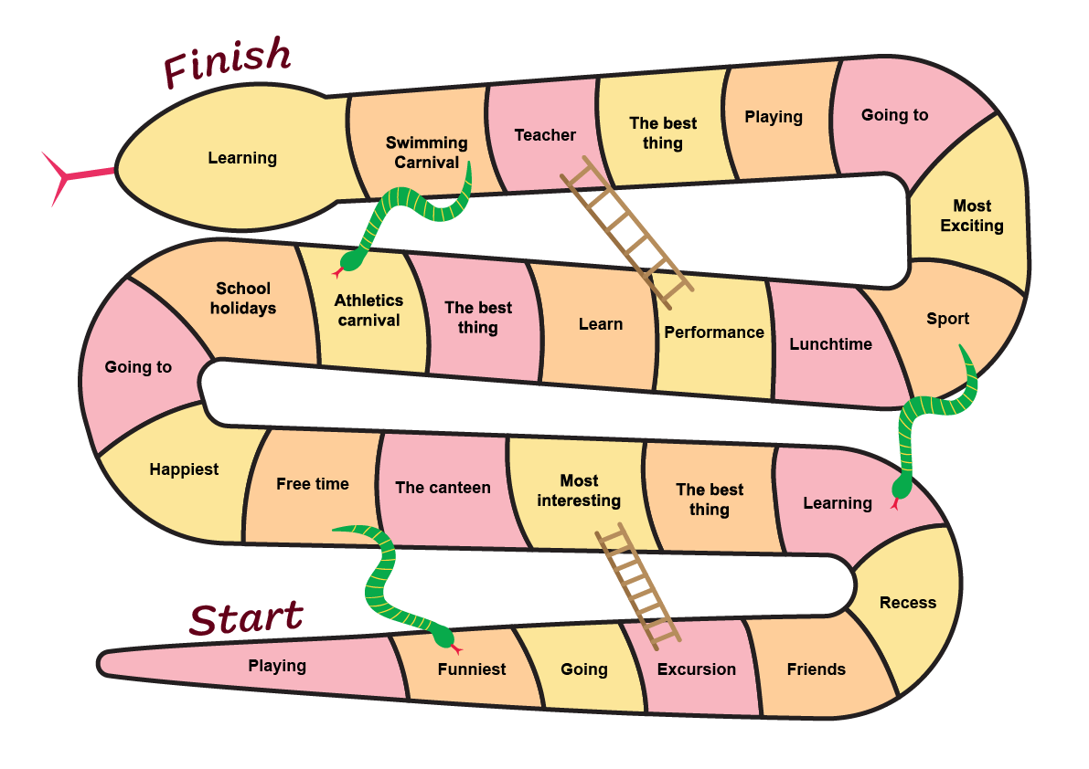
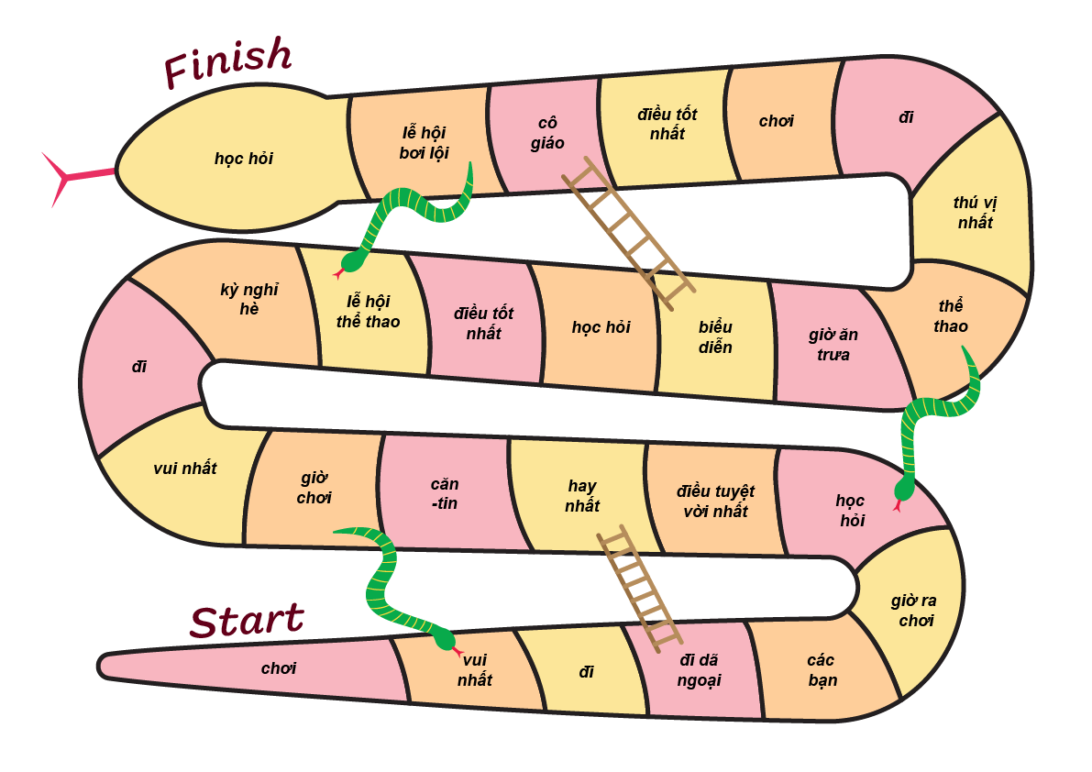

Resource 5 – memories flashcards
 |  | 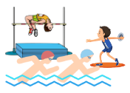 |  |  |  | 
camp |  | sports carnival |  | Book Week |  | Easter hat parade
 |  |  |  |  |  | 
excursion |  | multicultural day |  | mufti day |  | concert

cắm trại |  | lễ hội thể thao |  | Tuần Lễ Sách |  | Diễu hành nón Phục Sinh
buổi tham quan |  | Lễ hội văn hóa |  | ngày mặc đồ thường |  | Buổi hòa nhạc

Resource 6 – matching words
Mixed-up words
New vocabulary | Từ mới
excursions | lễ hội thể thao
camp | ngày mặc quần áo thường
mufti day | Tuần Lễ Sách
Book Week | lễ hội bơi lội
concert | cuộc diễu hành mũ Phục Sinh
multicultural day | buổi hòa nhạc
Easter hat parade | đi cắm trại
swimming carnival | lễ hội văn hóa
athletics carnival | đi dã ngoại

Correct matches (Answers sheet)
New vocabulary | Từ mới
excursions | đi dã ngoại
camp | đi cắm trại
mufti day | ngày mặc quần áo thường
Book Week | Tuần Lễ Sách
concert | buổi hòa nhạc
multicultural day | lễ hội văn hóa
Easter hat parade | cuộc diễu hành mũ Phục Sinh
swimming carnival | lễ hội bơi lội
athletics carnival | lễ hội thể thao

Resource 7 – sentence builder
My | superlative | memory of school is | memory
Của em (My) | vui nhất (funniest)  hay nhất (most interesting)  hạnh phúc nhất (happiest)  thú vị nhất (most exciting) | kỷ niệm ở trường là (memory of school is) | đi cắm trại (camp)  lễ hội bơi lôi (swimming carnivals)  lễ hội thể thao (athletics carnivals)  Tuần Lễ Sách (Book Week)  diễu hành nón Phục Sinh (the Easter hat parades)  lễ hội văn hóa (multicultural days)  đi dã ngoại (excursions)  ngày mặc quần áo thường (mufti days)

My | superlative | memory of school is | memory
Của em | vui nhất  hay nhất  hạnh phúc nhất  thú vị nhất | kỷ niệm ở trường là | đi cắm trại  lễ hội bơi lôi  lễ hội thể thao  Tuần Lễ Sách  diễu hành nón Phục Sinh  lễ hội văn hóa  đi dã ngoại  ngày mặc quần áo thường

Resource 8 – role-play scaffold cards
Student A (journalist): Hello, could you tell me about your time in Primary school?  Student B (student): Sure, I would love to.  Student A (journalist): What is the best thing about school?  Student B (student): The best thing about school is my teacher.  Student A (journalist): What is your happiest memory of school?  Student B (student): My happiest memory of school is going to school camp.  Student A (journalist): Thank you for talking to me today.  Student B (student): You’re welcome. | Học sinh A (nhà báo): Xin chào, bạn có thể kể về kỷ niệm của mình ở trường tiểu học không?  Học sinh B (học sinh): Chắc chắn rồi. Mình sẽ kể cho bạn nghe.  Học sinh A (nhà báo): Điều tuyệt vời nhất ở trường là gì?  Học sinh B (học sinh): Điều tuyệt vời nhất ở trường là cô giáo của mình.  Học sinh A (nhà báo): Kỷ niệm vui nhất ở trường là gì?  Học sinh B (học sinh): Kỷ niệm vui nhất ở trường là khi đi cắm trại.  Học sinh A (nhà báo): Cám ơn bạn đã chia sẻ.  Học sinh B (học sinh): Không có chi.

Resource 9 – assessment task – Our yearbook

Outcomes
You will be assessed on how well you:
- exchange information and opinions in familiar contexts by using culturally appropriate rehearsed language.

Task
Your class has been asked to create a video yearbook in Vietnamese to celebrate your time in primary school. Provide information to a student journalist on your favourite subjects, friends, and memories.
The table below outlines the communicative task students will need to complete.
Too hard? | Too easy?
Create a video yearbook  Provide a scaffold template for students with visuals and some phrases. | Create a video yearbook  Students provide detailed information about their friendship and/or explanations for their favourite subjects and memories.

Learning intention
Students will be able to participate in conversations to talk about their time at primary school.

Success criteria
You will create a video yearbook and talk about your favourite things and memories at school. You will need to include these in your conversations: favourite subjects, best friend, and fun memories.
You will be successful if you can:
- speak in Vietnamese using modelled sentences
- speak in a well-paced manner
- include personal information such as your favourite subject, best friend, and memories
- correctly use grammar and pronounce learned vocabulary
- use superlatives to describe your memories.

Task instructions
- This task will be completed in groups of 4. Each student will take turns at all 4 roles:
- the student (the interviewee)
- peer-assessor
- the student journalist (the interviewer)
- camera operator.
- The student being interviewed is completing the communicative task, so you will only be assessed for task completion while performing this role. You will be assessed on all other criteria in the rubric while performing all roles except for camera operator.
- When you are the camera operator, you will record the interaction between the other members of your group.
- Either the student journalist or camera operator will also provide feedback to the student being interviewed. This feedback will take the form of ‘Tell, Ask, Give’.
- Reflect on your performance and identify areas for improvement. Use this information to set a learning goal for the next stage of learning.

Resource 10 – rubric – Our yearbook
Name:
Table 3 – rubric for Lưu Bút của chúng ta (Our yearbook)
Criteria | Excellent | Got it | Sort of | Not yet | Limited
Communication | Your audience, the student journalist, clearly understand what you want to communicate.  Successfully and thoroughly complete all of the following aspects of the task:  - speak in Vietnamese using modelled sentences  - speak in a well-paced manner  - include personal information such as favourite subject, best friend, and memories  - correctly use grammar and pronounce learned vocabulary  - use superlatives to describe your memories. | Your audience, the student journalist, can understand what you want to communicate.  Successfully complete all of the following aspects of the task:  - speak in Vietnamese using modelled sentences  - speak in a well-paced manner  - include personal information such as favourite subject, best friend, and memories  - correctly use grammar and pronounce learned vocabulary  - use superlatives to describe your memories. | Your audience, the student journalist, can mostly understand what you want to communicate.  Successfully complete most of the following aspects of the task:  - speak in Vietnamese using modelled sentences  - speak in a well-paced manner  - include personal information such as favourite subject, best friend, and memories  - correctly use grammar and pronounce learned vocabulary  - use superlatives to describe your memories. | Your audience the student journalist, struggles to understand what you want to communicate. However, communication is successful.  Do not complete all aspects of the task. | Your audience, the student journalist, is unable to understand what you want to communicate.  Unable to complete any aspect of the task.
Fluency | Speak Vietnamese with ease in a well-paced manner without long pauses. | Speak confidently with appropriate speed and expression. | Usually speak confidently with appropriate speed and expression. | Don’t speak confidently. | Unable to be understood.
Grammar | Always use correct grammar when writing and speaking. | Usually use correct grammar when writing and speaking. | Make some grammar mistakes when writing and speaking. | Rarely make sense when speaking. | Unable to be understood.
Pronunciation | Pronounce all learned vocabulary correctly. | Pronounce most learned vocabulary correctly. | Consistently make pronunciation errors. | Pronounce only a few words correctly. | Unable to be understood.
Vocabulary | Use expected vocabulary correctly by adding superlatives to describe memories. | Use expected vocabulary in dialogue correctly. | Make some mistakes when trying to use expected vocabulary. | Make many mistakes when trying to use expected vocabulary. | Unable to use vocabulary in appropriate context.

Resource 11 – peer feedback strategy – TAG feedback slip
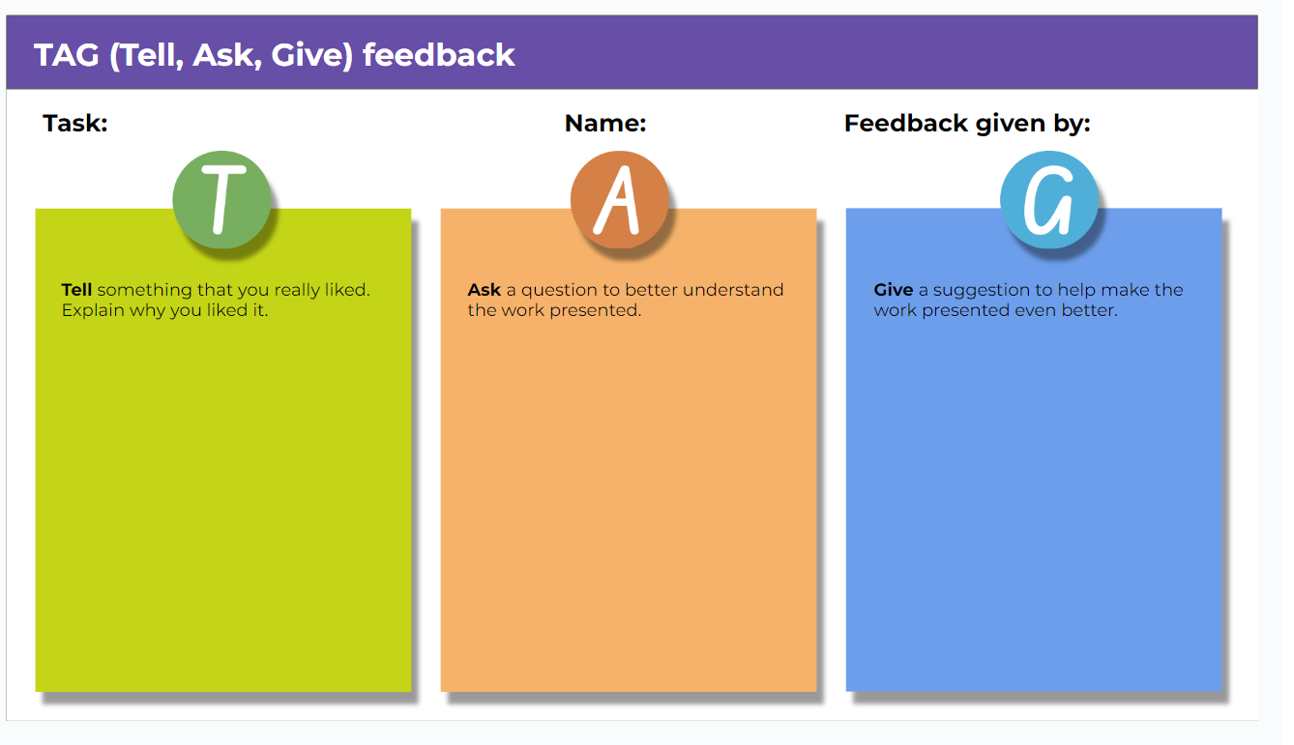

Resource 12 – learning goal form
Learning goal | Notes
My learning goal | I will pronounce [X] sound correctly in Vietnamese words and sentences.
The steps I will take | I will:  - say 5 different Vietnamese words with [X] sound every day  - record and listen to myself saying the sound in Vietnamese  - practise the sound with my friends and ask for their feedback  - listen and act on my teacher’s feedback.
Target date | Term 2, Week 8
Target achieved | Term 2, Week …

Support and alignment
Resource evaluation and support: all curriculum resources are prepared through a rigorous process. Resources are periodically reviewed as part of our ongoing evaluation plan to ensure currency, relevance, and effectiveness. For additional support or advice, contact the Primary Languages team by emailing primlang@det.nsw.edu.au.
Alignment to system priorities and/or needs: School Excellence Policy
Alignment to the School Excellence Framework: this resource supports the School Excellence Framework elements of curriculum (curriculum provision, teaching and learning programs) and effective classroom practice (lesson planning).
Alignment to Australian Professional Teaching Standards: this resource supports teachers to address Australian Professional Teaching Standards 2.2.2, 3.2.2.
Consulted with: Curriculum, Secondary Learners, school-based staff and NESA subject matter experts. Advice from Aboriginal Outcomes and Partnerships, EAL/D, HPGE and Inclusive Education for Modern Languages Stage 3 Italian Mangiare in Ristorante has been considered in preparing this document.
NSW syllabus: Modern Languages K–10 Syllabus
Syllabus outcomes: ML3-INT-01, ML3-UND-01, ML3-CRT-01
Author: Primary Curriculum
Publisher: State of NSW, Department of Education
Resource: unit
Related resources: further resources to support Stage 3 Modern Languages can be found on the Languages K–6 curriculum page.
Professional learning: relevant professional learning is available through Primary Languages Networks on Teams (staff only).
Universal Design for Learning: support the diverse learning needs of students using inclusive teaching and learning strategies. Some students may require more specific adjustments to allow them to participate on the same basis as their peers. For further advice see Inclusive practice resources for primary school.
Differentiation: when using these resources in the classroom, it is important for teachers to consider the needs of all students in their class, including:
- Aboriginal and Torres Strait Islander students. Targeted strategies can be used to achieve outcomes for Aboriginal students in K-12 and increase knowledge and understanding of Aboriginal histories and cultures. Teachers should use students’ Personalised Learning Pathways to support individual student needs and goals.
- EAL/D learners. EAL/D learners may require scaffolding to support them to gain content knowledge, while providing extra time and assistance to master the English language required to engage with texts or complete classroom tasks. View some samples of differentiating through scaffolding.
- Students with additional learning needs. Learning adjustments enable students with disability and additional learning and support needs to access syllabus outcomes and content on the same basis as their peers. Teachers can use a range of adjustments to ensure a personalised approach to student learning.
- High potential and gifted learners. Assessing and identifying high potential and gifted learners will help teachers decide which students may benefit from extension and additional challenge. In addition, the Differentiation Adjustment Tool can be used to support the specific learning needs of high potential and gifted students.
Creation date: 7 August 2024
Rights: © State of New South Wales, Department of Education

References
This resource contains NSW Curriculum and syllabus content. The NSW Curriculum is developed by the NSW Education Standards Authority. This content is prepared by NESA for and on behalf of the Crown in right of the State of New South Wales. The material is protected by Crown copyright.
Please refer to the NESA Copyright Disclaimer for more information https://educationstandards.nsw.edu.au/wps/portal/nesa/mini-footer/copyright.
NESA holds the only official and up-to-date versions of the NSW Curriculum and syllabus documents. Please visit the NSW Education Standards Authority (NESA) website https://educationstandards.nsw.edu.au/ and the NSW Curriculum website https://curriculum.nsw.edu.au/home.
Modern Languages K–10 Syllabus © NSW Education Standards Authority (NESA) for and on behalf of the Crown in right of the State of New South Wales, 2022.
8 Ways (n.d.) 8 Aboriginal Ways of Learning [website], accessed 13 December 2022.
AITSL (Australian Institute for Teaching and School Leadership (2017) ‘Feedback Factsheet’, AITSL, accessed Thursday 25 July 2024.
Brookhart SM (2011) How to Assess Higher-Order Thinking Skills in Your Classroom, Hawker Brownlow Education, Victoria, accessed Thursday 25 July 2024.
CESE (Centre for Education Statistics and Evaluation) (2020a) What works best: 2020 update, NSW Department of Education, accessed Thursday 25 July 2024.
CESE (Centre for Education Statistics and Evaluation) (2020b) What works best in practice, NSW Department of Education, accessed Thursday 25 July 2024.
Conti G (28 September 2015) ‘16 tips for effective grammar teaching in the foreign language classroom’, The Language Gym, accessed Day Month Year.
Conti G (28 May 2017) From Target Language to Model Language – the mind shift that has transformed my teaching, The Language Gym, accessed Thursday 25 July 2024.
Henshaw FG and Hawkins MD (2022) Common Ground: Second Language Acquisition Theory Goes to the Classroom, Focus, Indianapolis, accessed Thursday 25 July 2024.
Jones J and Wiliam D (2014) Modern Foreign Languages Inside the Black Box: Assessment for Learning in the Modern Foreign Languages Classroom (Black P, Harrison C, Marshall B and Wiliam D, eds), Learning Sciences International, United States, accessed Thursday 25 July 2024.
NESA (NSW Education Standards Authority) (2020) NSW Curriculum Review – final report, NESA, NSW Government, accessed Thursday 25 July 2024.
NESA (NSW Education Standards Authority) (2024) ‘Proficient Teacher: Standard descriptors’, Achieve Proficient Teacher accreditation, NESA website, accessed 11 September 2024.
Rosenshine B (2012) ‘Principles of Instruction: Research-Based Strategies That All Teachers Should Know’, American Educator, 36(1):12–19, 39, accessed Thursday 25 July 2024.
Smith S (2022) Becoming an Outstanding Languages Teacher, 2nd edn, Routledge, United Kingdom, accessed Thursday 25 July 2024.
Wisniewski B, Zierer K and Hattie J (2020) ‘The Power of Feedback Revisited: A Meta-Analysis of Educational Feedback Research’, Frontiers In Psychology, 10(3087), doi:10.3389/fpsyg.2019.03087, accessed Thursday 25 July 2024.
Wiliam D (2013) ‘Assessment: The bridge between teaching and learning’, Voices from the Middle, 21(2):15–20, accessed Thursday 25 July 2024.
Wiliam D and Leahy S (2015) Embedding Formative Assessment: Practical Techniques for K–12 Classrooms, Learning Sciences International, United States.

© State of New South Wales (Department of Education), 2024
The copyright material published in this resource is subject to the Copyright Act 1968 (Cth) and is owned by the NSW Department of Education or, where indicated, by a party other than the NSW Department of Education (third-party material).
Copyright material available in this resource and owned by the NSW Department of Education is licensed under a Creative Commons Attribution 4.0 International (CC BY 4.0) license.

This license allows you to share and adapt the material for any purpose, even commercially. Attribution should be given to © State of New South Wales (Department of Education), 2024.
Material in this resource not available under a Creative Commons license:
- the NSW Department of Education logo, other logos and trademark-protected material
- material owned by a third party that has been reproduced with permission. You will need to obtain permission from the third party to reuse its material.
Links to third-party material and websites
Please note that the provided (reading/viewing material/list/links/texts) are a suggestion only and implies no endorsement, by the New South Wales Department of Education, of any author, publisher, or book title. School principals and teachers are best placed to assess the suitability of resources that would complement the curriculum and reflect the needs and interests of their students.
If you use the links provided in this document to access a third-party's website, you acknowledge that the terms of use, including licence terms set out on the third-party's website apply to the use which may be made of the materials on that third-party website or where permitted by the Copyright Act 1968 (Cth). The department accepts no responsibility for content on third-party websites.

