Chinese Stage 2
永远的朋友 (Friends forever)
Contents
Unit overview 6
Stage 2 outcomes and content to be addressed 7
Learning map 11
Assessment 14
Assessment opportunities 15
Teaching and learning activities 16
Week 1 – What is your friend’s name? 16
Vocabulary 1 – introductory phrases 16
Activity 1 – learning map 17
Activity 2 – Timmy the puppet 18
Activity 3 – What’s your friend’s name? 20
Activity 4 – sing a song 22
Activity 5 – dialogue dance 22
Week 2 – appearance 24
Vocabulary 2 – describing people 25
Activity 1 – pre-assessment 26
Activity 2 – ‘The Big Wind blows’ 27
Activity 3 – asking and responding to questions 29
Activity 4 – sentence builder – appearance 30
Activity 5 – listen, draw and label 31
Activity 6 – recording vocabulary 32
Week 3 – things that you do together 33
Vocabulary 3 – verb phrases 33
Activity 1 – guess who 35
Activity 2 – verbal phrases 35
Activity 3 – act it out 36
Activity 4 – asking and responding to questions 37
Activity 5 – sentence builder – activities 38
Activity 6 – role play 39
Week 4 – personality 41
Vocabulary 4 – personality 41
Activity 1 – vocabulary 43
Activity 2 – friend profile 43
Activity 3 – asking questions 44
Activity 4 – pass the ball 45
Activity 5 – because 46
Activity 6 – poster of my friend 47
Week 5 – assessment criteria and practice task 49
Activity 1 – speed chatting 49
Activity 2 – introduce assessment task 51
Activity 3 – success criteria 52
Activity 4 – discuss the rubric 52
Activity 5 – practice task 53
Week 6 – communicative task – describe a friend in Australia 55
Activity 1 – mind reader 55
Activity 2 – task set-up 56
Activity 3 – communicative task – describe a friend in Australia 57
Activity 4 – peer assessment 58
Week 7 – feedback and goal setting 60
Activity 1 – translation 61
Activity 2 – self-assessment 61
Activity 3 – set learning goals 61
Activity 4 – friends bingo! 62
Activity 5 – KWL chart 63
Week 8 – language review 64
Activity 1 – student questions 65
Activity 2 – musical statues 65
Activity 3 – sentence building relay 66
Student resources 67
Resource 1 – question cards 67
Resource 2 – What is your friend’s name? lyrics 69
Resource 3 – KWL chart 70
Resource 4 – describing people flashcards 71
Resource 5 – matching cards 75
Resource 6 – sentence builder – appearance 76
Resource 7 – verb phrases flashcards 78
Resource 8 – sentence builder – activities 80
Resource 9 – personality flashcards 82
Resource 10 – sentence builder – personality 84
Resource 11 – assessment task – describe a friend in Australia 86
Outcomes 86
Task 86
Learning intention 87
In the conversation, include additional information such as how long you’ve been friends and what you like most about your friend. 87
Success criteria 87
Task instructions 87
Resource 12 – rubric – Friends forever 89
Resource 13 – TAG (Tell, Ask, Give) peer feedback strategy 92
Resource 14 – translation cards examples 93
Resource 15 – learning goal form 95
Resource 16 – sentence building relay 96
Support and alignment 99
References 102

Unit overview
Stage: 2
Title: 永远的朋友 (Friends forever)
Description: In this unit, students have a conversation online with their friend in China telling them about their friend in Australia. In their conversation, students describe their friend’s appearance, things that they do together and their personality.
Duration: This lesson sequence is designed to be completed over approximately 8 weeks.
Student proficiency levels: It is assumed that many Stage 2 students have been learning Chinese since Kindergarten and for many, their proficiency level will be Intermediate, although some students will still be at the Beginner level. Every classroom will be different, and teachers will need to adapt to their context. Many classes may include a combination of Beginner, Intermediate and Advanced students.

Stage 2 outcomes and content to be addressed
The table below outlines the focus area, outcomes and content points for Stage 2 students.
Focus area and outcome | Content points
Interacting  A student:  - exchanges information in familiar contexts by selecting culturally appropriate modelled language ML2-INT-01 | Exchanging meaning in oral interactions in the target language  - Ask and answer modelled questions in a guided conversation  - Interact in conversation with teacher and peers in familiar social contexts  Applying knowledge of language systems to interact in the target language  - Recognise and use modelled sounds, including pronunciation and intonation patterns and/or rhythms to interact  - Select familiar vocabulary and formulaic phrases to interact  - Use modelled sentence structures to interact  Applying knowledge of the target language culture(s) to interact  - Use modelled language structures and nonverbal communication that are appropriate to cultural practices
Understanding texts  A student:  - identifies and responds to information in texts to demonstrate understanding ML2-UND-01 | Understanding and responding to target language texts  - Listen to, read and view information in texts on familiar themes  - Respond to questions about specific information in texts on familiar themes, using modelled target language sentence structures and/or English  - Respond to texts through actions, visuals, written or spoken responses in the target language and/or English to demonstrate understanding and convey meaning  Applying knowledge of language systems to understand and respond to target language texts  - Identify and use the sounds of familiar vocabulary and phrases in the target language to understand and respond to texts  - Recognise and use sound–symbol correspondences to understand and respond to texts  - Identify and use knowledge of vocabulary and formulaic phrases from familiar themes to understand and respond to texts  - Identify and use elements of grammar in familiar language patterns  - Recognise modelled target language features and compare them with English features  - Recognise and use modelled structures and features of the target language writing system to understand and respond to texts  Developing intercultural understanding through target language texts  - Respond to texts and identify connections between language and cultural practices and reflect on their own language(s) and culture(s)
Creating texts  A student:  - creates texts for familiar communicative purposes by selecting culturally appropriate modelled language ML2-CRT-01 | Creating spoken, written and multimodal texts in the target language  - Create informative texts appropriate to context, purpose and audience describing themselves and their personal world  - Create imaginative texts appropriate to context, purpose and audience using a series of modelled sentence structures and visuals to add meaning  Applying knowledge of language systems to create texts in the target language  - Use pronunciation and intonation patterns to create spoken texts  - Use sound–symbol correspondence to create written texts  - Use vocabulary, formulaic expressions or modelled phrases from familiar themes to create texts  - Use elements of simple grammar patterns in modelled sentence structures to create texts  - Use modelled structures and features of the target language writing system to create written texts  Applying knowledge of the target language culture(s) to create texts  - Select language appropriate to cultural practices to create texts
Modern Languages K–10 Syllabus © NSW Education Standards Authority (NESA) for and on behalf of the Crown in right of the State of New South Wales, 2022.

Learning map
The creation of maps for learning is a planning process that incorporates Aboriginal intellectual tradition. Learning maps are a visual pathway of what students will learn.
Share the learning map with your students, briefly explaining the learning that will happen in each lesson. Provide students with a copy of the learning map or display the learning map in the classroom. This learning map can be adapted to Chinese by accessing a copy of Learning map – 永远的朋友 (Friends forever) (Stage 2).
Figure 1 – Friends forever learning map
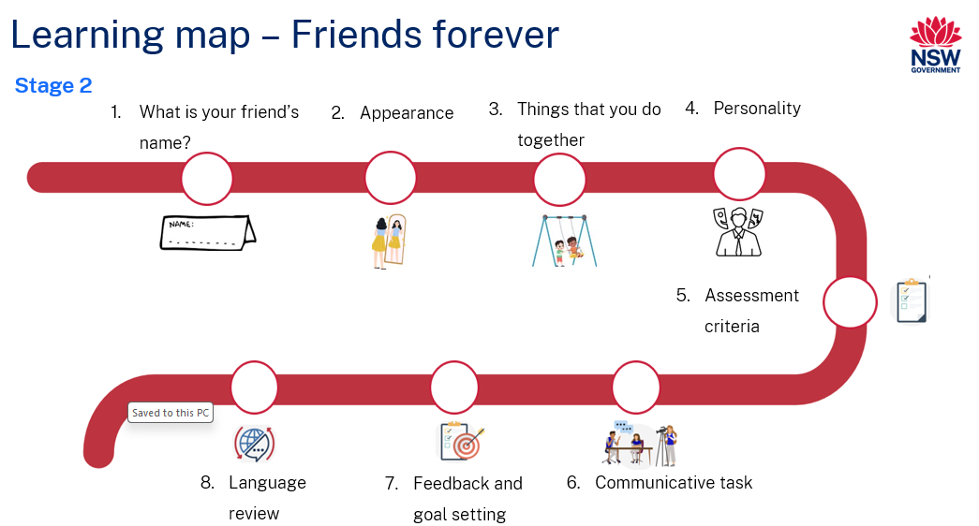

Figure 2 – 永远的朋友 learning map
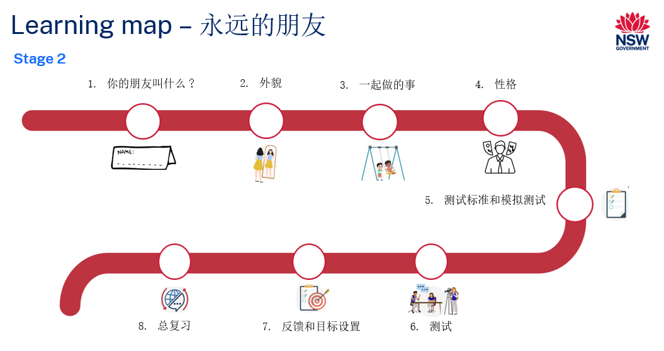

Assessment
Stage 2 communicative task: Tell a friend who lives in China about a friend in Australia. Include what your friend looks like, things that you do together and their personality.
Too hard?
In the conversation, describe your friend’s appearance and things that you do together.
Too easy?
In the conversation, include additional information such as how long you’ve been friends and what you like most about your friend.
Context: talking to your friend in China
Audience: friend in China
Purpose: to tell a friend in China about your Australian friend

Assessment opportunities
The table below details assessment opportunities and differentiation ideas.
Assessment opportunities | Too hard? | Too easy?
Week 1 – dialogue dance  Students practise asking and responding to a question about their friend’s name. | Dialogue dance  Include Pinyin alongside the sample interaction to offer support. | Dialogue dance  Students ask about multiple friends.
Week 2 – listen, draw and label  One student verbally describes the appearance of their friend while the other student illustrates. After completing their drawings, both students label what they have drawn. | Listen, draw and label  Students refer to the word wall or a scaffold to support labelling. | Listen, draw and label  Students write in Chinese characters.
Week 4 – profile of my friend  Students write sentences about their hypothetical friend matching the picture they create. | Profile of my friend  Students are given sentence starters to help them to complete the sentences. | Profile of my friend  Students write more detailed sentences, including additional information, such as hobbies.

Teaching and learning activities

Week 1 – What is your friend’s name?
The table below outlines the learning intention and success criteria of the lesson, and materials that the teacher and students will need to complete the teaching and learning activities.
Learning intention and success criteria | Materials
Students will ask someone what their friend’s name is in Chinese.  Students can:  - ask and answer questions about themselves and a friend. | - Resource 1 – question cards  - Resource 2 – What is your friend’s name? lyrics  - Learning map  - Intentional observation checklist for communicative activities  - A puppet

Vocabulary 1 – introductory phrases
The table below outlines suggested vocabulary for the unit. It includes the original Chinese characters, a Romanised version of the Chinese characters (Pinyin) and the corresponding English translations.
English | Romanised Chinese (Pinyin) | Chinese
How are you? | Nǐ hǎo ma? | 你好吗？
What are you doing? | Nǐ zài gàn shénme? | 你在干什么？
What is your friend’s name? | Nǐ de péngyou jiào shénme míngzì? | 你的朋友叫什么名字？
My friend’s name is … | Wǒ de péngyou jiào … | 我的朋友叫...
His name is ... | Tā de míngzì shì … | 他的名字是…
Her name is ... | Tā de míngzì shì … | 她的名字是…
I am playing with my friend. | Wǒ zhèngzài hé wǒ de péngyou yìqǐ wán. | 我正在和我的朋友一起玩。

Activity 1 – learning map
Explain and display the Learning map to give students a more detailed breakdown of lessons during the unit. Point out that the Learning map is a plan that may need to change.
Tell students that in this unit, they will be asking and responding to questions about their friend, their appearance, things they do together and their personality using questions on Resource 1 – question cards which will each be the focus of a lesson.

Activity 2 – Timmy the puppet
- Introduce a puppet to the class and tell them that in this unit, you and your friend, Timmy the puppet, will have a conversation about your friend in China. You and Timmy will ask and respond to the questions about your friend on the various topics every week. Display and point to a picture of your friend (see Figure 3).
Figure 3 – friend in China
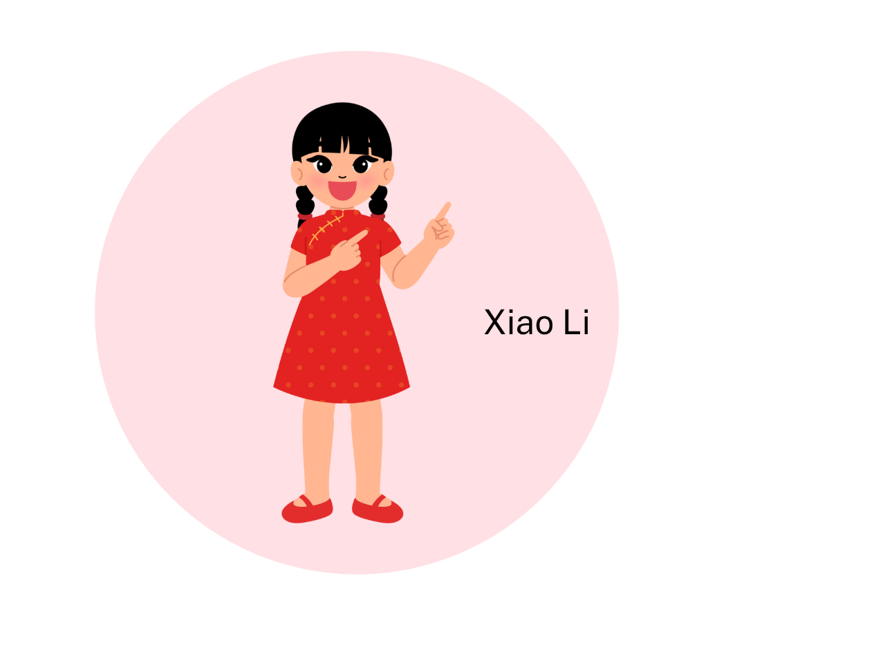
- Sample conversation:
- Timmy the puppet: 你好! 你好吗？ (Hello! How are you?)
- Teacher: 你好! 我很好.(Hello! I’m good.)
- Repeat the conversation a few times. Ask students if they can identify any words. Have students Think-Pair-Share to discuss any Chinese words they already know in the conversation. Ask students if they can predict the meaning of the words我很好 (I’m good), 你好吗？ (How are you?) in English.
- Display Vocabulary 1 – introductory phrases on the board and point to the questions 你好！你好吗？ (Hello! How are you?) and 你在干什么？ (What are you doing?) on the board from Vocabulary 1 – introductory phrases. Tell students that you will be calling out greetings and asking them how they are and what they are doing in Chinese. Greet and ask students how they are in Chinese. Call out each word on the board in Chinese and ask students to tell their partners the words they know in English. Check if their prediction was correct. Model and drill the correct pronunciation of the phrase and ask them to repeat each word after you.
- Point to the sentence 我正在和我的朋友一起玩. (I am playing with my friend.) Tell them to respond to the question 你在干什么？ (What are you doing?). They might say, 我正在和我的朋友一起玩. (I am playing with my friend.)
- Practise the conversation as a whole class.
- Sample conversation:
- Timmy the puppet: 你好! 你好吗？ (Hello! How are you?)
- Teacher: 你好! 我很好. (Hello! I’m good.)
- Timmy the puppet: 你在干什么？ (What are you doing?)
- Teacher: 我正在和我的朋友一起玩. (I am playing with my friend.)

Activity 3 – What’s your friend’s name?
- Tell students that they will revise how to ask someone their name. Ask students what their name is by asking, ‘What’s your name?’ in Chinese. Students turn to face a partner and ask them their name in Chinese.
- Display Resource 1 – question cards on the board. Read Question 1 aloud. After reading, ask students to show a thumbs up near their chest if they know each question well, a thumb sideways if they somewhat understand it and a thumbs down if they have never heard the question.
- Point out that the learning intention and success criteria of the lesson is to ask your friend their friend’s name in Chinese. Prompt students to ask their friend what their name is. Have students Think-Pair-Share to discuss any Chinese words they might use when asking someone what their name is.
- Read aloud the first question, 你的朋友叫什么名字? (What is your friend’s name?), using Resource 1 – question cards and have students repeat each word after you.
- Point to the picture of the friend (see Figure 3) and tell students that to respond to the question, ‘What is your friend’s name’, say 我的朋友叫... (My friend’s name is ...), Xiao Li in this case.
- Present the puppet to the students again and demonstrate the conversation with Timmy the puppet.
- Sample interaction:
- Timmy the puppet: 你好! 你好吗？ (Hello! How are you?)
- Teacher: 你好! 我很好.(Hello! I’m good.)
- Timmy the puppet: 你在干什么？ (What are you doing?)
- Teacher: 我正在和我的朋友一起玩. (I am playing with my friend.)
- Timmy the puppet: 你的朋友叫什么名字？ (What is your friend’s name?)
- Teacher: 我的朋友叫Xiao Li. (My friend’s name is Xiao Li.)
- Explain to students that sometimes pronouns are also used when responding to the question about their friend’s name. They can respond to the question 你的朋友叫什么名字？ (What is your friend’s name?) by saying 她的名字是 ... (her name is ...) for feminine and 他的名字是 ... (his name is ...) for masculine.
- Ask students to turn and face a partner and practise asking and responding to the question about their friend’s name by using pronouns.
- Sample interaction:
- Student A: 你的朋友叫什么名字？ (What is your friend’s name?)
- Student B: 她的名字是Kim. (Her name is Kim (feminine)). 他的名字是Ken. (His name is Ken (masculine)).
- Students take turns at asking and responding to the question.

Activity 4 – sing a song
- Display Resource 2 – ‘What is your friend’s name?’ lyrics and model singing it to the tune of the Chinese children’s song 我的朋友在哪里？(Where is my friend?).
- Sing the song again, one line at a time. Ask students to repeat each line after you.
- Ask students to listen to the song twice and get familiar with the tune. Sing the song again and ask students if they know any of the words in the song or can guess the meaning of unfamiliar words.
- Repeat the phrases or lyrics, as a whole and in chunks. Ask students to practise singing the song using correct pronunciation.

Activity 5 – dialogue dance
Students practise telling their classmates about their friend. They walk around the classroom with the music. When the music stops, they pair up to practise the dialogue, then switch partners each time the music stops again. This continues until each student has practised with 3 to 5 different classmates. Encourage students to use the pronouns ‘his/her’ when asked about their friend’s name.
Sample interaction:
- Student A: 你好! 你好吗？ (Hello! How are you?)
- Student B: 你好！我很好. (Hello! I am good.)
- Student A: 你在干什么？ (What are you doing?)
- Student B: 我正在和我的朋友一起玩. (I am playing with my friend.)
- Student A: 你的朋友叫什么名字？ (What is your friend’s name?)
- Student B: 我的朋友叫… (My friend’s name is …) / 他的名字是… (His name is ...) / 她的名字是… (Her name is ...)
Note: students with Advanced proficiency may choose different verb in this sentence, for example, talking, eating, and so on.
Evaluation: use Intentional observation checklist for communicative activities to make notes about student understanding of the target language and their pronunciation.

Week 2 – appearance
The table below outlines the learning intention and success criteria of the lesson, and materials that the teacher and students will need to complete the teaching and learning activities.
Learning intention and success criteria | Materials
Students will learn to describe the appearance of a person.  Students can:  - say the adjectives using correct pronunciation  - describe their friend’s appearance  - say sentences in Chinese using the correct sentence structure. | - Resource 3 – KWL chart  - Resource 4 – describing people flashcards  - Resource 5 – matching cards  - Resource 6 – sentence builder – appearance  - Intentional observation checklist for communicative activities  - A puppet  - Chinese exercise books  - Pencils  - Word wall

Vocabulary 2 – describing people
The table below outlines suggested vocabulary for the unit. It includes the original Chinese characters, a Romanised version of the Chinese characters (Pinyin) and the corresponding English translations.
English | Romanised Chinese (Pinyin) | Chinese
straight | zhí de | 直的
curly | juǎn de | 卷的
long | cháng de | 长的
short (length) | duǎn de | 短的
tall | gāo de | 高的
short (height) | ǎi de | 矮的
red | hóngsè de | 红色的
brown | zōngsè de | 棕色的
black | hēisè de | 黑色的
blonde | jīnsè de | 金色的

Activity 1 – pre-assessment
Note: it is assumed that by Stage 2 most students would know some words from Vocabulary 2 – describing people. For pre-assessment, prepare the flashcards from Resource 4 – describing people flashcards with images only.
- Display Resource 3 – KWL chart in the classroom. Tell students that they will write words under each column depending on the vocabulary they already know and want to know for Vocabulary 2 – describing people.
- Hand out a copy of the chart to each student.
- As a class, brainstorm vocabulary related to describing people in English and display images from Resource 4 – describing people flashcards one at a time. Have students Think-Pair-Share to discuss the words they might know.
- As you call out the words in English, ask students to write the words they already know under the ‘K’ column in Chinese, and words they want to learn under the ‘W’ column in English.
- Display flashcards from Resource 4 – describing people flashcards one at a time and have students help place each card next to the correct flashcard. Students check their responses.
- Model and drill the correct pronunciation of all the words. Ask students to pay careful attention to the words that are in their ‘W’ column of the KWL chart.
- Begin a class word wall. Have students record the words they wanted to learn under ‘W’ column in Chinese.
- Tell students that they will revisit the KWL chart later in the unit.
- Split the class in small groups of 3. Hand a set of Resource 5 – matching cards to each group. Explain that they will match the English translation, Pinyin, and Chinese characters when a word from Vocabulary 2 – describing people is called out. The first group to correctly match the words earns one point. The activity continues until all the words have been called out.
Note: for students with Advanced proficiency, introduce additional phrases to describe someone’s appearance, such as 戴眼镜 (wears glasses), 又大又圆的眼睛 (big and round eyes).

Activity 2 – ‘The Big Wind blows’
- Tell the students that they will play a game called ‘The Big Wind blows’. Write 大风吹. 吹什么？ (The Big Wind blows. What does it blow?) on the board. Have the students repeat it after you several times. Explain that when they hear you say 大风吹 (The wind blows), they should respond with 吹什么？ (What does the wind blow?). Rehearse the phrase until students are familiar with it. To this, you can respond with any description that could apply to any or all the students. Examples include: 吹黑头发的小朋友 (The wind blows the children with black hair), 吹卷头发的小朋友. (The wind blows the children with curly hair).
- Have students sit in a circle and you stand in the middle of the circle.
- Demonstrate the game to the whole class. Begin the game by saying: 大风吹 (the wind blows). The students respond by saying: 吹什么？ (What does the wind blow?) either in English or Chinese.
- Respond with: 吹棕色眼睛的小朋友 (The wind blows the children with brown eyes) or 吹卷头发的小朋友. (The wind blows the children with curly hair).
- All students with the characteristic that has been called out stand up and move out of the circle. The last student remaining will be in the middle to give instructions for the next round.
- Divide students into groups of 6. Select one student from each group to lead the game. Continue playing until every student in each group has had a turn.
Note: if the students require assistance to remember the dialogue ‘The Big Wind blows. What does it blow?’ in Chinese, say it in English. However, students must respond with adjectives in Chinese.

Activity 3 – asking and responding to questions
Note: When asking a question in Chinese, 什么样 (what) is positioned at the end of the sentence, unlike in English where ‘what’ is placed at the beginning of a question.
- Display Figure 3 and Question card 2 in Resource 1 – question cards on the board. Hold Timmy the puppet in your hand, and tell students that you are going to have a conversation with Timmy about your friend’s name and appearance.
- Sample interaction:
- Timmy the puppet: 你的朋友叫什么名字？ (What is your friend’s name?)
- Teacher: 我的朋友叫小丽. (My friend’s name is Xiao Li.)
- Timmy the puppet: 你的朋友长什么样？ (What does your friend look like?) / 她长什么样？ (What does she look like?) / 他长什么样? (What does he look like?)
- Teacher: 我的朋友有黑头发. (My friend has black hair.) / 她有黑头发 (She has black hair.) / 他有黑头发 (He has black hair.)
- Point to the question: What does your friend look like? from Resource 1 – question cards. Read aloud the question 你的朋友长什么样? (What does your friend look like?) After reading, ask students to show a thumbs up near their chest if they know the question well, a thumb sideways if they somewhat understand it and a thumbs down if they are unfamiliar with the question.
- Read the question aloud again using the correct pronunciation and intonation. Have students repeat each word after you. Explain them that they can also use pronouns such as 他/她 (he/she) instead of their friend’s name when asking about their friend’s appearance, for example: 她长什么样？ (What does she look like?) for feminine form and 他长什么样？ (What does he look like?) for masculine form.
- Write the question, ‘What does your friend look like?’ on the board in English, then write the question in Chinese, 你的朋友长什么样？ (What does your friend look like?) and compare it with the English translation. Highlight that in Chinese, when asking a question, 什么 (what) is placed at the end of a sentence.
- In pairs, students practise asking the question about their friend’s appearance using their friend’s name and pronouns.

Activity 4 – sentence builder – appearance
- Display Figure 3 to students and ask the question 小丽长什么样子？ (What does Xiao Li look like?) Possible answers may include Xiao Li有黑头发. (Xiao Li has black hair.) Xiao Li很高. (Xiao Li is tall.) Students may respond in English at this point. As students are giving answers, display the relevant flashcards from Resource 4 – describing people flashcards on the board.
- Display Resource 6 – sentence builder – appearance to the students. Explain that they will be using this resource to make sentences about their friend’s appearance. Point out each of the columns: person, verb, adjective and noun.
- Introduce the phrases under the ‘person’ column, 我的朋友有/是…，他有/是…，她有/是… (my friend has/is ..., he has/is ..., she has/is ...) Model and drill the correct pronunciation of each phrase. Explain that these phrases are used as a sentence starter to describe someone’s appearance.
- Students self-assess their understanding of each phrase by raising their thumb up to their chest if they are familiar with the meaning of each phrase.
- Model saying a few sentences to describe the appearance of a friend and ask students to repeat the sentence after you. For example, my friend is [adjective]. She has [adjective] [noun]. 我的朋友很高。她有长头发。(My friend is tall. She has long hair.) Then, ask them to turn to a partner and repeat the sentence. Repeat by making more sentences to describe the appearance.
- Explain to students that both 红色的头发 (red hair) and 红头发 (red hair) are correct, but 红发 (red hair) is more concise and commonly used. When an adjective comes before 头发 (hair) and 的 is omitted, 头 (head) can also be omitted. Here are the examples:
- 黑头发 (black hair) can be simplified to 黑发.
- 短头发 (short hair) can be simplified to 短发.
Note: for students with Advanced proficiency, add measure words to describe the appearance in the sentence, for example, 我的朋友有一头红头发. (My friend has red hair.) 他有一双大眼睛. (He has a pair of big brown eyes.)

Activity 5 – listen, draw and label
Note: as students are completing the activity, use the Intentional observation checklist for communicative activities to record your observations of students' pronunciation and their use of grammar and vocabulary.
- One student verbally describes a friend's appearance in Chinese and the other student draws and labels the description on paper using Chinese characters or Pinyin.
- The students switch roles, allowing both to practise describing and illustrating.
- Sample interaction:
- Student A: 我的朋友有长发. (My friend has long hair.)
- Student B draws a picture of a friend with long hair and labels it with the Chinese characters for 长发 (long hair).
- Student B: 我的朋友很高. (My friend is tall.)
- Student A draws a picture of a tall friend and labels it with the Chinese characters for 高 (tall).

Activity 6 – recording vocabulary
Have students record the new language into their Chinese exercise books and update the KWL chart with the words they have learned or words they may want to know.

Week 3 – things that you do together
The table below outlines the learning intention and success criteria of the lesson, and materials that the teacher and students will need to complete the teaching and learning activities.
Learning intention and success criteria | Materials
Students will use both familiar and new vocabulary to discuss activities they engage in with their friends.  Students can:  - say vocabulary related to activities done with friends  - ask and respond to questions about the activities done with friends. | - Resource 7 – verb phrases flashcards  - Resource 8 – sentence builder – activities  - A puppet  - Chinese exercise books

Vocabulary 3 – verb phrases
The table below outlines suggested vocabulary for the unit. It includes the original Chinese characters, a Romanised version of the Chinese characters (Pinyin) and the corresponding English translations.
English | Romanised Chinese (Pinyin) | Chinese
play soccer | tī zúqiú | 踢足球
kick shuttlecock | ti jiànzi | 踢毽子
eat lunch | chī wǔfàn | 吃午饭
chat | liáotiān | 聊天
swim | yóuyǒng | 游泳
play hide and seek | zhuō mícáng | 捉迷藏
sit | zuò | 坐
play cards | dǎ pái | 打牌
play games | wán yóuxì | 玩游戏
play table tennis | dǎ pingpāng qiú | 打乒乓球

Activity 1 – guess who
Review Resource 4 – describing people flashcards. Tell the students that you will provide a description of one of the students in the class, and they must guess who that is. For example: 他有短头发. 他很高. (He has short hair. He is tall.)
Split the class in small groups of 4. Ask them to complete the activity in small groups of 4. Encourage them to use positive language when describing their peers.

Activity 2 – verbal phrases
- Display images from Resource 7 – verb phrases flashcards one at a time. Say each phrase in English as they are placed on the board.
- Explain to students that there are varied expressions for ‘play’ in Chinese. For example, in the phrase ‘play soccer’, the word ‘play’ is translated to踢 (kick), while in the phrase ‘play table tennis’, the word ‘play’ is translated to 打 (hit).
- Display a picture of people kicking a shuttlecock 踢毽子. Explain to them that 踢毽子 (kick shuttlecock) is a traditional Chinese game where players use their feet to keep a shuttlecock in the air. To kick well requires coordination, balance, and skill.
Figure 4 – kicking a shuttlecock
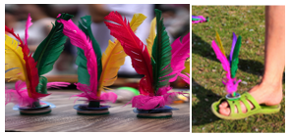
- Pre-assessment: students look at Resource 7 – verb phrases flashcards. Ask students to identify how many words they know in Chinese by answering the following questions, showing thumbs up at their chests:
- Do you know all the words?
- Do you know most of them?
- Do you know any of them?
- Students Think-Pair-Share and tell their partners the words they know and report back to the class.
- On the other side of the board, put the Chinese words for the activities one at a time in a random order. Model the pronunciation of each activity and have students imitate the pronunciation. Students match each word to an image.
- Model and have students repeat the pronunciation of each word.
- Add these words to the class word wall. Have students record these words into their exercise books and update the KWL chart.

Activity 3 – act it out
- Demonstrate playing charades with the students. Show an action, such as kicking, and encourage students to guess your action by calling out 踢足球 (play soccer).
- Choose a student and show them a flashcard from Resource 7 – verb phrases flashcards. The student must act out the action without speaking. The first student to guess correctly becomes the next participant to act out an action.
- Divide the class into small groups. Each group will take turns selecting a card and acting out the word or phrase for their classmates to guess.

Activity 4 – asking and responding to questions
- To pre-assess students’ vocabulary before teaching new words, have students Think-Pair-Share to discuss any Chinese words they might use when asking what they like doing with their friend?
- Display Resource 1 – question cards on the board. Read aloud the question 你喜欢跟你的朋友一起做什么？ (What do you like to do with your friend?) After reading, ask students to show a green card if they know the question well, and a red card if they are unfamiliar with the question.
- Read aloud the question again and have students repeat each word after you call them out.
- Explain the structure of the question to students, highlighting the question pattern 你喜欢跟你的朋友一起做什么？ (What do you like to do with your friend?). Point out that in a question, 什么样 (what) is positioned at the end of the sentence, unlike in English where ‘what’ is placed at the beginning of a question.
- Model saying the question 你喜欢跟你的朋友一起做什么？ (What do you like to do with your friend?) using the correct pronunciation and intonation. Have students repeat after you to practice the correct pronunciation.
Note: for students with Advanced language proficiency, introduce time phrases, such as 通常(usually), 有时候 (sometimes) to include in their sentences to provide additional context. For example, 你通常喜欢跟你的朋友一起做什么？ (What do you usually like to do together with your friend?)
- If needed, refer to Table 1.
Table 1 – sentence structure
English | Romanised Chinese (Pinyin) | Chinese
What do you like to do with your friend? | Nǐ xǐhuan gēn nǐ de péngyou yìqǐ zuò  shénme？ | 你喜欢跟你的朋友一起做什么？
I like to ... with my friend. | Wǒ xǐhuan hé wǒ de péngyou yìqǐ … | 我喜欢…和我的朋友一起

Activity 5 – sentence builder – activities
- Display Resource 8 – sentence builder – activities on board. Tell students that that they will use the sentence builder to answer the question 你喜欢跟你的朋友一起做什么？ (What do you like to do with your friend?).
- Point to the phrase, verb and noun one at a time, to make various sentences using different verbs and nouns. For example: 我喜欢聊天. (I like to chat with my friend).
- Display Figure 3 and Resource 1 – question cards on the board. Hold Timmy the puppet, in your hand and tell students that you are going to have a conversation with Timmy about what you like to do with your friend.
- Sample interaction:
- Timmy the puppet: 你喜欢跟你的朋友小丽一起做什么？ (What do you like to do with your friend Xiao Li?)
- Teacher: 我喜欢跟我的朋友小丽一起聊天. (I like to chat with my friend Xiao Li.)
- Repeat the conversation with different combination of verbs, nouns and friend names.

Activity 6 – role play
- Divide the class into pairs and hand out Resource 8 – sentence builder – activities to the students. Ask them to use the sentence builder and practise asking and responding to the question 你喜欢跟你的朋友一起做什么？ (What do you like to do with your friend?)
- Example interaction:
- Student A: 你喜欢跟你的朋友一起做什么？ (What do you like to do with your friend?)
- Student B: 我喜欢跟我的朋友一起踢毽子. (I like to kick shuttlecock with my friend)
- Repeat with another student.
- Student A: 你喜欢跟你的朋友一起做什么？ (What do you like to do with your friend?)
- Student B: 我喜欢跟我的朋友一起聊天. (I like to chat with my friend.)
- After the students practise the conversation in pairs, play music and have them walk around the classroom. Inform them that when the music stops, they should find a partner to practise the dialogue with. Repeat this process with different partner.
- After students have had a few turns asking and responding to the question, ask them to write the sentence in their books using Resource 8 – sentence builder – activities.
Note: students with Beginner proficiency level can use their creativity to come up with different responses based on their own preferences. For example, 我喜欢跟我的朋友一起玩玩具. (I like to play toys with my friend.) 我喜欢跟我的朋友在假期一起去滑冰. (I like to go skating with my friend over the holidays.)

Week 4 – personality
The table below outlines the learning intention and success criteria of the lesson, and materials that the teacher and students will need to complete the teaching and learning activities.
Learning intention and success criteria | Materials
Students will use learned vocabulary and sentence structures to describe their friend’s personality.  Students can:  - say vocabulary related to personality  - ask and answer questions about a friend’s personality  - create a profile on a hypothetical friend. | - Resource 1 – question cards  - Resource 6 – sentence builder – appearance  - Resource 8 – sentence builder – activities  - Resource 9 – personality flashcards  - Resource 10 – sentence builder – personality  - Drawing materials  - Paper

Vocabulary 4 – personality
The table below outlines suggested vocabulary for the unit. It includes the original Chinese characters, a Romanised version of the Chinese characters (Pinyin) and the corresponding English translations.
English | Romanised Chinese (Pinyin) | Chinese
kind | shànliáng | 善良
helpful | rèxīn | 热心
brave | yǒnggǎn | 勇敢
funny | yǒuqù | 有趣
cheerful | kāilǎng | 开朗
caring | tiēxīn | 贴心
friendly | yǒushàn | 友善
clever | cōngmíng | 聪明
naughty | wánpí | 顽皮

Activity 1 – vocabulary
- Pre-assess the Vocabulary 4 – personality by showing students the images from Resource 9 – personality flashcards. Ask students to give a thumbs-up as you ask the following questions:
- Do you know all the Chinese words for these images?
- Do you know most of them?
- Do you know any of them?
- Students pair up and engage in a Think-Pair-Share activity, where they identify the words they are familiar with and discuss them with a partner.
- Read out the flashcards and model the correct pronunciation of each Chinese word. Have students repeat each word after you several times. Ask students to suggest other adjectives related to personality traits to add to the word wall.

Activity 2 – friend profile
- Display Resource 9 – personality flashcards one at a time and ask students what each personality trait means.
- Tell students that you will describe a personality trait and they will guess the personality traits in the description. The description can be called out in English. Some examples are:
- Teacher: 他总是笑嘻嘻的. (He always smiles.)
- Students: 开朗 (cheerful)
- Teacher: 小红喜欢帮助人. Xiaohong likes to help others.）
- Students: 热心 (helpful)
- Split the class in small groups of 6. Students take turns to give a description of a personality trait in English and other students call out the personality trait described in the description.

Activity 3 – asking questions
- Display Resource 1 – question cards on the board. Read aloud the question 为什么他/她是你的朋友？ (Why is he/she your friend?). After reading, ask students to show a thumbs up near their chest if they know the question well, a thumb sideways if they somewhat understand it and a thumbs down if they have never heard the question.
- Read the question aloud again using the correct pronunciation and intonation. Have students repeat each word after you.
- Write ‘Why is he/she your friend?’ on the board in English. Ask them what type of sentence it is. Remind them that it is a question and point out that in English, ‘why’ is placed at the beginning of questions.
- Then, write the question in Chinese, 为什么他/她是你的朋友？ (Why is he/she your friend?) and compare it with the English translation. Explain the structure of the question to students, highlighting the question pattern 为什么他/她是你的朋友？ (Why is he/she your friend?). Emphasise that unlike other questions in Resource 1 – question cards that are ‘what’ questions, this is a ‘why’ question. In this sentence, 为什么 (why) is also positioned at the beginning of a sentence in this question, like in English.
- Model saying the question from Resource 1 – question cards using the correct pronunciation and intonation. Have students repeat after you to practice the correct pronunciation of the questions.

Activity 4 – pass the ball
- Display Resource 10 – sentence builder – personality on the board. Revise the phrases, 她是 (she is ...) / 他是 (he is ...) under the third column. Model and repeat the correct pronunciation of each phrase. Explain that these phrases are also used as a sentence starter to describe someone’s personality.
- Students self-assess their understanding of each phrase by raising their thumb up to their chest if they are familiar with the meaning of each phrase.
- Tell students that they will use Resource 10 – sentence builder – personality to make sentences to describe their friend’s personality.
- Model saying few sentences to describe the personality of a friend and ask students to repeat the sentence after you. For example, 她很有趣 (she is funny), 他很善良 (he is kind), following the sentence structure she/he is [adjective]. Then, ask them to turn to a partner and repeat the sentence. Repeat by making more sentences to describe the personality. Repeat with other adjectives.
- Demonstrate the game to the whole class. Have students sit in a circle and place flashcards from Resource 9 – personality flashcards in the middle of the circle.
- Give a soft ball to a student. Start the music and students begin passing the ball around the circle. Let them know that they should only pass the ball to the person sitting next to them. Show them the direction they should pass it around the circle.
- When the music stops, the student holding the ball picks up a card from Resource 9 – personality flashcards and says a sentence referring to Resource 10 – sentence builder – personality, for example, if a student picks up a card of 开朗 (cheerful), he would say他/她很开朗. (He/she is cheerful.)
- The card is put back into the middle of the circle and when the music starts again the ball is passed to the next student. Keep playing until each student has had a turn.
- Split the class in groups of 6. Students play the game in their groups.

Activity 5 – because
- Write the question, 为什么他/她是你的朋友？ (Why is he/she your friend?) on the board. Explain to the students that they will respond using full sentences from Resource 10 – sentence builder – personality. Tell them that they will use 因为 ‘because’ to connect the 2 phrases, 他/她是我的朋友 (He/she is my friend) and 他/她是 (he/she is) followed by an adjective. For example, 他是我的朋友因为他很有趣。 (He is my friend because he is funny.)
- Model saying few sentences and ask students to repeat the sentence after you. Then, ask them to turn to a partner and repeat the sentence.
- Display Figure 3 on the board. Hold Timmy the puppet in your hand and tell students that you are going to have a conversation with Timmy about why Xiao Li is your friend.
- Sample interaction.
- Timmy: 你好！(Hello!)
- Teacher: 你好！(Hello!)
- Timmy the puppet: 为什么Li En是你的朋友？ (Why is Li En your friend?)
- Teacher: Li En是我的朋友因为她乐于助人. (Li En is my friend because she is helpful.)
- Ask students to repeat after you to practise speaking the sentences aloud.
- In pairs, students take turns asking and answering questions about their imaginary friends using Resource 10 – sentence builder – personality.

Activity 6 – poster of my friend
- Hand out paper and drawing materials to students.
- Ask them to create a poster profile of an imaginary friend by drawing them.
- They write sentences about their hypothetical friend matching the picture using Resource 6 – sentence builder – appearance, Resource 8 – sentence builder – activities and Resource 10 – sentence builder-personality. See the below as an example:
Figure 2 – sample profile of a friend
My friend’s name is Jen.  She is tall.  She has long brown hair.  I like to eat lunch with Jen.  Jen is kind and helpful. | 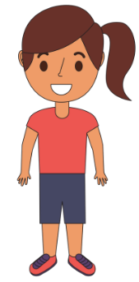 | wǒ péngyǒu jiào zhēn.  我朋友叫珍.  tā hěn gāo.  她很高.  Zhēn yǒu yītóu zōngsè de cháng fā.  珍有一头棕色的长发.  wǒ xǐhuan hé zhēn yìqǐ chī wǔcān.  我喜欢和珍一起吃午餐.  zhēn hěn Shànliáng， yě hěn rèxīn.  珍很善良，也很热心.
Note: students with Beginner proficiency may write key vocabulary and phrases to describe the profile of a friend. For example: tall, short, red hair, kind, helpful, eat lunch, and so on.

Week 5 – assessment criteria and practice task
The table below outlines the learning intention and success criteria of the lesson, and materials that the teacher and students will need to complete the teaching and learning activities.
Learning intention and success criteria | Materials
Students will develop a clear understanding of the requirements of the assessment task.  Students can:  - suggest appropriate success criteria  - explain what they need to do to be successful in the task. | - Resource 1 – question cards  - Resource 11 – assessment task – describe a friend in Australia  - Resource 12 – rubric – Friends forever  - Intentional observation checklist for communicative activities

Activity 1 – speed chatting
Note: use the Intentional observation checklist for communicative activities to make notes about student understanding of the target language, their pronunciation and use of gesture, facial expression and tone to support communication.
- Divide students into pairs and give each pair a set of Resource 1 – question cards.
- Explain that they will be taking turns asking and answering questions about their friend including name, appearance, things they do together and their personality. Refer to the success criteria.
- Demonstrate the activity as a whole class. Ask a student to come to the front. Hand them the question cards and ask them to ask you the questions on the cards one at a time. Answer the student’s questions appropriately.
- Remind students that they need to greet each other before asking questions and end the conversation by saying goodbye.
- Instruct student pairs to begin speed chatting, taking turns asking and answering questions from the cards.
- After a few minutes, have students switch partners and continue the speed chatting talking about a different friend.
- Monitor the conversation by walking around the classroom and providing support if needed.
- Sample interaction:
- Student A: 你好吗? (Hello, how are you?)
- Student B: 我很好. 我正在和我的朋友一起玩. (I’m good. I am playing with my friend.)
- Student A: 你的朋友叫什么名字? (What is your friend’s name?)
- Student B: 我朋友的名字是Sam. (My friend’s name is Sam.)
- Student A: 他长什么样? (What does he look like?)
- Student B: Sam很高. 他有黑头发. (Sam is tall. He has black hair.)
- Student A: 你们喜欢一起做什么? (What things do you like doing together?)
- Student B: 我喜欢跟我的朋友一起打乒乓球. (I like to play table tennis with my friend.)
- Student A: 为什么他是你的好朋友? (Why is he your good friend?)
- Student B: 他是我的好朋友因为他很善良, 也很热心. (He is my good friend because he is kind and helpful.)
- Student A: 快聊聊，再见！(Chat soon, goodbye!)
- Student B: 再见! (Goodbye!)
Note: Beginner students may use sentence builders to assist them with answering the questions. Encourage students with Advanced proficiency to increase the complexity of their answers by adding more verbs and additional activities, for example, 假期里，我喜欢和朋友一起去滑冰. 然后，我们去商店买食物. (In the holidays, I like to go skating with my friend. Then, we go to the shops and buy food.)

Activity 2 – introduce assessment task
- Hand out Resource 11 – assessment task – describe a friend in Australia.
- Tell students that their communicative task is: Tell a friend who lives in China about a friend in Australia. Include what your friend looks like, things that you do together and their personality.
- Point out that:
- the context of the task is that you talk about your friend who lives in Australia
- the audience of the communication will be your friend who lives in China
- the communicative purpose is to inform about your friend in China about your friend in Australia.

Activity 3 – success criteria
After looking at the assessment task, students Think-Pair-Share and suggest appropriate success criteria, such as:
I will be successful if I can:
- answer a question about my friend’s name
- describe the appearance of my friend using at least 2 adjectives
- talk about the things that I like to do with my friend
- describe my friend’s personality
- end the conversation in an appropriate way.

Activity 4 – discuss the rubric
- Show students an unmarked rubric please see Resource 12 – rubric – Friends forever. This may need to be adapted if the class has decided on different success criteria.
- The teacher explains metalanguage such as fluency, accuracy, pronunciation and vocabulary.
- Students read and then discuss the ‘excellent’ column of the rubric in pairs. They share their understanding of what is needed to be successful.
- Point out and provide examples of what ‘excellent’ and ‘sound’ samples of task completion, fluency, accuracy, pronunciation and vocabulary look and sound like.

Activity 5 – practice task
- Using the poster from Week 4, students will practise role-playing with a partner. Each student takes a turn describing their friend to their partner, who plays the role of ‘mum’.
- Below is the sample interaction:
- Mum: 你好吗? (Hello, how are you?)
- You: 我很好. (I’m good.)
- You: 我想告诉你关于我朋友的事. (I want to tell you about my friend.) (Display the poster)
- Mum: 你朋友的名字是什么？ (What is your friend’s name?)
- You: 我朋友的名字叫Kim. (My friend’s name is Kim.)
- Mum: 她长什么样? (What does she look like?)
- You: 她很高。她有一头黑发. (She is tall. She has black hair.)
- Mum: 你喜欢跟你朋友一起做什么? (What things do you like doing together?)
- You: 我喜欢跟我的朋友一起打乒乓球. (I like to play table tennis with my friend.)
- Mum: 为什么她是你的好朋友? (Why is she your good friend?)
- You: 她是我的好朋友因为她很友善. (She is my friend because she is kind.)
- In pairs, students practise the example interaction. They then each choose different adjectives, activities they do with their mum/dad and different personality traits to have conversations with each other.
Note: as students are completing the practise task, use the Intentional observation checklist for communicative activities to record your observations of students' pronunciation and their use of grammar and vocabulary.

Week 6 – communicative task – describe a friend in Australia
The table below outlines the learning intention and success criteria of the lesson, and materials that the teacher and students will need to complete the teaching and learning activities.
Learning intention and success criteria | Materials
Students will describe their friend in Australia to a friend in China.  Students can:  - answer a question about their friend’s name  - describe the appearance of their friend using at least 2 adjectives  - talk about the things that they like to do with their friend  - describe their friend’s personality  - end the conversation in an appropriate way. | - Resource 7 – verb phrases flashcards  - Resource 13 – TAG (Tell, Ask, Give) peer feedback strategy  - Intentional observation checklist for communicative activities  - Paper or mini whiteboards  - Recording devices for each group  - Writing materials

Activity 1 – mind reader
- Display Resource 7 – verb phrases flashcards on the board. Read the phrases together as a class or have students take turns reading them aloud.
- Introduce the game ‘mind reader’ to the students. Explain that they will be playing this game to revise the verbs.
- To start the game, write a phrase or a word from the flashcards on a mini whiteboard without revealing it to the students.
- Distribute mini whiteboards to each student and instruct them to write down a phrase or word from the flashcards as well.
- Afterwards, count together: 一、二、三 (one, two, three), and have all the students reveal their words or phrases simultaneously.
- Students earn one point if their word or phrase matches the one written on your whiteboard. They earn 2 points if they can correctly say the word or phrase out loud.
- Students then play the game in small groups of 4. The winner of the round gets to write the next word on the whiteboard.

Activity 2 – task set-up
Split the class into groups of 3. Groups are given a few minutes to ensure everybody knows the order in which they will perform each role. ‘You’ is the student who will be completing the assessed communicative task.
Suggested rotations:
- Role-play 1: Student 1 – ‘You’, Student 2 – Peer assessor/Camera operator, Student 3 – friend in China
- Role-play 2: Student 1 – friend in China, Student 2 – ‘You’, Student 3 – Peer assessor/Camera operator
- Role-play 3: Student 1 – Peer assessor/Camera operator, Student 2 – friend in China, Student 3 – ‘You’.

Activity 3 – communicative task – describe a friend in Australia
Note: make sure to space students apart when filming. Demonstrate how to film using a recording device. Use microphones, if possible, to maximise sound quality. Highlight the importance of holding the recording device still by using a tripod or resting it on a table.
Students split into groups of 3 and complete the task. Students are asked to choose different adjectives, activities they do with a friend and different personality traits from those in the example interaction and the ones used in the practice task.
Example interaction:
- Friend in China: 你好吗? (Hello, how are you?)
- You: 我很好. (I’m good.)
- Friend in China: 你在干什么? (What are you doing?)
- You: 我正在和我的朋友一起玩. (I am playing with my friend.)
- Friend in China: 你的朋友叫什么名字? (What is your friend’s name?)
- You: 我朋友的名字是Sam. (My friend’s name is Sam.)
- Friend in China: 他长什么样? (What does he look like?)
- You: Sam很高。 他有黑头发. (Sam is tall. He has black hair.)
- Friend in China: 你们喜欢一起做什么? (What things do you like doing together?)
- You: 我喜欢跟我的朋友一起打乒乓球. (I like to play table tennis with my friend.)
- Friend in China: 为什么他是你的好朋友? (Why is he your good friend?)
- You: 他是我的好朋友因为他很善良, 也很热心. (He is my good friend because he is kind and helpful.)
- You: 快聊聊! 再见! (Chat soon! Goodbye!)
- Friend in China: 再见! (Goodbye!)
Note: before recording interactions, check if any students do not have permission to be filmed. Alternatives to video recording include audio recording or the teacher watching the interactions while taking notes and marking the rubric.

Activity 4 – peer assessment
Confirm which peer feedback strategy will be used after the task, for example Resource 13 – TAG (Tell, Ask, Give) peer feedback strategy. Explain what is required with this strategy and provide example feedback.
- Tell them something they really liked and explain why.
- Example: I like how you pronounced all the words correctly and kept the conversation going.
- Ask a question to clarify or confirm something from the role-play.
- Example: What adjectives did you use to describe your friend?
- Give a suggestion to make their classmates’ use of language even better.
- Example: I think you should speak more clearly when saying sentences in Chinese.

Week 7 – feedback and goal setting
Note: if there is insufficient time to mark the videos before Week 8, Weeks 7 and 8 can be swapped.
The table below outlines the learning intention and success criteria of the lesson, and materials that the teacher and students will need to complete the teaching and learning activities.
Learning intention and success criteria | Materials
Students will reflect on recordings of themselves completing the task to assess how well they completed the task and to set learning goals.  Students can:  - accurately self-assess their completion of the task  - set appropriate learning goals based on previous learning goals and teacher-, peer- and self-assessment. | - Resource 12 – rubric – Friends forever  - Resource 14 – translation cards examples  - Resource 15 – learning goal form  - Chinese exercise books  - Counters  - Recorded student videos  - Set of cards with sentences in English  - Writing and drawing materials

Activity 1 – translation
Note: prepare a set of cards with English sentences for students to translate prior to the lesson. See Resource 14 – translation cards examples. Make enough sets for the class.
- Divide the class in groups of 3 and hand each group a set of cards.
- Students take turns in picking a card and translating. One student is the referee who checks for the correct translation. Hand out the answer sheet with the correct translation to the referee.
- The student who correctly translates the sentence to Chinese gets to keep the card. The player with the most accurate translated cards wins.
- Students may also take turns at translating the Chinese sentences to English.

Activity 2 – self-assessment
Students watch the video of themselves completing the task and mark themselves using the rubric. Students then compare both the teacher completed rubric and the one they completed.

Activity 3 – set learning goals
Note: learning goals should be SMART: Specific, Measurable, Achievable, Realistic, Timely.
Students reflect on the teacher-, peer- and self-evaluation to set goals for the next phase of learning. Example learning goals include:
- I will use the correct word for ... when saying and writing words in Chinese.
- I will not worry about making small mistakes when having a conversation in Chinese.
- I will say tricky sounds in Chinese correctly, for example /棕色 (brown), 是(is), /色 (colour).
Students record their learning goals using a copy of Resource 15 – learning goal form.
Evaluation: students set appropriate learning goals based on teacher-, peer- and self-assessment.

Activity 4 – friends bingo!
- Play a whole class communicative language learning game, such as bingo, to review Vocabulary 2 – adjectives, Vocabulary 3 – verb phrases and Vocabulary 4 – personality.
- Show students the word wall and ask them to make a bingo card by dividing a blank piece of paper into 6 squares and then writing 6 words from the word wall in each square.
- Lead a whole-class game by calling out words from the word wall, ensuring to model the correct pronunciation.
- Provide a handful of counters to each student. Each time a word is called out in Chinese, a counter must be placed on that word called on the bingo card. The winner is the first student to get a whole row of counters.

Activity 5 – KWL chart
Revisit the KWL chart throughout the unit. Ask students to write the vocabulary learned through the unit under ‘L’ column of the chart. They may add additional words related to verbal phrases and personality.

Week 8 – language review
Note: if there is insufficient time to mark the videos before Week 8, Weeks 7 and 8 can be swapped.
The table below outlines the learning intention and success criteria of the lesson, and materials that the teacher and students will need to complete the teaching and learning activities.
Learning intention and success criteria | Materials
Students will reflect on and ask questions about the language taught in this unit.  Students can:  - ask questions about vocabulary, grammar, or pronunciation they have used in this unit  - use Chinese they have learned to communicate with classmates. | - Resource 4 – describing people flashcards  - Resource 9 – personality flashcards  - Resource 16 – sentence building relay  - Chinese exercise books  - Envelopes  - Rulers  - Pens or pencils
Note: over the course of the unit, gaps in student knowledge, misconceptions and misuse of language will have been identified. These observations are addressed using engaging and interactive activities and strategies.

Activity 1 – student questions
Remind students of the activities and tasks they have completed over the course of the unit. Give students time to Think-Pair-Share any questions they may have about any aspect of the language taught.

Activity 2 – musical statues
- Play music and have students move along to the rhythm. When the music stops, the students must freeze like statues.
- Then, give a statement using Vocabulary 1 – introductory phrases, Vocabulary 2 – describing people, Vocabulary 3 – verb phrases and Vocabulary 4 – personality for the students to decide as true or false. If the statement is true, they will raise their hands to form a V-shape. If it is false, they will cross their arms and squat down. For example, when students hear ‘funny in Chinese is 善良 (kind)’, they will cross their arm and squat down.
- The last student to perform the correct action, as well as any students who made the wrong choice, are out of the game.
- The last remaining student wins the round.

Activity 3 – sentence building relay
Note: prior to the lesson, cut out the words from each sentence in Resource 16 – sentence building relay and place them in separate envelopes. Have correct sentences available for ‘checker’ to check the answers.
- Cut out the words, either in characters or characters with Pinyin, from each sentence in Resource 16 – sentence building relay.
- Place the words for each sentence into separate envelopes. There should be 6 envelopes per team. Label each envelope with a number from 1 to 6.
- Divide the students into small teams of 4. Nominate one student from each team to be the ‘checker’ to check the assembled sentences from a different team. Hand out the sheet with the correct answers to the checker of each team.
- Give each team their first envelope, containing the word cards for one sentence.
- Teams will race to correctly assemble the sentence using the word cards from their envelope.
- Once a team correctly assembles a sentence and reads it aloud to the ‘checker’, they will receive the next envelope. If the sentence is incorrect, the checker should provide feedback on what needs to be corrected before the team can move on.
- The first team to correctly assemble and read aloud all the sentences wins the game.
Evaluation: students can use Chinese words, phrases and sentences they have learned to communicate with classmates.

Student resources

Resource 1 – question cards
Question card 1  What is your friend’s name? | Question card 2  What does your friend look like?
Question card 3  What do you like to do with your friend? | Question card 4  Why is he/she your good friend?

问题卡1  你的朋友叫什么名字？ | 问题卡2  你的朋友长什么样?
问题卡3  你喜欢跟你的朋友一起做什么？ | 问题卡4  为什么她/是你的朋友？

Resource 2 – What is your friend’s name? lyrics
What is your friend's name?  To the tune of the children’s song 'Where is my friend?'  One, two, three, four, five, six, seven.  What is your friend's name?  What is it?  What is it?  My friend's name is Timmy. | 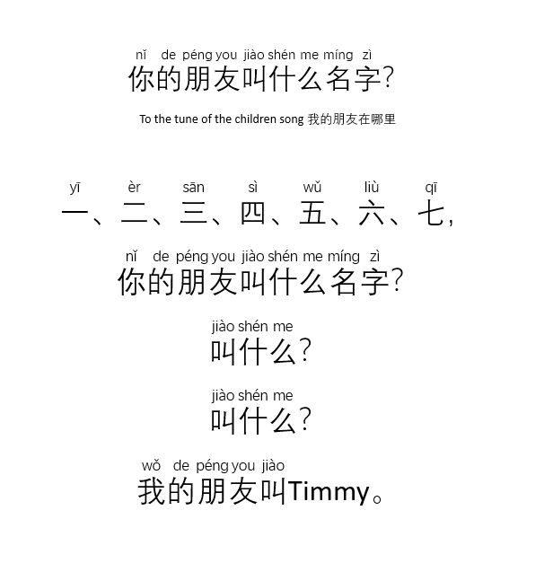

Resource 3 – KWL chart
What I know   | What I want to know   | What I learned  
In this column write what vocabulary you already know about friends in Chinese, including their appearance, personality and things friends do together. | In this column write what you want to know about friends in Chinese, including their appearance, personality and things friends do together. | In this column write what you have already learned about friends in Chinese, including their appearance, personality and things friends do together.

Resource 4 – describing people flashcards
This resource can be adapted by replacing the text to suit your language.
 |  |  |  |  |  | 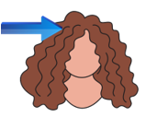
short |  | long |  | straight |  | curly

 |  | 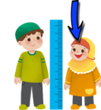 |  |  |  | 
tall |  | short |  | red |  | black
 |  |  |  |  |  | 
brown |  | blonde |  | hair |  | eyes

短的 |  | 长的 |  | 直的 |  | 卷的

高的 |  | 矮的 |  | 红色的 |  | 黑色的
棕色的 |  | 金色的 |  | 头发 |  | 眼睛

Resource 5 – matching cards
Chinese characters | English translation | Pinyin
红色的 | red | hóngsè de
棕色的 | brown | zōngsè de
黑色的 | black | hēisè de
金色的 | blonde | jīnsè de
长的 | long | cháng de
短的 | short (in length) | duǎn de
矮的 | short (in height) | ǎi de
高的 | tall | gāo de
直的 | straight | zhí de
卷的 | curly | juǎn de

Resource 6 – sentence builder – appearance
Question: What does your friend look like?
你 的 朋 友 长 什 么 样?
person | verb | adjective | noun
我的朋友 (my friend)  他 (he)  她 (she) | 有 (has)  是 (is) | 很高 (tall)  很矮 (short in height)  长的 (long)  短的 (short in length)  卷的 (curly)  直的 (straight)  红色的 (red)  黑色的 (black)  棕色的 (brown)  金色的 (blonde)  蓝色的 (blue)  绿色的 (green） | 头发 (hair)  眼睛 (eyes)

Resource 7 – verb phrases flashcards
 |  | 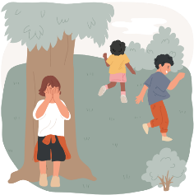 |  |  |  |  |  | 
play soccer |  | play hide-and-seek |  | eat lunch |  | play games |  | swim
 |  | 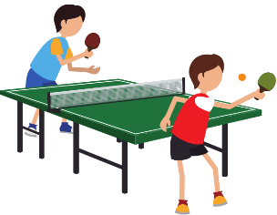 |  | 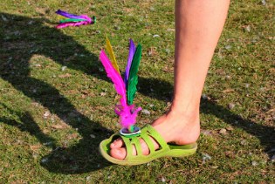 |  | 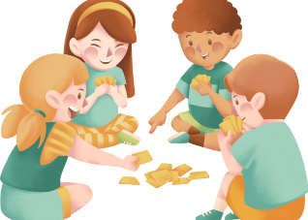
chat |  | play table tennis |  | kick shuttlecock |  | play cards |  | sit

踢 球 |  | 玩捉迷藏 |  | 吃 饭 |  | 玩游戏 |  | 游泳
聊天 |  | 打乒乓球 |  | 踢 子 |  | 打牌 |  | 坐

Resource 8 – sentence builder – activities
Question: What do you like to do with your friend?
你喜欢跟你的朋友做什么?
phrase (beginning) | verb | noun | phrase (conclusion)
我喜欢...  I like to… | 玩 (play)  打 (play)  踢 (kick/play)  吃 (eat)  聊天 (chat)  游泳 (swim)  坐 (sit) | 游戏 (games)  牌 (cards)  乒乓球 (table tennis)  毽子 (shuttlecock)  捉迷藏 (hide and seek)  午饭 (lunch)  足球 (soccer) | 跟我的朋友一起  ...with my friend

Resource 9 – personality flashcards
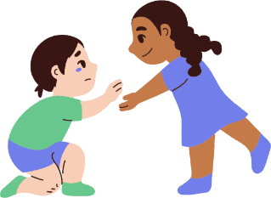 |  | 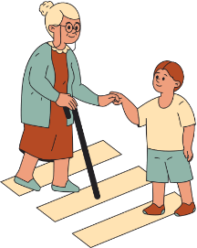 |  |  |  |  |  | 
kind |  | helpful |  | brave |  | funny |  | cheerful
 |  |  |  |  |  | 
caring |  | clever |  | friendly |  | naughty
善良 |  | 热心 |  | 勇敢 |  | 有趣 |  | 开朗
贴心 |  | 聪明 |  | 友善 |  | 顽皮

Resource 10 – sentence builder – personality
Question: Why is he/she your good friend?
为什么他/是你的好朋友?
Phrase | conjunction | phrase | Adjective
他是我的朋友  (He is my friend)  她是我的朋友  (She is my friend) | 因为 (because) | 她是 (she is)  他是 (he is) | 很善良 (kind)  很热心 (helpful)  很勇敢 (brave)  很有趣 (funny)  很开朗 (cheerful)  很贴心 (caring)  很聪明 (clever)  很顽皮 (naughty)

Resource 11 – assessment task – describe a friend in Australia

Outcomes
You will be assessed on how well you:
- exchange information in familiar contexts by selecting culturally appropriate modelled language.

Task
Tell a friend who lives in China about a friend in Australia. Include what your friend looks like, things that you do together and their personality.
- Context: talking to your friend in China
- Audience: friend in China
- Purpose: to tell a friend in China about your Australian friend.
The table below outlines the communicative task students will need to complete.
Too hard? | Too easy?
In the conversation, tell a friend about your friend’s appearance and things that you do together. | In the conversation, include additional information such as how long you’ve been friends and what you like most about your friend.

Learning intention

In the conversation, include additional information such as how long you’ve been friends and what you like most about your friend.

Success criteria
You will be successful if you can:
- answer a question about your friend’s name
- describe the appearance of your friend using at least 2 adjectives
- talk about the things that you like to do with your friend
- describe your friend’s personality
- end the conversation in an appropriate way.

Task instructions
- Tell a friend who lives in China about a friend in Australia. Include what your friend looks like, things that you do together and their personality.
- the context of the task is that you are telling a friend who lives in China about a friend in Australia.
- the audience of the communication will be your friend in China.
- the communicative purpose is to tell a friend in China about your Australian friend.
- This task will be completed in groups of 3. Each student will take turns at all 3 roles:
- you (the student talking about their Australian friend)
- friend in China
- camera operator/peer-assessor.
- The student talking about their Australian friend is completing the communicative task, so you will only be assessed for task completion while performing this role. You will be assessed on all other criteria in the rubric while performing all roles except for camera operator/peer-assessor.
- Following the task, you will watch a recording of yourself completing the task. You can self-assess by marking yourself on the ‘Friends forever’ assessment rubric. Then compare your self-assessed rubric with the teacher-marked rubric.
- Reflect on your performance and identify areas for improvement. Use this information to set a learning goal for the next stage of learning using Resource 15 – learning goal form.

Resource 12 – rubric – Friends forever
Name:
Table 2 – rubric for Friends forever
Criteria | Excellent | Got it | Sort of | Not yet | Limited
Communication | Your audience, a friend in China, clearly understands what you want to communicate.  Successfully and thoroughly complete all of the following aspects of the task:  - start the conversation in an appropriate way, for example, 喂，你好，我是...（Hello, I am…）  - describe the appearance of your friend with more than 3 adjectives  - talk about the things you do together  - describe your friend’s personality.  - End the conversation in an appropriate way, for example, 我们下次再聊吧! 再见. (Let’s chat next time! Goodbye!) | Your audience, a friend in China, can understand what you want to communicate.  Successfully complete all of the following aspects of the task:  - start the conversation in an appropriate way, for example, 喂，你好，我是...（Hello, I am…）  - describe the appearance of your friend  - talk about the things you do together  - describe your friend’s personality.  - End the conversation in an appropriate way, for example, 我们下次再聊吧! 再见. (Let’s chat next time! Goodbye!) | Your audience, a friend in China, can mostly understand what you want to communicate.  Successfully complete most of the following aspects of the task:  - start the conversation in an appropriate way, for example, 喂，你好，我是...（Hello, I am…）  - describe the appearance of your friend  - talk about the things you do together  - describe your friend’s personality.  - End the conversation in an appropriate way, for example, 我们下次再聊吧! 再见. (Let’s chat next time! Goodbye!) | Your audience, a friend in China, struggles to understand what you want to communicate. However, communication is successful.  Do not complete all aspects of the task. | Your audience, a friend in China, is unable to understand what you want to communicate.  Unable to complete any aspect of the task.
Fluency | Speak with ease in a well-paced manner without long pauses | Speak confidently with appropriate speed and expression | Usually speak confidently with appropriate speed and expression | Don’t speak confidently | Unable to be understood
Grammar | Always say words in the correct order when speaking | Usually say words in the correct order when speaking | Make some grammar mistakes when speaking | Rarely make sense when speaking | Unable to be understood
Pronunciation | Pronounce all words correctly | Pronounce most words correctly | Make noticeable pronunciation errors | Pronounce only a few words correctly | Unable to be understood
Vocabulary | Use expected vocabulary correctly and add interesting vocabulary to dialogue | Use expected vocabulary in dialogue correctly | Make some mistakes when trying to use expected vocabulary | Make many mistakes when trying to use expected vocabulary | Unable to use vocabulary in appropriate context

Resource 13 – TAG (Tell, Ask, Give) peer feedback strategy
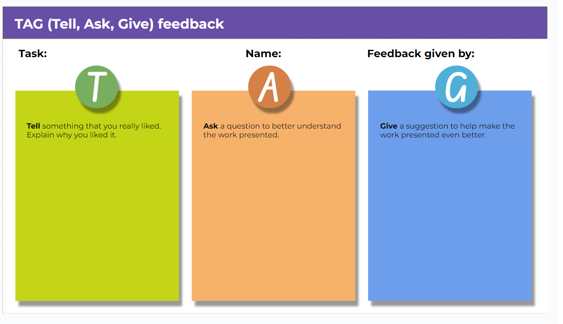

Resource 14 – translation cards examples
Question card 1  I like to play hide and seek with my friend. | Question card 2  She has long brown hair.
Question card 3  He is helpful. | Question card 4  He is tall.

问题卡1  我喜欢和我的朋友玩捉迷藏。 | 问题卡2  她有棕色长发。
问题卡3  他很热心。 | 问题卡4  他很高。

Resource 15 – learning goal form
Learning goal | Notes
My learning goal | I will pronounce [X] sound correctly in Chinese words and sentences.
The steps I will take | I will:  - say 5 different Chinese words with [X] sound every day  - practise pronouncing words correctly by playing tongue twister games  - record and listen to myself saying the sound in Italian  - practise the sound with my friends and ask for their feedback  - listen and act on my teacher’s feedback.
Target date | Term [X], Week 8
Target achieved | Term [X], Week ….

Resource 16 – sentence building relay
你的 | 朋友 | 叫 | 什么 | 名字？
我的 | 朋友 | 叫 | Timmy。
你的 | 朋友 | 长 | 什么样？
我的 | 朋友 | 有 | 黑色的 | 短发。
你 | 喜欢 | 跟 | 你的 | 朋友 | 一起 | 做什么？
我 | 喜欢 | 跟 | 我的 | 朋友 | 一起 | 聊天。

你的 | 朋友 | 叫 | 什么 | 名字？
我的 | 朋友 | 叫 | Timmy。
你的 | 朋友 | 长 | 什么样？
我的 | 朋友 | 有 | 黑色的 | 短发。
你 | 喜欢 | 跟 | 你的 | 朋友 | 一起 | 做什么？
我 | 喜欢 | 跟 | 我的 | 朋友 | 一起 | 聊天。

What | is | your | friend’s | name?
My | friend’s | name | is | Timmy.
What | does | your | friend | look | like?
My | friend | has | short | black | hair.
What | do | you | like | to | do | with | your | friend?
I | like | to | chat | with | my | friend.

Support and alignment
Resource evaluation and support: all curriculum resources are prepared through a rigorous process. Resources are periodically reviewed as part of our ongoing evaluation plan to ensure currency, relevance, and effectiveness. For additional support or advice, contact the Primary Languages team by emailing primlang@det.nsw.edu.au.
Alignment to system priorities and/or needs: School Excellence Policy
Alignment to the School Excellence Framework: this resource supports the School Excellence Framework elements of curriculum (curriculum provision, teaching and learning programs) and effective classroom practice (lesson planning).
Alignment to Australian Professional Teaching Standards: this resource supports teachers to address Australian Professional Teaching Standards 2.2.2, 3.2.2.
Consulted with: Curriculum, Secondary Learners, school-based staff and NESA subject matter experts. Advice from Aboriginal Outcomes and Partnerships, EAL/D, HPGE and Inclusive Education for Modern Languages Stage 3 Italian Mangiare in Ristorante has been considered in preparing this document.
NSW syllabus: Modern Languages K–10 Syllabus
Syllabus outcomes: ML2-INT-01, ML2-UND-01, ML2-CRT-01
Author: Primary Curriculum
Publisher: State of NSW, Department of Education
Resource: unit
Related resources: further resources to support Stage 2 Modern Languages can be found on the Languages K–6 curriculum page.
Professional learning: relevant professional learning is available through Primary Languages Networks on Teams (staff only).
Universal Design for Learning: support the diverse learning needs of students using inclusive teaching and learning strategies. Some students may require more specific adjustments to allow them to participate on the same basis as their peers. For further advice see Inclusive practice resources for primary school.
Differentiation: when using these resources in the classroom, it is important for teachers to consider the needs of all students in their class, including:
- Aboriginal and Torres Strait Islander students. Targeted strategies can be used to achieve outcomes for Aboriginal students in K-12 and increase knowledge and understanding of Aboriginal histories and cultures. Teachers should use students’ Personalised Learning Pathways to support individual student needs and goals.
- EAL/D learners. EAL/D learners may require scaffolding to support them to gain content knowledge, while providing extra time and assistance to master the English language required to engage with texts or complete classroom tasks. View some samples of differentiating through scaffolding.
- Students with additional learning needs. Learning adjustments enable students with disability and additional learning and support needs to access syllabus outcomes and content on the same basis as their peers. Teachers can use a range of adjustments to ensure a personalised approach to student learning.
- High potential and gifted learners. Assessing and identifying high potential and gifted learners will help teachers decide which students may benefit from extension and additional challenge. In addition, the Differentiation Adjustment Tool can be used to support the specific learning needs of high potential and gifted students.
Creation date: 17 July 2024
Rights: © State of New South Wales, Department of Education

References
This resource contains NSW Curriculum and syllabus content. The NSW Curriculum is developed by the NSW Education Standards Authority. This content is prepared by NESA for and on behalf of the Crown in right of the State of New South Wales. The material is protected by Crown copyright.
Please refer to the NESA Copyright Disclaimer for more information https://educationstandards.nsw.edu.au/wps/portal/nesa/mini-footer/copyright.
NESA holds the only official and up-to-date versions of the NSW Curriculum and syllabus documents. Please visit the NSW Education Standards Authority (NESA) website https://educationstandards.nsw.edu.au/ and the NSW Curriculum website https://curriculum.nsw.edu.au/home.
Modern Languages K–10 Syllabus © NSW Education Standards Authority (NESA) for and on behalf of the Crown in right of the State of New South Wales, 2022.
8 Ways (n.d.) 8 Aboriginal Ways of Learning [website], accessed 13 December 2022.
AITSL (Australian Institute for Teaching and School Leadership (2017) ‘Feedback Factsheet’, AITSL, accessed 26 May 2024.
Brookhart SM (2011) How to Assess Higher-Order Thinking Skills in Your Classroom, Hawker Brownlow Education, Victoria.
CESE (Centre for Education Statistics and Evaluation) (2020a) What works best: 2020 update, NSW Department of Education, accessed 5 April 2024
CESE (Centre for Education Statistics and Evaluation) (2020b) What works best in practice, NSW Department of Education, accessed 5 April 2024.
Conti G (28 September 2015) ‘16 tips for effective grammar teaching in the foreign language classroom’, The Language Gym, accessed 15 August 2024.
Conti G (28 May 2017) ‘From Target Language to Model Language – the mind shift that has transformed my teaching’, The Language Gym, accessed 5 April 2024.
Henshaw FG and Hawkins MD (2022) Common Ground: Second Language Acquisition Theory Goes to the Classroom, Focus, Indianapolis.
Jones J and Wiliam D (2014) Modern Foreign Languages Inside the Black Box: Assessment for Learning in the Modern Foreign Languages Classroom (Black P, Harrison C, Marshall B and Wiliam D, eds), Learning Sciences International, United States.
NESA (NSW Education Standards Authority) (2020) NSW Curriculum Review – final report, NESA, NSW Government, accessed 5 April 2024.
NESA (NSW Education Standards Authority) (2024) ‘Proficient Teacher: Standard descriptors’, Achieve Proficient Teacher accreditation, NESA website, accessed 28 August 2024.
Rosenshine B (2012) ‘Principles of Instruction: Research-Based Strategies That All Teachers Should Know’, American Educator, 36(1):12–19, 39, accessed 15 April 2024.
Smith S (2022) Becoming an Outstanding Languages Teacher, 2nd edn, Routledge, United Kingdom.
Wisniewski B, Zierer K and Hattie J (2020) ‘The Power of Feedback Revisited: A Meta-Analysis of Educational Feedback Research’, Frontiers In Psychology, 10(3087), doi:10.3389/fpsyg.2019.03087, accessed 5 April 2024.
Wiliam D (2013) ‘Assessment: The bridge between teaching and learning’, Voices from the Middle, 21(2):15–20, accessed 16 May 2024.
Wiliam D and Leahy S (2015) Embedding Formative Assessment: Practical Techniques for K–12 Classrooms, Learning Sciences International, United States.
© State of New South Wales (Department of Education), 2024
The copyright material published in this resource is subject to the Copyright Act 1968 (Cth) and is owned by the NSW Department of Education or, where indicated, by a party other than the NSW Department of Education (third-party material).
Copyright material available in this resource and owned by the NSW Department of Education is licensed under a Creative Commons Attribution 4.0 International (CC BY 4.0) license.

This license allows you to share and adapt the material for any purpose, even commercially. Attribution should be given to © State of New South Wales (Department of Education), 2024.
Material in this resource not available under a Creative Commons license:
- the NSW Department of Education logo, other logos and trademark-protected material
- material owned by a third party that has been reproduced with permission. You will need to obtain permission from the third party to reuse its material.
Links to third-party material and websites
Please note that the provided (reading/viewing material/list/links/texts) are a suggestion only and implies no endorsement, by the New South Wales Department of Education, of any author, publisher, or book title. School principals and teachers are best placed to assess the suitability of resources that would complement the curriculum and reflect the needs and interests of their students.
If you use the links provided in this document to access a third-party's website, you acknowledge that the terms of use, including licence terms set out on the third-party's website apply to the use which may be made of the materials on that third-party website or where permitted by the Copyright Act 1968 (Cth). The department accepts no responsibility for content on third-party websites.

