Chinese Stage 1
包里有什么？ (What is in my bag?)
Contents
Unit overview 5
Stage 1 outcomes and content to be addressed 6
Learning map 10
Assessment 13
Assessment opportunities 14
Teaching and learning activities 16
Week 1 – clothes 16
Vocabulary 1 – clothes 16
Activity 1 – learning map 18
Activity 2 – vocabulary 18
Activity 3 – Simon says 19
Activity 4 – pass the parcel 20
Activity 5 – fly swat 20
Week 2 – weather and seasons 22
Vocabulary 2 – weather and seasons 23
Activity 1 – pre-assessment 23
Activity 2 – reading ‘What’s in my bag?’ 24
Activity 3 – hot and cold 24
Activity 4 – conversation builder 25
Activity 5 – label the pictures 28
Week 3 – Where are you going on holiday? 29
Activity 1 – Where are you going on holiday? I am going to … 29
Activity 2 – roll and respond 31
Activity 3 – survey 31
Activity 4 – have a lovely holiday! 32
Week 4 – you should bring … 33
Activity 1 – maze muncher 33
Activity 2 – you should bring … 34
Activity 3 – good advice or bad advice 35
Activity 4 – silly sentences 36
Activity 5 – around the world 37
Week 5 – assessment criteria and practice task 38
Activity 1 – relay race 38
Activity 2 – assessment task 39
Activity 3 – success criteria 39
Activity 4 – discuss the rubric 40
Activity 5 – peer assessment 40
Activity 6 – practice task 41
Week 6 – communicative task – advise your friend what to pack for a holiday 42
Activity 1 – translator 43
Activity 2 – task set-up 43
Activity 3 – communicative task – advise your friend about what to pack for a holiday 44
Activity 4 – peer assessment 45
Week 7 – feedback and goal setting 46
Activity 1 – word shuffle 47
Activity 2 – self-assessment 47
Activity 3 – set learning goals 47
Week 8 – language review 49
Activity 1 – student questions 50
Activity 2 – oral gap reading 50
Activity 3 – memory game 50
Activity 4 – scrambled sentences 51
Student resources 52
Resource 1 – clothes flashcards 52
Resource 2 – weather and seasons flashcards 56
Resource 3 – countries flashcards 58
Resource 4 – conversation builder 59
Resource 5 – student rubric – What’s in my bag? 64
Resource 6 – peer feedback strategy – Two stars and a wish 65
Resource 7 – scrambled sentences 66
Resource 8 – memory game 69
Support and alignment 74
References 77

Unit overview
Stage: 1
Title: 包里有什么？ What’s in my bag?
Description: In this unit, students advise their friend what to pack for a family holiday. They use vocabulary related to clothes and weather to create simple sentences.
Duration: This lesson sequence is designed to be completed over approximately 8 weeks.
Student proficiency levels: It is assumed that most Stage 1 students have been learning Chinese since Kindergarten and their proficiency level will still be Beginner. The assessment tasks in this scope and sequence are aimed at Beginner students. Every classroom will be different and teachers will need to adapt to their context. Many classes may include a combination of Beginner, Intermediate and Advanced students with varying skills and abilities within these proficiency levels. Assessment tasks and opportunities in this unit can be differentiated using the ‘Too hard?’ and ‘Too easy?’ suggestions.

Stage 1 outcomes and content to be addressed
The table below outlines the focus area, outcomes and content points for Stage 1 students.
Focus area and outcome | Content points
Interacting  A student:  - exchanges meaning by selecting culturally appropriate modelled language ML1-INT-01 | Exchanging meaning in oral interactions in the target language  - Interact by selecting modelled language in games or scenarios using imagination  Reproducing oral language to interact in the target language  - Recognise and reproduce modelled sounds, including pronunciation and intonation patterns to interact  - Reproduce familiar vocabulary and short formulaic phrases to interact  Applying knowledge of the target language culture(s) to interact  - Use familiar verbal and nonverbal communication that is appropriate to cultural practices
Understanding texts  A student:  - recognises and responds to information in simple texts to demonstrate understanding  ML1-UND-01 | Understanding and responding to target language texts  - Listen to, read and/or view simple texts such as stories, songs, charts, rhymes or lists on familiar themes  - Use auditory cues, gestures, visuals and other forms of nonverbal communication to support comprehension  - Associate vocabulary on familiar themes with known actions, people, places, objects and ideas  - Recognise information in simple texts and respond to simple questions in the target language and/or English to show understanding of texts  - Demonstrate understanding when responding to texts using actions, drawing, singing or simple exchanges in the target language and/or English  Applying knowledge of language systems to understand and respond to target language texts  - Recognise and use sounds of modelled vocabulary and phrases to understand and respond to texts  - Recognise sound–symbol correspondences in modelled words and phrases to understand and respond to texts  - Recognise and use knowledge of modelled vocabulary, high-frequency words and formulaic phrases on familiar themes to understand and respond to texts  - Use simple grammar patterns to understand and respond to texts  - Recognise that the target language has features that may be similar to or different from English  - Recognise and reproduce symbols or modelled vocabulary and phrases of the writing system to understand and respond to texts  Developing intercultural understanding through target language texts  - Notice that language is used in ways that reflect cultural practices and reflect on their own language and cultural practices
Creating texts  A student:  - creates simple texts by selecting culturally appropriate modelled language ML1-CRT-01 | Creating spoken, written and multimodal texts in the target language  - Create texts using familiar vocabulary, phrases and visuals to express meaning  Applying knowledge of language systems to create texts in the target language  - Use pronunciation patterns to create spoken texts  - Use familiar sound–symbol correspondences to create written texts  - Use familiar vocabulary and formulaic phrases to create texts  - Use simple modelled sentence structures to create texts  - Reproduce modelled features of the target language writing system to create written texts  Reproducing how target language speakers communicate to create texts  - Reproduce language appropriate to cultural practices to create texts
Modern Languages K–10 Syllabus © NSW Education Standards Authority (NESA) for and on behalf of the Crown in right of the State of New South Wales, 2022.

Learning map
The creation of maps for learning is a planning process that incorporates Aboriginal intellectual tradition. Learning maps are a visual pathway of what students will learn.
Share the learning map with your students, briefly explaining the learning that will happen in each lesson. Provide students with a copy of the learning map or display the learning map in the classroom. This learning map can be adapted to Chinese by accessing a copy of Learning map – 包里有什么What’s in my bag? (Stage 1).
Figure 1 – What’s in my bag? learning map
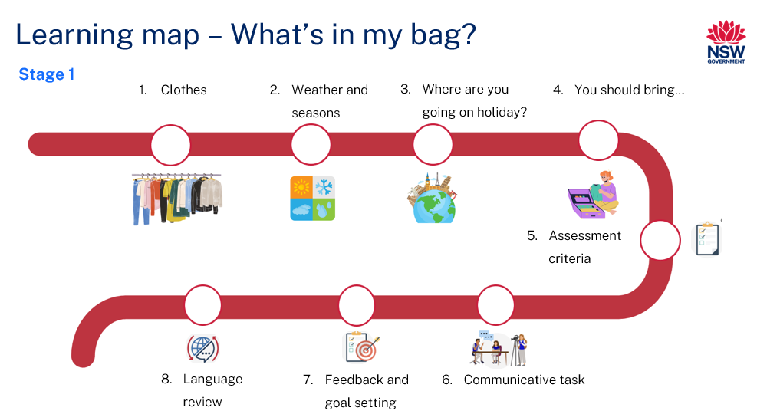
Figure 2 – 包里有什么？learning map
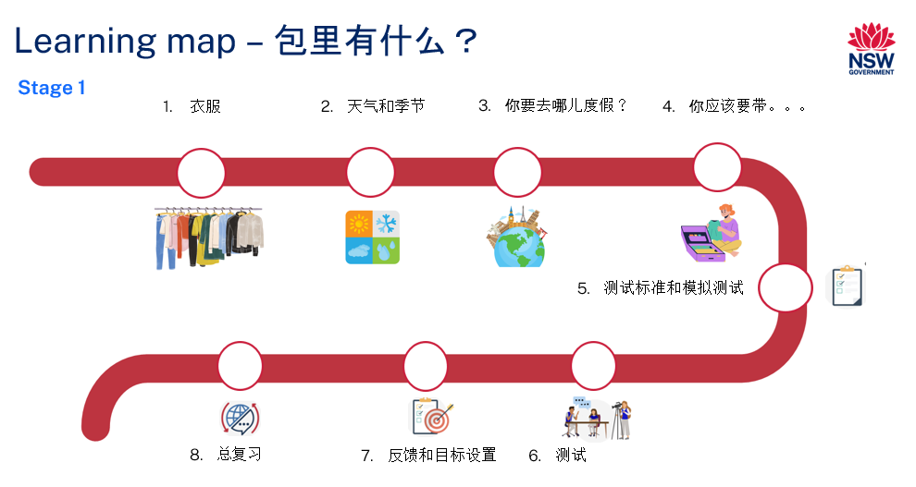

Assessment
Stage 1 communicative task: Your friend is going on a holiday to a place you have been to. Tell your friend suitable clothes to pack for the weather in the country they are travelling to in Chinese.
Too hard?
Students tell their friend clothing items to pack for a country they are travelling to.
Too easy?
Students also include suitable activities for the weather in the country their friend is travelling to.
Context: your friend is going on a holiday to a place you have been to
Audience: your friend
Purpose: to let your friend know what to pack for a holiday

Assessment opportunities
The table below details assessment opportunities and differentiation ideas.
Assessment opportunities | Too hard? | Too easy?
Week 1 – fly swat  Students practise saying clothing vocabulary by playing the game ‘Fly swatter’. Students take turns to call out the words. The first student to correctly swat the called-out word wins the round. | Fly swat  Provide students with a set of Resource 1 – clothes flashcards to assist them with vocabulary. | Fly swat  Students call out a phrase or a sentence including a clothing item, for example, 这是我的裤子. (These are my trousers.)
Week 2 – label the pictures  Students label the weather pictures in Chinese characters. | Label the pictures  Students label the weather pictures in Pinyin with correct tones. | Label the pictures  Students write a simple sentence for each picture, for example, 天气热. (It is hot.)
Week 4 – around the world  Students say a sentence in Chinese using flashcards. Show 2 players an image of a clothing item. The first one to say the sentence corresponding to the picture correctly competes against the next player. | Around the world  Students use sentence builder to help them complete the sentences. | Around the world  Students use adjectives to describe the clothing item in the picture. For example, 你要带厚的毛衣. (You should bring thick sweaters).

Teaching and learning activities

Week 1 – clothes
The table below outlines the learning intention and success criteria of the lesson, and materials that the teacher and students will need to complete the teaching and learning activities.
Learning intention and success criteria | Materials
Students will learn vocabulary related to clothes.  Students can:  - say the name of common clothing items in Chinese. | - Learning map  - Resource 1 – clothes flashcards  - A box  - A soft ball  - Fly swatters (class set)

Vocabulary 1 – clothes
The table below outlines the suggested vocabulary for Activity 2, Activity 3, Activity 4 and Activity 5. It includes the original Chinese characters, a Romanised version of the Chinese characters (Pinyin) and the corresponding English translations.
English | Romanised Chinese (Pinyin) | Chinese characters
clothes | yī fu | 衣服
sweaters | máo yī | 毛衣
scarves | wéi jīn | 围巾
shoes | xié zi | 鞋子
skirts | duǎn qún | 短裙
dresses | lián yī qún | 连衣裙
trousers | kù zi | 裤子
shorts | duǎn kù | 短裤
hats | mào zi | 帽子
qi pao （Chinese cheongsam） | qí páo | 旗袍
hanfu | hàn fu | 汉服
sandals | liáng xié | 凉鞋

Activity 1 – learning map
Explain and display the Learning map to give students a more detailed breakdown of lessons during the unit. Point out that the Learning map is a plan that may need to change.

Activity 2 – vocabulary
Note: this unit will focus on teaching the plural forms of clothing items to simplify the learning process. For students with Advanced proficiency, teachers can introduce the singular forms of clothing items and the corresponding ‘measure’ words for each type.
- Display images from Resource 1 – clothes flashcards one at a time. Say the words that appear on each flashcard in English as they are placed on the board.
- Pre-assessment: Students look at the flashcards. Ask students to identify how many words they know in Chinese by answering the following questions, showing thumbs up at their chests for each question which applies to them.
- Do you know all the words?
- Do you know most of them?
- Do you know any of them?
- Students Think-Pair-Share and tell their partners the words they know and report back to class.
- On the other side of the board, write the Chinese words for the clothes one at a time in a random order. Model the pronunciation of each word and have students imitate the pronunciation.
- Model and drill the words for clothes to ensure students have the correct pronunciation.
- Introduce qipao and hanfu to the students. Explain that they are traditional Chinese costumes. Qipao is a Chinese dress worn by women which goes back approximately 100 years in history. Hanfu is the traditional style of clothing worn by the Han people with a cultural legacy extending back over a thousand years. In modern times, people typically wear them on special occasions. Ask students to share their experience of people they know wearing these costumes.
Figure 3 – qipao and hanfu Chinese costumes


Activity 3 – Simon says
- Ask students to stand up. In response to spoken words, students should either touch or point to the corresponding clothing item. For example, when they hear Simon says 裤子 (trousers), they should point to their trousers while also saying aloud the word 裤子(trousers).
- Continue this activity using various clothing items.
- Ask students to put their hands on their head if they are not wearing that clothing item.

Activity 4 – pass the parcel
- Have students sit in a circle and place flashcards from Resource 1 – clothes flashcards in the middle of the circle.
- Give a soft ball to a student. Start the music and have students begin passing the ball around the circle. Let them know that they should only pass the ball to the person sitting next to them. Show them the direction they should pass it around the circle.
- When the music stops, the student holding the ball picks up a card and says the clothing item in Chinese.
- The card is put back into the middle of the circle and when the music starts again the ball is passed to the next student.
- Keep playing until each student has a turn.

Activity 5 – fly swat
- Demonstrate the game as a whole class. Ask 2 students to come to the front and hand each of them a fly swatter. Place Resource 1 – clothes flashcards face up on the floor. Call out a word from Vocabulary 1 – clothes.
- Students listen and quickly swat the flashcard with the called-out word. For example, if 毛衣 (jumper) is called out, the first student to ‘swat’ the word keeps the card. The winner is the player or team with the most cards at the end of the game.
- Ask students to play the game in small groups of 3 to 4 students.
Evaluation: use the Intentional observation checklist for communicative activities to record observations of students’ performance in group work. Students can understand and say the clothes items with correct pronunciation.

Week 2 – weather and seasons
The table below outlines the learning intention and success criteria of the lesson, and materials that the teacher and students will need to complete the teaching and learning activities.
Learning intention and success criteria | Materials
Students will describe common weather conditions.  Students can:  - say and write common weather words in Chinese  - say and write seasons in Chinese. | - Resource 1 – clothes flashcards  - Resource 2 – weather and seasons flashcards  - Resource 3 – countries flashcards  - Resource 4 – conversation builder  - What’s in my bag? PowerPoint book (English)  - What’s in my bag? PowerPoint book (Chinese)  - Music for Activity 2  - Pencils

Vocabulary 2 – weather and seasons
The table below outlines the suggested vocabulary for Activity 2, Activity 3 and Activity 4. It includes the original Chinese characters, a Romanised version or the Chinese characters (Pinyin) and the corresponding English translations.
English | Romanised Chinese | Chinese
weather | tiān qì | 天气
very | hěn | 很
hot | rè | 热
cold | lěng | 冷
summer | xià tiān | 夏天
winter | dōng tiān | 冬天

Activity 1 – pre-assessment
- To pre-assess students’ vocabulary, ask them to brainstorm weather words and season words in Chinese.
- Display Resource 2 – weather and seasons flashcards and Resource 3 – countries flashcards on the board. Ask students to tell a partner how to say the word in Chinese and what it means in English.
- Read the weather and season words aloud and have students repeat after you. Model and drill the vocabulary to ensure students have the correct pronunciation.

Activity 2 – reading ‘What’s in my bag?’
Have students sit on the floor and read the PowerPoint book What’s in my bag? Ask the following questions in English:
- What is this story is about?
- What clothing items are mentioned in the book in Chinese?
- Why did Lily ask Alice to bring her qi pao?

Activity 3 – hot and cold
- Revise the clothing items learned in the previous lesson using Resource 1 – clothes flashcards.
- Demonstrate the game ‘Hot and cold’ to the whole class. Have students sit in a circle. Choose one student to cover their eyes or go outside the classroom while you hide one of the flashcards in the classroom.
- The student opens their eyes or comes back to the class and looks for the hidden picture of a clothing item in the classroom.
- The rest of the class use temperature words to tell the student if they are moving towards the picture, saying 热，热，非常热 (hot, hot, very hot) or away from it, saying冷，冷，非常冷 (cold, cold, very cold). The game finishes when the student finds the picture.
- Play this game a few times with the whole class.
- Split the class into small groups of 6 and students complete this activity in their groups.

Activity 4 – conversation builder
Note: in Chinese sentences, words for time and location are usually placed after the subject and before the predicate. For example, 我昨天在图书馆看书. (I read books in the library yesterday.) In this sentence,看书 (read books) is the predicate. It consists of the verb 看 (read) and the object 书 (books).
On some occasions, for emphasis or to provide context, words for time and location can be placed at the beginning of a sentence. This is common in both spoken and written Chinese. For example, 昨天，我在图书馆看书. (I read books in the library yesterday.)
- Display the following sentence in English: It is cold in winter in China.
- Ask students what the different ways are of saying ‘It is cold in winter in China’ in English so that the sentence is grammatically acceptable. Rearrange the words in the sentence so that the new sentences still make sense. Possible responses may include:
- It is cold in China in winter.
- In China, it is cold in winter.
- In China, in winter it is cold.
- In winter, it is cold in China.
Note: typically, winter in China is cold. However, some provinces in southern China experience comparatively warmer temperatures during winter.
- Then, display the following sentence in Chinese: 中国冬天很冷 (It is cold in China in winter.)
- Highlight that in the sentence 中国冬天很冷 (It is cold in China in winter), 中国 (China) is placed at the beginning of this sentence. Emphasise that in Chinese, the words for location can never be placed at the end of a sentence as in English.
- Discuss the similarities and differences of sentence structure between Chinese and English. Using the above examples of saying ‘It is cold in winter in China’ in different ways, explain to the students that in English, the order of the words for country, season and temperature do not affect the meaning of the sentence. But in Chinese, this order of words is used to talk about the weather conditions of a country.
- Draw 3 columns on the whiteboard to demonstrate the structure of a sentence: 中国冬天很冷 (It is cold in winter in China). Spread out Resource 2 – weather and seasons flashcards and Resource 3 – countries flashcards on the floor. Say the sentence 中国冬天很冷 (It is cold in China in winter). Ask 3 students to come to the front and pick one flashcard each and place it under the appropriate heading. For example, 冬天 (winter) is positioned under the heading of season, 冷 (cold) is under the heading of temperature, 中国 (China) is under the heading of country. Then students can say the correct sentence 中国冬天很冷 (It is cold in China in winter) together.
- Split the class in small groups of 3. Hand out individual whiteboards, Resource 2 – weather and seasons flashcards and Resource 3 – countries flashcards to the groups. Students divide the whiteboard into 3 columns and practise making and saying sentences in Chinese by putting the flashcards in the correct order. They tell their sentences to their partner.
Table 1 – order of words in Chinese
Country | Season | Temperature
 |   冬天winter | 
Table 2 – order of words in English
Temperature | Country | Season
 |  | 冬天winter
Evaluation: students can say the weather words with correct pronunciation and label the pictures in Chinese characters.

Activity 5 – label the pictures
Note: Chinese radicals are the base component of each character. They can hold information about the meaning and/or the sound. The structure of Chinese characters are the rules of how the characters are formed, including single structure, left-right structure and up-down structure. Understanding the radicals and structure of Chinese characters is important for effective character acquisition.
- Show Resource 2 – weather and seasons flashcards to the students and point to the Chinese characters and Pinyin on the flashcards.
- Explain the radical and structure of the characters 冷 (cold), 热 (hot). Explain to the students that 两点水 (ice radical) means cold while 四点水 (fire radical with 4 dots at the bottom) means hot. Explain that the character 冷 (cold) is a left-right structure, while the character 热 (hot) is an up-down structure.
- Write the 2 characters on the board and ask one student to trace 两点水 (ice radical) in blue and trace 四点水 (fire radical with 4 dots at the bottom) in red.
- Model labelling the pictures as a whole class.
- Students draw pictures of words in Resource 2 – weather and seasons flashcards and label them using Chinese characters.
Evaluation: students use fire and ice radicals correctly when labelling their pictures.

Week 3 – Where are you going on holiday?
The table below outlines the learning intention and success criteria of the lesson, and materials that the teacher and students will need to complete the teaching and learning activities.
Learning intention and success criteria | Materials
Students will ask and respond to a question about holidays in Chinese.  Students can:  - ask a question using the correct sentence structure in Chinese  - respond accurately to the question using the correct sentence structure in Chinese. | - Resource 3 – countries flashcards  - What’s in my bag? PowerPoint book  - Editable dice  - Paper

Activity 1 – Where are you going on holiday? I am going to …
Note: in the sentence, 你要去哪儿度假？ (Where are you going on holiday?), the interrogative word 哪儿 is placed within the sentence to form a question. Both 哪儿and 哪里mean ‘where’ in Chinese, but their usage can differ based on regional preferences and context: 哪儿 (where) is used in informal, spoken contexts, especially in northern China. 哪里 (where) is used in more formal contexts, in written Chinese, and in general conversation, especially in southern China. Both forms are correct and understood throughout China, so the choice largely depends on regional habits and the formality of the situation.
- Read through the PowerPoint book What’s in my bag? again. Ask the following questions in English:
- Where is Lily going on holiday?
- Where is Alice going on holiday?
- Point out the sentences 你要去哪儿度假? (Where are you going on holiday?), 我要去新加坡 (I am going to Singapore.), 我要去中国 (I am going to China.) in the book. Emphasise that the interrogative words such as ‘where’ are placed in the middle of a sentence in Chinese. Ask students to say the chunk of words after you while doing actions. Suggested actions include:
- 你要 (you are going) – index fingers pointing forward
- 去哪儿 (where) – shrug your shoulders
- 度假 (on holiday) – folding arms
- 我要 (I am) – thumbs pointing to myself
- 去 (going to) – flying like a bird
- 新加坡 (Singapore) – pointing fingers into the distance
- 中国 (China) – eating bamboo like a panda.
- Tell the students that you will say the question then say the answer and they will do the actions. You will then do the actions while they say the chunk of words. Students repeat this activity several times in small groups.

Activity 2 – roll and respond
Note: prepare an editable dice with the names of different countries from Resource 3 – countries flashcards prior to this activity.
Show pictures of different countries from Resource 3 – countries flashcards. Divide the class into pairs or small groups. Assign roles where one student asks the question 你要去哪儿度假？ (Where are you going on holiday?) and the other student rolls the dice and responds with the destination based on the rolled dice. For example, student says 我要去中国. (I am going to China), when the dice lands with the picture of China.
Students take turns in asking and responding to the question.

Activity 3 – survey
- Conduct a class survey where students ask at least 5 classmates the question 你要去哪儿度假? (Where are you going on holiday?) 中国(China) or 新加坡 (Singapore)?
- Ask students to record their classmates’ responses on a piece of paper.
- As a whole class examine the results and discuss which country more students said they are going to on holiday.

Activity 4 – have a lovely holiday!
- Introduce the phrase 假期快乐 (Have a lovely holiday). Model and drill the correct pronunciation of the phrase with students. Where possible, invite students from different cultural backgrounds to share how they say, ‘Have a lovely holiday!’ in their language.
- In pairs, students take turns in asking and respond to the question on where they are going on holiday. They end the conversation by greeting each other with 假期快乐 (Have a lovely holiday).
- Sample interaction:
- Student A: 你要去哪儿度假? (Where are you going on holiday?)
- Student B: 我要去新加坡. (I am going to Singapore.)
- Student A: 假期快乐! (Have a lovely holiday!)
Note: as students are completing this activity, use the Intentional observation checklist for communicative activities to record your observations of students pronunciation and their use and understanding of the correct sentence structure.

Week 4 – you should bring …
The table below outlines the learning intention and success criteria of the lesson, and materials that the teacher and students will need to complete the teaching and learning activities.
Learning intention and success criteria | Materials
Students will use Chinese phrases to give advice on what to bring on a holiday.  Students can:  - say the phrase 你要带... (You should bring …) correctly  - provide advice to your friend using the correct sentence structure in Chinese. | - Resource 1 – clothes flashcards  - Resource 2 – weather and seasons flashcards  - Resource 3 – countries flashcards  - Butcher’s paper  - Editable dice

Activity 1 – maze muncher
Note: emphasise that China has different seasons, but Singapore is warm or hot throughout the year. For the assessment task, assume that you go to China in winter and Singapore in summer.
- Have students stand and spread out at arm’s length from a partner. Call out a phrase or a word from the vocabulary taught in the previous lessons either in English or in Chinese.
- The first student to correctly translate the phrase or word gently taps their partner and wins a point.
- Students find a new partner. Continue playing the game until each student has won a point. The winner is the student with the most points.
Note: alternatively, show students pictures, Chinese characters or Pinyin. The first student to correctly call out the phrase or word in Chinese may take a step and ‘tap’ their partner to win a point.

Activity 2 – you should bring …
- Display the phrase, 你要带... (you should bring …) on the board. Ask the following questions to assess their prior understanding of the phrase:
- Have you seen or heard of this phrase in the PowerPoint book What’s in my bag?
- Can you remember how to say ‘you should bring ...’ in Chinese?
- In pairs, students Think-Pair-Share and tell their partners how to say ‘you should bring ...’ in Chinese.
- Model and drill the phrase 你要带... (you should bring …) to ensure that students have correct pronunciation. Check the students’ understanding of the meaning of each character.
- Split the class in groups of 5. Students take turns and practise saying 你要带… (you should bring …) by adding an item of clothing from Vocabulary 1 – clothes at the end of the phrase. The next student in the group adds on another item of clothing to the phrase along with the old one. For example, one student in the group says, 你要带帽子 (You should bring hats). The next student says 你要带帽子和鞋子 (You should bring hats and shoes.) Repeat the activity until everyone had a turn starting the sentence.

Activity 3 – good advice or bad advice
- In pairs, students Think-Pair-Share and tell their partners which clothes to pack for summer and winter.
- Then as a whole class, using butcher’s paper, create 2 mind maps by brainstorming clothes to pack for summer and winter in Chinese. As an extension, add some extra clothing items, such as 大衣 (coat), 夹克 (jacket) for the cold days or T恤衫 (T shirt) for the hot days.
- Tell students that they will be giving advice to the class on clothes to pack based on the weather in Chinese. Students identify whether the advice given is good or bad using thumbs up or down. Thumbs up indicate good advice and thumbs down indicates bad advice. For example: Say 天气冷了. 你要带短裤. (It is cold. You should bring shorts.) Students put thumbs down to show that it is bad advice.
- Students repeat this activity in small groups of 3 or 4.
Evaluation: students can correctly provide advice to others using the correct sentence structure in Chinese.

Activity 4 – silly sentences
Note: prior to this activity, prepare a class set of 3 editable dice with the names of different clothing items from Resource 1 – clothes flashcards on the first dice, season and weather from Resource 2 – weather and seasons flashcards on the second dice and the names of different countries from Resource 3 – countries flashcards on the third dice.
- Display and revise the sentence 我们去度假. (I am going on holiday) and the phrases 天气热 (It is hot) and 你要带 (you should bring) on the board.
- Ask 3 students to come to the front and demonstrate the activity to the whole class. Hand them a dice each. Students take turns rolling the dice and making sentences.
- The following are sample responses from students.
- Student 1 rolls the country dice and says 我们去度假 (I am going on a holiday to Singapore) if the dice lands on ‘Singapore’ flashcard.
- Student 2 rolls the weather and seasons dice and says 天气冷 (It is cold) if the dice lands on the ‘cold’ flashcard.
- Student 3 rolls the clothes dice and says 你要带短裙 (you should bring skirts) if the dice lands on ‘skirts’ flashcard.
- Students complete the activity in small groups of 3.
Note: as students are completing this activity, use the Intentional observation checklist for communicative activities to record your observations of students pronunciation and their use and understanding of the correct sentence structure.

Activity 5 – around the world
- Students sit in a circle. Have 2 players sitting next to each other stand up.
- Show an image of a clothing item from Resource 1 – clothes flashcards to the class. The first one to correctly say the sentence corresponding to the picture in Chinese competes against next player. For example, if the flashcard with ‘sweaters’ is displayed, the student who correctly says你要带毛衣. (You should bring sweaters) first is the winner and moves on to the next student. If a player beats 4 classmates, they ‘retire’ as an undefeated champion.
- Students break into smaller groups and start the game again.
Note: as students are completing this activity, use the Intentional observation checklist for communicative activities to record your observations of students pronunciation and their use and understanding of the vocabulary.

Week 5 – assessment criteria and practice task
The table below outlines the learning intention and success criteria of the lesson, and materials that the teacher and students will need to complete the teaching and learning activities.
Learning intention and success criteria | Materials
Students will develop a clear understanding of the requirements of the assessment task.  Students can:  - suggest appropriate success criteria  - explain what they need to do to be successful in the task. | - Resource 1 – clothes flashcards  - Resource 2 – weather and seasons flashcards  - Resource 3 – countries flashcards  - Resource 5 – student rubric – What’s in my bag?  - Buckets

Activity 1 – relay race
- Divide the class into 2 teams and have them stand in lines at one end of the room. Nominate a student from each team to be the ‘checker’ to check that the other team correctly translates the vocabulary.
- Place Resource 1 – clothes flashcards, Resource 2 – weather and seasons flashcards and Resource 3 – countries flashcards both in English and Chinese in buckets at opposite ends of the room. Each team has access to their own set of flashcards in the bucket.
- Place empty buckets in front of each team.
- One student from each team races to grab a flashcard from the opposite end. They return to show the card to their team. The team must accurately say and translate the words written on it before the next team member takes their turn. The ‘checker’ checks if the translated word is correct. If the translated word is incorrect, the flashcard is placed outside the bucket. Correctly translated flashcards are placed into the relevant bucket.
- The team with the most correctly translated flashcards at the end of the game wins.

Activity 2 – assessment task
Explain the communicative task: Your friend is going on a holiday to a place you have been to. Tell your friend what to pack for the holiday in Chinese based on the weather and place they are going to. Point out that:
- the context of the task is that your friend is going on a holiday to a place you have been to
- the audience of the communication will be your friend
- the communicative purpose or reason is to let your friend know what to pack for a holiday.

Activity 3 – success criteria
After looking at the assessment task, students Think-Pair-Share and suggest appropriate success criteria, such as:
I will be successful if I can:
- use Chinese vocabulary related to clothing
- describe the weather in a country in Chinese
- ask where someone is going on a holiday in Chinese
- advise what to pack for a holiday in Chinese
- say sentences in Chinese with words in the correct order.

Activity 4 – discuss the rubric
- To help students understand the rubric for the final task, show them Resource 5 – student rubric – What’s in my bag?. It is important to note that this rubric can be adapted if the class has decided on different success criteria.
- Explain that the rubric has been written using ‘I can’ statements to help students understand each component of the task.
- Introduce the concept of a thumb signal for each level of achievement. A thumbs up means students have achieved the task completion objectives, while a thumbs sideways or down signal means they still need to work on it. Go through each component of the rubric and explain what is expected at each level of achievement.

Activity 5 – peer assessment
Note: this may be the first-time students are engaging in peer-assessment. As a result, you may need to provide further explanations on why this is important and what students should and should not do while giving and receiving peer-assessment.
Explain that, as part of the task, peer feedback will be incorporated. To help with this, use the thumbs up, down or thumbs sideways strategy as the scale of understanding. Explain that students will use this strategy to provide feedback to the student introducing themselves. A thumbs-up signal means ‘You did it!’, while a sideways thumb signal means ‘Tell me more!’ and down thumb signal means 'need help’.

Activity 6 – practice task
In pairs, students practise having a conversation using Resource 4 – conversation builder.
Sample interaction:
- Student A (Kim): 嗨Ken, 你要去哪儿度假? Hi Ken, where are you going on holiday?
- Student B (Ken): 嗨 Kim, 我要去新加坡. 你要去哪儿？Hi Kim, I am going to Singapore. Where are you going?
- Student A (Kim): 我要去中国. 新加坡夏天很热. I am going to China. It is hot in Singapore in summer.
- Student B (Ken): 中国冬天很冷. 你应该带毛衣、围巾和鞋子. It is cold in China in winter. You should bring sweaters, scarves and shoes.
- Student A (Kim): 新加坡很热. 你应该带短裤和凉鞋. Singapore is hot. You should bring shorts and sandals.
- Student A (Ken): 谢谢. 假期快乐. Thank you. Have a lovely holiday.
- Student A (Kim): 谢谢. 假期快乐. Thank you. Have a lovely holiday.

Week 6 – communicative task – advise your friend what to pack for a holiday
The table below outlines the learning intention and success criteria of the lesson, and materials that the teacher and students will need to complete the teaching and learning activities.
Learning intention and success criteria | Materials
Students will ask questions and give advice to their friend on what to pack for a holiday.  Students can:  - use Chinese vocabulary related to clothing  - describe the weather in a country in Chinese  - ask where someone is going on a holiday in Chinese  - advise what to pack for a holiday in Chinese  - say sentences in Chinese with words in the correct order. | - Resource 4 – conversation builder  - Resource 5 – student rubric – What is in my bag?  - Resource 6 – peer feedback strategy – Two stars and a wish.  - Resource 7 – scrambled sentences  - Microphones or tripod (if possible)  - Recording device

Activity 1 – translator
Hand out Resource 4 – conversation builder to each pair of students. In pairs, one student says a sentence in English and the other student translates it to Chinese using the conversation builder. Allow students to take turns.
Encourage students to help each other if they get stuck, using Resource 4 – conversation builder.
Note: as students are completing this activity, use the Intentional observation checklist for communicative activities to record your observations of students pronunciation and their use and understanding of vocabulary.

Activity 2 – task set-up
Students get into groups of 4. Give students a few minutes to ensure everybody knows the order in which they will be performing each role. Tell students that they and their friend are advising each other about things to pack for a holiday. The peer assessor will provide feedback to the student ‘you’, who is completing the assessed communicative task.
Suggested rotations:
- Role-play 1: Student 1 – ‘You’, Student 2 – Your friend, Student 3 – Peer assessor for Student 1, Student 4 – Camera operator
- Role-play 2: Student 1 – Camera operator, Student 2 – ‘You’, Student 3 – Your friend, Student 4 – Peer assessor for Student 2
- Role-play 3: Student 1 – Peer assessor for Student 3, Student 2 – Camera operator, Student 3 – ‘You’, Student 4 – Your friend
- Role-play 4: Student 1 – Your friend, Student 2 – Peer assessor for Student 4, Student 3 – Camera operator, Student 4 – You.

Activity 3 – communicative task – advise your friend about what to pack for a holiday
Note: make sure to space students apart when filming. Demonstrate how to film using a recording device. Use microphones, if possible, to maximise sound quality. Highlight the importance of holding the recording device still by using a tripod or resting it on a table.
For this task, students will work in pairs and take turns in advising each other 2 things to pack for a holiday.
Example interaction:
- Student A: 嗨, 你要去哪儿度假? (Hi, where are you going on a holiday?)
- Student B: 嗨, 我要去新加坡. 你要去哪儿？ (Hi, I am going to Singapore. Where are you going?)
- Student A: 我要去中国. 新加坡夏天很热. (I am going to China. It is hot in Singapore in summer.)
- Student B: 中国冬天非常冷. 你应该带毛衣和鞋子. (It is very cold in China in winter. You should bring sweaters and shoes.)
- Student A: 新加坡很热. 你应该带短裤、帽子和凉鞋. (Singapore is hot. You should bring shorts, hats and sandals.)
- Student B: 谢谢. 假期快乐. (Thank you. Have a lovely holiday.)
- Student A: 谢谢.假期快乐. (Thank you. Have a lovely holiday.)
Note: before recording interactions, check if any students do not have permission to be filmed. Alternatives to video recording include audio recording or the teacher watching the interactions while taking notes and marking the rubric.

Activity 4 – peer assessment
Note: this may be the first time students have engaged in peer-assessment. As a result, you may need to provide further explanation on why this is important and what students should and should not do while giving and receiving peer-assessment. Explain that it is important that students check not only their own work, but also provide feedback to their classmates regarding their work. Remind students that they need to be respectful to each other when giving and receiving feedback. Co-construct ‘ground rules’ for peer feedback. It may be helpful for students to provide sentence starters to prompt them. For example, ‘I like the way …’, ‘You did an excellent job of …’, ‘My favourite part was …’, ‘I didn’t understand …’. Emphasise that the peer feedback should be related to the visual rubric provided in this task.
The student providing the peer-assessment will give feedback to the student being ‘you’ using the thumbs up or thumbs sideways strategy or Resource 6 – peer feedback strategy – Two stars and a wish.

Week 7 – feedback and goal setting
Note: if there is insufficient time to mark the videos before Week 8, Weeks 7 and 8 can be swapped.
The table below outlines the learning intention and success criteria of the lesson, and materials that the teacher and students will need to complete the teaching and learning activities.
Learning intention and success criteria | Materials
Students will reflect on feedback to set suitable learning goals.  Students can:  - self-assess their completion of the task  - set appropriate learning goals based on previous learning goals and teacher, peer- and self-assessment. | - Resource 5 – student rubric – What’s in my bag?
Note: prior to this lesson, view each video and mark each student according to the criteria on the rubric for communicative language tasks.

Activity 1 – word shuffle
- Ask all students to walk around the classroom while you play some Chinese music. When the music stops, call out a word from Vocabulary 1 – clothes or Vocabulary 2 – weather and seasons in English.
- After hearing a word in English, students will find a partner and say the word in Chinese. For example, if the teacher calls out ‘hot’. The students will turn to a partner and say 热 (hot) in Chinese.
- Play the music again and when the music stops, say a different word in English for students to say it in Chinese. The students find a new partner every time the next word is called out.

Activity 2 – self-assessment
Students watch the video of themselves completing the task and use the rubric to self-assess. Students compare their self-assessment rubric with the teacher’s completed rubric.

Activity 3 – set learning goals
- Students reflect on the teacher, peer- and self-evaluation to set learning goals for the next phase of learning. Example learning goals could be: ‘I will not be worried about making a mistake when speaking Chinese’. Learning goals are written in students’ language notebooks.
Note: this may be the first time students will be setting learning goals. Students will choose a suggested learning goal from the list below by raising their hand.
- To foster student ownership of their learning, facilitate a class discussion to help students reflect on their marked rubric, peer- and self-assessment and set their own personalised learning goals for the next phase. Use simplified language to ensure that the students can understand and engage with the discussion effectively.
- Provide sentence starters and example prompts, such as the following, to guide students’ thinking:
- I now feel confident when saying a sentence with ‘You should bring …’ in Chinese.
- I always/sometimes feel confused when choosing the radical and structure of the characters in Chinese.
- A next step for me is to write Chinese characters using the correct structure.
- Present suggestions like the above and others appropriate to the context of your class. Encourage students to raise their hands when they hear a goal that resonates with them. By doing so, students will understand their options and select a learning goal that is most relevant and suitable for their needs. Students record their learning goals.

Week 8 – language review
Note: if there is insufficient time to mark the videos before Week 8, Weeks 7 and 8 can be swapped.
The table below outlines the learning intention and success criteria of the lesson, and materials that the teacher and students will need to complete the teaching and learning activities.
Learning intention and success criteria | Materials
Students will review the language learned during this unit to be able to provide advice.  Students can:  - ask questions about vocabulary, grammar or pronunciation they have used in this unit  - use Chinese words, phrases and sentences they have learned to communicate with classmates. | - Resource 7 – scrambled sentences  - Resource 8 – clothing memory game  - What’s in my bag? PowerPoint book  - Pencils  - Workbooks
Note: over the course of the unit, gaps in student knowledge, misconceptions and misuse of language will have been identified. These observations are addressed using engaging and interactive activities and strategies.

Activity 1 – student questions
Remind students of the activities and tasks they have completed over the course of the unit. Give students time to Think-Pair-Share any questions they may have about any aspect of the language taught.

Activity 2 – oral gap reading
- Re-read the What’s in my bag? PowerPoint book to the class.
- Read the first half of each sentence and have the students complete the second half. For example, say 我要去... (I am going …) and students say 度假 (on holiday) or say 天气热，你要带... (It is hot, you should bring) and students say 短裤 (shorts).
- Students take turns at leading oral gap reading in small groups.

Activity 3 – memory game
- In pairs or small groups, students are given a set of cards from Resource 8 – memory game. Shuffle the cards and lay them face down.
- Each set consists of a card with the picture and card with its description. For example, a picture of a pair of trousers will have a corresponding card with the phrase 裤子and Pinyin Kùzi.
- Each student takes a turn to flip 2 cards at a time. The goal of the game is for students to collect as many matching cards as possible. If a player flips over a matching set, they will keep it. If they do not find a matching set, they must turn the cards back over and let the other player take their turn.
- At the end of the game, the player with the most pairs of cards wins.

Activity 4 – scrambled sentences
- Cut the words, characters or Pinyin, from each sentence in Resource 7 – scrambled sentences and put them into an envelope.
- Have students work in pairs. Hand out one envelope to each pair. Students collaboratively rearrange the characters, words or Pinyin to construct correct sentences. Ask other students to check the sentences.
- Students copy the correct sentences in their workbook.
Note: written sentences can be displayed for students to refer to, if necessary.
Evaluation: students can use Chinese words, phrases and sentences they have learned to communicate with classmates.

Student resources

Resource 1 – clothes flashcards
 |  |  |  |  |  | 
衣服 |  | 围巾 |  | 裤子 |  | 短裤
 |  | 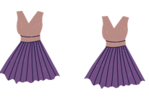 |  | 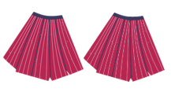 |  | 
帽子 |  | 连衣裙 |  | 短裙 |  | 鞋子

 |  | 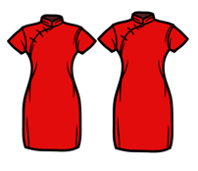 |  |  |  | 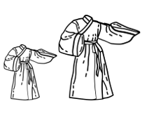
拖鞋 |  | 旗袍 |  | 毛衣 |  | 汉服
This resource can be adapted by replacing the text to suit your language.

clothes |  | scarves |  | trousers |  | shorts
hats |  | dresses |  | skirts |  | shoes

sandals |  | qi pao |  | sweaters |  | hanfu
This resource can be adapted by replacing the text to suit your language.

Resource 2 – weather and seasons flashcards
 |  |  |  |  |  | 
热 |  | 很热 |  | 冷 |  | 很冷
 |  |  |  | 
冬天 |  | 夏天 |  | tiān qì  天气
hot |  | very hot |  | cold |  | very cold
winter |  | summer |  | weather
This resource can be adapted by replacing the text to suit your language.

Resource 3 – countries flashcards
This resource can be adapted by replacing the text to suit your language.
 |  |  |  | 
中国 |  | 新加坡 |  | 澳大利亚
 |  |  |  | 
China |  | Singapore |  | Australia

Resource 4 – conversation builder
Country | Season | Temperature
中国  新加坡 | 冬天  夏天 | 很冷  很热

Sentence starter (you should bring) | Clothes
你要带 | 衣服  毛衣  围巾  鞋子  短裙  连衣裙  裤子  短裤  帽子  旗袍（Chinese cheongsam）  汉服  凉鞋
假期快乐！(Have a lovely holiday!)

Temperature | Season | Country
It is cold  It is hot | in winter  in summer | In China  In Singapore

Sentence starter | Clothes
You should bring | clothes  sweaters  scarves  shoes  skirts  dresses  trousers  shorts  hats  qi pao （Chinese cheongsam）  Hanfu  Sandals
Have a lovely holiday!

Resource 5 – student rubric – What’s in my bag?
I can use vocabulary related to clothing.
I can describe the weather in a country.
I can ask where you are going on a holiday.
I can advise what to pack for a holiday.
I can say sentences in Chinese with words in the correct order.

Resource 6 – peer feedback strategy – Two stars and a wish
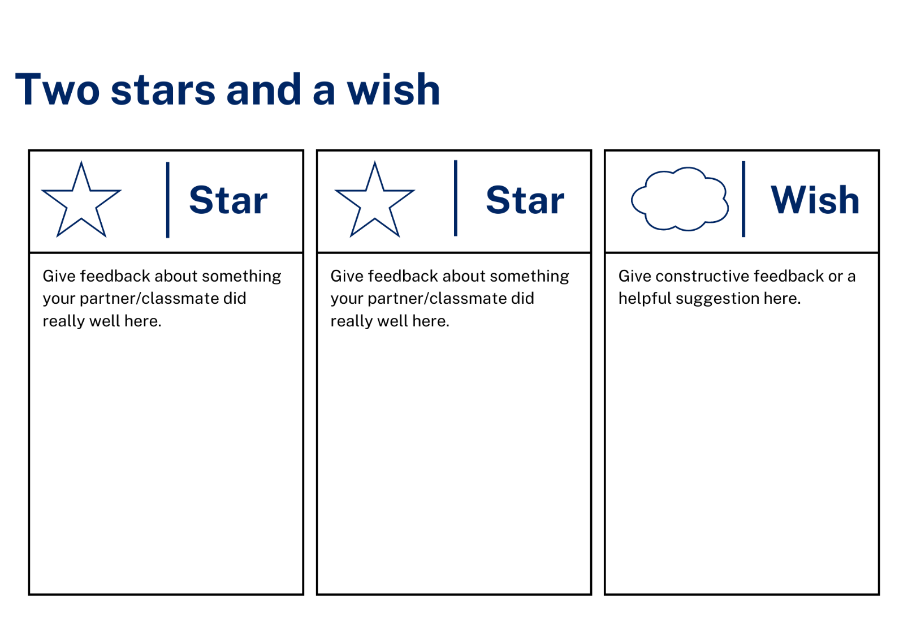

Resource 7 – scrambled sentences
Cut the words
去 | 我 | 要 | 度 | 假。
天 | 夏 | 热。 | 很
天 | 冷。 | 气 | 很
要 | 你 | 带 | 毛 | 衣。
哪儿 | 你 | 去 | 要 | 度 | 假？

Cut the Pinyin
qù | wǒ | yào | dù | jià.
tiān | xià | rè. | hěn
tiān | lěng. | qì | hěn
yào | nǐ | dài | máo | yī.
nǎ'er | nǐ | qù | yào | dù | jià?

Cut the English words
going | I | am | on | holiday.
is | summer | hot. | very
is | cold. | It | very
should | You | bring | sweaters.
Where | you | are | going | on | holiday?

Resource 8 – memory game

yīfu  衣服 |  | máoyī  毛衣 |  | duǎnkù  短裤 |  | duǎnqún  短裙
màozǐ  帽子 |  | wéijīn  围巾 |  | liányīqún  连衣裙 |  | kùzi  裤子
xiézi  鞋子 |  | liángxié  凉鞋 |  | qípáo  旗袍 |  | hànfú  汉服

clothes |  | sweaters |  | shorts |  | skirts
hats |  | scarves |  | dresses |  | trousers

Support and alignment
Resource evaluation and support: all curriculum resources are prepared through a rigorous process. Resources are periodically reviewed as part of our ongoing evaluation plan to ensure currency, relevance, and effectiveness. For additional support or advice, contact the Primary Languages team by emailing primlang@det.nsw.edu.au.
Alignment to system priorities and/or needs: School Excellence Policy
Alignment to the School Excellence Framework: this resource supports the School Excellence Framework elements of curriculum (curriculum provision, teaching and learning programs) and effective classroom practice (lesson planning).
Alignment to Australian Professional Teaching Standards: this resource supports teachers to address Australian Professional Teaching Standards 2.2.2, 3.2.2.
Consulted with: Curriculum, Secondary Learners, school-based staff and NESA subject matter experts. Advice from Aboriginal Outcomes and Partnerships, EAL/D, HPGE and Inclusive Education for Modern Languages Stage 3 Italian Mangiare in Ristorante has been considered in preparing this document.
NSW syllabus: Modern Languages K–10 Syllabus
Syllabus outcomes: ML1-INT-01, ML1-UND-01, ML1-CRT-01
Author: Primary Curriculum
Publisher: State of NSW, Department of Education
Resource: unit
Related resources: further resources to support Stage 1 Modern Languages can be found on the Languages K–6 curriculum page.
Professional learning: relevant professional learning is available through Primary Languages Networks on Teams (staff only).
Universal Design for Learning: support the diverse learning needs of students using inclusive teaching and learning strategies. Some students may require more specific adjustments to allow them to participate on the same basis as their peers. For further advice see Inclusive practice resources for primary school.
Differentiation: when using these resources in the classroom, it is important for teachers to consider the needs of all students in their class, including:
- Aboriginal and Torres Strait Islander students. Targeted strategies can be used to achieve outcomes for Aboriginal students in K-12 and increase knowledge and understanding of Aboriginal histories and cultures. Teachers should use students’ Personalised Learning Pathways to support individual student needs and goals.
- EAL/D learners. EAL/D learners may require scaffolding to support them to gain content knowledge, while providing extra time and assistance to master the English language required to engage with texts or complete classroom tasks. View some samples of differentiating through scaffolding.
- Students with additional learning needs. Learning adjustments enable students with disability and additional learning and support needs to access syllabus outcomes and content on the same basis as their peers. Teachers can use a range of adjustments to ensure a personalised approach to student learning.
- High potential and gifted learners. Assessing and identifying high potential and gifted learners will help teachers decide which students may benefit from extension and additional challenge. In addition, the Differentiation Adjustment Tool can be used to support the specific learning needs of high potential and gifted students.
Creation date: 15 April 2024
Rights: © State of New South Wales, Department of Education

References
This resource contains NSW Curriculum and syllabus content. The NSW Curriculum is developed by the NSW Education Standards Authority. This content is prepared by NESA for and on behalf of the Crown in right of the State of New South Wales. The material is protected by Crown copyright.
Please refer to the NESA Copyright Disclaimer for more information https://educationstandards.nsw.edu.au/wps/portal/nesa/mini-footer/copyright.
NESA holds the only official and up-to-date versions of the NSW Curriculum and syllabus documents. Please visit the NSW Education Standards Authority (NESA) website https://educationstandards.nsw.edu.au and the NSW Curriculum website https://curriculum.nsw.edu.au.
Modern Languages K–10 Syllabus © NSW Education Standards Authority (NESA) for and on behalf of the Crown in right of the State of New South Wales, 2022.
8 Ways (n.d.) 8 Aboriginal Ways of Learning [website], accessed 13 December 2022.
AITSL (Australian Institute for Teaching and School Leadership (2017) ‘Feedback Factsheet’, AITSL, accessed 10 January 2024.
Brookhart SM (2011) How to Assess Higher-Order Thinking Skills in Your Classroom, Hawker Brownlow Education, Victoria.
CESE (Centre for Education Statistics and Evaluation) (2020a) What works best: 2020 update, NSW Department of Education, accessed 15 April 2024.
CESE (Centre for Education Statistics and Evaluation) (2020b) What works best in practice, NSW Department of Education, accessed 17 February 2024
Conti G (28 September 2015) ‘16 tips for effective grammar teaching in the foreign language classroom’, The Language Gym, accessed Day Month Year.
Conti G (28 May 2017) From Target Language to Model Language – the mind shift that has transformed my teaching, The Language Gym, accessed 12 March 2024.
Henshaw FG and Hawkins MD (2022) Common Ground: Second Language Acquisition Theory Goes to the Classroom, Focus, Indianapolis, accessed 9 February 2024.
Jones J and Wiliam D (2014) Modern Foreign Languages Inside the Black Box: Assessment for Learning in the Modern Foreign Languages Classroom (Black P, Harrison C, Marshall B and Wiliam D, eds), Learning Sciences International, United States.
NESA (NSW Education Standards Authority) (2020) ‘NSW Curriculum Review – final report’, NESA, accessed 15 April 2024.
Rosenshine B (2012) ‘Principles of Instruction: Research-Based Strategies That All Teachers Should Know’, American Educator, 36(1):12–19, 39, accessed 30 March 2024.
Smith S (2022) Becoming an Outstanding Languages Teacher, 2nd edn, Routledge, United Kingdom.
Wisniewski B, Zierer K and Hattie J (2020) ‘The Power of Feedback Revisited: A Meta-Analysis of Educational Feedback Research’, Frontiers In Psychology, 10(3087), doi:10.3389/fpsyg.2019.03087, accessed 30 March 2024.
Wiliam D (2013) ‘Assessment: The bridge between teaching and learning’, Voices from the Middle, 21(2):15–20, accessed 5 January 2024.
Wiliam D and Leahy S (2015) Embedding Formative Assessment: Practical Techniques for K–12 Classrooms, Learning Sciences International, United States.

© State of New South Wales (Department of Education), 2024
The copyright material published in this resource is subject to the Copyright Act 1968 (Cth) and is owned by the NSW Department of Education or, where indicated, by a party other than the NSW Department of Education (third-party material).
Copyright material available in this resource and owned by the NSW Department of Education is licensed under a Creative Commons Attribution 4.0 International (CC BY 4.0) license.

This license allows you to share and adapt the material for any purpose, even commercially.
Attribution should be given to © State of New South Wales (Department of Education), 2024.
Material in this resource not available under a Creative Commons license:
- the NSW Department of Education logo, other logos and trademark-protected material
- material owned by a third party that has been reproduced with permission. You will need to obtain permission from the third party to reuse its material.
Links to third-party material and websites
Please note that the provided (reading/viewing material/list/links/texts) are a suggestion only and implies no endorsement, by the New South Wales Department of Education, of any author, publisher, or book title. School principals and teachers are best placed to assess the suitability of resources that would complement the curriculum and reflect the needs and interests of their students.
If you use the links provided in this document to access a third-party's website, you acknowledge that the terms of use, including licence terms set out on the third-party's website apply to the use which may be made of the materials on that third-party website or where permitted by the Copyright Act 1968 (Cth). The department accepts no responsibility for content on third-party websites.

