Making onigiri – activity package
This activity package is designed for Stage 4 students. The package can be incorporated into a variety of existing units, for example food in Japan. Alternatively, it may be used as a stand-alone activity.

Outcomes
- ML4-UND-01 interprets and responds to information, opinions and ideas in texts to demonstrate understanding

Package inclusions
- Onigiri video (2:26)
- Ingredients
- Vocabulary
- Video script
- Wizer activities

Ingredients
Amounts shown are for 10 people – please multiply the amount to suit your class size.
All ingredients are available at most large supermarkets.
- Rice – short or medium grain, 600 g before being cooked
- Tuna in spring water can – 185 g, drain water before using
- Mayonnaise – a quarter of a cup, Japanese mayonnaise preferred (see image 1)
- Salt – one pinch per person
- Seaweed – one sheet (or as required) if seasoned. If using unseasoned seaweed, use one whole sheet (21 cm × 19 cm), one sheet can be cut into 8 pieces (see image 2)
- Plastic wrap
- Small plates
- Hand sanitiser
Image 1 | Image 2
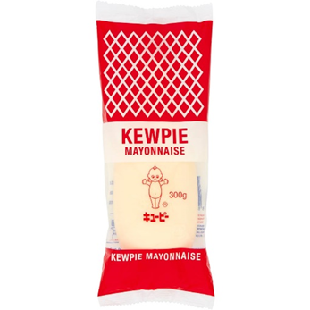 | 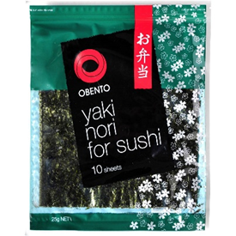
Other suggested fillings:
- pickled plum (umeboshi)
- bonito flakes and soy sauce
- BBQ prawn
- fried chicken
- any meat cooked with teriyaki sauce
- tinned ham with soy sauce.

Vocabulary
Japanese | English
つくります | to make
ごはん | rice (usually steamed rice)
ツナ（つな） | tuna
マヨネーズ (mayoneezu) | mayonnaise
しお | salt
のり | seaweed (nori)
おさら | plate
うえ | on top, above, up
ラップ (rappu) | wrap
おきます | to put, to place
まんなか | centre
ぱらぱら | onomatopoeia for small objects falling (in this case salt)
ツナマヨ (tsunamayo) | tuna-mayo
あわせます | to put together
さんかく | triangle
たいら | flat
おします | to push
できました | done
はずします | to take off
つけます | to put on
いただきます | greeting that is said before eating in Japanese

Video script
Time | Japanese | English
0:12 | おにぎりをつくります | We are making onigiri
0:17 | ごはん、ツナ、マヨネーズ、しお、のり | Rice, tuna, mayonnaise, salt, seaweed
0:24 | おさらのうえにラップをおきます | Place wrap on the plate
0:30 | ラップのまんなかにおさらをおきます | Place the wrap on the centre of the plate
0:38 | しおをぱらぱらぱらぱら | Sprinkle salt
0:54 | ごはんをおきます | Place rice
1:03 | ごはんのまんなかに | At the centre of rice
1:07 | ツナとマヨネーズ、ツナマヨをおきます | Place tuna-mayo
1:18 | ラップのコーナーをあわせます | Pull the corners of the wrap together
1:27 | さんかくのおにぎりをつくります | Make the onigiri into triangle
1:33 | てをたいらにしてごはんをおきます | Lay your hand out flat and place the rice there
1:39 | てをさんかくにして | Make a triangle with your hand
1:42 | ごはんをぎゅっとおします | Squeeze the rice
1:50 | さんかくのおにぎりができました | Then you have a triangle shaped onigiri
1:57 | ラップをはずします | Take the wrap away
2:00 | のりをつけます | Put the seaweed around it
2:12 | いただきます | (Said before eating)

References
This resource contains NSW Curriculum and syllabus content. The NSW Curriculum is developed by the NSW Education Standards Authority. This content is prepared by NESA for and on behalf of the Crown in right of the State of New South Wales. The material is protected by Crown copyright.
Please refer to the NESA Copyright Disclaimer for more information https://educationstandards.nsw.edu.au/wps/portal/nesa/mini-footer/copyright.
NESA holds the only official and up-to-date versions of the NSW Curriculum and syllabus documents. Please visit the NSW Education Standards Authority (NESA) website https://educationstandards.nsw.edu.au/ and the NSW Curriculum website https://curriculum.nsw.edu.au/home.
Modern Languages K–10 Syllabus © NSW Education Standards Authority (NESA) for and on behalf of the Crown in right of the State of New South Wales, 2022.

© State of New South Wales (Department of Education), 2024
The copyright material published in this resource is subject to the Copyright Act 1968 (Cth) and is owned by the NSW Department of Education or, where indicated, by a party other than the NSW Department of Education (third-party material).
Copyright material available in this resource and owned by the NSW Department of Education is licensed under a Creative Commons Attribution 4.0 International (CC BY 4.0) license.

This license allows you to share and adapt the material for any purpose, even commercially.
Attribution should be given to © State of New South Wales (Department of Education), 2024.
Material in this resource not available under a Creative Commons license:
- the NSW Department of Education logo, other logos and trademark-protected material
- material owned by a third party that has been reproduced with permission. You will need to obtain permission from the third party to reuse its material.
Links to third-party material and websites
Please note that the provided (reading/viewing material/list/links/texts) are a suggestion only and implies no endorsement, by the New South Wales Department of Education, of any author, publisher, or book title. School principals and teachers are best placed to assess the suitability of resources that would complement the curriculum and reflect the needs and interests of their students.
If you use the links provided in this document to access a third-party's website, you acknowledge that the terms of use, including licence terms set out on the third-party's website apply to the use which may be made of the materials on that third-party website or where permitted by the Copyright Act 1968 (Cth). The department accepts no responsibility for content on third-party websites.

