Programming guidelines for the Auslan K–10 Syllabus
Contents
Introduction 2
Understanding the syllabus 3
Focus areas 3
Outcomes 3
Content 4
Programming 7
Elements of a program 8
Scope and sequence 8
Units 13
Assessment 17
Register 19
Appendix A – scope and sequence checklist 21
Appendix B – unit checklist 22
Appendix C – summative assessment task and marking guidelines checklist 24
Support and alignment 26
Evidence base 27
Note: this document provides advice only. It is the responsibility of individual school executive and teaching staff to ensure programming documents are compliant with both NSW Education Standards Authority (NESA) and departmental requirements and policies.

Introduction
This document supports teachers of Auslan 7–10, their supervisors and the educational teams who provide universal support to schools. For detailed advice on assessment in Auslan 7–10, please access ‘Assessment guidelines for the Auslan K–10 Syllabus’ from our Auslan webpage.
Auslan is the language of the Deaf community of Australia, with its own grammar and vocabulary which are different from those of English. The Auslan K–10 Syllabus focuses on the Northern dialect of Auslan.
Students come to the learning of Auslan with a range of prior learning experiences, either in Auslan or another language. In Years 7–10, syllabus content is developed for 4 broad student groups to accommodate the range of learners. It is up to the teacher to develop a program that differentiates content for these groups where required. The student groups are:
- students with no prior learning or experience of Auslan who are studying Auslan as an additional language (‘Additional language pathway’)
- students with prior learning and/or experience of Auslan who are studying Auslan as an additional language (‘Prior learning and/or experience pathway’)
- students who are studying Auslan as a first language. This may include students who are bilingual in Auslan and English, and students who have no other language to reference when they commence learning Auslan (‘First language pathway’)
- students undertaking a course based on Life Skills outcomes and content. Consideration should be given to other ways of assisting the student to engage with the Stage 4 and/or Stage 5 outcomes, or prior stage outcomes if appropriate, including a range of Adjustments to teaching, learning and assessment activities. The needs of the individual student and the Collaborative curriculum planning process should be considered when assessing the eligibility of a student with an intellectual disability to undertake a course based on Life Skills outcomes (from NESA’s Life Skills webpage).
For a sample unit for Stage 4 Auslan with supporting resources which provides content for students learning Auslan as an additional language, please access the Planning, programming and assessing languages 7–10 webpage. For detailed advice on assessment in Auslan 7–10, including sample tasks, marking guidelines and sample answers, access ‘Assessment guidelines for the Auslan K–10 Syllabus’ on the same page.

Understanding the syllabus

Focus areas
The Auslan K–10 Syllabus (2023) has 4 focus areas:
- Interacting in Auslan
- Understanding texts in Auslan
- Creating texts in Auslan
- Role of language, culture and identity.
Through all focus areas, students learn to communicate meaning in Auslan and develop intercultural capability in d/Deaf and hearing environments.
Communicating meaning in Auslan includes interacting, understanding and creating texts effectively in Auslan, including fingerspelling, vocabulary (for example, depicting and lexical signs), and grammar (for example, referring pronouns, manipulative verbs and constructed action), as well as effective use of signing space and non-manual features for contextual nuances.
Intercultural capability is the capacity to exchange, understand and create meaning between people in Deaf and hearing communities.

Outcomes
Each focus area has 4 stage-based outcomes.
Stage 4
- AU4-INT-01 exchanges information, opinions and ideas using a range of linguistic structures and protocols appropriate for different audiences
- AU4-UND-01 explains how texts represent information, opinions and/or ideas and responds in Auslan and/or English
- AU4-CRE-01 creates informative and imaginative texts for different contexts and audiences using a range of linguistic structures
- AU4-RLC-01 explains the relationship between language, culture and identity
Stage 5
- AU5-INT-01 exchanges information, opinions, ideas and perspectives by manipulating linguistic structures and using protocols appropriate for different audiences
- AU5-UND-01 analyses how texts represent information and/or perspectives and responds in Auslan and/or English
- AU5-CRE-01 creates informative and imaginative texts for different contexts and audiences using complex linguistic structures
- AU5-RLC-01 analyses the interrelationship between language, culture and identity
Auslan K–10 Syllabus © NSW Education Standards Authority (NESA) for and on behalf of the Crown in right of the State of New South Wales, 2023.

Content
Each stage-based outcome includes content. The content in the syllabus is represented through content groups, student groups and content dot points, as seen in the figure below.
Figure 1 – syllabus content groups, student groups and content
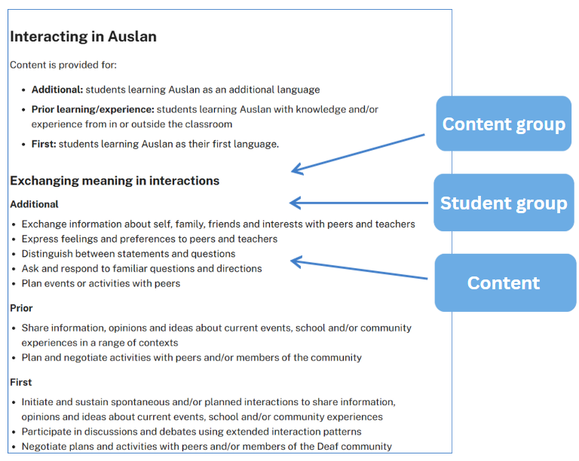
This image has been adapted from the Auslan K–10 Syllabus © NSW Education Standards Authority (NESA) for and on behalf of the Crown in right of the State of New South Wales, 2023.
All of the content is considered ‘essential learning’ for students to demonstrate achievement of the outcome. As such, when designing your scope and sequences and units, you should program for all content, adjusting the time required for attainment, depending on student ability and proficiency.
The examples in the digital curriculum and the teaching advice provide guidance on how the outcomes and content are to be interpreted and applied. They also provide examples of themes you could include in your units. By ascertaining students’ learner entry points, which includes their prior language experience, their existing language skills and their interests, you can draw on relevant content to design learning which is engaging, as well as age and stage appropriate.
In reviewing and planning for the content, the following diagram may assist you to understand the layout of the syllabus.
Figure 2 – organisation of content groups
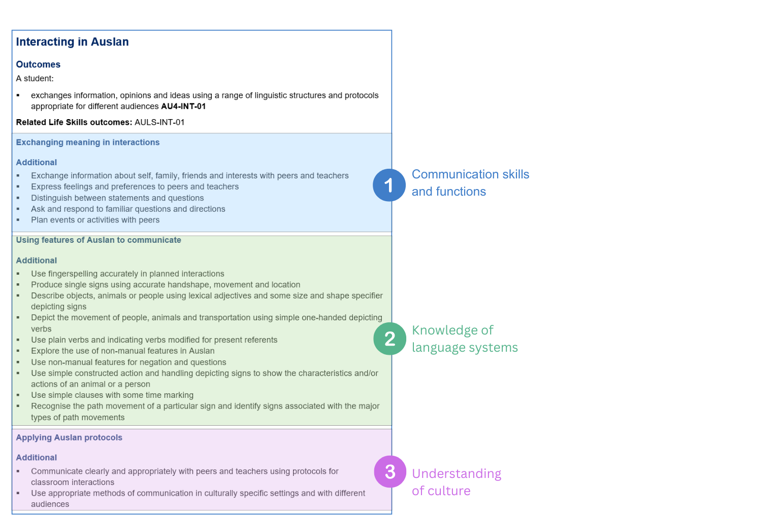
This image has been adapted from the Auslan K–10 Syllabus © NSW Education Standards Authority (NESA) for and on behalf of the Crown in right of the State of New South Wales, 2023.
All the teaching, learning and assessment activities you design for your program should focus on developing students’ ability to communicate in Auslan, using effective and culturally-appropriate communication strategies to engage the receiver. This includes instruction on culturally-appropriate interaction protocols, such as entry/exit cues, turn-taking, backchannelling and respectful visual attention. These support effective communication and intercultural understanding. Where possible, teachers are encouraged to collaborate with members of the local Deaf community and Deaf-led organisations.

Programming
Programming is the process through which teachers select and sequence teaching, learning and assessment experiences which cater for the diversity of learners in a particular year or stage.
A program is all of the documents involved in the overall planning for each language and year or stage.
Effective programs enable teachers to:
- plan for the delivery of syllabus outcomes and content
- improve student learning outcomes
- respond to student learning needs, school context, self-reflection and evaluation
- record planned learning experiences of how syllabus requirements are met.
Programs are evidence of compliance in NESA’s Registration process webpage.
The department also sets additional requirements, outlined in the ‘Curriculum planning and programming, assessing and reporting to parents K-12 policy’ available in the Policy Library.
A program also allows for continuity of quality learning for students, by allowing other teachers to continue teaching students if required, for example during periods of absence.
This document guides you through the elements of a program, and links each element to the Auslan K–10 Syllabus within the context of teaching Auslan in Years 7–10.

Elements of a program
For each year or stage, you need to have a program that includes the elements listed below.
Figure 3 – elements of a program
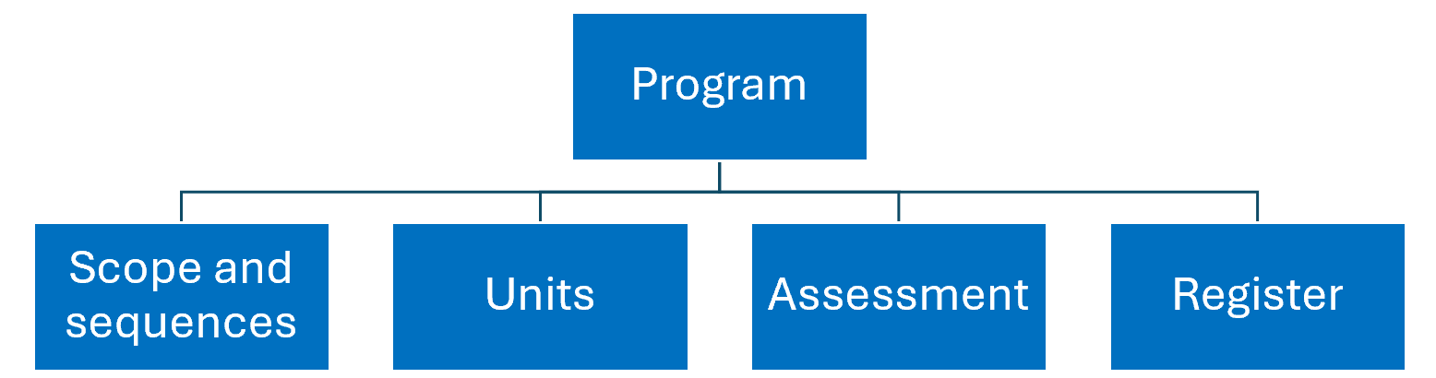
In this document, you can find more information about each element, as well as checklists to help you program, including NESA requirements and other considerations.

Scope and sequence
A scope and sequence summarises what is to be taught and the sequence in which it will be taught within a year or stage. For example, you may have one unit for each term of learning, which looks at a particular theme or topic.
NESA requires that a scope and sequence includes the title of each unit, the sequence of each unit for the year or stage, the duration of each unit and syllabus outcomes included in each unit (as outcomes codes).
While not required by NESA for school registration, the department recommends including the following in your scope and sequence, for each unit:
- the skills students will develop
- a short description of the summative assessment task.
These inclusions support a backward mapping approach and provide a succinct reminder of what skills are important for students to successfully demonstrate achievement of the outcomes and content in the context of the unit.
Take a look at the example below.
Table 1 – sample scope and sequence
Term/  duration | Learning overview | Outcomes | Skills | Assessment
Term 1  10 weeks | Myself and my class  Students introduce themselves and a classmate, using appropriate protocols.  Students share information about names, ages, where they live, how they describe themselves and basic likes and dislikes.  Students develop an understanding of the nature of identity in relation to themselves, the Deaf community and the wider hearing community. | AU4-INT-01  exchanges information, opinions and ideas using a range of linguistic structures and protocols appropriate for different audiences  AU4-UND-01  explains how texts represent information, opinions and/or ideas and responds in Auslan and/or English  AU4-CRE-01  creates informative and imaginative texts for different contexts and audiences using a range of linguistic structures  AU4-RLC-01  explains the relationship between language, culture and identity | - Use simple/single signs and fingerspelling to introduce yourself and where you live.  - Indicate active engagement through backchannelling (facial expressions, body language and signs).  - Understand classroom instructions.  - Exchange respectful greetings with teachers and peers.  - Ask for permission, assistance and clarification.  - Understand the use of appropriate protocols for interactions, to support inclusion.  - Understand differences between interacting in Auslan and in spoken language, for example, pointing to convey meaning and proximity to the receiver.  - Identify and describe key people in your life.  - Exchange information about yourself.  - Access texts in Auslan and English that explore the concept of identity in relation to themselves, the Deaf community and the wider hearing community, for example, I am d/Deaf, I am hearing, I am a CODA.  - Explore statistics around Auslan use and numbers of d/Deaf and d/Deafblind people in Australia, and compare these with the wider population.  - Understand that sign languages (also known as hand sign, hand talk or hand speak) are also part of Aboriginal and Torres Strait Islander Aboriginal Languages and are used by hearing and d/Deaf people as an alternative or supplement to spoken language.  - Discover icons and symbols of sign languages and the Deaf community, for example the Deaf flag. | Part A – Creating texts in Auslan  (AU4-CRE-01)  You have been nominated as the buddy for a new class member who is d/Deaf or hard of hearing. To help them transition to your class, create a video for them in Auslan that introduces yourself and someone in your class. In your video, demonstrate strategies that are used to communicate effectively in Auslan, for example, eye contact to engage the audience and facial expressions to express yourself clearly and meaningfully. Include a greeting, and an image of the person you are introducing.  In your introduction, for yourself and the classmate you are introducing, include:  - names  - ages  - where each of you lives  - how each person describes themselves, for example, ME DEAF, MY FRIEND HEARING, ME BORN AUSTRALIA, <POINT> ABORIGINAL AUSTRALIA LIVE WHERE D-A-R-U-G AREA  - basic likes and dislikes for each person  - something you do together or have in common.  Part B – Role of language, culture and identity (AU4-RLC-01)  You have been asked to create an infographic or article for the school newsletter, to explain to the school community the importance of the Stage 4 Auslan program. Reflect on the knowledge and understanding you have gained in this unit about Auslan and the Deaf community. Then create a detailed infographic or article, in English, outlining how identity is shaped by language, culture and community, and ways to foster inclusion for d/Deaf people. Include information relating to:  - types of visual communication  - communication style (storytelling, humour, directness)  - visual alerts  - attracting someone’s attention  - sense of community.
You should address each outcome within each unit on your scope and sequence, although you do not need to assess each one. As you design your summative assessment task for each unit in your scope and sequence, avoid targeting the same outcomes each time. By assessing all outcomes (and a range of their related content) across a year or stage, you are allowing opportunities for students to demonstrate their achievement more broadly.
For communication to be meaningful, students need to understand the context, purpose and audience. These elements need to be clear when describing the summative assessment task for each unit on your scope and sequence.
When designing your scope and sequence, embed the spiral approach to learning. The acquisition of a language is a cumulative process, therefore a continuous and sequenced approach is essential when developing your units. This allows students to develop their skills gradually, reinforcing and building vocabulary and structures over time. By providing opportunities to revisit and build upon what they have learned, they can use the language and cultural understanding they have acquired to participate in increasingly complex situations. It also supports the shift of new content into students’ long-term memory, lightening cognitive load. Students’ knowledge is deepened and broadened, and they experience a feeling of success by building on prior learning.
Finally, the department recommends providing a ‘student-friendly’ copy to students at the start of the year, written and presented in a way that is appropriate to them. This gives students a sense of what they may be able to achieve by the end of each year or stage, which can be motivating. Students will also be able to see how all their learning links and builds, enhancing engagement and supporting students to reflect on areas for growth.
When planning your scope and sequence, use the checklist provided in Appendix A.

Units
A unit is a flexible, working document that reflects the thoughtful planning and collaboration between teacher(s) delivering the learning to students whose needs, interests and abilities have been carefully considered. Teachers make decisions about how the following elements are shared, either in units or through other means relevant to their context:
- a unit description
- syllabus outcomes
- duration
- stage or year
- integrated teaching and learning activities
- differentiation catering to the range of student groups, as well as their abilities and interests
- opportunities to collect evidence of student achievement
- subject-specific requirements (where relevant)
- resources
- reflection and evaluation
- adjustments for students with disability, where appropriate (NESA 2023b).

While not required by NESA for school registration, the department recommends the following:
- Designing your summative assessment task first, and then backward mapping your unit, including your teaching and learning activities and formative assessment opportunities for students. It is important the students receive ongoing feedback and time for reflection as the unit progresses, so they are engaged with and involved in their learning journey and can identify their individual learning goals (learn more in the Assessment section below).
- Organising your unit into sequences of learning which break down aspects of the final summative task, with clear learning intentions and success criteria for each sequence. By ‘chunking’ the learning in this way, with each sequence of learning building towards a particular aspect of the final task, students are supported to develop the necessary skills to succeed at the summative task.
For example, if your summative task for Stage 4 requires students to create a welcome video for a new student, introducing themselves and a classmate, you may consider breaking your unit into the following sequences, learning intentions and success criteria. Note: the table below is a condensed example only, to provide a snapshot of the process.
Table 2 – sample learning sequence
Learning sequence focus | Learning intentions | Success criteria | Mini task – progress checkpoint
What is the appropriate way to interact with people who communicate using Auslan? | Students are learning:  - appropriate protocols to use when interacting in Auslan  - ways to engage and maintain a conversation with a receiver in Auslan. | Students can:  - use backchannelling and non-manual features to interact appropriately with a person who is d/Deaf or hard of hearing  - gain a receiver’s attention and use appropriate eye contact, facial expression and gaze to maintain an interaction. | Students create an infographic about strategies that facilitate effective communication in Auslan, for example, backchannelling, gaining attention, facial expression, body language, hand movement and location.
How do you describe yourself? | Students are learning:  - signs and non-manual features to express preferences  - the different ways to identify themselves in the community  - to describe the likes and dislikes of a third person. | Students can:  - describe what they like and don’t like to eat and do  - clearly describe themselves in relation to their community  - set up and maintain a referent when describing a friend or family member. | Students are asked to judge the ‘Meet me in Auslan’ video clip competition and answer questions in English based on the information in the conversation.
How do you introduce yourself? | Students are learning:  - how signed names are formed  - numbers  - how to fingerspell place names. | Students can:  - exchange names with a new person  - express their own and a third person’s age  - express where they live. | To prepare for a visit with a class of students who are d/Deaf or hard of hearing, interact in Auslan with a peer to ask and respond to questions about:  - names  - ages  - where you live  - describing your identity  - basic likes and dislikes.
While each of your units should address all outcomes, each unit does not need to cover all the content dot points for each outcome. These can be covered across a year or stage of learning.
Where possible, maximise Auslan input before expecting students to interact or create texts. This includes using Auslan as the medium of instruction and encouraging students to respond in Auslan. Provide concrete examples, such as video clips and community-produced content, adapting texts for diverse learners, including students with no prior learning or experience of Auslan, students learning Auslan with knowledge and/or experience from in or outside the classroom, and students learning Auslan as their first language.
When planning your unit, use the checklist provided in Appendix B.

Assessment
Assessment provides opportunities for teachers to gather evidence about student achievement in relation to syllabus outcomes, including a range of student work samples.
NESA states:
‘The primary role of assessment is to establish where students are in their learning so that teaching can be differentiated and further learning progress can be monitored over time. It provides information that assists teachers to target their teaching at the point of student need. Assessment is most effective when it is an integral part of teaching and learning programs.
Assessment involves:
- establishing where students are in their learning
- ongoing monitoring
- formative and summative tasks
- providing feedback about student progress.’
Auslan K–10 Syllabus © NSW Education Standards Authority (NESA) for and on behalf of the Crown in right of the State of New South Wales, 2023.

Formative assessment
Formative assessment aims to close the gap between where a student is now and where they need to be, to successfully demonstrate their achievement of the outcomes. Teachers use evidence of students’ knowledge, understanding and skills to inform their teaching and to provide feedback to students about their learning and how to improve.
It is important to plan opportunities which allow students to discover where they are now and enable them to plan how to move to the next stage of their learning.
For example:
- pre-testing for prior knowledge prior to starting a unit (Are you aware of what students already know and can do? Does your unit ‘tap into’ areas of student interest and acknowledge their cultural and background knowledge?)
- activities and quizzes to monitor learning
- mini tasks which allow opportunities for students to practise new vocabulary and skills, and receive feedback, to support their success in the summative assessment task (progress checkpoints)
- effective feedback, including peer feedback and self-reflection opportunities.

Summative assessment
Summative assessment allows teachers to gather evidence of achievement of learning intentions and outcomes against performance standards, thus measuring student achievement at a point in time. Like all assessment, it provides an opportunity to provide feedback to students on their progress.
By providing students with your planned assessment and related marking guidelines at the start of each unit, you will support them to plan and link their learning. Allow time to discuss the task, and then revisit the task at various points throughout your teaching of the unit, so students are reminded of why each sequence of learning is relevant.
With effective communication in Auslan being the central goal in the syllabus, summative assessment takes the form of real-world or simulated real-world tasks, which articulate the context, purpose and audience of the communicative act.
For example: ‘You have been nominated as the buddy for the new class member who is d/Deaf or hard of hearing. To help them transition to your class create a video for them in Auslan, to introduce yourself and someone in your circle’.
In this task it is clear the student is creating a video text in Auslan for a new student who is d/Deaf or hard of hearing. The audience is the new class member, and the purpose is to introduce yourself and someone in your circle to them.
By designing your summative assessment first, then backward mapping your teaching, learning and formative assessment opportunities, you are supporting your students to develop the skills required for effective communication.
Assessment opportunities are required to be inclusive of and accessible for all students. It is important to consider how you will support the needs of all students, for example by:
- providing a scaffold
- allowing the use of assistive technology to communicate
- negotiating a plan to prepare students for a summative assessment task.
Additional information for assessment, including what, when and how to assess is included in our ‘Assessment guidelines for the Auslan K–10 Syllabus’. When planning your summative assessment task, use the checklist provided in Appendix C.

Register
A register is a document which tracks the progress of each unit, including any variations made, and allows for evaluation of the strategies and activities used. Teachers and schools may approach this differently. For example, some teachers may annotate units, indicating when activities and tasks were completed by each class and noting any adjustments which were required, including a self-reflection. Other teachers may have their register as a separate document. It will depend on the requirements of your faculty and/or school.
Please complete this feedback form to help us improve our resources and support.

Appendix A – scope and sequence checklist
My scope and sequence includes:
☐ NESA’s advice on scope and sequences
☐ title of each unit
☐ sequence of each unit for the year or stage
☐ duration of each unit
☐ syllabus outcomes included in each unit (as outcomes codes)
☐ effective communication in Auslan as the central goal
☐ the skills students will develop in each unit
☐ a short description of the summative assessment task for each unit, which focuses on real-world communication, with a purpose, context and audience
☐ a range of assessment opportunities for each year or stage, assessing different outcomes and content
☐ opportunities for students to revisit language from previous units, building on existing knowledge and skills, in new contexts.
I have:
☐ shared my scope and sequence with students, using student-friendly language.

Appendix B – unit checklist
My unit includes:
☐ NESA’s advice on units
☐ unit description
☐ syllabus outcomes
☐ duration
☐ year or stage
☐ integrated teaching and learning activities
☐ differentiation catering to the range of student abilities and interests
☐ content developed to cater for all 4 student groups
☐ opportunities to collect evidence of student achievement (through formative and summative assessment)
☐ resources
☐ reflection and evaluation
☐ adjustments for students with disability, where appropriate
☐ opportunities to ascertain students’ prior knowledge
☐ effective communication in Auslan as the central goal
☐ opportunities for students to develop knowledge of the parameters of Auslan (including fingerspelling, depicting signs, non-manual features, depicting and lexical signs)
☐ opportunities to develop intercultural capability by using culturally-appropriate communication strategies including backchannelling, feedback indicators and use of space to convey meaning
☐ learning intentions and success criteria for each sequence of learning within the unit, supporting student engagement and success
☐ opportunities for feedback and student reflection for deeper understanding and identification of individual learning goals.

Appendix C – summative assessment task and marking guidelines checklist
Assessment is an ongoing process where progress is monitored over time through a range of task types.
For summative assessment, I have included:
☐ NESA’s advice on assessment
☐ based on syllabus outcomes
☐ valid (assesses what it is designed to assess)
☐ criteria which clarifies for students what aspects of learning are being assessed
☐ reliable, measuring what the task intends to assess, and providing accurate information on each student’s achievement
☐ free from bias and providing evidence that accurately represents a student’s knowledge, understanding and skills
☐ enables students and teachers to use feedback effectively and reflect on the learning process
☐ inclusive of and accessible for all students
☐ part of an ongoing process where progress is monitored over time through a range of task types
☐ effective communication in Auslan as the central goal, through a real-world or simulated real-world context, with a clear purpose and audience
☐ relevant support for all students to succeed
☐ how feedback will be provided.

I have:
☐ shared the assessment task and marking guidelines with students at the start of the unit, and discussed it with them, supporting them to see the relevance of the upcoming learning
☐ planned opportunities for students to revisit the assessment task throughout the unit, so they can see if they are on track and plan their next steps.
If your school requires you to provide a related assessment task notification, include:
☐ a clear task description
☐ marking criteria (‘You will be assessed on your ability to …’)
☐ marking guidelines (descriptions of achievement across a range of marks/grades)
☐ how feedback will be provided.

Support and alignment
Resource evaluation and support: All curriculum resources are prepared through a rigorous process. Resources are periodically reviewed as part of our ongoing evaluation plan to ensure currency, relevance, and effectiveness. For additional support or advice, contact the Languages and Culture team by emailing languagesnsw@det.nsw.edu.au.
Alignment to system priorities and/or needs: Curriculum planning and programming, assessing and reporting to parents K-12
Alignment to the School Excellence Framework: This resource supports the School Excellence Framework elements of curriculum (teaching and learning programs).
Alignment to Australian Professional Standards for Teachers: This resource supports teachers to address Proficient Teacher Standard Descriptors 2.2.2, 2.3.2, 3.2.2.
Consulted with: Curriculum and subject matter experts
NSW syllabus: Auslan K–10 Syllabus
Author: Languages and Culture
Publisher: State of NSW, Department of Education
Resource: Programming guidelines for the Auslan K–10 Syllabus
Related resources: Further resources to support Auslan can be found on the Languages curriculum page.
Professional learning: Relevant professional learning is available through the Languages statewide staffroom (entry survey link for staff only).
Creation date: August 2025
Rights: © State of New South Wales, Department of Education

Evidence base
This resource contains NSW Curriculum and syllabus content. The NSW Curriculum is developed by the NSW Education Standards Authority. This content is prepared by NESA for and on behalf of the Crown in right of the State of New South Wales. The material is protected by Crown copyright.
Please refer to the NESA Copyright Disclaimer for more information https://educationstandards.nsw.edu.au/wps/portal/nesa/mini-footer/copyright.
NESA holds the only official and up-to-date versions of the NSW Curriculum and syllabus documents. Please visit the NSW Education Standards Authority (NESA) website https://educationstandards.nsw.edu.au and the NSW Curriculum website https://curriculum.nsw.edu.au.
Auslan K–10 Syllabus © NSW Education Standards Authority (NESA) for and on behalf of the Crown in right of the State of New South Wales, 2023.
NESA (NSW Education Standards Authority) (2023a) ‘Advice on scope and sequences’, Programming, NESA website, accessed 16 July 2025.
——(2023b) ‘Advice on units’, Programming, NESA website, accessed 15 July 2025.
——(2023c) ‘Life Skills’, Special education, NESA website, accessed 16 June 2025.
——(2023d) ‘Proficient Teacher Standard Descriptors’, Proficient Teacher, NESA website, accessed 4 June 2025.

© State of New South Wales (Department of Education), 2025
The copyright material published in this resource is subject to the Copyright Act 1968 (Cth) and is owned by the NSW Department of Education or, where indicated, by a party other than the NSW Department of Education (third-party material).
Copyright material available in this resource and owned by the NSW Department of Education is licensed under a Creative Commons Attribution 4.0 International (CC BY 4.0) license.

This license allows you to share and adapt the material for any purpose, even commercially.
Attribution should be given to © State of New South Wales (Department of Education), 2025.
Material in this resource not available under a Creative Commons license:
- the NSW Department of Education logo, other logos and trademark-protected material
- material owned by a third party that has been reproduced with permission. You will need to obtain permission from the third party to reuse its material.
Links to third-party material and websites
Please note that the provided (reading/viewing material/list/links/texts) are a suggestion only and implies no endorsement, by the New South Wales Department of Education, of any author, publisher, or book title. School principals and teachers are best placed to assess the suitability of resources that would complement the curriculum and reflect the needs and interests of their students.
If you use the links provided in this document to access a third-party's website, you acknowledge that the terms of use, including licence terms set out on the third-party's website apply to the use which may be made of the materials on that third-party website or where permitted by the Copyright Act 1968 (Cth). The department accepts no responsibility for content on third-party websites.

A child of d/Deaf adults.
As preparation for this task, students could complete a class survey, with this information. Students can then be allocated a classmate to introduce in their presentation, to build relationships in the classroom context.
Opportunities to collect evidence of achievement can occur through formative and summative assessment.
Texts should be sourced from authentic, culturally-appropriate Auslan sources in the Northern dialect. Avoid Key Word Sign, Signed English or other sign systems. Preference should be given to texts created by members of the Deaf community or proficient Auslan users.

